**Chapter 11 Project 1**

Step 1: Create new modified sequential search routine

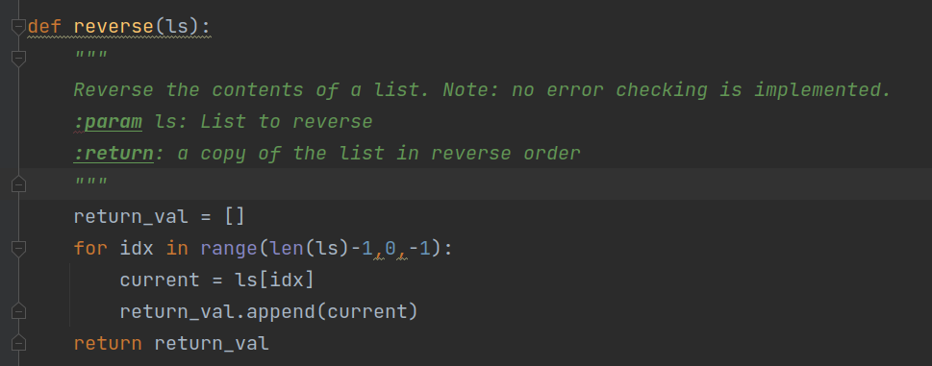

Step 2: Write code to test algorithm.

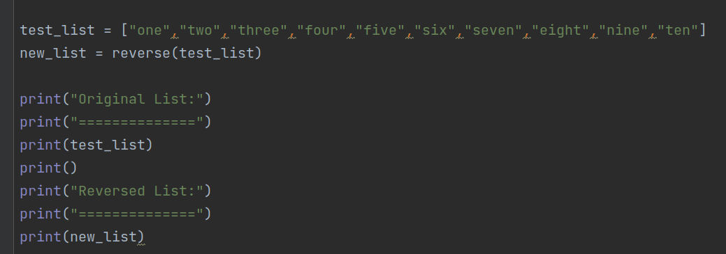

Step 3: Execute code to test algorithm

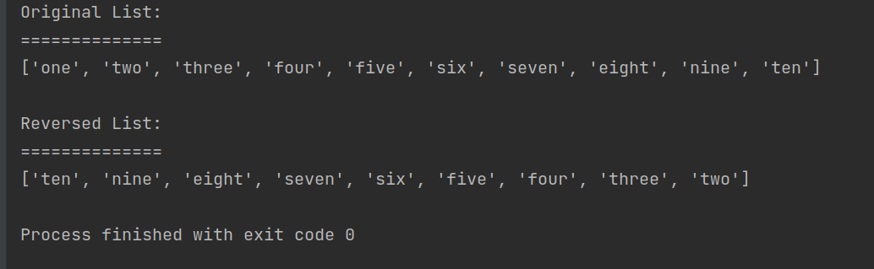

Step 4: Discuss the computational complexity.

All cases must traverse the entire list one time making the time complexity the same for all possibilities. Since the list is traversed 1 time, n elements are visited making the algorithm **O(n)**.