**Chapter 11 Project 3**

Step 1: Write exponent function.

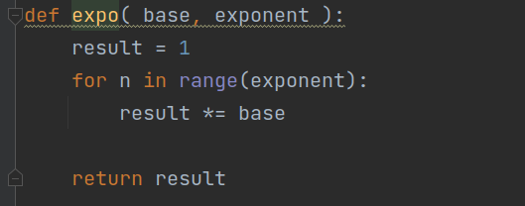

Step 2: Write code to test algorithm.

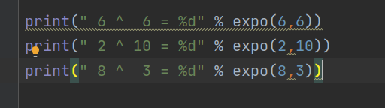

Step 3: Execute code to test algorithm

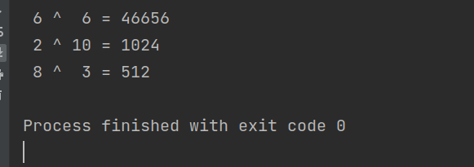

Step 4: Discuss the computational complexity.

All cases must loop from 1 to the exponent (technically from 0 to exponent-1) making the time complexity **O(n)** where n is the size of the exponent.