Screenshots showing program in action.

**SERVER**

The server is not too exciting. It can be started from the command line and will log a connection message to the console for each connection.

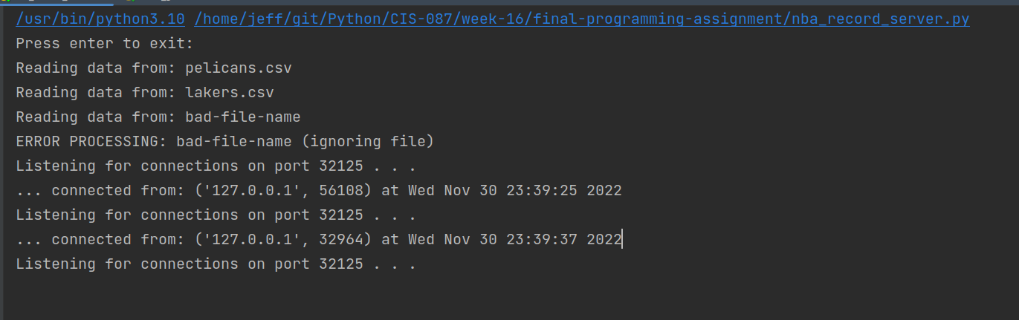

**CLIENT**

The client is a single framed gui interface. The user selects the Team and season to search for and press the button. The client requests the information from the server and populates the bottom portion of the frame with the data returned.

Here is the gui frame at startup.

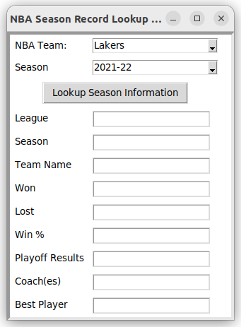

The user can select the team and season from the supplied lists.

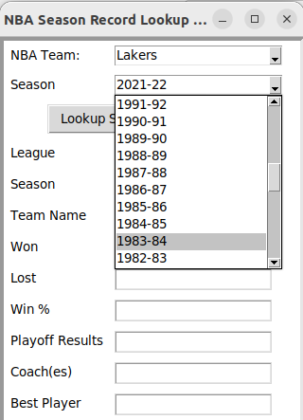

Once the user chooses a team and season, here is what it looks like.

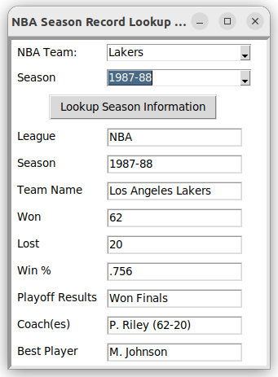

If the server does not know the information or the team did not play during that year, the fields are filled with an informative message such as this one:

