**USE CASE DOCUMENT**

This document gives direction for use of the CIS-087 Python final project submitted by Jeff Alkire.

Using this environment is a three step process.

Note: instructions are given for use with Ubuntu Linux version 22.04. Changes may be necessary if you are using a different version and/or Operating System.

**STEP 1: START THE INFORMATION SERVER**

The following steps will allow the user to start the server that will handle information requests:

1. Open a bash shell.

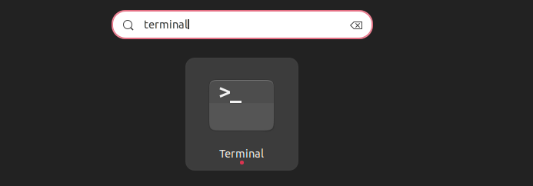

1. Move to the directory the nba_record_server.py file is located in.

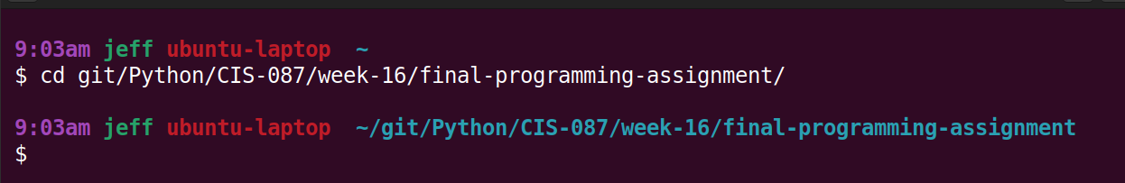

1. Use Python to start the information server using the command:

python nba_record_server.py

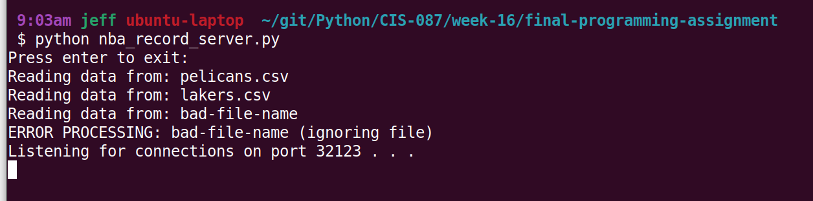

1. Check for the “Listening for connections on port ….” message. If it is there, you have successfully started the server process.

The ERROR PROCESSING: bad-file-name (ignoring file) is there intentionally. An extra file was added to the data directory in order to show recovery from difficulties in loading data.

**STEP 2: START CLIENT PROCESS**

1. Start a second terminal and move to the directory with the project in it. This is the same as steps A and B from step 1.
2. Use Python to start the information server using the command:

python client_gui.py

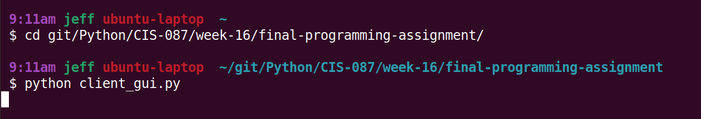

1. You should now see the simple client’s GUI interface.

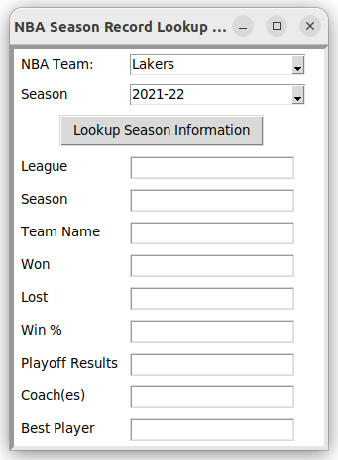

**STEP 3: USE GUI TO SUBMIT REQUEST FOR INFORMATION**

1. Select a team from the currently limited selection of NBA Teams by choosing one from the NBA Team combo box.

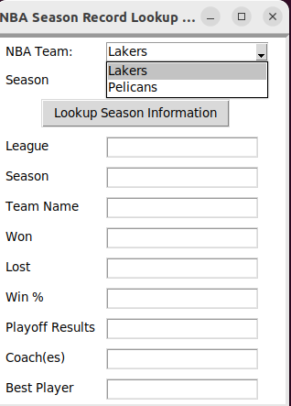

1. Select a season from the Season drop down box:

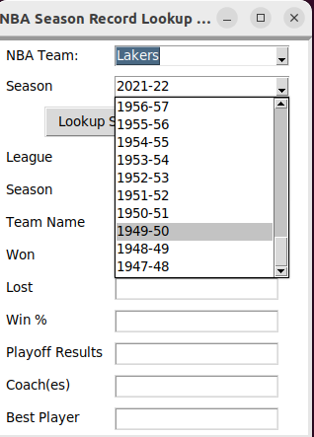

1. Press the button labeled “Lookup Season Information”
2. View the resulting information as displayed below the button.

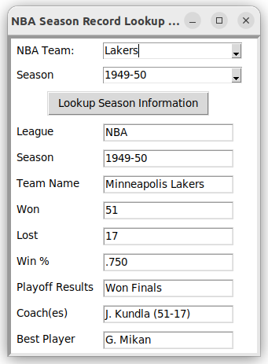

What a great coincidence, the Lakers won the championship this year. Who would of known? :)