Chapter 11 Project 1

Step 1: Create new modified sequential search routine
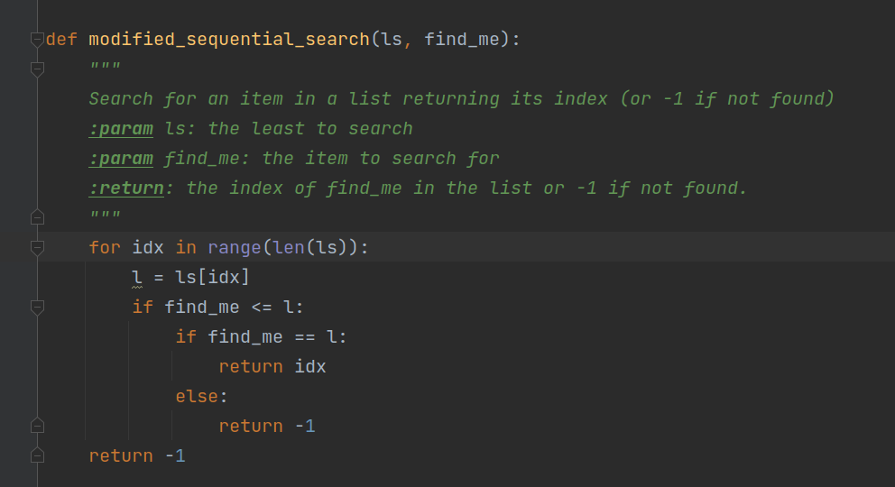

Step 2: Write code to test algorithm.
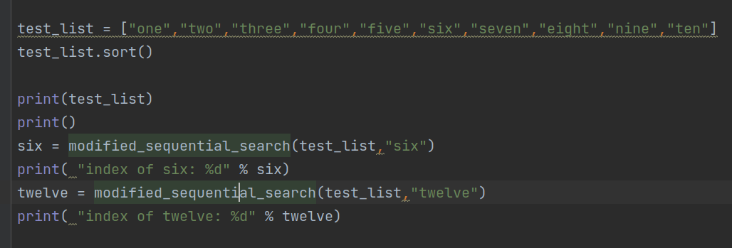

Step 3: Execute code to test algorithm
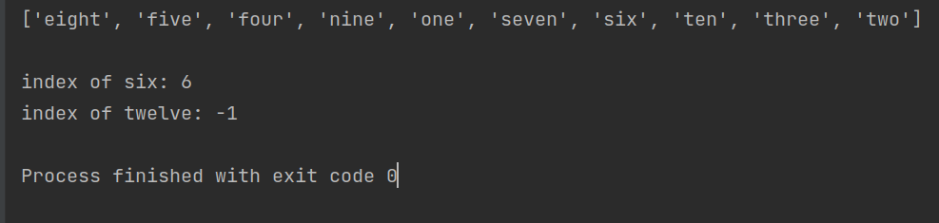

Step 4: Discuss computational complexity of best, worst, and average cases.
Best Case: If the item matches the first item or precedes it, then the routine returns after 1 examination. This is O(1).

Average Case: On average, the search should search about ½ of the list. This is time complexity of ½ n or O(n).

Worst Case: In the worst case, the entire list is searched without finding a match. This is time complexity of n or O(n).

