**Main artery Pulmonary Embolism detection,   
using traditional computer vision techniques**



Master of Science (MS) in Data Science  
Module: ITC6009A1 – Machine Vision in Data Science  
Instructor: Dr. Drakakis Georgios

Students’ names & IDs:

Alkiviadis Kariotis 241735

Konstantinos Tzoras

Christos Karatsiolis 270254

Dimitra Chatzopoulou

Term: Fall Term 2023  
Type: Group Term Project - Report

Submission Date: Tuesday 19th of December

Words:

AUTOMATED DETECTION OF PULMONARY EMBOLIMS UTILIZING COMPUTER VISION TECHNIQUES

Table of Contents

Abstract 3

Keywords 3

Introduction 4

Materials & Methods 6

Reading & creating slices 6

Results & Discussion 6

Conclusion and Future Work 8

References 8

Appendices 9

Appendix 1 9

Radiologist multiple Interviews Summary 9

Appendix 2 12

# Abstract

200-250 Words

Pulmonary embolism (PE) and more specifically, a large PE can lead to severe life-threatening problems or even mortality. Over 100.000 deaths have been reported between the last 10 years, due to this disease, from which the 10-30% of people died within the first month of diagnosis. Thus, there is a necessity for further investigations and improvements of the early detection of this disease.   
In order to diagnose the PE, the patients should take a computed tomography pulmonary angiography (CTPA). This examination consists of multiple scans which are pictures of the blood vessels that run from the heart to the pulmonary arteries.

The aim of this project is to diagnose if a patient is positive to pulmonary embolism, by detecting the presence of the embolism from computed tomographic pulmonary angiographies dataset. The scope is to provide rapid automated detection of pulmonary embolisms of patients so as to avoid human errors and reduce their effort. The dataset contains 91 patients with multiple scans per CTPA.   
Computer vision techniques are utilized in order to approach this goal since there is a pattern of the identification of PE through the computed pulmonary angiographies. Specifically, the diagnosis is based on sufficient contrast enhancement. However, the diverse range of clinical representations from people that are not ail to death diagnosis can be very challenging. Thus, aiming to address these challenges, various methods of computer vision were utilized such as histogram equalization, blur, canny edge detector, thresholding from which some of them brought better results than others.

## Keywords

5 Keywords

# Introduction

700-800 words Literature Review

Computer Vision is a part of artificial intelligence, which is used for training computers to comprehend and interpret the visual world. This field includes image processing techniques which aim to assist machines to recognize and detect objects from digital images. These advanced techniques enable the automation of tasks; thus, human effort can be minimized, as well as multiple fields of research and applications can benefit from increased efficiency and accuracy.  
 This development can be applied to various industries and fields such as medicine, agriculture, healthcare. The following project aims to apply this knowledge for the detection of Pulmonary Embolism (PE).  
Pulmonary Embolism is a blood clot that blocks the pulmonary artery in the lungs. To be more precise this blood clot comes from a deep vain in the leg and afterwards transfer itself to the lungs where it gets trapped in a smaller lung artery. Pulmonary Embolism can be life threatening without treatment and cause various problems such as cardiac arrest and arrhythmia. The occurrence and fatality of this disease have been increased between the last 10 years, with more than 100.000 deaths from which the 10-30% died within the first month of diagnosis. Thus, with that rate of mortality and the creation of future health issues it is necessary to investigate and provide ways that will help to address this illness. One improvement which is also the scope of the project, is to provide rapid automated detection of pulmonary embolisms in patients so as to avoid human errors and reduce their effort.   
The dataset that is used in the project consists of 91 computed topographies of various patients. The files are in the format of nrrd, thus, Simple ITK library will be used since it’s well known for medical image data processing, as well as nrrd library which is used to read and write NRRD files. Each CTPA consists of numerous scans since it takes pictures of the blood vessels that go from the heart to the lungs. The arteries can be detected through these scans as bright and white. In contrast, the blockages or blood clots are inside or at the outline of an artery and are presented darker and with higher contrast (grey color). That is the pattern that will be used.   
Initially, each CTPA consisted of hundreds of images from which only a few of them display the two arteries clearly and from which is accurate if the patient is positive to PE or not. In this part, the first challenge was to identify and keep only the images that were containing the central artery in a clear way. Thus, the first filtering was completed by applying a specific threshold to the intensities of pixels from the grayscale images. However, that wasn’t enough, thus, by tuning the parameters of trackbars, it was managed to detect the circles in the image. In this way, we filtered all the images that were containing a circle meaning that they were having a central artery.  
Afterwards, it was crucial by using the scans that were found and saved from the above steps, to manage to detect the embolisms more accurate as possible. Aiming to do so, multiple image processing techniques as well as multiple different parameters were examined and applied again in order to end up with the more accurate result. For instance, gaussian blur, crop of an image, application of binary threshold (also adaptive and band thresholds were tested), connected components, erosion, and dilation. The final step was to save the images that contained the central artery with colored embolism. During these processes, we were facing many challenges since there was a diverse range of clinical representations from people that are not ail to death diagnosis. Moreover, a lot of parts outside of the main artery were misleading thus, there could be applied many improvements that will be profoundly analyzed during this project.

Jupyter Notebook will be the environment that will be used in order to run the desired processes and the files that contains the codes will be saved in “. ipynd” format.

# Materials & Methods

1000-1200 words

Approximately 1000-1200 words. This should be a concise outline of all steps

followed, all methods used (and explained), all parameters, etc., structured

logically. It should not include any results.

- It is common to use subheadings.

## Reading & creating slices

Start by reading the NRRD files (Appendix 2),

# Results & Discussion

Results and Discussion: approximately 1000-1200 words. This should be an

objective presentation of all results, followed by interpretation based on the

numbers (not intuition!). This is a good place to mention any shortcomings and

reasons behind these.

• Do not overflow this with 47 figures and tables, provide those necessary to

show your analysis (those that contribute to your story) and place the rest in the

appendix.

• This is commonly carried out second

* the images will be converted to grayscale since they have a single channel that represents the intensity (brightness) of each pixel, in comparison with colored images that have three channels (red, green and blue). As a result, grayscale images are less complex. Additionally, the dimensionality is lower in comparison with colored images which can lead to less costly in computations output.
* Secondly, Gaussian blur will be applied to the grayscale images which reduces the high frequency components that are also known as “noise”. This application makes the image cleaner and smoother. In this case the size of kernel is (5,5) which means that is a larger blur so, the emphasis is to achieve a smoother general appearance and not pay that much attention to the details.
* Thirdly, a 3x3 matrix that is filled with ones will be created for the next step which is about morphological transformations (dilation and erosion).

**Future Improvements**

As has been demonstrated, in the end of all these attempts, we managed to provide enough accurate results by detecting and classifying the embolisms. However, it is unquestionable that this subject is about a life-threatening illness that leaves absolutely no margin for error. Thus, it would be crucial and interesting to attempt to improve the procedures that end up to the result.   
One of the main reasons of wrong classifications was the fact that there was a diverse representation of arteries due to the fact that from patient to patient there are several differences in their organs as well as, the fact that computed tomography pulmonary angiographies come from various equipment. These two factors resulted in a chasm that could not be satisfied only by choosing the best parameters. Thus, we came up with the idea to create clusters for every possible type of scan that represents the artery we are interested in. In that way, for each cluster it is beneficial to examine and change the parameters until we find the best ones for each specific cluster. After this application of clusters, it would be expected to significantly reduce the error.   
Another interesting approach would be to apply deep learning techniques that could classify if the patient was positive or not to pulmonary embolism. In this view, it is necessary to have the assistance of a doctor who would provide a labeled dataset. The labels would be pictures which would contain scans from the computed tomography pulmonary angiographies and would have marked the exact place that the embolism is detected. Similarly, we would need a dataset of scans that no embolism is detected. To continue, the dataset would be used to apply deep learning techniques, for instance, convolutional neural networks (CNN) which are widely known for image analysis.

# Conclusion and Future Work

Conclusion and Future Work: approximately 700-800 words. This contains a very

brief summary of the results, leading to the decision as to whether or not the

goal was fulfilled and why. It is common to reiterate a major shortcoming and

provide realistic future work, i.e. use a different method and why, try to include

more data from source X, apply the same methodology to a different problem

(transferability of your work is very useful), or the like.

# References

References: Approximately 10-12 should suffice in this case. Choose any style you

wish but be consistent

https://www.svhlunghealth.com.au/procedures/imaging/ctpa-ct-pulmonary-angiogram

# Appendices

## Appendix 1

### Radiologist multiple Interviews Summary

Question 1 *:Can you explain to us, the depicted components, and their use in the following CT scans?*

In the Figure … we can see the Liver depicted, which is responsible for the production of bile which helps towards the breakdown of fats in the small intestine during digestions.

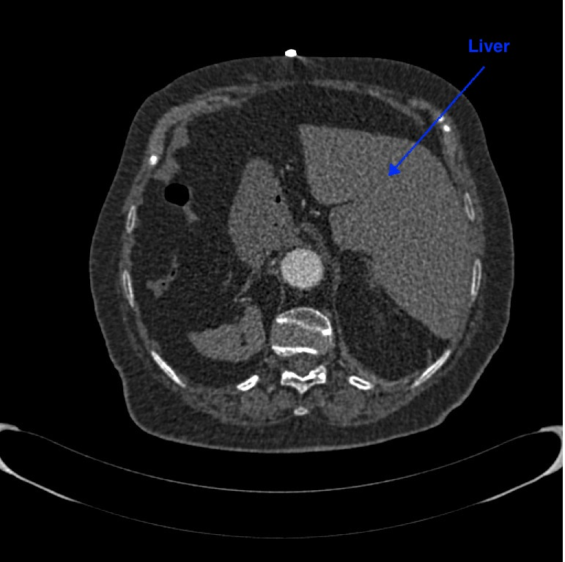

Figure 1:CT slice 145 of patient 006

In the Figure __ we can see the Heart depicted, which is the center of the circulation system and it pubs around the body as it beats. In simple words pushes the highly oxygen blood and pumps it back to the body.

Figure 2: CT slice 238 of patient 006

In the Figure __ we can the left atrium, which takes the blood from the pulmonary veins, which is the only case where veins are filled with arteria blood, brought from the lungs completely cleaned.

Figure 3: CT slice 278 of patient 006

In the Figure __ we can see the aortic arch, which is the middle transformation from the ascending thoracic aorta to the descending one and is the one the leaves from the left ventricle of the heart in order to get the blood to the tissues and organs. During this process it splitted into various branches.

Figure 4:CT slice 413 of patient 006

In the Figure __ we can and the superior vena cava or great venus trunk, which is a vein who drains the vein blood and returns the vein blood to the right atrium of the heart from the brain, the neck, and the upper limbs.

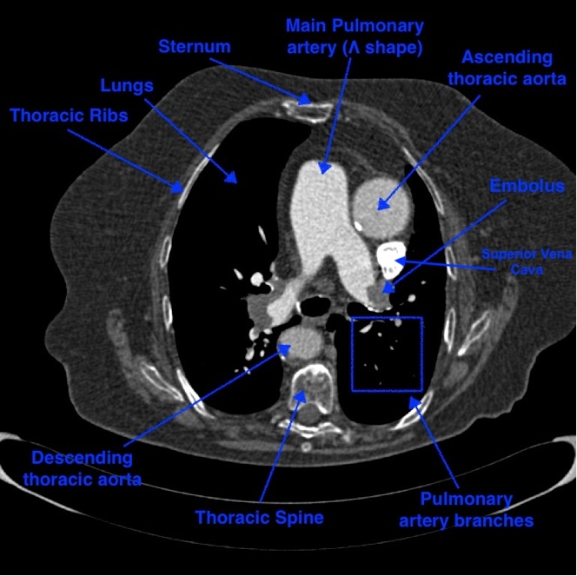

Figure 5:CT slice 341 of patient 006

Question 2 *:Can you give us a brief overview of the whole context in order to provide us the necessary knowledge to proceed with our project?*

Some general information about the blood cycle. Arterial blood begins with the aorta from the left ventricle of the heart and delivers oxygen and nutrients to all organs and tissues. Then it removes carbon dioxide and other waste products from the organs and tissues to the right atrium. From the right atrium the blood goes to the right ventricle and then with the pulmonary article goes to the two lungs. In lungs the blood is filled with oxygen and get ridded of the carbon dioxide. Afterwards, it becomes arterial blood again because it has been oxygened again, and it return to the right atrium with pulmonary veins. From there to the right ventricle to the aorta and the whole process in loop again.

In the process of the blood transition from the main pulmonary artery to the lungs, there embolisms can be spotted. Embolisms are blood clots (πήγματα). Those travels through vessels where it can cause a blockage. In simple words they are blocking the arteries, not letting the blood flow through the artery to the lungs, stopping the entire blood cycle.

Throughout our interview with the team, they have built for us an UI interface in which they demonstrated the basic techniques that we were using to inspect the CT scans. With our guidance we ended up with the specific window and width levels which in our industry understanding are parameters for change the brightness and the contrast of the CT scans. There are many windows in the medical industry, such as lung window, bone window, brain window and many more, but the one tailored to the project was the soft tissue one, which highlighted the arteries and veins of the CT scans.

Question 3 *: Why are there different number of CT scans for different patients in our dataset?*

The reason of the different number of CT scans slices can be due the gender of the patient, the weight of the patient and also the height of the patient. The reason why a small percentage of your patients is having much less than around 500 hundred slices (which is the normal) is due to the fact that maybe the urgent that was examined, was in a rush to get to the surgery so we just needed a few scans to serve as guidelines for the surgeon to operate.

Question 4 *: Why are there different coloring and pixel variations from patient to patient?*

This happens because the dataset does not consist of patients, who have examined in the same Computed tomography system. Each system has as default values for the CT scans different values of brightness and contrast, so that means that different masking is needed from one to another. After inspecting with the team approximately 10-15 patients from their dataset, we came up with some level and width windows that could serve their purpose for almost all of them.

## Appendix 2

NRRD or Nearly Raw Raster Data files, are the files that are stored in this specific format. Those files find application in the medical industry such as CT or MRI scans, and they are used for visualizing the medical image data. This type of file makes handy because of the various support for numerous data types and meta-information, providing the possibility for processing and analysis.