**Assignment 4: Group Project – Build A WebApplication**

1. **Name and student numbers of all team members and Web Application Name**

Student Name 1 Maxime DROUIN Student Number 1 3008951 Student Name 2 Achille LAROCHE Student Number 2 3008965 Name of Web Application Taskify

# A brief overview of the application, including any details that differentiate your application

# Our application is Fastify, a To do list web application. The main feature of this application is that it has an adaptative theming corresponding on the user preferences (Dark & Light theme)

# The app is available at <https://taskify-griffith.herokuapp.com/login>

1. **User Groups and Permissions**

Make any change you feel appropriate to the section below

# User Groups

* + Member Free (Free registered users of the app)
  + Public

# Basic Features

1. A task can be created by Member free
2. A task can be edited by Member free
3. A task can be deleted by Member free
4. A public member can register
5. A free member can login

# Additional Features

# Inspired by

Identify 3 applications that you would like to draw design inspiration from and say what factors and features you would like to incorporate from each of them

1. <https://todoist.com/app/#start>
2. <https://ticktick.com/>
3. <https://www.sortd.com/>

# The main features

Screen shots and a line of explanation for each.

# Sign up and log in

# 

# 

* **Create tasks (With a title, details, date for completion, level of priority etc.)**

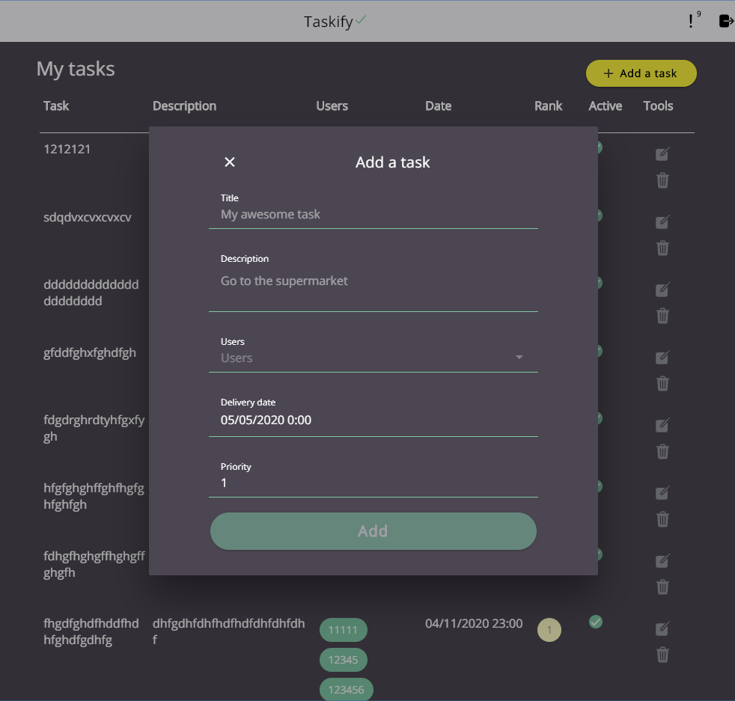

* **View tasks**

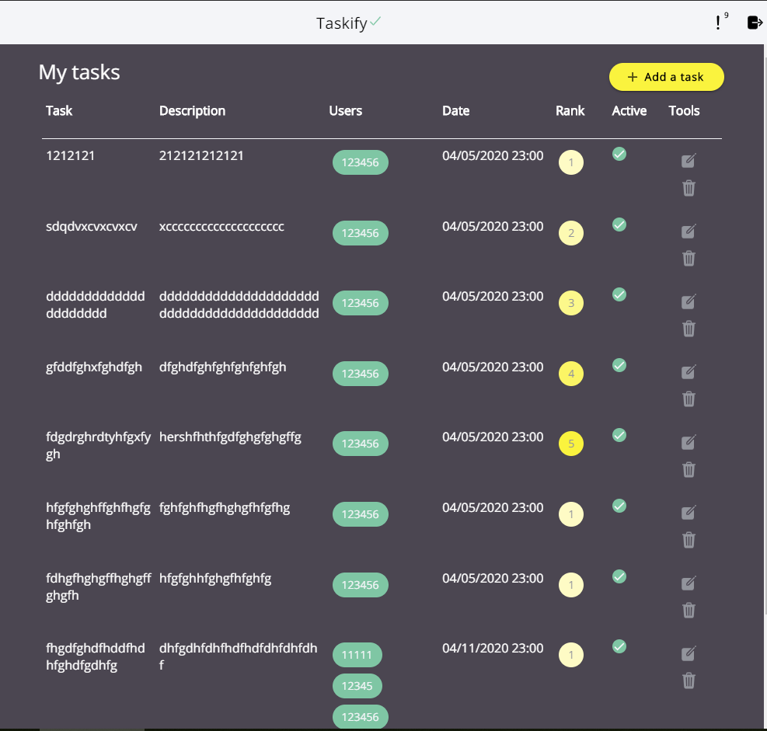

* **Update including set tasks as complete**

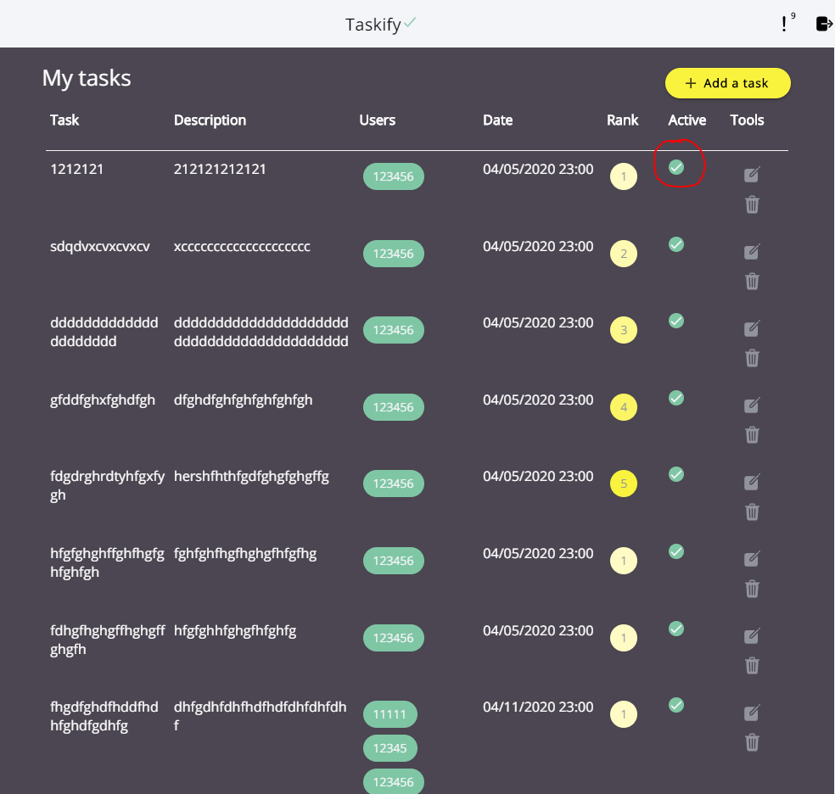

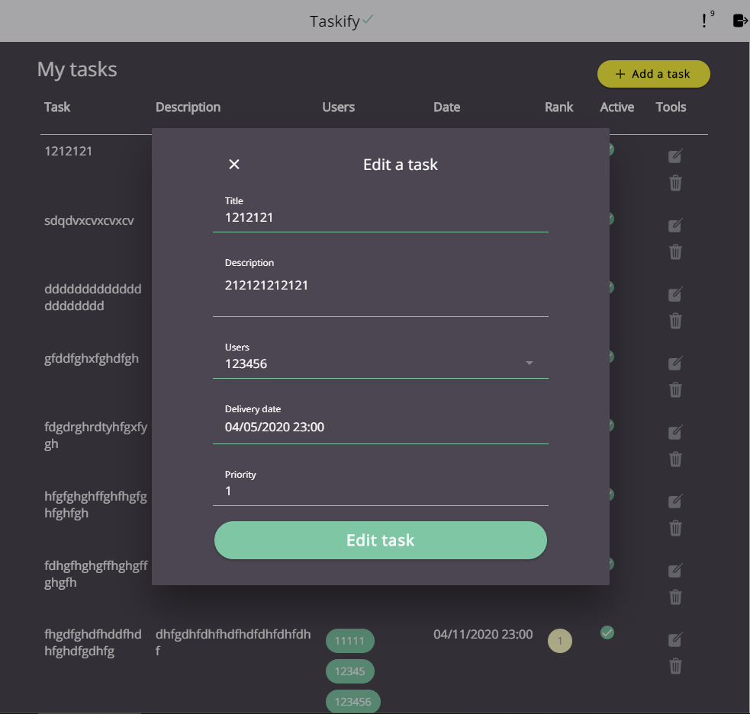

* **Delete a task**

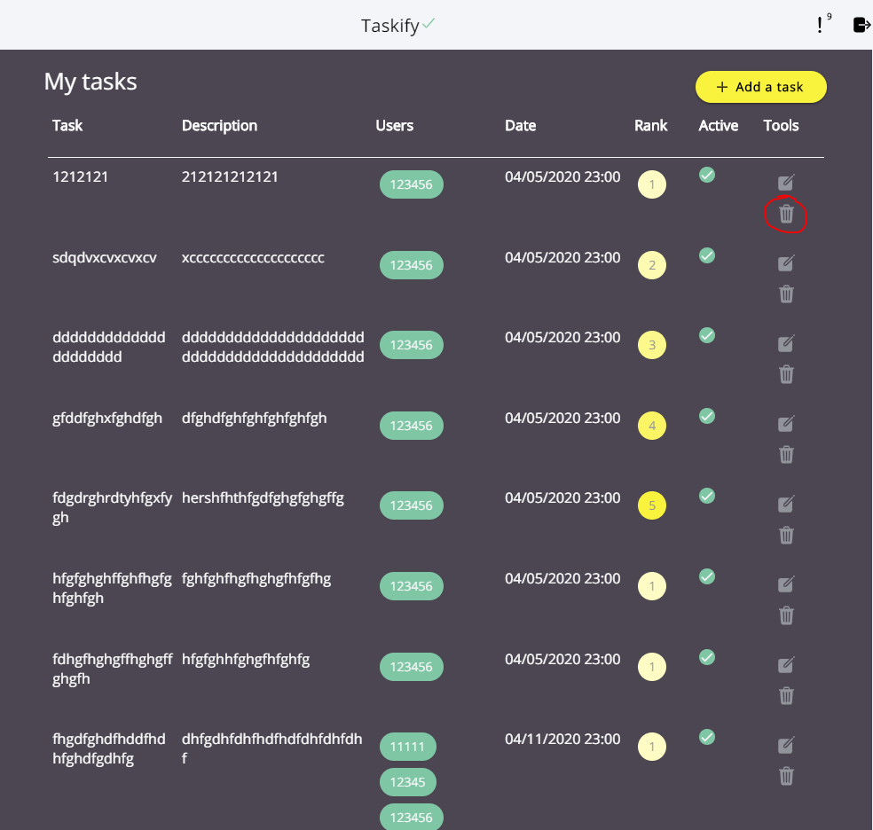

* **Assign other users to a task**

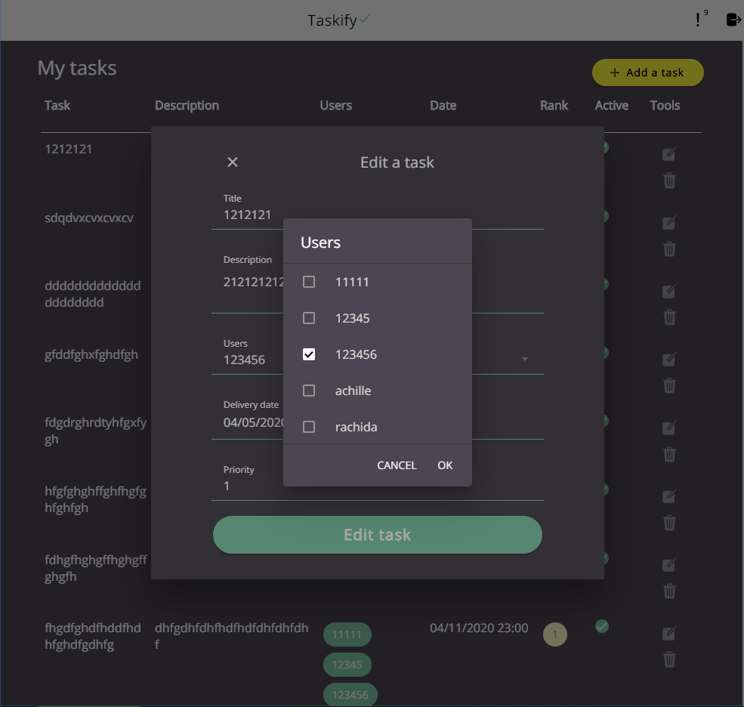

* **Alert users about their incomplete tasks**

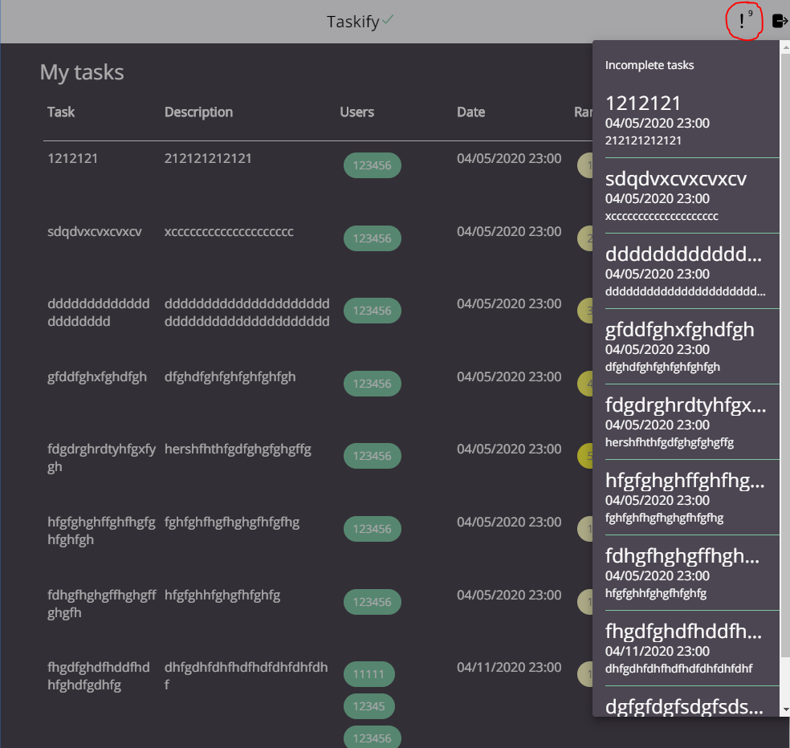

1. **Additional features and improvements (Innovation)**

The theme is adapted to the user OS theme preferences (If the user use the dark mode on his computer, the application will automatically switch to a Dark theme)

How to switch theme on windows 10:

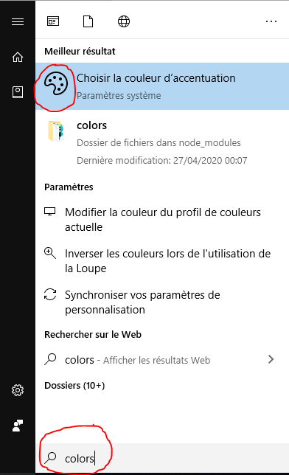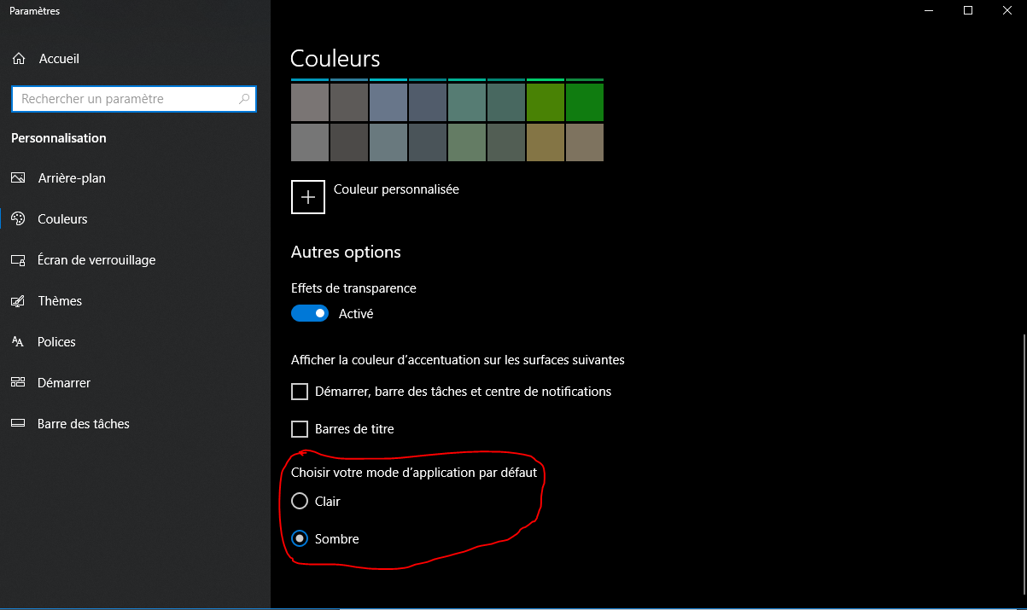

Light theme:

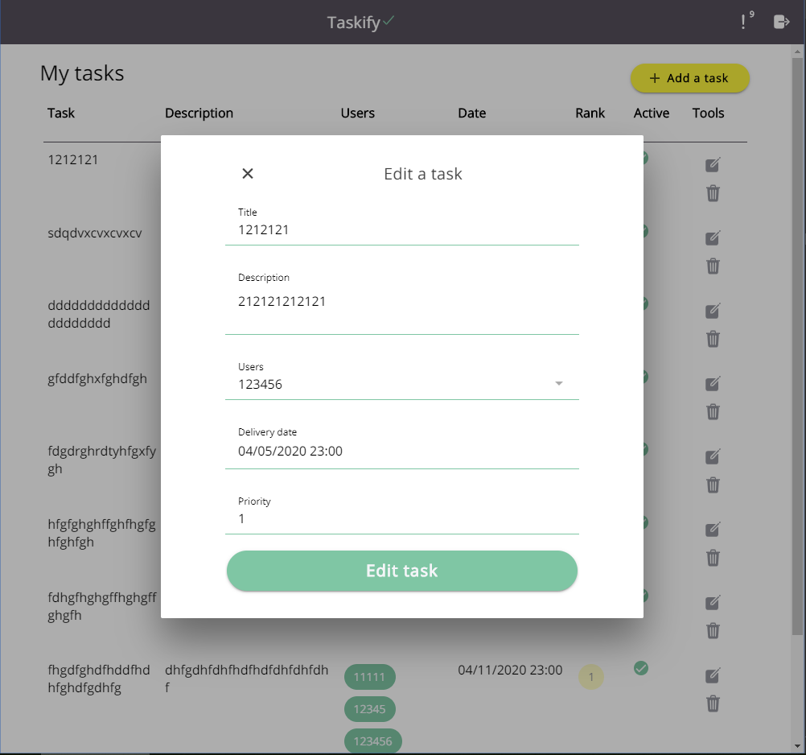

Dark theme:

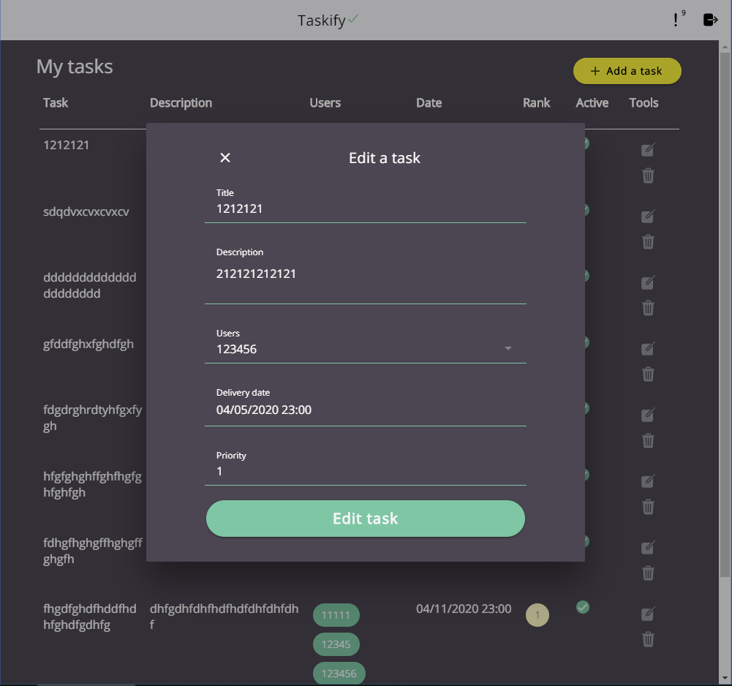

# features list

A table listing all the features which are working and not working. You can use the following table as an outline or guide, you will need to add to and change according to your application….

|  |  |  |  |  |  |
| --- | --- | --- | --- | --- | --- |
| **NAME** | **FUNCTION** | **SCHEMA** | **FUNCTIONAL** | **PUBLIC** | **MEM. FREE** |
| sign up | Displays registration information and allows pubic to register. | user | Y | Y | Y |
| logout | A user should be able to access a logout script from a link in the header. When this logout script executes the session should be destroyed and the user should receive a logout confirmation message and then be returned to the main page |  | Y | N | Y |
| login | A member can login to access to the full application and will be redirected to the Home page | user | Y | Y | Y |
| task_create | Allows a logged in member to add a task. Each task should contain at least the task name, a description, a priority, the members associated with this task and a  completion date | task | Y | N | Y |
| task_delete | Allows the deletion of a task | task | Y | N | Y |
| task_update | Allows the editing of a task | task | Y | N | Y |
| task_view | Shows a list of tasks created by a member | task | Y | N | Y |
| Task_alert | Alert users about their incomplete tasks | task | Y | N | Y |

# Wireframes

Include wireframes for your application for Mobile, Tablet and desktop and a few lines of explanation for each. Ensure that the app meets the requirements as indicated in the description document.

<https://www.figma.com/file/PjkJwUj80D5KQa06EXtBEv/Untitled?node-id=0%3A1>

# Username and password for Group online account.

A personal backup of your workspace must be made to avoid any loss of data. You must also submit a zipped version of your application to Moodle as per the assignment description.

# Set up instructions

Install node and NPM then

npm i && npm run build && npm run start

Then go to <http://localhost:3000>

Website available at <https://taskify-griffith.herokuapp.com/login>

# Database Schema Diagram

A diagram of your database schema

From database instructions:

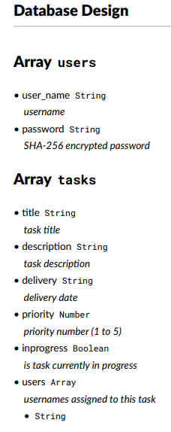

# Division of Labour

Please complete the sections below regarding the estimate of the division of work between the 2 team members.

Summary of division of work

If the work was split in the range of 40% to 50% per team member then that is fine and simply say “Work was evenly divided”. If this was not the case, then state with a summary sentence. This is an important statement of this file.

Division of work: ***work was evenly divided***

Percentage of work completed by each partner on each class / task

Some area requires more work than others, so this is only for reference. An average of these values will not be calculated.

|  |  |  |
| --- | --- | --- |
| **Filename / Task** | **Maxime DROUIN** | **Achille LAROCHE** |
| Database Design | 0% | 100% |
| Database implement  ation | 0% | 100% |
| GUI design | 100% | 0% |
| GUI  implementation | 100% | 0% |
| Documentation assignment | 100% | 0% |
| Database documentation | 0% | 100% |
| Heroku deployment | 100% | 0% |