Diab Care Analytics Dashboard
Project Documentation
Clinical Deep-Dive, Predictive Risk Stratification & Patient Registry Platform
by
Abdelrahman Mohamed Ahmed Hassan
Fatma Ahmed Abdul Qader Mohamed
Ahmed Awad Ahmed
Mohamed Mamdouh Abdelaty
Yasmin Taha Alsayed

TABLE OF CONTENTS
TABLE OF CONTENTS
ABSTRACT
TERMS AND DEFINITIONS & ABBREVIATIONS
Clinical Terms
Analytics & Technical Terms
CHAPTER ONE
Introduction
1.1 Problem Statement
1.1.1 Raw Clinical Data Is Hard to Interpret
1.1.2 Late Detection of Diabetes Risk
1.1.3 One Report for Every Audience
1.1.4 Intuition Versus Evidence
1.1.5 No Link Between Insight and Action
1.2 Project Objectives
1.3 Overview of the Suggested Technologies
1.3.1 Microsoft Power BI
1.3.2 Power Query & DAX
1.3.3 AI Visuals: Key Influencers & Decomposition Tree
1.4 Main Outlines
CHAPTER TWO
Literature Review
2.1 Risk Factors for Type 2 Diabetes
2.2 Clinical Dashboards in Healthcare
2.3 Explainable Machine Learning in Care Analytics
2.4 The Dataset
CHAPTER THREE
System Analysis
3.1 System Scenario
3.2 System Architecture
3.3 Users and Use Cases
3.4 Data Model
3.4.1 Fact Table: Fact_Patient
3.4.2 Dimension Tables
3.4.3 Relationships
3.5 Data Flow
3.6 Functional Requirements
3.7 Non-Functional Requirements
CHAPTER FOUR
System Design & Implementation
4.1 Design Language
4.1.1 KPI Tiles
4.1.2 Navigation Architecture
4.2 First, Welcome Page — Wellness Indicators
4.3 Second, Overview Page — Population Epidemiology
4.4 Third, Clinical Deep-Dive Page — Metabolic Pathophysiology
4.4.1 The Age 50–59 Tipping Point
4.4.2 Genetics Versus Age
4.5 Fourth, Patient Registry Page — AI-Assisted Triage
4.6 Data Preparation Process
4.7 DAX Measures
4.8 Interactivity
CHAPTER FIVE
Results
5.1 Results
5.2 Stratified Care Protocols
5.3 Recommendations and Implementation Roadmap
5.4 Limitations
5.5 Future Work
5.6 General Conclusion
APPENDIX
Project Deliverables
Metric Reconciliation

ABSTRACT
Diabetes is one of the fastest-growing chronic conditions worldwide, and care teams are often asked to make triage and prevention decisions from raw spreadsheets that hide the relationships between glucose, body mass, age, genetics and pregnancy history. The Diab Care Analytics Dashboard turns a registry of 768 patients into an interactive Microsoft Power BI report that answers four questions in four pages: how healthy is the cohort day to day, how widespread is the disease and who is affected, which metabolic factors drive it, and which individual patients should be acted on first.
The report is organized as a four-page triage workflow (Welcome, Overview, Clinical Deep-Dive, Patient Registry) with a shared KPI strip, a consistent futuristic dark theme, cross-filtering slicers, and AI-assisted visuals (Key Influencers and Decomposition Tree). Headline results show 268 diabetic patients (34.9% prevalence), 201 prediabetic at-risk patients and 148 high-risk patients, of whom 112 (75.7%) are not yet diabetic and therefore represent the highest-value prevention window. Obesity (BMI 30+) carries a 45.8% diabetes rate against 6.9% in normal-weight patients, and the machine-learning Key Influencers analysis ranks glucose reduction (1.87x) and BMI reduction (1.51x) as the strongest levers.
The project demonstrates a complete analytics workflow: data cleaning and enrichment, star-style semantic modelling, DAX measure design, visual storytelling for different clinical roles, and translation of findings into a tiered care protocol.

TERMS AND DEFINITIONS & ABBREVIATIONS
This section clarifies the clinical and technical terms used throughout this documentation.

Clinical Terms
- Diabetes Mellitus (DM) — A chronic condition in which the body cannot regulate blood glucose properly because of insufficient insulin production or insulin resistance.
- High Risk Patient — In this model, a patient with plasma glucose above 140 mg/dL and BMI above 30 (148 patients; 36 are already diabetic and 112 are not).
- Critical Risk Patient — An obese patient with diabetic-range glucose (126+) and high blood pressure (90+).
- Prediabetic At-Risk — A non-diabetic patient whose glucose falls in the prediabetic band (201 patients).
- Prediabetes — Blood glucose is higher than normal but not yet in the diabetic range; the best window for preventive intervention.
- Glucose — Plasma glucose concentration in mg/dL; the primary diagnostic marker in the dataset.
- Insulin — Serum insulin in µU/mL; elevated values indicate compensatory hyperinsulinemia / insulin resistance.
- BMI (Body Mass Index) — Weight (kg) divided by height squared (m²). Normal 18.5–24.9, overweight 25–29.9, obese 30+.
- Blood Pressure (BP) — Diastolic blood pressure in mm Hg, grouped into Low (<60), Normal (60–79), Elevated (80–89) and High (90+).
- Skin Thickness — Triceps skin-fold thickness in mm; a proxy for subcutaneous fat storage.
- Diabetes Pedigree Function (DPF) — A score that summarizes hereditary diabetes risk from family history.
- Parity / Pregnancies — Number of times the patient has been pregnant; a gestational insulin-resistance indicator.
- HbA1c, OGTT, CGM — Long-term glucose test, oral glucose tolerance test, and continuous glucose monitoring (used in the care protocols).

Analytics & Technical Terms
- Power BI — Microsoft business-intelligence platform used to model data and build the interactive report.
- Power Query (M) — The data transformation engine used to clean and enrich the source data.
- DAX (Data Analysis Expressions) — The formula language used to define measures such as Diabetes Rate %.
- KPI (Key Performance Indicator) — A headline metric displayed on a card, such as Total Patients.
- Slicer — An on-page filter control (for example Age Group) that cross-filters all visuals.
- Key Influencers — A Power BI AI visual that ranks the factors that most increase or decrease an outcome.
- Decomposition Tree — An AI visual that lets the user drill into a metric along the dimensions that explain it most.
- XAI — Explainable AI: models whose drivers can be inspected and understood by clinicians.
- Cross-filtering — Selecting a data point in one visual to filter all other visuals on the page.

CHAPTER ONE

Introduction

1.1 Problem Statement
Care teams collect rich patient data, yet decisions about who needs attention first are frequently made from flat tables or static reports. The main issues are the following.

1.1.1 Raw Clinical Data Is Hard to Interpret
A registry row contains nine measurements. Without visualization it is nearly impossible to see how glucose, BMI, age and pregnancy history interact across hundreds of patients.

1.1.2 Late Detection of Diabetes Risk
Risk is usually recognized after a patient crosses the diagnostic threshold. A large share of patients who are already high-risk are not yet diabetic, and these are exactly the patients for whom prevention is most effective and least expensive.

1.1.3 One Report for Every Audience
Triage nurses, population-health directors, endocrinologists and case managers need different views of the same data. Generic reports either overwhelm clinicians with detail or give executives too little.

1.1.4 Intuition Versus Evidence
Clinical intuition suggests that hypertension mirrors diabetes severity, or that obesity alone is the problem. The registry shows more nuanced patterns (for example, 56.8% of high-risk patients have normal blood pressure) that can only be discovered by exploring the data.

1.1.5 No Link Between Insight and Action
Analytics that stop at charts leave the care team without a protocol. The project therefore connects each finding to a recommended intervention tier.

1.2 Project Objectives
- Build an interactive, role-based analytics platform that summarizes the patient cohort in four navigable pages.
- Quantify the prevalence of diabetes and identify the demographic and metabolic factors that drive it.
- Apply machine-learning visuals (Key Influencers, Decomposition Tree) to explain which factors matter most and by how much.
- Isolate the high-risk patients who are not yet diabetic as the priority prevention cohort.
- Translate findings into a tiered, actionable care protocol and an implementation roadmap.

1.3 Overview of the Suggested Technologies

1.3.1 Microsoft Power BI
Power BI provides the data model, the DAX calculation engine, the interactive visuals and publishing. Its cross-filtering behaviour allows a single click on an age group or BMI class to update every visual on the page.

1.3.2 Power Query & DAX
Power Query is used to clean the source data and to derive category columns (age group, BMI category, glucose category, blood-pressure category, pregnancy group). DAX is used to build the measures shown in the KPI cards.

1.3.3 AI Visuals: Key Influencers & Decomposition Tree
Key Influencers fits a model on the Outcome column and reports, for each factor, how much a change multiplies the likelihood of the result. The Decomposition Tree lets users drill from the diabetic population into BMI class and age group to find where the burden concentrates.

1.4 Main Outlines
The remainder of this document is organized as follows:
- Chapter Two: Literature review of diabetes risk factors and analytics approaches.
- Chapter Three: System analysis including scenario, architecture, data model and requirements.
- Chapter Four: System design and implementation of each dashboard page and its visuals.
- Chapter Five: Results, care protocols, future work and conclusion.

CHAPTER TWO

Literature Review

2.1 Risk Factors for Type 2 Diabetes
Clinical literature consistently identifies elevated plasma glucose, excess body weight, advancing age, family history and reproductive history as the main risk factors for type 2 diabetes. Obesity drives insulin resistance, while genetic susceptibility determines how early the disease manifests. This dashboard examines each of these factors on one registry and measures their relative strength.

2.2 Clinical Dashboards in Healthcare
Dashboards are widely used in hospitals for operational monitoring, but many are built as a single page of charts. Good practice for clinical analytics is to separate the audience-specific views, keep headline metrics visible at all times, and allow drill-down from population to patient. The Diab Care dashboard follows this principle with a shared KPI strip and four role-based pages.

2.3 Explainable Machine Learning in Care Analytics
Black-box models are difficult for clinicians to trust. Explainable techniques such as feature-attribution and decomposition trees make the drivers of risk visible and therefore actionable. Power BI’s Key Influencers visual provides this explanation without requiring users to write code, and is used here to rank glucose, BMI, age, parity and genetics.

2.4 The Dataset
The registry contains 768 female patient records with nine clinical variables and a binary diabetes outcome, a structure that matches the widely used Pima Indians Diabetes dataset (768 records, 268 positive cases). The project enriches it with categorical groupings so that results can be explained in clinical language.

CHAPTER THREE

System Analysis

3.1 System Scenario
A population-health director opens the report on the Overview page and sees that 34.9% of the cohort is diabetic. Filtering by age group and glucose category, they note that obesity is the steepest driver. A care coordinator then opens the Patient Registry page, where the Key Influencers visual shows that a 30.44 mg/dL fall in glucose multiplies the odds of a non-diabetic outcome by 1.87, and the KPI strip shows that 148 patients are high-risk. The coordinator selects the high-risk cohort and finds that 112 of them are not yet diabetic, so they enrol those patients in a lifestyle-intervention programme.

3.2 System Architecture
The solution follows a layered business-intelligence architecture:
Layer | Responsibility | Technology
Data Source | Patient registry (768 records, 9 clinical attributes + outcome) | CSV / Excel
Preparation | Cleaning, type conversion, building the dimension tables and keys | Power Query (M)
Semantic Model | Star schema (1 fact + 6 dimensions) and a dedicated measures table | Power BI model + DAX
Visualization | Four report pages, KPI strip, slicers, AI visuals | Power BI Desktop
Delivery | Publishing, sharing and embedded viewing | Power BI Service / Embedded

3.3 Users and Use Cases
Role | Primary Page | Goal
Triage Nurse / Intake | Welcome | Establish a lifestyle and wellness baseline for the patient
Population Health Director | Overview | Understand prevalence and segment risk by demographics
Staff Endocrinologist | Clinical Deep-Dive | Study insulin, genetics, adiposity and metabolic decompensation
Care Coordinator / Case Manager | Patient Registry | Identify and act on the high-risk cohort using AI explanations

3.4 Data Model
The semantic model follows a star schema: one fact table (Fact_Patient) holds the clinical measurements and one foreign key per classification, six dimension tables provide the descriptive labels and sort order, and a dedicated measures table (DAX_Measure) groups every calculation. Separating labels from measurements keeps the visuals readable and guarantees that categories sort in clinical order (for example Low, Normal, Elevated, High) rather than alphabetically.
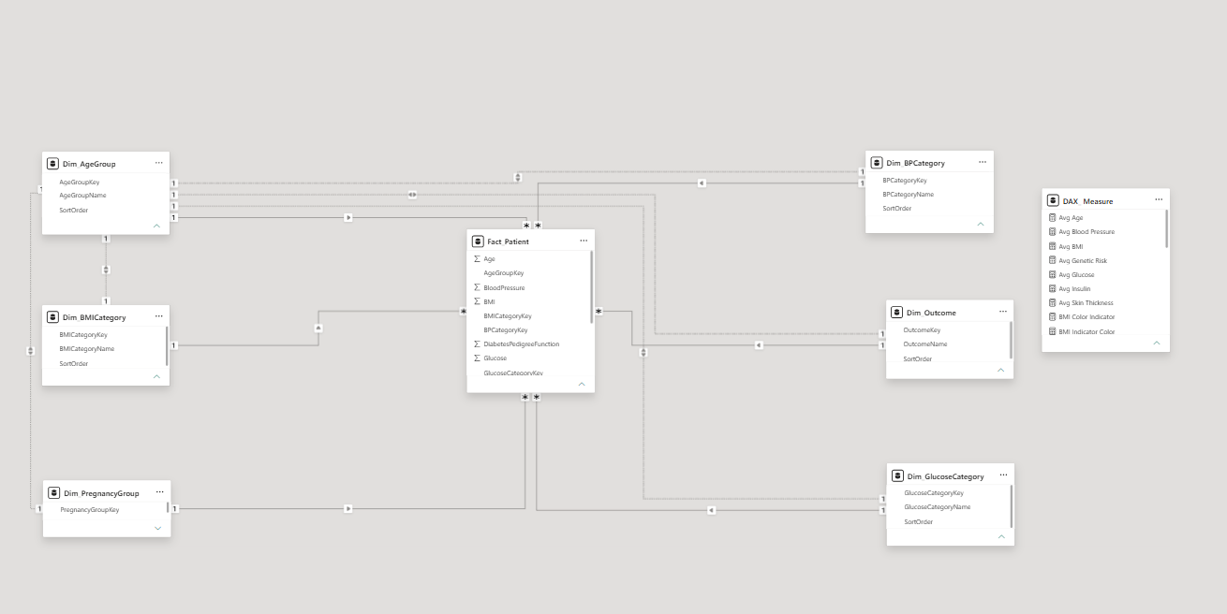
Figure 1: Star-Schema Data Model in Power BI Model View

3.4.1 Fact Table: Fact_Patient
Column | Type | Description
PatientID | Key | Unique patient identifier (counted to get Total Patients)
Age | Numeric | Age in years
Pregnancies | Numeric | Number of pregnancies
Glucose | Numeric | Plasma glucose concentration (mg/dL)
BloodPressure | Numeric | Diastolic blood pressure (mm Hg)
SkinThickness | Numeric | Triceps skin-fold thickness (mm)
Insulin | Numeric | Serum insulin (µU/mL)
BMI | Numeric | Body mass index (kg/m²)
DiabetesPedigreeFunction | Numeric | Hereditary risk score
AgeGroupKey | Foreign key | Relates to Dim_AgeGroup
BMICategoryKey | Foreign key | Relates to Dim_BMICategory
BPCategoryKey | Foreign key | Relates to Dim_BPCategory
GlucoseCategoryKey | Foreign key | Relates to Dim_GlucoseCategory
OutcomeKey | Foreign key | Relates to Dim_Outcome (1 = Diabetic, 0 = Non-Diabetic)
PregnancyGroupKey | Foreign key | Relates to Dim_PregnancyGroup

3.4.2 Dimension Tables
Dimension | Columns | Purpose
Dim_AgeGroup | AgeGroupKey, AgeGroupName, SortOrder | Age brackets (for example 21–29, 30–39, 50–59)
Dim_BMICategory | BMICategoryKey, BMICategoryName, SortOrder | Normal, Overweight, Obese
Dim_BPCategory | BPCategoryKey, BPCategoryName, SortOrder | Low, Normal, Elevated, High blood pressure
Dim_GlucoseCategory | GlucoseCategoryKey, GlucoseCategoryName, SortOrder | Glucose classification bands
Dim_Outcome | OutcomeKey, OutcomeName, SortOrder | Diabetic / Non-Diabetic labels
Dim_PregnancyGroup | PregnancyGroupKey | Parity bands (0–2, 3–5, 6+)

3.4.3 Relationships
Each dimension relates to Fact_Patient on its key (one-to-many, with the dimension on the one side), so a selection on a dimension attribute filters the fact table and every measure. Where more than one filter path exists between tables, the secondary relationships are kept inactive to avoid ambiguity and activated inside specific measures when required.

3.5 Data Flow
Data flows in one direction: the registry file is loaded into Power Query, where types are fixed and the dimension tables and keys are built; the fact and dimension tables are loaded to the semantic model; DAX measures aggregate it; and report pages query the model whenever a slicer or visual selection changes. Cross-filtering means a selection on one visual re-evaluates every measure on the page.

3.6 Functional Requirements
- The system must display headline KPIs (cohort size, diabetic count, diabetes rate, average glucose, average BMI, and at-risk or high-risk counts) on every page.
- The system must provide four navigable pages with a consistent navigation bar.
- The system must support filtering by age group, glucose category and other demographic slicers, cross-filtering all visuals.
- The system must show prevalence by BMI, blood pressure, age and pregnancy group.
- The system must explain the drivers of diabetes using a Key Influencers visual and a Decomposition Tree.
- The system must identify the high-risk cohort and break it down by outcome, blood-pressure category and age group.

3.7 Non-Functional Requirements
- Performance: Every page must refresh in under two seconds after a slicer interaction for a dataset of this size.
- Usability: A clinician with no analytics training must be able to read each page without guidance; colours and layout are consistent across pages.
- Accuracy: All measures must reconcile with the source data (for example, 268 diabetic + 500 non-diabetic = 768).
- Privacy: The report must not display direct patient identifiers; access is controlled through Power BI workspace permissions.
- Maintainability: Measures and category logic must be defined once in the model and reused by all visuals.

CHAPTER FOUR

System Design & Implementation

4.1 Design Language
The report uses a dark clinical theme with cyan accents, glowing panel borders and a custom background so that data stands out and the interface is suitable for wall displays. A top navigation bar (Welcome, Overview, Clinical Deep-Dive, Patient Registry), a live date-time stamp and a KPI strip are repeated on each page so users never lose context. KPI tiles use a coloured status indicator (red for adverse metrics, green for the cohort to protect).

4.1.1 KPI Tiles
The KPI tiles show the headline metrics at a glance. Supplementary card visuals (as shown below) summarise average blood pressure and insulin.
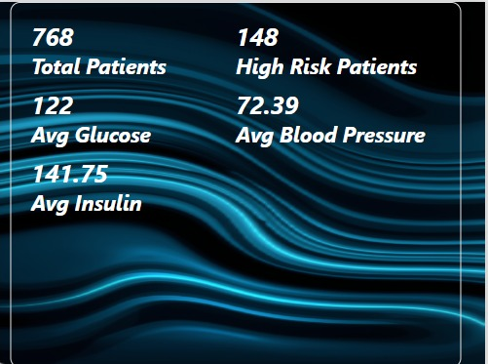
Figure 2: Summary KPI Card Visual
KPI | Value | Definition
Total Patients | 768 | Distinct count of PatientID
Diabetic Patients | 268 | Total patients with OutcomeKey = 1
Diabetes Rate % | 34.9% | Diabetic patients ÷ total patients
Avg Glucose | 122 | Average plasma glucose (mg/dL)
Avg BMI | 32.4 | Average body mass index (kg/m²)
Prediabetic At-Risk | 201 | Non-diabetic patients whose glucose falls in the prediabetic band (GlucoseCategoryKey = 2)
High Risk Patients | 148 | Patients with Glucose above 140 and BMI above 30
Avg Blood Pressure | 72.39 | Average diastolic blood pressure (mm Hg)
Avg Insulin | 141.75 | Average serum insulin (µU/mL)

4.1.2 Navigation Architecture
Each page maps to one stage of the clinical workflow. A hidden Tooltip page provides contextual detail when the user hovers over a data point.

4.2 First, Welcome Page — Wellness Indicators
The Welcome page is the biometric-triage entry point. It presents a wellness “heads-up display” for the intake nurse so that a lifestyle baseline is established before any diagnostic procedure.
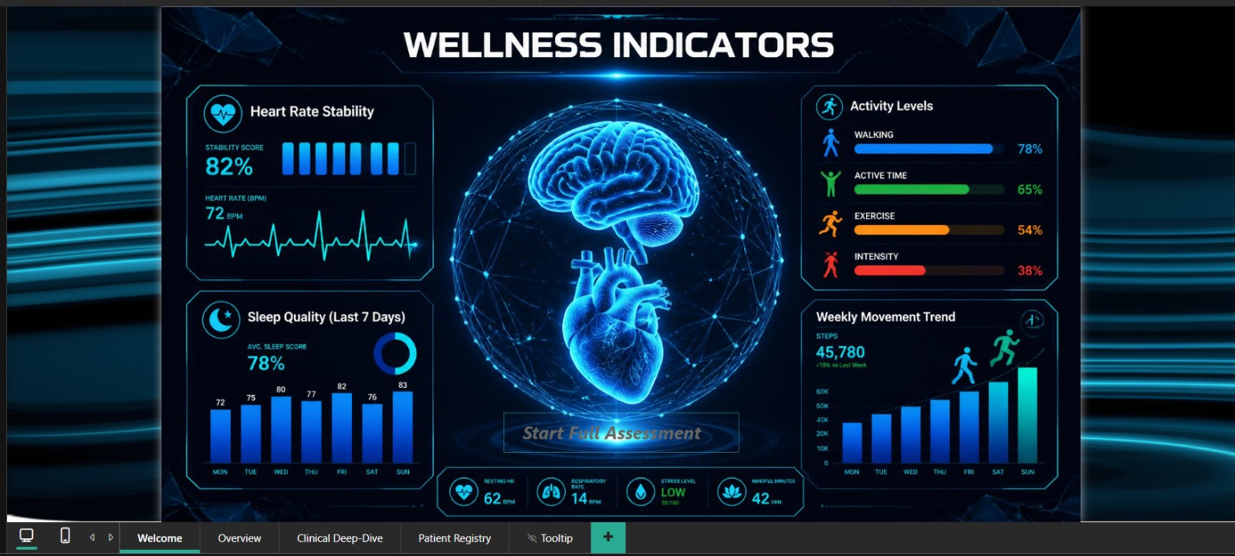
Figure 3: Welcome Page — Wellness Indicators
- Heart Rate Stability: 82% stability score with 72 BPM and a live ECG-style trace.
- Sleep Quality (7 days): 78% average sleep score with the daily score from Monday to Sunday (72–83).
- Activity Levels: Walking 78%, active time 65%, exercise 54%, intensity 38%.
- Weekly Movement Trend: 45,780 steps (+18% versus the previous week).
- Vital strip: Resting HR 62 BPM, respiratory rate 14 BPM, stress level Low (32/100), mindful minutes 42.
- Call to action: A “Start Full Assessment” button that leads into the clinical pages.
Note
The wellness indicators on this page are a presentation of lifestyle telemetry and are not computed from the 768-record clinical registry; they are intended to show how wearable data could feed the platform.

4.3 Second, Overview Page — Population Epidemiology
The Overview page gives the population-health director a macro view of prevalence and segmentation.
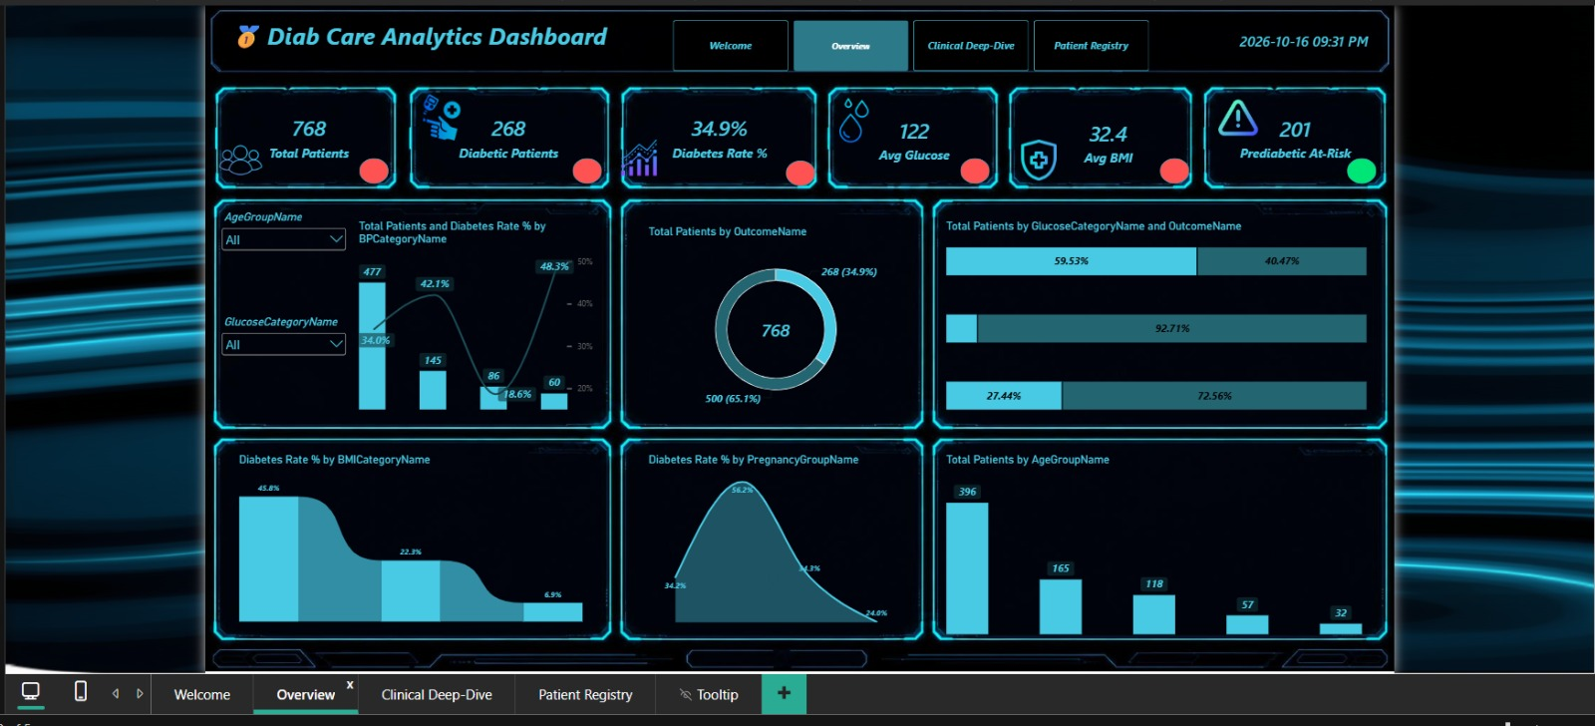
Figure 4: Overview Page
Visual | Type | Insight
Total Patients and Diabetes Rate % by BP Category | Combo (column + line) | 477 patients with normal BP still show a 34.0% diabetes rate; the 80–89 group reaches 48.3%
Total Patients by Outcome | Donut | 268 diabetic (34.9%) versus 500 non-diabetic (65.1%)
Total Patients by Glucose Category and Outcome | 100% stacked bar | Diabetes share rises sharply with glucose band
Diabetes Rate % by BMI Category | Area | 45.8% obese, 22.3% overweight, 6.9% normal weight
Diabetes Rate % by Pregnancy Group | Area | 34.2% (0–2), peak 56.2% (3–5), 24.8% for older multiparous group
Total Patients by Age Group | Column | 396 patients aged 21–29, then 165, 118, 57 and 32 in older groups

Two slicers (Age Group and Glucose Category) cross-filter every visual on the page.

4.4 Third, Clinical Deep-Dive Page — Metabolic Pathophysiology
The Clinical Deep-Dive page is designed for the endocrinologist and explores insulin kinetics, genetics and adiposity.
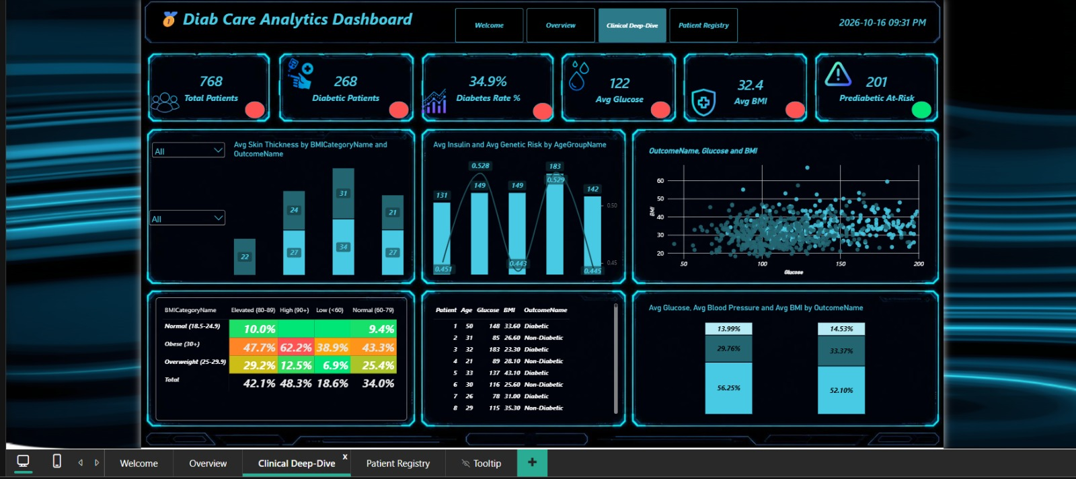
Figure 5: Clinical Deep-Dive Page
Visual | Type | Insight
Avg Skin Thickness by BMI Category and Outcome | Stacked column | Obese non-diabetics average 34 mm versus 21 mm in obese diabetics
Avg Insulin and Avg Genetic Risk by Age Group | Column + line | Insulin peaks at 183 µU/mL in ages 50–59, with a genetic score of 0.529
Outcome, Glucose and BMI | Scatter | Diabetic cases cluster at glucose above 130 mg/dL and BMI above 32
BMI Category × BP Category | Matrix heatmap | Obese patients with elevated BP show 47.7% diabetes rate; overall rates by BP group range 18.6%–48.3%
Patient detail table | Table | Age, glucose, BMI and outcome for individual patients
Avg Glucose, BP and BMI by Outcome | 100% stacked column | Compares the metabolic profile of diabetic and non-diabetic patients

4.4.1 The Age 50–59 Tipping Point
Mean insulin rises from 131 µU/mL in the twenties to 149 µU/mL by the late forties, reaches a maximum of 183 µU/mL in the 50–59 group and then falls to 142 µU/mL after sixty. This pattern is consistent with maximal compensatory hyperinsulinemia followed by beta-cell fatigue, and identifies the 50–59 decade as the key window for insulin-sensitising therapy.

4.4.2 Genetics Versus Age
The 30–39 and 50–59 groups carry virtually identical pedigree scores (0.528 versus 0.529), yet disease manifestation differs markedly. Genetics therefore provides the susceptibility, while age-related adiposity triggers onset.

4.5 Fourth, Patient Registry Page — AI-Assisted Triage
The Patient Registry page is designed for care coordinators and case managers. It combines two AI visuals with high-risk breakdowns and a single-purpose KPI strip whose final tile shows the 148 high-risk patients.
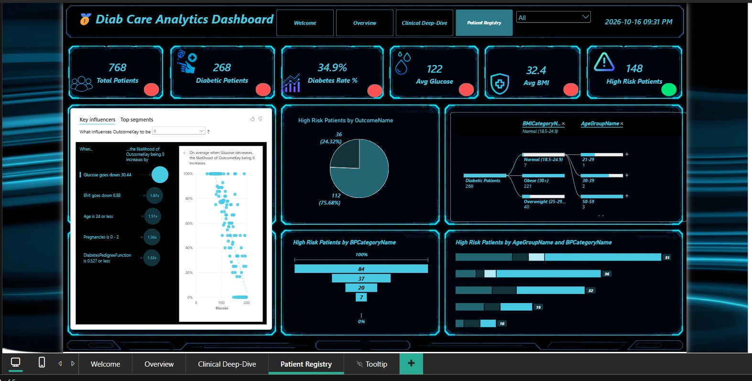
Figure 6: Patient Registry Page
- Key Influencers: Ranks factors that increase the likelihood of the selected outcome. Glucose reduction of 30.44 mg/dL gives 1.87x, BMI reduction of 6.88 gives 1.51x, age ≤ 24 gives 1.36x, 0–2 pregnancies gives 1.32x and a pedigree score ≤ 0.527 gives 1.25x.
- High Risk Patients by Outcome: Pie chart showing 112 non-diabetic (75.68%) and 36 diabetic (24.32%) patients among the 148 high-risk patients.
- Decomposition Tree: Drills from 268 diabetic patients into BMI category (221 obese, 40 overweight, 7 normal) and then into age group (for example 21–29, 30–39, 50–59).
- High Risk Patients by BP Category: Funnel showing 84, 37, 20 and 7 patients across the BP bands; 84 of 148 (56.8%) have normal BP.
- High Risk Patients by Age Group and BP Category: Stacked bar showing the age groups with the largest high-risk counts (51, 36, 32, 19 and 10).

4.6 Data Preparation Process
- Import the registry file into Power Query.
- Set data types and verify there are no missing outcome values.
- Build one dimension table per classification (age group, BMI category, BP category, glucose category, pregnancy group, outcome), each with a key, a readable name and a SortOrder column so labels sort in clinical order.
- Add the matching foreign key to Fact_Patient and create the one-to-many relationships.
- Create the DAX_Measure table and define all measures in it.
- Apply colour-indicator measures to the KPI tiles for conditional formatting.

4.7 DAX Measures
All calculations live in a dedicated DAX_Measure table so that any visual can reuse them. The model contains 31 measures, listed below with their exact expressions and grouped by purpose.
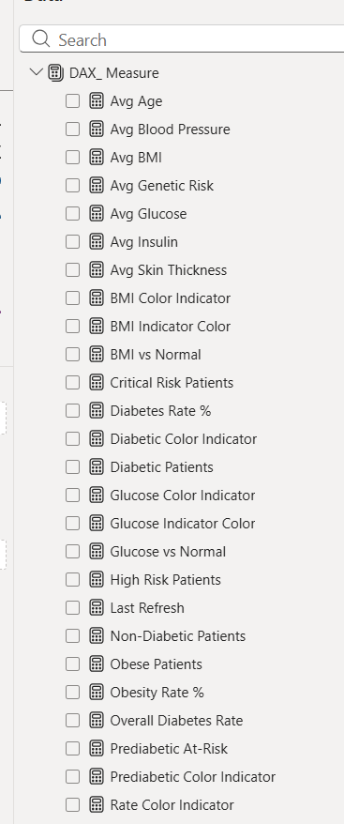
Figure 7: DAX_Measure Table (Part 1)
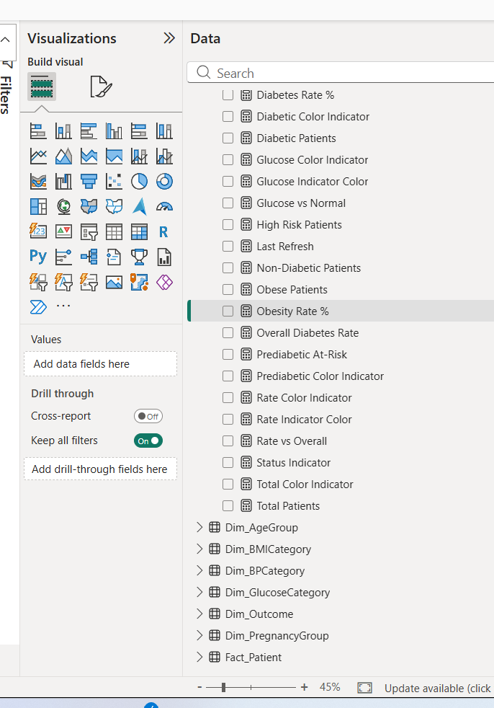
Figure 8: DAX_Measure Table (Part 2) and Dimension Tables
Core counts
Measure | DAX Expression | Purpose
Total Patients | DISTINCTCOUNT ( Fact_Patient[PatientID] ) | Cohort size; base for every rate.
Diabetic Patients | CALCULATE (  [Total Patients],  Fact_Patient[OutcomeKey] = 1  ) | Patients with a positive outcome.
Non-Diabetic Patients | CALCULATE (  [Total Patients],  Fact_Patient[OutcomeKey] = 0  ) | Patients with a negative outcome.
Obese Patients | CALCULATE (  [Total Patients],  Fact_Patient[BMICategoryKey] = 4  ) | Patients in the Obese BMI category.
Risk segments
Measure | DAX Expression | Purpose
Prediabetic At-Risk | CALCULATE (  [Total Patients],  Fact_Patient[OutcomeKey] = 0,  Fact_Patient[GlucoseCategoryKey] = 2  ) | Non-diabetic patients in the prediabetic glucose band.
High Risk Patients | CALCULATE (  COUNTROWS ( Fact_Patient ),  Fact_Patient[Glucose] > 140  && Fact_Patient[BMI] > 30  ) + 0 | Glucose above 140 and BMI above 30. The + 0 shows 0 instead of blank.
Critical Risk Patients | CALCULATE (  [Total Patients],  Fact_Patient[BMICategoryKey] = 4, // Obese  Fact_Patient[GlucoseCategoryKey] = 3, // Diabetic range (126+)  Fact_Patient[BPCategoryKey] = 4 // High BP (90+)  ) | Obese, diabetic-range glucose and high blood pressure together.
Rates
Measure | DAX Expression | Purpose
Diabetes Rate % | DIVIDE (  [Diabetic Patients],  [Total Patients],  0  ) | Share of diabetic patients in the current filter context.
Obesity Rate % | DIVIDE ( [Obese Patients], [Total Patients], 0 ) | Share of obese patients.
Overall Diabetes Rate | CALCULATE (  [Diabetes Rate %],  ALL ( Fact_Patient )  ) | Cohort-wide baseline that ignores all filters.
Rate vs Overall | [Diabetes Rate %] - [Overall Diabetes Rate] | Difference of the selected group from the baseline.
Clinical averages
Measure | DAX Expression | Purpose
Avg Age | AVERAGE ( Fact_Patient[Age] ) | Mean age.
Avg Blood Pressure | AVERAGE ( Fact_Patient[BloodPressure] ) | Mean diastolic blood pressure.
Avg BMI | AVERAGE ( Fact_Patient[BMI] ) | Mean body mass index.
Avg Genetic Risk | AVERAGE ( Fact_Patient[DiabetesPedigreeFunction] ) | Mean pedigree score.
Avg Glucose | AVERAGE ( Fact_Patient[Glucose] ) | Mean plasma glucose.
Avg Insulin | AVERAGE ( Fact_Patient[Insulin] ) | Mean serum insulin.
Avg Skin Thickness | AVERAGE ( Fact_Patient[SkinThickness] ) | Mean skin-fold thickness.
Benchmarks
Measure | DAX Expression | Purpose
BMI vs Normal | [Avg BMI] - 25 | Distance of average BMI from the 25 threshold.
Glucose vs Normal | [Avg Glucose] - 100 | Distance of average glucose from 100 mg/dL.
Conditional formatting (colour indicators)
Measure | DAX Expression | Purpose
BMI Color Indicator | VAR CurrentBMI = [Avg BMI]  RETURN  IF ( CurrentBMI > 25, "#FF5252", "#00E676" ) | Red when average BMI exceeds 25, otherwise green.
BMI Indicator Color | IF ( [BMI vs Normal] > 0, "#FF3B30", "#00E676" ) | Red when above the BMI benchmark.
Glucose Color Indicator | VAR CurrentGlucose = [Avg Glucose]  RETURN  IF ( CurrentGlucose > 120, "#FF5252", "#00E676" ) | Red when average glucose exceeds 120.
Glucose Indicator Color | IF ( [Glucose vs Normal] > 0, "#FF3B30", "#00E676" ) | Red when above the glucose benchmark.
Diabetic Color Indicator | VAR CurrentVal = [Diabetic Patients]  RETURN  IF ( CurrentVal > 100, "#FF5252", "#00E676" ) | Red when diabetic patients exceed 100.
Prediabetic Color Indicator | VAR CurrentPre = [Prediabetic At-Risk]  RETURN  IF ( CurrentPre > 50, "#FF5252", "#00E676" ) | Red when the at-risk group exceeds 50.
Rate Color Indicator | VAR CurrentRate = [Diabetes Rate %]  RETURN  IF ( CurrentRate > 0.30, "#FF5252", "#00E676" ) | Red when the diabetes rate exceeds 30%.
Rate Indicator Color | IF ( [Rate vs Overall] > 0, "#FF3B30", "#00E676" ) | Red when the group is above the overall rate.
Status Indicator | VAR HighRiskCount = [High Risk Patients]  RETURN  IF ( HighRiskCount > 10, "#FF5252", "#00E676" ) | Red when more than 10 high-risk patients are in scope.
Total Color Indicator | "#00E676" | Always green (neutral tile).
Housekeeping
Measure | DAX Expression | Purpose
Last Refresh | FORMAT ( NOW (), "yyyy-mm-dd hh:nn AM/PM" ) | Shows the report refresh timestamp.
Design note
Colour thresholds are fixed values (for example average glucose above 120, diabetes rate above 30%). Adjust them in the model if the clinical team changes its targets.

4.8 Interactivity
- Page navigation buttons in the header, with the active page highlighted.
- Slicers (age group, glucose category, BMI/BP selectors) with cross-filtering.
- Hover tooltips from the dedicated Tooltip page.
- Drill-down in the Decomposition Tree and click-through on Key Influencers segments.
- Automatic date-time stamp in the header to show when the report was viewed.

CHAPTER FIVE

Results

5.1 Results
The dashboard successfully converts a flat registry into a decision-support tool. The principal findings are summarised below.
Finding | Key Number | Interpretation
Cohort and prevalence | 768 / 34.9% | 268 diabetic and 500 non-diabetic patients
Obesity multiplier | 45.8% vs 6.9% | Obese patients are about 6.6 times more likely to be diabetic than normal-weight patients
Blood pressure paradox | 56.8% | 84 of 148 high-risk patients have normal BP; BP screening alone misses most cases
Parity curve | 56.2% peak | Diabetes rate peaks at 3–5 pregnancies
Insulin tipping point | 183 µU/mL | Maximum compensation at ages 50–59, collapsing after 60
Prevention window | 112 of 148 | 75.7% of the high-risk cohort is not yet diabetic
Obesity concentration | 221 of 268 | 82.5% of diabetics are obese
Strongest lever | 1.87x | Glucose reduction of 30.44 mg/dL, followed by BMI reduction (1.51x)

5.2 Stratified Care Protocols
The findings are translated into four proposed care tiers. These are analytical recommendations to be validated and adopted by the clinical governance team; they are not a substitute for individual clinical judgement.
Tier | Cohort | Proposed Protocol
Tier 1 | 268 confirmed diabetic and 148 high-risk (36 overlap) | Continuous glucose monitoring, targeted glycaemic reduction, pharmacotherapy evaluation for obesity and renal protection, weekly multidisciplinary review
Tier 2 | 201 prediabetic at-risk | Structured lifestyle-prevention programme targeting about 7% weight loss, wearable monitoring, early metformin consideration for the 50–59 cohort, regular HbA1c testing
Tier 3 | High pedigree and 3+ pregnancies | Annual OGTT for multiparous women, familial screening counselling, nutrition consultation, post-partum metabolic follow-up
Tier 4 | General wellness cohort | Digital biomarker tracking, activity and sleep promotion, annual wellness check-up

5.3 Recommendations and Implementation Roadmap
- Glucose and weight interception. Prioritise metabolic coaching and therapy review for the 221 obese diabetic patients.
- Protect the 75.7% prevention window. Enrol the 112 non-diabetic high-risk patients in nurse-led coaching and remote monitoring.
- Age 50–59 targeted protocols. Trigger an advanced endocrine panel (C-peptide, fasting insulin, hs-CRP) for patients reaching age 50.
- Continuous wellness loop. Integrate wearable telemetry into the Welcome page to move from intermittent visits to continuous surveillance.

5.4 Limitations
- The registry is a single snapshot of 768 patients; relationships are associations, not proof of causation.
- Key Influencers multipliers describe patterns in this dataset and should be validated before clinical use.
- The Welcome page indicators are illustrative and not connected to the registry.
- Estimated prevention outcomes in the executive deck are projections that require a prospective study.

5.5 Future Work
- Connect live data from the electronic health record and wearable devices instead of a static file.
- Add a predictive risk score per patient with an explicit validation of model accuracy.
- Implement row-level security so each care team sees only its own patients.
- Add time-series views to track the effect of interventions on glucose and BMI over time.
- Provide an Arabic-language version of the report and a mobile-optimised layout.

5.6 General Conclusion
By combining a cleaned and enriched patient registry with role-based pages and explainable AI visuals, the Diab Care Analytics Dashboard moves a care team from describing the cohort to acting on it. It shows that obesity and glucose are the dominant levers, that blood pressure alone is an unreliable screen, and that three quarters of high-risk patients can still be reached before they become diabetic.

APPENDIX

Project Deliverables
Item | Description
Power BI report (.pbix) | The four-page interactive dashboard (Welcome, Overview, Clinical Deep-Dive, Patient Registry) plus Tooltip page
Executive presentation (.pptx) | Diab_Care_Analytics_Dashboard_Clean.pptx — 8-slide executive summary
Source data | Patient registry (768 records) and cleaned model
This documentation | Project report

Metric Reconciliation
Check | Result
Diabetic + non-diabetic = total | 268 + 500 = 768
Diabetes rate | 268 ÷ 768 = 34.9%
High-risk non-diabetic share | 112 ÷ 148 = 75.7%
Obese share of diabetics | 221 ÷ 268 = 82.5%
High-risk with normal BP | 84 ÷ 148 = 56.8%

