Video Game Industry Analysis
Task 11 - Summary of findings, insights and recommendations

1. Scope and data
The main dataset holds 16,719 game releases (one row per game per platform, 1980-2016) with regional sales in millions of units, critic and user scores, genre, publisher and age rating. The PS4 and Xbox One files are newer snapshots that overlap the main file, so they were used only as a post-2016 cross-check rather than merged (merging would double-count sales).
Data issue | Size | Treatment
Missing Name and Genre | 2 rows | Dropped (unidentifiable)
Missing release year | 269 rows | Kept; excluded from time charts
Impossible years (2017, 2020) in a Dec-2016 file | 4 rows | Set to missing
Missing publisher / developer | 54 / ~6,600 | Labelled Unknown
Duplicate game + platform | 5 rows | 2 split-sales rows merged (sales summed); 3 genuine remakes kept
Publisher spelling variants, old rating labels, stray spaces | ~45 values | Standardised
Missing critic / user scores | ~51% / ~55% | Not imputed; score analysis uses rated games only
Result: 16,715 clean rows and 8.92 billion units of sales.

2. Key findings
- A hit-driven market. The top 1% of releases earn 21% of all units and the top 10% earn 59%; 35% of releases sold fewer than 100,000 copies.
- Genres. Action (19.6% of units), Sports (14.9%) and Shooter (11.8%) lead in volume. Per release, Platform (0.93M), Shooter (0.80M) and Role-Playing (0.62M) earn the most, while Adventure is common but weak (0.18M).
- Platforms. PS2 is the best-selling platform (1,256M), followed by X360, PS3 and Wii. Sony (3.59B) and Nintendo (3.50B) are level; Microsoft has 1.39B. Platforms sell mainly in a 5-8 year window.
- Publishers. The top 10 publishers hold about 71% of units. Nintendo leads (1.79B) with 2.5M units per release, about three times Electronic Arts (0.82M) although EA released nearly twice as many games.
- Best sellers. Wii Sports (82.5M) is the top single release. Combining platforms, Grand Theft Auto V (56.6M) ranks second.
- Trend. Sales rose from 1995 to a peak in 2008 (672M units) and then fell about 80% by 2016. Average sales per release held up through 2015, so the market shifted to fewer, bigger titles. The source covers mostly physical sales and 2016 is partial, so part of the decline reflects coverage.
- Regions. North America 49.4%, Europe 27.2%, Japan 14.6%, rest of world 8.9%. Role-Playing is 38% Japan while Shooters are only 4% Japan.
- Ratings and sales. Critic score and sales are positively but moderately related (Spearman 0.38; user score 0.16). Games scoring 90+ average 3.2M units, about 14 times games under 50 (0.23M).
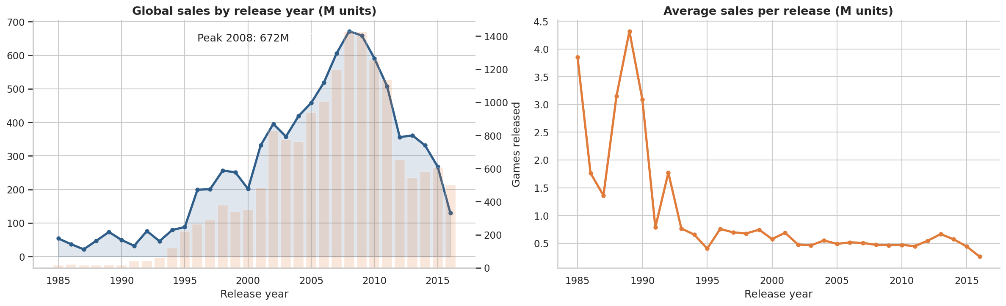
Figure 1. Sales peaked in 2008 and declined sharply afterwards.
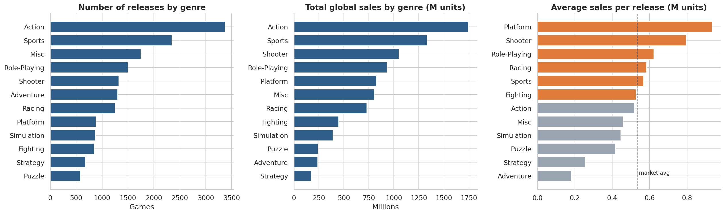
Figure 2. Genre supply versus demand: popular genres are not always the most profitable per release.
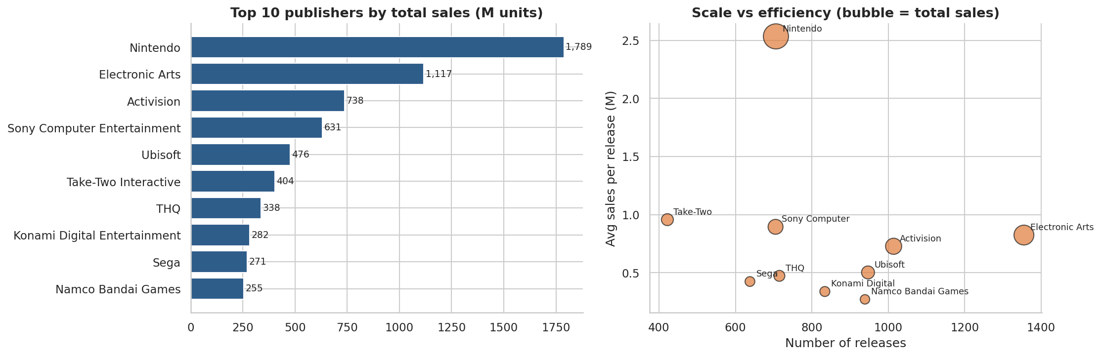
Figure 3. Nintendo wins on per-title efficiency; EA and Activision win on scale.
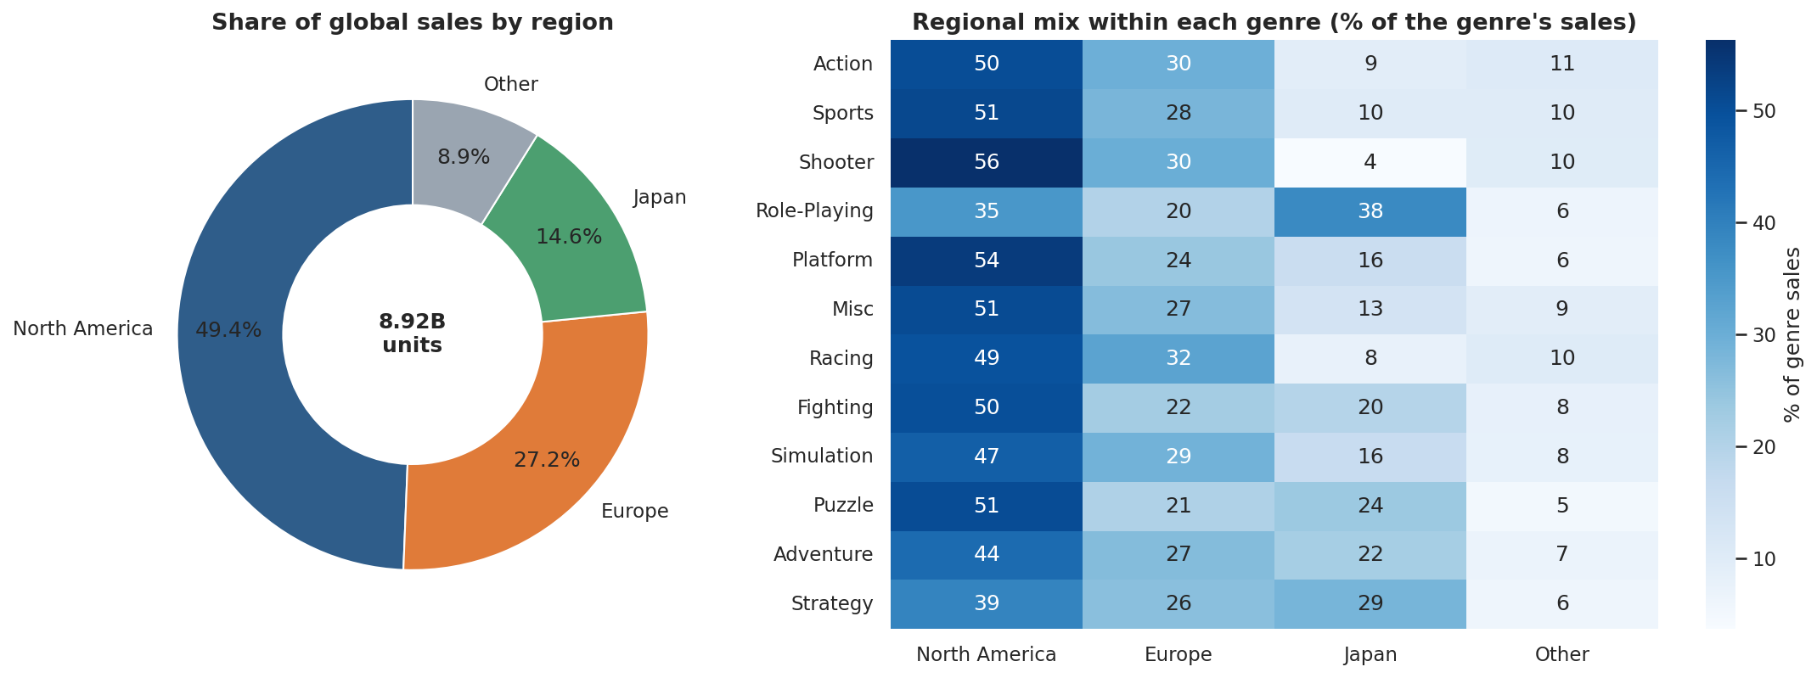
Figure 4. North America is half the market; genre tastes differ strongly by region.
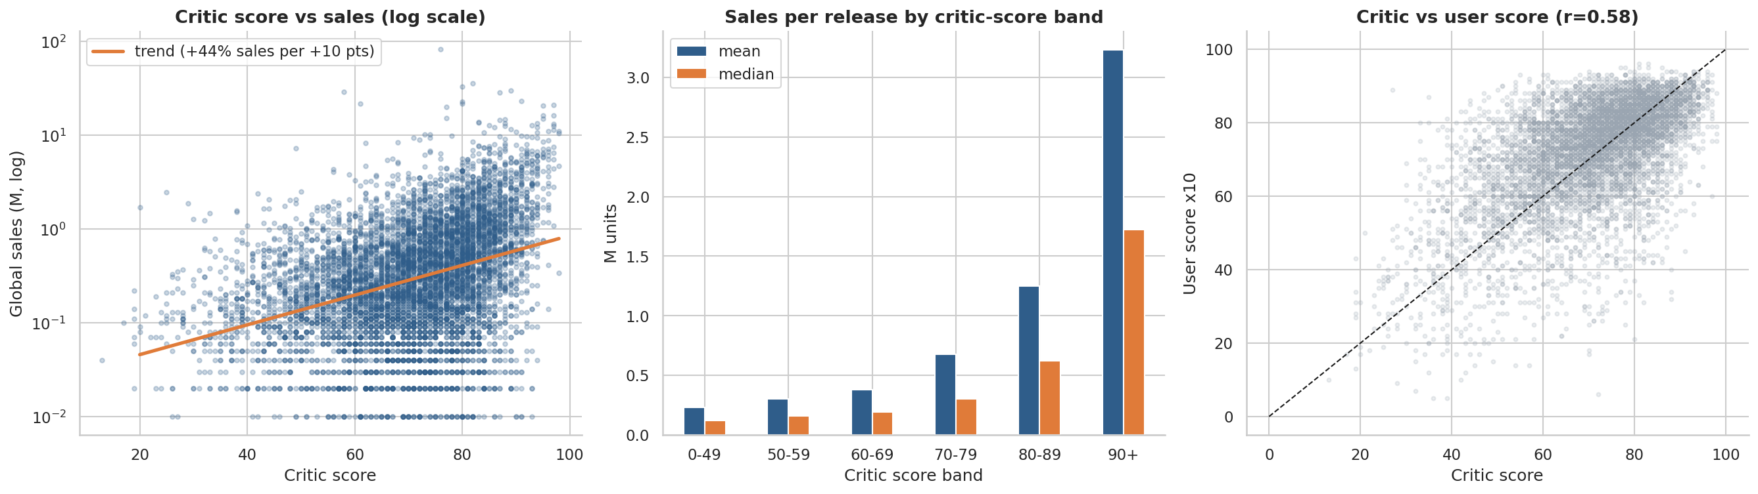
Figure 5. Higher critic scores go with much higher sales, especially above 80.

3. Recommendations for a gaming company
- Portfolio: focus budget on Action, Shooter, RPG and Platform franchises; limit spending on Adventure, Strategy and Puzzle unless costs are low.
- Quality: invest in testing and polish to reach 80+ critic scores - the largest sales step-up of any factor tested.
- Platforms: launch early to mid-lifecycle on current-generation platforms and release on several platforms at once.
- Regions: lead with North America and Europe for shooters, sports and racing; plan a dedicated Japan strategy for RPG, puzzle and strategy games.
- Strategy: build on strong franchises rather than catalogue size; a mid-size studio may gain most from co-publishing with a top-10 publisher.

4. Limitations
The data is a 2016 snapshot of mostly physical retail sales with no mobile or digital-only titles, no revenue, cost or marketing data (so ROI cannot be measured), and about half the games have no scores. Findings describe associations, not proven causes.

5. Deliverables
data/cleaned_video_games.csv | notebook/Video_Game_Analysis.ipynb | charts/ (13 PNG files) | dashboard/Video_Game_Dashboard.xlsx (dropdown filters) | dashboard/app.py (Streamlit) | this summary.

