UBER END-TO-END AZURE DATA ENGINEERING PROJECT
Real-Time Streaming Pipeline with Azure Event Hubs, Databricks & Star Schema
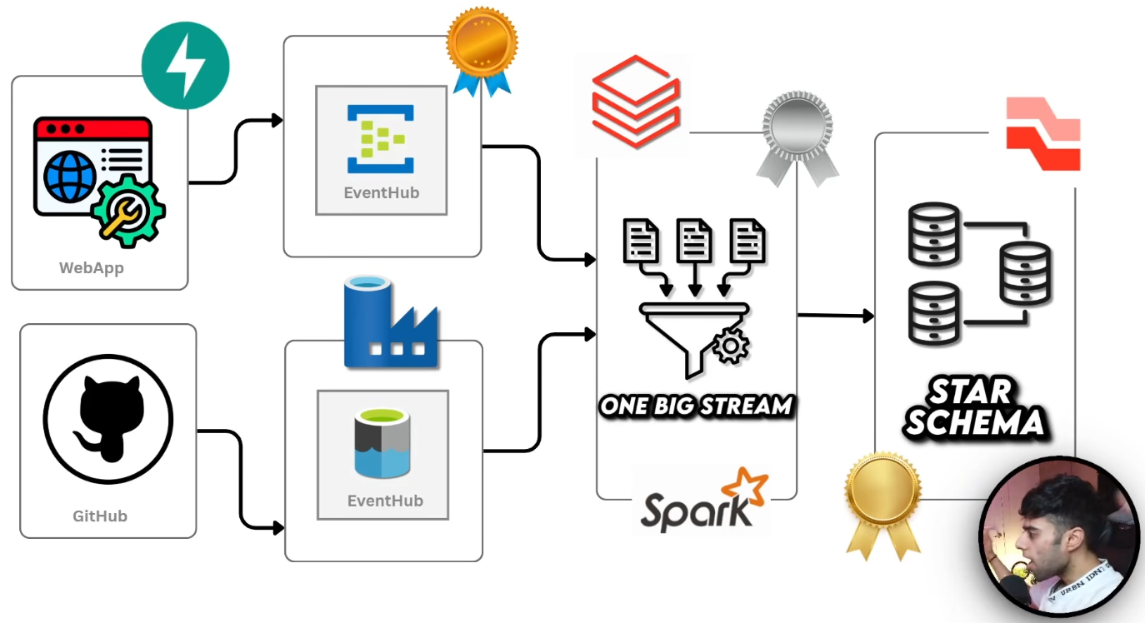
Figure 1: Uber Real-Time Streaming Architecture (WebApp + Event Hubs → Spark → Star Schema)

PROJECT OVERVIEW
This project demonstrates a complete end-to-end real-time data engineering solution for Uber-like ride booking data. It covers the full pipeline from event generation (WebApp) to real-time streaming processing (Azure Event Hubs + Spark(Spark Declarative Pipeline)) and finally building a production-ready Star Schema with Slowly Changing Dimensions (SCD Type 2) in the Gold layer.

ARCHITECTURE
The architecture follows a modern real-time streaming pattern:
- Web Application (FastAPI) generates ride booking events
- Azure Event Hubs ingests real-time events (two instances for high throughput)
- Azure Data Factory handles batch/reference data ingestion from GitHub
- Azure Databricks + PySpark Structured Streaming processes the data in real-time
- Spark Declarative Pipelines (SDP) used for bronze → silver → gold transformation
- Final output is a Star Schema model ready for analytics and BI
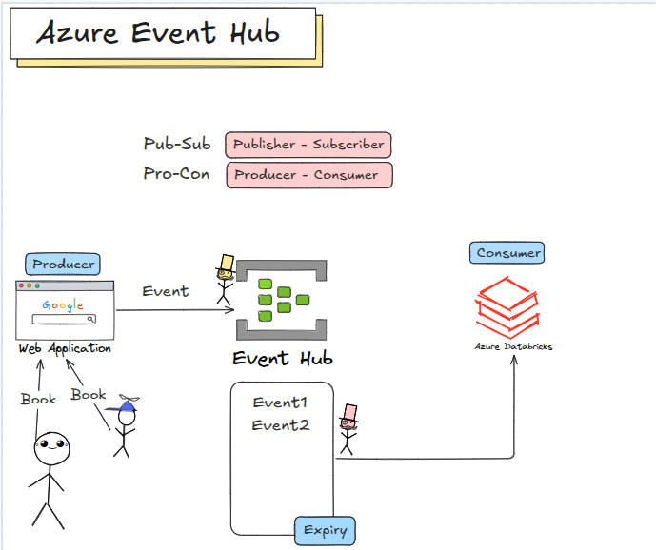
------
can have multiple consumers as well for ex : azure synapse analytics etc.
Events have an expiry duration
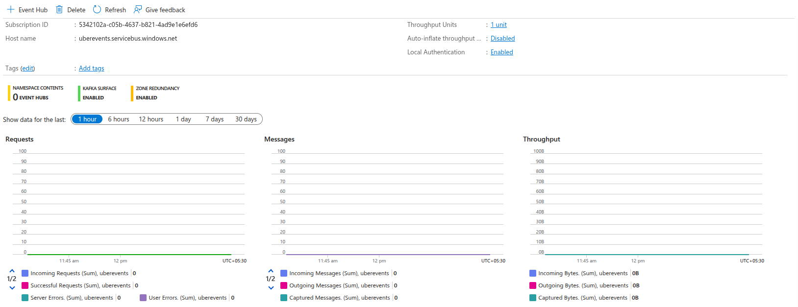
------
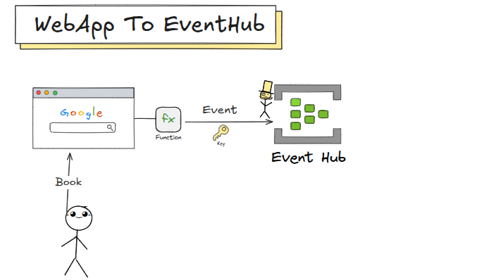
------
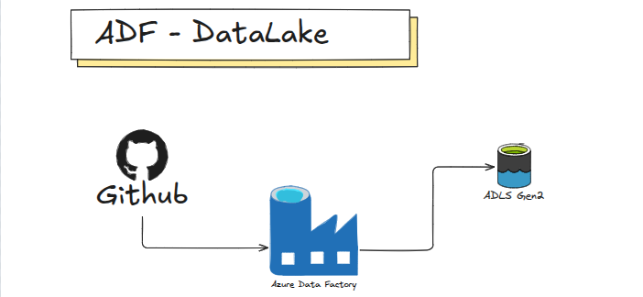
------
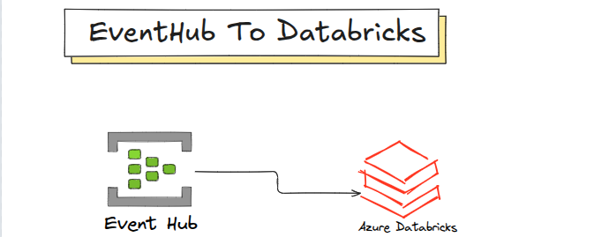
------
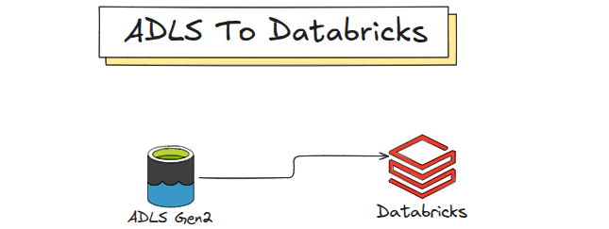
------
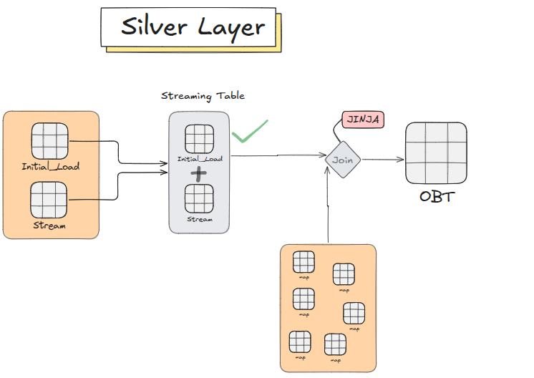
------
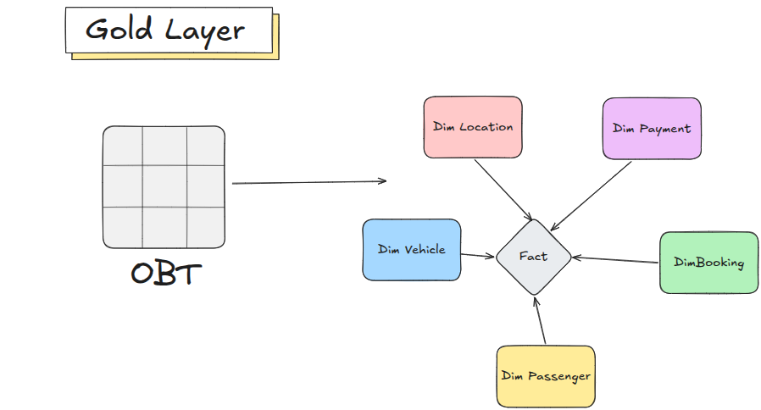
------

TECHNOLOGY STACK
Layer | Technology | Purpose
Event Ingestion | Azure Event Hubs | Real-time event streaming from WebApp
Batch Ingestion | Azure Data Factory | Reference data & initial load from GitHub
Processing Engine | Azure Databricks + PySpark | Structured Streaming + Declarative Pipelines
Storage | Azure Data Lake Gen2 | Bronze, Silver, Gold layers
Data Modeling | Star Schema + SCD Type 2 | Fact + Dimension tables with historical tracking
Orchestration | Databricks Workflows | Job scheduling and dependency management
Governance | Unity Catalog | Access control and data lineage

KEY FEATURES
- Real-time event streaming using Azure Event Hubs
- Exactly-once processing with Spark Structured Streaming
- Metadata-driven PySpark transformations
- Declarative pipelines using Spark Declarative Pipelines (SDP)
- Star Schema data model with SCD Type 2 dimensions
- One Big Stream (OBS) / One Big Table (OBT) pattern in Silver layer
- Production-ready CI/CD using Databricks Asset Bundles

IMPLEMENTATION HIGHLIGHTS
- Built a FastAPI WebApp to simulate real-time Uber ride bookings
- Configured Azure Event Hubs with multiple partitions for high throughput
- Implemented PySpark Structured Streaming to read from Event Hubs in real-time
- Created metadata-driven notebooks for Silver layer transformations (joins with mapping tables)
- Built Gold layer with Star Schema (Fact + Dimensions) and SCD Type 2 for location dimension
- Used Spark Declarative Pipelines (SDP) for bronze → silver → gold flow
- Implemented streaming joins with watermarks for late-arriving data

CHALLENGES SOLVED
- Handling high-volume real-time events → Azure Event Hubs with multiple partitions
- Exactly-once processing in streaming → Spark Structured Streaming + checkpointing
- Maintaining historical data in dimensions → SCD Type 2 with start/end dates
- Making transformations maintainable → Metadata-driven Jinja2 templates
- Late-arriving data in streaming joins → Watermark-based streaming joins

SKILLS DEMONSTRATED
- Real-Time Streaming Architecture (Event Hubs + Spark)
- Azure Databricks + PySpark Structured Streaming
- Spark Declarative Pipelines (SDP)
- Star Schema + Slowly Changing Dimensions (SCD Type 2)
- Metadata-Driven Pipeline Development
- One Big Stream / One Big Table (OBS/OBT) Pattern
- Streaming Joins with Watermarks
- Production CI/CD with Databricks Asset Bundles

