Game Design Document

Garrett McKenney

Tom Callister

COMMANDER

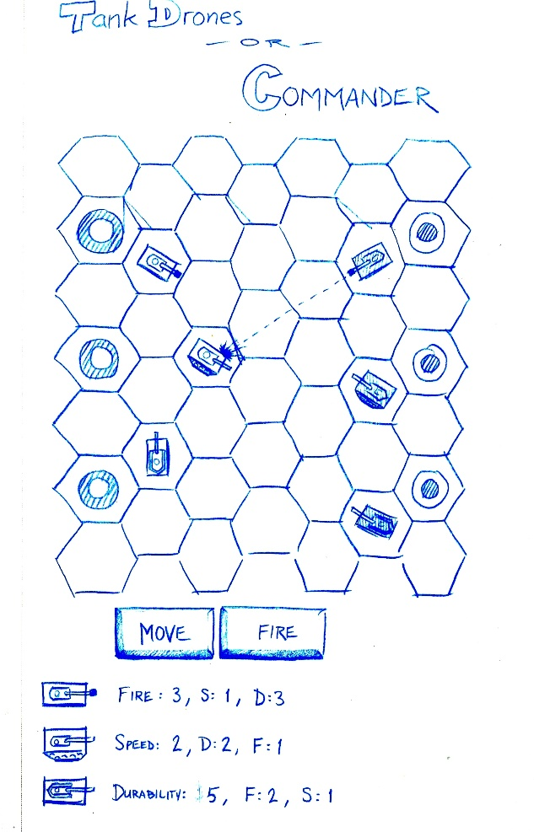Objective: You must develop effective turn-based strategies to control multiple tanks to destroy 2 of your computer-driven opponent's 3 base modules while defending your own bases from enemy tanks.

* Top-down turn-based strategy on a playing field of hexagonal units to provide greater movement/aiming options
* Tap buttons and locations to plan your move (e.g., tap "Move" button followed by the hexagonal space to which you want to move, or tap "Fire" followed by the enemy tank you want to target). You must plan ahead to turn your tanks in a strategic direction because your turret gun is always fixed straight ahead
* Tanks vary in abilities, such as shot range, durability, and speed
* Style: grungy, military, hand-drawn 2D assets in 3D environment
* Designed for quick learning—ideal for casual online gamers