Anh Tran

Assignment 7 write-up

CS 4300

I created a volcano smoke using Pyro FX in this assignment. First, I create a sphere with a radius of 6, which is going to be my smog at the beginning.

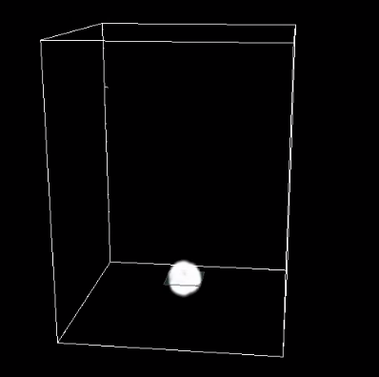

Then I applied the Volcano effect on it and it created a smoke inside a container. If you play it, you will see that the container is basically the volume of the smoke that expands on each second.

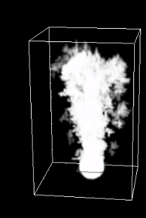

To make the smoke looks more natural, I added point lights twice on it. For the second time, I reduced the Light Intensity to 0.3 and change the Light Color from white to light blue.

