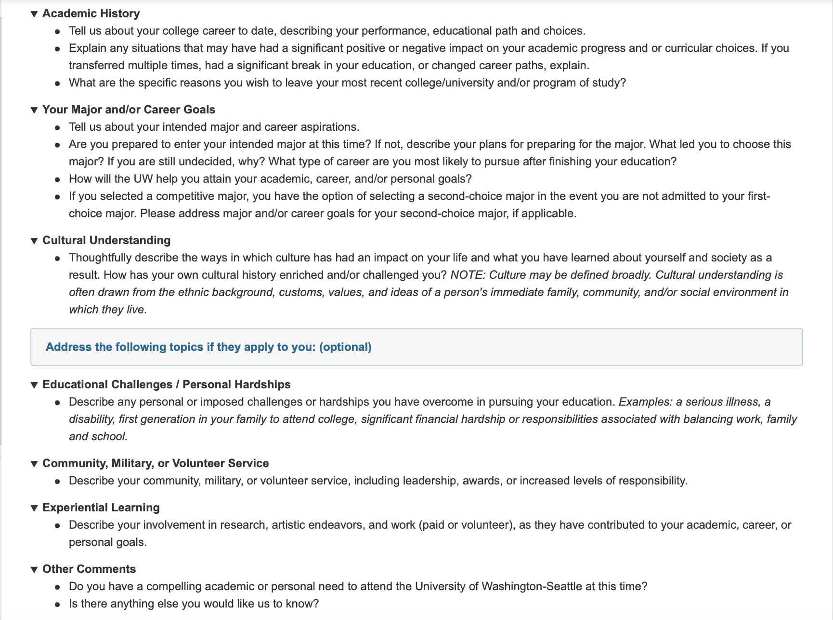

Suggested Word Count: 750-1000

1081 words

I sat quietly in the corner of the dining room, staring blankly at my outmoded PC screen. Every week, my uncle would assign me an Arduino project to complete. As I progressed, the difficulty of each project heightened. This week’s objective was to design an NXT program that used a light sensor to park a Lego car between obstacles. It was unbelievably complex, and all of my tests had failed. Once again, I tested the programmed car, this time, from a different starting position. As the car bumped the obstacle and demolished its back wheel, my frustration became anger. “Why doesn’t it work?!” I screamed.

The outburst prompted my father to enter the dining room. He sat down beside me, concerned. He took the pieces from my sweaty palms and looked at my computer screen.

A machine-enthusiast himself, my father had spent a decade working as a chemical engineer. He had left the rural village where he had grown up, adapted to urban life in Jakarta, and eventually built a successful career.

As he continued surveying the program, my dad pointed to an angle miscalculation of the car’s retreating movement. The problem I had been dealing with for three hours was solved! Immediately, I rebuilt the damaged wheel and programmed the correct angle. As I added my final touch, a thrill shot through my body. Success! Holding the robot, I wondered, *Can I actually build something real instead of just this robot?* Fulfilling my passion for innovating through electrical engineering may be a long process with many hurdles but the perseverance instilled by my father and the Indonesian culture will inevitably help me achieve success.

My struggle began in high school as I attempted to find adequate learning resources to build a foundation in engineering. Despite my school offering a small selection of engineering electives, I found valuable opportunities beyond the classroom. I built a solid foundation of knowledge in electrical circuitry, code programming, and calculus.

Then, one day, I received a brochure containing images of electrical circuitry, copper wires, and light bulbs. It was for an electrical engineering workshop held by the dean of Pelita Harapan University’s engineering department. The workshop featured theoretical applications of electric sources, such as converting wind energy to electricity and generating hydroelectric power. Also, I assembled resistors, torched alloys, and constructed circuitry which provided me a brief hands-on experience in the electrical engineering’s field. As the dean began his lecture about renewable energy, my excitement turned into devastation. “We must save our consumption of electricity, fossil fuels are running out in a few years…” he said. My mind froze and spontaneously looked at the corners of the room while pondering, *Are we not going to experience the water and light we are using today in the future?* Since then, I realized it’s no longer a want to pursue a career in electrical engineering, rather it is a need. By doing so, I could innovate a variety of low energy consuming goods and promote saving the earth’s natural resources. Through this, I could provide future generations access to fossil fuels.

Reassured of my urgent desire in studying electrical engineering, I enrolled in Shoreline Community College to continue my exploration. Through the college’s computer science classes, I honed my critical thinking and creative skills. I programmed Java code to sort emails and repaired coding problems using loops and arrays. During the final project, I designed a programmable code prompting a robot simulation to detect and respond to objects placed on the ground. These experiences prepared me to participate in Shoreline’s annual Hackathon, where I earned the runner-up award with my creation of Shooting Stars! — an animated game played by moving a bullet-shooting ship to sink enemies.

My desire to continue pursuing electrical engineering was tested as I was tasked to activate the switch within a machine by coding a C-language program and detect the defects in food plastic-wrapper in an internship program at PT. Swissplast Industries. In a small meeting board table, along with Swissplast’s professional computer scientists and engineers, we discussed and attempted to code for weeks to accomplish the project. I was clueless, looking around the room asking for guidance as I had no idea how these small components work in the machine. Then, a worry crossed my mind — *Do I have what it takes to be an electrical engineer?* I recalled my dad’s words, “I would not have forged this life if I had given up...” I chose to persist through the challenge and followed the footsteps of these engineers. With hard work and perseverance, we eventually accomplished the project successfully!

As I continue persevering towards my lifelong goal in engineering, I strongly believe the University of Washington provides an optimal and expansive environment to continue my education. Specialized courses like EE 448’s Systems, Controls, and Robotics Capstones and EE 458’s Power Electronic Controls grant hands-on experiences in developing modern electronic control methods for circuits and communication. Additionally, a vast and diverse community is optimal for studying electrical engineering as it promotes the exchange of ideas among a multicultural student body and provides collaborative opportunities with people of different cultures. Off-campus learning opportunities are also vital to a fulfilling college experience. Through Handshake, the University of Washington offers a wide variety of internship and employment opportunities. I plan to use this unique feature by launching my career at a well-known company such as Amazon, Boeing, or Microsoft. Premier electrical engineering faculty and activities like active research and development projects make the University of Washington an ideal fit. Professor Baosen Zhang’s research project about producing a cheaper and more controllable usage of energy in advanced technologies like electric vehicles and smart home management systems interests me.

Moreover, I am intrigued by the Institute of Electrical and Electronic Engineers, where fellow passionate engineers share knowledge and expand social networks through events like Concentration Panels and programming workshops. Programs such as Industry Sponsors act as conduits for mentorship opportunities and work experiences with companies such as ENGINE and Industry Capstone. These experiences will help me expand my advanced engineering skills.

The University of Washington is not just any university. It is a metaphorical bridge between my studies and professional engineering. The institution promotes diversity and fosters a wide community of passionate lifelong learners inside and outside of the classroom. As an aspiring part of the Husky family, we share the same desire — to utilize our passion and skills to help fulfill the world’s needs.

*Hi Michael!*

*I think overall you have a rough gist of what you’re writing in this transfer essay.*

*However, a lot of the prompt points you tried to address missed the bullseye. As you use my comments as a guideline, always keep in mind the purpose of this essay: why should the admissions committee accept you over all the transfer applicants?*

*One way of doing this is by showing a clear motivation – both academic and career-wise – which you have not depicted so far. The other one is by “selling” your diversity – do Indonesia justice on this one!*

*All the best for your revision – you want to make sure that your piece as a whole is solid and makes logical sense from the first to the very last sentence.*

* *Matthew*