**UW’s prompt: Tell a story from your life, describing an experience that either demonstrates your character or helped to shape it: (650 words max)**

Monkeys and Chris Evans’ physique. These are why I got into calisthenics.

I know this combination may sound weird, but who wouldn’t want to look like a super-soldier while having the agility of a monkey? I know I do!

Initially, during my search for a method to achieve both, I landed on a YouTube video showcasing a person propping himself up perpendicular to a pole: a literal human flag. It was as if he had defied the laws of gravity itself, reminiscent of a monkey’s complete control over its body. I went bananas over it. Ever since, calisthenics has been my way of working out for the last three years.



A year into calisthenics, I felt phenomenal. It felt as if I was improving at such a spectacular rate, to the point where I truly believed I could even become a personal trainer...or so I thought until I actually tried coaching my gym enthusiast cousin. He was always strongly opinionated. So, when I walked him through my usual routine hoping for admiration, he instead criticized how randomly put together my workout was. “This must be why I haven’t seen any changes in your physique,” he said.



Those measly 12 words stuck to me and it felt heavier than any weight I’ve lifted, chipping away at my confidence ever since. In a desperate attempt to boost my ego once more, I flexed into the mirror only to witness a sorry sight of an overweight kid. He was right. Looking back: my workouts were basically a sloppy mix of exercises from different youtube videos.



Something had to change.



I overclocked my brain for days to discover a better way of creating a calisthenics workout. Alas, my brain overheated to no avail. So to cool off, I watched a Korean drama called “Startup”. It was then when one of the most memorable scenes appeared—the protagonist was taking notes in preparation to face a challenging conundrum. It was such a simple act, but I knew it was my ticket out of my slump.



Following the character’s footsteps, I took notes on my Youtube’s calisthenics playlist: the different movements, the muscle groups, and the number of sets and reps to name a few. It wasn’t apparent at first, but slowly my cluttered thought process seemed to have rewired itself. The more notes I took, the more patterns I was able to recognize that propelled me into thinking in the forms of algorithms—making use of my computer science knowledge. Thus, optimizing my once jumbled workout into having a clear structure.



Six months later, here I am, still taking notes. I also started tracking my progress: body measurements, fat percentage, muscle mass, etc. I saw more progress than I ever did. My old shirts didn't fit my shoulders anymore, I dropped 5% in body fat, and I conquered multiple advanced calisthenics movements such as the muscle-up. Best of all, I regained my confidence!



Before I knew it, I was incorporating this new algorithmic thinking into other aspects of my life like grocery shopping. Depending on what I needed, I have formulated an efficient route to navigate around the store to reach all the items in my shopping list. This brought me to think, “What if online-grocery delivery services have a grocery-route optimizer? It would optimize both the service provider’s and customer’s life.” My newfound habit had also activated my forward-thinking process. Realizing how much my note-taking, pattern-seeking, and algorithmic thinking has improved my life, a new passion has kindled: to share my new perspective with the entire world. How do I do it? Simply, through innovations of new software and algorithms that will improve people’s life and habits.

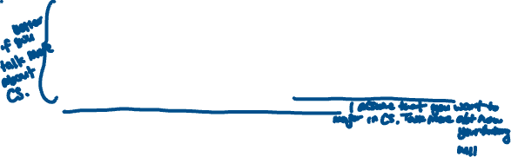

Although I am still far from looking like Chris Evans or moving like a monkey, I’m excited to pursue my newfound passion fueled by my newfound way of thinking for the next chapters of my life.

