Scripts

findByLogin(String login) sql = "SELECT * FROM users WHERE login = ?"

insertClient(User u) sql = "INSERT INTO users (nom, prenom, login, password, role, telephone, adresse) VALUES (?, ?, ?, ?, ?, ?, ?)"

insert(Commande c) sql = "INSERT INTO commande (date_com, montant, etat, client_id, adresse_livraison) VALUES (?, ?, ?, ?, ?)";

updateEtat(int id, EtatCommande etat) sql = "UPDATE commande SET etat = ? WHERE id = ?"

getChiffreAffaireByDate(java.sql.Date date) sql = "SELECT SUM(montant) as total FROM commande WHERE date_com = ? AND etat != 'ANNULE'";

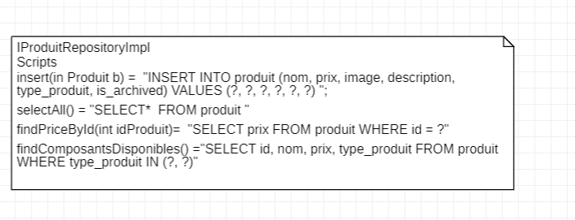
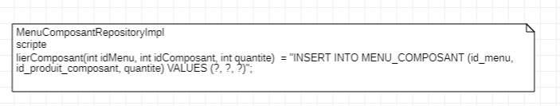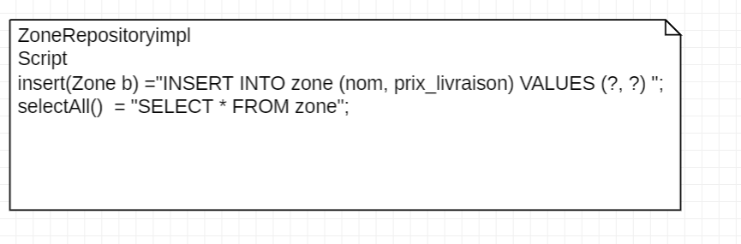
Creation des tables
