Austin Linder (all141) & Jacqueline Marx (JAMarx39)

<https://github.com/all141/Deliverable-4>

CS 1632 - DELIVERABLE 4: Automated Web Testing

The first problem that occurred during the course of this project was understanding how to use Katalon in the first place. We wrote test cases that passed for 2 requirements before realizing that we hadn’t actually added any steps to the test case we were running. This resulted in a bit of backtracking.

Next was learning what assert commands we needed to use for which purposes. Luckily due to a decent amount of web development knowledge, it was not too difficult to discern the abilities of each of the assert commands. Even then it was difficult to decide for example whether to use assertText or assertTextPresent.

In addition, the first experience of having tests pass even when our testing was incorrect had us on our toes. We were often unsure if our tests were passing because the web app was behaving as expected or if they were passing because our test case was flawed. Additionally, we had three tests fail once we had completed writing them. The three tests that failed were FIB-100-TEST, FIB-STRING-TEST, and FACT-STRING-TEST

Testing Logs

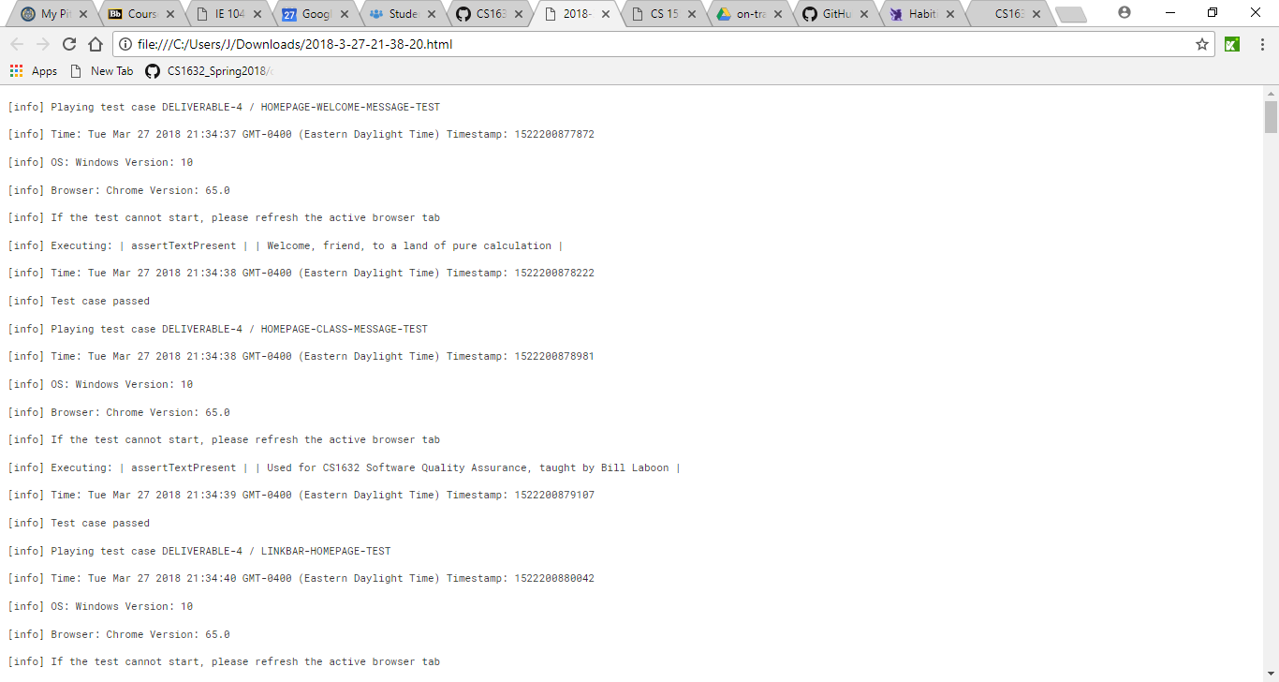

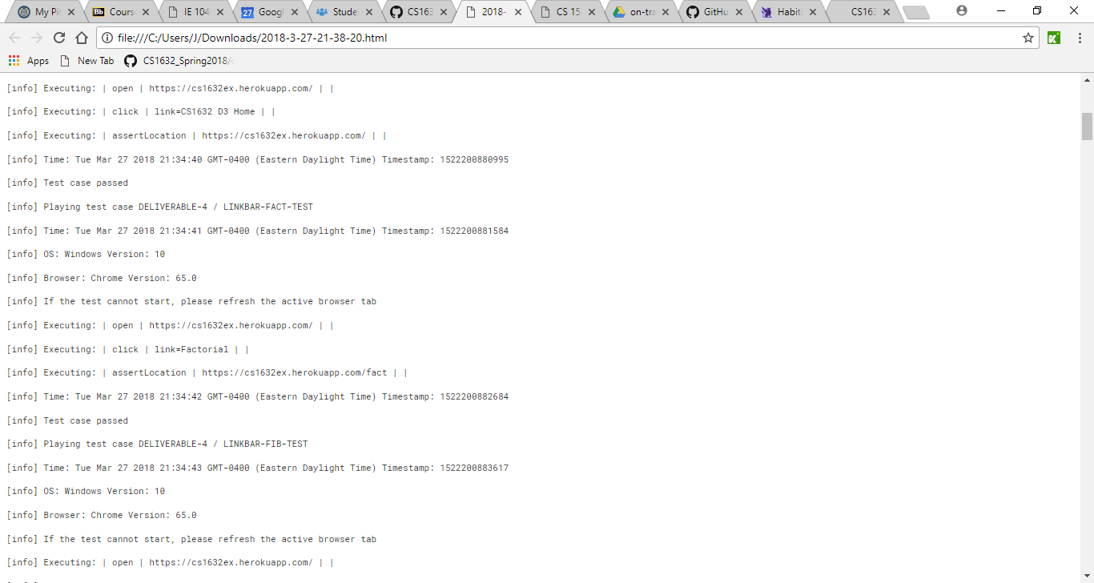

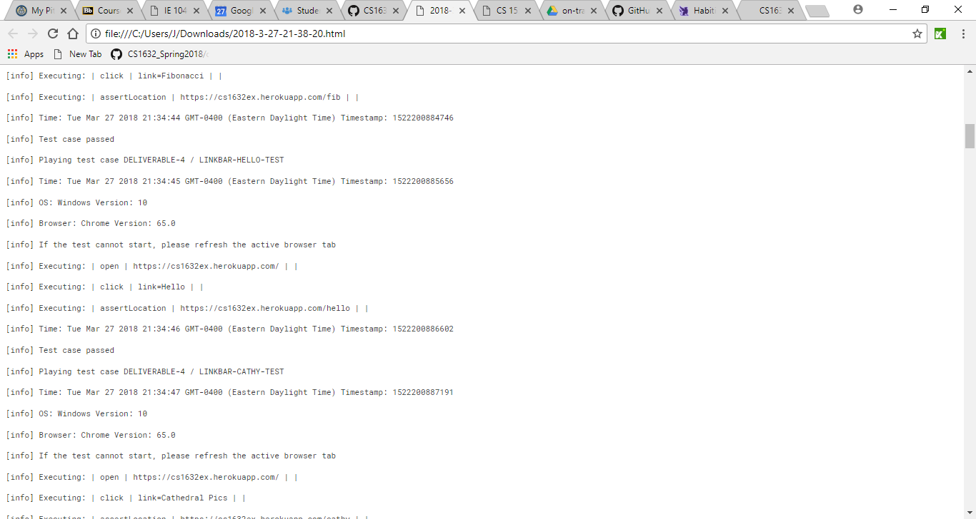

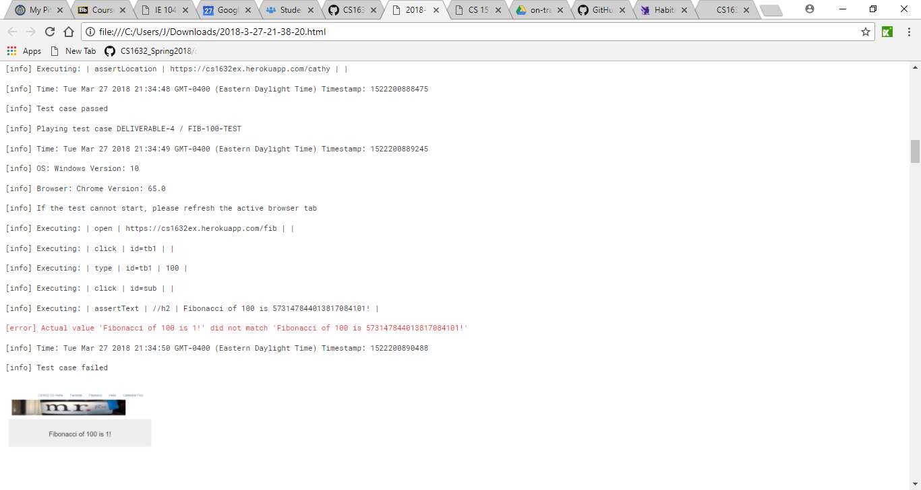

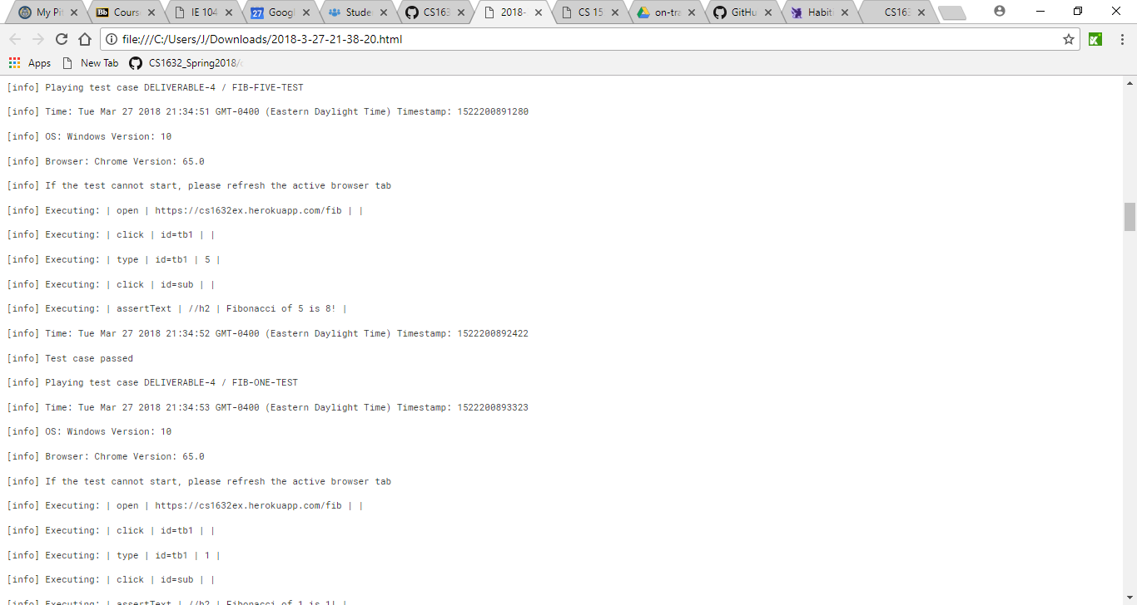

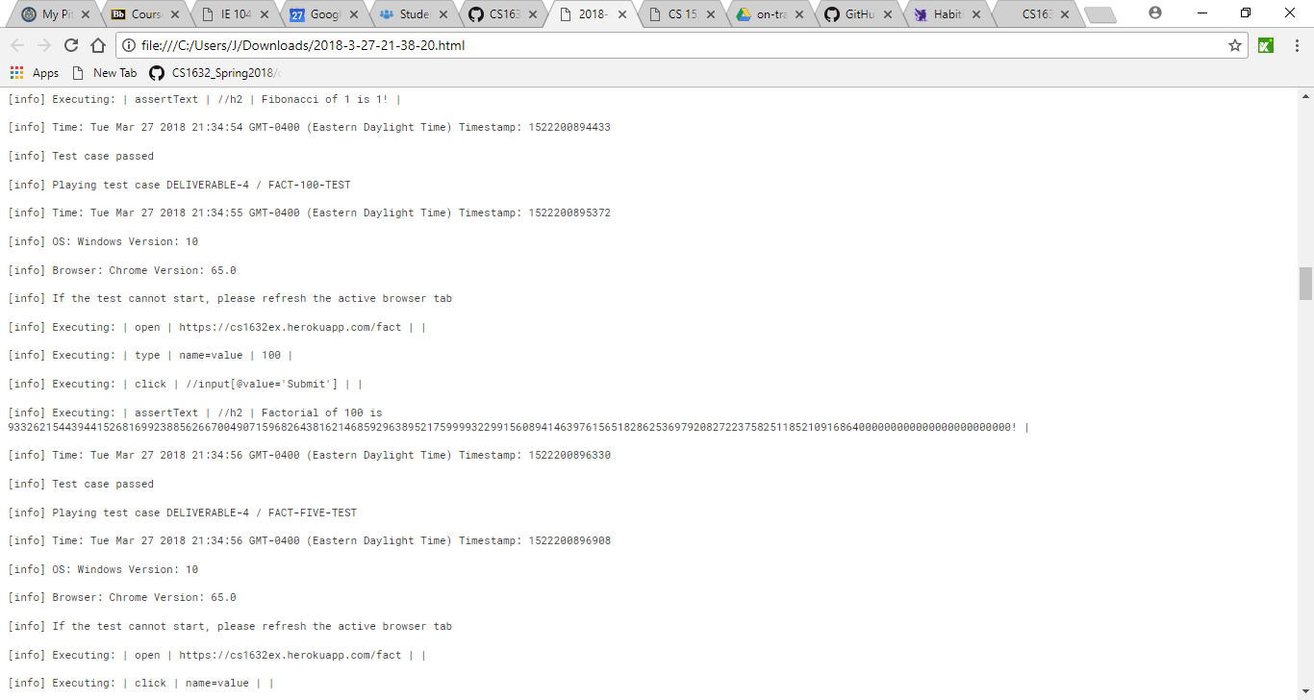

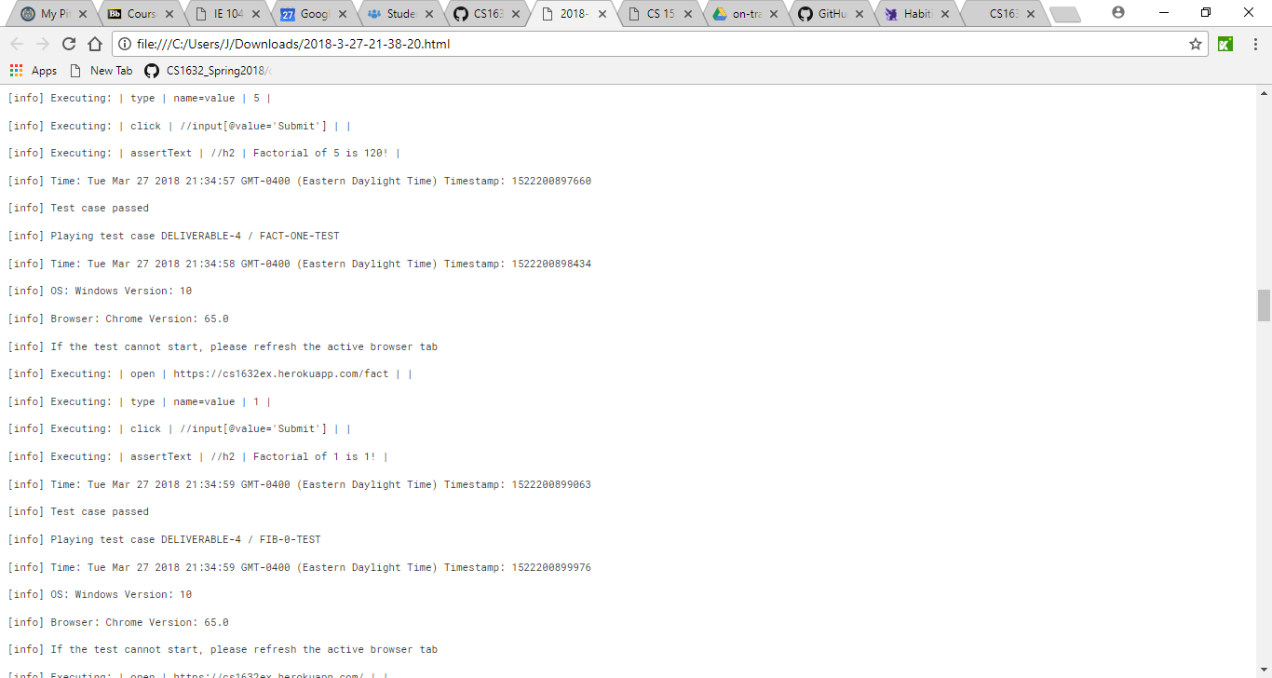

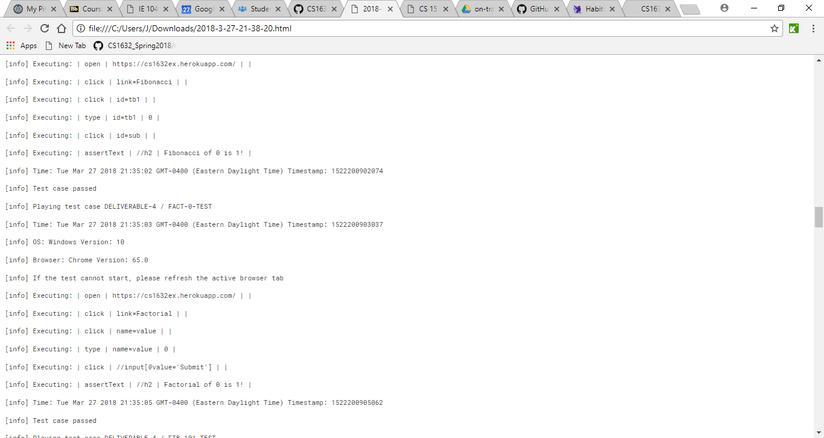

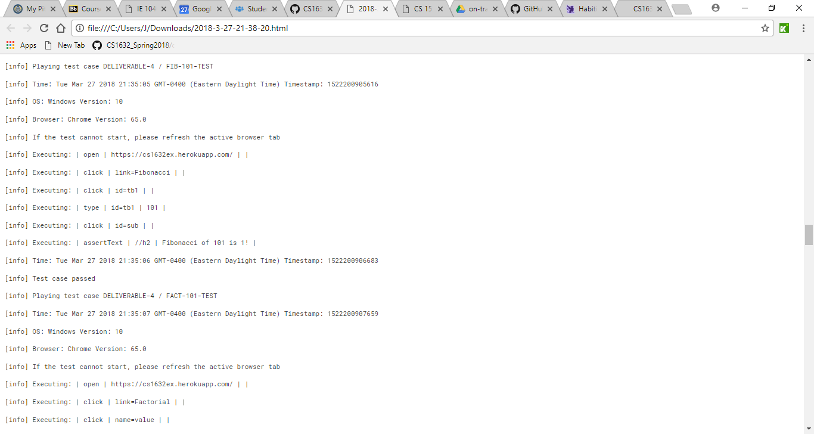

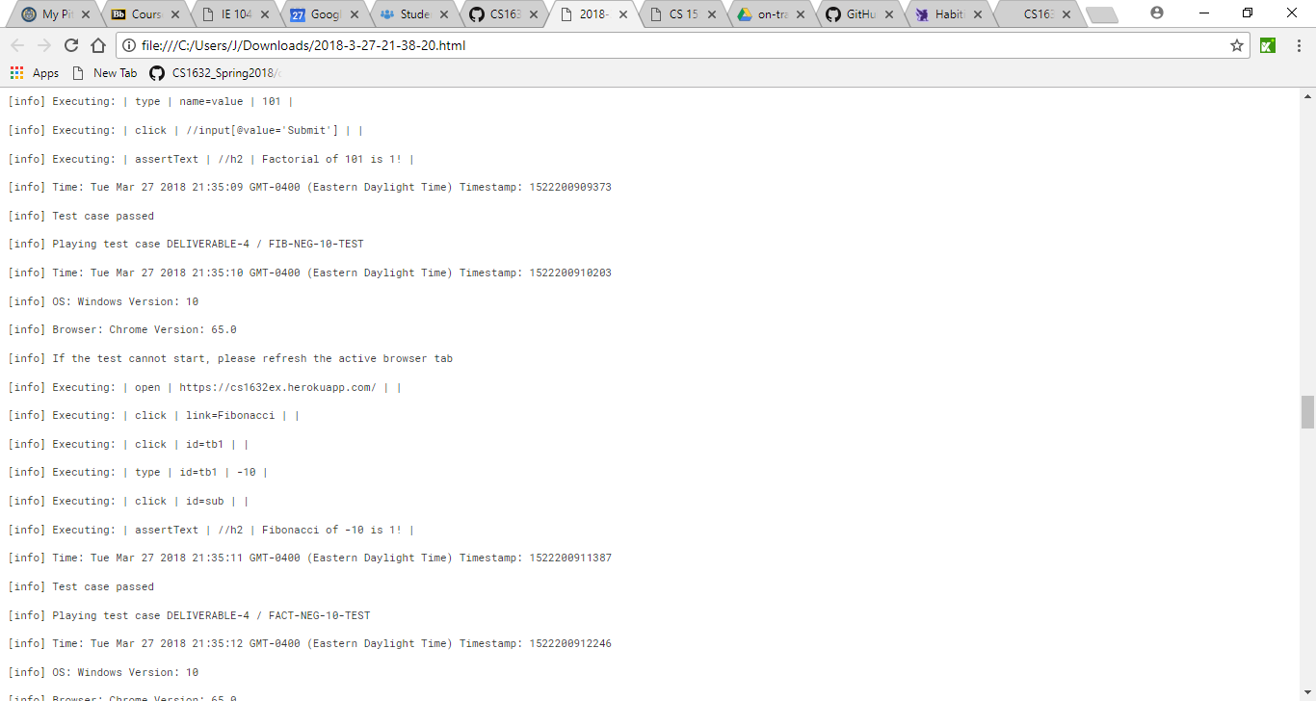

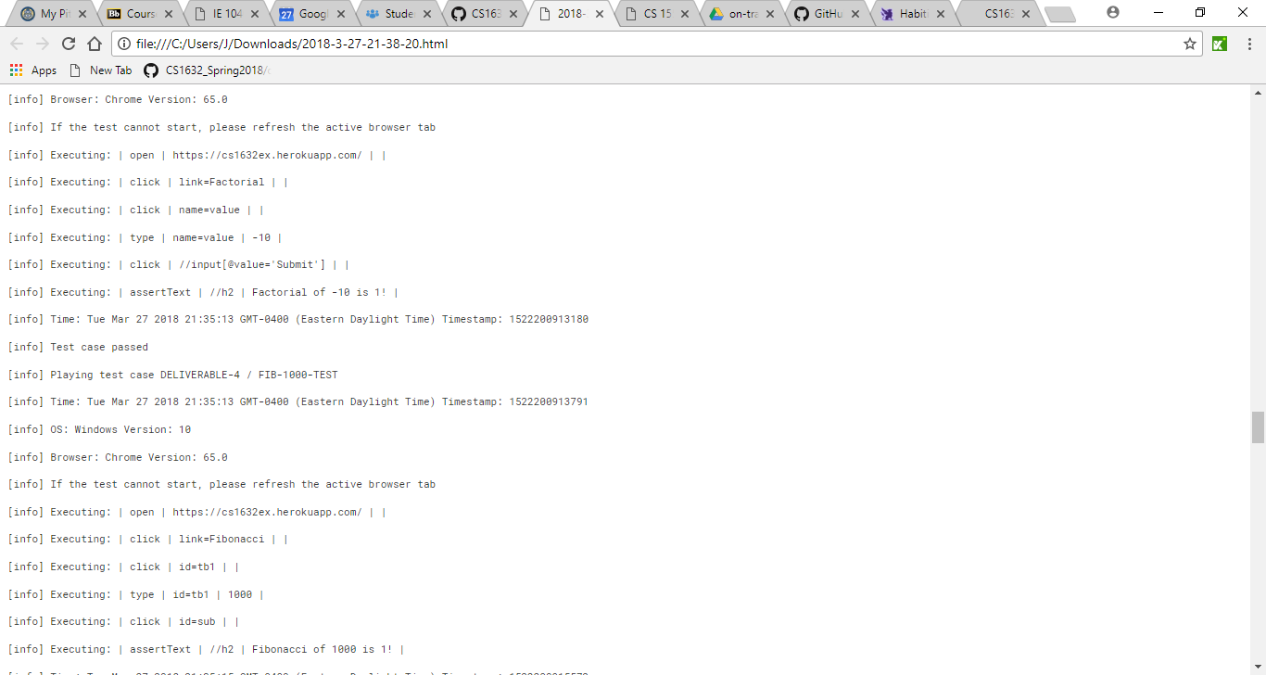

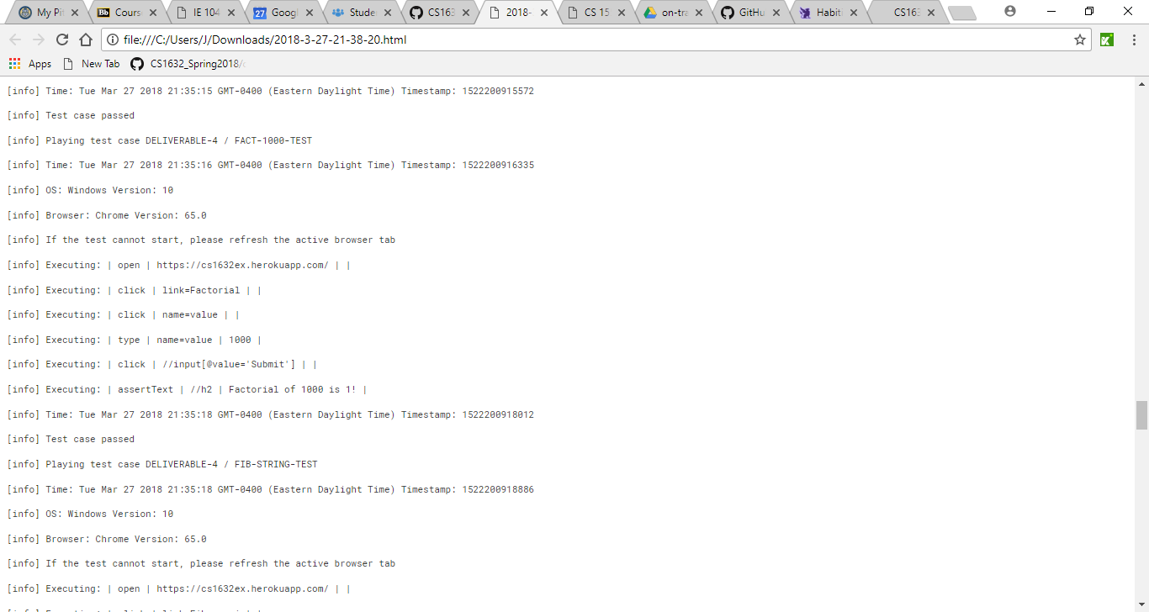

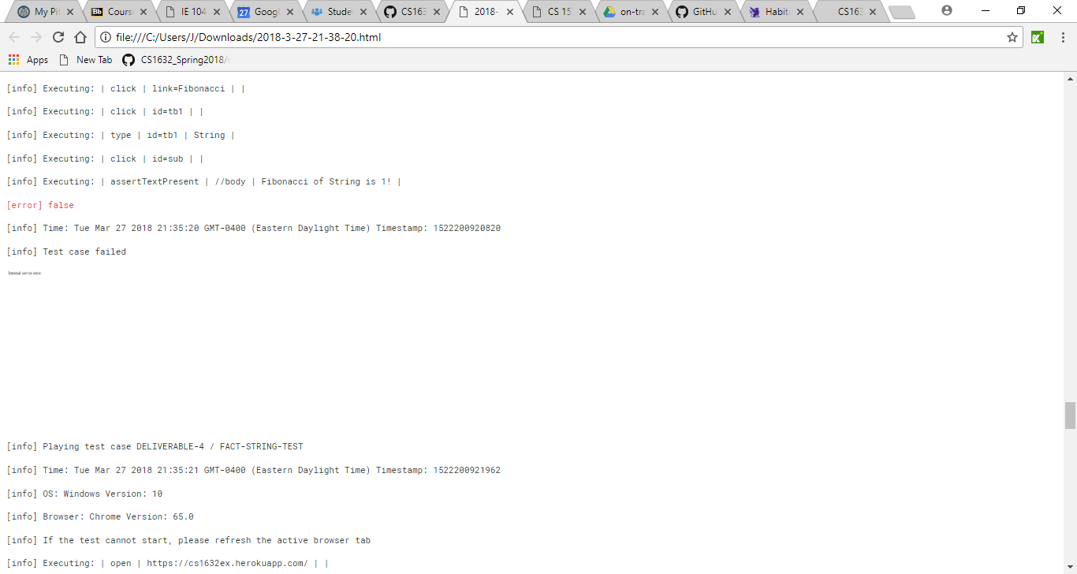

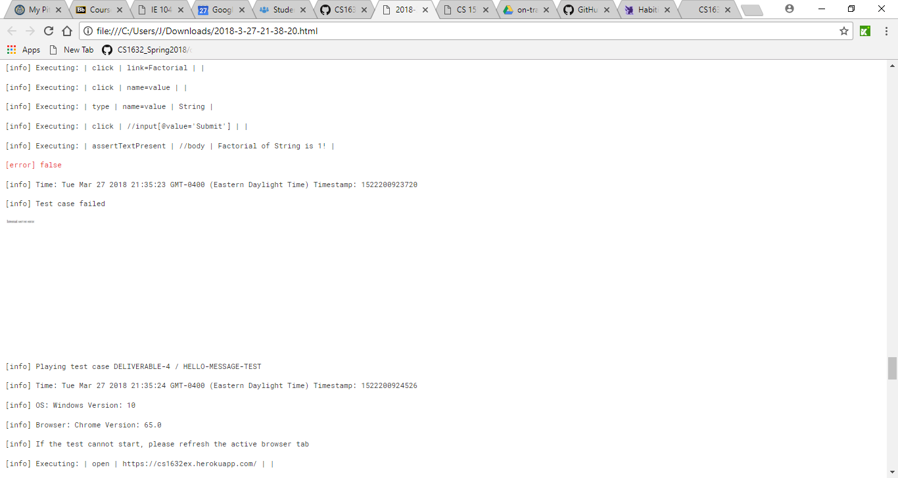

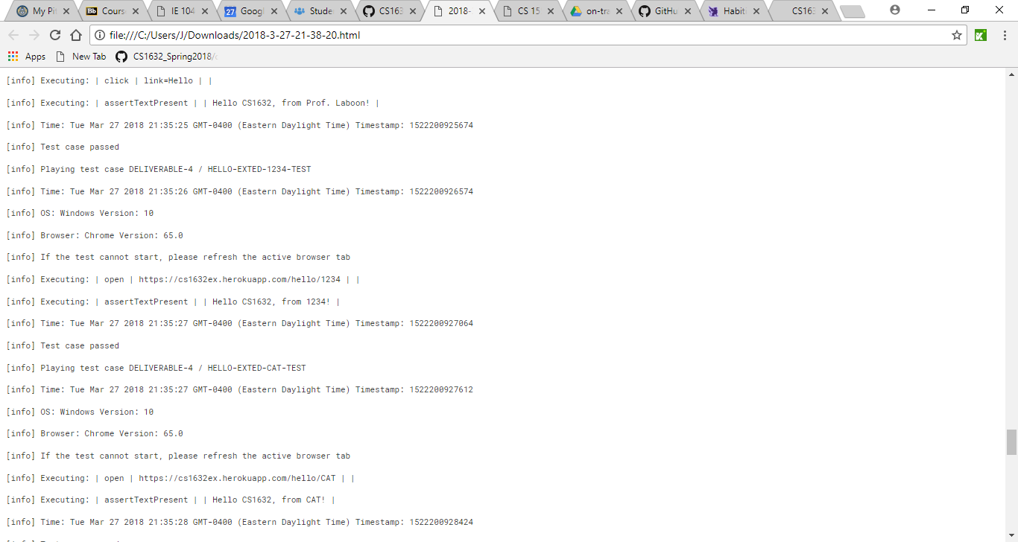

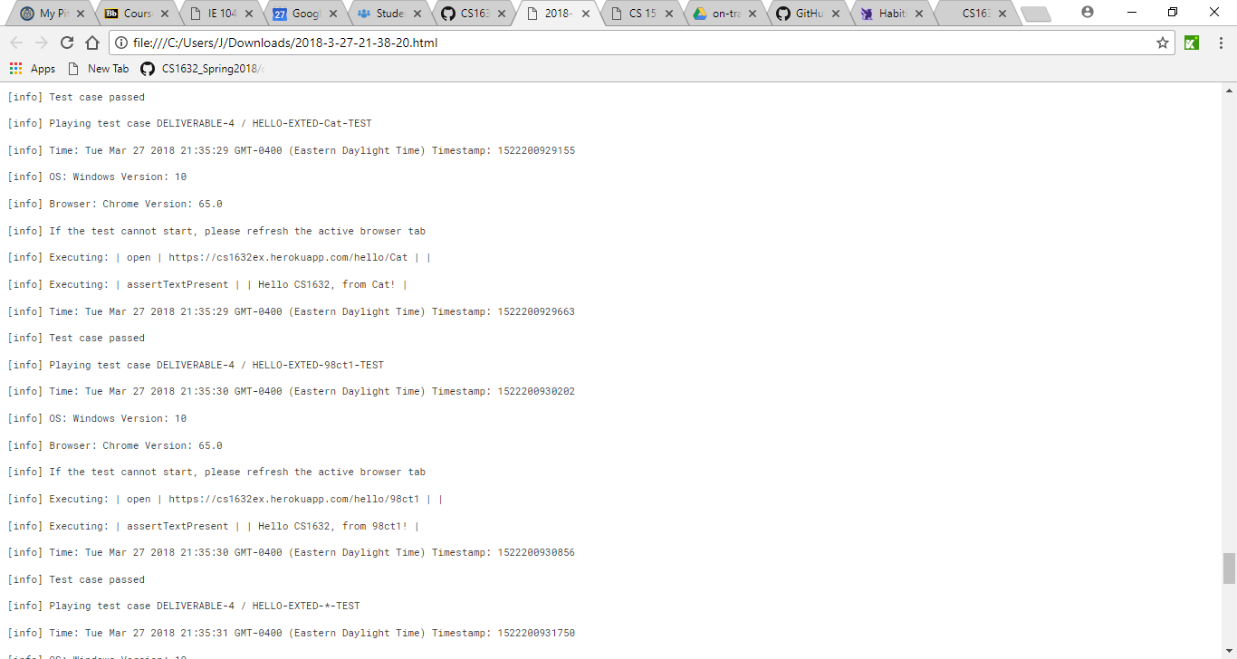

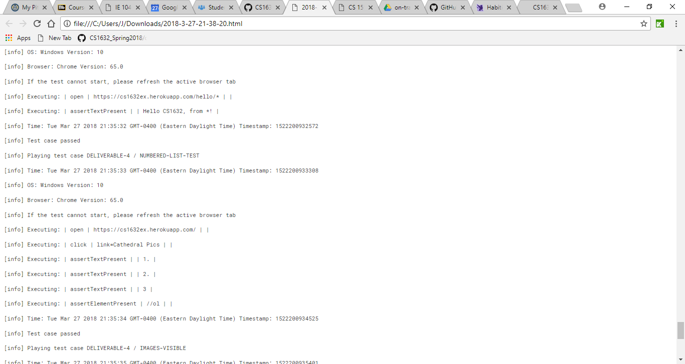

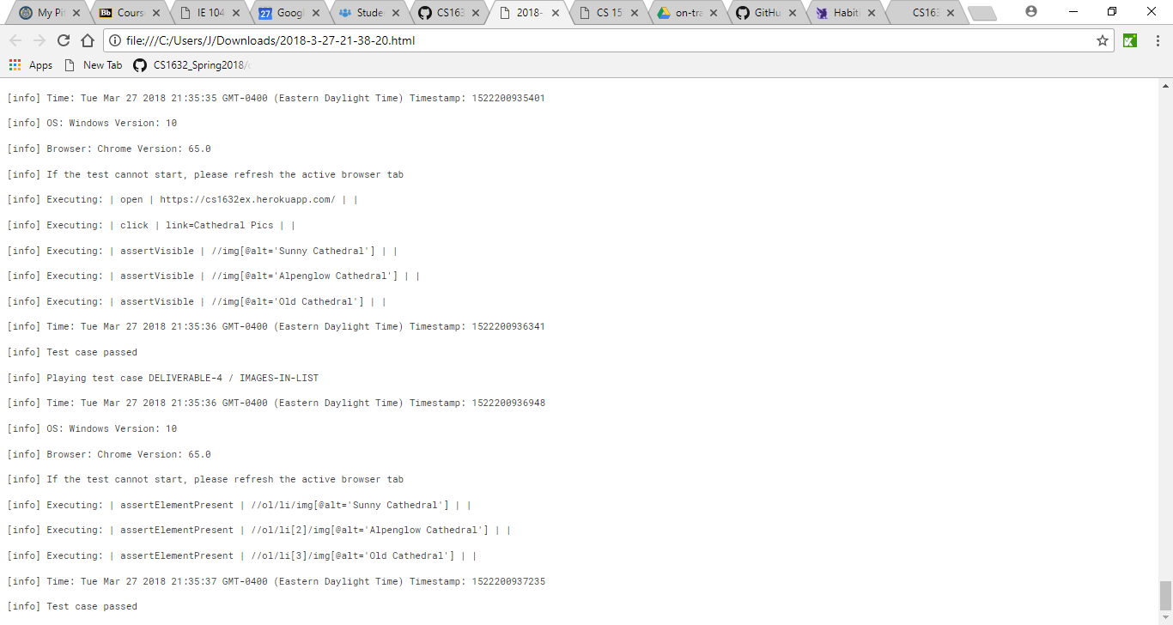

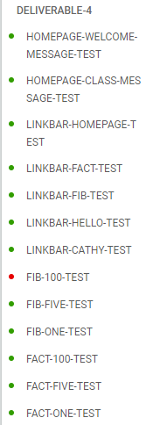

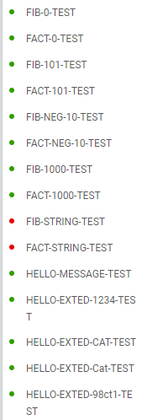

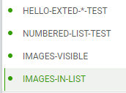

Traceability Matrix:

HOMEPAGE-TEXT: HOMEPAGE-WELCOME-MESSAGE-TEST, HOMEPAGE-CLASS-MESSAGE-TEST

FIVE-LINKS: LINKBAR-HOMEPAGE-TEST, LINKBAR-FACT-TEST, LINKBAR-FIB-TEST,

LINKBAR-HELLO-TEST, LINKBAR-CATHY-TEST

SHOW-FACTORIAL-VALUE: FACT-ONE-TEST, FACT-FIVE-TEST, FACT-100-TEST

SHOW-FIBONACCI-VALUE: FIB-ONE-TEST, FIB-FIVE-TEST, FIB-100-TEST

INVALID-VALUE: FIB-0-TEST, FACT-0-TEST, FIB-101-TEST, FACT-101-TEST, FIB-NEG-10-TEST,

FACT-NEG-10-TEST, FIB-1000-TEST, FACT-1000-TEST

HELLO-MESSAGE: HELLO-MESSAGE-TEST

HELLO-TRAILING-MESSAGE: HELLO-EXTED-1234-TEST, HELLO-EXTED-CAT-TEST,

HELLO-EXTED-Cat-TEST, HELLO-EXTED-98ct1-TEST,

HELLO-EXTED-\*-TEST

CATHEDRAL-PAGE-IMAGES: NUMBERED-LIST-TEST, IMAGES-VISIBLE, IMAGES-IN-LIST

Defect Report

SUMMARY: Calculate Fibonacci of 100

DESCRIPTION: The webpage should display the valid calculated Fibonacci for any number

between 1 and 100.

REPRODUCTION STEPS: Open <https://cs1632ex.herokuapp.com/fib>

Click on the Input Bar

Enter 100

Click Submit

EXPECTED BEHAVIOR: Screen displays "Fibonacci of 100 is 573147844013817084101!"

OBSERVED BEHAVIOR: Screen displays “Fibonacci of 100 is 1!”

SUMMARY: Invalid String Fibonacci

DESCRIPTION: The webpage should display a message stating that the Fibonacci for any input

that is not a number between 1 and 100 as 1, no matter the data type.

REPRODUCTION STEPS: Open <https://cs1632ex.herokuapp.com/fib>

Click on the Input Bar

Enter “String”

Click Submit

EXPECTED BEHAVIOR: Screen displays "Fibonacci of String is 1!”

OBSERVED BEHAVIOR: Web Page Crashes with an Internal Server Error

SUMMARY: Invalid String Factorial

DESCRIPTION: The webpage should display a message stating that the Factorial for any input

that is not a number between 1 and 100 as 1, no matter the data type.

REPRODUCTION STEPS: Open <https://cs1632ex.herokuapp.com/fact>

Click on the Input Bar

Enter “String”

Click Submit

EXPECTED BEHAVIOR: Screen displays "Factorial of String is 1!”

OBSERVED BEHAVIOR: Web Page Crashes with an Internal Server Error