Mini Project 1 · Northwest Architecture Studio · Team 4: The Avengers

Evidence Document
Administrative Assistant workstation: SQL table built and run on OneCompiler
Student: Sorena Role covered: Administrative Assistant (3 PCs) Date: 21 October 2026

1. What this evidence shows
For my part of the team project I specified the workstation for the Administrative Assistant role. To show the build and its budget check in the same way as the team database, I designed a MySQL table for my build, inserted my figures, and ran queries that display the key specifications and the budget check. I wrote and ran the code in the OneCompiler online MySQL editor, and the screenshots in Section 4 were taken from that site after the code ran successfully.
The prices come from my BuildCores build and the parts table in 01_Contributions/Team_Work_Allocation_SQL.md. The budget comes from the brief. The same figures are in the team database (SQL_Database/Team_Database.sql).

2. My build at a glance

Key specifications
Part | Administrative Assistant (built by Sorena)
CPU | AMD Ryzen 5 8500G
Graphics | Built into the CPU
RAM | 16GB DDR5-5600
Storage | 500GB NVMe SSD
Monitor | 1 × Dell 24" S2425H
Also included | Case, power supply, keyboard, mouse, webcam, headset and a Cat6 network cable

Budget check
Item | Amount
PCs needed | 3
Cost per PC | £808.81
Budget per PC | £950.00
Left per PC | £141.19
Role total (3 PCs) | £2,426.43
Role budget (3 PCs) | £2,850.00
Status | Under budget

3. How I designed the table
I made one table, admin_assistant_build, with one row for the Administrative Assistant workstation. The first twelve columns hold the facts I typed in. The last four are generated columns, so MySQL works them out from the cost, budget and number of PCs instead of me typing them by hand. This means the figures for money left, role total, role budget and status cannot be mistyped and always agree with the cost and budget.
Column | Data type | What it stores
build_id | INT, PRIMARY KEY | Unique number for the build
role_name | VARCHAR(40) | Job role the PC is for
built_by | VARCHAR(20) | Team member who specified the build
cpu | VARCHAR(40) | Processor
graphics | VARCHAR(40) | Graphics (built into the CPU here)
ram | VARCHAR(30) | Memory size and speed
storage | VARCHAR(30) | Main drive
monitors | VARCHAR(40) | Number and model of monitors
extras | VARCHAR(120) | Case, power supply and peripherals
pcs_needed | INT | How many PCs this role needs (3)
cost_per_pc | DECIMAL(8,2) | Cost of one PC from BuildCores (£)
budget_per_pc | DECIMAL(8,2) | Budget for one PC from the brief (£)
left_per_pc | Generated | budget_per_pc − cost_per_pc
role_total | Generated | cost_per_pc × pcs_needed
role_budget | Generated | budget_per_pc × pcs_needed
budget_status | Generated | "Under budget", "On budget" or "Over budget"

Every column is NOT NULL so a row cannot be saved with a missing part or price, and money is stored as DECIMAL(8,2) so pounds and pence stay exact. To display the results, I used two queries that list each item on its own row (Item and value). I chose this layout because the normal one-row layout was wider than the OneCompiler output panel and could not be read in a screenshot.

4. Screenshots from OneCompiler
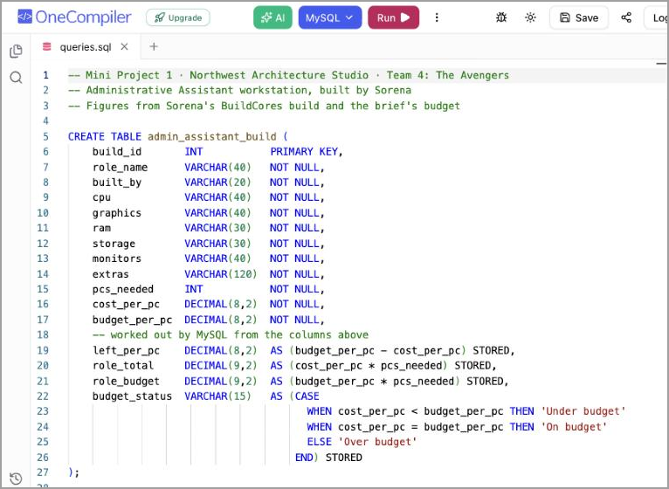
Figure 1: CREATE TABLE statement in the OneCompiler MySQL editor (lines 1–27)
Lines 5–27 create the admin_assistant_build table. Lines 6–17 are the columns I fill in, and lines 19–26 are the generated columns that MySQL calculates.
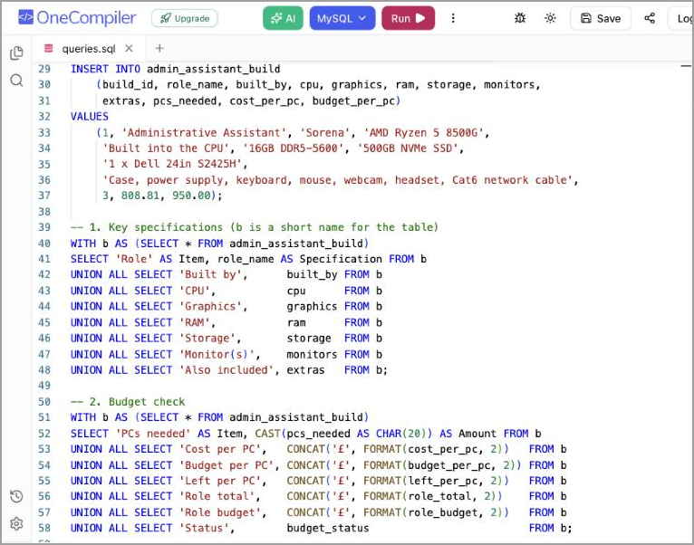
Figure 2: INSERT statement and the two SELECT queries (lines 29–58)
Lines 29–37 insert my build as one row. Lines 39–48 list the key specifications, and lines 50–58 list the budget check with the amounts shown in pounds.
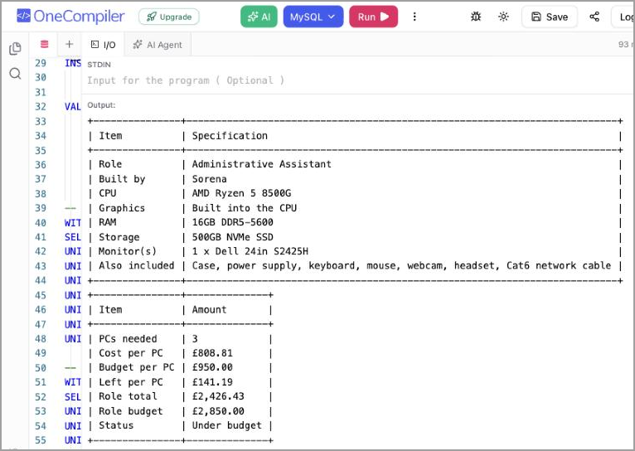
Figure 3: Output after clicking Run: key specifications and budget check
The output panel shows both result tables. The green tick and run time at the top right show that the code ran without errors.
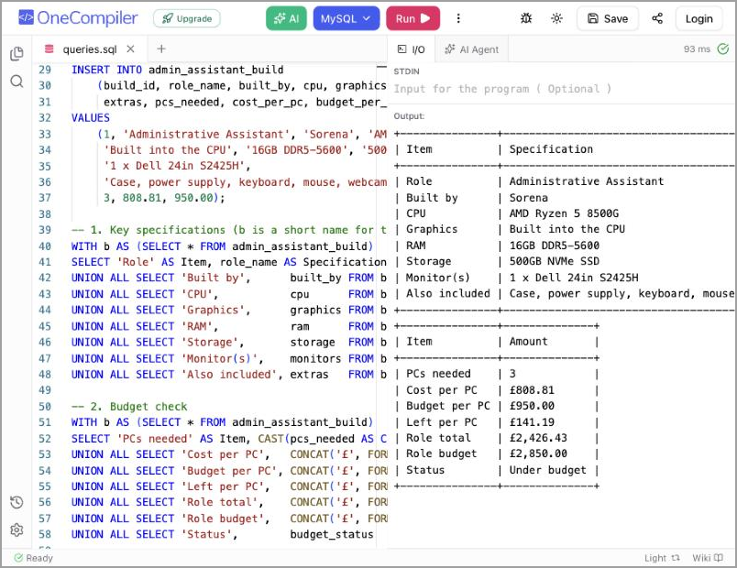
Figure 4: Full OneCompiler window with the queries and their results side by side
This view shows the MySQL editor, the Run button, the queries on the left and the matching results on the right in one screenshot.

5. Checking the results
I compared the OneCompiler output with the team budget table to make sure they match. MySQL worked out the last four figures itself, and they agree with the team table.
Figure | Team table | OneCompiler output | Match
Cost per PC | £808.81 | £808.81 | Yes
Budget per PC | £950.00 | £950.00 | Yes
Left per PC | £141.19 | £141.19 | Yes
Role total | £2,426.43 | £2,426.43 | Yes
Role budget | £2,850.00 | £2,850.00 | Yes
Status | Under budget | Under budget | Yes

Working shown:
- Left per PC: £950.00 − £808.81 = £141.19
- Role total: £808.81 × 3 = £2,426.43
- Role budget: £950.00 × 3 = £2,850.00
- Left for the whole role: £2,850.00 − £2,426.43 = £423.57 (the same as £141.19 × 3)
The Administrative Assistant build comes in under budget, both per PC and for all three PCs.

Appendix: full SQL code
This is the exact code that was pasted into OneCompiler and run (MySQL).
1 -- Mini Project 1 · Northwest Architecture Studio · Team 4: The Avengers
2 -- Administrative Assistant workstation, built by Sorena
3 -- Figures from Sorena's BuildCores build and the brief's budget
4
5 CREATE TABLE admin_assistant_build (
6 build_id INT PRIMARY KEY,
7 role_name VARCHAR(40) NOT NULL,
8 built_by VARCHAR(20) NOT NULL,
9 cpu VARCHAR(40) NOT NULL,
10 graphics VARCHAR(40) NOT NULL,
11 ram VARCHAR(30) NOT NULL,
12 storage VARCHAR(30) NOT NULL,
13 monitors VARCHAR(40) NOT NULL,
14 extras VARCHAR(120) NOT NULL,
15 pcs_needed INT NOT NULL,
16 cost_per_pc DECIMAL(8,2) NOT NULL,
17 budget_per_pc DECIMAL(8,2) NOT NULL,
18 -- worked out by MySQL from the columns above
19 left_per_pc DECIMAL(8,2) AS (budget_per_pc - cost_per_pc) STORED,
20 role_total DECIMAL(9,2) AS (cost_per_pc * pcs_needed) STORED,
21 role_budget DECIMAL(9,2) AS (budget_per_pc * pcs_needed) STORED,
22 budget_status VARCHAR(15) AS (CASE
23 WHEN cost_per_pc < budget_per_pc THEN 'Under budget'
24 WHEN cost_per_pc = budget_per_pc THEN 'On budget'
25 ELSE 'Over budget'
26 END) STORED
27 );
28
29 INSERT INTO admin_assistant_build
30 (build_id, role_name, built_by, cpu, graphics, ram, storage, monitors,
31 extras, pcs_needed, cost_per_pc, budget_per_pc)
32 VALUES
33 (1, 'Administrative Assistant', 'Sorena', 'AMD Ryzen 5 8500G',
34 'Built into the CPU', '16GB DDR5-5600', '500GB NVMe SSD',
35 '1 x Dell 24in S2425H',
36 'Case, power supply, keyboard, mouse, webcam, headset, Cat6 network cable',
37 3, 808.81, 950.00);
38
39 -- 1. Key specifications (b is a short name for the table)
40 WITH b AS (SELECT * FROM admin_assistant_build)
41 SELECT 'Role' AS Item, role_name AS Specification FROM b
42 UNION ALL SELECT 'Built by', built_by FROM b
43 UNION ALL SELECT 'CPU', cpu FROM b
44 UNION ALL SELECT 'Graphics', graphics FROM b
45 UNION ALL SELECT 'RAM', ram FROM b
46 UNION ALL SELECT 'Storage', storage FROM b
47 UNION ALL SELECT 'Monitor(s)', monitors FROM b
48 UNION ALL SELECT 'Also included', extras FROM b;
49
50 -- 2. Budget check
51 WITH b AS (SELECT * FROM admin_assistant_build)
52 SELECT 'PCs needed' AS Item, CAST(pcs_needed AS CHAR(20)) AS Amount FROM b
53 UNION ALL SELECT 'Cost per PC', CONCAT('£', FORMAT(cost_per_pc, 2)) FROM b
54 UNION ALL SELECT 'Budget per PC', CONCAT('£', FORMAT(budget_per_pc, 2)) FROM b
55 UNION ALL SELECT 'Left per PC', CONCAT('£', FORMAT(left_per_pc, 2)) FROM b
56 UNION ALL SELECT 'Role total', CONCAT('£', FORMAT(role_total, 2)) FROM b
57 UNION ALL SELECT 'Role budget', CONCAT('£', FORMAT(role_budget, 2)) FROM b
58 UNION ALL SELECT 'Status', budget_status FROM b;

