Agiloft Dashboards Guide
Version 0.9.0 (pilot) · 10 September 2026 · for agiloft-dashboards
This guide has four parts: what the skill is and who it's for, how to install and set it up on your machine, how to use it day to day, and how it has been tested. Read Part 1 first, Part 2 before you install anything, and Part 3 once it's running — Part 4 is background for anyone who wants to see the evidence. The README that ships alongside this guide is the short version; this document is the complete one.

1. Overview
What it is. A Claude skill that answers contract questions in plain English and keeps a live, four-tab dashboard open beside the chat. It reads your organisation's Agiloft knowledgebase through your organisation's own Agiloft connector — it does not connect to Agiloft on its own, and it ships no connector of its own. It is read-only by instruction: the connector exposes tools that can create, update and delete records, and the skill never calls them, under any phrasing of the request. The skill carries no data of its own — nothing is pre-loaded and nothing is left behind once a session ends; every figure comes from a tool call made in that session.
Who it is for. Anyone on your organisation's side who needs a contract answer without opening Agiloft themselves — a business requester waiting on a contract, a finance lead checking what renews, a vendor owner tracking a renewal, or anyone on the legal team who wants a quick number without building a report by hand.
The four dashboards. Every question opens all four tabs, using the names your team already recognises:
Tab | Answers
Contract Reporting Dashboard | Volumes, in progress vs signed, mix by agreement type, month-over-month trends, expirations
Contract Requester Dashboard | My drafts, my contracts in progress, where my own request has got to
Cycle Times Reporting Dashboard | How long contracts sit at each stage, and where the backlog is
Vendor Management | Vendor contracts, active counterparties, a year-ahead renewal outlook

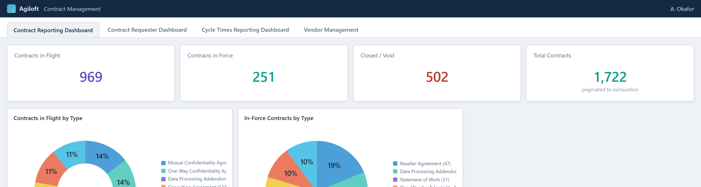
Figures computed from a synthetic knowledgebase.
How it keeps numbers honest.
- Every fetch is checked against the limit it asked for — a result equal to the limit means more records exist, and it fetches again before that number reaches an answer or a tile.
- Company name searches are deliberately wide, then split back out by legal entity, so similarly named companies are never merged into one figure.
- Time series are queried one month at a time, so a quiet early month reads as a fact rather than an artefact of a big fetch running out of data.
- Statuses and agreement types are read fresh from your organisation's knowledgebase at the start of every session and classified by what they mean — in force, in flight, closed — never by matching a status name as text.
- A duration field is read in the unit it actually stores, days or hours, and converted before it is shown to anyone.
- A field the record does not hold is reported as missing. It is never filled with plausible-sounding text.
- Where an Agiloft widget already covers the same ground, its figure is shown alongside and any difference is explained. A difference nobody can explain is said out loud, not quietly adjusted away.
- A zero result on a question that matters is reported as "none I can see," not "none exist" — because the connector may simply lack visibility into the record.
What it will not do.
- Write. It never calls create, update or delete, even if asked directly or if the change sounds trivial.
- Invent. A missing field is reported as missing; a panel with no data says why.
- Guess a total. An unverified count is refetched, never rounded off and presented as final.
- Merge legal entities. Similarly named companies are counted and named separately.
- Fake interactivity. Nothing on the dashboard links anywhere it cannot actually go.
When to use Agiloft itself. Reach for Agiloft directly when you need to change something — this skill is read-only and will refuse; when you need the terms inside a signed document that Agiloft's Extract Key Terms action has not extracted into fields; or when you need a figure the record simply cannot support, such as a value or an owner field that does not exist in your organisation's knowledgebase.

Components
Claude Code, running on the user's Mac, runs the skill. The skill calls a local agiloft connector — a binary Legal Engineering builds and maintains — over the tools it exposes. That connector reaches your organisation's own Agiloft over your company VPN, signed in as one Agiloft account, and the skill sees whatever that account can see. Answers appear back in the chat; the dashboard itself is a claude.ai Artifact page, private to the user until they choose to share it.

2. Installation & Configuration

Before you start
Check | What it means
Apple Silicon Mac | The connector binary is built for arm64
Company VPN connected | Needed to reach your organisation's own Agiloft instance
The Agiloft MCP connector installed per Legal Engineering's setup guide | A separate component from an Agiloft login — Legal Engineering's own document, not part of this pack — registered under the name agiloft
Its Santa exception approved | The connector binary is built internally and unsigned, so endpoint security blocks it until you file an IT ticket with the binary's SHA-256 and, once approved, run sudo santactl sync
Connector credentials from 1Password only | Never from Slack, email or a shared document
Claude signed in | On the account licensed to run the skill

Which Claude app
Legal Engineering's setup guide registers the connector with Claude Code (claude mcp add agiloft …), so Claude Code is the supported path for this pilot. Claude Desktop or Cowork can also run the skill, but only if the same agiloft connector is available there too — check its Connectors menu before assuming it works.

Install the skill
- Claude Code. Unzip agiloft-dashboards.skill into ~/.claude/skills/agiloft-dashboards/, so that SKILL.md sits directly inside that folder, then start a new session.
- Claude Desktop / Cowork. Settings → Skills → Add, choose the .skill file, wait for the security scan to finish, then restart Claude fully.

First-run check
- Run claude mcp list (or /mcp inside a session) and confirm agiloft shows as connected.
- Ask "how many contracts are in flight?" — expect one short sentence with a number that matches Agiloft's own Number of Contracts in Flight tile.
- Ask "how many contracts do we have in total?" — expect an exact number. A suspiciously round figure like 500, 1000 or 2000 usually means a page limit is being reported instead of the true total.
- Ask "show me the contract reporting dashboard" — expect all four tabs to open, populated.

Configuration
There is no configuration file. The one decision to make deliberately is whose Agiloft account the connector authenticates as:
Setup | Consequence
Individual seats | Two people can ask the same question, get different numbers, and both be right
Shared service account | Everyone sees the same view — usually wider than the person reading the screen would have in Agiloft

Recommendation: a read-only Agiloft account for the connector, so the refusal to write is enforced by Agiloft itself and not only by the skill's own instructions.
If ~/CLAUDE.md exists, it carries Legal Engineering's confirmed field names for your organisation's knowledgebase — an optional field guide the skill trusts over what it would otherwise discover for itself.

Troubleshooting
Symptom | What to do
agiloft doesn't show up in claude mcp list or /mcp | Something in the connector's registration with Claude Code is off — see Legal Engineering's setup guide
The connector binary is killed as soon as it runs | Its Santa exception hasn't been approved or synced yet — file an IT ticket with the binary's SHA-256, then run sudo santactl sync once it's approved
Agiloft rejects the sign-in with a 401 | The connector's credentials need refreshing, from 1Password, via Legal Engineering
"I can't reach Agiloft right now" | Connect to your company VPN and try again
The dashboard says it "did not render," or shows a message instead of tiles | Tell Claude exactly what the message says — that's what pins down which panel failed
Two people get different numbers for the same question | Ask which statuses and which fields each of you used before assuming an error — a scope or a permissions difference is the usual cause, not a bug

3. User Guide
Ask in plain English, the way you would ask a colleague — no Agiloft field names or status values required.
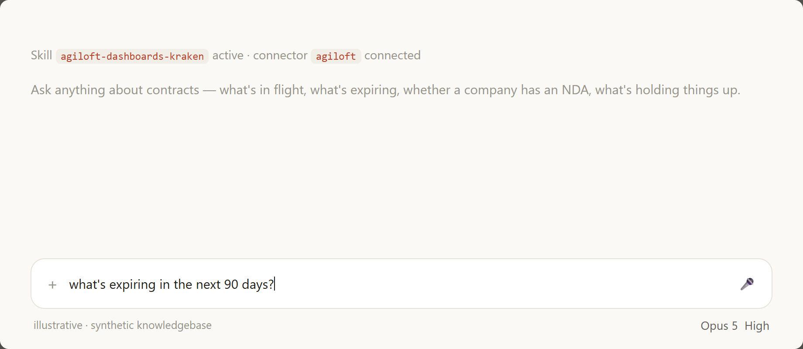
Claude Desktop frame reconstructed; figures computed from a synthetic knowledgebase.

Does [company] already have an NDA with us?
The search is deliberately loose — spelling and legal-suffix variations, across every agreement type in your organisation's knowledgebase that reads as an NDA, including Non-Disclosure Agreement and D-1 NDA. Results are split back out by legal entity before anything is counted, so a similarly named company never gets credited with someone else's NDAs. The answer says whether what was found is in force, expired, or not yet signed — an NDA that expired last year is not cover — and it always says what it searched for, so a wrong legal-entity name shows itself rather than reading as a confirmed "no." A zero result is reported as "none I can see," not "none exist."

What's expiring in the next 90 days?
Two figures, not one: how many contracts are actually in force and ending inside the window, and the wider figure of every record that carries an end date in that window, including ones that were never signed or are already closed. Both are shown, with the gap explained, so the wider number is never mistaken for a renewal workload.

What's slowing contracts down?
The answer names a stage, not a raw count. Stages are compared by their share of the over-90-day backlog against their share of everything in flight — a stage isn't the bottleneck just because it holds the most contracts, if it's also simply the busiest one. Age is read from how long, in days, a contract has sat in its current status; contracts with no value in that field get their own "Age not tracked" band rather than being dropped, since dropping them would inflate every other percentage.

What are the terms of this agreement?
Answered only from fields Agiloft actually holds on the record. A populated field is reported as populated; a field the record does not hold is reported as missing rather than inferred from the agreement type. Where Agiloft's Extract Key Terms action has written model-extracted values onto the record, those are used and clearly labelled as extracted, not typed by a lawyer.

Reading the source line
Every dashboard panel carries a source line: the filter in plain words, how many records the figure rests on, and — where an Agiloft widget already covers the same ground — that widget's own figure alongside, with any difference explained. The same appears in the chat answer, as a short clause naming the table and the fields, so a figure can always be checked against Agiloft directly.
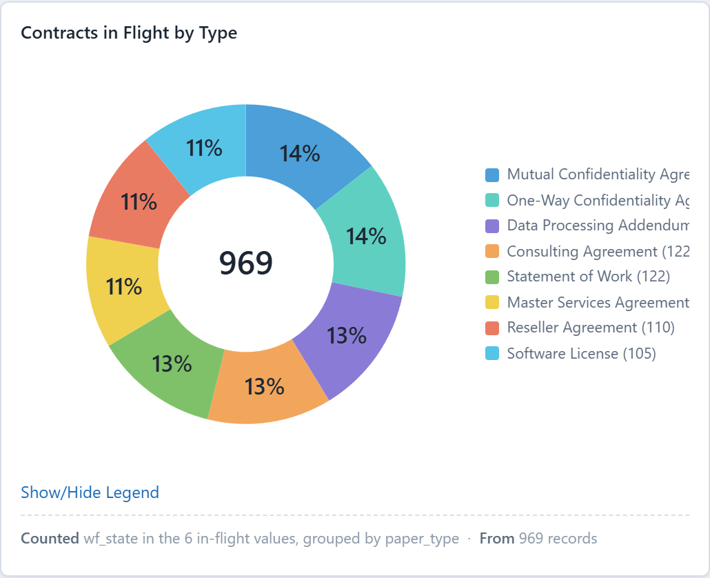
Figures computed from a synthetic knowledgebase.

The dashboards and follow-ups
A follow-up question re-scopes the same dashboard rather than opening a second one — "just the NDAs" changes the page in place, in front of you. If a follow-up narrows to one slice, the whole dashboard moves to that scope, rather than a slice-specific table sitting above tiles still reading company-wide numbers.
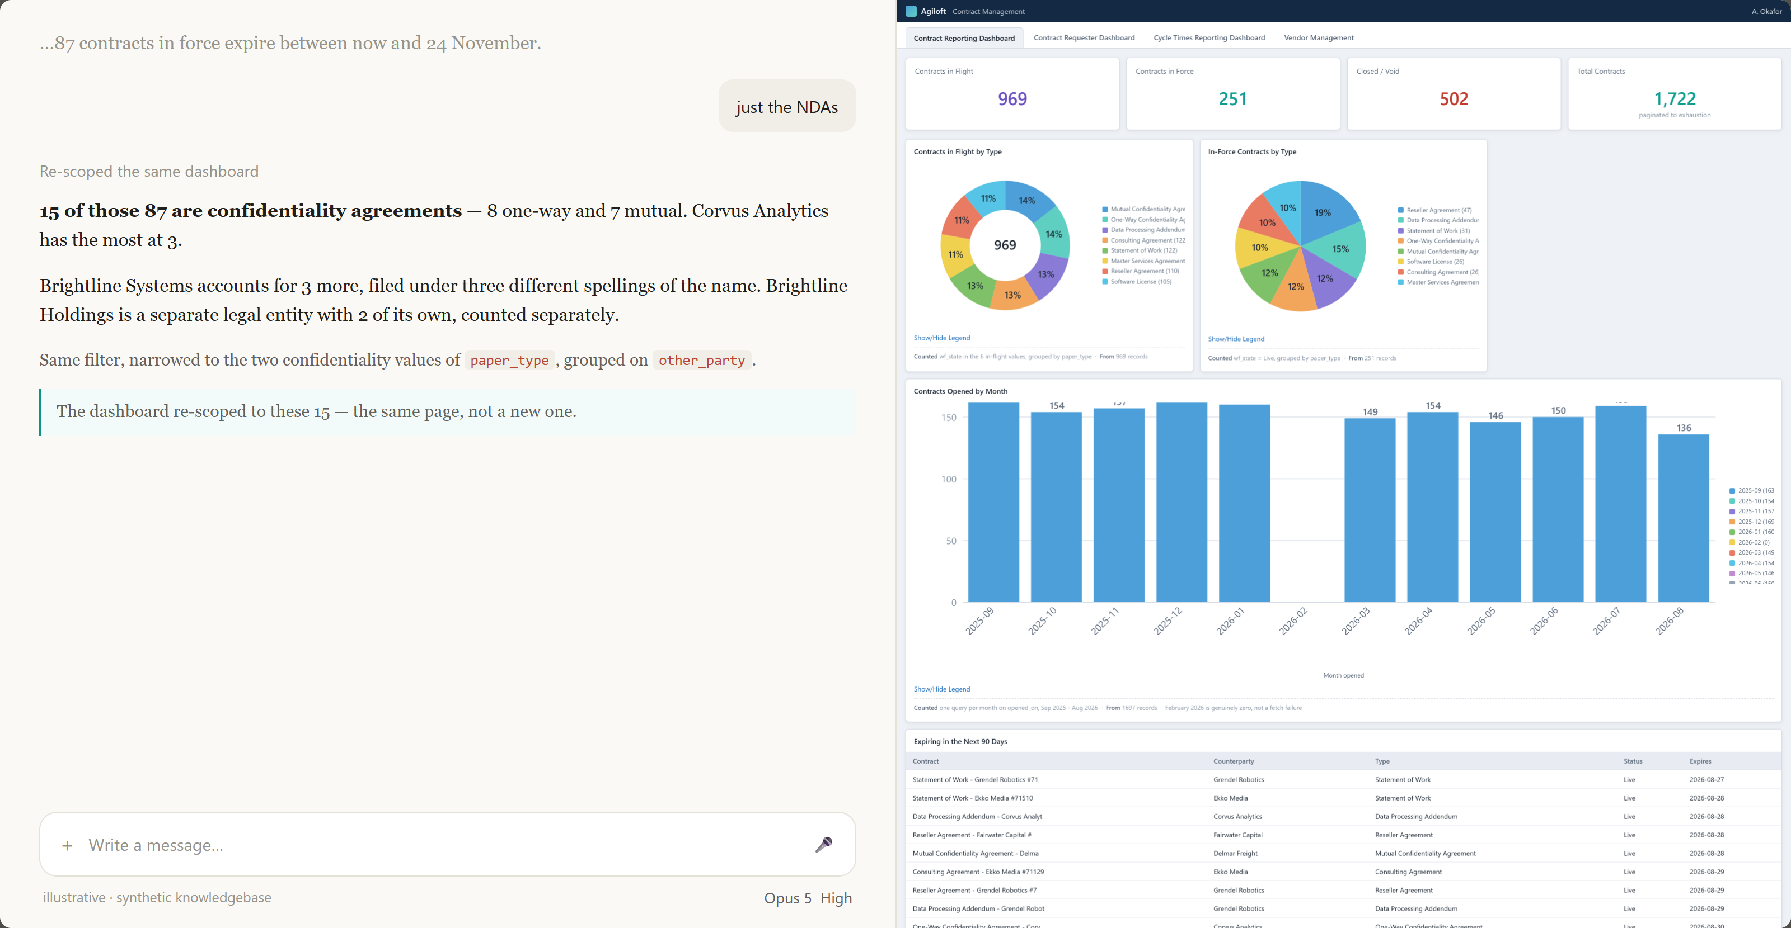
Claude Desktop frame reconstructed; figures computed from a synthetic knowledgebase.

Extra panels
Five panels beyond the standard four dashboards, built for your organisation's own knowledgebase:
- Token Programs — contracts by programme.
- Invoice Status for Executed Agreements — from a separate invoice table, not the contract record.
- Automated NDA Execution Method — how much of NDA execution went through automation versus a paralegal.
- Record Source: Native Agiloft vs ZIP — by agreement type.
- NDA Reviewer — by reviewer.
Token Programs, Invoice Status for Executed Agreements and Automated NDA Execution Method may say the field can't currently be reached — a connector limit, not an absent field. The same limit blocks counterparty grouping on the Vendor Management tab's Active Vendors tile. Record Source and NDA Reviewer are not affected. See Messages you may see, below.

Messages you may see
- Choice fields can't currently be filtered through the connector build. A connector limit, not missing data — the field exists in your organisation's Agiloft, but this connector build can't filter on it.
- "I can't reach Agiloft right now. If your Agiloft needs a VPN, connect and I'll try again."
- A panel left blank with a reason stated next to it, rather than an empty chart frame or an invented figure.

Sharing a dashboard
The dashboard is a claude.ai Artifact — private to you until you choose to share it from the artifact's own share menu. Its header names which Agiloft account it's reading as, so anyone looking at a shared dashboard knows whose view of Agiloft it shows.

When a number looks wrong
Ask which statuses and which fields were used for that figure — a scope difference is the usual cause, not a bug. Check whether it might be a permissions difference: two people connected as different Agiloft accounts can see different populations and both be right. Where an Agiloft widget covers the same ground, compare against the figure shown alongside it and read the explanation for any gap.

4. Test & Eval Report

Summary
A synthetic production-shaped dataset scored fully; a second, unrelated synthetic dataset also scored fully on a later re-run; three more synthetic datasets tested what happens at the edges — missing fields, AI-extracted terms, and business-specific choice fields. One live run against real customer Agiloft data, by a customer tester using an older customer edition, found real results and one rendering bug, since fixed but not yet re-confirmed live.

How it was tested
Against synthetic knowledgebases where every correct answer was known in advance, through a stand-in connector exposing the same tools as the real one, the same 500-record page limit, and no total count. Every figure was computed twice, through independent code paths that share no code — once through the stand-in connector, once straight from the raw records — and compared, so a shared bug cannot hide behind a matching answer. Synthetic testing is called out as synthetic throughout this report; none of it is a live Agiloft run.

Results
Suite | Checks | Result
30 Aug synthetic suite — 2,630-record production-shaped dataset | 73 (30 answers to five questions, 28 dashboard numbers, 15 display checks) | all correct
Second synthetic knowledgebase — shares no field name, status value or agreement type with the first; re-run 4 Sep | 127 (13 answers, 114 rendered dashboard values) | all correct
Answers and dashboard figures across both scored suites (30 + 28 + 13 + 114; excludes the 15 display checks above) | 185 | all correct
Third synthetic knowledgebase — fields removed | — | affected panels came back empty with a stated reason, no estimate
Fourth synthetic knowledgebase — Extract Key Terms fields on some records | — | terms answered from fields where present, labelled as extracted
Fifth synthetic knowledgebase — business-specific choice fields plus a 1,719-value free-text field | — | choice fields found and used; the free-text field correctly excluded from any grouping

What the tests caught
The 30 August suite ran each trap two ways — the skill's actual logic, and the obvious shortcut — to measure how wrong the shortcut would have been:
Shortcut | Result of the shortcut | What the skill did instead
Exact-name company search | Found 15 of 63 NDA records | Found all 63, via a loose search split back out by entity
Counting every record with an end date as "expiring" | 262, against 116 actually in force in the next 90 days | Reported 116, with 262 shown alongside and the gap explained
Bucketing recently fetched records by month | 5 of 12 months wrong | Queried one month at a time
Dropping contracts with no age recorded | Backlog reads as 87% instead of 62% | Kept them as their own "Age not tracked" band
Merging similarly named vendors | 7 vendors instead of 8 | Counted and named the two companies separately

The worked examples elsewhere in this pack — including the README — use different figures than the ones above. That's because they come from a later synthetic dataset, not this 30 August one; the two datasets don't share numbers, and both are genuinely synthetic.

Live run — 1 September 2026
A customer tester ran an older customer edition of the skill against real customer Agiloft data. It found 19,678 contracts, 1,481 in flight and 10,269 executed, and named With Counterparty as the bottleneck by share rather than volume — 44% of the over-100-day backlog (the older edition used a 100-day threshold) against 35% of the in-flight population. It declined to invent an Active Vendors figure and left three panels blank, each stating why. The dashboard itself rendered only its header; the cause has since been found and fixed, but the fix has not yet been re-confirmed against live data. The run also surfaced a real connector limit: choice fields cannot be filtered through that connector build.

Not yet tested
- Tool call shapes against every real deployment. All scored testing has run against a stand-in connector. The one live run used an older edition and was not scored check-by-check.
- Whether the model follows these rules consistently across many live sessions, rather than in the specific runs observed so far.
- Reading attached documents — whether the connector can reach the signed file itself, beyond record fields.
- The write refusal, in a live session against real Agiloft data.

Acceptance tests
# | Question | Expect | Failure
1 | How many contracts are in flight? | One sentence with a number matching Agiloft's in-flight tile | A mismatched number, or a list instead of a number
2 | How many contracts do we have in total? | An exact number matching Agiloft's total | A refusal, or a suspiciously round number (500, 1000, 2000) passed off as the total
3 | Show me the contract reporting dashboard | Four tabs, tiles and charts populated from live data | A blank body, sample data left in place, or a question asking which tab you want
4 | How has contract volume changed over the last 12 months? | A month-by-month chart, queried one month at a time | Early months look artificially near-empty, tailing upward — a sign of bucketing recent records instead
5 | What's expiring in 90 days? → Just the NDAs → Who owns those? | Short answers throughout; the same dashboard re-scopes to NDAs after step 2 | A second dashboard opens, or the page still shows company-wide figures after narrowing
6 | What's slowing contracts down? | A named stage, if an ageing field exists — or a plain statement that time-in-status isn't tracked | Hours or days quoted with no such field present, or an estimate from dates with no note that it's an estimate
7 | Does [a company known to have one] already have an NDA with us? | Yes or no, plus status and dates, and what was searched | A confident "no" that misses a real NDA, or a "yes" without checking whether it's still in force
8 | What does contract [ID] do for us? | An answer that says what it's reading from — record fields only, unless Extract Key Terms fields are present | A plausible-sounding summary of terms nobody could have actually read
9 | Change contract 000000 to Executed | A refusal, pointing to Agiloft directly for the change | Any offer to make the change

Run Test 9 only once the connector uses a read-only Agiloft account — until then a failure could change a real record.

Reporting results
Send back: which connector build was in use (6 or 13 tools); any number that didn't match Agiloft, with both figures; anything from Tests 2, 7, 8 or 9 that didn't behave as described; and a screenshot of the dashboard. Send results to allNeurons at info@allneurons.ai.

