Lab 3: Ring-Oscillator Based Strong PUF

# Introduction:

Ring-Oscillator based PUFs are among the most common Strong PUFS for FPGAs. There are many implementations with various benefits. Below are three papers which outline FPGA PUFs implemented using various forms of Ring-Oscillators.

1. “An analysis of Ring Oscillator PUF Behavior on FPGAs”, by Eiroa and Baturone
2. “Improved Ring Oscillator PUF: An FPGA-friendly Secure Primitive”, by Maiti and Schaumont
3. “A Configurable Ring-Oscillator-Based PUF for Xilinx FPGAs”, by Xin, Kaps, and Gaj

These papers build on each other and should optimally be read in order. For this lab you will be implementing a design very similar to the one described by Xin et al. in the third paper.

# Lab Products

1. An answer to all questions in the lab (*these will be in italics*)
2. A description of approaches taken, problems encountered, and techniques used to overcome these challenges.
3. A working PUF challenge response function based on the design described in the “PUF Design” Section.
4. An analysis of the behavior of your produced on three **different locations** on the FPGA.
   1. For this you should document the output of the PUF across all the challenges and determine the average hamming distance.

# PUF Design

You will be implementing a modified version of the PUF described by Xin, Kaps, and Gaj. Your PUF should accept an 8-bit challenge, with the 6 lower challenge bits for the configurable ring-oscillators and 2 challenge bits for the ring-oscillator mux (Figure 7).

The paper describes two new methods used to generate a ring-oscillator based PUF. The first is to develop a different configurable ring-oscillator (Figure 6). As previously described your configurable ring-oscillator should only take a 6-bit portion of the challenge. Your ROs should also use KEEP and S attributes to avoid signal optimization (see potential problems). Design and implement your own configurable ring-oscillator using these requirements. *What did you change about the provided configurable ring-oscillator?*

Once you have completed the configurable ring-oscillator design and implement the PUF described in the paper using only 2 challenge bits for the ring-oscillator mux and producing only 8 challenge-response bits. Ensure that there is a way to determine from outside the module if the response is complete. *How many ROs are necessary? Why will a 50 MHz clock work for this design? Would any arbitrary clock speed work for this design? What did you decide to use for the max value of std_counter? How does this value impact the PUF? Why would we want to know if the challenge response is complete?*

Now that you should have a working PUF implement a whole PUF on the BASYS 3 with the following input/output scheme.

1. Switches 0 through 7 should be the challenge response bits.
2. The bits of the challenge response are displayed on LEDs 0 through 8.
3. Once the challenge response is complete light LED 14
4. The seven-segment display shows the challenge byte concatenated with the challenge response bits. (This can be accomplished using the provided sseg_des module)
5. Anytime any of the input bits are changed the challenge response is re-calculated
6. If the middle button is pressed the challenge response recalculates

Once you have completed this step and test for the following errors before moving on:

1. Any challenge Ci  always produces the same response CRi even across many separate calculations.

Now that you have a working PUF incorporate the included SHA128 algorithm onto the board. (Note that once you add the SHA128 module, the implementation time is going to increase dramatically) It should be implemented as follows:

1. The input to the SHA hash should be the challenge concatenated with the challenge response.
   1. Note that the provided function automatically deals with padding.
2. Ensure that anytime the challenge or challenge response change the hash is updated.
3. When the hash is completed turn on LED 15.
4. When switches 12 through 15 are all low the seven-segment display continues to display the challenge and challenge response concatenation as before.
5. When any of the switches 12 through 15 are up the input on these four switches should be decoded and the corresponding two bytes displayed on the seven-segment display.
   1. I.e. if the four switches are “1010” this decodes to 6 so the 6th pair of bytes (bytes 11 and 12) are displayed.
   2. If the four bits decode to a number greater than 8 then display all zeroes.

*What is the purpose of this (why might we want to hash the challenge concatenated with the challenge response)?*

Finally, using the instructions provided in “Using Vivado pblocks to Adjust the Location of the Components” generate 3 constraint files which each specify a different location for the ROs. (Note that because of the long compile time it might be useful to develop several constraint files and implement them simultaneously, see “Potential Problems” for more details) Once you have three working PUFs with ROs in three different locations record the challenge-response pairs and analyze them. *Are the challenge-response pairs the same for each location? Should they be (include details)? What are the intra-board and inter-board hamming distances? What are ideal? Discuss anything of note about your particular implementation or results.*

# Provided VHDL Code

## sseg_des –

This module is used to output two bytes to the seven-segment display.

Inputs:

1. COUNT – The two bytes to display
2. CLK – A 100 MHz clock
3. VALID – ‘1’ If the input data is valid, ‘0’ otherwise

Outputs:

1. DISP_EN – Determines which of the 4 seven-segment displays to drive. Should drive the “an” input in the constraints file
2. SEGMENTS – Determine which segments to illuminate.

See the comment block in the module for more details.

## sha128_simple

This is the provided module which performs a SHA128 hash on a given 16 bits of data. This implementation is a SHA256 using the last 128 bits as output.

Inputs:

1. CLK – Clock input (tested up to 100 MHz)
2. DATA_IN – The 16 bits of data to run through the SHA hash.
3. RESET – Resets the HASH without generating a new hash (Must be high for at least one clock cycle)
4. START – Resets the HASH and starts a new hash (Must be high for at least one clock cycle, but no more than 16)

Outputs:

1. READY – ‘1’ when the last HASH was complete, and the module is ready to accept a new value to HASH
2. DATA_OUT – The 128 output bits

# Potential Problems

Here is a list of potential problems you will encounter during the process and a brief description of their solutions. Take into consideration that this is by no means a complete list.

## VHDL Optimization

Xilinx Vivado works very hard to optimize the VHDL you write. However, there are some instances were this can become an annoyance. This will almost certainly happen during the creation of your ring-oscillators in order to prevent this we can use Xlinix attributes. The attributes we will use are the KEEP and SAVE (S) attributes. The KEEP attribute preserves signals in the netlist. The SAVE attribute prevents nets from being absorbed into logic blocks and prevents related LUT from being optimized away. (For more details on attributes in Xilinx see the Xilinx XST User Guide)

Below is an example of how the attributes could be applied to a signal called “sig”.

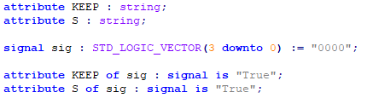

## Combinatorial Loops

Vivado will not allow combinatorial loops within the nets. In order to allow this the following line must be added to the constraint file for each net containing a combinatorial loop.

set_property ALLOW_COMBINATORIAL_LOOPS true [get_nets {last_signal_in_loop}]

The last signal in the loop can occasionally be difficult to do, however if the implementation is run without this line in the constraints file the error will tell you what this value should be.

# Using Vivado pblocks to Adjust the Location of the Components

1. Synthesize and Implement your working design
2. Open the Implemented Design
   1. On the “Design” page there are blue spots. These are resources used by the design
   2. On the left are the nets and components of the implemented design
   3. You can highlight a particular component by left clicking on it
   4. Zoom in on the component you are going to be placing and analyze the resources is uses
3. Open the Synthesized Design
   1. On the left are the nets and components of the synthesized design

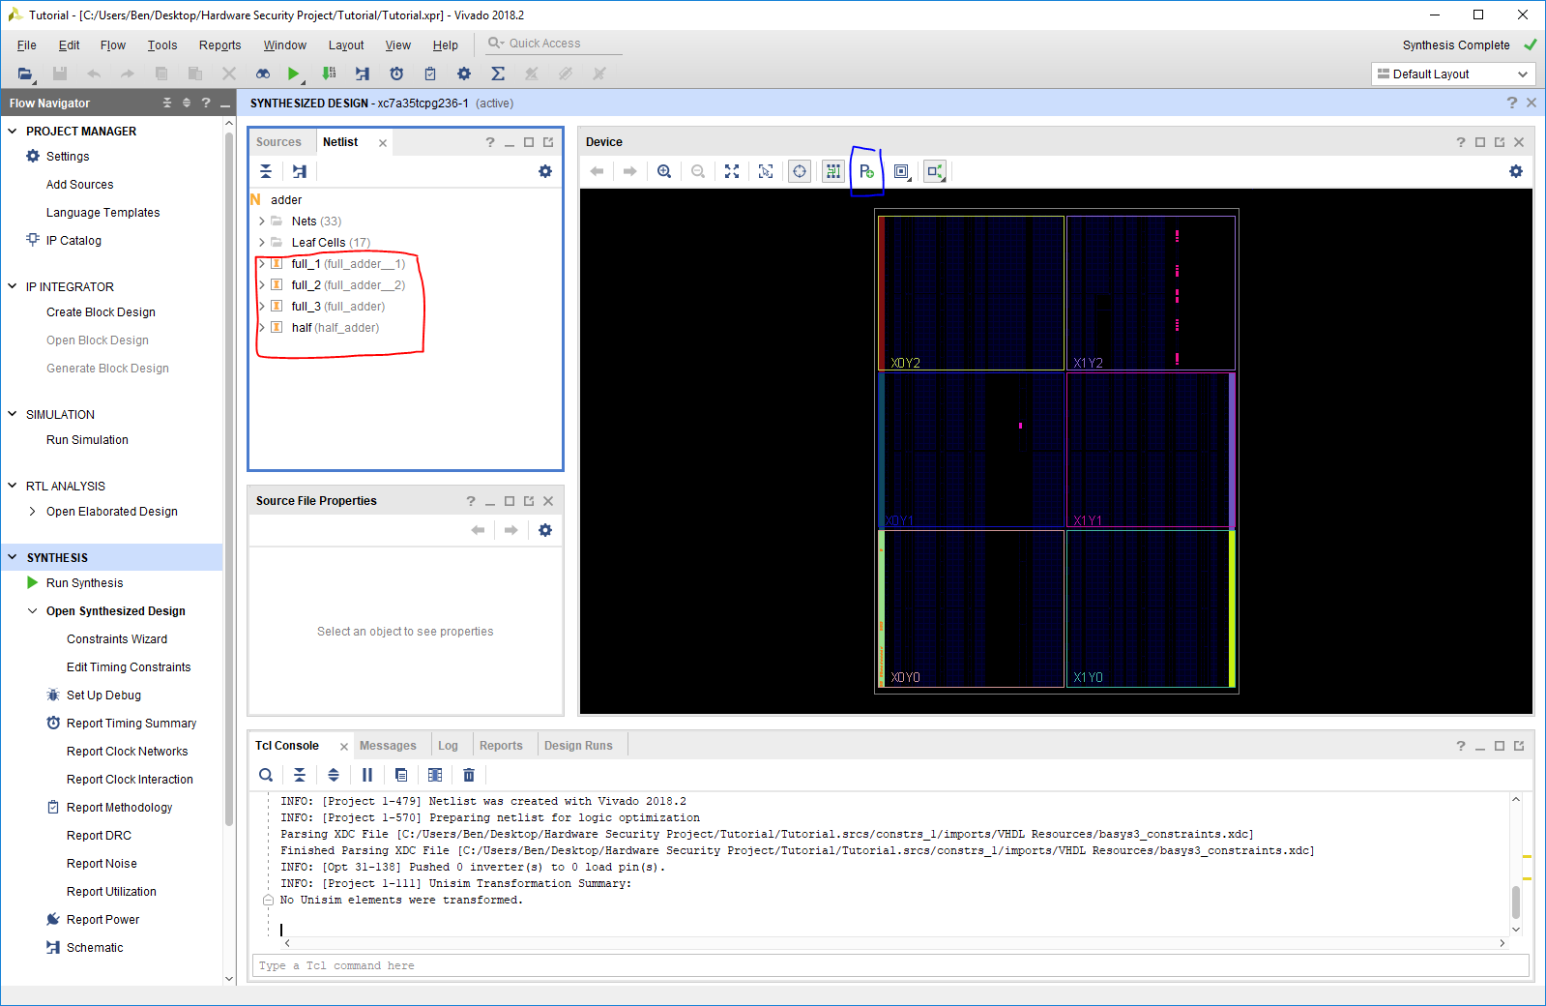

* 1. Right-Click on the component you are going to be placing and select Draw Pblock
  2. Draw a Pblock, if the rectangles selected don’t contain any valid sites you will receive an error.
  3. Name you Pblock
  4. Save
     1. Note this will add to your constraints file
     2. It is likely best to save to a new constraint file so the working constraint file is not overwritten

1. Rerun the synthesis and implementation
2. Verify the implementation has changed so the component is now where the pblock you selected was.

# Final Questions

1. *How difficult would it be to expand the number of challenge bits and the bits of the response? Describe the process and any considerations needed to ensure the PUF functions correctly.*
2. *How might variations in temperature and voltage of the chip effect PUF? Think both raw entropy and the result of the hash. What are some methods which could mitigate the effect?*
3. *You might have noticed in the paper and in our implementation the hamming distance between adjacent challenges is fairly minimal (15% in Xin et. Al). What might cause this? Can you think of a way of changing how we use the counter output to increase the hamming distance? Hint: This might mean reducing the number of usable response bits in the counter.*
4. *How could this implementation be modified on a board so that it could be verified from an*

*external source and ensure freshness? (Don’t think about the BASYS 3 board, instead consider the fundamental structure of the device, including generic inputs and outputs)*