
G231210563
Abdullah Allabban
2. C
SYSTEM PROGRAMMING 2025-2026 SPRING SEMESTER PROJECT REPORT

BİLGİSAYAR VE BİLİŞİM BİLİMLERİ FAKÜLTESİ
BİLGİSAYAR MÜHENDİSLİĞİ BÖLÜMÜ

1. Project Overview
The objective of this project was to develop "tarsau", a command-line archiving utility written in the C programming language for Linux environments. The program functions similarly to tar, merging multiple files into a single .sau archive file without applying any data compression. The application is strictly driven via the terminal, supporting custom target outputs and directory extraction.
2. Development Process & Architecture
To ensure a clean and maintainable codebase, the project was developed using a modular architecture with separate .c and .h files linked together via a custom Makefile. The logic is divided into three primary modules:
A. Interface (main.c)
This module handles user input parsing. It detects the -b flag for archiving operations and the -a flag for extraction operations, while enforcing strict parameter limits.
B. Archiving (archive.c)
The archiving logic implements robust validation before writing any data.
- Validation: The engine verifies that no more than 32 files are processed and that the total combined size does not exceed 200 MB. Furthermore, it reads each file to ensure it contains only standard text (ASCII, 1 byte per character).
- The .sau Format: The archive is generated in two strict sections. The organization (metadata) block begins with a 10-byte string representing its numerical size. This is followed by file records separated by the | character, using the format |filename,permissions,size|. The raw ASCII data of the files is then appended consecutively without separators.

C. Extraction Engine (extract.c)
This module reverse-engineers the .sau format. It reads the 10-byte header to dynamically allocate memory for the metadata block. It uses standard string manipulation to parse the filenames and byte sizes. If a target directory is specified and does not exist, the program uses the mkdir system call to create it. Finally, the original file permissions (read, write, execute) are faithfully restored using the chmod system call based on the saved metadata.

3. Core Code Snippets
Archive Metadata Generation (from archive.c)
This snippet demonstrates how the system retrieves system statistics and formats the organizational records.
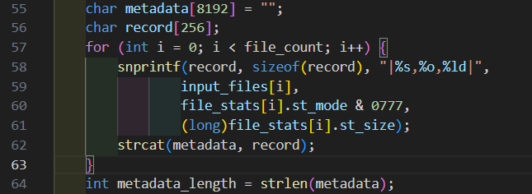

Header Reading and Parsing (from extract.c) This snippet illustrates the extraction of the 10-byte header required to isolate the metadata section safely.
C
char header_size_str[11] = {0};
if (fread(header_size_str, 1, 10, in_file) != 10) {
printf("Arşiv dosyası uygunsuz veya bozuk!\n");
fclose(in_file);
return 1;
}
int metadata_length = atoi(header_size_str);
4. Terminal Output & Testing Execution
The program was compiled and tested successfully under normal operating conditions. Below is the exact terminal output demonstrating successful archiving and extraction to a custom directory.
make
./bin/tarsau -b t1.txt t2.txt -o myarchive.sau
Archive Mode: 2 file(s) will be merged into 'myarchive.sau'.
Dosyalar birleştirildi.

./bin/tarsau -a myarchive.sau output_dir
Extract Mode: Archive 'myarchive.sau' will be extracted to directory 'output_dir'.
output_dir dizininde dosyalar açıldı.
