VELOOP REWARDS
Product Analytics, Data Readiness & Data Management Blueprint
Data Analyst Internship, Task 01. Final Consolidated Report, version 1.0, 31 October 2026
DATA AUTHENTICITY NOTICE. VELOOP is a real product under development, but all data analysed in this report is fictional/simulated (SIMULATED DATA - CREATED FOR ANALYTICAL TESTING). No figure here describes actual VELOOP users, earnings, withdrawals, revenue, retention or performance. Every event, field and KPI is Proposed or To Be Verified unless marked Confirmed.

Contents of this deliverable pack
Required deliverable | Where
01 Executive summary | Section 1
02 Product data audit | Section 3; workbook sheets 01-03
03 Data coverage matrix | Workbook sheet 02
04 User analytics specification | Section 4; sheet 04
05-07 Earning/reward, wallet/withdrawal, referral/engagement | Sections 5-7
08 Event tracking plan | Section 8; sheet 05
09 Data dictionary | Sheet 06 (100 fields)
10 Logical data model | Section 9; figure er_diagram.png
11 KPI catalogue | Section 10; sheet 08 (46 KPIs)
12 Simulated data profiling | Section 11; Data_Profiling_and_DQ_Audit.xlsx
13 Data quality audit | Section 12; sheet K_DQ_Report (34 issues)
14 Dashboard blueprint | Section 13; wireframes (figures/)
15 Developer handoff | Section 14; sheet 12
16 Pipeline proposal | Section 15
17 Privacy & governance | Section 16
18 Readiness assessment | Section 17
19 Assumption register | Section 18; sheet 16
20 Implementation backlog | Section 19; sheet 17
21 Final consolidated report | This document
Code, tests, cleaning | src/, tests/, README.md

1. Executive summary
What was investigated
The brief's product scope (accounts, earning tasks, rewards, wallet, withdrawals, referrals, engagement and support) was turned into a complete analytics foundation: a data-readiness audit, a 38-event tracking plan, a 100-field data dictionary, a logical data model, 46 KPIs, quality controls, dashboard specifications, an engineering handoff, a pipeline, governance rules, a change process and a prioritised backlog. Two simulated workbooks were then profiled and audited with reusable, tested code.
What was discovered
- Two Users tables contradict each other. Both files use the same 1,000 user IDs (VLUSR000001 to VLUSR001000), yet names, emails and registration times differ for all 1,000 users. One table must be declared the user master before any join.
- The supplied pack is incomplete. Rewards, Wallet, Withdrawals and Referrals tables, which the brief lists, were not supplied. The behaviour file contains users, sessions, 35,704 events, daily activity, task activity and milestones only.
- Structure is sound but not production-ready. No orphan user or session references exist, but task attempts carry no reward amount or unit, the task catalogue is missing (every task_id maps to several categories), and stored counts do not reconcile (events_in_session wrong for 7,537 of 7,913 sessions; 423 daily rows with more completed than total tasks).
- The messy sheet behaves as designed. Automated checks found 8 duplicate user rows, 9 missing required values, 1 malformed date and 2 conflicting registration times; the event audit sheet holds 10 duplicate events, 4 trailing-space statuses and 5 inconsistent feature names.
- Personal data is over-collected. Full name, email, age, gender and city are present for every user, contrary to the brief's data-minimisation rule.
What is currently unknown
Whether any event, session ID, transaction ID, reward pending state, withdrawal state history, acquisition source or the Spin/Mining/Missions/Badges features exist in production. 18 such unknowns are in the assumption register; none has been converted into a fact.
What VELOOP should implement first
- A stable user_id and one user master table.
- An immutable transaction_id with idempotent wallet writes, and separate reward-versus-activity records.
- Defined value units (VE, XP, Gems, Tokens) with conversion rules, so amounts are never summed across units.
- Withdrawal state and timestamp history; UTC timestamps everywhere.
- The Critical events REQ-001 to REQ-013, validated at ingestion by the proposed rules.
Major risks
Reporting activity as earnings; summing across units; duplicate credits; unreliable daily metrics without a UTC standard; third-party outcomes outside VELOOP's control; and silently mixing simulated with production data.
Major priorities
Six Critical, seven High, five Medium and two Low backlog items (Section 19). The Critical items are all Prelaunch.

Key figures from this work (simulated data and design artefacts)
Measure | Value
Proposed events / data-dictionary fields / KPIs | 38 / 100 / 46
Dashboards / visuals / developer requirements | 7 / 28 / 15
Quality rules designed / automated tests passing | 20 / 11 of 11
Simulated datasets profiled (sheets) / records in largest | 9 / 35,714 (event audit sheet)
Data quality issues found (Critical / High / Medium / Low) | 3 / 11 / 15 / 5 (34 in total; see Section 12)
Referential-integrity orphans between users, sessions, events, tasks | 0
Proposed KPI groups testable on supplied data (yes / partial / no) | 10 / 3 / 5
Open unknowns in the assumption register | 18, none converted into a fact

Recommended roadmap
- Before launch (Critical and High): user master and stable user_id; transaction_id and idempotent wallet writes; unit and conversion rules; reward-versus-activity separation; withdrawal state history; UTC timestamps; ingestion validation; role-based access to curated tables.
- At launch: emit events REQ-001 to REQ-013; run the quality checks and the reward-to-wallet reconciliation (K29) daily; certify the analytical tables that power Dashboards 1, 5 and 6.
- After launch: session identifier, acquisition source capture, support categories, engagement events for Spin, Missions and Streaks; remaining dashboards; replace simulated data with governed production data, never mixing them.

Decisions needed from the team
- Which of the two Users tables is the user master (assumption A016).
- Whether the behaviour workbook ('Task 02') is intended input for this task.
- Whether Rewards, Wallet, Withdrawals and Referrals datasets exist and can be supplied.
- The qualifying-activity list that defines DAU and the referral activation rule (A017, A010).

2. Scope, method and evidence discipline
Method: (1) read the brief and record each product fact in a Source & Verification Register with status Confirmed, Proposed or To Be Verified; (2) design the analytics model from the product areas; (3) profile and audit the two supplied workbooks with a Python package whose checks are small functions and are covered by automated tests; (4) test whether each proposed KPI can actually be calculated from what was supplied; (5) consolidate.
ID | Information | Source Type | Status
S001 | VELOOP is described as a developing online rewards/engagement ecosystem | Internal | Confirmed
S002 | Product areas listed: accounts, earning activities, VEs, XP, Gems, Tokens, Spins, daily rewards, streaks, tasks, missions, badges, levels, referrals, wallet, exchange, withdrawals, support, future features | Internal | To Be Verified
S003 | Supplied dataset is fictional/simulated (Users, Task Activity, Rewards, Wallet, Withdrawals, Referrals, Feature Events, Messy Data) | Simulated | Confirmed
S004 | Supplied files: VELoop_Rewards_Data_01.xlsx (Users) and VELOOP_Simulated_User_Behavior_1000.xlsx (behaviour, labelled Task 02) | Simulated | Confirmed
S005 | Whether any analytics events, IDs, or tables exist in production | Internal | To Be Verified
S006 | Currency/units: VEs, XP, Gems, Tokens exist as value units | Internal | To Be Verified
S007 | Withdrawal lifecycle Requested > Processing > Completed (+Rejected/Reversed) | Internal | Proposed
S008 | Event names, naming convention, field names in this workbook | Internal | Proposed
S009 | Public web search for official VELOOP Rewards product documentation | Official (search) | To Be Verified

Naming standard. Events use object_action in lowercase snake_case and past tense (task_completed, withdrawal_rejected). One object, one action, no feature prefixes: the feature is a property. This matches the brief's examples, sorts by object, and is easy for engineers to implement and test. Every event carries a common envelope: event_id, event_name, event_timestamp_utc, user_id, schema_version, platform, app_version, session_id (if available), source_system.

3. Product data audit and coverage
31 product-area rows are mapped (user action, system action, business outcome, data required, proposed event, source, business question, status, priority). Events are classed as User Event (the user did something), System Event (the system recorded an outcome) or Business Outcome (a derived result computed in the analytics layer, for example a converted referral).
Product Area | Feature | Proposed Event | Status | Priority
Registration | Account creation | user_registered | To Be Verified | Critical
Login | Authentication | user_logged_in | To Be Verified | Critical
Login | Logout | user_logged_out | Proposed | Low
Onboarding | Onboarding flow | onboarding_started / onboarding_step_completed / onboarding_completed | Proposed | High
Account lifecycle | Status management | account_status_changed | Proposed | High
Tasks | Task catalogue | task_viewed | Proposed | High
Tasks | Task open | task_opened | Proposed | Medium
Tasks | Task start | task_started | Proposed | Critical
Tasks | Task completion | task_completed | Proposed | Critical
Tasks | Task failure | task_failed | Proposed | High
Ads / third-party earning | Watch Ads | task_completed (task_type=ad) + provider_ref | To Be Verified | High
Rewards | Reward credit | reward_credited | Proposed | Critical
Rewards | Reward pending | reward_pending | Proposed | High
Rewards | Reward reversal | reward_reversed | Proposed | Critical
Rewards | Reward correction | reward_corrected | Proposed | Medium
Daily Rewards | Daily claim | daily_reward_claimed | To Be Verified | High
Streaks | Streak tracking | streak_updated | To Be Verified | Medium
Missions | Mission progress | mission_started / mission_completed | To Be Verified | Medium
Badges / Levels / XP | Progression | badge_earned | To Be Verified | Low
Spin | Spin game | spin_started / spin_completed | To Be Verified | Medium
Tap & Earn / Mining | Passive/active earn | task_* or feature-specific events | To Be Verified | Medium
Referrals | Referral creation | referral_created | Proposed | High
Referrals | Referred sign-up | referral_registered | Proposed | High
Referrals | Activation / conversion | referral_activated / referral_converted | Proposed | High
Wallet | Ledger entry | wallet_transaction_created / _completed / _reversed | Proposed | Critical
Exchange | Unit exchange | wallet_transaction_created (type=exchange) | To Be Verified | Medium
Withdrawals | Request | withdrawal_requested | Proposed | Critical
Withdrawals | Processing/Decision | withdrawal_processing / _completed / _rejected / _reversed | Proposed | Critical
Help Center | Help content | help_article_viewed / support_request_created | Proposed | Medium
Sessions | App session | session_started | Proposed | High
Future features | Unlisted | - | To Be Verified | Low

Fifteen analytics gaps
Gap ID | Gap | Priority | Reason
G01 | No verified stable user_id across systems | Critical | Every KPI needs unique-user counting
G02 | No verified wallet transaction_id/idempotency key | Critical | Ledger integrity and money-like reporting
G03 | Reward credited vs activity occurred not verified as separate records | Critical | Core brief requirement (C3)
G04 | No withdrawal state/timestamp history verified | Critical | Withdrawals are a major product-data area
G05 | Task validation status/third-party callback data not verified | High | External systems may differ from VELOOP records
G06 | Failure classification does not exist/unknown | High | Needed for C2; proposal only
G07 | Referral activation rule undefined | High | Brief E: distinguish stages
G08 | Session identifier existence unknown | High | Cannot assume it is stored
G09 | Event timestamp standard (UTC, client vs server) unknown | High | Daily KPIs depend on day boundaries
G10 | Acquisition source capture unknown | Medium | Acquisition dashboards need it
G11 | Account status change history unknown | High | Lifecycle analysis
G12 | Unit definitions (VE/XP/Gems/Tokens) and conversions unknown | Critical | Mixing units gives meaningless totals
G13 | No data dictionary / schema versioning in place | Medium | Engineering and analyst alignment
G14 | Support/help content tracking unknown | Medium | Brief section I
G15 | Feature-level event coverage for Spin/Mining/Tap unknown | Medium | Features may not be implemented

4. User and account analytics specification
Identifiers: user_id (stable join key across everything; immutable, never reused), event_id (deduplication of events), session_id (groups activity; its existence is To Be Verified), transaction_id (ledger deduplication and reconciliation). No names, emails, phone numbers or addresses are required for analytics.
Field | Type | Required? | Purpose | Status
user_id | string (UUID/opaque) | Yes | Stable join key across all entities | To Be Verified
registered_at | timestamp UTC | Yes | Cohorting, lifecycle | Proposed
registration_source | string enum | Yes (default 'unknown') | Acquisition analysis | Proposed
referral_id_at_signup | string | No | Link to referral | Proposed
platform | string enum | Yes | Platform mix | Proposed
app_version | string | Optional | Release impact | Proposed
country_code | string (ISO-3166 alpha-2) | Optional | Coarse geography; no address needed | Proposed
account_status | string enum | Yes | Lifecycle state | To Be Verified
status_changed_at | timestamp UTC | Conditional | Lifecycle timing | Proposed
onboarding_started_at | timestamp UTC | Optional | Onboarding funnel | Proposed
onboarding_completed_at | timestamp UTC | Optional | Activation | Proposed
first_activity_at | timestamp UTC | Derived | Time-to-first-action | Proposed
last_activity_at | timestamp UTC | Derived | Inactivity | Proposed
last_login_at | timestamp UTC | Optional | Returning-user logic | Proposed
session_id | string | Optional | Session grouping | To Be Verified

5. Earning and reward analytics
Lifecycle measured: Discovery (task_viewed) > Start (task_started) > Completion (task_completed, emitted only after the applicable validation) > Validation (validation_status) > Reward (reward_pending, reward_credited). Activity occurring and a reward actually being credited are two separate records, linked by source_activity_id; the KPI 'activity-to-credit rate' (K24) exposes any gap between them.
- Failed activity is classified with a Proposed category list: user_abandoned, tracking_failed, validation_failed, provider_error, system_error, unknown. These are not existing VELOOP codes.
- Reward events: reward_credited, reward_pending, reward_reversed (references original_reward_id), reward_corrected (carries amount_delta).
- Third parties: ads, surveys, offers and games may fail, change or charge back outside VELOOP's control, so provider and provider_ref are recorded and provider-caused outcomes are reported separately.

6. Wallet and withdrawal analytics
Wallet transaction model: transaction_id, user_id, timestamp, transaction_type, amount (always positive; direction gives the sign), unit, status, source, reference_id, related_transaction_id (reversal/correction chain). Transaction types reward_credit, redemption, reversal, adjustment and exchange are all Proposed.
Withdrawal lifecycle: requested > processing > completed, with rejected and reversed as alternatives. Fields: withdrawal_id, user_id, requested_amount, final_amount, method (a category, never account details), requested_at, processing_started_at, finalized_at, status, reason_category. Withdrawal KPIs are K30 to K38 in the catalogue (requests, completed, pending queue, rejected, reversed, processing time, completion rate, volume, method distribution), each with definition, formula, data required, source, frequency, stakeholder, purpose and limitation.

7. Referral and engagement analytics
Referral stages are kept separate: created > registered > activated > converted. Registration never counts as conversion; the activation rule is an open question (A010). Engagement is measured through DAU/WAU/MAU, returning users, feature adoption, repeat usage, task activity and stickiness (K03 to K05, K08, K15 to K17), all defined over a documented list of qualifying events.

8. Event tracking plan
38 events are catalogued with trigger, definition, class, properties, data type, validation, deduplication, source, purpose, KPI dependency and implementation status ('Proposed - To Be Verified' for all). The table below lists them; the complete specification is sheet 05.
Event Name | Class | Feature | Required Properties | Priority
user_registered | System Event | account | registration_source, platform | Critical
user_logged_in | User Event | account | platform | Critical
user_logged_out | User Event | account | platform | Low
session_started | User Event | app | platform | High
onboarding_started | User Event | onboarding | platform | High
onboarding_step_completed | User Event | onboarding | step_name, step_number | Medium
onboarding_completed | User Event | onboarding | platform | High
account_status_changed | System Event | account | old_status, new_status, change_actor_type | High
task_viewed | User Event | tasks | task_id, task_type, feature | Medium
task_opened | User Event | tasks | task_id, task_type, feature | Medium
task_started | User Event | tasks | task_activity_id, task_id, task_type, feature | Critical
task_completed | System Event | tasks | task_activity_id, task_id, task_type, feature, status, validation_status, reward_amount, reward_unit | Critical
task_failed | System Event | tasks | task_activity_id, task_id, failure_category | High
reward_pending | System Event | rewards | reward_id, user_id, source_activity_id, amount, unit, pending_reason | High
reward_credited | System Event | rewards | reward_id, source_activity_id, amount, unit, transaction_id, feature | Critical
reward_reversed | System Event | rewards | reward_id, original_reward_id, amount, unit, reason_category | Critical
reward_corrected | System Event | rewards | reward_id, original_reward_id, amount_delta, unit, reason_category | Medium
daily_reward_claimed | User Event | daily_rewards | claim_date, reward_id | High
streak_updated | System Event | streaks | streak_length, change_type(increment|reset) | Medium
mission_started | User Event | missions | mission_id | Medium
mission_completed | System Event | missions | mission_id | Medium
badge_earned | System Event | progression | badge_id | Low
spin_started | User Event | spin | spin_id | Medium
spin_completed | System Event | spin | spin_id, outcome_unit, outcome_amount | Medium
referral_created | User Event | referrals | referral_id, referrer_user_id | High
referral_registered | System Event | referrals | referral_id, referred_user_id | High
referral_activated | System Event | referrals | referral_id, referred_user_id, activation_rule_id | High
referral_converted | System Event | referrals | referral_id, conversion_rule_id | High
wallet_transaction_created | System Event | wallet | transaction_id, transaction_type, amount, unit, status, reference_id | Critical
wallet_transaction_completed | System Event | wallet | transaction_id, completed_at | Critical
wallet_transaction_reversed | System Event | wallet | transaction_id, related_transaction_id, reason_category | Critical
withdrawal_requested | User Event | withdrawals | withdrawal_id, requested_amount, unit, method | Critical
withdrawal_processing | System Event | withdrawals | withdrawal_id | Critical
withdrawal_completed | System Event | withdrawals | withdrawal_id, final_amount, method | Critical
withdrawal_rejected | System Event | withdrawals | withdrawal_id, reason_category | Critical
withdrawal_reversed | System Event | withdrawals | withdrawal_id, reason_category | High
support_request_created | User Event | support | ticket_id, issue_category | Medium
help_article_viewed | User Event | help | article_id, category | Medium

9. Logical data model
Ten entities, each with a primary key and foreign keys. Solid entities exist in the supplied simulated data; dashed entities are proposed only.
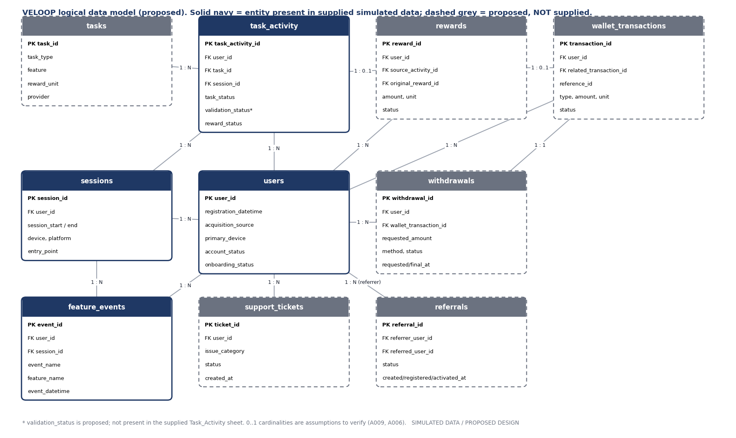
Figure 1. Logical data model (proposed).
Entity | Primary Key | Foreign Keys | Grain
users | user_id | - | One row per account
sessions | session_id | user_id>users | One session per user visit (TBV)
tasks | task_id | - | Catalogue
task_activity | task_activity_id | user_id>users; task_id>tasks | One attempt
rewards | reward_id | user_id>users; source_activity_id>task_activity (or other); original_reward_id>rewards; transaction_id>wallet_transactions | One reward record
wallet_transactions | transaction_id | user_id>users; related_transaction_id>wallet_transactions | Ledger entry
withdrawals | withdrawal_id | user_id>users; wallet_transaction_id>wallet_transactions | Payout request
referrals | referral_id | referrer_user_id>users; referred_user_id>users | Referral
feature_events | event_id | user_id>users; session_id>sessions | Event stream
support_tickets | ticket_id | user_id>users | Ticket
users 1:N task_activity | A user has many attempts; each attempt has one user
tasks 1:N task_activity | A task catalogue item has many attempts
task_activity 1:0..1 rewards | An attempt yields at most one reward (assumption; TBV)
rewards 1:N rewards (self) | A reward can have reversal/correction rows via original_reward_id
rewards 1:0..1 wallet_transactions | A credited reward has one ledger credit
wallet_transactions 1:N wallet_transactions (self) | Reversals link to original
users 1:N withdrawals | -
withdrawals 1:1 wallet_transactions | Debit entry (assumption; TBV)
users M:N users via referrals | Referrer/referred; each referred user at most one referrer
users 1:N feature_events | -
sessions 1:N feature_events | -
users 1:N support_tickets | -

Relationships: users 1:N task_activity, sessions, feature_events, rewards, wallet_transactions, withdrawals, support_tickets; tasks 1:N task_activity; sessions 1:N feature_events; task_activity 1:0..1 rewards; rewards 1:0..1 wallet_transactions; withdrawals 1:1 wallet_transactions (debit entry); rewards and wallet_transactions each relate to themselves for reversal chains; referrals link two users (referrer, referred), many-to-many through users. The 0..1 cardinalities are assumptions to verify.

10. KPI catalogue
46 KPIs across user, engagement, reward, wallet, withdrawal, referral, support/content and data-quality areas. No targets are set; each KPI has a reproducible definition, formula, required fields, data source, frequency, stakeholder, purpose, interpretation, limitation and status. Example: Daily Active Users = unique users generating a qualifying activity event within a UTC calendar day.
KPI ID | KPI Name | Area | Definition | Frequency
K01 | Registrations | User | Count of accounts with a registration timestamp in the period | Daily
K02 | Registrations by source | User | Registrations grouped by registration_source | Weekly
K03 | Daily Active Users (DAU) | User | Unique users generating a qualifying activity event within a calendar day (UTC) | Daily
K04 | Returning users | User | Active users in the period who also had qualifying activity in an earlier period (or registered earlier) | Weekly
K05 | Weekly/Monthly Active Users | User | Unique users with qualifying activity in 7/30 days | Weekly/Monthly
K06 | Onboarding completion rate | User | Registered users who completed onboarding / registered users | Weekly
K07 | Inactive users | User | Registered, non-closed users with no qualifying activity for N days (N defined by Product) | Weekly
K08 | Stickiness | User | DAU / MAU for the same month | Monthly
K09 | Time to first activity | User | Median time from registration to first qualifying event | Weekly
K10 | Account status distribution | User | Users per account_status | Weekly
K11 | Task starts | Engagement | Task attempts with a start timestamp | Daily
K12 | Task completion rate | Engagement | Validated completions / starts | Daily
K13 | Task completions | Engagement | Count of validated completions | Daily
K14 | Task failure rate by category | Engagement | Failed attempts by failure_category / starts | Weekly
K15 | Feature usage | Engagement | Distinct users using each feature | Weekly
K16 | Repeat usage rate | Engagement | Users with >=2 activity days in a feature / users who used it | Weekly
K17 | Feature adoption rate | Engagement | Users who used a feature at least once / active users | Monthly
K18 | Reward transactions | Reward | Count of reward records created | Daily
K19 | Reward credited amount | Reward | Sum of credited reward amounts, per unit | Daily
K20 | Reward reversals | Reward | Count and sum of reversed rewards | Weekly
K21 | Reward reversal rate | Reward | Reversed / credited rewards | Weekly
K22 | Pending rewards | Reward | Rewards in pending status and age | Daily
K23 | Reward by feature | Reward | Credited amount per feature/source | Weekly
K24 | Activity-to-credit rate | Reward | Validated completions with a credited reward / validated completions | Weekly
K25 | Wallet transactions | Wallet | Count of ledger entries | Daily
K26 | Wallet credit volume | Wallet | Sum of credit entries completed per unit | Daily
K27 | Redemption activity | Wallet | Count/sum of redemption/exchange entries | Weekly
K28 | Wallet reversals | Wallet | Reversal entries and share of all transactions | Weekly
K29 | Ledger reconciliation gap | Wallet | Credited rewards without matching wallet credit (and reverse) | Daily
K30 | Withdrawal requests | Withdrawal | Requests created in period | Daily
K31 | Completed withdrawals | Withdrawal | Requests with status completed | Daily
K32 | Pending withdrawals (queue) | Withdrawal | Requests in requested/processing at snapshot | Hourly/Daily
K33 | Rejected withdrawals | Withdrawal | Requests rejected, by reason_category | Weekly
K34 | Reversed withdrawals | Withdrawal | Requests reversed | Weekly
K35 | Withdrawal processing time | Withdrawal | Median/P90 of finalized_at - requested_at for completed | Daily
K36 | Withdrawal completion rate | Withdrawal | Completed / (completed+rejected+reversed) for requests older than a stated window | Weekly
K37 | Withdrawal volume | Withdrawal | Sum of completed final_amount per unit | Daily
K38 | Method distribution | Withdrawal | Share of requests per method | Weekly
K39 | Referrals created | Referral | Referral records created | Daily
K40 | Referral registrations | Referral | Referrals with registered_at | Daily
K41 | Referral activations | Referral | Referrals with activated_at | Daily
K42 | Referral conversion rate | Referral | Converted / created referrals (cohorted) | Weekly
K43 | Support requests | Support/Content | Tickets created | Daily
K44 | Issue categories | Support/Content | Tickets by issue_category | Weekly
K45 | Help-center engagement | Support/Content | Help article views and users per category | Weekly
K46 | Data quality pass rate | Data Quality | Records passing all hard rules / records loaded | Daily

11. Simulated data profiling (Work Package J)
All statements describe the supplied simulated datasets only. Reference period stated in the files: 1 April to 15 September 2026.
dataset | records | columns | earliest | latest | duplicate_rows | missing_cells
A:Users_1000_Clean | 1000 | 27 | 2026-04-01 02:10:00 | 2026-09-17 10:08:00 | 0 | 953
A:Users_Messy_Audit | 1008 | 28 | 2026-04-01 02:10:00 | 2026-09-17 10:08:00 | 8 | 966
B:01_Users_1000 | 1000 | 16 | 2026-04-01 02:00:41 | 2026-09-15 20:26:50 | 0 | 846
B:02_Sessions | 7913 | 12 | 2026-04-02 20:14:28 | 2026-09-15 22:14:12 | 0 | 466
B:03_Feature_Events | 35704 | 13 | 2026-04-02 20:14:31 | 2026-09-15 22:13:50 | 0 | 0
B:04_Daily_Activity | 6667 | 17 | 2026-04-02 00:00:00 | 2026-09-15 00:00:00 | 0 | 0
B:05_Task_Activity | 9846 | 12 | 2026-04-02 20:14:41 | 2026-09-15 21:59:48 | 0 | 10494
B:06_Milestones | 4799 | 6 | 2026-04-02 08:18:00 | 2026-09-15 22:13:28 | 0 | 40
B:10_Event_Data_Quality_Audit | 35714 | 13 | 2026-04-02 20:14:31 | 2026-09-15 22:13:50 | 10 | 0

Relationship tests
parent | child | child_rows | orphans | parents_without_children | result
B:01_Users_1000 | B:02_Sessions | 7913 | 0 | 16 | PASS
B:01_Users_1000 | B:03_Feature_Events | 35704 | 0 | 16 | PASS
B:01_Users_1000 | B:04_Daily_Activity | 6667 | 0 | 16 | PASS
B:01_Users_1000 | B:05_Task_Activity | 9846 | 0 | 16 | PASS
B:01_Users_1000 | B:06_Milestones | 4799 | 0 | 0 | PASS
B:01_Users_1000 | B:10_Event_Data_Quality_Audit | 35714 | 0 | 16 | PASS
B:02_Sessions | B:03_Feature_Events | 35704 | 0 | 302 | PASS
B:02_Sessions | B:05_Task_Activity | 9846 | 0 | 3301 | PASS
B:02_Sessions | B:06_Milestones | 4799 | 0 | 4665 | PASS
A:Users_1000_Clean | B:02_Sessions | 7913 | 0 | 16 | PASS
A:Users_1000_Clean | A:Users_Messy_Audit | 1008 | 0 | 0 | PASS

Result: every user_id and session_id reference resolves (0 orphans). 16 users have no sessions, events or tasks. The cross-file test passes on IDs but fails on content: the two Users tables disagree (see below).

Cross-file conflict between the two Users tables
field | users_where_A_differs_from_B | of
full_name | 1000 | 1000
email | 1000 | 1000
age | 960 | 1000
gender | 655 | 1000
state | 945 | 1000
city | 977 | 1000
registration_datetime | 1000 | 1000
acquisition_source | 829 | 1000
account_status | 571 | 1000
onboarding_status | 463 | 1000
primary_device | 492 | 1000
referral_code | 1000 | 1000

KPI test: can the proposed KPIs be calculated from what was supplied?
kpi | name | calculable | limitation_or_data_required
K01-K02 | Registrations (by source) | YES | Needs one master users table
K03-K05 | DAU / WAU / MAU | YES (proxy) | Qualifying-event list still to be defined
K04 | Returning users | YES
K06 | Onboarding completion rate | PARTIAL | Snapshot only; no onboarding events or timestamps
K07 | Inactive users | YES | As-of date undocumented
K09 | Time to first activity | YES
K10 | Account status distribution | YES | No status history
K11-K13 | Task starts / completions / completion rate | YES | No validation_status; 648 Pending
K14 | Failure rate by category | PARTIAL | Reasons contradict status in some rows
K15-K17 | Feature usage / adoption / repeat | YES
K18-K20,K23 | Reward transactions / amounts / by feature | NO | Only reward_status; counts of credited tasks possible, amounts not
K21-K22 | Reversal rate / pending rewards | PARTIAL | No reversal state
K24 | Activity-to-credit rate | YES (count only) | Credited equals Completed in every row
K25-K29 | Wallet KPIs and reconciliation | NO | No ledger table; only wallet_viewed events
K30-K38 | Withdrawal KPIs | NO | Not supplied
K39-K42 | Referral funnel | NO | Only referral_code and referral events; no referrer/referred link
K43-K45 | Support KPIs | NO | Not supplied
K46 | Data-quality pass rate | YES

12. Data quality audit (Work Package K)
34 issues were found by automated checks: 3 Critical, 11 High, 15 Medium, 5 Low. Each has detection logic, likely cause, correction, prevention and owner in the workbook; the critical, high and most informative issues are listed here.
issue_id | dataset | field | issue_type | records | severity
DQ-001 | A:Users_Messy_Audit | user_id | duplicate IDs / duplicate rows | 8 | High
DQ-005 | A:Users_Messy_Audit | registration_datetime | unexpected null in required field | 1 | Critical
DQ-008 | A:Users_Messy_Audit | email_verification_status | unexpected null in required field | 1 | High
DQ-009 | A:Users_Messy_Audit | onboarding_status | unexpected null in required field | 1 | High
DQ-011 | A:Users_Messy_Audit | registration_datetime | malformed date | 1 | Critical
DQ-012 | A:Users_Messy_Audit | registration_datetime | value conflicts with clean baseline | 2 | High
DQ-015 | A:Users_1000_Clean | (table) | personal data present beyond need | 1000 | High
DQ-016 | B:01_Users_1000 | referral_code | duplicate IDs (codes should be unique) | 2 | High
DQ-017 | A vs B | user_id (cross-file) | conflicting attributes for identical user_ids | 1000 | Critical
DQ-018 | B:02_Sessions | events_in_session | aggregate cannot be reconciled with Feature_Events | 7537 | High
DQ-023 | B:04_Daily_Activity | completed_task_count | impossible value (completed > total) | 423 | High
DQ-025 | B:05_Task_Activity | task_id | one task_id mapped to several categories | 80 | High
DQ-027 | B:05_Task_Activity | reward amount / unit | missing required analytical field | 9846 | High
DQ-030 | B:10_Event_Data_Quality_Audit | event_id | duplicate events | 10 | High

Cleaning demonstration
dataset | input_rows | duplicates_removed | quarantined | clean_rows | status_normalised
Users_Messy_Audit | 1008 | 8 | 9.0 | 991 | -
Event_Data_Quality_Audit | 35714 | 10 | - | 35704 | 4.0

Rules: exact duplicates are removed by ID (first kept); rows with a malformed date or a missing required value are quarantined, never imputed; status and feature names are trimmed and normalised to their most frequent spelling. Rows are traceable: input rows equal clean plus quarantined plus removed duplicates.

Data quality control framework (Work Package L)
Rule ID | Rule | Layer | Action on Failure
Q01 | Primary key present and unique | Application + Ingestion | Reject at ingestion; quarantine
Q02 | ID format | Ingestion | Trim/reject; log
Q03 | Allowed status values | Application + Raw validation | Quarantine unknown value; alert if >0
Q04 | Timestamp validity | Ingestion | Quarantine; never silently coerce
Q05 | Timestamp ordering | Transformation | Flag; exclude from duration KPIs
Q06 | Amount validity | Application + Ingestion | Reject
Q07 | Unit validity | Transformation/Analytics | Block KPI if mixed
Q08 | Referential integrity | Transformation | Orphan table; alert
Q09 | Duplicate transaction/event | Ingestion + Raw | Keep first, log duplicates
Q10 | Valid state transitions | Application + Transformation | Flag impossible transitions
Q11 | Reward-wallet reconciliation | Analytics | Daily reconciliation report (K29)
Q12 | Reversal linkage | Transformation | Flag
Q13 | Conditional required fields | Application + Transformation | Flag
Q14 | Consistent naming/case | Collection + Raw | Normalise in staging; report drift
Q15 | Referral stage order | Transformation | Flag
Q16 | Freshness | Pipeline monitoring | Alert owner
Q17 | Volume anomaly | Pipeline monitoring | Alert (no fixed thresholds invented here)
Q18 | Schema drift | Raw | Alert; block load if breaking
Q19 | PII/secrets screening | Collection + Raw | Quarantine and escalate
Q20 | Dashboard certification | Dashboard | Block uncertified

13. Dashboard blueprint
Seven dashboards with 28 visuals, each specified with metric, calculation, source, visualization, filters, dimensions, date range, refresh, business question and decision supported (workbook sheet 11). Wireframes show layout only. They carry no values.
Dashboard | Metric | Visualization | Refresh | Decision Supported
1 Executive Overview | Registrations (K01) | Line + KPI card | Daily | Acquisition focus
1 Executive Overview | DAU/WAU/MAU (K03,K05) | Line + cards | Daily | Product priorities
1 Executive Overview | Task completion rate (K12) | KPI card + trend | Daily | Fix vs expand tasks
1 Executive Overview | Reward credited by unit (K19) | Stacked bar per unit (never mixed) | Daily | Reward economy review
1 Executive Overview | Withdrawal queue + processing time (K32,K35) | Card + trend | Hourly/Daily | Ops staffing
1 Executive Overview | Referral funnel (K39-K42) | Funnel | Daily | Referral program design
1 Executive Overview | Data quality pass rate (K46) | Card | Daily | Hold/publish decision
2 User Analytics | Registrations by source (K02) | Stacked bar | Daily | Channel focus
2 User Analytics | Returning vs new (K04) | Stacked area | Daily | Retention work
2 User Analytics | Cohort retention | Heatmap | Weekly | Onboarding/feature changes
2 User Analytics | Device/platform and country mix | Bar/table (no map unless country verified) | Weekly | Platform priorities
2 User Analytics | Account status (K10), inactive (K07) | Donut + trend | Weekly | Re-engagement
3 Engagement | Feature usage (K15, K17) | Bar | Daily | Feature roadmap
3 Engagement | Task funnel viewed>opened>started>completed | Funnel | Daily | UX fixes
3 Engagement | Failure categories (K14) | Bar | Daily | Provider/engineering action
3 Engagement | Repeat usage (K16) | Line | Weekly | Habit features
4 Rewards | Credited by source (K23) | Bar | Daily | Reward design
4 Rewards | Reward status mix (K18-K22) | Stacked bar | Daily | Integrity review
4 Rewards | Activity-to-credit (K24) | Line | Daily | Bug triage
5 Wallet | Transactions by type (K25) | Stacked bar | Daily | Monitoring
5 Wallet | Credits vs redemptions (K26,K27) | Line (per unit) | Daily | Economy balance
5 Wallet | Reconciliation gap (K29) | Table (should be empty) | Daily | Incident
6 Withdrawals | Status distribution (K30-K34) | Stacked bar | Daily | Ops process
6 Withdrawals | Processing time (K35) | Line + histogram | Daily | SLA discussion
6 Withdrawals | Method distribution (K38), volume (K37) | Bar | Weekly | Method support
6 Withdrawals | Rejection reasons (K33) | Bar | Weekly | Guidance to users
7 Referrals | Referral funnel (K39-K42) | Funnel | Daily | Program design
7 Referrals | Time created>registered>activated | Box plot | Weekly | Activation rule review

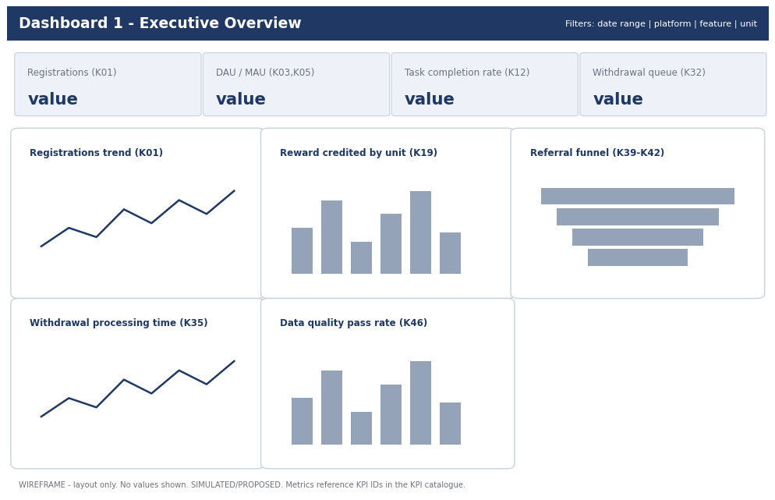
Wireframe: 1 Executive Overview
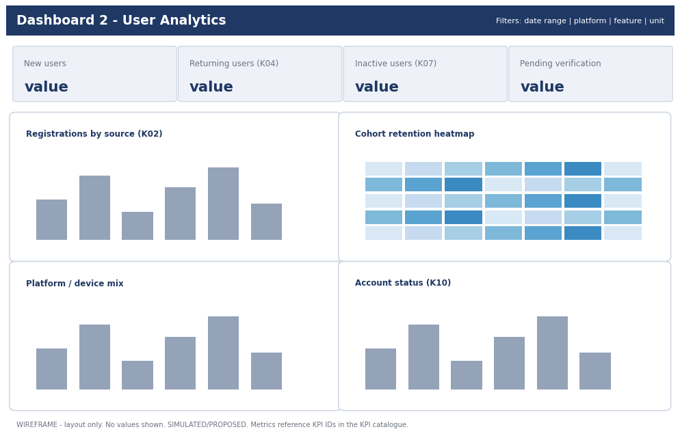
Wireframe: 2 User Analytics
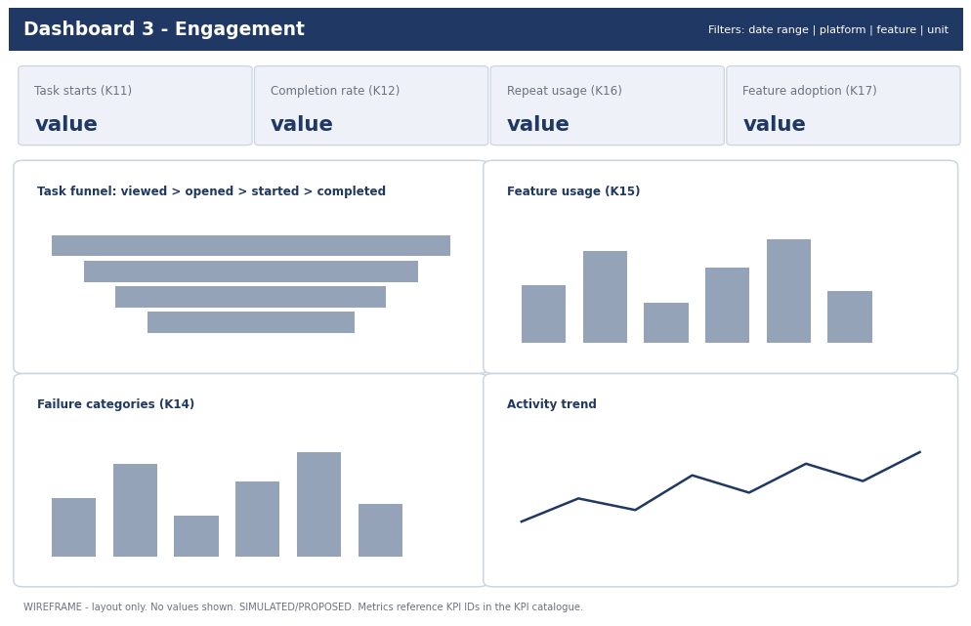
Wireframe: 3 Engagement
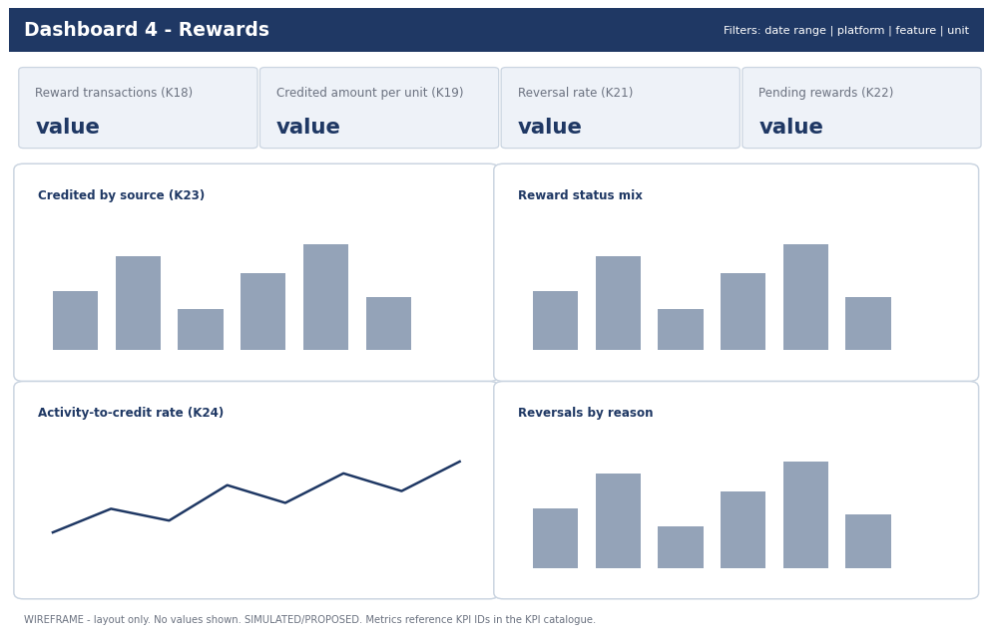
Wireframe: 4 Rewards
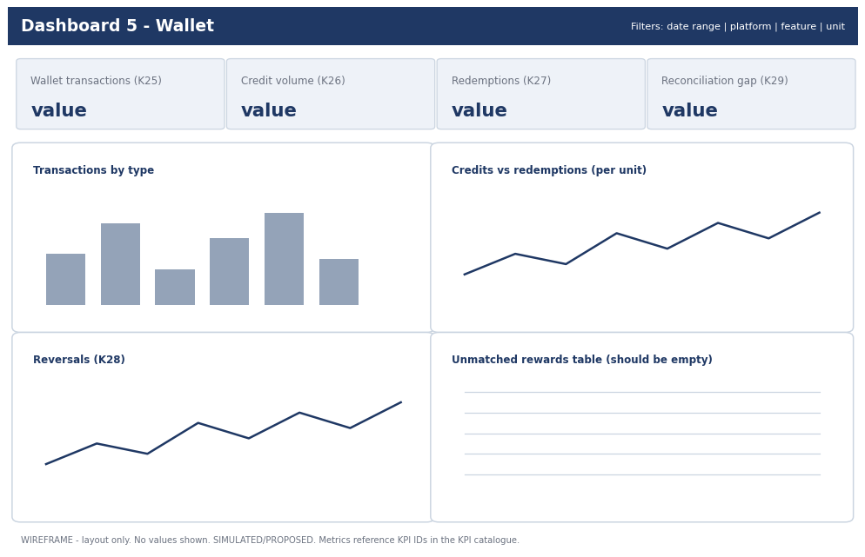
Wireframe: 5 Wallet
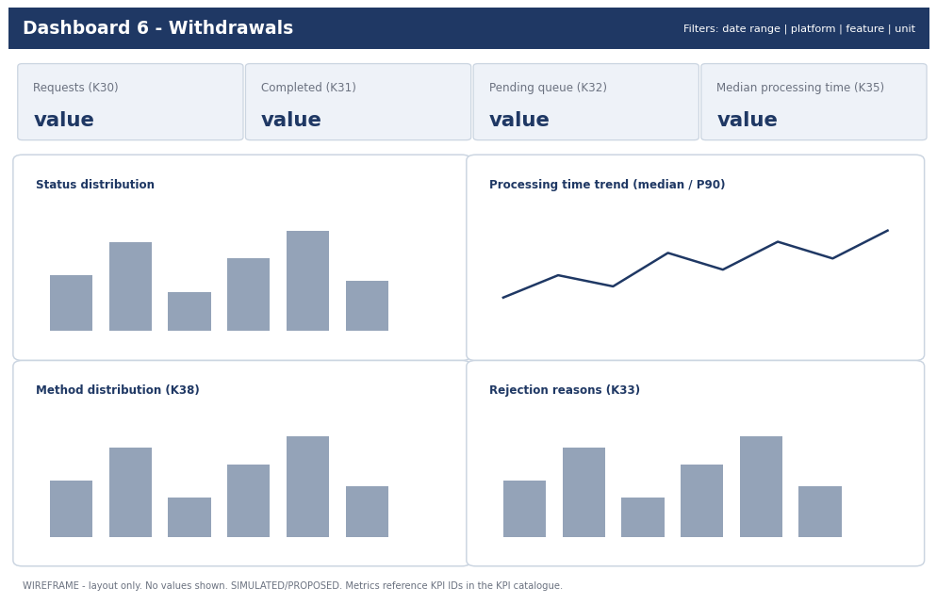
Wireframe: 6 Withdrawals
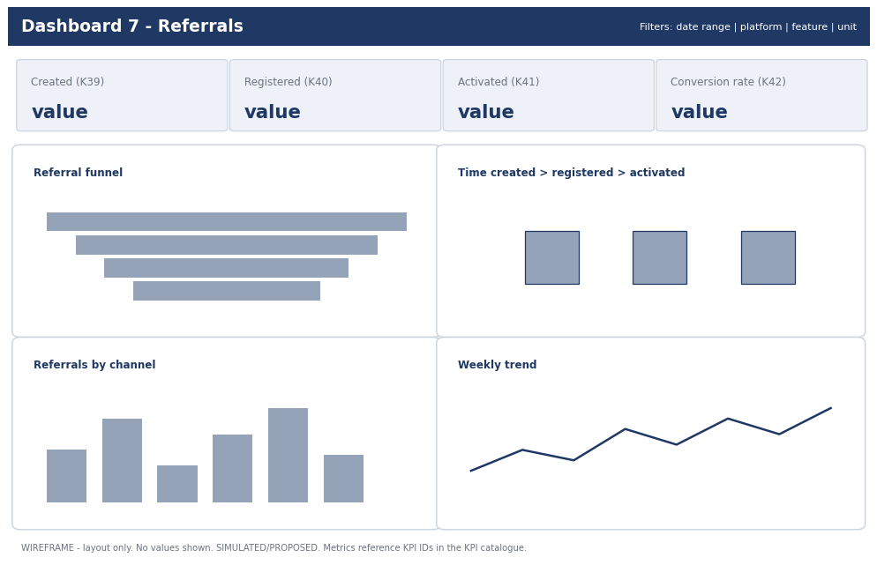
Wireframe: 7 Referrals

14. Developer analytics handoff
15 requirements (REQ-001 to REQ-015) specify, per event: trigger, payload with type, required flag and validation, deduplication key, timestamp rule, source, why needed, KPI dependency, acceptance test and priority. Example:
Item | Specification
Requirement ID | REQ-004
Event | task_completed
Trigger | Completion has passed applicable validation
Payload | task_activity_id:Y; user_id:Y; task_id:Y; task_type:Y; status:enum(completed):Y; validation_status:enum:Y; reward_amount:decimal:N; reward_unit:enum:N; provider_ref:string:N
Deduplication | event_id; task_activity_id+status
Timestamp | completion time UTC
Acceptance test | When a valid completion occurs, exactly one analytically usable completion event is recorded for that task_activity_id, subject to final engineering idempotency design
Priority | Critical

Requirement ID | Event | KPI Dependency | Priority
REQ-001 | user_registered | K01,K02 | Critical
REQ-002 | user_logged_in | K03,K04 | Critical
REQ-003 | task_started | K11,K12 | Critical
REQ-004 | task_completed | K12,K13,K24 | Critical
REQ-005 | task_failed | K14 | High
REQ-006 | reward_credited | K19,K23,K24 | Critical
REQ-007 | reward_reversed | K20,K21 | Critical
REQ-008 | wallet_transaction_created | K25-K29 | Critical
REQ-009 | wallet_transaction_reversed | K28 | Critical
REQ-010 | withdrawal_requested | K30 | Critical
REQ-011 | withdrawal_processing | K32,K35 | Critical
REQ-012 | withdrawal_completed | K31,K35,K37 | Critical
REQ-013 | withdrawal_rejected | K33 | Critical
REQ-014 | referral_registered / referral_activated / referral_converted | K40-K42 | High
REQ-015 | onboarding_completed | K06 | High

15. Data pipeline and operating model
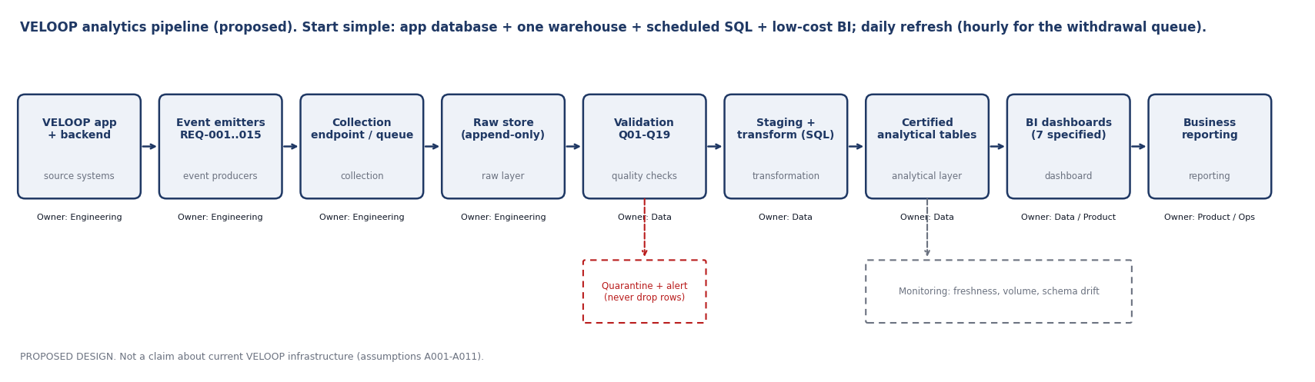
Figure 2. Proposed analytics pipeline with owners, quarantine path and monitoring.
A practical flow, deliberately without expensive infrastructure: VELOOP application and backend > event emitters (REQ-001 to 015) > collection endpoint or queue > raw append-only store > validation (rules Q01 to Q19; failures go to quarantine and alert) > staging and transformation (SQL models) > certified analytical tables > BI dashboards > business reporting, with monitoring on freshness, volume and schema drift.
- Start small: the application database plus one managed warehouse (or a relational database) with scheduled SQL transformations and a low-cost BI tool. Move to streaming or heavier tooling only when volume or latency requires it.
- Refresh: daily batch; hourly only for the withdrawal queue.
- Failure handling: failed loads retried; bad rows quarantined, never dropped; owners alerted.
- Ownership: Engineering owns emitters and the raw layer; Data owns validation, transformation, KPI definitions and dashboards; Product and Operations own definitions of qualifying activity and states.

16. Privacy, access and governance
Role | Access Scope | Level | Notes
Engineering | Event emitters, raw/staging, schemas | Full on raw; no credentials in analytics stores | Secrets, keys never enter analytics
Data Analyst | Curated analytical tables, DQ logs | Read curated; read raw only if justified | No restricted fields by default
Product/Operations | Aggregated dashboards | Aggregates; row-level only for ops queues (IDs, no personal data) | provider_ref restricted
Content Team | Aggregated help/content metrics | Aggregates only | -
Finance | Ledger and withdrawal aggregates, reconciliation | Curated ledger views | -
Intern/Trainee | Sanitised/simulated datasets | Approved sanitised datasets only | No raw production
Never collected | Passwords, authentication secrets, API keys, payment credentials, card/bank numbers, private credentials, security-control details, fraud thresholds | - | Block at ingestion (Q19)

Never collected or stored in analytics: passwords, authentication secrets, API keys, payment credentials, card or bank numbers, security-control details, fraud thresholds. Payout provider references are Restricted. The supplied Users data breaks the minimisation rule (DQ-015) and should be reduced to user_id plus coarse attributes in the analytics layer.

Change management
Every change to an event, field, reward mechanic, withdrawal method, KPI or dashboard is logged (date, change, old and new definition, reason, affected KPIs, dashboards and reports, owner, version). Event schemas are versioned; renamed events keep an alias for a declared period; a changed KPI becomes a new version annotated on its dashboards; every new feature passes an analytics checklist (events, dictionary entries, KPIs, quality rules) before launch.

17. Analytics readiness assessment
Rubric (not a company metric): 0 = nothing verified, 1 = designed only, 2 = designed and tested on simulated data, 3 = verified in production. No dimension can reach 3 until production data exists.
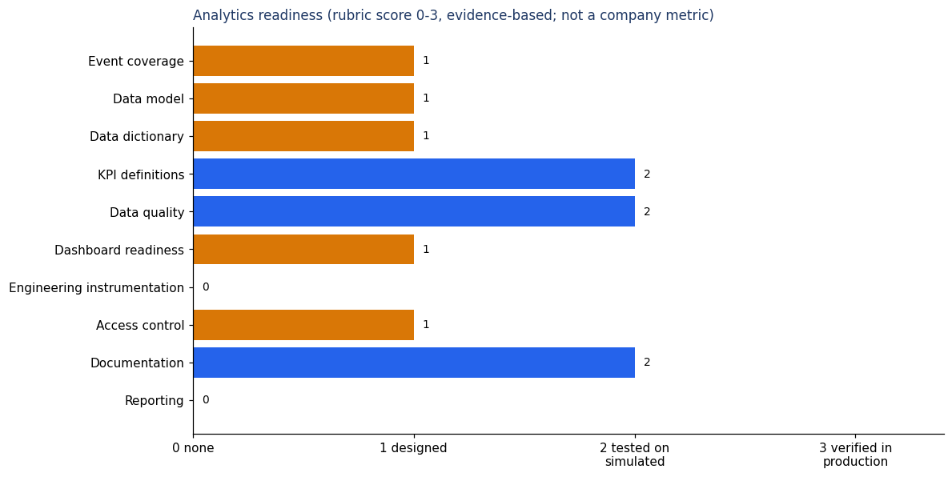
Figure 3. Readiness scorecard.
Dimension | Score | Priority | Evidence
Event coverage | 1 | Critical | 38 events designed; none verified as implemented; supplied events do not follow the catalogue
Data model | 1 | Critical | Model designed; keys/links tested only for users, sessions, events, tasks. Rewards, wallet, withdrawals, referrals not supplied
Data dictionary | 1 | High | 100 fields proposed; supplied dictionaries cover 2 + 26 fields and miss columns (DQ-033, DQ-034)
KPI definitions | 2 | High | 46 KPIs defined; 18 KPI groups tested against supplied structure (10 calculable, 3 partial, 5 not)
Data quality | 2 | High | 20 rules designed; 34 issues detected by automated checks with 11 passing tests; cleaning rules implemented
Dashboard readiness | 1 | Medium | 7 dashboards specified and wireframed; no certified tables to power them
Engineering instrumentation | 0 | Critical | Nothing verified: IDs, idempotency, UTC timestamps and event emitters are all unknown (A001-A011)
Access control | 1 | High | Role model proposed; supplied data contains unnecessary personal fields (DQ-015)
Documentation | 2 | Medium | README, report, workbook, ER diagram, handoff spec; versioned in this project
Reporting | 0 | Medium | No governed recurring report exists; depends on production data

Dimension | Priority | Reason
Event coverage | Critical | Without events no behaviour KPI can be produced
Data model | Critical | Joins depend on stable keys
Data dictionary | High | Misread fields cause wrong KPIs
KPI definitions | High | Definitions must be reproducible
Data quality | High | Bad data silently skews reports
Dashboard readiness | Medium | Needs data first
Engineering instrumentation | Critical | No stable transaction_id means no reliable wallet dedup
Access control | High | Restricted fields must not leak
Documentation | Medium | Reuse by next analyst
Reporting | Medium | Depends on above

18. Assumption and verification register
ID | Unknown | Why It Matters | Risk | Verification Owner | Status
A001 | Does backend currently emit task completion events? | Required for task analytics | High | Engineering | To Be Verified
A002 | Is there a stable user_id independent of email/phone? | Join key | High | Engineering | To Be Verified
A003 | Does a session identifier exist? | Session analytics | High | Engineering | To Be Verified
A004 | Is there a unique transaction_id per wallet entry? | Dedup, reconciliation | High | Engineering | To Be Verified
A005 | Which units are withdrawable and how are units converted? | Unit-safe KPIs | High | Product | To Be Verified
A006 | What withdrawal states and timestamps are stored? | Lifecycle KPIs | High | Engineering/Ops | To Be Verified
A007 | Which withdrawal methods exist? | Method distribution | Medium | Ops | To Be Verified
A008 | How is reward validation done for third-party tasks? | Completion trust | High | Engineering | To Be Verified
A009 | Are rewards pending before credit? | Pending KPI | Medium | Product | To Be Verified
A010 | How is a referral activated/converted? | Referral KPIs | High | Product | To Be Verified
A011 | Are timestamps stored in UTC? | Daily KPIs | High | Engineering | To Be Verified
A012 | Are Spin, Mining, Tap&Earn, Missions, Badges, Levels live? | Event scope | Medium | Product | To Be Verified
A013 | What account statuses exist? | Lifecycle | Medium | Engineering | To Be Verified
A014 | Is acquisition source captured? | Acquisition | Medium | Engineering/Marketing | To Be Verified
A015 | What support tool is used and does it export categories? | Support KPIs | Low | Support | To Be Verified
A016 | Which Users table is the master (A or B share user_ids but conflict)? | Cross-file integrity | High | Product/Data | To Be Verified
A017 | Which events count as 'qualifying activity' for DAU? | DAU definition | High | Product | To Be Verified
A018 | Is a legal/privacy review of country and device fields needed? | Governance | Medium | Legal/Product | To Be Verified

19. Implementation backlog
Priority | Requirement | Reason | Dependency | Owner | Stage
Critical | Stable user_id | Join key for all analysis | Auth | Engineering | Prelaunch
Critical | Immutable transaction_id + idempotency on wallet writes | Ledger dedup | Wallet | Engineering | Prelaunch
Critical | Define units and conversion rules | Unit-safe totals | Product decision | Product | Prelaunch
Critical | Withdrawal state + timestamp history | Lifecycle KPIs | Withdrawal service | Engineering | Prelaunch
Critical | Separate reward record from activity record | Activity vs credited | Rewards service | Engineering | Prelaunch
Critical | Emit events REQ-001..013 | Behaviour KPIs | Event SDK/backend | Engineering | Prelaunch
High | UTC timestamp standard | Daily KPIs | Platform | Engineering | Prelaunch
High | Ingestion validation rules Q01-Q06,Q09,Q19 | Prevent bad data | Pipeline | Data/Engineering | Prelaunch
High | Task failure classification | Failure analysis | Task service | Product/Engineering | Prelaunch
High | Referral stage rules | Referral KPIs | Referral service | Product | Prelaunch
High | Approved status/enum lists | Validation | Dictionary | Data/Engineering | Prelaunch
High | Role-based access to curated tables | Governance | Data platform | Data/Engineering | Prelaunch
High | Reward-wallet reconciliation job (K29) | Ledger trust | Analytics layer | Data | Prelaunch
Medium | Session identifier | Session analytics | Client SDK | Engineering | Prelaunch/Postlaunch
Medium | Acquisition source capture | Acquisition | Client/backend | Engineering | Postlaunch
Medium | Support ticket categories export | Support KPIs | Support tool | Support | Postlaunch
Medium | Engagement events for Spin, Missions, Streaks | Feature KPIs | Feature teams | Engineering | Postlaunch
Medium | Dashboards 1,5,6 on certified tables | Management reporting | Production data | Analytics | Postlaunch
Low | Dashboards 2,3,7 refinements, cohort views | Insight | Production data | Analytics | Postlaunch
Low | Badge/level analytics | Progression | Feature live | Analytics | Postlaunch

20. Limitations and decisions needed
- Rewards, Wallet, Withdrawals and Referrals datasets were not supplied: related KPIs and tables are design-only.
- The behaviour workbook labels itself 'Task 02'. It was used as additional simulated data because it overlaps the Task 01 scope; please confirm.
- Decision needed: which Users table is the master (A016).
- Nothing is marked Confirmed beyond the brief and the supplied files' own READMEs; engineering verification is required before any proposed event or field is treated as real.
- When production data exists, the simulated datasets must be replaced by governed production data and never silently mixed with it.

Integrity checklist (brief section 34)
Rule | Status
Never fabricate production data | Met
Never represent simulated data as actual VELOOP statistics | Met: every sheet and section is labelled
No fake company performance claims | Met: no targets, no success rates
No invented security mechanisms or fraud thresholds | Met
No credentials requested | Met
No proposed event claimed to exist | Met: all 'Proposed - To Be Verified'
Uncertainty not hidden | Met: 18-item register, Section 20
No unnecessary personal-data fields | Met in design; supplied data violates it (DQ-015)
Conclusions traceable to dataset, source or assumption | Met: issue IDs, KPI IDs, assumption IDs

