Fish Disease Detection Using Image Based Machine Learning Technique in Aquaculture

Worldwide 20% of the revenue generated from Aquaculture (sea food) and it’s important to produce and deliver fresh sea food and to identify INFECTED or FRESH fishes author of this paper is using various machine learning algorithm such as SVM, Decision Tree, Naïve Bayes and Logistic Regression and among all algorithm SVM is giving better performance.

Before training ML model author has applied various preprocessing task on images such as Cubic Splines Interpolation, CLAHE and LAB KMEANS colour segmentation

1. Cubic Splines Interpolation: using this module we will apply image magnification and fixed-size conversion, we use an improved interpolation method called extended Cubic Splines interpolation
2. Adaptive Histogram Equalization: using this module we will enhance image contrast by applying histogram algorithm called CLAHE (contrast limited adaptive histogram equalization)
3. RGB Colour Space to L\*a\*b Colour Space: using this module we will segment image by using colour format. LAB algorithm will use KMEANS algorithm to segment similar colours into same cluster.

We will process all images using above 3 techniques and then processed images will be input to SVM algorithm to build fish freshness prediction model.

To implement this project we have used below images

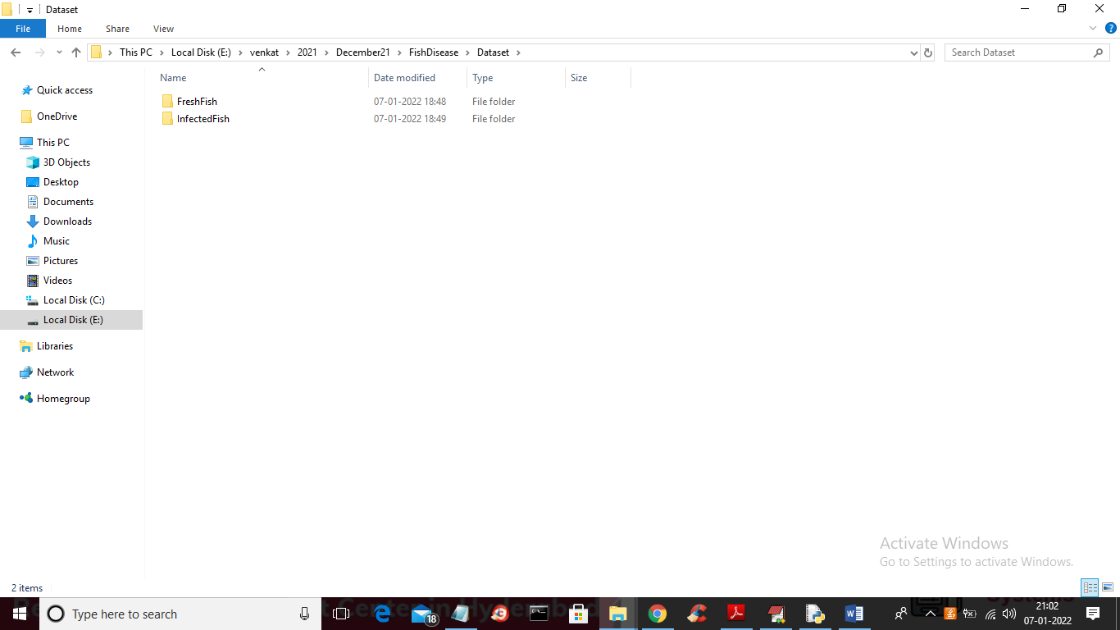

In above screen we have two folders called ‘Fresh Fish” and “Infected Fish” inside dataset folder and you can go inside any folder to see either fresh or infected fish images

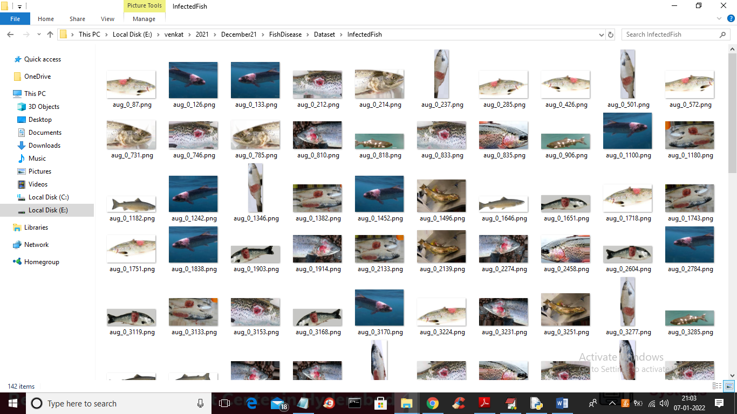

In above screen we can see all infected fish images. In below screen we can see code for SPLINE CUBIC, CLAHE and LAB implementation

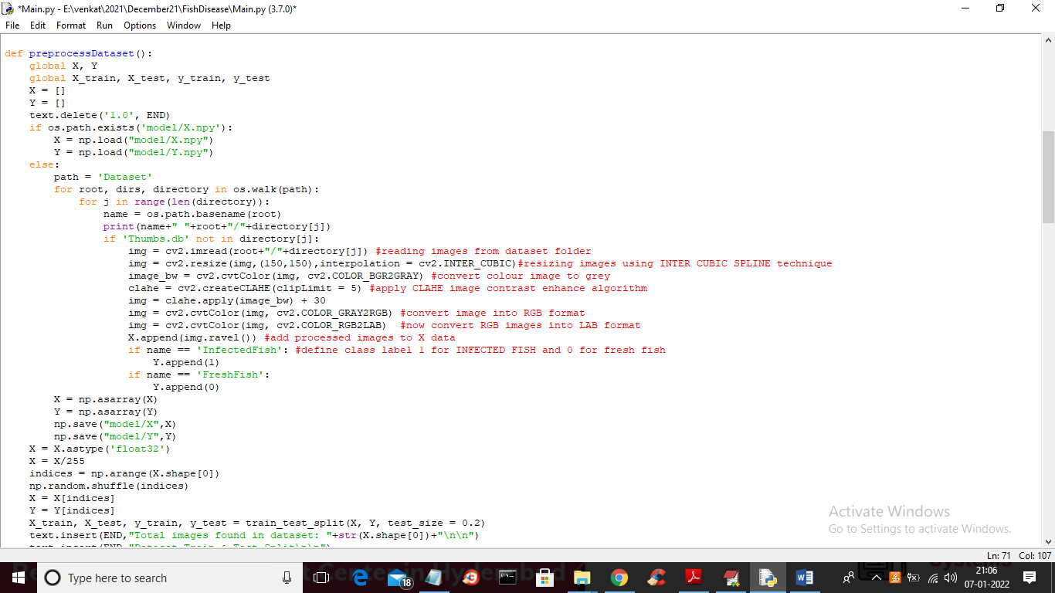

In above screen read red colour comments to know about coding

To implement this project we have designed following modules

1. Upload Fish Dataset: using this module we will upload dataset to application
2. Run Interpolation, CLAHE & LAB: using this module we will read all images and then apply interpolation, CLAHE and LAB to process all images and then normalize images and then split dataset into train and test
3. Run Decision Tree: processed train images will be input to decision tree to trained a model and this model will be applied on TEST images to calculate prediction accuracy and other metrics
4. Run Logistic Regression: processed train images will be input to logistic regression to trained a model and this model will be applied on TEST images to calculate prediction accuracy and other metrics
5. Run Naive Bayes: processed train images will be input to naïve bayes to trained a model and this model will be applied on TEST images to calculate prediction accuracy and other metrics
6. Run Propose SVM Algorithm: processed train images will be input to SVM algorithm to trained a model and this model will be applied on TEST images to calculate prediction accuracy and other metrics
7. Comparison Graph: using this module we will plot accuracy and other metric graphs
8. Predict Fish Status: using this module we will upload test image and then SVM algorithm will predict whether image contains fresh or infected fish.

SCREEN SHOTS

To run project double click on ‘run.bat’ file to get below screen

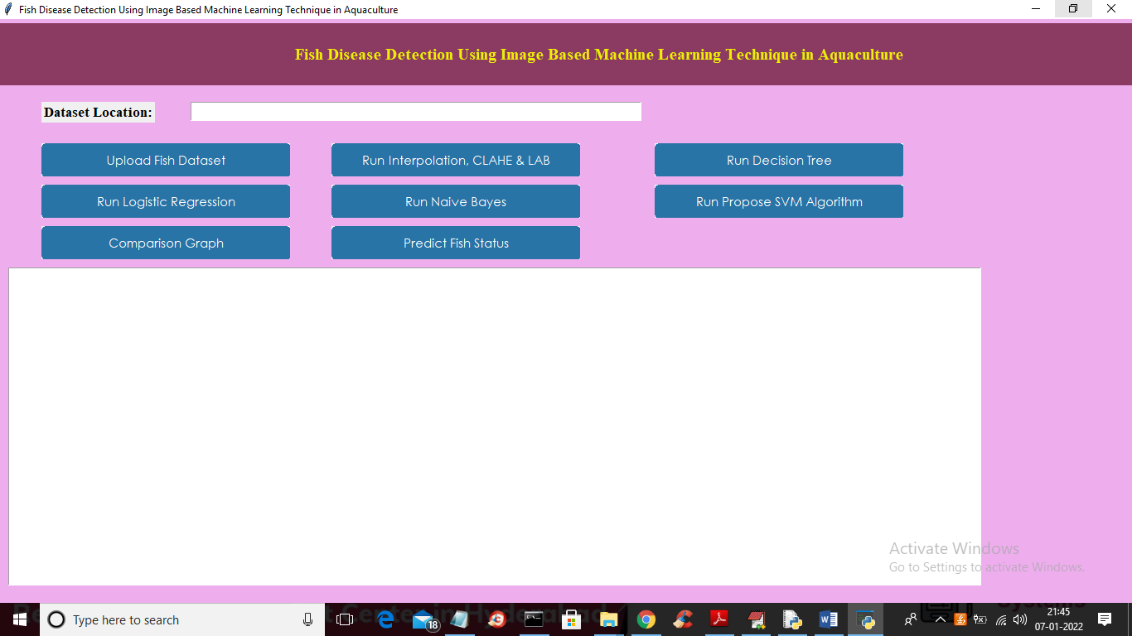

In above screen click on ‘Upload Fish Dataset’ button to upload dataset and to get below screen

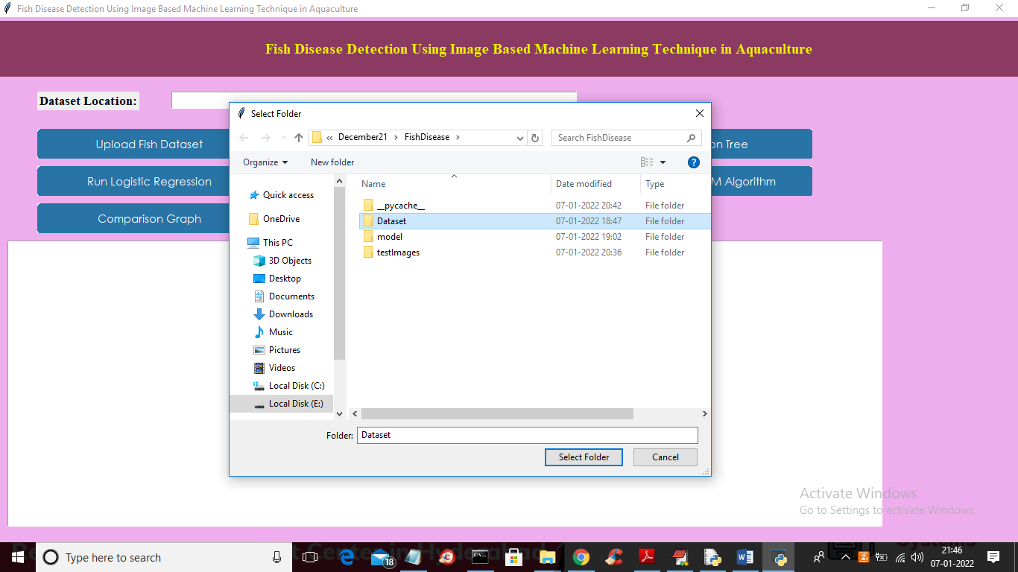

In above screen selecting and uploading ‘Dataset’ folder and then click on ‘Select Folder’ button to load dataset and to get below screen

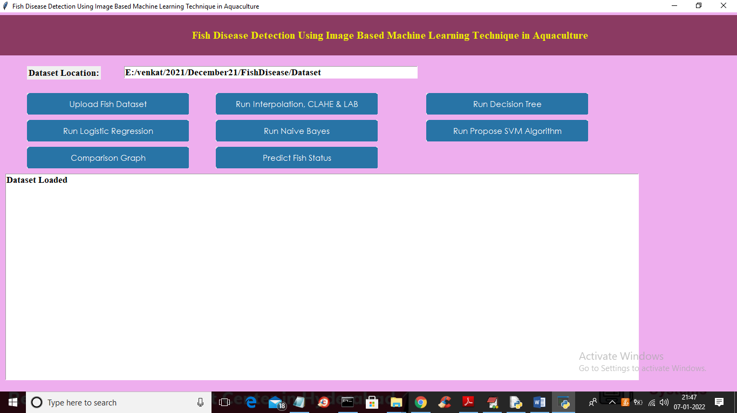

In above screen dataset loaded and now click on ‘Run Interpolation, CLAHE & LAB’ button to apply all 3 techniques and to process images and then split dataset into train and test

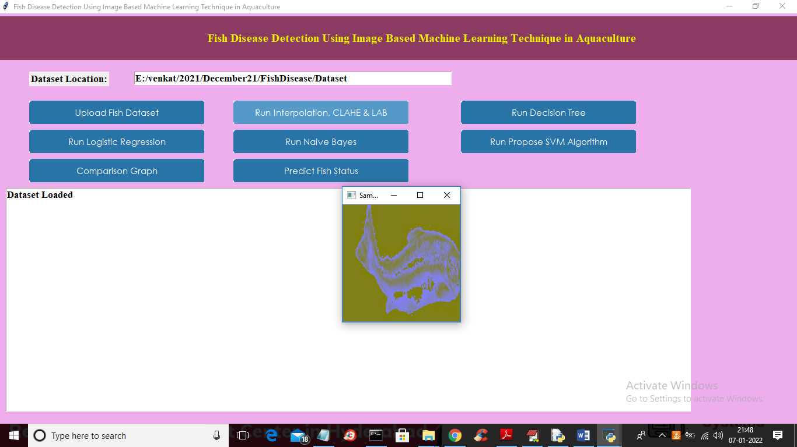

In above screen we can see all images are process using 3 techniques and after processing image will be converted to above format and now close above image to get below screen

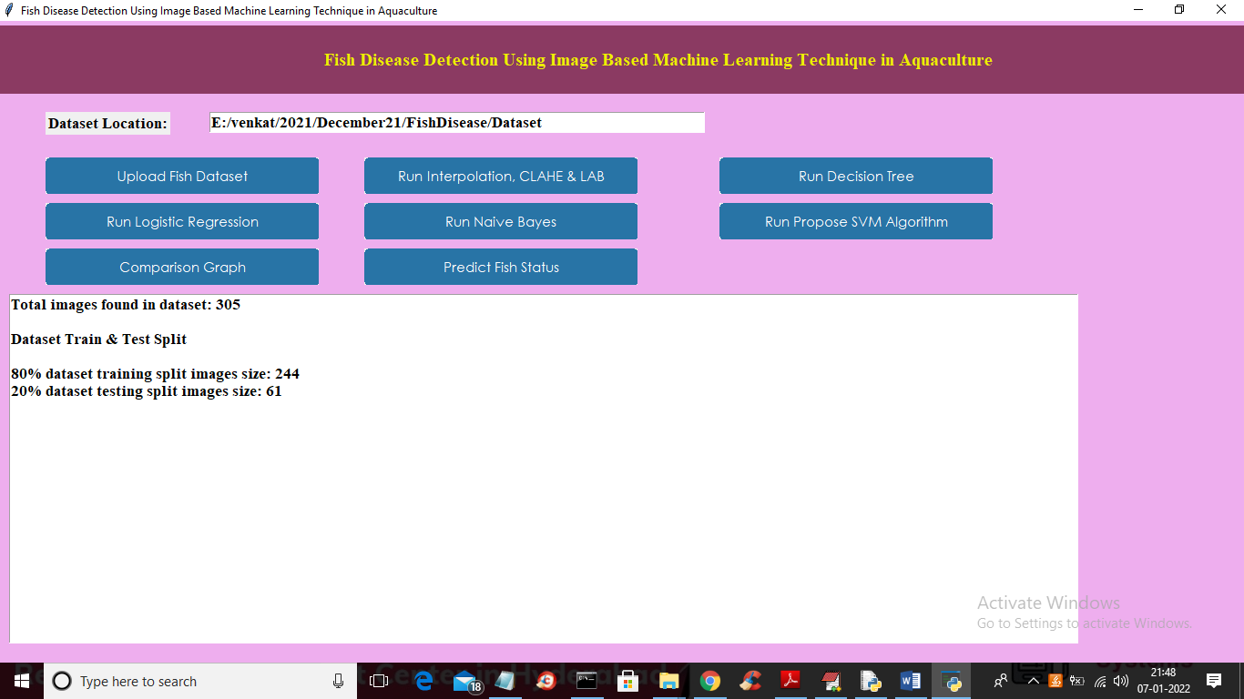

In above screen we can see dataset contains 305 image and then split into 80 and 20% train and test data to get 244 as training images and 61 as test images. Now process images are ready with train and test data and now click on ‘Run Decision Tree’ button to train decision tree and to get below screen

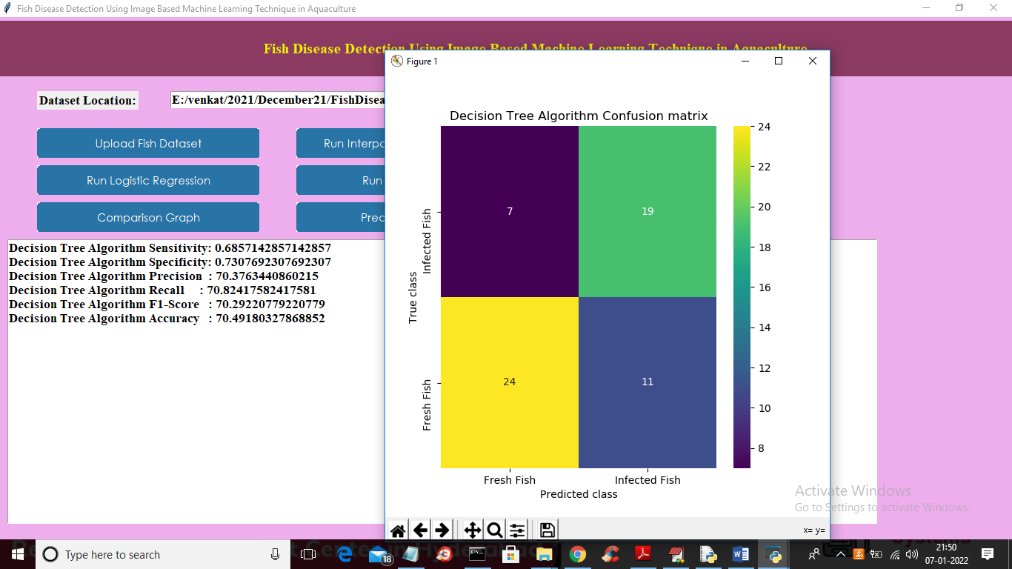

In above screen with decision tree we got 70% accuracy and we can see other metric values also and in confusion matrix graph we can see 24 images are correctly predicted as Fresh fish and 7 is wrongly predicted as infected fish. Now close above graph and then click on ‘Run Logistic Regression’ button to train logistic regression algorithm and to get below output

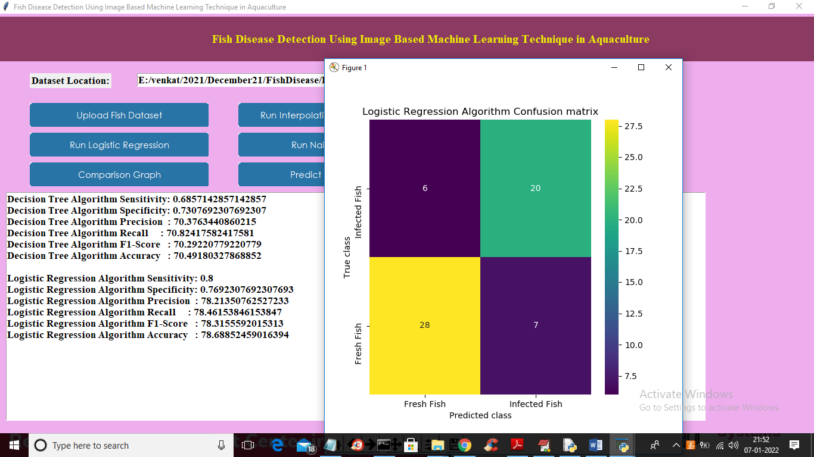

In above screen with logistic regression we got 78% accuracy and in confusion matrix we can see 28 predicted as Fresh fish image correctly and 6 are wrongly predicted. Now close above graph and then click on ‘Run Naïve Bayes’ button to train Naïve Bayes and to get below screen

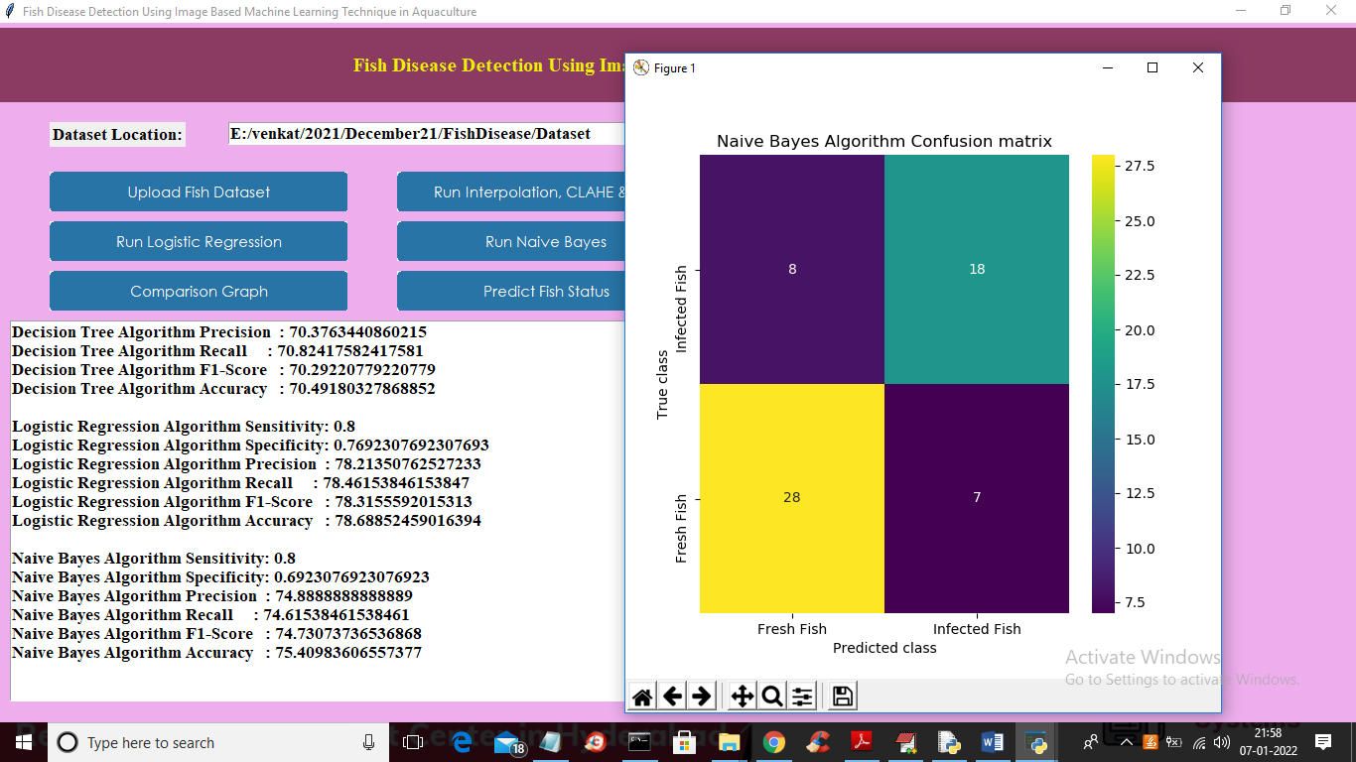

In above screen with Naïve Bayes we got 75% accuracy and in confusion matrix 28 images are correctly predicted ad fresh fish and 8 incorrectly predicted and now close above graph and then click on ‘Run Propose SVM Algorithm’ button to train SVM and to get below output

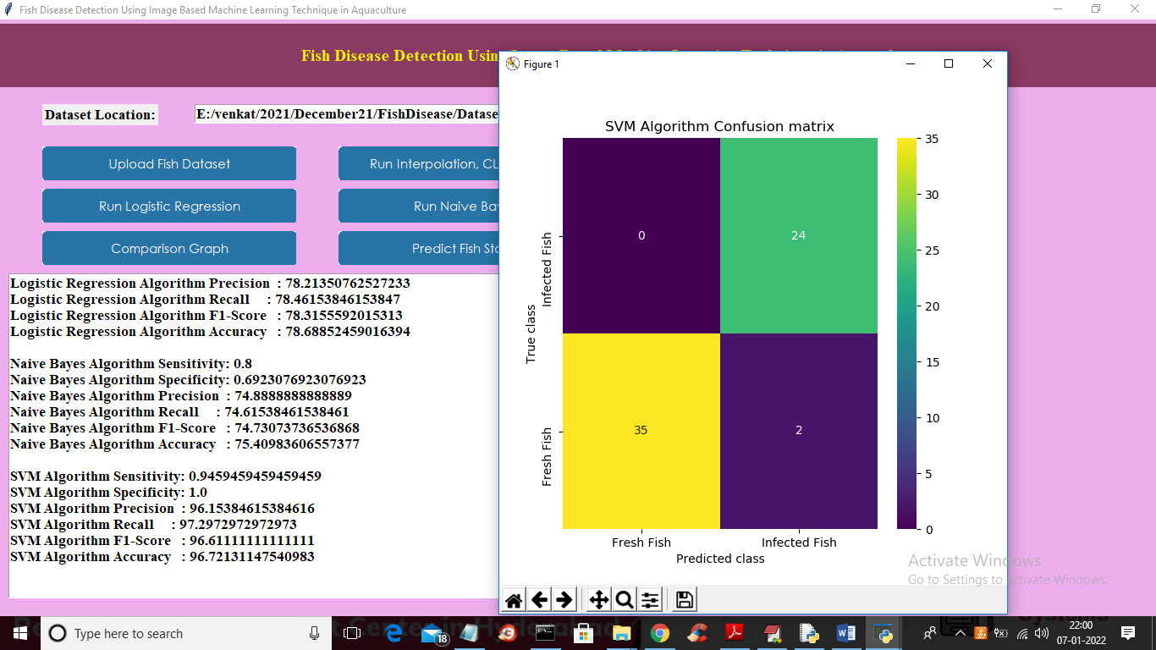

In above screen with SVM we got 96% accuracy and in confusion matrix graph we can see all 35 are correctly predicted as fresh fish and 0 incorrectly predicted. So SVM is better than other algorithms. Now click on ‘Comparison Graph’ button to get below comparison graph

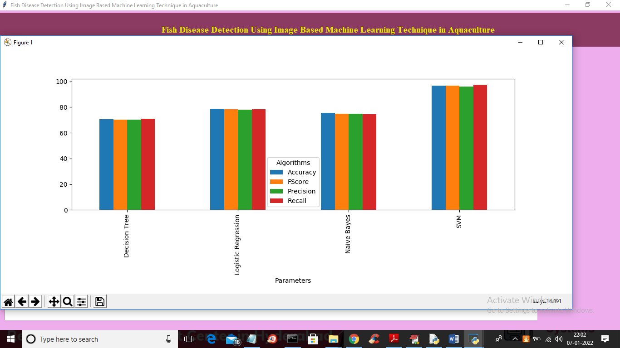

In above graph x-axis represents algorithm names and y-axis represents accuracy, precision and other metric in different colour bar. In above graph we can see SVM got high performance and now close above graph and then click on ‘Predict Fish Status’ button to upload test image and to get prediction

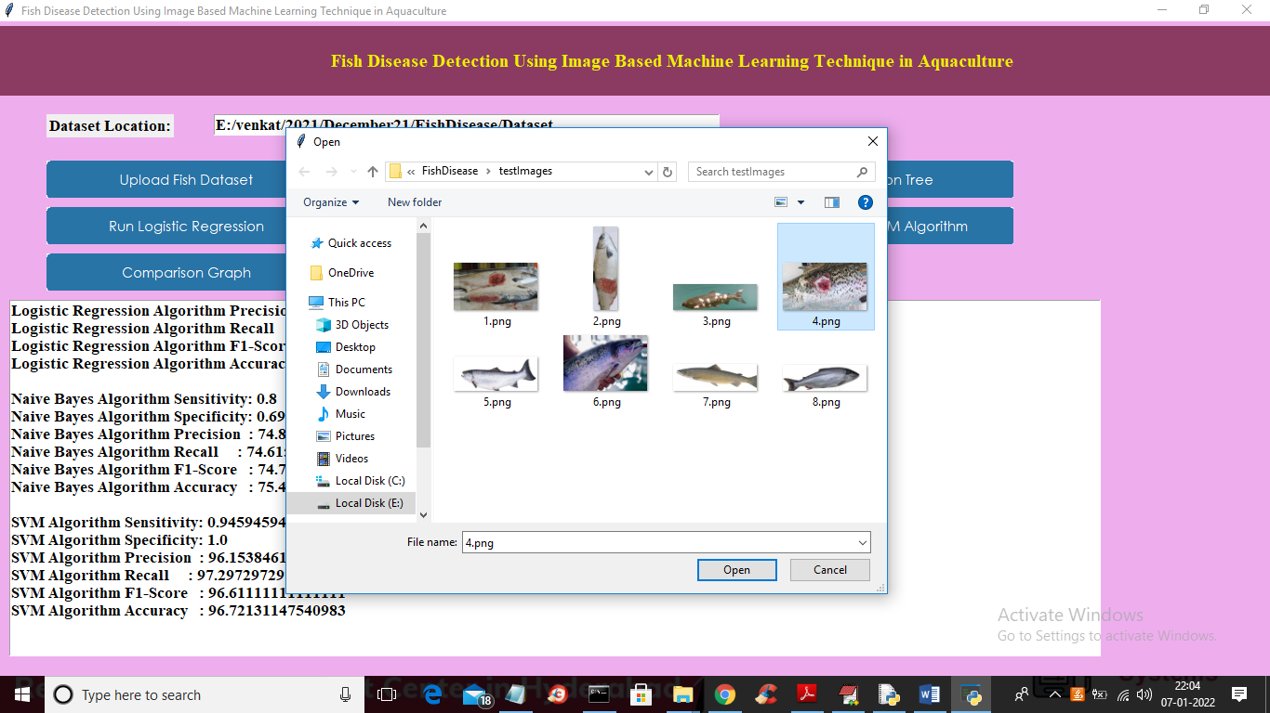

In above screen selecting and uploading ‘4.png’ file and then click on ‘Open’ button to load image and to get below prediction

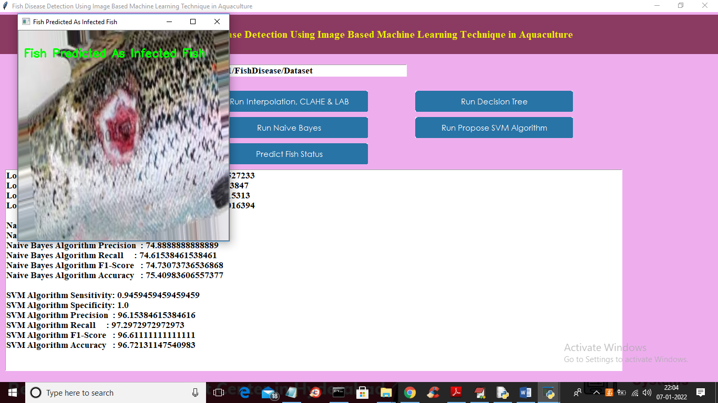

In above screen fish predicted as INFECTED FISH and now test other images

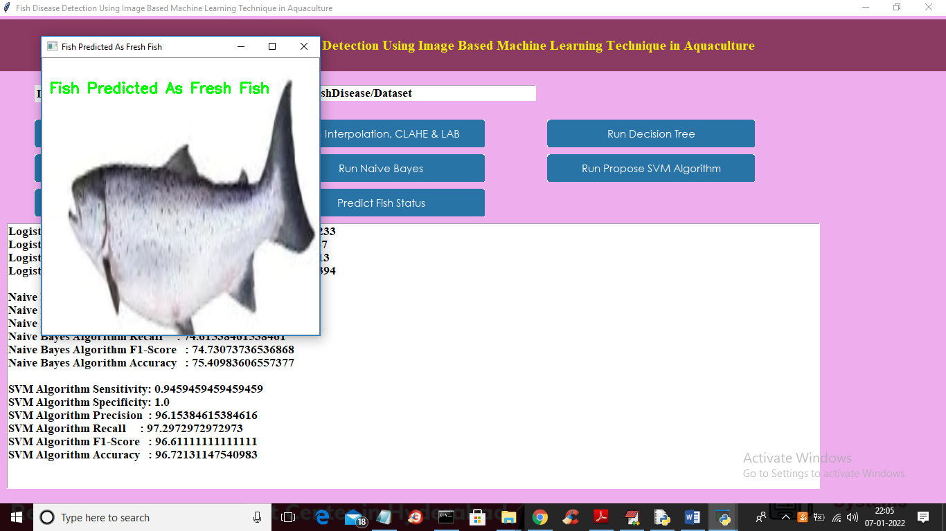

In above screen uploaded fish predicted as FRESH

Similarly you can upload other images and test