Homework5

Khalid Al-Lakhen

2023-11-29

library(tidyverse)  
library(dplyr)  
library(ggplot2)  
library(ggthemes)  
library(stringr)  
library(forcats)  
library(broom)  
library(purrr)  
library(maps)

library(sf)  
library(tigris)

# getting maps

nm_counties <- counties(state = "NM", cb = TRUE, class = "sf")

class(nm_counties)

## [1] "sf" "data.frame"

nm_counties %>%   
 slice(1:3)

## Simple feature collection with 3 features and 12 fields  
## Geometry type: MULTIPOLYGON  
## Dimension: XY  
## Bounding box: xmin: -109.0475 ymin: 31.86361 xmax: -103.365 ymax: 36.21853  
## Geodetic CRS: NAD83  
## STATEFP COUNTYFP COUNTYNS AFFGEOID GEOID NAME NAMELSAD STUSPS  
## 1 35 017 00915980 0500000US35017 35017 Grant Grant County NM  
## 2 35 021 00933055 0500000US35021 35021 Harding Harding County NM  
## 3 35 051 01702370 0500000US35051 35051 Sierra Sierra County NM  
## STATE_NAME LSAD ALAND AWATER geometry  
## 1 New Mexico 06 10259478771 15294669 MULTIPOLYGON (((-109.0475 3...  
## 2 New Mexico 06 5504963122 1162620 MULTIPOLYGON (((-104.439 36...  
## 3 New Mexico 06 10829279105 147645503 MULTIPOLYGON (((-108.0006 3...

bernalillo_county <- nm_counties %>% #Let's filter to only bernalillo county  
 filter(NAME %in% c("Bernalillo"))  
bernalillo_county

## Simple feature collection with 1 feature and 12 fields  
## Geometry type: MULTIPOLYGON  
## Dimension: XY  
## Bounding box: xmin: -107.1972 ymin: 34.86928 xmax: -106.1497 ymax: 35.21946  
## Geodetic CRS: NAD83  
## STATEFP COUNTYFP COUNTYNS AFFGEOID GEOID NAME NAMELSAD  
## 1 35 001 01702363 0500000US35001 35001 Bernalillo Bernalillo County  
## STUSPS STATE_NAME LSAD ALAND AWATER geometry  
## 1 NM New Mexico 06 3007611393 15882874 MULTIPOLYGON (((-107.1968 3...

county_sub <- county_subdivisions(state = "NM", county = "Bernalillo", cb = TRUE, class = "sf")

class(county_sub)

## [1] "sf" "data.frame"

blocks <- blocks(state = "NM", county = "Bernalillo", class = "sf")

class(blocks)

## [1] "sf" "data.frame"

## Organizing Data

setwd("C:/Users/khali/OneDrive/Desktop/PhD coursework/Fall 2023/ERHS 535/Homework5")  
homicides <- read_csv("data/homicide-data.csv")  
head(x = homicides)

## # A tibble: 6 × 12  
## uid reported_date victim_last victim_first victim_race victim_age victim_sex  
## <chr> <dbl> <chr> <chr> <chr> <chr> <chr>   
## 1 Alb-… 20100504 GARCIA JUAN Hispanic 78 Male   
## 2 Alb-… 20100216 MONTOYA CAMERON Hispanic 17 Male   
## 3 Alb-… 20100601 SATTERFIELD VIVIANA White 15 Female   
## 4 Alb-… 20100101 MENDIOLA CARLOS Hispanic 32 Male   
## 5 Alb-… 20100102 MULA VIVIAN White 72 Female   
## 6 Alb-… 20100126 BOOK GERALDINE White 91 Female   
## # ℹ 5 more variables: city <chr>, state <chr>, lat <dbl>, lon <dbl>,  
## # disposition <chr>

albq_homicides <- homicides %>% #Let's filter to only Albuquerque as the city  
 filter(city %in% c("Albuquerque"))  
albq_homicides

## # A tibble: 378 × 12  
## uid reported_date victim_last victim_first victim_race victim_age  
## <chr> <dbl> <chr> <chr> <chr> <chr>   
## 1 Alb-000001 20100504 GARCIA JUAN Hispanic 78   
## 2 Alb-000002 20100216 MONTOYA CAMERON Hispanic 17   
## 3 Alb-000003 20100601 SATTERFIELD VIVIANA White 15   
## 4 Alb-000004 20100101 MENDIOLA CARLOS Hispanic 32   
## 5 Alb-000005 20100102 MULA VIVIAN White 72   
## 6 Alb-000006 20100126 BOOK GERALDINE White 91   
## 7 Alb-000007 20100127 MALDONADO DAVID Hispanic 52   
## 8 Alb-000008 20100127 MALDONADO CONNIE Hispanic 52   
## 9 Alb-000009 20100130 MARTIN-LEYVA GUSTAVO White 56   
## 10 Alb-000010 20100210 HERRERA ISRAEL Hispanic 43   
## # ℹ 368 more rows  
## # ℹ 6 more variables: victim_sex <chr>, city <chr>, state <chr>, lat <dbl>,  
## # lon <dbl>, disposition <chr>

albq_homicides <- homicides %>%   
 filter(city %in% c("Albuquerque")) %>%  
 select(victim_race, lat, lon, disposition)  
albq_homicides

## # A tibble: 378 × 4  
## victim_race lat lon disposition   
## <chr> <dbl> <dbl> <chr>   
## 1 Hispanic 35.1 -107. Closed without arrest  
## 2 Hispanic 35.1 -107. Closed by arrest   
## 3 White 35.1 -107. Closed without arrest  
## 4 Hispanic 35.1 -107. Closed by arrest   
## 5 White 35.1 -107. Closed without arrest  
## 6 White 35.2 -107. Open/No arrest   
## 7 Hispanic 35.1 -107. Closed by arrest   
## 8 Hispanic 35.1 -107. Closed by arrest   
## 9 White 35.1 -107. Open/No arrest   
## 10 Hispanic 35.1 -107. Open/No arrest   
## # ℹ 368 more rows

albq_homicides2 <- na.omit(albq_homicides)  
albq_homicides2

## # A tibble: 375 × 4  
## victim_race lat lon disposition   
## <chr> <dbl> <dbl> <chr>   
## 1 Hispanic 35.1 -107. Closed without arrest  
## 2 Hispanic 35.1 -107. Closed by arrest   
## 3 White 35.1 -107. Closed without arrest  
## 4 Hispanic 35.1 -107. Closed by arrest   
## 5 White 35.1 -107. Closed without arrest  
## 6 White 35.2 -107. Open/No arrest   
## 7 Hispanic 35.1 -107. Closed by arrest   
## 8 Hispanic 35.1 -107. Closed by arrest   
## 9 White 35.1 -107. Open/No arrest   
## 10 Hispanic 35.1 -107. Open/No arrest   
## # ℹ 365 more rows

albq_homicides2 <- st_as_sf(albq_homicides2, coords = c("lon", "lat")) %>%   
 st_set_crs(4269)  
albq_homicides2

## Simple feature collection with 375 features and 2 fields  
## Geometry type: POINT  
## Dimension: XY  
## Bounding box: xmin: -106.7566 ymin: 35.03799 xmax: -106.4874 ymax: 35.20513  
## Geodetic CRS: NAD83  
## # A tibble: 375 × 3  
## victim_race disposition geometry  
## * <chr> <chr> <POINT [°]>  
## 1 Hispanic Closed without arrest (-106.5386 35.09579)  
## 2 Hispanic Closed by arrest (-106.7153 35.05681)  
## 3 White Closed without arrest (-106.6956 35.08609)  
## 4 Hispanic Closed by arrest (-106.5561 35.07849)  
## 5 White Closed without arrest (-106.581 35.13036)  
## 6 White Open/No arrest (-106.5378 35.15111)  
## 7 Hispanic Closed by arrest (-106.7126 35.11178)  
## 8 Hispanic Closed by arrest (-106.7126 35.11178)  
## 9 White Open/No arrest (-106.5535 35.07538)  
## 10 Hispanic Open/No arrest (-106.5723 35.06593)  
## # ℹ 365 more rows

## Map with shapes for disposition

ggplot() +  
 geom_sf(data = bernalillo_county) +  
 geom_sf(data = county_sub) +  
 geom_sf(data = blocks) +   
 geom_sf(data = albq_homicides2, aes(color = victim_race,  
 shape = disposition)) +  
 xlim(c(106.8, 106.4)) + ylim(c(35, 35.20)) +  
 ggtitle("Homicides In Albuquerque")

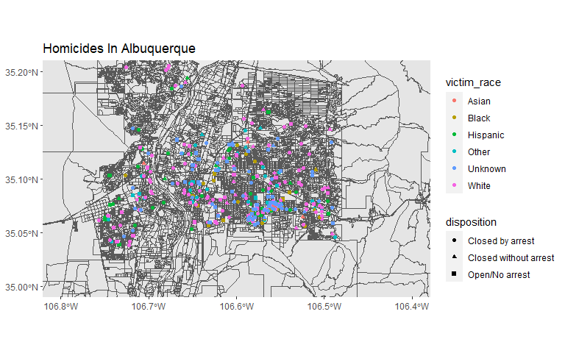

## Map with facet wrap for each disposition

ggplot() +  
 geom_sf(data = bernalillo_county) +  
 geom_sf(data = county_sub) +  
 geom_sf(data = blocks) +   
 geom_sf(data = albq_homicides2, aes(color = victim_race)) +  
 facet_wrap(~ disposition, ncol = 3) +  
 xlim(c(106.8, 106.4)) + ylim(c(35, 35.20)) +  
 ggtitle("Homicides In Albuquerque")

