Figures and tables — generated by weedenroll
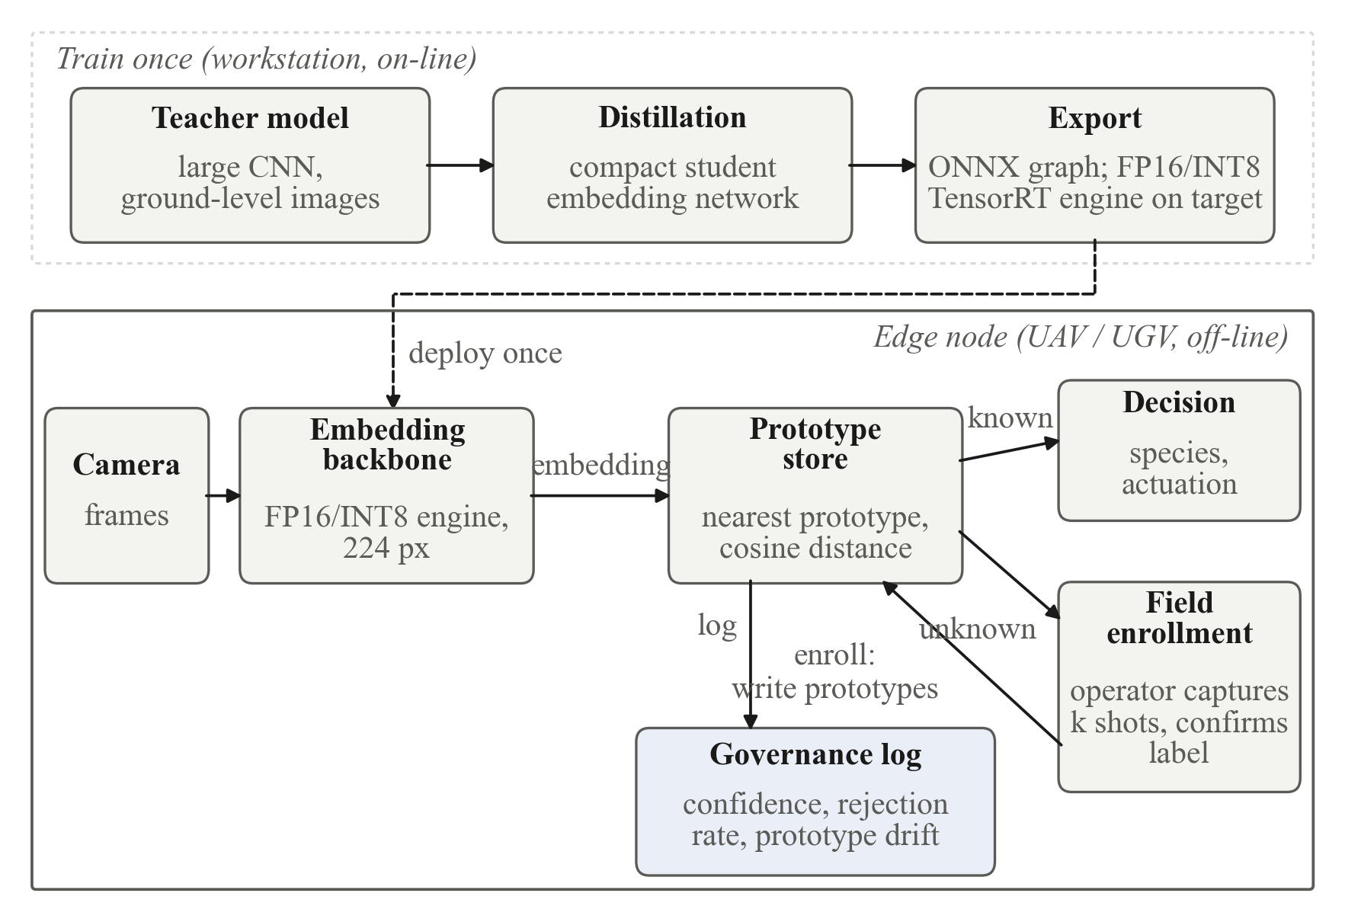
Figure 1. System architecture. The embedding backbone is trained once off-line and deployed as an ONNX graph (built into an FP16 or INT8 TensorRT engine on the target); inference, open-set rejection, field enrollment and governance logging all run on the edge node with no network connection. Enrollment writes prototypes to the store; no model weights change after deployment.
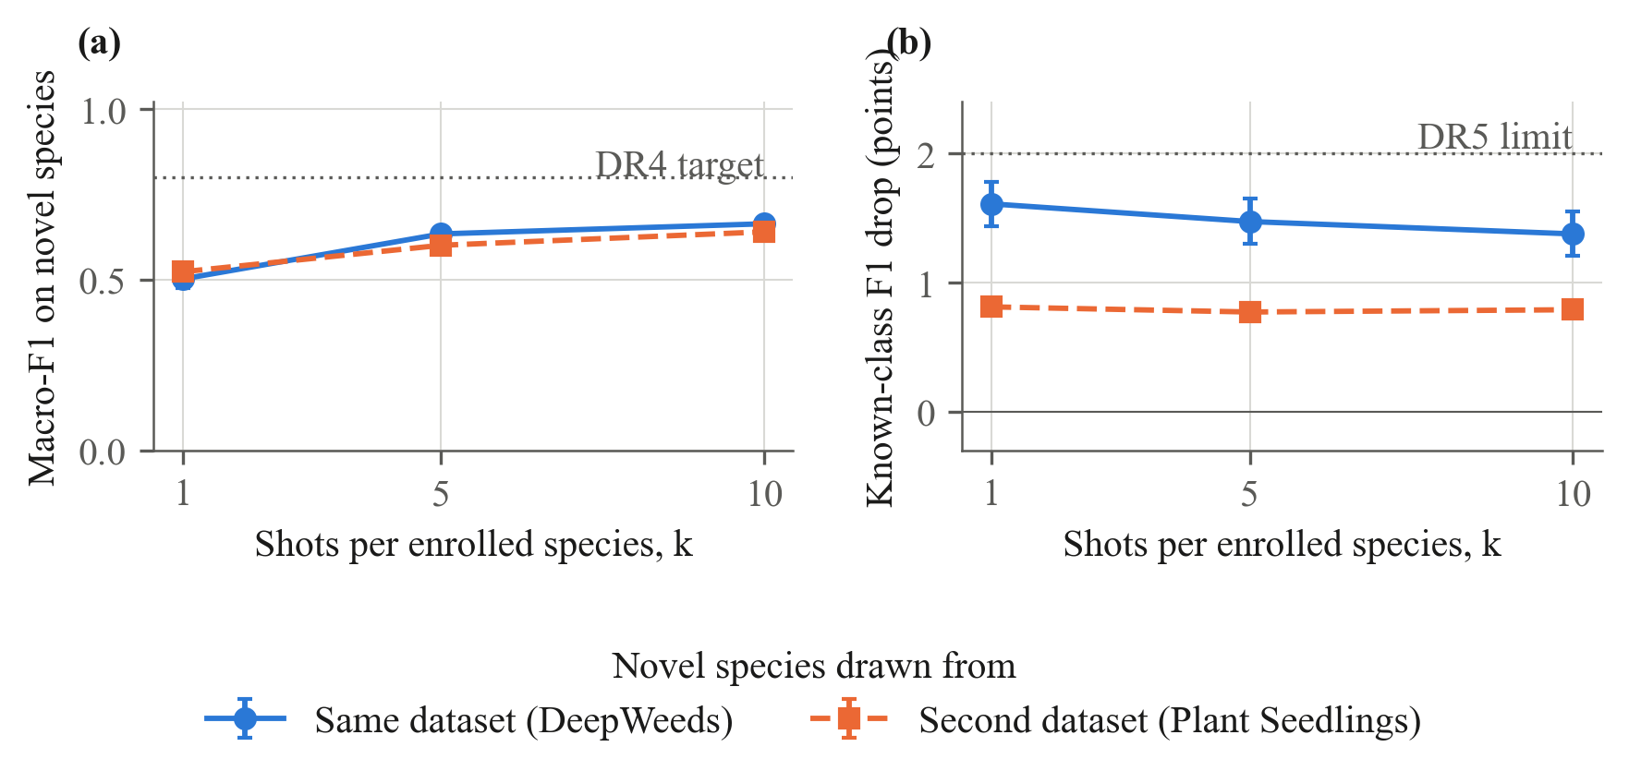
Figure 2. Field enrollment without retraining. (a) Macro-F1 on newly enrolled species versus number of enrollment shots k; (b) change in macro-F1 on the species already in the store after enrollment (DR5). Points are means over n = 30 episodes; error bars are ± 1 SE. The legend applies to both panels.
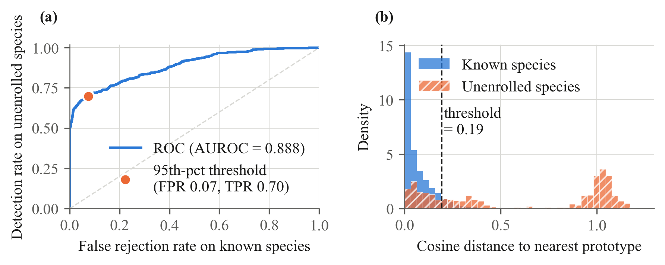
Figure 3. Open-set rejection of unenrolled species (DR6). (a) ROC of the nearest-prototype distance as an unknown-ness score for one representative episode, with the operating point at the calibrated 95th-percentile threshold; (b) distance distributions behind it. Across n = 60 episodes the mean AUROC was 0.922 ± 0.003 (SE).
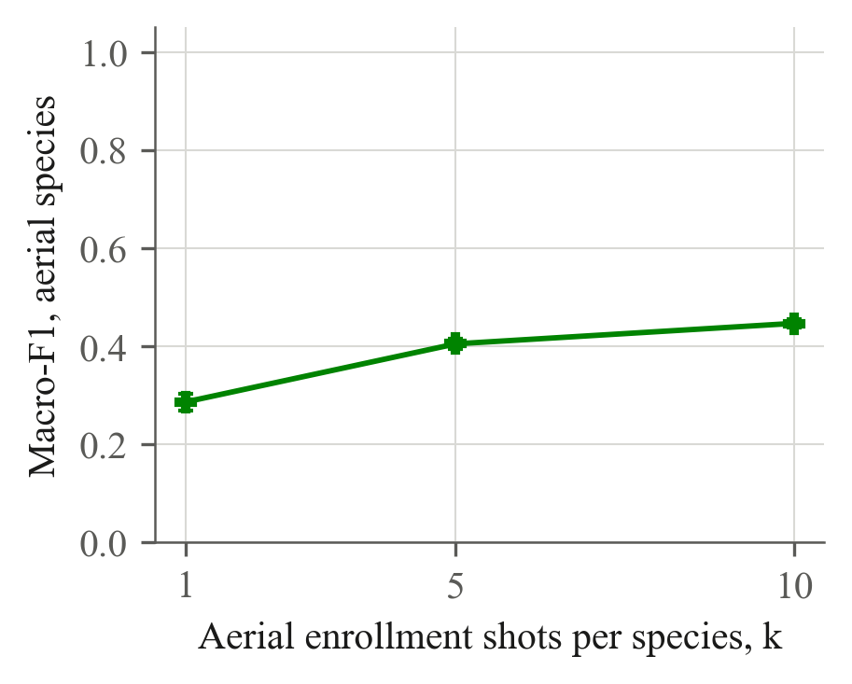
Figure 4. Aerial enrollment with a ground-trained backbone (DR7). Species seen only from the air (CoFly-WeedDB) enrolled from k UAV image crops per species and evaluated on held-out crops. Means over n = 30 episodes; error bars ± 1 SE.
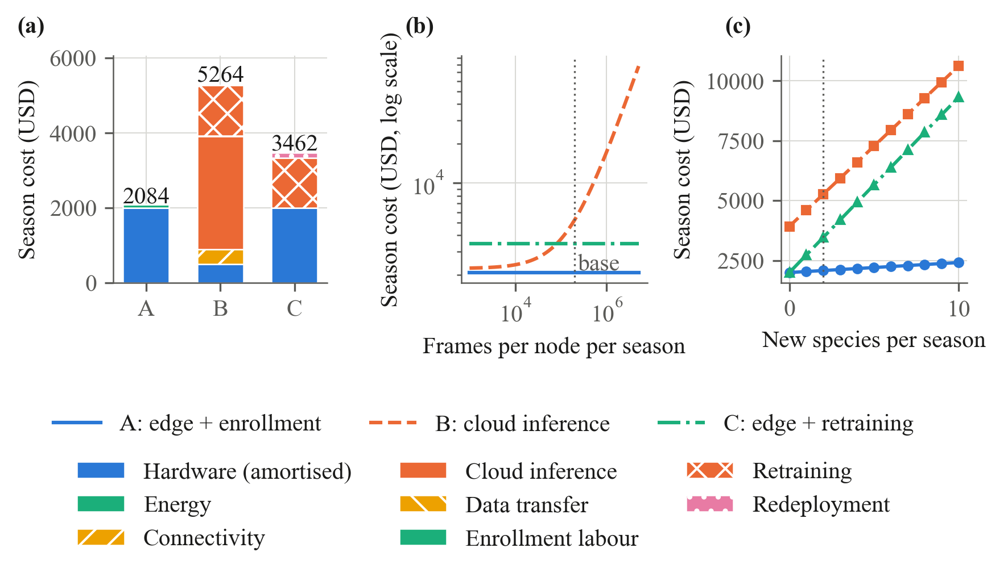
Figure 5. Season-level cost of three deployment options for a fleet of 10 nodes (DR8). (a) Cost breakdown at the base case of 200 000 frames per node and 2 newly encountered species per season; (b) total cost as the inference workload varies; (c) total cost as the number of new species varies, the driver of retraining cost. Dotted vertical lines mark the base case. Assumptions in Table 4.
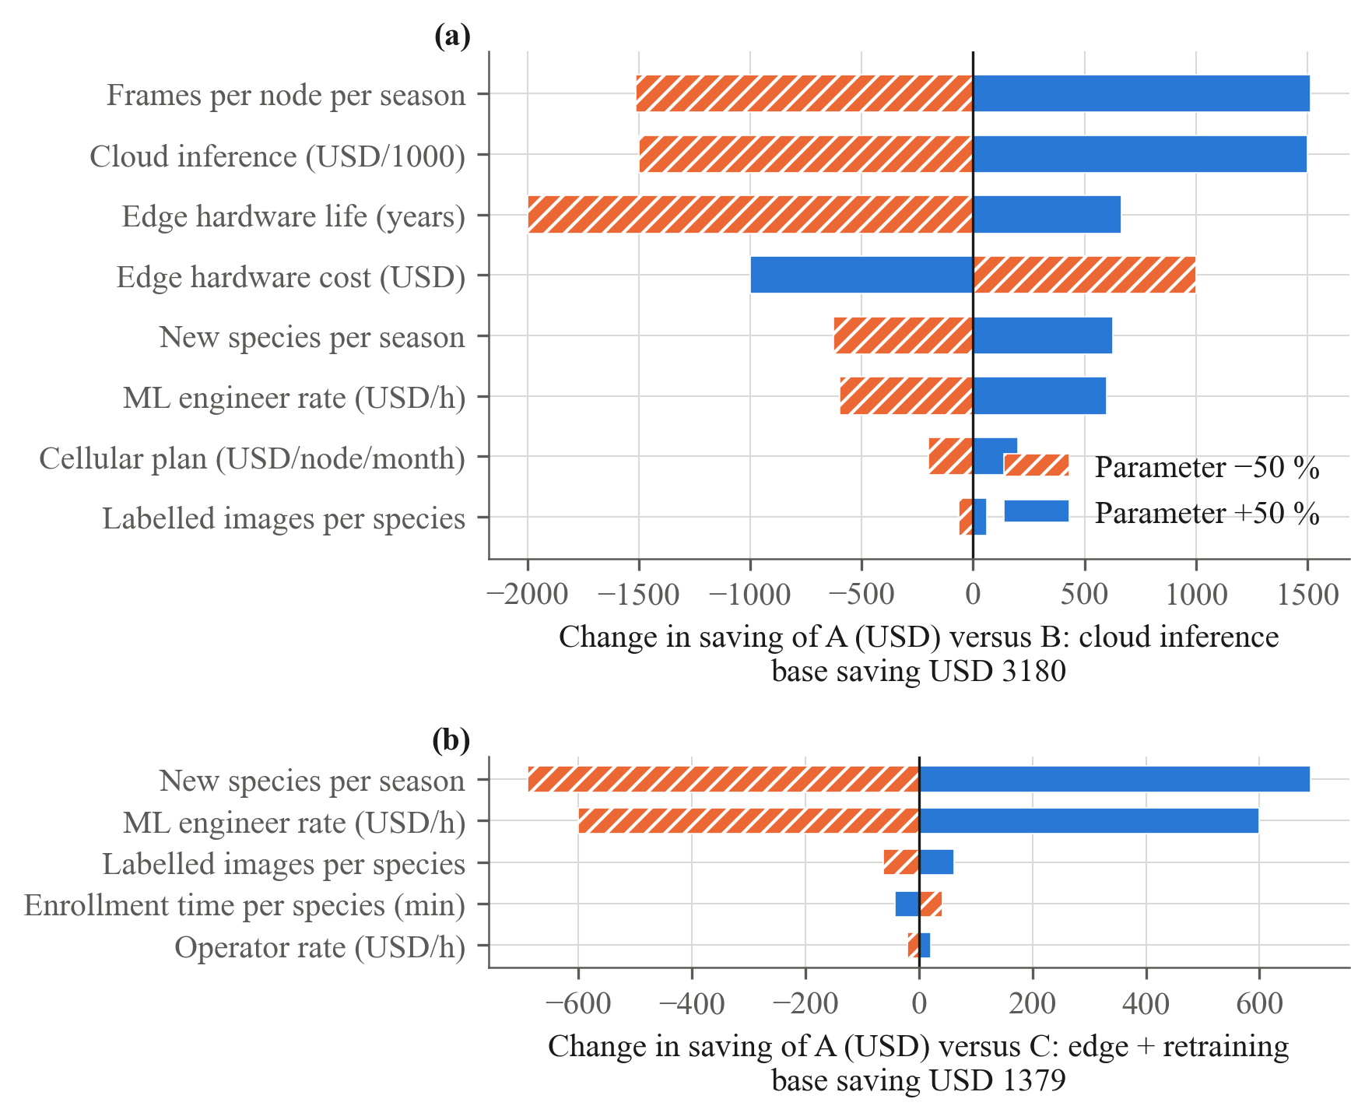
Figure 6. One-at-a-time sensitivity of the season saving of option A (offline edge with field enrollment) to ± 50 % changes in each cost assumption, (a) relative to cloud inference (base saving USD 3180) and (b) relative to a closed-world edge model with periodic retraining (base saving USD 1379). Parameters shared by both options cancel and are omitted.
Table 1. Datasets and their role in the evaluation protocol.
Dataset | Platform | Species | Images | Images per species (min–max) | Role
deepweeds | ground | 8 | 8403 | 1009–1125 | Backbone domain; known-class baseline; held-out species for enrollment
seedlings | ground | 12 | 5539 | 253–762 | Second enrollment source (cross-dataset)
cofly | aerial | 3 | 377 | 21–283 | Aerial-only species: aerial enrollment

Table 2. Inference latency, power, energy and footprint (DR2, DR3). Latency over n frames at batch size 1. Rows measured on the benchmark host CPU are an upper bound for the target device; the Orin Nano row is projected from published batch-1 measurements on that board (Nishikawa, 2026, arXiv:2607.26238; Mishra and Lone, 2026, arXiv:2606.17241) and is not a measurement of this system. Power is board input (VDD_IN) from tegrastats where measured.
Device | Backbone | Precision | Latency, mean ± SD (ms) | Latency, p95 (ms) | Throughput (frames/s) | Power (W) | Energy (mJ/frame) | Model (MB) | Store (kB) | Peak RSS (MB) | 10-shot enrollment (ms) | n frames | Basis
x86_64 CPU (x86_64) | mobilenet_v3_small | FP32 | 8.0 ± 0.3 | 8.4 | 125 | n/a | n/a | 4.1 | 4.6 | 1975 | 81.5 | 200 | measured on benchmark host (upper bound for the target)
NVIDIA Jetson Orin Nano 8 GB, 15 W mode (projected) | mobilenet_v3_small | FP16 (TensorRT) | 2–4 (TensorRT FP16); ≤ 22 (PyTorch FP32) | n/a | 250–450 (TensorRT FP16) | ≤ 15 (power-mode cap) | n/a | 2.1 (FP16) | 4.6 | n/a | n/a | — | projected from published Orin Nano benchmarks (Nishikawa, 2026; Mishra and Lone, 2026)

Table 3. Recognition, enrollment, open-set and transfer results (mean ± SE over n episodes).
Experiment | k | Metric | Mean ± SE | n
Closed-set, deepweeds (ground, FP32) | all | macro-F1 | 0.818 | 2522
Closed-set, seedlings (ground, FP32) | all | macro-F1 | 0.252 | 1662
Closed-set, cofly (aerial, FP32) | all | macro-F1 | 0.476 | 113
Enrollment, cross | 1 | novel macro-F1 (DR4) | 0.524 ± 0.026 | 30
Enrollment, cross | 1 | known macro-F1 drop, pts (DR5) | 0.815 ± 0.062 | 30
Enrollment, cross | 5 | novel macro-F1 (DR4) | 0.601 ± 0.020 | 30
Enrollment, cross | 5 | known macro-F1 drop, pts (DR5) | 0.775 ± 0.044 | 30
Enrollment, cross | 10 | novel macro-F1 (DR4) | 0.641 ± 0.020 | 30
Enrollment, cross | 10 | known macro-F1 drop, pts (DR5) | 0.793 ± 0.029 | 30
Enrollment, within | 1 | novel macro-F1 (DR4) | 0.503 ± 0.027 | 30
Enrollment, within | 1 | known macro-F1 drop, pts (DR5) | 1.612 ± 0.173 | 30
Enrollment, within | 5 | novel macro-F1 (DR4) | 0.635 ± 0.018 | 30
Enrollment, within | 5 | known macro-F1 drop, pts (DR5) | 1.475 ± 0.175 | 30
Enrollment, within | 10 | novel macro-F1 (DR4) | 0.664 ± 0.018 | 30
Enrollment, within | 10 | known macro-F1 drop, pts (DR5) | 1.380 ± 0.172 | 30
Open-set, cross | — | AUROC (DR6) | 0.935 ± 0.003 | 30
Open-set, cross | — | TPR at 5 % FPR | 0.598 ± 0.019 | 30
Open-set, cross | — | known false-rejection rate | 0.086 ± 0.000 | 30
Open-set, within | — | AUROC (DR6) | 0.909 ± 0.006 | 30
Open-set, within | — | TPR at 5 % FPR | 0.679 ± 0.015 | 30
Open-set, within | — | known false-rejection rate | 0.067 ± 0.001 | 30
Transfer: aerial-only enrollment (disjoint species) | 1 | macro-F1 (DR7) | 0.286 ± 0.017 | 30
Transfer: aerial-only enrollment (disjoint species) | 5 | macro-F1 (DR7) | 0.405 ± 0.011 | 30
Transfer: aerial-only enrollment (disjoint species) | 10 | macro-F1 (DR7) | 0.446 ± 0.008 | 30

Table 4. Season-level cost breakdown of the three deployment options (base case).
Option | Hardware (USD) | Energy (USD) | Connectivity (USD) | Cloud inference (USD) | Data transfer (USD) | Enrollment labour (USD) | Retraining (USD) | Redeployment (USD) | Total (USD) | Per node (USD) | Per 1000 decisions (USD)
A: Offline edge + field enrollment | 2,000.00 | 0.42 | 0.00 | 0.00 | 0.00 | 83.33 | 0.00 | 0.00 | 2,083.75 | 208.38 | 1.04
B: Cloud inference | 500.00 | 0.00 | 400.00 | 3,000.00 | 27.00 | 0.00 | 1,337.00 | 0.00 | 5,264.00 | 526.40 | 2.63
C: Edge, closed-world, periodic retraining | 2,000.00 | 0.42 | 0.00 | 0.00 | 0.00 | 0.00 | 1,337.00 | 125.00 | 3,462.42 | 346.24 | 1.73

Table 4 (continued). Cost model assumptions.
Parameter | Value | Source / note
n nodes | 10.0
frames per node season | 200000.0
new species per season | 2.0
season years | 1.0
edge hw usd | 600.0 | Orin Nano-class board (Jetson Orin Nano Super Developer Kit, USD 399 list, Oct 2026) + camera/enclosure/power
edge hw life years | 3.0
edge power w | 10.0
edge idle power w | 4.0
edge hours per season | 28.0
electricity usd kwh | 0.15
enrollment minutes per species | 10.0
operator usd hour | 25.0 | farm technician wage incl. overhead
thin device usd | 150.0
thin device life years | 3.0
cellular usd node month | 20.0 | IoT data plan, 1–5 GB/month
months per season | 2.0
image kb | 150.0
egress usd gb | 0.09 | major cloud provider internet egress, first 10 TB
cloud inference usd per 1000 | 1.5 | typical managed image-classification endpoint pricing tier
cloud latency penalty usd | 0.0
label images per species | 300.0
label minutes per image | 0.5
labeller usd hour | 25.0
gpu train hours | 4.0
gpu usd hour | 1.5
ml engineer hours per cycle | 8.0
ml engineer usd hour | 75.0 | contract ML engineer, fully loaded
redeploy minutes per node | 15.0

Table 5. Design requirements (DR1–DR8): target versus achieved. DR2 is projected from the host-CPU upper bound and published Orin Nano benchmarks, not measured on the device.
ID | Design requirement | Target | Result | Status
DR1 | Fully offline inference and enrollment | No network calls at runtime | 0 socket calls (benchmark run with sockets disabled) | met
DR2 | Real-time inference on UAV-class hardware | < 50 ms per frame at 224 px, < 15 W | 8.0 ms measured on x86_64 CPU (x86_64) (upper bound); projected on Orin Nano: 2–4 ms (TensorRT FP16) and at most 22 ms (PyTorch FP32) at the 15 W power-mode cap, from published benchmarks | projected (not measured on device)
DR3 | Compact model footprint | < 25 MB model + prototype store | 4.1 MB + 4.6 kB | met
DR4 | Field enrollment without retraining | macro-F1 on new species > 0.80 at 5–10 shots | 0.652 ± 0.013 at k = 10 (n = 60) | not met
DR5 | No harm to existing classes | < 2-point drop in known-class macro-F1 | 1.09 ± 0.09 points at k = 10 | met
DR6 | Open-set detection of unenrolled plants | AUROC > 0.85 | 0.922 ± 0.003 (n = 60) | met
DR7 | Transfer across imaging platforms | Documented degradation and recovery | aerial-only enrollment (CoFly), macro-F1 k = 1: 0.286; k = 5: 0.405; k = 10: 0.446 | documented
DR8 | Cost-effectiveness | Per-node cost and break-even vs cloud and retraining | season cost A $2,084 vs B $5,264 vs C $3,462 | met

