ASSIGNMENT

Deep Learning using Python (CSE 4685)
Programme: B. Tech (CSE) Semester: 7th
Full Marks: 20 Date of Submission: 20-12-2025

Subject/Course Learning Outcome | *Taxonomy Level | Question Nos. | Marks
Able to apply the key fields of linear algebra and probability to build complex neural models. | L2 | 1 | 2
Able to analyse, design and implement Artificial Neural Networks (ANNs) and optimization techniques for solving complex  learning problems. | L3 | 2,9 | 4
Able to analyse, build and implement Convolutional Neural Networks (CNNs) using PyTorch for solving classification problems. | L3 | 3,4,5,10 | 8
Able to analyse, design and  implement autoencoder using PyTorch for nonlinear data handling. | L3 | 7 | 2
Able to design and interpret Recurrent Neural Networks (RNNs) and long short-term memory (LSTM) for sequential data analysis. | L3 | 6 | 2
Able to develop Generative  Adversarial Networks (GANs) to synthesize new data. | L3 | 8 | 2

*Bloom’s taxonomy levels: Knowledge (L1), Comprehension (L2), Application (L3), Analysis (L4), Evaluation (L5), Creation (L6).

Answer all questions. Each question carries equal mark.

- Assignment scores/markings depend on neatness, clarity and date of submission.
- Write your answers with enough detail about your approach and concepts used, so that the grader will be able to understand it easily.
- You are allowed to use only those concepts which are covered in the lecture class.

  - What is the prerequisite for deep learning? Explain in details, how these concepts are helpful to build Deep learning models.

Ans) The main prerequisites for deep learning are linear algebra, probability & statistics, calculus, optimization, and programming.
- Linear algebra is used to represent inputs, weights, and outputs using vectors and matrices and to perform operations like matrix multiplication in neural networks.
- Probability and statistics help in modeling uncertainty, defining loss functions, and evaluating model performance.
- Calculus is used to compute gradients during backpropagation to update weights.
- Optimization techniques such as gradient descent are used to minimize the loss function.
- Programming (Python) enables implementation of deep learning models using libraries like PyTorch.
These concepts together make it possible to design, train, and optimize deep learning models effectively.

  - Given perceptron weights w1=1, w2=-1, b=-0.2. Write the equation of the decision boundary and classify the points (0.5,0.5) and (0.8,0.2).
Ans) 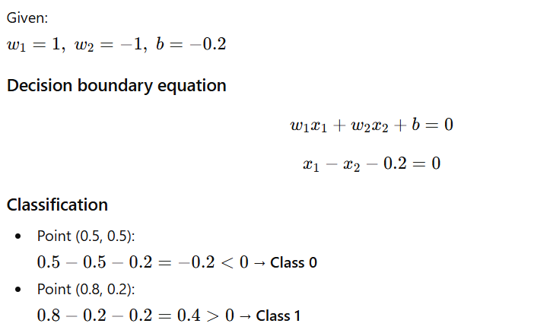
  - Explain the role of the following layers in CNN:
    - Convolution layer
    - Pooling layer
    - Fully connected layer
Ans) 1. Convolution Layer
The convolution layer is responsible for feature extraction from the input image. It uses learnable filters (kernels) that slide over the image to detect local patterns such as edges, corners, textures, and shapes. Each filter produces a feature map, helping the network learn spatial features while reducing the number of parameters through weight sharing.

2. Pooling Layer
The pooling layer is used to reduce the spatial dimensions of feature maps. It helps in lowering computational cost and controlling overfitting. Commonly used max pooling selects the maximum value from a region, making the network invariant to small translations in the input image.

3. Fully Connected Layer
The fully connected layer performs high-level reasoning and classification. It takes the flattened feature maps as input and combines the learned features to predict the final output classes. This layer acts as a classifier based on the features extracted by previous layers.

  - Table1: Network parameter details
Layer | Parameters
Conv 2D | Filter size=5×5, stride=1, padding=0, #filters=6
Max Pooling 2D | Stride=2, filter size=2×2
Conv 2D | Filter size=5×5, stride=1, padding=0, #filters=16
Max Pooling 2D | Stride=2, filter size=2×2
Conv 2D | Filter size=5×5, stride=1, padding=0, #filters=32
Max Pooling 2D | Stride=2, filter size=2×2
Flatten
Dense 1 | 120
output | 10

Draw the CNN architecture with the following information given in Table.1 for image classification. The input image size is 128×128×3. Find the total no. of learnable parameters in the network.
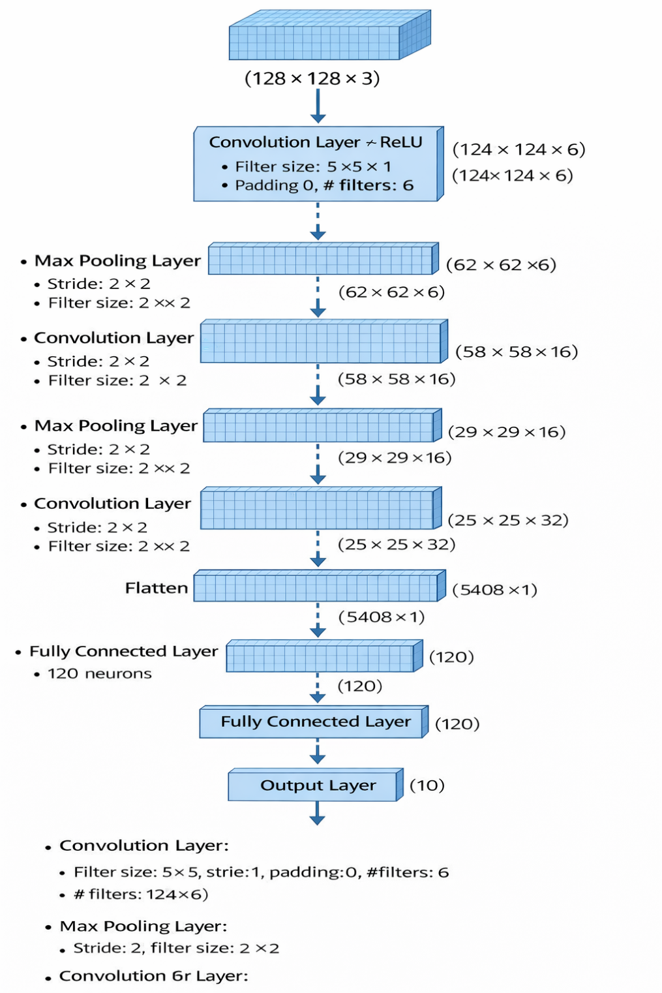

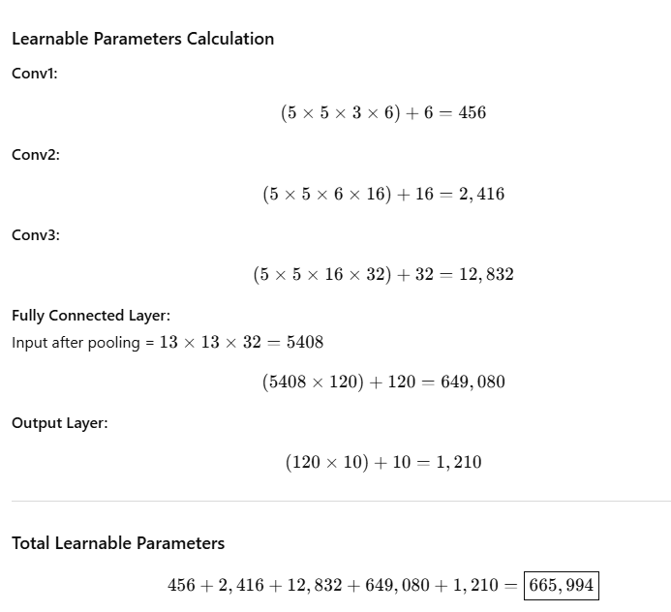

  - State batch normalization. Discuss the limitations of batch normalization and how layer and group normalization overcomes it with example.

Ans) Batch Normalization (BN) is a technique used to normalize the activations of a neural network layer by using the mean and variance of a mini-batch. It reduces internal covariate shift, speeds up training, and allows higher learning rates.
Limitations of Batch Normalization
- Depends on batch size; performance degrades with very small batches.
- Not suitable for RNNs and sequence models with varying lengths.
- Different behavior during training and inference, which adds complexity.
Layer Normalization
Layer Normalization normalizes across features of a single data sample instead of across a batch.
- Works well with small batch sizes.
- Commonly used in RNNs and Transformers.
Group Normalization
Group Normalization divides channels into groups and normalizes within each group.
- Independent of batch size.
- Useful for CNNs when batch size is small.
Example:
For small batch image classification, Group Normalization performs better than Batch Normalization because it does not rely on batch statistics.

  - Draw a RNN network with input(2) →hidden(2) →output(1), calculate the Y predicted for the following given parameter values in Table.2 with input x1=[1, 0], x2=[0, 1]
,h0=[0,0].
Table2: Network parameter details
Layer | Weights | Bias
Input to hidden | [0.5 0.8 , −0.3 0.2] | -
Hidden-to hidden | [0.1 −0.4, 0.2 0.3] | 0.0,0.1
Hidden to output | [1.0, −1.0] | 0.0
  - What is autoencoder? How does it work? What are the loss functions used in autoencoder, elaborate?

Ans) An autoencoder is an unsupervised neural network used to learn compressed representations of data. It consists of two parts: encoder and decoder.
- The encoder compresses the input into a lower-dimensional latent representation.
- The decoder reconstructs the original input from this compressed form.
Loss Functions used in Autoencoders:
- Mean Squared Error (MSE): Used for continuous data (images).
- Binary Cross-Entropy (BCE): Used when inputs are binary.
- Reconstruction loss: Measures difference between input and reconstructed output.
Autoencoders are used for dimensionality reduction, noise removal, and feature learning.

  - Answer the followings
    - What is a Generative Adversarial Network (GAN)?
    - Name the two main components of a GAN and state their roles.
    - What is meant by adversarial training?
    - Define generator loss and discriminator loss.

Ans) A Generative Adversarial Network (GAN) is a deep learning model used to generate new, realistic data similar to the training data by learning its distribution.

The two main components of a GAN are:
Generator – generates fake data samples from random noise.
Discriminator – distinguishes between real data and generated (fake) data.

Adversarial training refers to the process where the generator and discriminator compete with each other: the generator tries to fool the discriminator, while the discriminator tries to correctly identify real and fake samples.

Generator loss measures how well the generator can fool the discriminator.
Discriminator loss measures how accurately the discriminator classifies real and fake data.

  - Implement a feedforward neural network with backpropagation using PyTorch to learn the XOR logic function for the following network architecture.
Input layer: 2 neurons, Hidden layer: 2 neurons, Output layer: 1 neuron, Activation function: Sigmoid, Loss function: Mean Squared Error (MSE), Learning rate: 0.1.
Ans) 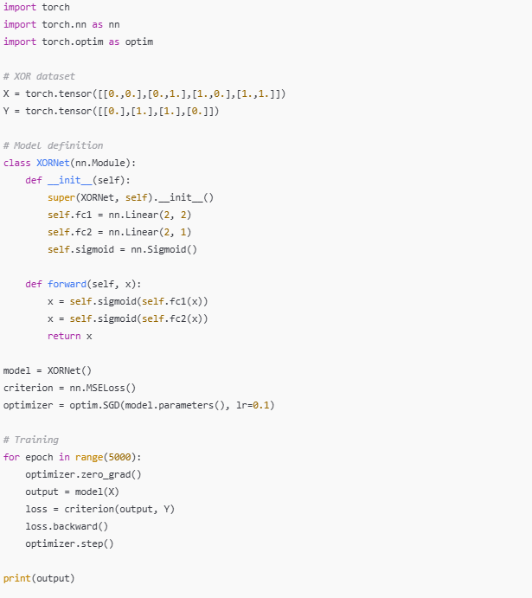

10. Implement a Convolutional Neural Network (CNN) using PyTorch to classify images from the MNIST handwritten digits dataset. Display training and testing outcome in-terms of confusion matrix, accuracy, precision, recall and F1-score.

Dataset:
MNIST (Image size: 28 × 28 pixels, Color channels: 1 (grayscale), Number of classes: 10 (digits 0–9), Training samples: 60,000, Testing samples: 10,000)

Architecture details:
Input Layer: Input shape (28, 28, 1)
Convolution Layer 1: Number of filters: 32 Kernel size: 3 × 3 Stride: 1 Padding: valid
Activation function: ReLU
Max Pooling Layer 1: Pool size: 2 × 2 Stride: 2
Convolution Layer 2: Number of filters: 64 Kernel size: 3 × 3 Activation function: ReLUMax Pooling Layer 2: Pool size: 2 × 2
Fully Connected Layer: Number of neurons: 128 Activation function: ReLU Output Layer: Number of neurons: 10 Activation function: Softmax

Ans) 