**Allan KiruiIndex: 183036Group: 1Term Code: Friday 2/2**

**Project Subject**

**Project Description**

**Project Details**

**ERD Diagram**

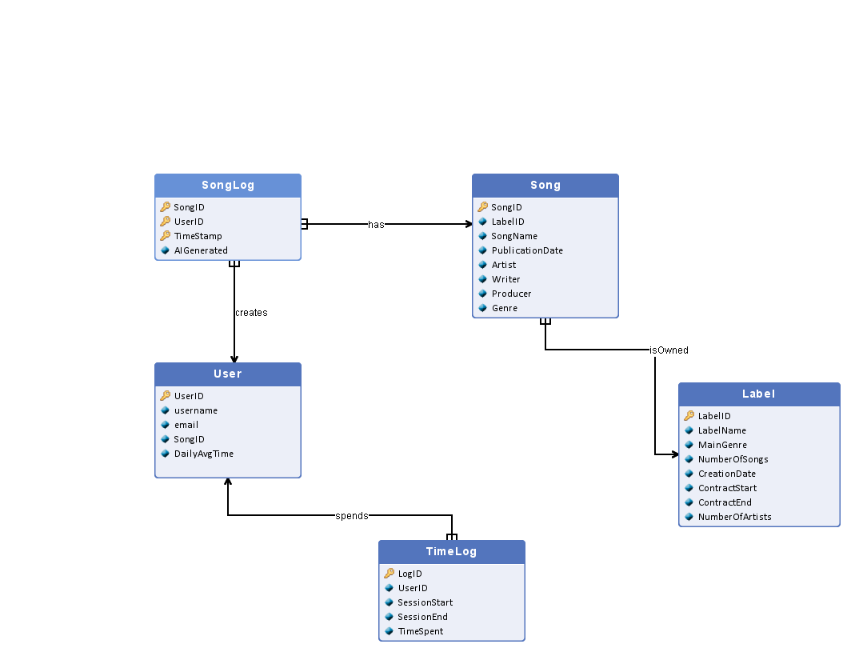

**Entity set description**

|  |  |  |  |  |  |
| --- | --- | --- | --- | --- | --- |
| **User** | | | | | |
| A majority of the data comes from a database that is automatically filled with data from user actions. It stores user-oriented data such as user identification details, favorite songs, user-created playlists, suggested playlists, and time logs: daily app use time | | | | | |
| **Name** | **Primary key** | **Type/Domain** | **Description** | | |
| UserID | **Yes** | Int range [1-100000] | Unique user ID | | |
| username | No | String length [5-10] | name chosen by user | | |
| email | No | String length [5-20] | user email address | | |
| SongID | No | String length [5-40] | Favorite user song | | |
| DailyAvgTime | No | Float range [0.0 - 24] | Daily average time spent on the app in hours | | |

|  |  |  |  |  |  |
| --- | --- | --- | --- | --- | --- |
| **Song** | | | | | |
| Spotify also has a second database that contains data about songs. The database should contain song-oriented data such as labels, publication dates, and writers/producers. | | | | | |
| **Name** | **Primary key** | **Type/Domain** | **Description** | | |
| SongID | **Yes** | String length [5-40] | Unique song ID | | |
| LabelID | No | Int range [1-100000] | Label which ows the song | | |
| SongName | No | String length [5-100] | Name of the song | | |
| PublicationDate | No | Date DD-MM-YYYY | Date that song was published | | |
| Artist | No | String length [5-40] | Artist who performs the song | | |
| Writer | No | String length [5-40] | Writer who wrote the song | | |
| Producer | No | String length [5-40] | Producer who produced the song | | |
| Genre | No | String length [5-40] | Genre of the song | | |

|  |  |  |  |  |  |
| --- | --- | --- | --- | --- | --- |
| **Label** | | | | | |
| Spotify has a database that contains label data, which includes the label name, the contract length signed with Spotify, the number of songs, the number of artists, and the main genre of music. | | | | | |
| **Name** | **Primary key** | **Type/Domain** | **Description** | | |
| LabelID | **Yes** | Int range [1-100000] | Unique Label ID | | |
| LabelName | No | String length [5-40] | Name of the label | | |
| MainGenre | No | String length [5-40] | The genre of the most number of songs that a label has | | |
| NumberOfSongs | No | Int range [1-1000000] | Total number of songs that the label owns | | |
| CreationDate | No | Date DD-MM-YYYY | The date that the label was founded | | |
| ContractStart | No | Date DD-MM-YYYY | The beginning date of the contract | | |
| ContractEnd | No | Date DD-MM-YYYY | The end date of the contract | | |
| NumberOfArtists | No | Int range [1-10000] | Total number of artists signed to the label | | |

|  |  |  |  |  |  |
| --- | --- | --- | --- | --- | --- |
| **TimeLog** | | | | | |
| Log of daily app user session | | | | | |
| **Name** | **Primary key** | **Type/Domain** | **Description** | | |
| LogID | **Yes** | Int range [1-100000] | Unique Log ID | | |
| UserID | No | Int range [1-100000] | Unique user ID | | |
| SessionStart | No | Timestamp YYYY-MM-DD HH:MM:SS | Precise time when user started using the app | | |
| SessionEnd | No | Timestamp YYYY-MM-DD HH:MM:SS | Precise time when user stopped using the app | | |
| TimeSpent | No | Float range [0.0 - 24] | Number of hours spent on the app, during a specific day | | |

|  |  |  |  |  |  |
| --- | --- | --- | --- | --- | --- |
| **SongLog** | | | | | |
| Log of time when a user chose to listen to a specific song | | | | | |
| **Name** | **Primary key** | **Type/Domain** | **Description** | | |
| SongID | **Yes** | String length [5-40] | Unique song ID | | |
| UserID | **Yes** | Int range [1-100000] | Unique user ID | | |
| TimeStamp | **Yes** | Timestamp YYYY-MM-DD HH:MM:SS | Precise time of playing the song by a user | | |
| AIGenerated | No | BOOLEAN | Determines whether the song played was from ai suggestions or chosen by user | | |

**Relationships description**

|  |
| --- |
|  |
| **Name** | **Entity set 1** | **Entity set 2** | **Cardinality** | **Description** | |
| isOwned | Song | Label | 1..n : 1 |  | |
| spends | TimeLog | User | 1..n : 1 |  | |
| creates | User | SongLog | 1 : 1..n |  | |
| has | SongLog | Song | 1..n : 1 |  | |

**Relational Database Schema**