**CURRICULUM VITAE: MWAGALE TATIANA**

**Personal Statement:** An enthusiastic, proactive and hardworking, one who strives to achieve best in all areas, willing to learn new skills, ambitious, with a developed and mature mind, always willing to take up new task, aspiring to gain further knowledge and skills as well as increased responsibility towards market-leading and innovative society.

NAME IN FULL: 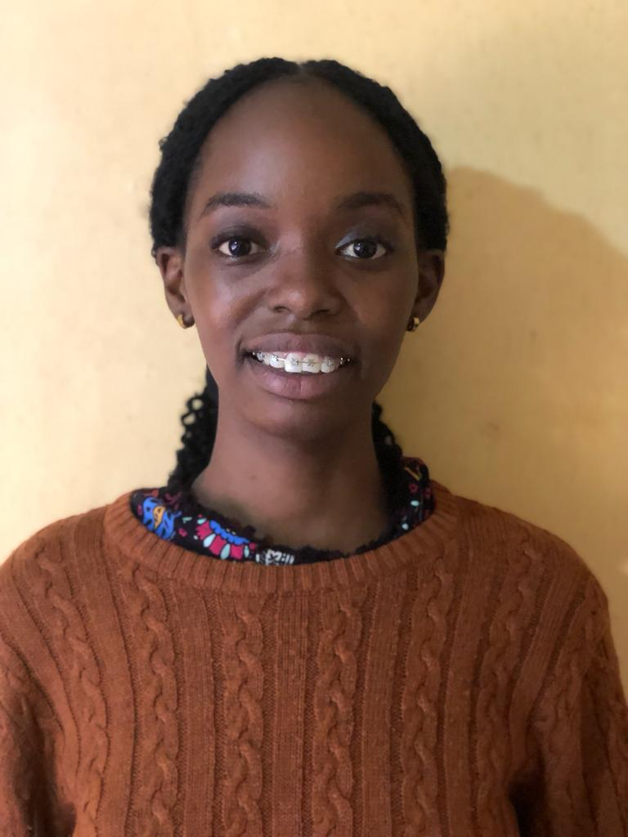MWAGALE TATIANA

CHINESE NAME: 钟尚娜

GENDER: FEMALE

Nationality: Uganda

DATE OF BIRTH: 28/04/2002

STATUS: SINGLE

PHONE CONTACT: +256750121549

EMAIL ADDRESS: tatianamwagale**@gmail.com**

**EDUCATION INSTITUTION Attended (with Dates):**

|  |  |  |
| --- | --- | --- |
| **YEAR** | **SCHOOL/ INSTITUTION** | **AWARD /CERTIFICATE** |
| 2021 to date | MAKERERE UNIVERSITY | Bachelor of Chinese and Asian studies |
| 2023 | CONFUCIUS INSTITUTE | **HSK 3 currently** |
| 2022 | CONFUCIUS INSTITUTE | **HSK 1 to 2** |
| 2019-2020 | NAALYA SECONDARY SCHOOL | UACE CERTIFICATE |
| 2015-2018 | SEETA HIGH SCHOOL | UCE CERTIFICATE |
| 2010 | MUGWANYA PPREARATORY SCHOOL, KABOJJA | PLE CERTIFICATE |

**ACADEMIC QUALIFICATIONS (with Dates):**

**Currently pursuing 汉语与亚洲专业三年级**

**Academic:**

**iii) Uganda Advanced Certificate of education: 2020**

**iv) Uganda Certificate of education: 2018**

**v) Primary leaving education certificate: 2014**

**WORK EXPERIENCE (With Dates):**

I) Worked as a librarain at Kabojja Junior School in 2018 and 2021

**Main Project features**

Skills Training

Case management

Client sustainability

Community service delivery

**Responsibilities**

Research

Communication

Team leader

**PERSONAL SKILLS**

* Knowledge of MS. Word and MS Excel and MS. PowerPoint

**LANGUAGE PROFICIENCY**

|  |  |  |
| --- | --- | --- |
| **Language** | **Spoken** | **Written** |
| English | Fluent | Excellent |
| Chinese | Good | Good |
| Luganda | Good | Good |

**CERTIFICATION**

I TATIANA MWAGALE do testify to the best of my knowledge, this CV best represents and witnesses my abilities, values, qualifications and experiences. Thank you.

**REFEREES**

**Madam CHEN SI QI, director Confucius institute Makerere university**

**+256780385685**

Mr. Ssensamba Zacharia**: Kabojja Junior School**

**Tel:** +256755222063