Allana Rose A. Saligumba

C334 – IT

MySQL successfully installed

PHP successfully installed 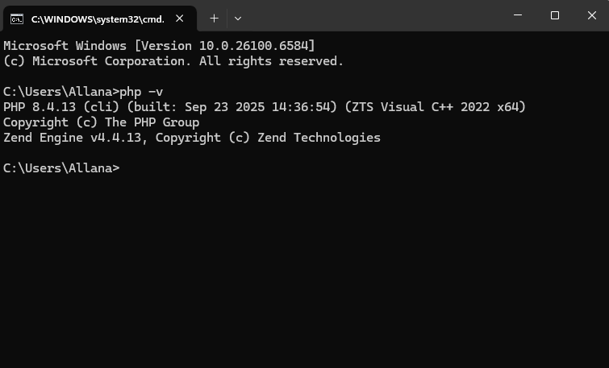

XAMPP running 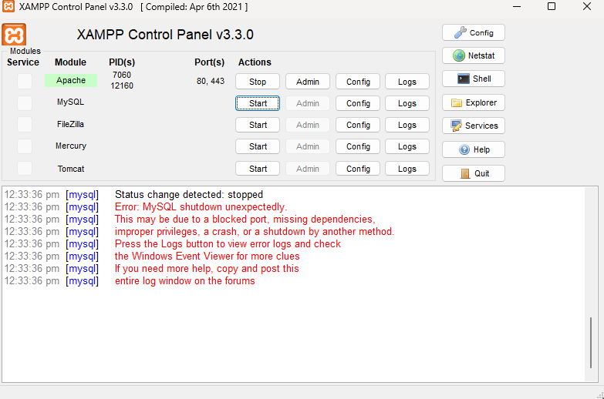

Simple PHP code displaying PHP version

http://localhost/version.php

