Dashboards by Feature — Analyst-Led Visualization Proposal
20 October 2026 · Visualization methods matched to the business question

Visualization approach
The best chart depends on the question the user needs to answer. This revision uses different methods for trends, comparisons, composition, process flow, exceptions, location, stock cover and prioritization. The figures below are mockups with illustrative data, not actual business results.
Business question | Recommended visualization | Why it fits
What needs attention today? | KPI scorecard + exception list | Mixed measures are clearer as labeled KPIs than one combined chart.
What reduced profit? | Waterfall chart | Shows how costs and expenses bridge sales to final profit.
What makes up landed cost? | Horizontal stacked bars | Compares total cost and each component across products.
Which products are slow movers? | Scatter plot with quadrants | Compares two measures and highlights high-stock/low-sales products.
Where are delays concentrated? | Route × stop heatmap | Makes recurring slow borders and stop points easy to spot.
Where do orders stall? | Stage/funnel bars | Shows counts dropping through the purchase process.
Where do quantities go missing? | Grouped bars + reconciliation table | Compares ordered, loaded and delivered quantities per order.
What causes the most delivery loss? | Pareto chart | Ranks loss drivers and shows cumulative contribution.
Which stock needs action? | Bullet-style stock-cover bars | Compares days of stock with a defined minimum target.
Which expenses drive cost? | Ranked bars | Makes the largest expense categories easy to identify and act on.
Which customer balances are risky? | Ageing stacked bars | Shows total debt and how long balances have remained unpaid.
Which alert should be handled first? | Severity × impact triage matrix | Combines urgency and business impact to prioritize action.

Illustrative visualizations
Each visual is paired with the type of decision it supports. Sample labels and values must be replaced by validated system data.

1. Executive overview — KPI scorecard
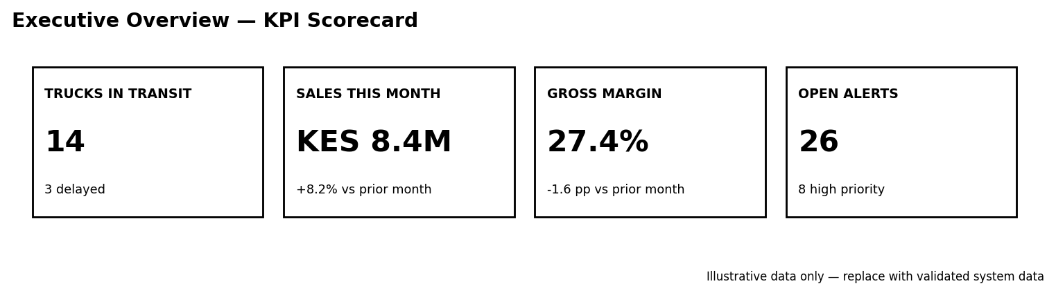
Use for the Directors' home screen. Keep each metric separate, show change against the previous period, and place delayed trucks and high-priority alerts in an exception list beneath the tiles.

2. Profit and margin — waterfall chart
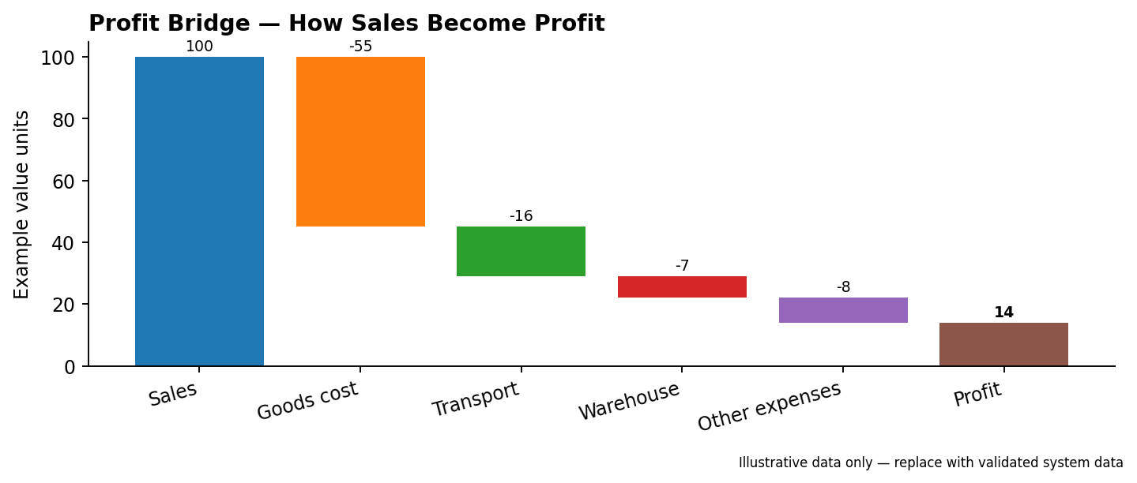
Use to explain how sales become profit after goods cost, transport, warehouse costs and other expenses. This is more diagnostic than a single stacked column because it shows the contribution of each deduction.

3. Landed cost per product — horizontal stacked bars
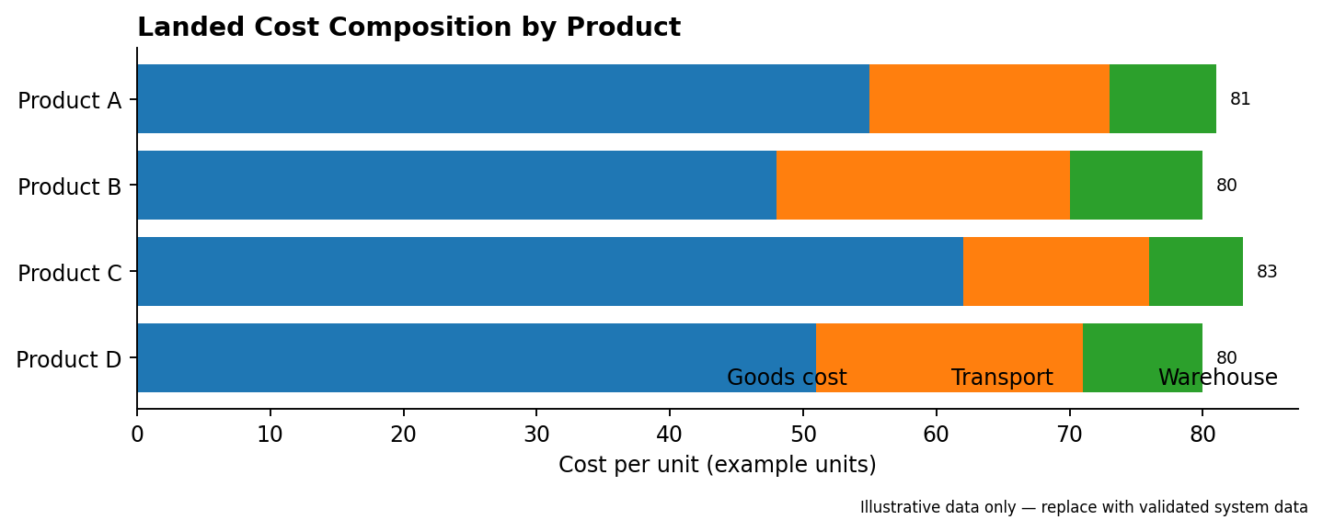
Use to compare the composition of unit cost across products. Include exact amounts in a drill-down table and clearly label the currency and unit.

4. Fast and slow products — scatter plot
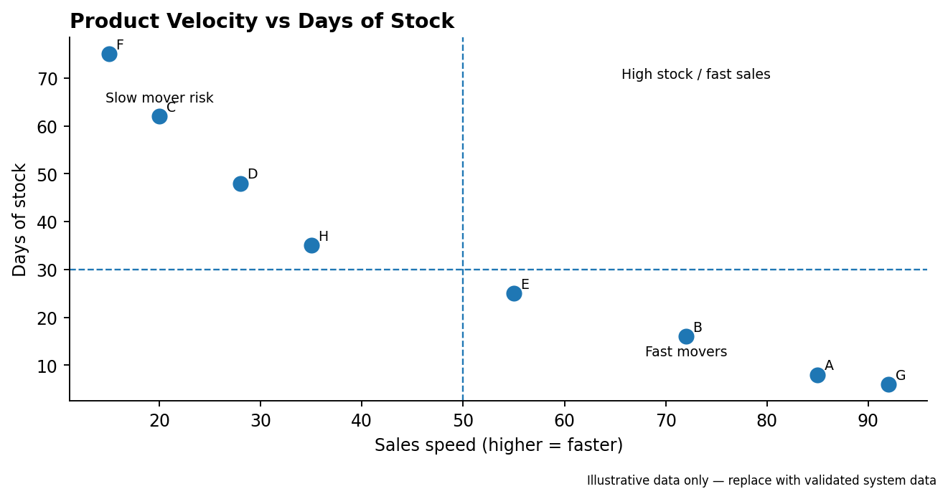
Use sales speed on one axis and days of stock on the other. Products with low sales speed and high stock cover deserve review; thresholds should be configurable by product category.

5. Border and stop analysis — heatmap
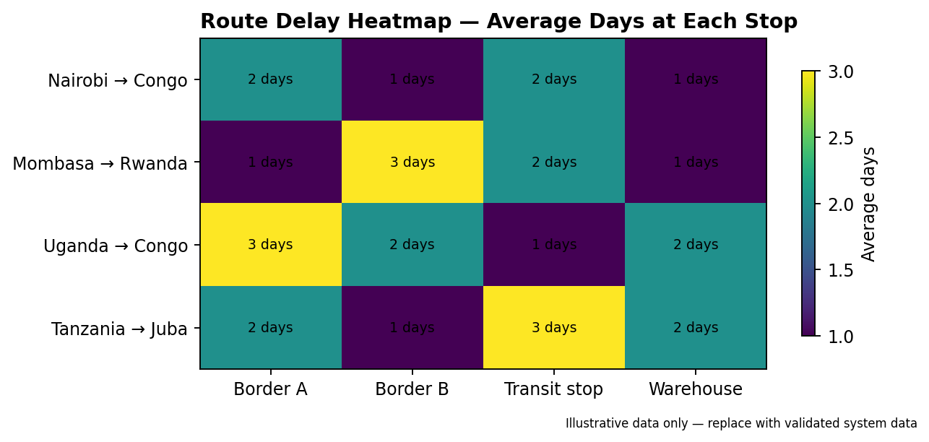
Use for average days at each stop by route. It reveals repeated delay hotspots; show the period and sample size so a small number of trips is not mistaken for a stable pattern.

6. Purchase order pipeline — stage bars
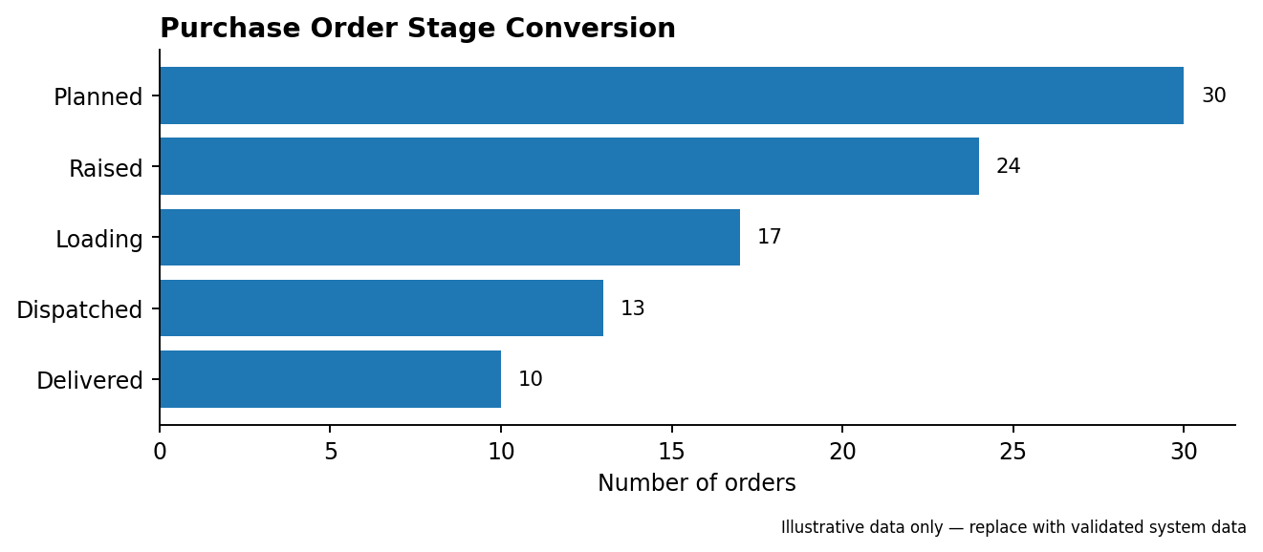
Use to monitor order counts at planned, raised, loading, dispatched and delivered stages. Clicking a stage should open the relevant orders and value, not just the count.

7. Ordered vs loaded vs delivered — grouped bars
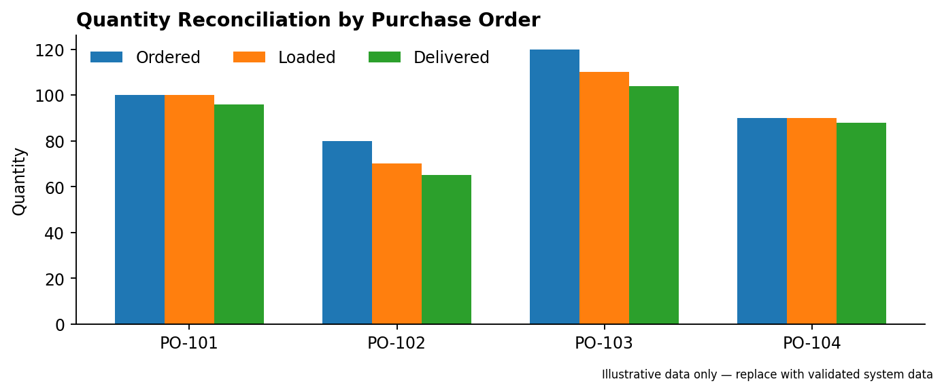
Use to compare quantities at each stage for every purchase order. Pair it with a table showing absolute and percentage gaps, since small differences can be important.

8. Delivery losses — Pareto chart
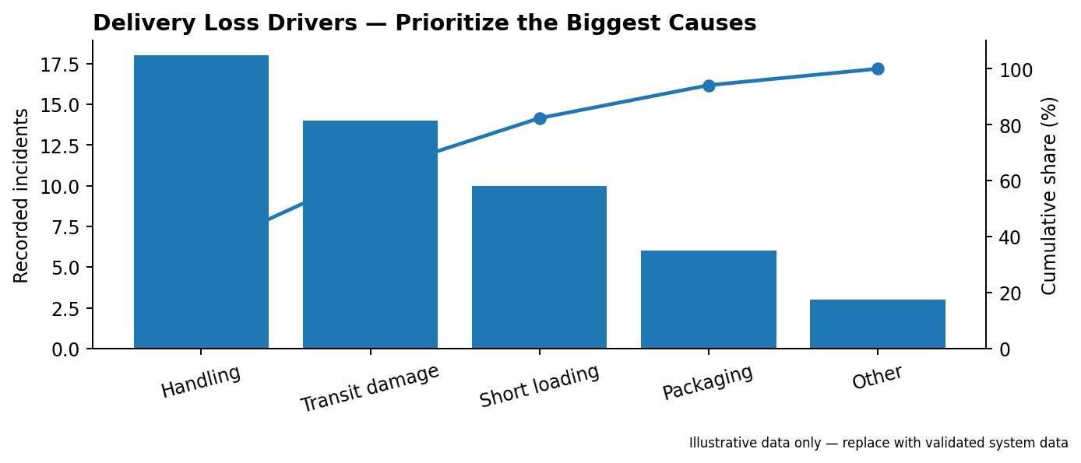
Use to rank causes of shortages and damages and show cumulative contribution. It helps teams focus on a few causes that account for a large share of incidents.

9. Stock on hand — stock-cover bars
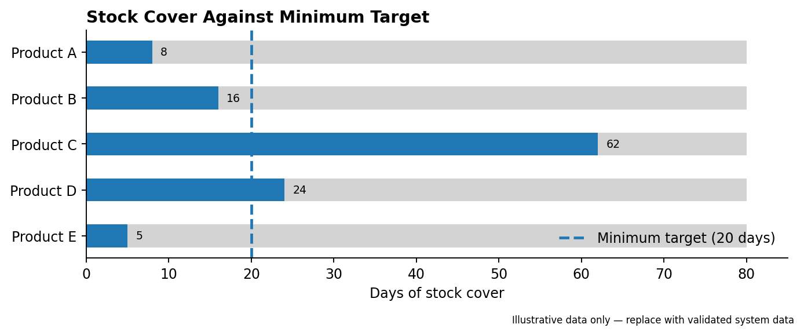
Use days of stock against a minimum target rather than only raw quantities. A threshold must be set per product; flag both stockout risk and excessive slow-moving stock.

10. Truck expenses — ranked category bars
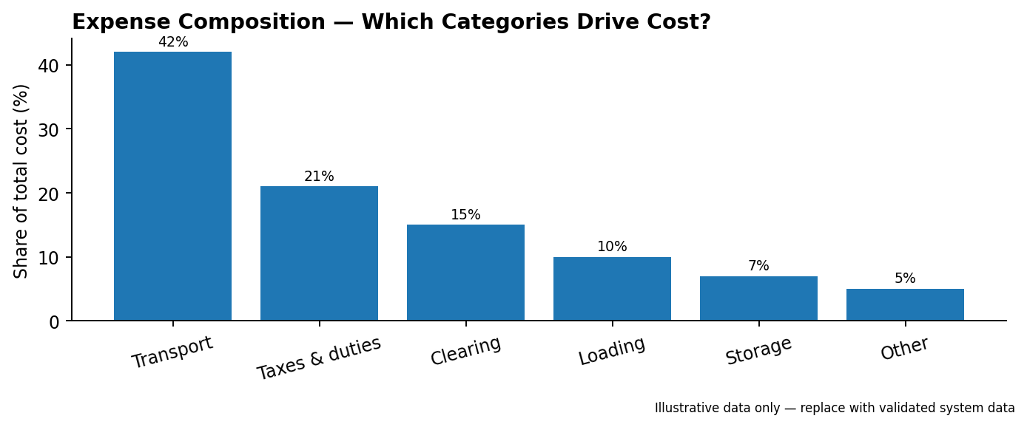
Use to compare transport, taxes, clearing, loading, storage and other costs. Add a month trend separately when the question is how costs change over time.

11. Customer balances — ageing stacked bars
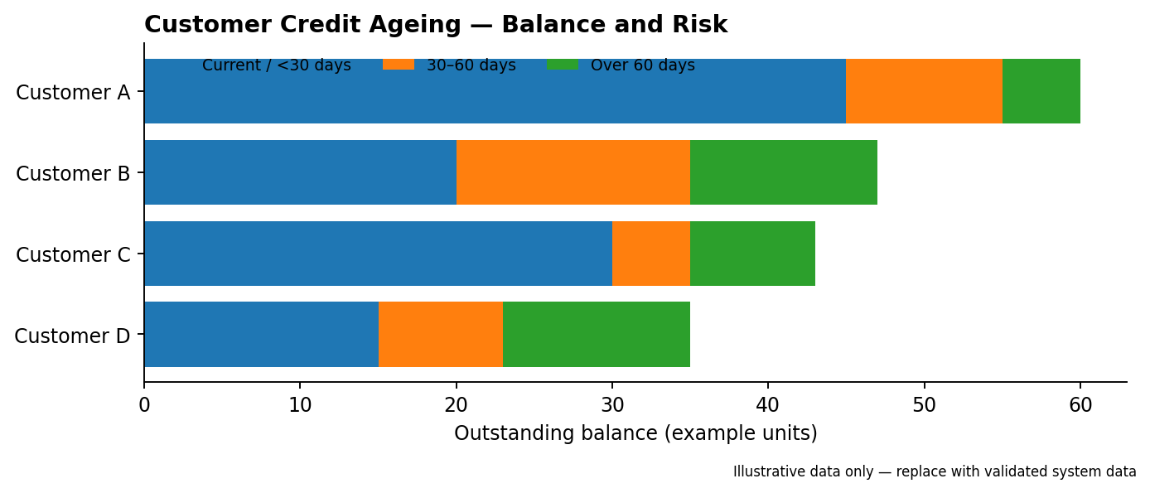
Use for credit exposure by customer and ageing band. Include overdue total, payment terms and a drill-down to invoices; do not treat all outstanding debt as equally risky.

12. Alerts centre — triage matrix
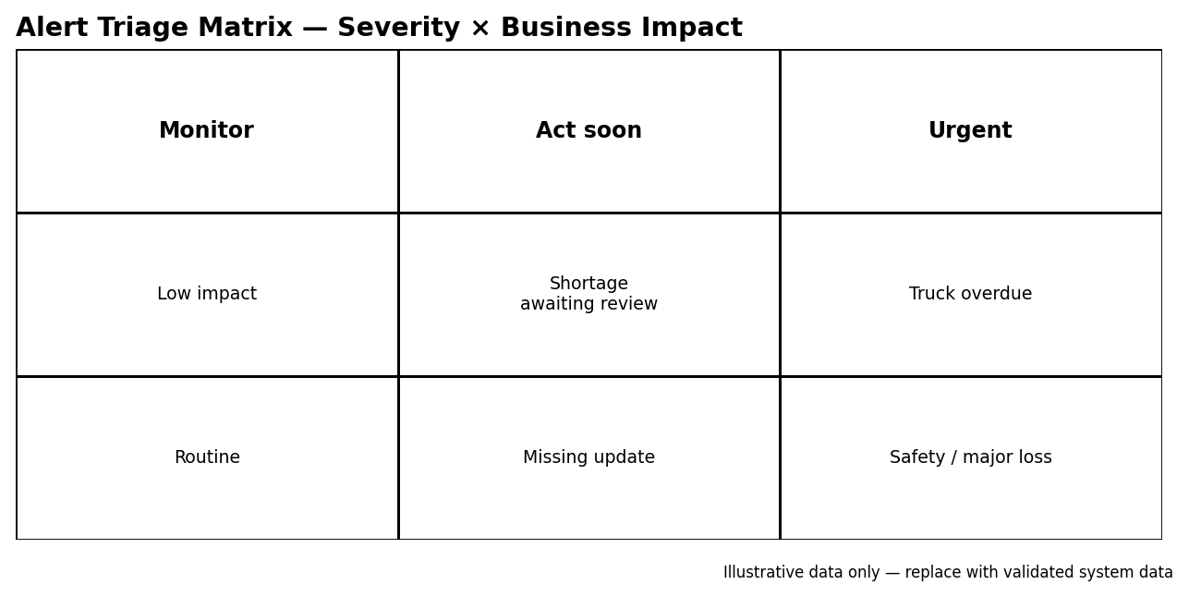
Use severity and business impact to prioritize action. Keep a named owner, due time, status and clear text label for every alert; the matrix supplements rather than replaces the alert list.

Additional recommendations for implementation
- Use line charts for trends over time, not for unrelated categories; use bar charts for comparisons and stacked bars only when component totals are meaningful.
- Use tables for exact values, document references, audit trails and operational worklists. Charts should help users spot patterns, not hide the underlying records.
- For route maps, plot only verified GPS coordinates and show the last update time. Fade stale positions and avoid implying a truck is live when its phone has not synced.
- For payments and approvals, use a status table with searchable references, ageing and action controls; use charts only for summary patterns.
- For mobile users, prioritize short lists, status chips, large tap targets and clear next actions over dense charts.
- Every chart should have a defined metric, unit/currency, date range, filters, data freshness indicator and drill-down path.
- Use consistent labels and accessible status cues; never rely on color alone. Validate that every metric has a clear definition and an accountable data owner.
- Treat sample visuals as design prototypes. Before launch, test them with actual users and check that the visualization answers a real operational question.

Original dashboard proposal
The original feature-by-feature scope is retained below as a reference. The analyst-led gallery above adds more suitable visualization patterns and explains when each should be used.

Purpose and shared rules
This proposal lists the dashboards to build for each feature in the Users, Roles and Access Control document: 56 in total, grouped by feature, each with its audience and the visualization used to show it. Every dashboard follows the access rules there, so a user sees only the companies, suppliers, warehouses and routes assigned to them.
Rules that apply to all dashboards:
- Filters: company, supplier, route, warehouse, product and date range, limited to what the user may see.
- Drill down: click any figure or chart element to reach the orders, trucks, deliveries or expenses behind it.
- Export: PDF, Excel and CSV for the Directors and office users.
- Mobile first for loaders, drivers and warehouse staff, who work from phones; driver screens work offline.
- Priority tags: P1 = needed at launch, P2 = soon after, P3 = later.

Shared visualization rules
- Chart choice: line charts for trends over time, bar charts for comparing categories, stacked bars for cost breakdowns, scatter plots for two-measure comparisons, heatmaps for route or border patterns, maps for position, and tables where users need exact figures.
- Status colors: the same everywhere. Green = on track or paid, amber = at risk or part paid, red = delayed, short, damaged or unpaid, grey = no data or not started.
- Never color alone: pair every status color with an icon or label so the screens work in sunlight and for color-blind users.
- KPI tiles: each shows the figure, change against the previous period, and a small trend line. Tapping a tile opens the drill-down.
- Money and units: always show currency and unit labels; one currency selector for the Directors.
- Mobile screens: one chart or list per screen, large tap targets, lists instead of charts for loaders, drivers and warehouse staff. Offline screens show a visible "last synced" time.
- Empty and partial data: show "no data yet" rather than a zero, so missing records are not mistaken for real zeros.

1. Directors: business overview and profit
Daniel and Michael need one home screen that shows where the business stands today, then deeper dashboards for margin, landed cost and pricing.
Dashboard
Audience
What it shows
Visualization
Priority
Executive overview
Directors
Today's snapshot: trucks on the road, delayed trucks, orders awaiting loading, stock value, sales this month, profit this month, open alerts
KPI tiles with trend lines; delayed trucks and alerts in red; a short list of top alerts below
P1
Combined performance
Directors
Quantity received, landed cost, cost per unit, selling price, sales, profit and margin; switch between product, warehouse, company and whole business
Summary table with in-cell bars; waterfall chart from sales down to profit; view switcher
P1
Profit and margin
Directors
Revenue, cost of units sold, expenses, profit and margin % by product, warehouse and company, with trend over months
Stacked columns (cost, expenses, profit) per month with a margin % line on top
P1
Landed cost per product
Directors
Goods cost + truck cost + warehouse expenses = landed cost per unit, with the share each part contributes
Horizontal stacked bar per product (goods, truck, warehouse) with share labels
P1
Landed cost per truck
Directors
Cost of each truck: agreed transport price, taxes and duties, clearing and forwarding, loading and offloading, storage, other charges
Stacked bar per truck; sortable table beneath; trucks above average cost highlighted
P1
Selling price and target margin helper
Directors
Landed cost per unit, current selling price, current margin, and the price needed for a target margin you enter
Interactive calculator with a target-margin slider; gauge showing current against target margin
P1
Fast and slow products
Directors
Products ranked by sales speed and days of stock, with slow movers flagged
Scatter plot (sales speed against days of stock) with quadrants; slow movers in red
P2
Company comparison
Directors
BTW, Nihna, Kivu, Asie and Yonas side by side on sales, cost, profit and stock
Small-multiple bar charts, one per measure, same company order and colors
P2
Route comparison
Directors
Cost per unit and delivery time by route: Nairobi, Uganda, Mombasa and Tanzania to Congo, Rwanda and Juba
Bar chart of cost per unit by route; heatmap of delivery days (origin by destination)
P2
Supplier comparison
Directors
KBL, UBL, GBI and SBL by volume bought, cost, loading speed and shortages
Supplier scorecard: bars for volume and cost, dot markers for loading speed and shortage rate
P3
Example: Profit and margin
Example: Landed cost per product

2. Purchasing and planning
Kabonge needs to see what is planned, ordered and still waiting to be loaded for BTW–KBL, Nihna–UBL and Kivu–SBL.
Dashboard
Audience
What it shows
Visualization
Priority
Purchase order pipeline
Kabonge, Directors
Orders by stage: planned, raised, loading, dispatched, delivered; count and value per stage
Funnel or stage columns showing count and value; click a stage to list its orders
P1
Ordered vs loaded vs delivered
Kabonge, Directors
Quantities per order and product, with the gap at each step
Grouped bars (ordered, loaded, delivered) per order; gap shown as a labelled difference
P1
Open and ageing orders
Kabonge
Orders raised but not loaded, sorted by days waiting
Sorted table with an age bar and color bands (under 3 days, 3 to 7, over 7)
P2
Plan vs actual
Kabonge, Directors
Planned purchase quantity against what was ordered and delivered, by month and buyer–supplier pair
Clustered columns by month (plan, ordered, delivered) with a buyer–supplier filter
P2
Supplier performance
Directors
Per supplier: orders, quantity, days to load, shortages
Scorecard table with bars and trend arrows
P3
Example: Purchase order pipeline

3. Loading
Loaders at KBL Nairobi (Joel, Eric), UBL Kampala (Moses) and GBI Mombasa (Testfie) need a short to-do list, and the Directors need to see loading speed and accuracy.
Dashboard
Audience
What it shows
Visualization
Priority
Today's loading list
Loaders, Testfie (Mombasa)
Orders ready to load at their point, with truck, driver and quantity ordered; no prices
Mobile card list with large status chips (ready, loading, loaded); no charts
P1
Loading status
Kabonge, Directors
Loaded against ordered per order, who loaded, documents and photos attached
Progress bar per order (loaded of ordered) with document and photo icons
P1
Dispatched today
Loaders, Directors
Trucks dispatched in the last 24 hours, by loading point and destination
Mobile list grouped by loading point; count tiles for the Directors
P2
Loading accuracy and time
Directors
Over- and under-loading, and hours from truck arrival to dispatch, by loading point
Diverging bar for over- and under-loading; box plot or column chart for hours to dispatch
P3

4. Fleet follow-up, truck issues and driver app
Testfie follows every truck on every route; trip status also arrives from drivers' phones, including updates sent after being offline.
Dashboard
Audience
What it shows
Visualization
Priority
Live fleet board
Testfie, Directors
Every truck by route and status: loaded, in transit, at border, stopped, arrived; expected arrival date
Kanban-style board by status, grouped by route; status counts across the top
P1
Map view
Testfie, Directors
Last reported position or stop of each truck on a route map
Route map with status-colored truck pins; stale positions shown faded
P2
Delayed trucks
Testfie, Directors
Trucks past their due date, days late, reason, and who needs to act
Table sorted by days late with a red severity bar and owner column
P1
Truck issues
Testfie, Directors
Open issues: what happened, where, days stopped, when fixed; repeat issues by truck and provider
Open-issues table with days-stopped bars; bar chart of repeat issues by truck and provider
P1
Border and stop analysis
Directors
Average days at each border and stop point, by route
Heatmap (stop point by route) of average days; bar chart for the slowest stops
P3
Driver status updates
Testfie
Updates received from the driver app, last update time per truck, and trucks with no update for over a set number of hours
Timeline feed with a last-update badge per truck; amber and red when the gap passes the limit
P1
Offline sync monitor
Testfie, admin
Updates waiting on phones, time between update made and received, and drivers who have not synced recently
Table of drivers with pending count and last sync; histogram of sync delay
P2
Re-export trucks Rwanda to Juba
Asie, Directors
Status of re-export trucks, which has no follow-up owner yet (see roles document)
Status board like the live fleet board, with an "owner not assigned" warning tag
P2
Transport provider performance
Directors
ETS Sabrina, Joly and Company 3 compared on transit days, delays, issues and cost
Small-multiple bars for transit days, delays, issues and cost, one per provider
P3
Example: Live fleet board

5. Truck expenses and transport fees
These dashboards track what each truck costs, what was agreed after loading, and which transport fees are paid against which document reference.
Dashboard
Audience
What it shows
Visualization
Priority
Agreed transport price
Testfie, Directors
Price agreed after loading per truck and leg, against actual transport cost
Paired bars (agreed, actual) per truck; variance column colored red when over
P1
Transport fee payments
Testfie, Directors
Each fee as paid, part paid or unpaid, with the document reference it was paid against
Table with paid, part paid and unpaid chips and a payment progress bar; reference number searchable
P1
Unpaid and ageing fees
Directors
Unpaid fees by age (for example over two weeks and over one month), by provider
Stacked bar by age band (under 2 weeks, 2 weeks to 1 month, over 1 month) per provider
P1
Expenses per truck
Testfie, Directors
Transport, taxes and duties, clearing and forwarding, loading and offloading, storage, other charges per trip and leg
Stacked bar per trip with legs expandable; category legend consistent across screens
P1
Expense breakdown
Directors
Truck expenses by category, route and provider, with month trend
Donut or treemap by category; stacked column trend by month
P2
Cost per unit by route
Directors
Truck cost divided by units delivered, by route and by provider
Bar chart by route; dot plot by provider within each route
P2
Payment approvals
Directors
Trip payments waiting for approval, approved and paid
Approval queue with status chips and total value waiting; approve action beside each row
P2
Example: Unpaid and ageing fees

6. Delivery acknowledgement
Asie and Yonas confirm what arrived; the Directors need to see shortages and damages quickly.
Dashboard
Audience
What it shows
Visualization
Priority
Incoming deliveries
Asie, Yonas
Trucks heading to their warehouse with expected arrival and quantities, plus trucks waiting to be acknowledged
Mobile card list ordered by expected arrival; "acknowledge" badge on arrived trucks
P1
Received, damaged and short
Asie, Yonas, Directors
Quantities received, damaged and short per delivery and product, with signature, stamp and photos
Stacked bar per delivery (received, damaged, short); photo and signature thumbnails on drill-down
P1
Outstanding acknowledgements
Directors, Kabonge
Deliveries arrived but not yet acknowledged, by receiver and days waiting
Table sorted by days waiting with age bars; count by receiver
P2
Shortage and damage trends
Directors
Loss rate by route, supplier, transport provider and driver, to spot patterns
Line chart of loss rate over time; heatmap of loss rate by route and provider; top-driver bar chart
P2
Example: Received, damaged and short

7. Warehouse inventory and expenses
The person at each warehouse records stock and expenses; these dashboards give them their daily view and the Directors the whole picture. Goods for Congo and Rwanda are recorded at Asie, goods for Juba at Yonas.
Dashboard
Audience
What it shows
Visualization
Priority
Stock on hand
Asie, Yonas, Directors
Stock by warehouse and product: received, held, moved out, damaged
Stacked bar per product (held, moved out, damaged); simple list on mobile
P1
Stock in transit
Directors, Asie, Yonas
Goods on the road heading to each warehouse, by truck and expected arrival
Timeline of expected arrivals with quantity per truck; totals per warehouse
P1
Low stock and slow stock
Asie, Yonas, Directors
Products running low, and products with many days of stock and little movement
Bullet bars showing days of stock against a minimum; slow movers flagged in amber
P2
Stock movements
Asie, Yonas
Daily log of stock in and out by product, including re-exports Rwanda to Juba
Daily in and out columns with a running balance line; log table beneath
P2
Warehouse expenses
Asie, Yonas, Directors
Offloading, storage, salary, rent, utilities and damaged goods by month, with each category's share
Stacked column by month; donut for category share
P1
Damaged goods
Asie, Yonas, Directors
Damaged stock by product, cause, route and value lost
Bar by cause; table of value lost by product and route
P2
Warehouse comparison
Directors
Each warehouse on stock value, expenses and cost per unit handled
Side-by-side bars for stock value, expenses and cost per unit handled
P3

8. Sales and company accounting
Each receiving company keeps its own accounts: stock, cash, credit and batch sales, expenses, profit and loss, retained earnings and dividends. Who records sales is still to be confirmed, so these start as Directors-only.
Dashboard
Audience
What it shows
Visualization
Priority
Sales summary
Directors
Sales by company, brand, product and customer, split into cash, credit and batch sales
Stacked column by month (cash, credit, batch); ranked bars for top products and customers
P1
Customer balances
Directors
Credit owed by each customer, age of balances, overdue amounts
Ranked bar of balance owed; stacked ageing bands per customer; overdue in red
P1
Profit and loss per company
Directors
Revenue, cost of goods, expenses and profit for Asie and Yonas, by month
Waterfall (revenue to profit) per company; monthly line for profit
P2
Retained earnings and dividends
Directors
Earnings kept, dividends paid, and what is available per company
Stacked bar per company (retained, paid out, available); line over time
P3
Cash and credit position
Directors
Cash received against credit given, by company and period
Dual columns (cash, credit) by period with a cash share % line
P2

9. Administration, audit and alerts
Because every user must log in, the Directors can see who is using the system and what changed.
Dashboard
Audience
What it shows
Visualization
Priority
Users and logins
Directors
Users by role, last login, inactive users, deactivated users
Table with role chips and last-login date; inactive users flagged; count tiles on top
P1
Audit log
Directors
Who did what and when, searchable by user, feature and date
Searchable event table with before and after values; activity-by-day sparkline
P1
Alerts centre
Directors, Testfie, Kabonge
Delays, shortages, damages, unpaid fees and missing updates, each with an owner and status
Prioritized list with severity icons, owner and status; count tiles by alert type
P1
Data completeness
Directors
Missing records: loadings without photos, deliveries not acknowledged, trucks without an agreed price, warehouses with no expense entries this month
Checklist of completeness scores with progress bars; each links to the missing records
P2
Daily and weekly digest
Directors
One summary sent by email or phone with the main figures and exceptions
Compact email or phone card: KPI row, mini trend lines, top exceptions
P3

10. Who gets which dashboards, and build order
There are 56 dashboards: 28 at P1, 20 at P2 and 8 at P3. Each user gets a home screen made of only their own dashboards.
User
Home screen contains
Directors (Daniel, Michael)
Everything: executive overview, profit and margin, landed cost, pricing helper, fleet, expenses, stock, sales, audit and alerts
Kabonge
Purchase order pipeline, ordered vs loaded vs delivered, open orders, plan vs actual, alerts
Testfie
Live fleet board, delayed trucks, truck issues, driver updates, agreed prices, fee payments, expenses per truck, Mombasa loading list
Joel, Eric, Moses
Today's loading list and dispatched today, with no prices or payments
Asie, Yonas
Incoming deliveries, received, damaged and short, stock on hand, stock movements, warehouse expenses, damaged goods
Drivers
Mobile app only: own trip, status update and sync state
Suggested build order:

1. P1, first release: the Directors' overview, margin and landed-cost dashboards, plus the daily working screens for Testfie, loaders, drivers and warehouse staff, so the data they record starts flowing from day one.

2. P2, second release: comparisons, trends, approvals, data completeness and the offline sync monitor, once a few weeks of data exist.

3. P3, later: supplier, provider and warehouse comparisons, retained earnings and the daily and weekly digest.
Open questions: whether the P1 list matches your first-release scope, and who will see sales and accounting dashboards beyond the Directors.

