System Capacity and Care Load Analytics for Unaccompanied Children
Project Report
1. Introduction
The UAC program takes children who are caught by CBP and moves them to HHS care. After that they are given medical and welfare support and then sent to sponsors. HHS collects daily numbers but does not have one simple way to see how full the system is. In this project I used the daily data to find the total number of children under care, whether more children are coming in than going out, and when the system was under strain or had relief.
2. Data
The dataset has daily numbers for children apprehended, children in CBP custody, children transferred out of CBP, children in HHS care and children discharged from HHS. It covers January 2023 to December 2025.
3. Data Cleaning
- The file had 450 empty rows, so I removed them. 720 days of data were left.
- I changed Date to a date format, sorted it, and changed the HHS care numbers (like 2,484) to numbers.
- There were no duplicate dates and no missing values.
- About 355 dates (33%) have no report, mostly weekends and holidays. I did not fill these in.
- Discharges were never more than HHS care. But transfers were more than CBP custody on 86 days. I marked these days but kept them.
4. Metrics I Calculated
- Total load = CBP custody + HHS care
- Net daily intake = transfers into HHS - discharges
- Growth rate = day to day percent change in total load
- Backlog = the 7-day average of net intake stays above 0
- 7-day and 14-day rolling averages
5. Results
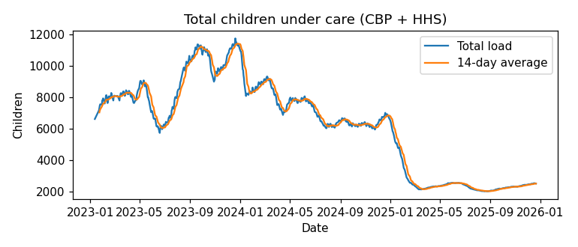
Figure 1: Total load
The total load went up in 2023 and reached its highest point of 11,762 children on 2023-12-20. It then came down in 2024 and dropped a lot in early 2025. From March 2025 it stayed around 2,000 to 2,500. The lowest was 2,002 on 2025-08-24.
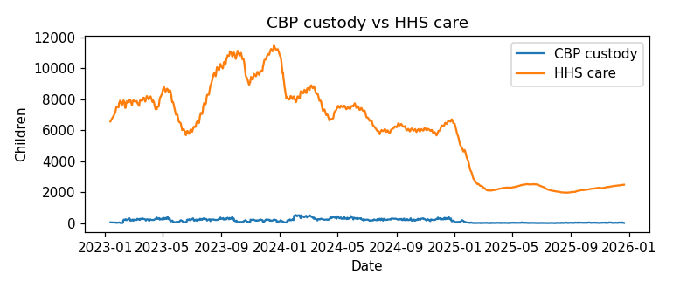
Figure 2: CBP vs HHS
Most of the children are in HHS care (about 97.5% of the total). CBP custody is small, with a highest value of 531 children. So HHS is where capacity matters most.
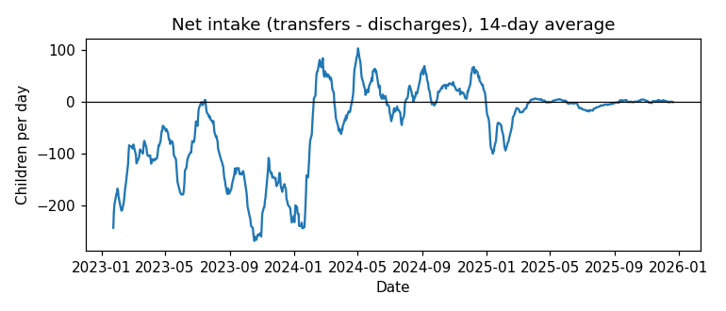
Figure 3: Net intake
In 2023 more children were discharged than transferred, so net intake was negative. In 2024 it was about the same (slightly positive), and backlog was seen on 67% of days. In 2025 net intake was negative again. Over the whole period discharges were 1.35 times the transfers.
Year | Avg load | Peak load | Net intake/day | Discharges / transfers
2023 | 8,847 | 11,762 | -131 | 1.83
2024 | 7,320 | 10,994 | 3.4 | 0.98
2025 | 2,576 | 6,471 | -12.4 | 1.75

6. Strain and Relief
I called it strain when the 14-day average load was in the top 25% (above 8,282) and relief when it was in the bottom 25% (below 2,494). The longest strain period was about 170 days, from August 2023 to January 2024, with average load above 10,000. All the relief periods were in 2025, each lasting about 3 months or more.
7. KPIs
KPI | Value
Total children under care (latest) | 2,502
Net intake pressure | -44.7 per day
Care load volatility index | 1.14%
Backlog accumulation rate | 34% of days
Discharge offset ratio | 1.35

8. Recommendations
- Keep watching the 14-day average load. If it goes above 8,282 and net intake stays positive for a week or more, plan for extra staff and shelter space.
- Use the average instead of single days, because daily numbers go up and down.
- Keep discharges and sponsor placements moving, since this is what brings the load down.
- Report every day and also record total admissions to HHS. I found that HHS care went up more than the transfer numbers explain, so some children probably come in from other sources.
9. Limitations
- Many dates are missing, so totals only cover reported days.
- The data only has counts, nothing about age, health or location.
- The strain limits are based on this data only, not on real bed capacity.
- I cannot say why the load dropped in 2025 from this data.
10. Conclusion
The system had a long high-load period at the end of 2023 and then became much smaller in 2025. Tracking total load, net intake and rolling averages can help HHS see problems earlier and plan staff and shelters better.

