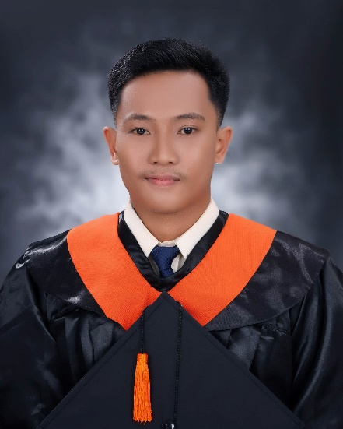**ALLAN JUSTINE MASCARIÑAS**

Purok-2 Tinangnan, Tubigon, Bohol

09512072888

[labya31@gmail.com](mailto:labya31@gmail.com)

**OBJECTIVES**

I am actively seeking employment within an organization that offers opportunities for professional growth. My aim is to continually enhance my skills, expand my knowledge, and gain valuable experience in a challenging work environment, contributing to both my personal development and the success of the organization.

**PERSONAL DATA**

Nationality : Filipino

Date of Birth : June 01, 2001

Place of Birth : Simbajon Medical Clinic, Tabunoc, Talisay City, Cebu

Age : 24

Height : 157cm

Weight : 65kls

Religion : Roman Catholic

Status : Single

**EDUCATIONAL BACKGROUND**

**Elementary School**

**2009-2012**

Tubigon West Central Elementary School

Pooc Oriental, Tubigon, Bohol

**High School**

**2012-2018**

Salus Institute of Technology

Cabulijan, Tubigon, Bohol

**College**

**2019-2023**

Bachelor of Science in Information Technology

Mater Dei College

Cabulijan, Tubigon, Bohol

**TRAININGS AND EXPERIENCE**

**On-the-Job Training (OJT)**

LGU Tubigon — Potohan, Tubigon, Bohol

**2023** (486 hours)

* Supported day-to-day IT operations
* Assisted in maintaining computer hardware and software systems

**Government Internship Program (GIP)**

LGU Tubigon, IT Office — Potohan, Tubigon, Bohol

**2023** (1 month)

* Assisted in basic IT support and documentation tasks
* Gained exposure to public sector digital processes

**Web Developer**

*SMCT Group of Companies — J.A. Clarin St, Tagbilaran City, Bohol*

**2024** **–** **2025**

* Full-stack development using Laravel, Next, React, and other modern web technologies
* Maintained and developed internal web systems for business operations
* Collaborated with the IT team to troubleshoot and deploy updates

**SKILLS AND ABILITIES**

**Technical Skills**

* **Frontend:** Proficient with HTML, CSS, JavaScript, TypeScript, Bootstrap, Tailwind CSS, React.js, Next.js, Vue.js, Livewire
* **Backend:** Proficient with Laravel (Blade & Livewire), REST APIs, NestJS
* **Full-stack Development:** Experience building full-stack applications using Laravel with Blade or Livewire, as well as React/Next.js frontends connected to Laravel/NestJS APIs
* **Version Control:** Basic knowledge of Git and GitHub
* **Hardware & Troubleshooting:** Understanding of computer hardware components, assembly/disassembly, and basic troubleshooting

**Soft Skills**

* Team-oriented and able to work collaboratively
* Willing and eager to learn new technologies
* Able to multi-task and adapt to changing priorities
* Can work well under pressure
* Flexible and open to feedback

**Other Skills**

* Familiar with Microsoft Word and basic office applications

**REFERENCES**

MRS. JOSEFINA J. PANGAN

Chairman, College of Arts, Sciences and Technology

09239113760

Mater Dei College

Cabulijan, Tubigon, Bohol