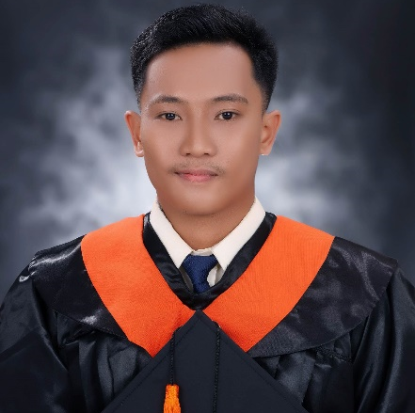
ALLAN JUSTINE MASCARIÑAS
Purok-2 Tinangnan, Tubigon, Bohol
09512072888
labya31@gmail.com

OBJECTIVES
I am actively seeking employment within an organization that offers opportunities for professional growth. My aim is to continually enhance my skills, expand my knowledge, and gain valuable experience in a challenging work environment, contributing to both my personal development and the success of the organization.

TRAININGS AND EXPERIENCE
On-the-Job Training (OJT)
LGU Tubigon — Potohan, Tubigon, Bohol
2023 (486 hours)
- Supported day-to-day IT operations
- Assisted in maintaining computer hardware and software systems
Government Internship Program (GIP)
LGU Tubigon, IT Office — Potohan, Tubigon, Bohol
2023 (1 month)
- Assisted in basic IT support and documentation tasks
- Gained exposure to public sector digital processes
Web Developer
SMCT Group of Companies — J.A. Clarin St, Tagbilaran City, Bohol
2024 – 2026
- Full-stack development using Laravel, Next, React, and other modern web technologies
- Maintained and developed internal web systems for business operations
- Collaborated with the IT team to troubleshoot and deploy updates
SKILLS AND ABILITIES
Technical Skills
- Frontend Development: HTML, CSS, JavaScript, TypeScript, Bootstrap, Tailwind CSS, React.js, Next.js, Vue.js, and Livewire
- Backend Development: Laravel, NestJS, RESTful API development, API integration, and server-side application development
- Full-Stack Development: Experience building full-stack applications using Laravel with Blade or Livewire, Laravel with Inertia.js and React.js/Vue.js, and separate React.js/Next.js or Vue.js frontends integrated with Laravel or NestJS REST APIs
- Authentication & API Security: JWT authentication, Bearer Token authentication, Laravel Sanctum, OAuth 2.0, and social login integration
- Real-Time Development: Experience implementing real-time features using Laravel Reverb and WebSockets
- Deployment & DevOps: Basic knowledge of Docker, including container management, Docker commands, and basic application deployment
- Version Control: Basic knowledge of Git and GitHub
- Hardware & Troubleshooting: Understanding of computer hardware components, assembly/disassembly, and basic troubleshooting
Soft Skills
- Team-oriented and able to work collaboratively
- Willing and eager to learn new technologies
- Able to multi-task and adapt to changing priorities
- Can work well under pressure
- Flexible and open to feedback
Other Skills
- Familiar with Microsoft Word and basic office applications

EDUCATIONAL BACKGROUND
Elementary School
2009-2012
Tubigon West Central Elementary School
Pooc Oriental, Tubigon, Bohol

High School
2012-2018
Salus Institute of Technology
Cabulijan, Tubigon, Bohol

College
2019-2023
Bachelor of Science in Information Technology
Mater Dei College
Cabulijan, Tubigon, Bohol

REFERENCES
MRS. JOSEFINA J. PANGAN
Chairman, College of Arts, Sciences and Technology
09239113760
Mater Dei College
Cabulijan, Tubigon, Bohol

