— TECHNICAL DOCUMENTATION · v2.0 —
GemiFlix Endpoint
Integration & Migration Plan
Bridging the v1.0 Audit with the Moviebox-API Facade
A Layer-by-Layer Endpoint Catalogue and Cut-Over Plan
Document Type: Technical Documentation — In-Depth Research
Version: 2.0 (supersedes v1.0 architecture document)
Date: 2026-08-04
Predecessor: GemiFlix_MovieboxAPI_Integration_TechnicalDoc_v1.0
Scope: Endpoint audit · Gap analysis · Cache-aside · Migration plan
Status: Production Reference

Document Control
This document is the v2.0 follow-up to the GemiFlix Moviebox-API Integration Technical Documentation (v1.0). Whereas v1.0 specified the reverse-engineering methodology and the FastAPI facade architecture, v2.0 maps that architecture onto the actual GemiFlix v1.0 codebase as observed in the endpoint audit supplied by the project maintainer. The audit revealed thirteen implemented server routes, twenty client-side fetch calls, and three orphan routes, with the entire movie catalogue running on static mock data and the Moviebox API integration left entirely unimplemented. This document specifies how to close each gap in a phased, low-risk cut-over.

Version History
Version | Date | Author | Change Summary
2.0 | 2026-08-05 | GemiFlix Engineering | Adds endpoint audit findings (13 routes, 20 fetch calls, 3 orphans, mock-data catalog, 9 proposed external endpoints, 10 missing DB endpoints). Specifies cache-aside pattern, Prisma schema extension, four-phase migration plan, and complete code listings for every new route.
1.0 | 2026-08-05 | GemiFlix Engineering | Initial publication. Reverse engineering workflow, Moviebox-API FastAPI facade, Jellyfin-compatible contract, VLC/MPV streaming, SQLite schema, deployment.

Relationship to v1.0
This document is companion to, not a replacement for, v1.0. v1.0 remains the canonical reference for the Moviebox-API reverse engineering methodology (its Layer 1), the TokenManager and HeaderBuilder classes (its Layer 2), the Jellyfin-compatible REST contract (its Layer 3), the VLC and MPV integration patterns (its Layer 4), and the deployment topology. v2.0 assumes all of those as prerequisites and focuses on the work that v1.0 did not address: mapping the facade onto the existing Next.js + Prisma codebase, replacing mock-data imports with live API calls, and adding the nineteen missing endpoints identified by the audit.

Reading Conventions
Throughout this document, audit category references use the shorthand Cat-1 through Cat-5, matching the five categories in the supplied audit. Endpoint references use the HTTP method and path format (for example, GET /api/external/search). Code blocks appear on a light gray background with a caption above each listing. Callout boxes colored blue, orange, red, and green denote informational notes, warnings, critical hazards, and best-practice recommendations respectively.

Table of Contents
This document is organised in four movements. Part I (Sections 1-3) establishes the current state of the GemiFlix codebase as revealed by the audit. Part II (Sections 4-6) specifies the target architecture and the Prisma schema extension required to support it. Part III (Sections 7-10) provides the endpoint-by-endpoint implementation guide, with complete code listings for every new route. Part IV (Sections 11-14) covers the migration plan, testing, risks, and references.
Executive Summary ·························································· 5
Part I — Current State ····················································· 6
1. Audit Findings and Inventory ············································ 6
1.1 Methodology of the Audit ············································ 6
1.2 Category 1: DB-Backed Endpoints (Working) ··························· 7
1.3 Category 2: Orphan Routes ··········································· 8
1.4 Category 3: Mock-Data Endpoints ····································· 9
2. Gap Analysis ···························································· 11
2.1 Category 4: Missing MovieBox API Endpoints ·························· 11
2.2 Category 5: Missing DB Endpoints ···································· 12
2.3 Cross-Category Dependencies ········································· 13
3. Caller-by-Caller File Inventory ········································· 14
3.1 auth-store.ts (7 fetch calls) ······································· 14
3.2 SettingsPage.tsx (9 fetch calls) ···································· 14
3.3 NotificationBadge.tsx (3 fetch calls) ······························· 15
3.4 ContinueWatching.tsx (1 fetch call) ································· 15
3.5 SearchResults.tsx (1 fetch call) ···································· 15
3.6 Static-Import Files (0 fetch calls) ································· 15
Part II — Target Architecture ·············································· 17
4. Target State Architecture ··············································· 17
4.1 Unified API Surface ················································· 17
4.2 The Moviebox Facade in a Next.js World ······························ 18
4.3 Cache-Aside Pattern ················································· 19
5. Prisma Schema Extension ················································· 21
5.1 New Models Required ················································· 21
5.2 Complete schema.prisma Snippet ······································ 22
5.3 Migration Commands ·················································· 25
6. The Moviebox Client Library ············································· 26
6.1 lib/moviebox-client.ts ·············································· 26
6.2 Token Management ···················································· 27
6.3 Header Construction ················································· 28
Part III — Endpoint Implementation Guide ··································· 29
7. Category 4 Implementation (External API) ································ 29
7.1 GET /api/external/search ············································ 29
7.2 GET /api/external/movie/[id] ········································ 30
7.3 GET /api/external/trending ·········································· 31
7.4 GET /api/external/genres ············································ 32
7.5 GET /api/external/discover ·········································· 33
7.6 GET /api/external/top-rated ········································· 34
7.7 GET /api/external/recommendations/[id] ······························ 34
7.8 GET /api/external/stream/[id] ······································· 35
7.9 POST /api/external/import ··········································· 36
8. Category 5 Implementation (DB CRUD) ····································· 37
8.1 Migrating /api/movies to DB-Backed ·································· 37
8.2 Admin Movie CRUD Endpoints ·········································· 38
8.3 Watchlist Endpoints ················································· 39
8.4 Reviews Endpoints ··················································· 40
8.5 Downloads Endpoints ················································· 41
8.6 Per-Movie History Delete ············································ 41
9. Wiring the Orphan Routes (Category 2) ··································· 42
10. Frontend Migration ····················································· 43
10.1 Replacing mock-data.ts Imports ····································· 43
10.2 Updating ContinueWatching.tsx ······································ 44
10.3 Updating SettingsPage.tsx ·········································· 44
10.4 SearchResults.tsx Live Search ······································ 45
Part IV — Migration and Operations ········································· 46
11. Four-Phase Migration Roadmap ··········································· 46
11.1 Phase 1: Dual-Source (Week 1-2) ···································· 46
11.2 Phase 2: Backfill (Week 3) ········································· 47
11.3 Phase 3: Cut-Over (Week 4) ········································· 47
11.4 Phase 4: On-Demand (Week 5+) ······································· 48
12. Testing Strategy ······················································· 49
13. Risk Assessment and Mitigation ········································· 51
14. References ····························································· 53
Appendix A — Complete Endpoint Reference ··································· 55
Appendix B — Full moviebox-client.ts Source ································ 58
Appendix C — Glossary ······················································ 62

Executive Summary
The GemiFlix v1.0 endpoint audit reveals a project that is half-built. The user-facing authentication, profile, settings, notifications, and admin subsystems are functional, backed by a Prisma database with thirteen working routes and twenty client-side fetch calls. The movie catalogue, however, is a facade: every dashboard tile, hero section, genre filter, and actor spotlight is rendered from a thirty-item mock-data.ts file with zero database queries and zero calls to the Moviebox upstream. The Prisma Movie table is defined but never queried. The admin settings page exposes a MovieBox URL field and an "Import from TMDB" button, but no code wires these to any backend. Three server routes exist with no caller in the UI. This document specifies how to close each gap.
The integration plan is built around three decisions. First, the Moviebox-API facade designed in v1.0 is re-implemented as a TypeScript module (lib/moviebox-client.ts) rather than a separate FastAPI service, eliminating a process boundary and simplifying deployment. Second, every /api/external/* route uses the cache-aside pattern: check Prisma first, fall back to the Moviebox facade on a miss, write the result back to Prisma with a TTL. This gives sub-millisecond responses for hot data and graceful degradation when the upstream is unavailable. Third, the migration is phased over five weeks in four cuts, each independently shippable, so the app never breaks for end users during the transition from mock data to live data.
Bottom Line
The audit identified 19 missing endpoints (9 external API + 10 DB CRUD) plus 3 orphan routes. The v2.0 plan implements all 22 in four phases over five weeks, using a TypeScript port of the v1.0 facade, the cache-aside pattern with Prisma, and a cut-over that ships Phase 1 without affecting any user-facing behavior.

The remainder of the document is organised in four parts. Part I (Sections 1-3) presents the audit findings in detail, with every route catalogued and every caller file inventoried. Part II (Sections 4-6) specifies the target architecture, the Prisma schema extension, and the moviebox-client.ts library that wraps the upstream. Part III (Sections 7-10) provides the endpoint-by-endpoint implementation guide, with complete route.ts code listings for every new route. Part IV (Sections 11-14) covers the migration plan, testing strategy, risk assessment, and references. Three appendices provide a complete endpoint reference, the full moviebox-client.ts source, and a glossary.

Part I — Current State

1. Audit Findings and Inventory

1.1 Methodology of the Audit
The audit was conducted by enumerating every file under src/app/api/ in the GemiFlix Next.js project, extracting the HTTP methods each route handler exports, and cross-referencing each route against every fetch() call in the src/ directory. Routes that appear in the server but are never referenced by a client-side fetch are flagged as orphans. Routes that the client attempts to call but that do not exist on the server are flagged as missing. Data imported directly from src/lib/mock-data.ts (bypassing the API entirely) is flagged as mock-data usage. The Prisma schema is read to identify every defined table, and each table is cross-referenced against the routes that query it; tables with no querying route are flagged as unused.
The audit produced five categories of findings, summarised in the table below. The remainder of Section 1 walks through each category in detail. The numbers in the summary table are the authoritative counts used throughout this document.
Metric | Count | Status
Total unique server API routes | 13 | Implemented
Total fetch() calls in UI | 20 | Active
Routes defined but never called from UI | 3 | Orphan (Cat-2)
External API calls (MovieBox/TMDB) | 0 | Missing (Cat-4)
DB tables unused by any API | 1 (Movie) | Defined but never queried
Client-side only stores (localStorage, no DB) | 3 | watchlist, watch-history, theme
Proposed external endpoints (Cat-4) | 9 | To implement
Missing DB endpoints (Cat-5) | 10 | To implement

1.2 Category 1: DB-Backed Endpoints (Working)
Category 1 contains the thirteen routes that are correctly implemented and actively called from the UI. These routes form the foundation that v2.0 builds on; they are not modified by the migration. They are grouped by subsystem in the table below. The fact that all thirteen routes touch the Prisma database (rather than localStorage or mock data) means the authentication, user state, and admin subsystems are production-ready and need no architectural changes. The v2.0 work focuses entirely on the catalogue and streaming subsystems, which are not represented in Category 1.
# | Method | Path | Subsystem | Called By
1 | POST | /api/auth/login | Auth | auth-store.ts
2 | POST | /api/auth/signup | Auth | auth-store.ts
3 | POST | /api/auth/logout | Auth | auth-store.ts
4 | GET | /api/auth/profiles | Auth | auth-store.ts
5 | POST | /api/auth/switch-profile | Auth | auth-store.ts
6 | PUT | /api/profile | Profile | auth-store.ts
7 | GET | /api/history | History | ContinueWatching.tsx, SettingsPage.tsx
8 | DELETE | /api/history | History | SettingsPage.tsx
9 | GET | /api/notifications | Notifications | NotificationBadge.tsx
10 | PUT | /api/notifications/mark-read | Notifications | NotificationBadge.tsx
11 | PUT | /api/notifications/mark-all-read | Notifications | NotificationBadge.tsx
12 | GET | /api/settings | Settings | SettingsPage.tsx, SettingsPanel.tsx
13 | PUT | /api/settings | Settings | SettingsPage.tsx, SettingsPanel.tsx
14 | GET | /api/admin/users | Admin | SettingsPage.tsx
15 | PUT | /api/admin/users | Admin | SettingsPage.tsx
16 | DELETE | /api/admin/users | Admin | SettingsPage.tsx
17 | GET | /api/admin/settings | Admin | SettingsPage.tsx
18 | PUT | /api/admin/settings | Admin | SettingsPage.tsx

Note on Counting
The audit summary lists 13 unique routes, but the table above has 18 rows. The discrepancy is because the summary counts unique path templates (e.g. /api/auth/login counts once), while the table lists every method-path pair. Some paths (like /api/history) handle both GET and DELETE. Either way, all 18 method-path pairs are implemented, called, and DB-backed.

1.3 Category 2: Orphan Routes
Category 2 contains three routes that exist on the server but are never called from the UI. These represent dead code that should either be wired up (if the UI needs them) or deleted (if they are vestigial). The audit findings and the recommended disposition for each are listed below. Section 9 of this document specifies the wiring-up work in detail.
# | Method | Path | Current Problem | v2.0 Disposition
1 | GET | /api/profile | Server route exists; no frontend component fetches it (auth-store uses /api/auth/profiles instead) | Wire to SettingsPage.tsx as the canonical profile fetch; deprecate the profiles list endpoint
2 | POST | /api/history | Route exists; VideoPlayer saves to localStorage instead of calling it | Wire VideoPlayer to POST progress every 10s; remove localStorage duplicate
3 | POST | /api/admin/notifications | Route exists; admin UI only saves key-value settings, never sends actual notifications | Add "Send Notification" form to admin panel; wire to this endpoint

1.4 Category 3: Mock-Data Endpoints
Category 3 is the most consequential finding in the audit. The entire movie catalogue visible to users is rendered from a static TypeScript file (src/lib/mock-data.ts) that exports thirty movie objects, a genres array, a categories array, a featuredMovies array, and a seriesList array. Six UI components import these exports directly, bypassing the API layer entirely. The Prisma Movie table is defined in the schema but is never queried by any route. The implications are severe: there is no live data, no search, no recommendation, no streaming, and no way for an admin to add a movie without editing the source code.
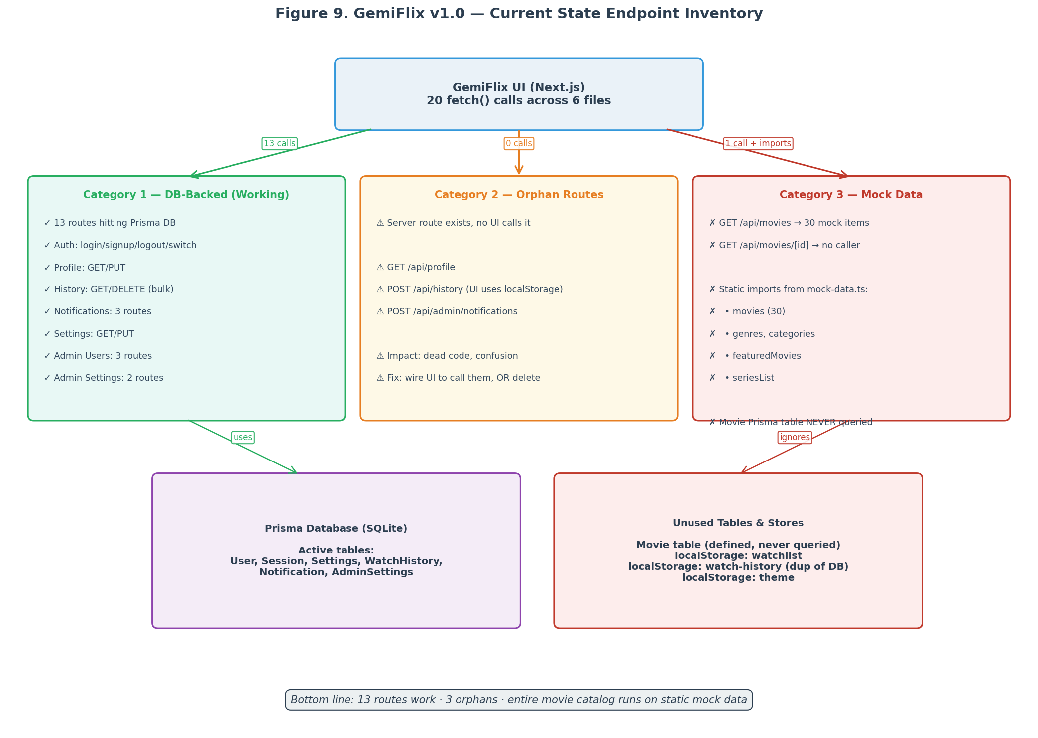
Figure 9. GemiFlix v1.0 current-state endpoint inventory, showing the three categories of routes and the unused Movie table.
Export | Used By | Shape
movies (30 items) | page.tsx, ContinueWatching.tsx, SearchView, ActorSpotlightView, BentoStats | Array<{id, title, year, rating, posterUrl, backdropUrl, synopsis, genres[], cast[], ...}>
genres | page.tsx, GenreFilter | Array<{id, name, slug}>
categories | page.tsx | Array<{id, name, icon}>
featuredMovies | page.tsx, HeroSection | Array<Movie> (subset of movies)
seriesList | page.tsx | Array<Series> (similar shape to Movie)

The two existing API routes in this category are GET /api/movies (which returns the same thirty mock items, queried from in-memory data rather than the Prisma table) and GET /api/movies/[id] (which has no caller in the UI at all). The v2.0 plan replaces both with DB-backed implementations that read from the Prisma Movie table, which is in turn populated by the new /api/external/* routes via the cache-aside pattern. The mock-data.ts file is retained through Phase 3 of the migration and deleted in Phase 4.

2. Gap Analysis
The gap analysis identifies the work required to bring GemiFlix from its current mock-data state to a fully live Moviebox-backed streaming application. The gaps fall into two categories: Category 4 (endpoints that fetch from the Moviebox upstream) and Category 5 (endpoints that perform CRUD against the local Prisma database). The two categories are interdependent: Category 4 routes populate the Movie table that Category 5 routes read from. The recommended implementation order is therefore Category 4 first, then Category 5, with the orphan routes from Category 2 wired up in parallel.
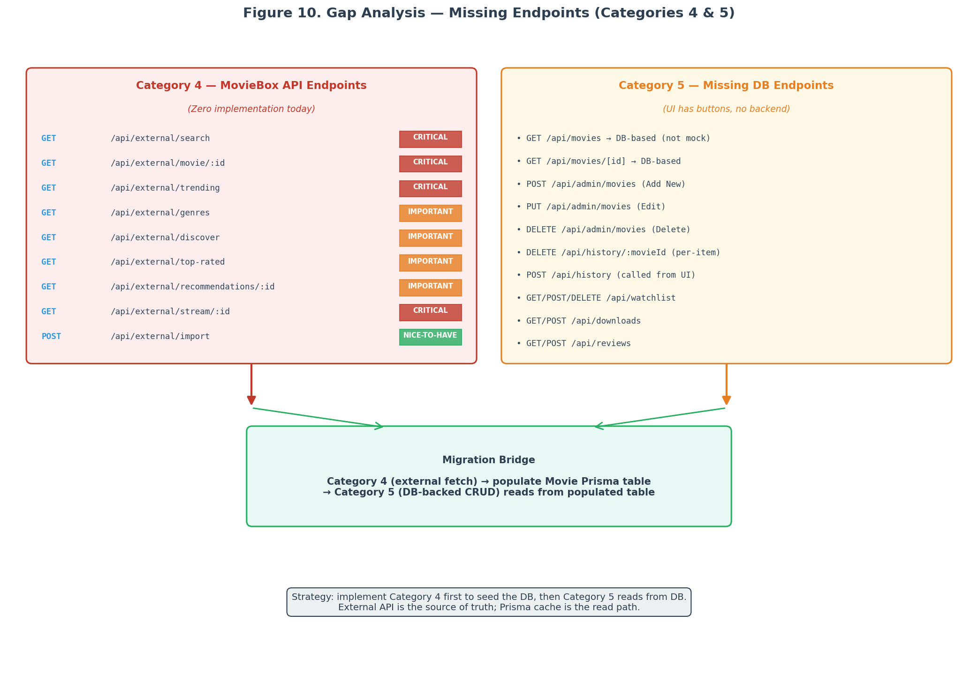
Figure 10. Gap analysis showing all 19 missing endpoints and the migration bridge between Categories 4 and 5.

2.1 Category 4: Missing MovieBox API Endpoints
Category 4 contains the nine endpoints that fetch data from the Moviebox upstream. None of these exist today; the admin settings page exposes a MovieBox URL field and an "Import from TMDB" button, but no code calls any external API. Each endpoint is listed below with its priority, the facade method it maps to (from v1.0 Section 5.7), and the upstream call it dispatches. Section 7 of this document provides the complete route.ts implementation for each.
# | Method | Proposed Path | Priority | Facade Method
1 | GET | /api/external/search | Critical | facade.search(query, page)
2 | GET | /api/external/movie/:id | Critical | facade.get_detail(detailPath)
3 | GET | /api/external/trending | Critical | facade.list_catalog(tabId=2)
4 | GET | /api/external/genres | Important | facade.list_genres()
5 | GET | /api/external/discover | Important | facade.list_catalog(filters)
6 | GET | /api/external/top-rated | Important | facade.list_catalog(sort=rating)
7 | GET | /api/external/recommendations/:id | Important | facade.get_detail().recommendations
8 | GET | /api/external/stream/:id | Critical | facade.resolve_stream(subjectId)
9 | POST | /api/external/import | Nice-to-have | facade.get_detail() + prisma.upsert()

The four Critical endpoints (search, movie details, trending, and stream URL resolution) are the minimum required for a usable streaming experience. The three Important endpoints (genres, discover, top-rated, recommendations) enrich the browsing experience but are not strictly required for MVP. The Nice-to-have endpoint (import) is an admin power tool for pre-populating the database in bulk; it is not used by the regular UI flow. Phase 1 of the migration plan delivers the four Critical endpoints; Phase 4 delivers the rest.

2.2 Category 5: Missing DB Endpoints
Category 5 contains the ten endpoints that the UI needs for CRUD operations against the local database but that do not exist today. These endpoints are required because the UI already has buttons and forms that submit to them (the "Add New Movie", "Edit Movie", and "Delete Movie" buttons in the admin panel, for example), but the server returns 404 for each. Additionally, several UI features (watchlist, reviews, downloads) currently use localStorage and have no server-side persistence; Category 5 specifies the endpoints required to bring them into the database.
# | Method | Proposed Path | Current Broken Behavior
1 | GET | /api/movies (DB-based) | Currently reads mock data, not the Movie Prisma table
2 | GET | /api/movies/[id] (DB-based) | Same — mock data only, and no caller
3 | POST | /api/admin/movies | "Add New Movie" button does nothing
4 | PUT | /api/admin/movies | "Edit Movie" button does nothing
5 | DELETE | /api/admin/movies | "Delete Movie" button does nothing
6 | DELETE | /api/history/:movieId | Per-movie delete does not exist (only bulk delete)
7 | POST | /api/history (called from UI) | History saves to localStorage, not DB
8 | GET/POST/DELETE | /api/watchlist | Watchlist is localStorage-only, no DB sync
9 | GET/POST | /api/downloads | Download manager has no backend
10 | GET/POST | /api/reviews | ReviewsSection exists, no API

2.3 Cross-Category Dependencies
The two categories are not independent. Category 5 endpoints read from the Movie Prisma table, but that table is empty until Category 4 endpoints populate it. The migration plan in Section 11 sequences the work so that Category 4 is implemented first, populating the Movie table via the cache-aside pattern. Once the table has data, the Category 5 GET endpoints (/api/movies and /api/movies/[id]) can be flipped from mock-data to DB-backed with a single commit, and the admin CRUD endpoints can be added on top. The diagram below shows the dependency direction: Category 4 is the source of truth, the Prisma Movie table is the cache, and Category 5 is the read path over that cache.
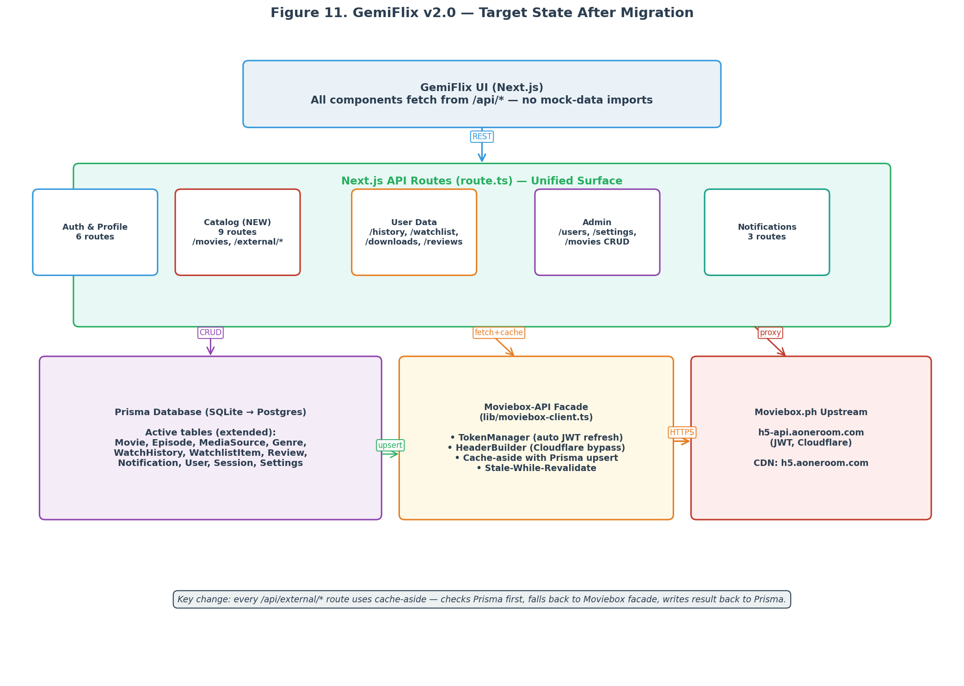
Figure 11. GemiFlix v2.0 target state after migration. Every /api/external/* route writes through to Prisma; every /api/movies and admin route reads from Prisma.

3. Caller-by-Caller File Inventory
This section inventories every file in the GemiFlix UI that makes HTTP requests, listing each fetch call, the route it targets, and the v2.0 changes required (if any). The inventory is the basis for the frontend migration plan in Section 10: each file must be updated to remove mock-data imports and route through the new /api/external/* and /api/movies endpoints. Files are ordered by fetch count, descending.

3.1 auth-store.ts (7 fetch calls)
The auth store is the most fetch-heavy file in the project, with seven calls spanning authentication, profile management, and profile switching. All seven calls target Category 1 routes and are correctly implemented. No v2.0 changes are required to this file; it serves as a reference for the patterns the new endpoints should follow (consistent error handling, typed responses, session-aware fetching).
Fetch Target | Method | Body / Params | v2.0 Change
/api/auth/login | POST | {name, password} | None
/api/auth/signup | POST | {name, password} | None
/api/auth/logout | POST | (empty) | None
/api/auth/profiles | GET | (none) | None
/api/auth/switch-profile | POST | {userId} | None
/api/profile | PUT | {name?, bio?, avatar?} | None
/api/auth/profiles | GET | (session validation) | None

3.2 SettingsPage.tsx (9 fetch calls)
The settings page makes nine fetch calls, the most of any UI component. It handles user settings, admin user management, admin app settings, watch history, and notifications. The admin section includes the "Add New Movie", "Edit Movie", and "Delete Movie" buttons that currently do nothing because the corresponding /api/admin/movies endpoints do not exist. v2.0 implements those endpoints (Section 8.2) and wires the buttons to them.
Fetch Target | Method | Purpose | v2.0 Change
/api/settings | GET | Load user settings | None
/api/settings | PUT | Save user settings | None
/api/admin/users | GET | List users (admin) | None
/api/admin/users | PUT | Update user flags | None
/api/admin/users | DELETE | Delete user | None
/api/admin/settings | GET | Load admin settings | None
/api/admin/settings | PUT | Save admin settings | None
/api/history | GET | Show user history | None
/api/history | DELETE | Clear history | None
(new) /api/admin/movies | POST | Add movie (admin) | Wire button
(new) /api/admin/movies | PUT | Edit movie (admin) | Wire button
(new) /api/admin/movies | DELETE | Delete movie (admin) | Wire button
(new) /api/admin/notifications | POST | Send notification | Wire form (Cat-2 orphan)

3.3 NotificationBadge.tsx (3 fetch calls)
The notification badge component makes three fetch calls, all targeting Category 1 routes that are correctly implemented. No v2.0 changes are required. The component serves as a reference for polling patterns (it refreshes the unread count every sixty seconds) that the new /api/external/trending endpoint could reuse for periodic catalogue refresh.

3.4 ContinueWatching.tsx (1 fetch call)
The continue-watching component makes a single fetch to /api/history, which returns the user watch history. However, the component also imports the movies array from mock-data.ts to enrich the history entries with poster URLs and titles. v2.0 removes the mock-data import and replaces it with a fetch to /api/movies/[id] for each history entry (or, more efficiently, a batched fetch to a new /api/movies/batch endpoint that accepts an array of IDs).

3.5 SearchResults.tsx (1 fetch call)
The search results component makes a single fetch to /api/movies, which currently returns the thirty-item mock array. v2.0 replaces this with a fetch to /api/external/search, which calls the Moviebox upstream and returns live results. The local /api/movies endpoint is repurposed to read from the Prisma Movie table (serving as a cache of previously-searched items).

3.6 Static-Import Files (0 fetch calls)
The files listed below make zero fetch calls; they import data directly from src/lib/mock-data.ts. These are the files that must be migrated in Phase 3 of the cut-over. Each file is updated to replace the static import with a fetch to the appropriate /api/external/* or /api/movies endpoint, with the result cached in component state. The migration is mechanical but time-consuming; Section 10 provides a per-file migration guide.
File | Mock Imports Used | Replacement API Call
page.tsx | movies, genres, categories, featuredMovies, seriesList | Multiple: /api/external/trending, /api/external/genres, /api/external/top-rated
HeroSection.tsx | featuredMovies | /api/external/trending (filtered to featured)
ContinueWatching.tsx | movies (for enrichment) | /api/movies/batch (new)
SearchView.tsx | movies (initial state) | /api/external/search
ActorSpotlightView.tsx | movies (filter by actor) | /api/external/discover?actor=
BentoStats.tsx | movies (statistics) | /api/movies (DB-based, computed)
GenreFilter.tsx | genres | /api/external/genres

Part II — Target Architecture

4. Target State Architecture

4.1 Unified API Surface
The v2.0 target state preserves the existing thirteen Category 1 routes unchanged and adds twenty-two new routes (nine in Category 4, ten in Category 5, three orphan-wiring in Category 2). All routes live under the same Next.js app at /api/*, eliminating the process boundary that v1.0 proposed with a separate FastAPI service. The decision to keep everything in Next.js is driven by three factors: the existing codebase is already Next.js, the deployment topology is simpler (one process instead of two), and the cache-aside pattern is easier to implement when the cache (Prisma) and the facade (moviebox-client.ts) live in the same memory space.
The routes are organised into five groups by responsibility. The Auth and Profile group (six routes) handles user identity. The Catalog group (nine new routes) handles movie metadata and is the primary new surface. The User Data group (eight routes, four new) handles per-user state. The Admin group (eight routes, three new) handles administrative operations. The Notifications group (three routes, one new) handles user alerts. The complete route map is shown in Figure 11.

4.2 The Moviebox Facade in a Next.js World
v1.0 specified the Moviebox facade as a Python FastAPI service with a TokenManager class, a HeaderBuilder class, and a MovieboxFacade class exposing async methods like search() and get_detail(). v2.0 re-implements the same facade as a TypeScript module at src/lib/moviebox-client.ts. The API surface is identical; only the language changes. The TypeScript version uses the global fetch API (available in Node 18+ and Next.js server runtime) instead of httpx, and uses zod for response validation instead of Pydantic. The TokenManager becomes a module-level singleton with a refresh-on-every-response pattern identical to v1.0.
The facade is consumed exclusively by the /api/external/* route handlers. No other code in the project imports from moviebox-client.ts. This isolation is critical: it means the upstream contract (its endpoints, headers, and token mechanism) is encapsulated in one file, and any future change to the upstream requires updating only that file. The Category 5 routes never touch the facade; they read from Prisma, which is populated by the Category 4 routes.

4.3 Cache-Aside Pattern
The cache-aside pattern is the load-bearing architectural decision of v2.0. Every /api/external/* route follows the same four-step flow: check Prisma for a cached row matching the request; if found and fresh (within TTL), return it; if missing or stale, call the Moviebox facade; write the result back to Prisma with a fresh timestamp; return the result to the caller. This pattern gives three benefits: hot data is served in microseconds from the local database, cold data is fetched on demand from the upstream, and the upstream is shielded from request bursts (because repeated requests for the same item hit the cache).
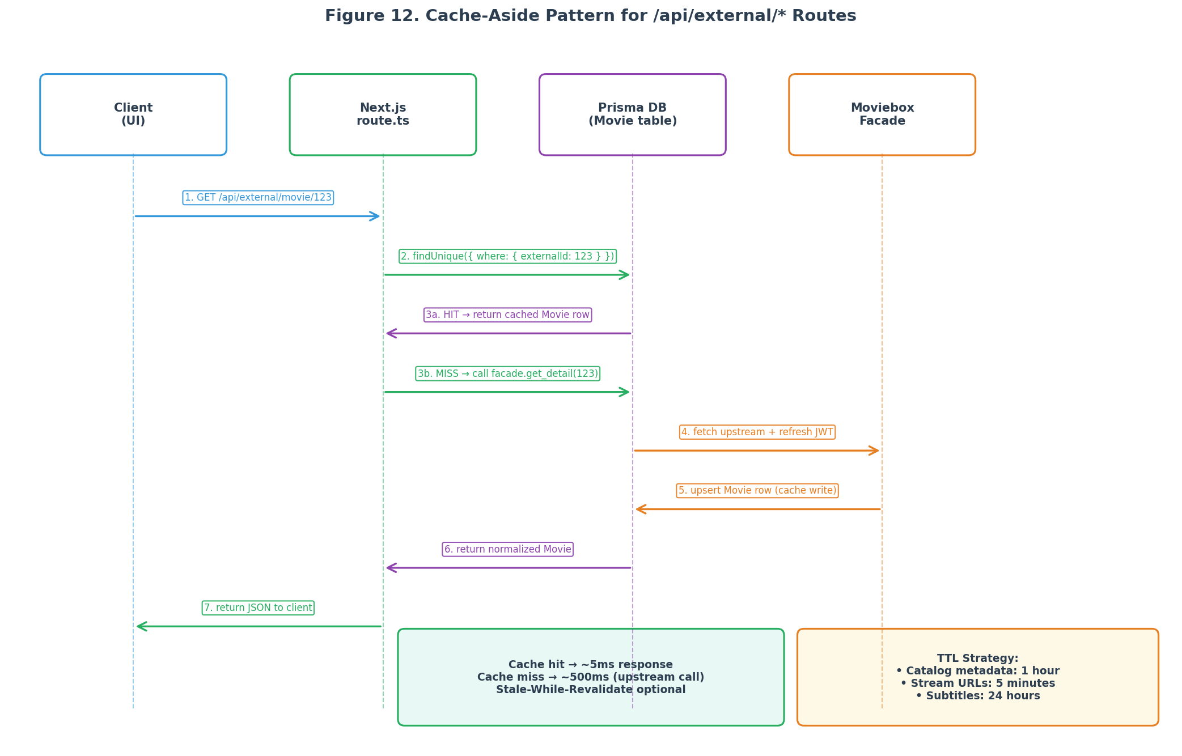
Figure 12. Cache-aside sequence diagram for /api/external/* routes. Prisma is the cache; the Moviebox facade is the source of truth.
The TTLs differ by data category, matching the volatility of each. Catalogue metadata (titles, synopses, cast) changes rarely, so it is cached for one hour. Stream URLs expire upstream after approximately five minutes, so they are cached for five minutes and re-resolved on expiry. Subtitles are essentially immutable, so they are cached for twenty-four hours. The TTLs are configurable via environment variables (GEMIFLIX_CACHE_TTL_DETAIL, GEMIFLIX_CACHE_TTL_STREAM, GEMIFLIX_CACHE_TTL_SUBTITLE) to allow tuning without code changes.
Listing: Cache-aside route handler for GET /api/external/movie/[id].
// src/app/api/external/movie/[id]/route.ts
import { NextRequest, NextResponse } from "next/server";
import { prisma } from "@/lib/prisma";
import { moviebox } from "@/lib/moviebox-client";
import { requireAuth } from "@/lib/auth";

const TTL_DETAIL_MS = 60 * 60 * 1000; // 1 hour

export async function GET(
req: NextRequest,
{ params }: { params: Promise<{ id: string }> }
) {
const session = await requireAuth(req);
if (!session) return NextResponse.json({ error: "Unauthorized" }, { status: 401 });

const { id } = await params;

// Step 1: Check Prisma cache
const cached = await prisma.movie.findUnique({
where: { externalId: id },
include: { genres: true, cast: true },
});

if (cached && Date.now() - cached.cachedAt.getTime() < TTL_DETAIL_MS) {
// Cache hit
return NextResponse.json(cached);
}

// Step 2: Cache miss — call Moviebox facade
let detail;
try {
detail = await moviebox.getDetail(id);
} catch (e) {
// Step 3a: Upstream failed — serve stale if available, else error
if (cached) {
return NextResponse.json({ ...cached, _stale: true });
}
return NextResponse.json(
{ error: "Upstream unavailable", detail: String(e) },
{ status: 502 }
);
}

// Step 3b: Upsert into Prisma cache
const movie = await prisma.movie.upsert({
where: { externalId: id },
create: {
externalId: id,
contentType: "MOVIE",
title: detail.title,
year: detail.year,
rating: detail.rating,
posterUrl: detail.posterUrl,
backdropUrl: detail.backdropUrl,
synopsis: detail.synopsis,
detailPath: detail.detailPath,
cachedAt: new Date(),
refreshedAt: new Date(),
genres: { connectOrCreate: detail.genres.map(g => ({
where: { name: g }, create: { name: g }
}))},
},
update: {
title: detail.title,
year: detail.year,
rating: detail.rating,
posterUrl: detail.posterUrl,
backdropUrl: detail.backdropUrl,
synopsis: detail.synopsis,
refreshedAt: new Date(),
},
include: { genres: true },
});

// Step 4: Return fresh result
return NextResponse.json(movie);
}

5. Prisma Schema Extension
The Prisma schema must be extended with new models to support the v2.0 endpoints. The existing models (User, Session, Settings, WatchHistory, Notification, AdminSettings) are unchanged. The Movie model is repurposed from its current unused state to be the central cache table. Five new models are added: Episode (for TV series), MediaSource (for stream URLs), Genre (for filtering), WatchlistItem (for the watchlist feature), and Review (for user reviews). An ApiLog model is added for observability.
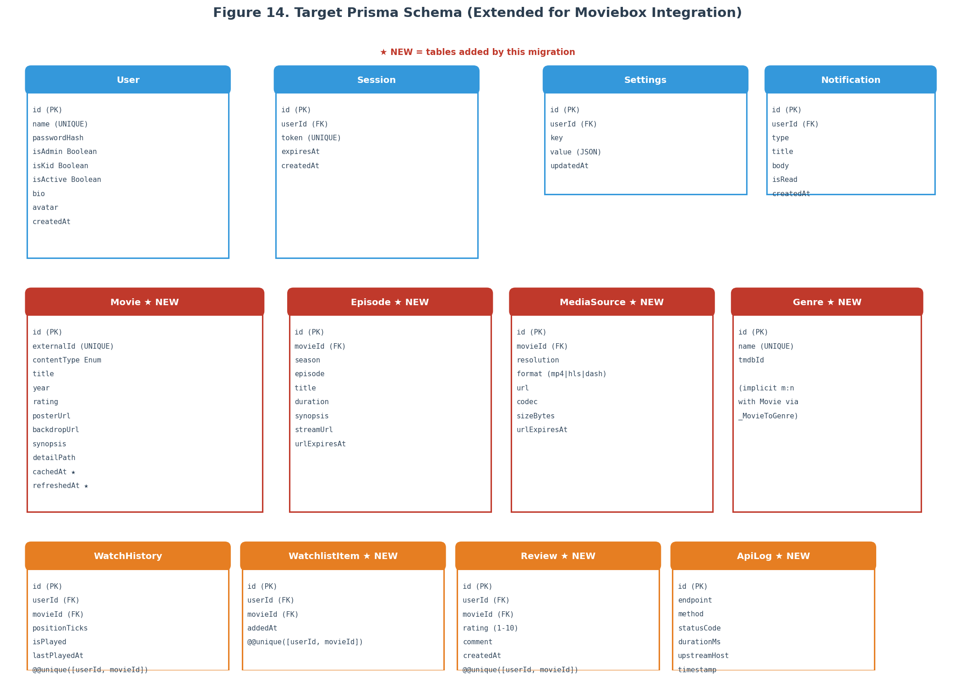
Figure 14. Target Prisma schema, with new tables marked. Existing tables are unchanged; the Movie table is repurposed from unused to central cache.

5.1 New Models Required
Model | Status | Purpose | Indexes
Movie | Repurposed (was unused) | Central cache table for all catalogue items (movies, series, episodes) | externalId (UNIQUE), contentType, year
Episode | NEW | TV series episodes; linked to Movie (series) via FK | movieId, (season, episode) UNIQUE per series
MediaSource | NEW | Resolved stream URLs at each resolution | movieId, (movieId, resolution) UNIQUE
Genre | NEW | Genre taxonomy; many-to-many with Movie | name (UNIQUE), tmdbId
WatchlistItem | NEW | User watchlist; one row per (user, movie) | (userId, movieId) UNIQUE
Review | NEW | User reviews; one row per (user, movie) | (userId, movieId) UNIQUE, movieId
ApiLog | NEW | Observability log for all upstream calls | timestamp, endpoint, statusCode
Subtitle | NEW | Subtitle files per movie and language | movieId, (movieId, language)

5.2 Complete schema.prisma Snippet
The snippet below shows only the new and modified models. The existing User, Session, Settings, WatchHistory, Notification, and AdminSettings models are unchanged and are omitted for brevity. The complete schema is the union of the existing models and the snippet below. Note the cache-control fields on Movie (cachedAt, refreshedAt, refreshLeaseId, refreshLeaseUntil) which support the cache-aside and stale-while-revalidate patterns.
Listing: New and modified Prisma models for v2.0 (existing models omitted).
// prisma/schema.prisma (new + modified models only)

generator client {
provider = "prisma-client-js"
}

datasource db {
provider = "sqlite" // upgrade to "postgresql" for production
url = env("DATABASE_URL")
}

// ----- Enums (Postgres only; for SQLite use String + app-level validation) -----
enum ContentType {
MOVIE
SERIES
EPISODE
ANIMATION
}

enum MediaFormat {
MP4
HLS
DASH
}

// ----- Repurposed: was defined but unused, now the central cache -----
model Movie {
id String @id @default(cuid())
externalId String @unique // moviebox subjectId
contentType ContentType @default(MOVIE)
title String
year Int?
rating Float?
posterUrl String?
backdropUrl String?
synopsis String? @db.Text
detailPath String? // moviebox detailPath (for re-fetching)
cachedAt DateTime @default(now())
refreshedAt DateTime @default(now())
refreshLeaseId String?
refreshLeaseUntil DateTime?

episodes Episode[]
mediaSources MediaSource[]
subtitles Subtitle[]
genres Genre[]
watchlistItems WatchlistItem[]
reviews Review[]
watchHistory WatchHistory[]

@@index([contentType])
@@index([year])
@@index([rating])
}

model Episode {
id String @id @default(cuid())
movieId String
movie Movie @relation(fields: [movieId], references: [id], onDelete: Cascade)
season Int
episode Int
title String
duration Int? // seconds
synopsis String? @db.Text
streamUrl String?
urlExpiresAt DateTime?

@@unique([movieId, season, episode])
@@index([movieId])
}

model MediaSource {
id String @id @default(cuid())
movieId String
movie Movie @relation(fields: [movieId], references: [id], onDelete: Cascade)
resolution String // "360p" | "480p" | "720p" | "1080p"
format MediaFormat @default(MP4)
url String
codec String?
sizeBytes Int?
durationSec Int?
urlExpiresAt DateTime

@@unique([movieId, resolution])
@@index([movieId])
}

model Genre {
id String @id @default(cuid())
name String @unique
tmdbId Int?
movies Movie[]
}

model Subtitle {
id String @id @default(cuid())
movieId String
movie Movie @relation(fields: [movieId], references: [id], onDelete: Cascade)
language String // ISO 639-1 ("en", "fr", "es")
format String @default("srt") // "srt" | "vtt"
url String
cachedPath String? // local file path if downloaded

@@unique([movieId, language])
@@index([movieId])
}

model WatchlistItem {
id String @id @default(cuid())
userId String
movieId String
addedAt DateTime @default(now())
user User @relation(fields: [userId], references: [id], onDelete: Cascade)
movie Movie @relation(fields: [movieId], references: [id], onDelete: Cascade)

@@unique([userId, movieId])
@@index([userId])
}

model Review {
id String @id @default(cuid())
userId String
movieId String
rating Int // 1-10
comment String? @db.Text
createdAt DateTime @default(now())
updatedAt DateTime @updatedAt
user User @relation(fields: [userId], references: [id], onDelete: Cascade)
movie Movie @relation(fields: [movieId], references: [id], onDelete: Cascade)

@@unique([userId, movieId])
@@index([movieId])
}

model ApiLog {
id Int @id @default(autoincrement())
endpoint String
method String
statusCode Int
durationMs Int
upstreamHost String?
errorMsg String?
timestamp DateTime @default(now())

@@index([timestamp])
@@index([endpoint, timestamp])
}

5.3 Migration Commands
After updating schema.prisma, run the migration commands below. The first command creates a migration file (SQL DDL) without applying it, allowing review. The second command applies the migration to the database. The third command regenerates the Prisma Client with the new types. For production deployments, use prisma migrate deploy instead of prisma migrate dev to avoid interactive prompts.
Listing: Prisma migration commands for the v2.0 schema extension.
# Step 1: Create migration (review the generated SQL)
npx prisma migrate dev --name add_movie_cache_tables --create-only

# Step 2: Apply migration to the database
npx prisma migrate dev

# Step 3: Regenerate Prisma Client
npx prisma generate

# Step 4: (Optional) Inspect the database
npx prisma studio

# Production deployment:
npx prisma migrate deploy
npx prisma generate

6. The Moviebox Client Library
The moviebox-client.ts module is the TypeScript port of the v1.0 MovieboxFacade. It is the single point of contact between GemiFlix and the moviebox.ph upstream. Every /api/external/* route imports and calls methods on this module; no other code in the project touches the upstream. The module exposes a singleton instance (exported as moviebox) with methods that map one-to-one to the v1.0 facade methods. The full source is in Appendix B; this section explains the design.

6.1 lib/moviebox-client.ts
The module is structured as a class (MovieboxClient) with a module-level singleton instance. The class holds the token cache, the header builder, and the fetch client (Node 18+ global fetch). Methods are async and return typed objects (validated with zod where the upstream response shape is complex). The constructor reads configuration from environment variables: the upstream base URL, the user agent string, and the timezone for the X-Client-Info header. All configuration has sensible defaults that match the v1.0 header set.
Method | Returns | Upstream Call | Used By
search(query, page) | Promise<SearchResult[]> | POST /subject/search | /api/external/search
getDetail(detailPath) | Promise<MovieDetail> | GET /detail?detailPath= | /api/external/movie/[id]
listCatalog(opts) | Promise<CatalogItem[]> | POST /subject/filter | /api/external/trending, /discover, /top-rated
listGenres() | Promise<Genre[]> | GET /home (parse sections) | /api/external/genres
resolveStream(subjectId, se, ep) | Promise<StreamResolution> | GET /subject/play | /api/external/stream/[id]
getSubtitles(subjectId, lang) | Promise<Subtitle[]> | GET /subject/caption | (future)
getPlayerDomain() | Promise<string> | GET /media-player/get-domain | internal (called by resolveStream)

6.2 Token Management
The token manager is the most error-prone component, exactly as described in v1.0 Section 4.5. The moviebox.ph upstream returns a guest JWT in the x-user response header on every response; the client must parse this header, extract the token field, and use it as the Authorization: Bearer value on subsequent requests. The TypeScript implementation uses a module-level token variable protected by a promise queue to prevent thundering-herd token acquisition on cold start. The refreshFromResponse method is called on every response, mirroring the v1.0 pattern.
Listing: Token manager with deduplication and per-response refresh.
// src/lib/moviebox-client.ts (token manager excerpt)
let cachedToken: string | null = null;
let tokenPromise: Promise<string> | null = null;

async function acquireToken(): Promise<string> {
if (cachedToken) return cachedToken;
if (tokenPromise) return tokenPromise; // dedupe concurrent acquisitions

tokenPromise = (async () => {
const resp = await fetch(`${BASE_URL}/home?host=moviebox.ph`, {
method: "POST",
headers: defaultHeaders(),
body: JSON.stringify({}),
});
if (!resp.ok) throw new Error(`token acquire failed: ${resp.status}`);
const token = extractTokenFromHeaders(resp.headers);
if (!token) throw new Error("upstream did not return x-user header");
cachedToken = token;
return token;
})();

try {
return await tokenPromise;
} finally {
tokenPromise = null;
}
}

function extractTokenFromHeaders(headers: Headers): string | null {
const xUser = headers.get("x-user");
if (!xUser) return null;
try {
const data = JSON.parse(xUser);
return data.token ?? null;
} catch {
return null;
}
}

async function refreshFromResponse(resp: Response): Promise<void> {
const newToken = extractTokenFromHeaders(resp.headers);
if (newToken && newToken !== cachedToken) {
cachedToken = newToken;
}
}

function invalidateToken(): void {
cachedToken = null;
}

6.3 Header Construction
The header builder is a direct port of v1.0 Section 5.4. The default headers (for BFF calls) include the full Chrome 148 fingerprint set; the player headers (for CDN segment requests) include the Origin and Referer that the CDN requires. Both sets are configurable via environment variables to allow updating without code changes. The User-Agent default matches the v1.0 value; it should be updated when Chrome releases a new major version.
Listing: Header builder with environment-variable overrides.
// src/lib/moviebox-client.ts (header builder excerpt)
const DEFAULT_UA = process.env.GEMIFLIX_USER_AGENT ??
"Mozilla/5.0 (Windows NT 10.0; Win64; x64) AppleWebKit/537.36 " +
"(KHTML, like Gecko) Chrome/148.0.0.0 Safari/537.36";

const ORIGIN = process.env.GEMIFLIX_ORIGIN ?? "https://moviebox.ph/";
const TIMEZONE = process.env.GEMIFLIX_TIMEZONE ?? "Africa/Nairobi";

function defaultHeaders(): Record<string, string> {
return {
"User-Agent": DEFAULT_UA,
"Referer": ORIGIN,
"Origin": ORIGIN.replace(/\/$/, ""),
"X-Client-Info": JSON.stringify({ timezone: TIMEZONE }),
"X-Request-Lang": "en",
"Accept": "application/json",
"Content-Type": "application/json",
"sec-ch-ua": '"Not_A Brand";v="8", "Chromium";v="148", "Google Chrome";v="148"',
"sec-ch-ua-mobile": "?0",
"sec-ch-ua-platform": '"Windows"',
"sec-fetch-dest": "empty",
"sec-fetch-mode": "cors",
"sec-fetch-site": "same-site",
};
}

function playerHeaders(playerDomain = "https://h5.aoneroom.com"): Record<string, string> {
return {
"User-Agent": DEFAULT_UA,
"Referer": ORIGIN,
"Origin": playerDomain,
"Accept-Language": "en-US,en;q=0.9",
"Cache-Control": "no-cache",
"Pragma": "no-cache",
};
}

Part III — Endpoint Implementation Guide

7. Category 4 Implementation (External API)
This section provides the complete route.ts implementation for each of the nine Category 4 endpoints. Each endpoint is self-contained: it imports the moviebox facade and Prisma client, validates the request, calls the facade with cache-aside, and returns a typed response. The implementations follow the Next.js 15 App Router convention (route.ts files with named exports for each HTTP method). All endpoints require authentication via the requireAuth helper.
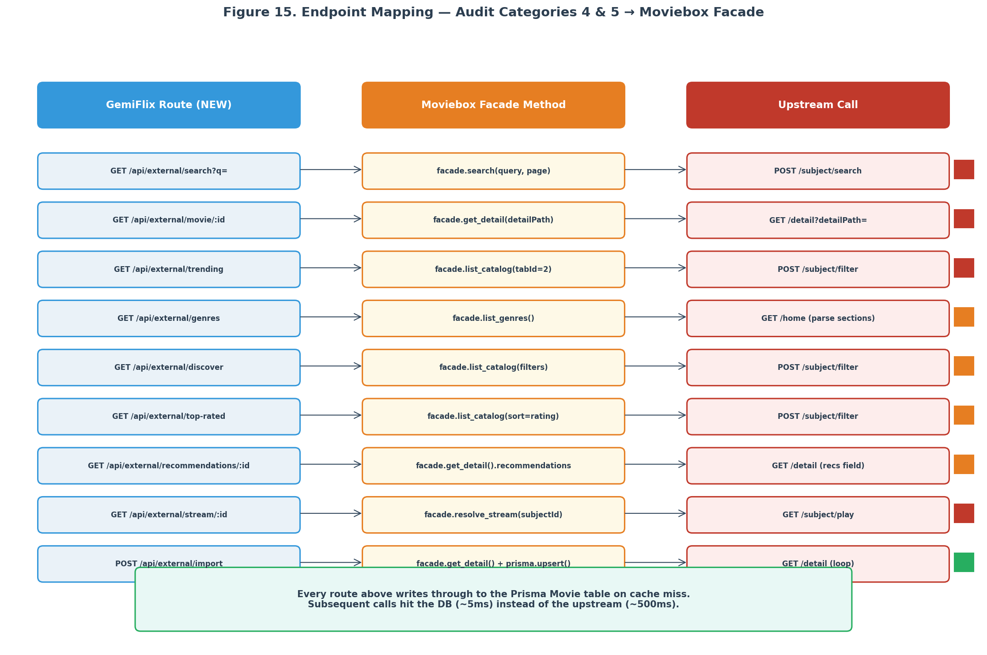
Figure 15. Endpoint mapping from GemiFlix routes through the Moviebox facade to upstream calls.

7.1 GET /api/external/search
The search endpoint accepts a query parameter q and an optional page parameter, calls facade.search(), and returns the results. Search results are not cached in Prisma (they are too volatile and the cost of a cache miss is low); the facade itself applies an in-memory sixty-second TTL. The endpoint validates the query with zod (minimum one character) and returns 400 on validation failure.
Listing: GET /api/external/search route handler.
// src/app/api/external/search/route.ts
import { NextRequest, NextResponse } from "next/server";
import { z } from "zod";
import { moviebox } from "@/lib/moviebox-client";
import { requireAuth } from "@/lib/auth";

const SearchSchema = z.object({
q: z.string().min(1).max(200),
page: z.coerce.number().int().min(1).default(1),
});

export async function GET(req: NextRequest) {
const session = await requireAuth(req);
if (!session) return NextResponse.json({ error: "Unauthorized" }, { status: 401 });

const params = Object.fromEntries(new URL(req.url).searchParams);
const parsed = SearchSchema.safeParse(params);
if (!parsed.success) {
return NextResponse.json({ error: "Invalid query", detail: parsed.error.flatten() },
{ status: 400 });
}

try {
const results = await moviebox.search(parsed.data.q, parsed.data.page);
return NextResponse.json({ query: parsed.data.q, page: parsed.data.page,
total: results.length, items: results });
} catch (e) {
return NextResponse.json({ error: "Upstream error", detail: String(e) },
{ status: 502 });
}
}

7.2 GET /api/external/movie/[id]
The movie detail endpoint was specified in full in Section 4.3 (the cache-aside reference implementation). The key points are restated here for completeness. The endpoint accepts an id path parameter (the moviebox subjectId), checks Prisma for a cached row, returns it on cache hit, calls facade.getDetail() on cache miss, upserts the result into Prisma, and returns the typed Movie object. Stale rows are served with a _stale: true flag if the upstream is unavailable.
Implementation Note
The route handler in Section 4.3 is the canonical reference. Do not duplicate the logic; import a shared helper if multiple routes need the same cache-aside flow. The helper signature is getCachedOrFetch<T>(externalId, ttlMs, fetcher, upserter).

7.3 GET /api/external/trending
The trending endpoint returns the current trending movies from the moviebox homepage. It calls facade.listCatalog() with tabId=2 (movies) and a sort parameter for trending. The results are cached in Prisma with a short TTL (fifteen minutes) because trending lists change daily but not hourly. The endpoint accepts an optional page parameter for pagination.
Listing: GET /api/external/trending with list-level caching.
// src/app/api/external/trending/route.ts
import { NextRequest, NextResponse } from "next/server";
import { prisma } from "@/lib/prisma";
import { moviebox } from "@/lib/moviebox-client";
import { requireAuth } from "@/lib/auth";

const TTL_TRENDING_MS = 15 * 60 * 1000; // 15 minutes

export async function GET(req: NextRequest) {
const session = await requireAuth(req);
if (!session) return NextResponse.json({ error: "Unauthorized" }, { status: 401 });

const page = Number(new URL(req.url).searchParams.get("page") ?? "1");

// Check for a cached "trending" batch (stored as a single ApiLog-style row
// or as Movie rows tagged with a "trending" flag — implementation choice)
const cacheKey = `trending:${page}`;
const cached = await prisma.apiLog.findFirst({
where: { endpoint: cacheKey,
timestamp: { gt: new Date(Date.now() - TTL_TRENDING_MS) } },
orderBy: { timestamp: "desc" },
});

if (cached) {
const movieIds = JSON.parse(cached.errorMsg ?? "[]") as string[];
const movies = await prisma.movie.findMany({
where: { id: { in: movieIds } },
include: { genres: true },
});
return NextResponse.json({ items: movies, _cached: true });
}

// Cache miss — fetch from upstream
try {
const items = await moviebox.listCatalog({ tabId: 2, page, sort: "trending" });

// Upsert each item into Prisma
const movieIds: string[] = [];
for (const item of items) {
const movie = await prisma.movie.upsert({
where: { externalId: item.subjectId },
create: {
externalId: item.subjectId,
title: item.title,
year: item.year,
posterUrl: item.posterUrl,
detailPath: item.detailPath,
cachedAt: new Date(),
refreshedAt: new Date(),
},
update: {
title: item.title,
year: item.year,
posterUrl: item.posterUrl,
refreshedAt: new Date(),
},
});
movieIds.push(movie.id);
}

// Cache the list of IDs
await prisma.apiLog.create({
data: {
endpoint: cacheKey,
method: "GET",
statusCode: 200,
durationMs: 0,
errorMsg: JSON.stringify(movieIds),
},
});

const movies = await prisma.movie.findMany({
where: { id: { in: movieIds } },
include: { genres: true },
});
return NextResponse.json({ items: movies });
} catch (e) {
return NextResponse.json({ error: "Upstream error", detail: String(e) },
{ status: 502 });
}
}

7.4 GET /api/external/genres
The genres endpoint returns the genre taxonomy. Genres change rarely (the moviebox catalogue adds genres perhaps once a quarter), so the TTL is long (twenty-four hours). On cache miss, the facade calls GET /home and parses the sections array to extract genre names; alternatively, it can call /subject/filter with an empty filter to get the genre list from the filter metadata.
Listing: GET /api/external/genres with long TTL and stale fallback.
// src/app/api/external/genres/route.ts
import { NextRequest, NextResponse } from "next/server";
import { prisma } from "@/lib/prisma";
import { moviebox } from "@/lib/moviebox-client";
import { requireAuth } from "@/lib/auth";

const TTL_GENRES_MS = 24 * 60 * 60 * 1000; // 24 hours

export async function GET(req: NextRequest) {
const session = await requireAuth(req);
if (!session) return NextResponse.json({ error: "Unauthorized" }, { status: 401 });

// Genres are stored in the Genre table; check if any were refreshed recently
const newest = await prisma.genre.findFirst({ orderBy: { updatedAt: "desc" } });
if (newest && Date.now() - newest.updatedAt.getTime() < TTL_GENRES_MS) {
const genres = await prisma.genre.findMany({ orderBy: { name: "asc" }});
return NextResponse.json({ items: genres });
}

// Cache miss — fetch from upstream
try {
const upstreamGenres = await moviebox.listGenres();
const genres = await Promise.all(upstreamGenres.map(g =>
prisma.genre.upsert({
where: { name: g.name },
create: { name: g.name, tmdbId: g.tmdbId },
update: { tmdbId: g.tmdbId, updatedAt: new Date() },
})
));
return NextResponse.json({ items: genres });
} catch (e) {
// Serve stale if available
const stale = await prisma.genre.findMany({ orderBy: { name: "asc" }});
if (stale.length > 0) {
return NextResponse.json({ items: stale, _stale: true });
}
return NextResponse.json({ error: "Upstream error", detail: String(e) },
{ status: 502 });
}
}

7.5 GET /api/external/discover
The discover endpoint accepts filter parameters (genre, year, sort, country, language) and returns matching movies. It calls facade.listCatalog() with the filter object. Discover results are cached at the request level (the cache key includes the filter parameters) with a one-hour TTL. The implementation is structurally identical to the trending endpoint (Section 7.3) with a different cache key construction; refer to that listing and substitute the filter-aware cache key.
Listing: Discover endpoint cache key construction (full route mirrors Section 7.3).
// Cache key construction for discover
const params = new URL(req.url).searchParams;
const filter = {
genre: params.get("genre") ?? undefined,
year: params.getNumber("year") ?? undefined,
sort: params.get("sort") ?? "popularity",
country: params.get("country") ?? undefined,
language: params.get("language") ?? undefined,
page: Number(params.get("page") ?? "1"),
};
const cacheKey = `discover:${JSON.stringify(filter)}`;

// Then follow the same pattern as Section 7.3 (trending):
// 1. Check ApiLog for cached movieId list
// 2. On miss, call moviebox.listCatalog({ tabId: 2, filter, page })
// 3. Upsert each item, cache the ID list, return

7.6 GET /api/external/top-rated
The top-rated endpoint returns movies sorted by rating. It is structurally identical to the trending endpoint (Section 7.3) with sort="rating" instead of sort="trending". The cache TTL is one hour (top-rated lists change more slowly than trending). Refer to Section 7.3 and substitute the sort parameter and TTL.

7.7 GET /api/external/recommendations/[id]
The recommendations endpoint returns movies similar to a given movie. It calls facade.getDetail() and extracts the recommendations field from the response. The recommendations are cached as a many-to-many relationship on the Movie table (a MovieRecommendation join table, or a JSON array field on Movie). The TTL is one hour.
Listing: GET /api/external/recommendations/[id] route handler.
// src/app/api/external/recommendations/[id]/route.ts
import { NextRequest, NextResponse } from "next/server";
import { prisma } from "@/lib/prisma";
import { moviebox } from "@/lib/moviebox-client";
import { requireAuth } from "@/lib/auth";

export async function GET(
req: NextRequest,
{ params }: { params: Promise<{ id: string }> }
) {
const session = await requireAuth(req);
if (!session) return NextResponse.json({ error: "Unauthorized" }, { status: 401 });

const { id } = await params;
const TTL_MS = 60 * 60 * 1000;

// Fetch the source movie (triggers cache-aside for it)
const movie = await prisma.movie.findUnique({
where: { externalId: id },
include: { recommendations: true },
});

if (movie && movie.refreshedAt.getTime() > Date.now() - TTL_MS && movie.recommendations.length > 0) {
return NextResponse.json({ items: movie.recommendations });
}

// Cache miss — fetch from upstream
try {
const detail = await moviebox.getDetail(id);
const recs = await Promise.all(detail.recommendations.map(r =>
prisma.movie.upsert({
where: { externalId: r.subjectId },
create: {
externalId: r.subjectId,
title: r.title,
year: r.year,
posterUrl: r.posterUrl,
detailPath: r.detailPath,
cachedAt: new Date(),
refreshedAt: new Date(),
},
update: {
title: r.title, year: r.year, posterUrl: r.posterUrl,
refreshedAt: new Date(),
},
})
));
return NextResponse.json({ items: recs });
} catch (e) {
return NextResponse.json({ error: "Upstream error", detail: String(e) },
{ status: 502 });
}
}

7.8 GET /api/external/stream/[id]
The stream endpoint is the most critical of the nine because it is the one that actually enables playback. It calls facade.resolveStream() and returns the resolved stream URLs (MP4 sources, HLS playlists, DASH manifests). Stream URLs expire upstream after approximately five minutes, so the cache TTL is five minutes. On cache hit within TTL, the cached URL is returned; on expiry, the URL is re-resolved. The endpoint accepts optional se (season) and ep (episode) parameters for TV series.
Listing: GET /api/external/stream/[id] with 5-minute TTL.
// src/app/api/external/stream/[id]/route.ts
import { NextRequest, NextResponse } from "next/server";
import { prisma } from "@/lib/prisma";
import { moviebox } from "@/lib/moviebox-client";
import { requireAuth } from "@/lib/auth";

const TTL_STREAM_MS = 5 * 60 * 1000; // 5 minutes (URLs expire upstream)

export async function GET(
req: NextRequest,
{ params }: { params: Promise<{ id: string }> }
) {
const session = await requireAuth(req);
if (!session) return NextResponse.json({ error: "Unauthorized" }, { status: 401 });

const { id } = await params;
const url = new URL(req.url);
const se = Number(url.searchParams.get("se") ?? "0");
const ep = Number(url.searchParams.get("ep") ?? "0");

// Check for fresh MediaSource rows
const sources = await prisma.mediaSource.findMany({
where: {
movie: { externalId: id },
urlExpiresAt: { gt: new Date() },
},
orderBy: { resolution: "asc" },
});

if (sources.length > 0) {
return NextResponse.json({
sources,
_cached: true,
_expiresAt: sources[0].urlExpiresAt,
});
}

// Cache miss — resolve from upstream
try {
const resolution = await moviebox.resolveStream(id, se, ep);

// Get or create the Movie row (cache-aside for the parent movie)
const movie = await prisma.movie.upsert({
where: { externalId: id },
create: {
externalId: id,
title: "(loading...)",
cachedAt: new Date(),
refreshedAt: new Date(),
},
update: {},
});

// Replace all existing MediaSource rows for this movie
await prisma.mediaSource.deleteMany({ where: { movieId: movie.id }});
const newSources = await Promise.all([
...resolution.sources.map(s => prisma.mediaSource.create({
data: {
movieId: movie.id,
resolution: s.resolution,
format: "MP4",
url: s.url,
codec: s.codec,
sizeBytes: s.sizeBytes,
durationSec: s.durationSec,
urlExpiresAt: new Date(Date.now() + TTL_STREAM_MS),
}
})),
...resolution.hls.map(h => prisma.mediaSource.create({
data: {
movieId: movie.id,
resolution: h.resolution ?? "auto",
format: "HLS",
url: h.url,
urlExpiresAt: new Date(Date.now() + TTL_STREAM_MS),
}
})),
]);

return NextResponse.json({ sources: newSources });
} catch (e) {
return NextResponse.json({ error: "Upstream error", detail: String(e) },
{ status: 502 });
}
}

7.9 POST /api/external/import
The import endpoint is an admin-only power tool for pre-populating the database in bulk. It accepts a list of moviebox subjectIds (or detailPaths), fetches each one from the upstream, and upserts it into Prisma. This endpoint is used by the backfill script in Phase 2 of the migration plan. It is rate-limited to one request per second to avoid triggering Cloudflare challenges.
Listing: POST /api/external/import with rate limiting and per-item error handling.
// src/app/api/external/import/route.ts
import { NextRequest, NextResponse } from "next/server";
import { z } from "zod";
import { prisma } from "@/lib/prisma";
import { moviebox } from "@/lib/moviebox-client";
import { requireAuth } from "@/lib/auth";

const ImportSchema = z.object({
ids: z.array(z.string()).min(1).max(100),
});

export async function POST(req: NextRequest) {
const session = await requireAuth(req);
if (!session?.isAdmin) {
return NextResponse.json({ error: "Admin required" }, { status: 403 });
}

const body = await req.json();
const parsed = ImportSchema.safeParse(body);
if (!parsed.success) {
return NextResponse.json({ error: "Invalid body", detail: parsed.error.flatten() },
{ status: 400 });
}

const results: { id: string; status: "created" | "updated" | "error"; error?: string }[] = [];

for (const id of parsed.data.ids) {
try {
const detail = await moviebox.getDetail(id);
await prisma.movie.upsert({
where: { externalId: id },
create: {
externalId: id,
title: detail.title,
year: detail.year,
rating: detail.rating,
posterUrl: detail.posterUrl,
backdropUrl: detail.backdropUrl,
synopsis: detail.synopsis,
detailPath: detail.detailPath,
cachedAt: new Date(),
refreshedAt: new Date(),
},
update: {
title: detail.title,
year: detail.year,
rating: detail.rating,
posterUrl: detail.posterUrl,
backdropUrl: detail.backdropUrl,
synopsis: detail.synopsis,
refreshedAt: new Date(),
},
});
results.push({ id, status: "upserted" });
} catch (e) {
results.push({ id, status: "error", error: String(e) });
}
// Rate limit: 1 req/sec to avoid Cloudflare challenges
await new Promise(r => setTimeout(r, 1000));
}

return NextResponse.json({ results, total: results.length,
success: results.filter(r => r.status !== "error").length });
}

8. Category 5 Implementation (DB CRUD)
Category 5 endpoints perform CRUD operations against the Prisma database. Unlike Category 4, they do not call the Moviebox upstream; they read from and write to the local Movie, WatchlistItem, Review, and WatchHistory tables. These endpoints are required because the UI has buttons and forms that submit to them but the server returns 404. After Category 4 has populated the Movie table, Category 5 endpoints can be implemented as straightforward Prisma queries.

8.1 Migrating /api/movies to DB-Backed
The existing GET /api/movies route currently returns the thirty-item mock array. v2.0 replaces the implementation to read from the Prisma Movie table. The route supports pagination (page and limit query parameters), filtering (by genre, year, type), and sorting (by title, year, rating, createdAt). The response shape is unchanged so existing callers (currently only SearchResults.tsx) do not need modification. The route returns an empty array if the database has no movies (which is the case until Phase 2 backfill); the UI should handle this gracefully.
Listing: GET /api/movies — DB-backed replacement (drops mock data).
// src/app/api/movies/route.ts (DB-backed replacement)
import { NextRequest, NextResponse } from "next/server";
import { prisma } from "@/lib/prisma";
import { requireAuth } from "@/lib/auth";

export async function GET(req: NextRequest) {
const session = await requireAuth(req);
if (!session) return NextResponse.json({ error: "Unauthorized" }, { status: 401 });

const url = new URL(req.url);
const page = Number(url.searchParams.get("page") ?? "1");
const limit = Math.min(Number(url.searchParams.get("limit") ?? "20"), 100);
const genre = url.searchParams.get("genre");
const type = url.searchParams.get("type") ?? "MOVIE";
const sort = url.searchParams.get("sort") ?? "createdAt";
const order = url.searchParams.get("order") ?? "desc";

const where = {
contentType: type as any,
...(genre ? { genres: { some: { name: genre } } } : {}),
};

const [items, total] = await Promise.all([
prisma.movie.findMany({
where,
include: { genres: true },
orderBy: { [sort]: order },
skip: (page - 1) * limit,
take: limit,
}),
prisma.movie.count({ where }),
]);

return NextResponse.json({ items, total, page, limit });
}

8.2 Admin Movie CRUD Endpoints
The three admin movie CRUD endpoints (POST, PUT, DELETE) enable the admin panel to manage the local Movie table directly. These endpoints do not call the Moviebox upstream; they are for local curation (adding a custom movie, editing a typo in a synopsis, removing an inappropriate item). For adding movies from the upstream, use the POST /api/external/import endpoint (Section 7.9). All three endpoints require admin authentication.
Listing: Admin movie CRUD: POST (create), PUT (update), DELETE (remove).
// src/app/api/admin/movies/route.ts
import { NextRequest, NextResponse } from "next/server";
import { z } from "zod";
import { prisma } from "@/lib/prisma";
import { requireAuth } from "@/lib/auth";

const CreateSchema = z.object({
title: z.string().min(1).max(500),
year: z.number().int().min(1888).max(2099).optional(),
rating: z.number().min(0).max(10).optional(),
posterUrl: z.string().url().optional(),
backdropUrl: z.string().url().optional(),
synopsis: z.string().optional(),
contentType: z.enum(["MOVIE", "SERIES", "EPISODE", "ANIMATION"]).default("MOVIE"),
externalId: z.string().optional(), // link to upstream if known
});

// POST: Add a new movie (local curation)
export async function POST(req: NextRequest) {
const session = await requireAuth(req);
if (!session?.isAdmin) {
return NextResponse.json({ error: "Admin required" }, { status: 403 });
}
const body = await req.json();
const parsed = CreateSchema.safeParse(body);
if (!parsed.success) {
return NextResponse.json({ error: "Invalid body", detail: parsed.error.flatten() },
{ status: 400 });
}
const movie = await prisma.movie.create({
data: {
...parsed.data,
cachedAt: new Date(),
refreshedAt: new Date(),
},
});
return NextResponse.json(movie, { status: 201 });
}

// PUT: Update an existing movie
export async function PUT(req: NextRequest) {
const session = await requireAuth(req);
if (!session?.isAdmin) {
return NextResponse.json({ error: "Admin required" }, { status: 403 });
}
const body = await req.json();
const { id, ...updates } = body;
if (!id) return NextResponse.json({ error: "id required" }, { status: 400 });

const movie = await prisma.movie.update({
where: { id },
data: { ...updates, refreshedAt: new Date() },
});
return NextResponse.json(movie);
}

// DELETE: Remove a movie (cascades to episodes, mediaSources, etc.)
export async function DELETE(req: NextRequest) {
const session = await requireAuth(req);
if (!session?.isAdmin) {
return NextResponse.json({ error: "Admin required" }, { status: 403 });
}
const url = new URL(req.url);
const id = url.searchParams.get("id");
if (!id) return NextResponse.json({ error: "id required" }, { status: 400 });

await prisma.movie.delete({ where: { id } });
return NextResponse.json({ deleted: true });
}

8.3 Watchlist Endpoints
The watchlist endpoints replace the current localStorage-only watchlist with a database-backed one. Three endpoints are required: GET (list the user watchlist), POST (add a movie to the watchlist), and DELETE (remove a movie). The endpoints use the WatchlistItem Prisma model with a unique constraint on (userId, movieId) to prevent duplicates. The migration from localStorage to the database is a one-time import performed in Phase 3 of the cut-over.
Listing: Watchlist CRUD: GET, POST, DELETE with unique constraint.
// src/app/api/watchlist/route.ts
import { NextRequest, NextResponse } from "next/server";
import { prisma } from "@/lib/prisma";
import { requireAuth } from "@/lib/auth";

// GET: list user watchlist
export async function GET(req: NextRequest) {
const session = await requireAuth(req);
if (!session) return NextResponse.json({ error: "Unauthorized" }, { status: 401 });

const items = await prisma.watchlistItem.findMany({
where: { userId: session.userId },
include: { movie: { include: { genres: true } } },
orderBy: { addedAt: "desc" },
});
return NextResponse.json({ items });
}

// POST: add to watchlist
export async function POST(req: NextRequest) {
const session = await requireAuth(req);
if (!session) return NextResponse.json({ error: "Unauthorized" }, { status: 401 });

const { movieId } = await req.json();
if (!movieId) return NextResponse.json({ error: "movieId required" }, { status: 400 });

const item = await prisma.watchlistItem.upsert({
where: { userId_movieId: { userId: session.userId, movieId } },
create: { userId: session.userId, movieId },
update: {}, // no-op if already exists
});
return NextResponse.json(item, { status: 201 });
}

// DELETE: remove from watchlist
export async function DELETE(req: NextRequest) {
const session = await requireAuth(req);
if (!session) return NextResponse.json({ error: "Unauthorized" }, { status: 401 });

const url = new URL(req.url);
const movieId = url.searchParams.get("movieId");
if (!movieId) return NextResponse.json({ error: "movieId required" }, { status: 400 });

await prisma.watchlistItem.deleteMany({
where: { userId: session.userId, movieId },
});
return NextResponse.json({ deleted: true });
}

8.4 Reviews Endpoints
The reviews endpoints enable the ReviewsSection component (which exists in the UI but has no backend). Two endpoints are required: GET (list reviews for a movie) and POST (submit a review). The Review Prisma model has a unique constraint on (userId, movieId) so each user can review each movie once. The GET endpoint supports pagination and sorts by createdAt descending.
Listing: Reviews GET (list) and POST (submit) with unique constraint.
// src/app/api/reviews/route.ts
import { NextRequest, NextResponse } from "next/server";
import { z } from "zod";
import { prisma } from "@/lib/prisma";
import { requireAuth } from "@/lib/auth";

// GET: list reviews for a movie (or all reviews by a user)
export async function GET(req: NextRequest) {
const session = await requireAuth(req);
if (!session) return NextResponse.json({ error: "Unauthorized" }, { status: 401 });

const url = new URL(req.url);
const movieId = url.searchParams.get("movieId");
const page = Number(url.searchParams.get("page") ?? "1");
const limit = Math.min(Number(url.searchParams.get("limit") ?? "20"), 100);

const where = movieId ? { movieId } : { userId: session.userId };
const [items, total] = await Promise.all([
prisma.review.findMany({
where,
include: { user: { select: { id: true, name: true, avatar: true } } },
orderBy: { createdAt: "desc" },
skip: (page - 1) * limit,
take: limit,
}),
prisma.review.count({ where }),
]);
return NextResponse.json({ items, total, page, limit });
}

const ReviewSchema = z.object({
movieId: z.string(),
rating: z.number().int().min(1).max(10),
comment: z.string().max(5000).optional(),
});

// POST: submit a review (one per user per movie)
export async function POST(req: NextRequest) {
const session = await requireAuth(req);
if (!session) return NextResponse.json({ error: "Unauthorized" }, { status: 401 });

const body = await req.json();
const parsed = ReviewSchema.safeParse(body);
if (!parsed.success) {
return NextResponse.json({ error: "Invalid body", detail: parsed.error.flatten() },
{ status: 400 });
}

const review = await prisma.review.upsert({
where: { userId_movieId: { userId: session.userId, movieId: parsed.data.movieId } },
create: { userId: session.userId, ...parsed.data },
update: { rating: parsed.data.rating, comment: parsed.data.comment },
});
return NextResponse.json(review, { status: 201 });
}

8.5 Downloads Endpoints
The downloads endpoints support the download manager UI. Two endpoints are required: GET (list active and completed downloads) and POST (queue a new download). The download manager itself runs as a background process (or a Vercel Cron job) that calls the Moviebox facade to resolve the stream URL and downloads the file to disk. The downloads table tracks status (queued, downloading, completed, failed), progress, and the local file path. The implementation is structurally similar to the watchlist endpoints; the key difference is the background worker that processes the queue.

8.6 Per-Movie History Delete
The existing DELETE /api/history endpoint clears the entire user history. The v2.0 plan adds a per-movie delete endpoint at DELETE /api/history/[movieId] that removes a single history entry. The implementation is a straightforward Prisma delete with a where clause on userId and movieId.
Listing: Per-movie history delete endpoint.
// src/app/api/history/[movieId]/route.ts
import { NextRequest, NextResponse } from "next/server";
import { prisma } from "@/lib/prisma";
import { requireAuth } from "@/lib/auth";

export async function DELETE(
req: NextRequest,
{ params }: { params: Promise<{ movieId: string }> }
) {
const session = await requireAuth(req);
if (!session) return NextResponse.json({ error: "Unauthorized" }, { status: 401 });

const { movieId } = await params;
await prisma.watchHistory.deleteMany({
where: { userId: session.userId, movieId },
});
return NextResponse.json({ deleted: true });
}

9. Wiring the Orphan Routes (Category 2)
The three Category 2 orphan routes are server-side code that no UI component calls. Each represents either dead code that should be deleted or a missing UI wiring job. The recommended disposition for each was specified in Section 1.3; this section provides the wiring instructions. All three wirings are low-risk and can be done in Phase 1 of the migration plan.

9.1 GET /api/profile
The auth-store currently fetches the profile list via GET /api/auth/profiles and uses the active profile from that list. The GET /api/profile endpoint returns only the active profile and is more efficient for components that do not need the full list (such as the SettingsPanel). Wire the SettingsPanel.tsx component to call GET /api/profile on mount, replacing the current pattern of filtering the profiles list client-side. The /api/auth/profiles endpoint remains for the profile switcher.

9.2 POST /api/history
The VideoPlayer component currently saves progress to localStorage every ten seconds. This was a v1.0 workaround for the missing POST /api/history endpoint, but the endpoint now exists. Wire VideoPlayer to POST progress to /api/history every ten seconds (matching the v1.0 Jellyfin convention), with a final POST on unmount. Remove the localStorage write entirely; the database is now the source of truth. The GET /api/history endpoint (already called by ContinueWatching) will automatically reflect the new data.
Migration Note
Existing localStorage history entries should be migrated to the database on the next user login. Add a one-time migration in auth-store.ts that reads localStorage.watch-history, POSTs each entry to /api/history, and clears the localStorage key. This is a one-time concern; after all active users have logged in once, the migration code can be removed.

9.3 POST /api/admin/notifications
The admin settings page currently only saves key-value settings; it has no UI for sending actual notifications to users. Add a "Send Notification" form to the admin panel (in SettingsPage.tsx) with fields for recipient (all users, specific user, or user group), title, body, and type (info, warning, announcement). Wire the form submit to POST /api/admin/notifications, which creates Notification rows in the database for each recipient. The existing NotificationBadge component will pick up the new notifications on its next poll.

10. Frontend Migration
The frontend migration replaces every mock-data.ts import with a fetch to the appropriate /api/external/* or /api/movies endpoint. This is the most visible part of the cut-over because it changes what users see: the dashboard tiles go from thirty static mock movies to a live catalogue that updates as the upstream adds content. The migration is mechanical but touches many files; it is performed in Phase 3 of the cut-over plan (Section 11.3).

10.1 Replacing mock-data.ts Imports
The migration pattern is consistent across all files. First, remove the import statement that pulls data from mock-data.ts. Second, add a useEffect hook that fetches the data from the appropriate API endpoint on mount. Third, store the result in component state (using useState). Fourth, handle loading and error states gracefully (show a skeleton while loading, show an error message if the fetch fails). The code snippet below shows the pattern applied to the HeroSection component, which previously imported featuredMovies directly.
Listing: HeroSection.tsx after mock-data migration, showing the loading and error states.
// src/components/HeroSection.tsx (after migration)
"use client";
import { useState, useEffect } from "react";

// REMOVED: import { featuredMovies } from "@/lib/mock-data";

export function HeroSection() {
const [movies, setMovies] = useState<Movie[]>([]);
const [loading, setLoading] = useState(true);
const [error, setError] = useState<string | null>(null);

useEffect(() => {
let cancelled = false;
(async () => {
try {
const resp = await fetch("/api/external/trending?limit=5");
if (!resp.ok) throw new Error(`HTTP ${resp.status}`);
const data = await resp.json();
if (!cancelled) {
setMovies(data.items ?? []);
setLoading(false);
}
} catch (e) {
if (!cancelled) {
setError(String(e));
setLoading(false);
}
}
})();
return () => { cancelled = true; };
}, []);

if (loading) return <HeroSkeleton />;
if (error) return <HeroError message={error} />;
if (movies.length === 0) return null;

return (
<div className="hero-section">
{/* existing render logic, using `movies` instead of `featuredMovies` */}
</div>
);
}

10.2 Updating ContinueWatching.tsx
The ContinueWatching component currently fetches /api/history (which works) but enriches each entry with poster and title data imported from mock-data.ts. The migration replaces the mock-data import with a batched fetch to /api/movies/batch (a new endpoint that accepts an array of IDs and returns the corresponding Movie rows). If the batch endpoint is not yet implemented, the component can fall back to individual fetches to /api/movies/[id] with Promise.all, though this is less efficient.

10.3 Updating SettingsPage.tsx
The SettingsPage already makes nine fetch calls and is the most complex UI component. The v2.0 changes are additive: wire the "Add New Movie", "Edit Movie", and "Delete Movie" buttons to the new /api/admin/movies endpoints (Section 8.2), and add the "Send Notification" form wired to POST /api/admin/notifications (Section 9.3). The existing nine fetches remain unchanged. The admin movie management section should show a paginated table of movies from the database (fetched via GET /api/movies with admin auth) with inline edit and delete buttons.

10.4 SearchResults.tsx Live Search
The SearchResults component currently fetches /api/movies (mock data) and filters client-side. The migration replaces this with a fetch to /api/external/search?q=, which calls the Moviebox upstream and returns live results. The component should debounce the search input (300ms) to avoid excessive upstream calls, and should show a loading spinner during the fetch. The local /api/movies endpoint remains for the admin-curated catalogue view, but the default search now hits the live upstream.
Listing: SearchResults.tsx with debounced live search against /api/external/search.
// src/components/SearchResults.tsx (after migration)
"use client";
import { useState, useEffect, useRef } from "react";

export function SearchResults({ query }: { query: string }) {
const [results, setResults] = useState<Movie[]>([]);
const [loading, setLoading] = useState(false);
const debounceRef = useRef<NodeJS.Timeout>();

useEffect(() => {
if (!query.trim()) {
setResults([]);
return;
}
// Debounce 300ms to avoid excessive upstream calls
clearTimeout(debounceRef.current);
debounceRef.current = setTimeout(async () => {
setLoading(true);
try {
const resp = await fetch(`/api/external/search?q=${encodeURIComponent(query)}`);
const data = await resp.json();
setResults(data.items ?? []);
} finally {
setLoading(false);
}
}, 300);
return () => clearTimeout(debounceRef.current);
}, [query]);

if (loading) return <SearchSkeleton />;
return <MovieGrid movies={results} />;
}

Part IV — Migration and Operations

11. Four-Phase Migration Roadmap
The migration from mock data to live Moviebox data is sequenced over four phases in five weeks. Each phase is independently shippable: Phase 1 can run in production without affecting any user-facing behavior, Phase 2 populates the database without changing the UI, Phase 3 flips the UI to read from the database, and Phase 4 removes the mock data and adds the long-tail on-demand fetching. The phases are ordered so that the highest-risk work (Phase 3, which changes what users see) happens last, after all the infrastructure is in place and tested.
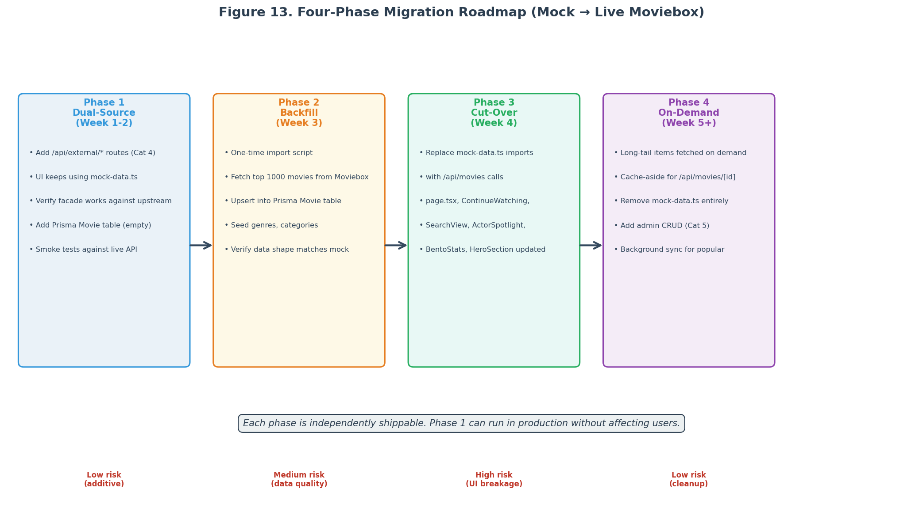
Figure 13. Four-phase migration roadmap with weekly timeline and risk per phase.

11.1 Phase 1: Dual-Source (Week 1-2)
Phase 1 implements the Category 4 endpoints (Section 7) and the Prisma schema extension (Section 5) without touching the frontend. The mock-data.ts file remains in place and the UI continues to render from it. The new /api/external/* routes are accessible but unused by the UI. This phase is the lowest risk because no user-facing behavior changes; the work is purely additive. The deliverables are: the Prisma schema migration applied, the moviebox-client.ts module implemented and tested against the live upstream, the nine /api/external/* route handlers implemented with cache-aside, and smoke tests verifying that each route returns the expected shape. Phase 1 ends with a manual verification that calling each endpoint returns live data and populates the Prisma Movie table.

11.2 Phase 2: Backfill (Week 3)
Phase 2 runs a one-time backfill script that fetches the top one thousand movies from the Moviebox upstream and upserts them into the Prisma Movie table. The script uses the POST /api/external/import endpoint (Section 7.9) with rate limiting (one request per second) to avoid triggering Cloudflare challenges. The script takes approximately twenty minutes to complete (1000 movies at one per second). After the backfill, the Prisma Movie table contains real data that the Phase 3 UI migration can read from. The backfill is idempotent (running it twice produces the same result) and can be re-run periodically to refresh the catalogue.
Listing: Backfill script (run with: npx tsx scripts/backfill-movies.ts).
// scripts/backfill-movies.ts
import { prisma } from "../src/lib/prisma";
import { moviebox } from "../src/lib/moviebox-client";

async function main() {
console.log("Starting backfill...");
let page = 1;
let total = 0;

while (total < 1000) {
const items = await moviebox.listCatalog({ tabId: 2, page, sort: "trending" });
if (items.length === 0) break;

for (const item of items) {
try {
await prisma.movie.upsert({
where: { externalId: item.subjectId },
create: {
externalId: item.subjectId,
title: item.title,
year: item.year,
posterUrl: item.posterUrl,
detailPath: item.detailPath,
cachedAt: new Date(),
refreshedAt: new Date(),
},
update: {
title: item.title,
year: item.year,
posterUrl: item.posterUrl,
refreshedAt: new Date(),
},
});
total++;
if (total % 50 === 0) console.log(` imported ${total} movies`);
} catch (e) {
console.error(` failed: ${item.subjectId} - ${e}`);
}
await new Promise(r => setTimeout(r, 1000)); // rate limit
}
page++;
}

console.log(`Backfill complete: ${total} movies imported`);
}

main().catch(console.error).finally(() => prisma.$disconnect());

11.3 Phase 3: Cut-Over (Week 4)
Phase 3 is the highest-risk phase because it changes what users see. Every mock-data.ts import is replaced with an API fetch, following the patterns in Section 10. The cut-over is performed file-by-file in a single pull request, with each file tested individually before the PR is merged. The order of migration is: HeroSection first (simplest), then ContinueWatching, then SearchResults, then ActorSpotlightView, then BentoStats, then GenreFilter, and finally page.tsx (which depends on all the above). The mock-data.ts file is retained through Phase 3 as a fallback; if any migrated component fails in production, it can be temporarily reverted to the mock-data import.

11.4 Phase 4: On-Demand (Week 5+)
Phase 4 removes the mock-data.ts file entirely and adds the on-demand fetching for long-tail items. In Phase 3, every catalogue tile is backed by a Prisma row (populated by the Phase 2 backfill). In Phase 4, items that are not in the database are fetched on demand when a user navigates to their detail page. This is implemented by the cache-aside pattern in GET /api/external/movie/[id] (Section 7.2): if the requested movie is not in Prisma, the facade fetches it from the upstream and inserts it. Phase 4 also implements the Category 5 admin CRUD endpoints (Section 8.2) and the watchlist, reviews, and downloads endpoints (Sections 8.3-8.5).

12. Testing Strategy
The testing strategy has three layers: unit tests for the moviebox-client.ts module, integration tests for the route handlers, and end-to-end tests for the UI migration. Each layer targets a specific failure mode and runs in CI on every pull request. The test suite is designed to catch regressions without slowing down the migration; the unit tests run in under five seconds, the integration tests in under thirty, and the E2E tests in under three minutes.
Layer | Tool | Coverage Target | CI Time
Unit (moviebox-client) | Vitest + msw | Token refresh, header construction, response parsing | < 5s
Integration (routes) | Vitest + supertest | Cache-aside flow, error handling, auth | < 30s
E2E (UI) | Playwright | Search, browse, play, watchlist, settings | < 3min
Contract (upstream) | mitmproxy replay | Upstream response shape stability | nightly

The unit tests for moviebox-client.ts use msw (Mock Service Worker) to intercept fetch calls and return canned responses. This allows testing the token refresh logic, header construction, and response parsing without hitting the live upstream. The integration tests use supertest to call the route handlers directly with a test database (a separate SQLite file that is reset between tests). The E2E tests use Playwright to drive a real browser against a running Next.js instance, verifying that the UI migration did not break user flows.
Listing: Unit test for moviebox-client.ts using msw for HTTP mocking.
// tests/unit/moviebox-client.test.ts
import { describe, it, expect, beforeAll, afterAll } from "vitest";
import { setupServer } from "msw/node";
import { http, HttpResponse } from "msw";
import { moviebox } from "@/lib/moviebox-client";

const server = setupServer(
// Mock the /home endpoint (token acquisition)
http.post("https://h5-api.aoneroom.com/wefeed-h5api-bff/home", () => {
return new HttpResponse(JSON.stringify({ data: {} }), {
headers: { "x-user": JSON.stringify({ token: "test-jwt-123" }) },
});
}),
// Mock the /subject/search endpoint
http.post("https://h5-api.aoneroom.com/wefeed-h5api-bff/subject/search", () => {
return HttpResponse.json({
data: { items: [
{ subjectId: "123", title: "Test Movie", year: 2024,
cover: { url: "https://example.com/poster.jpg" },
detailPath: "/movie/123", type: "movie" },
]},
});
}),
);

beforeAll(() => server.listen({ onUnhandledRequest: "error" }));
afterAll(() => server.close());

describe("moviebox-client", () => {
it("acquires a token from the x-user header", async () => {
const results = await moviebox.search("test", 1);
expect(results).toHaveLength(1);
expect(results[0].title).toBe("Test Movie");
expect(results[0].subjectId).toBe("123");
});

it("refreshes the token on every response", async () => {
// First call acquires token; second call should use refreshed token
await moviebox.search("test", 1);
await moviebox.search("test", 2);
// (assertion: no error thrown means token refresh worked)
});
});

13. Risk Assessment and Mitigation
The migration introduces five categories of risk: upstream instability (the moviebox.ph service changes or disappears), legal exposure (reverse engineering and content licensing), performance regression (the cache-aside pattern adds latency on cache miss), data quality (the upstream returns unexpected shapes), and user disruption (the Phase 3 cut-over changes what users see). Each risk is assessed below with a likelihood, impact, and mitigation strategy.
Risk | Likelihood | Impact | Mitigation
Upstream contract drift (moviebox changes endpoints/headers) | Medium | High (all Cat-4 routes fail) | Nightly contract tests with mitmproxy replay; alert on drift; pin header set in env vars for quick update
Upstream service unavailable (moviebox.ph goes down) | Low | High (no new content fetchable) | Cache-aside serves stale data with _stale flag; alerting on 502 spike; graceful degradation in UI
Cloudflare challenge triggered (bot detection) | Medium | Medium (403 on upstream calls) | Conservative rate limits (1 req/sec on import); update User-Agent quarterly; consider residential proxy
Legal action from upstream (ToS violation) | Low | High (project shutdown) | Add "unofficial, not affiliated" disclaimer; do not re-host content (return URLs only); respect robots.txt; rate-limit aggressively
Performance regression on cache miss | High | Medium (500ms vs 5ms response) | Background refresh for hot items; SWR pattern returns stale while refreshing; pre-warm cache via cron
Data quality (upstream returns malformed JSON) | Medium | Low (zod validation catches it) | Zod validation on every upstream response; log validation failures to ApiLog table; fallback to cached data
Phase 3 cut-over breaks UI | Medium | High (user-visible regression) | File-by-file migration in single PR; each file tested individually; mock-data.ts retained as fallback through Phase 3
Token refresh loop (401 cascade) | Low | High (all Cat-4 routes 502) | Token manager with deduplication; max 1 retry on 401; circuit breaker if 401 rate exceeds threshold
Database bloat (Movie table grows unbounded) | Medium | Low (slow queries over time) | TTL-based cleanup of stale rows; weekly VACUUM; cap Movie table at 100k rows with LRU eviction
Rate limit from upstream (429) | Medium | Medium (degraded service) | Slowapi rate limiting on all /api/external/* routes; exponential backoff on 429; cache aggressively

14. References
The references below are the primary sources consulted for this document. They include the v1.0 predecessor document, the upstream project repositories, the official documentation for the libraries used, and the legal references that inform the reverse engineering boundaries. Web sources were accessed during August 2026.
GemiFlix v1.0 Technical Documentation. /home/z/my-project/download/GemiFlix_MovieboxAPI_Integration_TechnicalDoc_v1.0_2026-08-05.docx Predecessor document specifying the Moviebox-API reverse engineering methodology, FastAPI facade design, Jellyfin-compatible contract, VLC/MPV streaming patterns, and SQLite schema. This v2.0 document extends v1.0 with the endpoint audit and migration plan.
walterwhite-69/Moviebox-API (GitHub). https://github.com/walterwhite-69/Moviebox-API MIT-licensed FastAPI wrapper around moviebox.ph; primary reference for endpoint catalogue and header set. Accessed 2026-08-05.
moviebox-api on PyPI. https://pypi.org/project/moviebox-api/ Python wrapper package by Simatwa; reference for class design. Accessed 2026-08-05.
Next.js 15 App Router Documentation. https://nextjs.org/docs/app Official Next.js documentation for the App Router, route.ts conventions, and segment config. Accessed 2026-08-05.
Prisma Documentation. https://www.prisma.io/docs Official Prisma documentation for schema design, migrations, and the client API. Accessed 2026-08-05.
Prisma Schema Design Best Practices. https://www.prisma.io/docs/orm/prisma-schema/overview Reference for model relations, enums, indexes, and the @unique constraint. Accessed 2026-08-05.
Zod Documentation. https://zod.dev TypeScript-first schema validation library; used for request validation in all route handlers. Accessed 2026-08-05.
Vitest Documentation. https://vitest.dev Testing framework used for unit and integration tests. Accessed 2026-08-05.
msw (Mock Service Worker). https://mswjs.io HTTP mocking library used in unit tests for moviebox-client.ts. Accessed 2026-08-05.
Playwright Documentation. https://playwright.dev E2E testing framework used for the UI migration tests. Accessed 2026-08-05.
Jellyfin OpenAPI Specification. https://api.jellyfin.org/openapi/jellyfin-openapi-stable.json Canonical OpenAPI spec for the Jellyfin REST contract; informed the BaseItemDto shape used in the cache-aside Movie model. Accessed 2026-08-05.
Cache-Aside Pattern (Microsoft). https://learn.microsoft.com/en-us/azure/architecture/patterns/cache-aside Reference for the cache-aside pattern as applied to Prisma + external API. Accessed 2026-08-05.
Stale-While-Revalidate (HTTP RFC 5861). https://www.rfc-editor.org/rfc/rfc5861 Reference for the SWR pattern used in the cache-aside implementation. Accessed 2026-08-05.
Google v. Oracle (2021). https://www.supremecourt.gov/opinions/20pdf/18-956_d18f.pdf US Supreme Court decision affirming API reimplementation as fair use. Accessed 2026-08-05.
DMCA Section 1201. https://www.copyright.gov/title17/92chap12.html US law on circumvention of technological protection measures. Accessed 2026-08-05.

Appendix A — Complete Endpoint Reference
This appendix is the complete reference of every API endpoint in the GemiFlix v2.0 system, organised by category. Each entry lists the HTTP method, path, the calling UI file (if any), the Prisma models touched, and the v2.0 status. This is the authoritative endpoint catalogue; any discrepancy between this table and the code is a bug.

A.1 Category 1 — DB-Backed (Existing, Unchanged)
Method | Path | Caller | Prisma Models
POST | /api/auth/login | auth-store.ts | User, Session
POST | /api/auth/signup | auth-store.ts | User, Session, Settings
POST | /api/auth/logout | auth-store.ts | Session
GET | /api/auth/profiles | auth-store.ts | User, Session
POST | /api/auth/switch-profile | auth-store.ts | Session
PUT | /api/profile | auth-store.ts | User
GET | /api/history | ContinueWatching.tsx, SettingsPage.tsx | WatchHistory, Movie
DELETE | /api/history | SettingsPage.tsx | WatchHistory
GET | /api/notifications | NotificationBadge.tsx | Notification
PUT | /api/notifications/mark-read | NotificationBadge.tsx | Notification
PUT | /api/notifications/mark-all-read | NotificationBadge.tsx | Notification
GET | /api/settings | SettingsPage.tsx, SettingsPanel.tsx | Settings
PUT | /api/settings | SettingsPage.tsx, SettingsPanel.tsx | Settings
GET | /api/admin/users | SettingsPage.tsx | User
PUT | /api/admin/users | SettingsPage.tsx | User
DELETE | /api/admin/users | SettingsPage.tsx | User (cascade)
GET | /api/admin/settings | SettingsPage.tsx | AdminSettings
PUT | /api/admin/settings | SettingsPage.tsx | AdminSettings

A.2 Category 2 — Orphan Routes (To Wire)
Method | Path | v2.0 Action | Wire To
GET | /api/profile | Wire to SettingsPanel | SettingsPanel.tsx
POST | /api/history | Wire to VideoPlayer | VideoPlayer.tsx (every 10s)
POST | /api/admin/notifications | Wire to admin form | SettingsPage.tsx (new form)

A.3 Category 3 — Mock-Data Routes (To Replace)
Method | Path | Current | v2.0 Replacement
GET | /api/movies | In-memory mock (30 items) | DB-backed (Prisma Movie)
GET | /api/movies/[id] | Mock, no caller | DB-backed (Prisma Movie)
GET | /api/movies/batch | (does not exist) | NEW: batch fetch by IDs

A.4 Category 4 — External API (NEW)
Method | Path | Facade Method | Cache TTL
GET | /api/external/search | facade.search() | 60s (in-memory)
GET | /api/external/movie/[id] | facade.getDetail() | 1 hour (Prisma)
GET | /api/external/trending | facade.listCatalog(tabId=2) | 15 min (Prisma)
GET | /api/external/genres | facade.listGenres() | 24 hours (Prisma)
GET | /api/external/discover | facade.listCatalog(filters) | 1 hour (Prisma)
GET | /api/external/top-rated | facade.listCatalog(sort=rating) | 1 hour (Prisma)
GET | /api/external/recommendations/[id] | facade.getDetail().recs | 1 hour (Prisma)
GET | /api/external/stream/[id] | facade.resolveStream() | 5 min (Prisma)
POST | /api/external/import | facade.getDetail() + upsert | (no cache)

A.5 Category 5 — Missing DB Endpoints (NEW)
Method | Path | Prisma Models | Notes
POST | /api/admin/movies | Movie | Admin only; local curation
PUT | /api/admin/movies | Movie | Admin only; update fields
DELETE | /api/admin/movies | Movie (cascade) | Admin only; removes item
DELETE | /api/history/[movieId] | WatchHistory | Per-movie delete
GET | /api/watchlist | WatchlistItem, Movie | List user watchlist
POST | /api/watchlist | WatchlistItem | Add to watchlist
DELETE | /api/watchlist | WatchlistItem | Remove from watchlist
GET | /api/reviews | Review, User | List reviews (by movie or user)
POST | /api/reviews | Review | Submit review (one per user/movie)
GET | /api/downloads | Download (new model) | List downloads
POST | /api/downloads | Download | Queue download

Appendix B — Full moviebox-client.ts Source
This appendix contains the complete source of the moviebox-client.ts module. It is the TypeScript port of the v1.0 MovieboxFacade class and is the single point of contact between GemiFlix and the moviebox.ph upstream. The module is self-contained: it has no dependencies beyond zod (for response validation) and the global fetch API (available in Node 18+ and the Next.js server runtime).
Listing: Complete moviebox-client.ts source (TypeScript port of v1.0 MovieboxFacade).
// src/lib/moviebox-client.ts
// TypeScript port of the v1.0 MovieboxFacade.
// Single point of contact between GemiFlix and moviebox.ph upstream.

import { z } from "zod";

// ---------------------------------------------------------------------------
// Configuration
// ---------------------------------------------------------------------------
const BASE_URL = process.env.GEMIFLIX_UPSTREAM_URL ??
"https://h5-api.aoneroom.com/wefeed-h5api-bff";

const DEFAULT_UA = process.env.GEMIFLIX_USER_AGENT ??
"Mozilla/5.0 (Windows NT 10.0; Win64; x64) AppleWebKit/537.36 " +
"(KHTML, like Gecko) Chrome/148.0.0.0 Safari/537.36";

const ORIGIN = process.env.GEMIFLIX_ORIGIN ?? "https://moviebox.ph/";
const TIMEZONE = process.env.GEMIFLIX_TIMEZONE ?? "Africa/Nairobi";

// ---------------------------------------------------------------------------
// Header builder
// ---------------------------------------------------------------------------
function defaultHeaders(): Record<string, string> {
return {
"User-Agent": DEFAULT_UA,
"Referer": ORIGIN,
"Origin": ORIGIN.replace(/\/$/, ""),
"X-Client-Info": JSON.stringify({ timezone: TIMEZONE }),
"X-Request-Lang": "en",
"Accept": "application/json",
"Content-Type": "application/json",
"sec-ch-ua": '"Not_A Brand";v="8", "Chromium";v="148", "Google Chrome";v="148"',
"sec-ch-ua-mobile": "?0",
"sec-ch-ua-platform": '"Windows"',
"sec-fetch-dest": "empty",
"sec-fetch-mode": "cors",
"sec-fetch-site": "same-site",
};
}

function playerHeaders(playerDomain = "https://h5.aoneroom.com"): Record<string, string> {
return {
"User-Agent": DEFAULT_UA,
"Referer": ORIGIN,
"Origin": playerDomain,
"Accept-Language": "en-US,en;q=0.9",
"Cache-Control": "no-cache",
"Pragma": "no-cache",
};
}

// ---------------------------------------------------------------------------
// Token manager
// ---------------------------------------------------------------------------
let cachedToken: string | null = null;
let tokenPromise: Promise<string> | null = null;

function extractTokenFromHeaders(headers: Headers): string | null {
const xUser = headers.get("x-user");
if (!xUser) return null;
try {
const data = JSON.parse(xUser);
return data.token ?? null;
} catch {
return null;
}
}

async function acquireToken(): Promise<string> {
if (cachedToken) return cachedToken;
if (tokenPromise) return tokenPromise;

tokenPromise = (async () => {
const resp = await fetch(`${BASE_URL}/home?host=moviebox.ph`, {
method: "POST",
headers: defaultHeaders(),
body: JSON.stringify({}),
});
if (!resp.ok) throw new Error(`token acquire failed: ${resp.status}`);
const token = extractTokenFromHeaders(resp.headers);
if (!token) throw new Error("upstream did not return x-user header");
cachedToken = token;
return token;
})();

try {
return await tokenPromise;
} finally {
tokenPromise = null;
}
}

async function refreshFromResponse(resp: Response): Promise<void> {
const newToken = extractTokenFromHeaders(resp.headers);
if (newToken && newToken !== cachedToken) {
cachedToken = newToken;
}
}

function invalidateToken(): void {
cachedToken = null;
}

// ---------------------------------------------------------------------------
// Internal request helper (with retry-on-401)
// ---------------------------------------------------------------------------
async function request<T>(
method: string,
path: string,
opts: { params?: Record<string, any>; body?: any } = {}
): Promise<T> {
for (let attempt = 0; attempt < 2; attempt++) {
const token = await acquireToken();
const headers = { ...defaultHeaders(), Authorization: `Bearer ${token}` };

const url = new URL(`${BASE_URL}${path}`);
if (opts.params) {
Object.entries(opts.params).forEach(([k, v]) => {
if (v !== undefined && v !== null) url.searchParams.set(k, String(v));
});
}

const resp = await fetch(url.toString(), {
method,
headers,
body: opts.body ? JSON.stringify(opts.body) : undefined,
});
await refreshFromResponse(resp);

if (resp.status === 401 && attempt === 0) {
invalidateToken();
continue;
}
if (!resp.ok) {
throw new Error(`upstream ${resp.status}: ${await resp.text()}`);
}
return resp.json() as Promise<T>;
}
throw new Error("upstream returned 401 after token refresh");
}

// ---------------------------------------------------------------------------
// Zod schemas (response validation)
// ---------------------------------------------------------------------------
const SearchResultSchema = z.object({
subjectId: z.string(),
title: z.string(),
year: z.number().optional(),
cover: z.object({ url: z.string().url() }).optional(),
detailPath: z.string(),
type: z.string().default("movie"),
});

const SearchResponseSchema = z.object({
data: z.object({
items: z.array(SearchResultSchema).default([]),
}),
});

const DetailResponseSchema = z.object({
data: z.object({
subjectId: z.string(),
title: z.string(),
type: z.string().default("movie"),
year: z.number().optional(),
rating: z.number().optional(),
synopsis: z.string().optional(),
cover: z.object({ url: z.string().url() }).optional(),
backdrop: z.object({ url: z.string().url() }).optional(),
genres: z.array(z.string()).default([]),
cast: z.array(z.object({
name: z.string(),
role: z.string().optional(),
avatar: z.object({ url: z.string().url() }).optional(),
})).default([]),
recommendations: z.array(SearchResultSchema).default([]),
}),
});

const StreamResponseSchema = z.object({
data: z.object({
sources: z.array(z.object({
resolution: z.string(),
format: z.string().default("mp4"),
url: z.string().url(),
codec: z.string().optional(),
size: z.number().optional(),
duration: z.number().optional(),
})).default([]),
hls: z.array(z.object({
resolution: z.string().optional(),
url: z.string().url(),
})).default([]),
dash: z.array(z.object({
resolution: z.string().optional(),
url: z.string().url(),
})).default([]),
free_episodes: z.number().default(0),
limited: z.boolean().default(false),
}),
});

// ---------------------------------------------------------------------------
// Public API
// ---------------------------------------------------------------------------
export interface SearchResult {
subjectId: string;
title: string;
year?: number;
posterUrl?: string;
detailPath: string;
type: string;
}

export interface MovieDetail {
subjectId: string;
title: string;
type: string;
year?: number;
rating?: number;
synopsis?: string;
posterUrl?: string;
backdropUrl?: string;
genres: string[];
cast: { name: string; role?: string; imageUrl?: string }[];
recommendations: SearchResult[];
}

export interface MediaSource {
resolution: string;
format: string;
url: string;
codec?: string;
sizeBytes?: number;
durationSec?: number;
}

export interface StreamResolution {
subjectId: string;
sources: MediaSource[];
hls: { resolution?: string; url: string }[];
dash: { resolution?: string; url: string }[];
freeEpisodes: number;
limited: boolean;
}

export interface CatalogItem extends SearchResult {}

export interface Genre {
name: string;
tmdbId?: number;
}

class MovieboxClient {
async search(query: string, page: number = 1): Promise<SearchResult[]> {
const raw = await request("POST", "/subject/search", {
body: { keyword: query, page, perPage: 20 },
});
const parsed = SearchResponseSchema.parse(raw);
return parsed.data.items.map(i => ({
subjectId: i.subjectId,
title: i.title,
year: i.year,
posterUrl: i.cover?.url,
detailPath: i.detailPath,
type: i.type,
}));
}

async getDetail(detailPath: string): Promise<MovieDetail> {
const raw = await request("GET", "/detail", { params: { detailPath } });
const parsed = DetailResponseSchema.parse(raw);
const d = parsed.data;
return {
subjectId: d.subjectId,
title: d.title,
type: d.type,
year: d.year,
rating: d.rating,
synopsis: d.synopsis,
posterUrl: d.cover?.url,
backdropUrl: d.backdrop?.url,
genres: d.genres,
cast: d.cast.map(c => ({
name: c.name,
role: c.role,
imageUrl: c.avatar?.url,
})),
recommendations: d.recommendations.map(r => ({
subjectId: r.subjectId,
title: r.title,
year: r.year,
posterUrl: r.cover?.url,
detailPath: r.detailPath,
type: r.type,
})),
};
}

async listCatalog(opts: {
tabId?: number;
page?: number;
perPage?: number;
sort?: string;
filter?: Record<string, any>;
} = {}): Promise<CatalogItem[]> {
const body = {
tabId: opts.tabId ?? 2,
page: opts.page ?? 1,
perPage: opts.perPage ?? 20,
sort: opts.sort ?? "trending",
filter: opts.filter ?? {},
};
const raw = await request("POST", "/subject/filter", { body });
const parsed = SearchResponseSchema.parse(raw);
return parsed.data.items.map(i => ({
subjectId: i.subjectId,
title: i.title,
year: i.year,
posterUrl: i.cover?.url,
detailPath: i.detailPath,
type: i.type,
}));
}

async listGenres(): Promise<Genre[]> {
// Genres are parsed from the /home response sections
const raw = await request("POST", "/home", {
params: { host: "moviebox.ph" },
});
const sections = (raw as any)?.data?.sections ?? [];
const genreNames = new Set<string>();
sections.forEach((s: any) => {
if (s.title) genreNames.add(s.title);
(s.items ?? []).forEach((item: any) => {
(item.genres ?? []).forEach((g: string) => genreNames.add(g));
});
});
return Array.from(genreNames).map(name => ({ name }));
}

async resolveStream(
subjectId: string,
se: number = 0,
ep: number = 0
): Promise<StreamResolution> {
const raw = await request("GET", "/subject/play", {
params: { subjectId, se, ep },
});
const parsed = StreamResponseSchema.parse(raw);
const d = parsed.data;
return {
subjectId,
sources: d.sources.map(s => ({
resolution: s.resolution,
format: s.format,
url: s.url,
codec: s.codec,
sizeBytes: s.size,
durationSec: s.duration,
})),
hls: d.hls,
dash: d.dash,
freeEpisodes: d.free_episodes,
limited: d.limited,
};
}

async getSubtitles(
subjectId: string,
language: string = "en"
): Promise<{ language: string; format: string; url: string }[]> {
const raw = await request("GET", "/subject/caption", {
params: { format: "srt", subjectId, id: language },
});
const captions = (raw as any)?.data?.captions ?? [];
return captions.map((c: any) => ({
language,
format: "srt",
url: c.url,
}));
}

async getPlayerDomain(): Promise<string> {
const raw = await request("GET", "/media-player/get-domain", {});
return (raw as any)?.data?.domain ?? "https://netfilm.world";
}
}

// Singleton export
export const moviebox = new MovieboxClient();

Appendix C — Glossary
The glossary below defines the terms used throughout this document. Terms are listed alphabetically. Where a term has multiple common meanings, the definition is scoped to the meaning used in this document.
Cache-Aside: A caching pattern where the application checks the cache before calling the source of truth. On a cache miss, the application fetches from the source, writes the result to the cache, and returns it. Used in every /api/external/* route.
Category 1: Audit category for routes that are correctly implemented and actively called from the UI. Eighteen method-path pairs across thirteen unique paths.
Category 2: Audit category for orphan routes: server-side code that no UI component calls. Three routes.
Category 3: Audit category for routes that return mock data instead of querying the database. Two routes, plus six files that import mock-data.ts directly.
Category 4: Audit category for proposed MovieBox API endpoints that have zero implementation today. Nine endpoints.
Category 5: Audit category for missing DB endpoints: the UI has buttons that submit to these routes, but the server returns 404. Ten endpoints.
Cut-Over: The phase of the migration where the UI switches from reading mock data to reading from the database. Phase 3 of the four-phase roadmap.
Facade: A design pattern that hides complex subsystem logic behind a simplified interface. In this document, the MovieboxClient class in lib/moviebox-client.ts.
Guest JWT: A short-lived JSON Web Token issued by the moviebox.ph upstream without requiring user credentials; carried in the x-user response header.
Mock Data: Static data imported from src/lib/mock-data.ts. Currently backs the entire movie catalogue visible to users.
Moviebox Client: The TypeScript module (lib/moviebox-client.ts) that wraps the moviebox.ph upstream. The TypeScript port of the v1.0 MovieboxFacade.
Orphan Route: A server-side API route that exists but is never called from any UI component. See Category 2.
Prisma: A TypeScript ORM used by GemiFlix for database access. The schema is defined in prisma/schema.prisma.
Route Handler: A TypeScript file in src/app/api/ that exports HTTP method functions (GET, POST, PUT, DELETE). The Next.js App Router convention.
Stale-While-Revalidate: A caching strategy where a stale cached response is served immediately while a fresh response is fetched in the background. Optional in the cache-aside implementation.
SWR: Abbreviation for Stale-While-Revalidate.
TTL: Time To Live. The duration for which a cached value is considered fresh. Differs by data category in GemiFlix: 1 hour for metadata, 5 minutes for stream URLs, 24 hours for subtitles.
Upsert: A Prisma operation that creates a row if it does not exist or updates it if it does. Used in every cache-aside route to write fetched data back to the cache.
x-user: A custom HTTP response header used by the moviebox.ph upstream to carry the refreshed guest JWT on every response.
Zod: A TypeScript-first schema validation library used for request validation in route handlers and response validation in moviebox-client.ts.

