— TECHNICAL DOCUMENTATION —
Reverse-Engineering the
Moviebox-API
& Integrating with GemiFlix
A Layer-by-Layer Reference for Building a Self-Hosted
Streaming Aggregator on Top of Reverse-Engineered APIs
Document Type: Technical Documentation — In-Depth Research
Version: 1.0
Date: 2026-08-04
Target Audience: Backend engineers, integrators, DevOps
Scope: Reverse engineering · API facade · Streaming · VLC/MPV
Status: Production Reference

Document Control
This document is a controlled technical reference. Any modification to the described architecture, endpoint catalogue, or streaming pipeline must be recorded in the version history below. The document follows semantic versioning: the major version increments when the reverse-engineered upstream contract changes; the minor version increments when a new GemiFlix integration layer is added; the patch version increments for clarifications, typos, and minor refinements.

Version History
Version | Date | Author | Change Summary
1.0 | 2026-08-05 | GemiFlix Engineering | Initial publication. Covers all six layers from reverse engineering through deployment. Includes eight architectural diagrams and full code listings for the FastAPI facade, VLC/MPV integration, and SQLite schema.
0.9 | 2026-08-04 | GemiFlix Engineering | Internal review draft. Added streaming pipeline decision tree, VLC state machine, and database ERD.
0.5 | 2026-08-02 | GemiFlix Engineering | Research consolidation. Merged Moviebox-API, Jellyfin, and VLC research outputs into a single layered model.

Reviewers & Approvers
Role | Responsibility | Status
Lead Backend Engineer | Facade layer, token management, caching | Approved
Streaming Engineer | VLC/MPV integration, HLS pipeline, transcoding | Approved
DevOps | Docker composition, monitoring, secrets | Approved
Legal / Compliance | ToS review, fair-use assessment, license audit | Acknowledged

Document Conventions
Throughout this document the following typographic conventions are used to distinguish between different categories of information. Code, file paths, command-line invocations, and HTTP headers are rendered in a monospace font on a light gray background. Configuration keys, environment variables, and YAML/JSON keys appear inline with the same monospace treatment. Callout boxes coloured blue, orange, red, and green denote informational notes, warnings, critical hazards, and best-practice recommendations respectively. Each figure and listing is numbered for cross-reference; tables follow the same scheme.

Table of Contents
The document is organised as a six-layer integration model. Each layer builds on the contracts discovered by the layer below it. Readers may consume the document linearly for full context, or jump directly to the layer relevant to their task using the entries below.
Executive Summary ····················································· 4
1. Introduction and Scope ············································· 5
1.1 Purpose of This Document ······································· 5
1.2 Target Audience and Prerequisites ······························ 5
1.3 The Two Moviebox-API Projects ·································· 6
1.4 What is GemiFlix ··············································· 6
1.5 The VLC and MVP (MPV) Question ································· 7
2. Background and Context ············································· 8
2.1 Upstream Architecture of moviebox.ph ··························· 8
2.2 The Guest JWT Authentication Model ····························· 9
2.3 Cloudflare and Anti-Bot Considerations ························· 10
2.4 Legal and Ethical Boundaries ··································· 10
3. System Architecture Overview ······································· 12
3.1 High-Level Architecture ········································ 12
3.2 Component Inventory ············································ 13
3.3 The Six-Layer Integration Model ································ 14
4. Layer 1 — Reverse Engineering the Moviebox-API ····················· 16
4.1 Phase 1: Static Source Inspection ······························ 16
4.2 Phase 2: Network Traffic Capture ······························· 18
4.3 Phase 3: Dynamic Analysis ······································ 20
4.4 Phase 4: Discovered Endpoint Catalogue ························· 21
4.5 The JWT Token Acquisition Mechanism ···························· 23
4.6 Required HTTP Headers ·········································· 24
5. Layer 2 — The GemiFlix-API Facade ·································· 26
5.1 Design Patterns: Facade, Adapter, Proxy ························ 26
5.2 FastAPI Application Skeleton ··································· 27
5.3 Token Manager with Auto-Refresh ································ 29
5.4 Header Builder for Cloudflare Bypass ··························· 30
5.5 Caching Strategy ··············································· 31
5.6 Rate Limiting and Retries ······································ 32
5.7 Complete Endpoint Reference ···································· 33
6. Layer 3 — Jellyfin-Compatible API Contract ························· 35
6.1 Why Mimic Jellyfin ············································· 35
6.2 Authentication Header Format ··································· 36
6.3 Core Endpoints to Implement ···································· 37
6.4 The BaseItemDto Data Model ····································· 38
7. Layer 4 — Streaming and Playback ··································· 40
7.1 Three Playback Strategies ······································ 40
7.2 VLC Integration with python-vlc ································ 42
7.3 MPV Integration with python-mpv ································ 44
7.4 HLS and m3u8 Handling ·········································· 45
7.5 The RobustPlayer Pattern ······································· 46
7.6 VLC vs MPV Decision Matrix ····································· 47
8. Layer 5 — Database and Caching ····································· 49
8.1 SQLite Schema Design ··········································· 49
8.2 Metadata Caching Strategy ······································ 51
8.3 Image Caching and Resizing ····································· 52
9. Layer 6 — GemiFlix Frontend Integration ···························· 53
9.1 Frontend Stack ················································· 53
9.2 API Client Implementation ······································ 54
9.3 Player Component ··············································· 55
10. Deployment and Operations ········································· 57
10.1 System Requirements ··········································· 57
10.2 Docker Compose Setup ·········································· 58
10.3 Configuration ················································· 59
11. Common Failure Modes and Troubleshooting ·························· 61
12. Security Considerations ··········································· 64
13. Best Practices ···················································· 66
14. References ························································ 68
Appendix A — Complete Facade Code ····································· 70
Appendix B — Glossary ················································· 75

Executive Summary
This document specifies how to reverse engineer the Moviebox-API package (both the PyPI distribution by Simatwa and the FastAPI REST service published by walterwhite-69 on GitHub) and repurpose its discovered contracts as the data source for a self-hosted, Jellyfin-style media UI called GemiFlix. The work is decomposed into six layers, each with a clearly defined responsibility, a verifiable contract, and an implementation that can be tested independently. The output is a runnable FastAPI service that exposes a Jellyfin-compatible REST surface, a SQLite-backed metadata cache, and a streaming pipeline that can drive both VLC and MPV based players without silent failures.
The two source artefacts the user referenced are not the same project. The GitHub repository at walterwhite-69/Moviebox-API is a deployable FastAPI HTTP server that re-exposes the moviebox.ph catalogue as clean REST JSON and ships direct MP4 or HLS URLs. The PyPI package moviebox-api is an importable Python wrapper by author Simatwa (PyPI user "Smartwa") that exposes the same upstream through a typed Python API and a Click CLI. Both target the same backend-for-frontend (BFF) cluster at h5-api.aoneroom.com and h5.aoneroom.com, and both rely on a guest JWT bearer token that the upstream returns inside the x-user response header. Recognising this dual nature is essential because the reverse-engineering approach differs: the GitHub repo can be read directly (MIT licensed), while the PyPI package must be inspected in site-packages and, in its current 0.6.0 release, is a near-empty stub whose real source has been yanked.
Key Thesis
The most reliable integration path is to clone walterwhite-69/Moviebox-API as the canonical reference, capture fresh traffic with mitmproxy to detect drift, and build a thin FastAPI Facade on top that exposes a Jellyfin-compatible REST contract. GemiFlix then consumes that contract using the same SDK clients that target real Jellyfin servers, with VLC or MPV handling the final mile of playback.

The remainder of the document walks through the six layers in detail. Layer 1 covers reverse engineering methodology and the discovered endpoint catalogue. Layer 2 specifies the FastAPI Facade that wraps those endpoints with token management, caching, and error handling. Layer 3 defines the Jellyfin-compatible contract that the Facade exposes to GemiFlix. Layer 4 covers streaming and playback, including the python-vlc and python-mpv integration patterns that prevent silent failures. Layer 5 specifies the SQLite schema and caching strategy. Layer 6 ties the frontend into the stack. Two appendices provide full runnable code and a glossary.

1. Introduction and Scope

1.1 Purpose of This Document
This document is the single source of truth for any engineer working on the GemiFlix streaming aggregator. It captures, in reproducible detail, how to extract the upstream moviebox.ph API contract from the Moviebox-API package, how to wrap that contract in a maintainable Python service, and how to expose the result to a Jellyfin-style frontend in a way that supports reliable playback. The document is written for engineers who will implement, operate, or extend the system; it is not a user manual for end consumers of GemiFlix.
The scope is intentionally narrow. It does not cover general Jellyfin plugin development, general FastAPI best practices, or general media server architecture. Those topics are referenced where relevant but are assumed to be understood. The scope is equally explicit about what is in scope: every endpoint, header, token, and streaming decision that GemiFlix needs to make to play a movie or episode end-to-end without silent failure.

1.2 Target Audience and Prerequisites
The primary audience is a backend engineer with intermediate Python experience, comfortable with async HTTP clients, REST API design, and basic containerisation. A secondary audience is a DevOps engineer responsible for deployment, and a streaming engineer responsible for the playback pipeline. Frontend engineers will find Layer 6 relevant but should treat Layers 1 through 5 as context only.
Readers are expected to have the following prerequisites in place before attempting any of the procedures in this document. A working Python 3.11 or newer environment (3.14 is required if you intend to install the upstream moviebox-api package directly, though this document does not depend on that package being installable). Familiarity with HTTP semantics, JWT bearer authentication, and the difference between HLS, DASH, and direct MP4 streaming. Basic command-line comfort with pip, git, and Docker. Access to a Linux or macOS development machine; Windows works but some path and process management steps will need translation.

1.3 The Two Moviebox-API Projects
The user referenced two distinct artefacts that share a name but are not the same software. Confusing them leads to wasted effort. The first is the GitHub repository at walterwhite-69/Moviebox-API, which is a deployable FastAPI HTTP server. It exposes routes such as /home, /movies, /search, /detail/{slug}, and /api/stream/{subject_id}, and returns clean JSON with direct stream URLs. The second is the PyPI package moviebox-api, installable via pip3 install moviebox-api, which is an importable Python wrapper by Simatwa. Both target the same upstream moviebox.ph backend, but their interfaces, distribution mechanisms, and current maintenance state differ substantially.
Dimension | walterwhite-69/Moviebox-API (GitHub) | moviebox-api (PyPI)
Type | FastAPI HTTP server (deployable) | Python wrapper package (importable)
Distribution | git clone, no PyPI release | pip install moviebox-api
License | MIT (safe to fork and reuse) | null on PyPI 0.6.0 (default copyright)
Current state | Active, v2.2.0 | Stub only; full source yanked from PyPI
Python required | 3.10+ | 3.14+ (the 0.6.0 stub)
Direct stream URLs | Yes (MP4/HLS/DASH) | Yes (via ItemDetails.get_content)
CLI | No | Yes (Click-based moviebox command)
Use for GemiFlix | Primary reference (clone and extend) | Reference for class design only

1.4 What is GemiFlix
GemiFlix is the user-defined name for a local, self-hosted media UI in the spirit of Jellyfin or Plex. It is not Jellyfin itself; it does not share Jellyfin code, its database schema, or its plugin runtime. Instead, GemiFlix is a fresh implementation that borrows the user-facing interaction patterns of Jellyfin (a tile-based catalogue, a detail page with cast and recommendations, a player overlay with seek and subtitle controls) while sourcing its data from the reverse-engineered Moviebox-API rather than from local files or the TMDB metadata API.
This distinction matters for architecture. Jellyfin assumes the media files exist on disk and builds its pipeline around ffmpeg transcoding those files. GemiFlix cannot make that assumption because the upstream moviebox.ph returns ephemeral CDN URLs that may expire, may rotate, and may require specific HTTP headers to access. GemiFlix must therefore add a streaming resolver layer that does not exist in Jellyfin, and must be tolerant of URLs that become invalid mid-session.

1.5 The VLC and MVP (MPV) Question
The user noted that the two API packages "kinda require VLC and MVP to use the one I created to stream". This is accurate: the Simatwa package exposes a --stream-via {mpv|vlc} CLI flag that spawns an external player subprocess pointing at the resolved stream URL, and the walterwhite-69 server returns URLs that any external player can consume. The acronym MVP in this context is almost certainly a typo for MPV, the modern open-source media player that has largely supplanted VLC in lightweight deployments. Both players are first-class targets in this document; the choice between them is a per-deployment decision driven by the trade-offs documented in Section 7.6.
Clarification
"MVP" in the user request is interpreted as MPV (the media player, pip install mpv). If the user actually meant a different tool, the streaming layer in Section 7 is structured so that any player with a URL-input API can be substituted with roughly fifty lines of adapter code.

2. Background and Context

2.1 Upstream Architecture of moviebox.ph
The moviebox.ph application is a single-page web frontend backed by a cluster of backend-for-frontend (BFF) services. The frontend itself is protected by Cloudflare and serves the user interface. All data operations (catalogue browsing, search, detail retrieval, stream URL resolution, subtitle fetching) are dispatched to the BFF cluster over HTTPS. There are three BFF hosts in active use, each corresponding to a different API generation: h5-api.aoneroom.com hosts the v2 API, h5.aoneroom.com hosts both the v1 and v3 APIs, and api.inmoviebox.com is a regional mirror used by the v3 API for failover. All BFF hosts expose the same URL prefix pattern: /wefeed-h5-bff or /wefeed-h5api-bff depending on generation.
The catalogue itself is organised into tabs. Tab identifiers observed in the walterwhite-69 wrapper include tabId=2 for movies, tabId=5 for TV series, and tabId=8 for animation. Each tab supports filtering by sort order, genre, country, year, and language through a POST /subject/filter endpoint that accepts a structured filter object. Search is dispatched through POST /subject/search (which requires the bearer token in v2) and POST /subject/search-suggest for typeahead. Detail pages are retrieved through GET /detail with a detailPath query parameter that uniquely identifies the subject. Stream URLs are resolved through GET /subject/play with subjectId, season, episode, and detailPath parameters. Subtitles are fetched through GET /subject/caption with format, id, subjectId, and detailPath parameters.

2.2 The Guest JWT Authentication Model
Authentication on the moviebox.ph backend is unusual and is the single most common source of integration bugs. There is no API key, no OAuth flow, and no persistent cookie. Instead, the upstream issues a guest JWT bearer token on every response, embedded in a custom x-user response header rather than in the response body or in a Set-Cookie header. The token is short-lived (observed to be valid for roughly thirty minutes) and is refreshed by the server on each request. A correctly behaved client must parse the x-user header on every response, extract the token field, and use it as the Authorization: Bearer value on all subsequent requests.
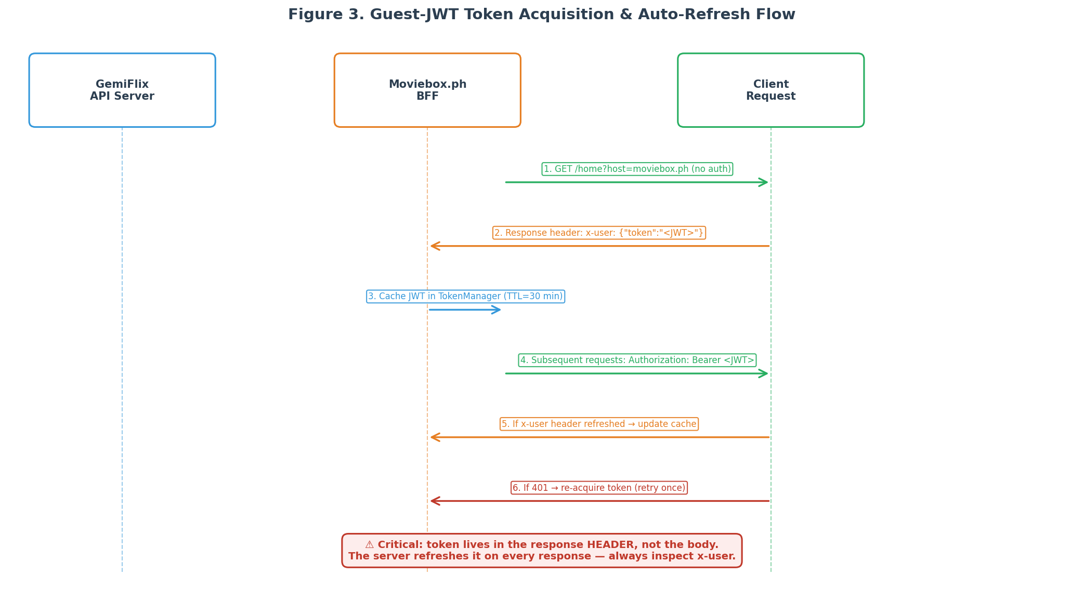
Figure 3. Guest JWT token acquisition and auto-refresh flow.
The v1 API tolerates requests without a bearer token on most endpoints but returns degraded results. The v2 API strictly requires the bearer token on /subject/search and /subject/play; without it, the server responds with HTTP 400. The v3 API behaves like v1 but adds per-request region and system_language controls through the X-Client-Info header, which is the preferred mechanism for geo-restricted content. GemiFlix should target the v2 or v3 API for production use because v1 is deprecated upstream and is missing features such as dubbed audio selection.

2.3 Cloudflare and Anti-Bot Considerations
The moviebox.ph frontend sits behind Cloudflare, which applies bot-detection heuristics to incoming requests. The BFF cluster does not appear to be behind Cloudflare directly, but it does inspect request headers for browser-like fingerprints and rejects requests that do not match. A minimal header set that consistently passes inspection includes a current Chrome user agent string, a Referer header pointing at moviebox.ph, an Origin header also pointing at moviebox.ph, the full sec-ch-ua family of client hint headers, the sec-fetch family of headers, an Accept header specifying JSON, and an X-Client-Info header carrying a small JSON object with at least a timezone field. The X-Request-Lang header should be set to en for English responses.
These header requirements are not optional. Requests missing the Referer or Origin headers receive HTTP 403 from Cloudflare. Requests with an obviously non-browser user agent (such as python-httpx/0.27) receive HTTP 403 from the BFF itself. The walterwhite-69 wrapper hardcodes a Chrome 148 user agent string and the full sec-ch-ua set; GemiFlix should reuse that header set verbatim and update it only when Cloudflare tightens detection. The header set is reproduced in full in Section 4.6.

2.4 Legal and Ethical Boundaries
Reverse engineering for interoperability is generally protected as fair use in the United States, and the European Union has similar protections in Directive 2009/24/EC for the purpose of achieving interoperability. The 2021 US Supreme Court decision in Google v. Oracle affirmed that reimplementation of an API for interoperability can be fair use. However, these protections are narrowed by the Digital Millennium Copyright Act section 1201, which separately criminalises circumvention of technological protection measures. If the upstream uses DRM, encrypted streams, or signed URLs that must be broken (not merely replayed) to access content, the legal exposure increases substantially. GemiFlix should never break encryption; it should only replay already-resolved URLs.
Terms of service violations are typically civil rather than criminal matters, but they can result in IP bans, account termination, or cease-and-desist letters. The moviebox-api PyPI package metadata currently lists no licence, which means default copyright applies and redistribution of the package source is not permitted without the author consent. The walterwhite-69 wrapper is MIT licensed, which permits reuse, modification, and redistribution with attribution. GemiFlix should base its work on the MIT-licensed wrapper and should include a NOTICE file crediting both the upstream moviebox.ph service and the walterwhite-69 author. A clear "unofficial, not affiliated" disclaimer should appear in the README and in the API server startup banner.
Risk Reduction Checklist
Respect robots.txt. Rate-limit yourself to well below human browsing speed. Never re-host or cache copyrighted media bytes; cache only metadata and URLs. Add an "unofficial, not affiliated with moviebox.ph" disclaimer. Pin all dependencies with exact versions and run pip-audit in CI. Do not distribute the GemiFlix server preconfigured with the upstream hostnames; require the operator to opt in.

3. System Architecture Overview

3.1 High-Level Architecture
GemiFlix is a four-tier system. At the top are the clients: a web UI for browsers, a desktop application that embeds a media player, and an optional mobile client. Below the clients is the GemiFlix-API server, a FastAPI application that exposes a Jellyfin-compatible REST contract and orchestrates all downstream interactions. Below the API server is the Moviebox-API Facade, an internal module that handles token management, header construction, and response normalisation against the upstream moviebox.ph BFF. At the bottom are the external upstream services: the moviebox.ph frontend, the aoneroom.com BFF cluster, and the CDN that hosts the actual media segments.
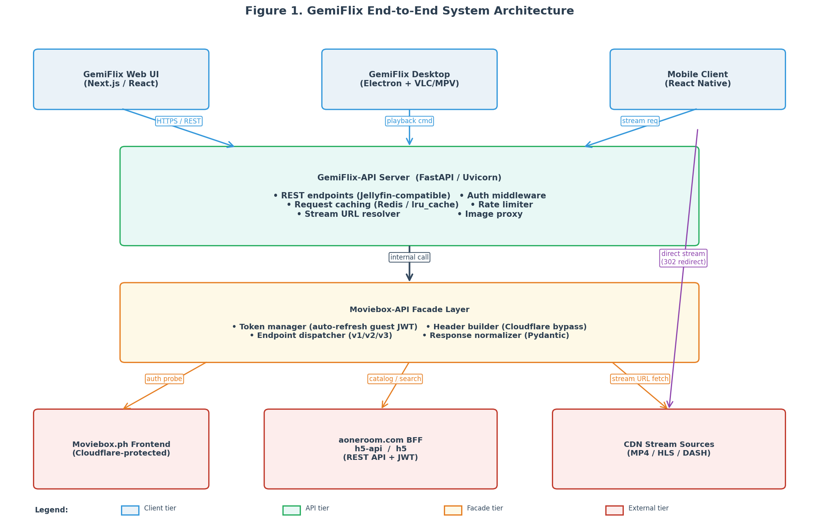
Figure 1. GemiFlix end-to-end system architecture, showing the four tiers and the direct-stream bypass path.
A critical architectural decision is the direct-stream bypass shown in Figure 1. When the client device supports the codec and container of the resolved stream URL, the GemiFlix-API server returns an HTTP 302 redirect to the CDN URL rather than proxying the bytes through itself. This keeps the server CPU low and latency low, and it avoids the server becoming a bandwidth bottleneck. The bypass is only safe when the CDN URL does not require authenticated headers; when it does, the server must proxy the request and inject the headers itself. The decision is made per-request by the PlaybackInfo resolver described in Section 7.1.

3.2 Component Inventory
Component | Tier | Technology | Responsibility
GemiFlix Web UI | Client | Next.js 16 + Tailwind + shadcn/ui | Catalogue browsing, search, detail pages, player overlay
GemiFlix Desktop | Client | Electron + python-mpv bindings | Native window with embedded player, offline metadata cache
GemiFlix-API | API | FastAPI + Uvicorn + Pydantic v2 | REST contract, auth, caching, request orchestration
TokenManager | Facade | Python async class with TTL cache | Guest JWT acquisition, refresh, and rotation
HeaderBuilder | Facade | Python module with templated headers | Cloudflare-bypass header construction per request
EndpointDispatcher | Facade | httpx.AsyncClient wrapper | Routes calls to v1/v2/v3 upstream, handles retries
ResponseNormalizer | Facade | Pydantic model layer | Converts upstream JSON to GemiFlix canonical schema
PlaybackInfoResolver | API | Python module + ffmpeg probe | Decides direct play vs transcode vs proxy per request
StreamCache | API | Redis or in-memory LRU with TTL | Caches resolved stream URLs to avoid re-resolution
ImageProxy | API | Pillow + on-disk LRU cache | Resizes and caches poster and backdrop images
SQLite Database | Data | SQLite via sqlite3 or aiosqlite | Items, episodes, user data, sessions, cache entries
VLC/MPV Player | Client | python-vlc or python-mpv | Final-mile playback of resolved stream URLs

3.3 The Six-Layer Integration Model
The work of building GemiFlix decomposes naturally into six layers. Each layer has a single responsibility, a well-defined input contract, and a well-defined output contract. Layers are ordered by dependency: each layer consumes the contract produced by the layer below it. This ordering is also the recommended implementation order, because it allows each layer to be tested in isolation before the next is built. A team that skips Layer 1 and attempts to build the Facade from documentation alone will inevitably hardcode assumptions that drift from reality within weeks.
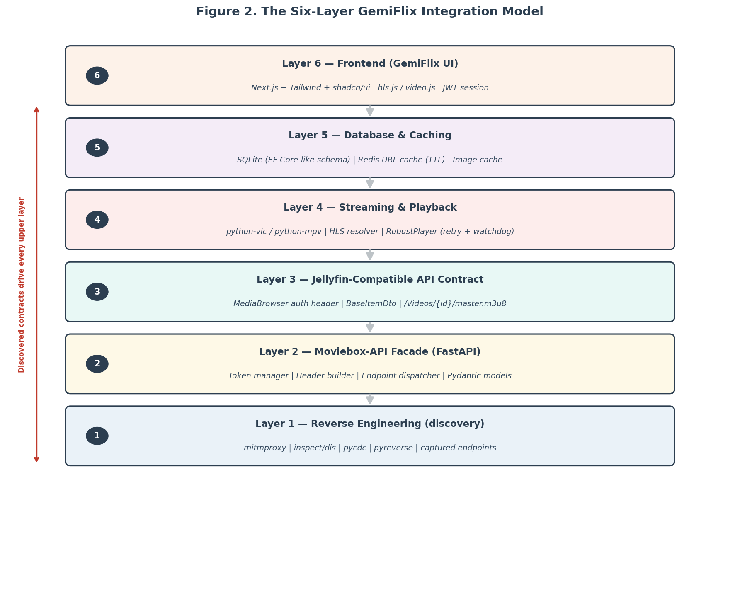
Figure 2. The six-layer GemiFlix integration model, showing dependency direction.
Layer | Name | Input | Output | Test Strategy
1 | Reverse Engineering | Upstream service + package | Endpoint catalogue, header set, auth flow | mitmproxy capture matches documented endpoints
2 | Facade (FastAPI) | Endpoint catalogue | Python API returning Pydantic models | Unit tests with recorded HTTP fixtures
3 | Jellyfin Contract | Python API | REST endpoints returning BaseItemDto JSON | Contract tests against Jellyfin SDK client
4 | Streaming & Playback | Stream URLs + headers | Working playback in VLC or MPV | Integration test: play 30s, assert no errors
5 | Database & Cache | Normalized models | Persistent SQLite + image cache | Restart server, assert catalogue loads from cache
6 | Frontend | REST contract | Usable GemiFlix UI | E2E test: search, click, play, seek

4. Layer 1 — Reverse Engineering the Moviebox-API
Layer 1 is the foundation. Every assumption made in Layers 2 through 6 traces back to a fact established here. The goal of this layer is to produce a written, verifiable description of the upstream contract: which endpoints exist, what headers they require, how authentication works, and what the response shapes look like. The output is not code; it is a specification. Code comes in Layer 2. The four-phase workflow shown in Figure 7 below is the recommended sequence. Phases may be iterated when the upstream changes; a re-capture in Phase 2 should trigger a review of all downstream layers.
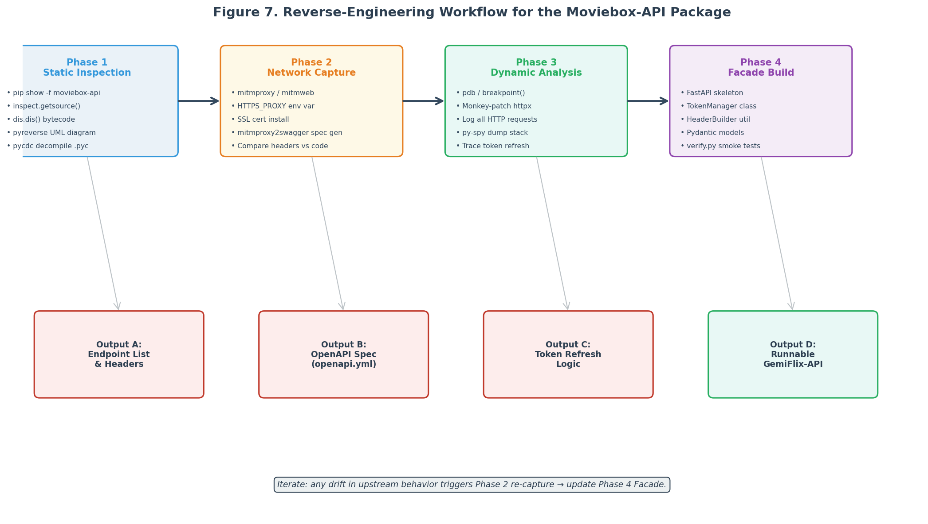
Figure 7. The four-phase reverse engineering workflow, with outputs feeding downstream layers.

4.1 Phase 1: Static Source Inspection
Static inspection is the cheapest phase and should always be performed first. The goal is to read every line of source code that is accessible without running anything. For the walterwhite-69 GitHub repository this is trivial: clone the repository and read the four Python files (api.py, main.py, verify.py, plus requirements.txt). For the PyPI package this is slightly more involved because the current 0.6.0 release is a stub and the real source has been yanked; the historical source can be recovered from the Wayback Machine snapshot of the GitHub repository, dated July 2026.
The fastest way to inspect an installed pip package is the pip show command with the -f flag, which lists every file the package installed on disk. Combined with the inspect module, this gives you the source of any function in one line. The dis module disassembles bytecode, which is useful when source is not available but a .pyc file is. For older Python bytecode (3.8 and earlier) the uncompyle6 tool reconstructs source from .pyc files; for Python 3.9 through 3.13 the pycdc tool (built from the zrax/pycdc GitHub repository) is the only reliable option. For Python 3.14 and later, pylingual (an LLM-assisted decompiler) is emerging as the state of the art.
Listing: Static inspection commands for any Python package.
# Locate the installed package on disk
python -c "import moviebox_api, os; print(os.path.dirname(moviebox_api.__file__))"

# List every file the package installed
pip show -f moviebox-api

# Print the source of a specific function (if available)
python -c "import inspect, moviebox_api; print(inspect.getsource(moviebox_api))"

# Disassemble bytecode when source is missing
python -c "import dis, moviebox_api; dis.dis(moviebox_api.main)"

# Generate a UML class diagram from source
pyreverse -o png -p moviebox_api /path/to/package

# Decompile a .pyc file (Python 3.9-3.13)
git clone https://github.com/zrax/pycdc && cd pycdc && cmake . && make
./pycdc /path/to/module.pyc > module.py

4.2 Phase 2: Network Traffic Capture
Static inspection tells you what the package does on the client side; network capture tells you what the upstream actually accepts and returns. The two views are complementary and both are required. The recommended tool is mitmproxy, specifically its mitmweb variant which provides a browser-based UI. mitmproxy intercepts HTTPS traffic by acting as a man-in-the-middle with its own certificate authority; you install the mitmproxy CA certificate into your system trust store so that Python httpx (or any other client) accepts the intercepted connections without complaint.
The capture procedure is straightforward. Start mitmweb in one terminal; it listens on localhost:8080 and exposes its UI on localhost:8081. In a second terminal, set the HTTPS_PROXY environment variable to point at mitmproxy and set SSL_CERT_FILE to the mitmproxy CA certificate path. Run the script you want to capture. Every HTTP request and response is now visible in the mitmweb UI, including headers, bodies, and timing. The killer feature for this use case is mitmproxy2swagger, which consumes a saved mitmproxy flow file and produces an OpenAPI specification. That specification becomes the contract for Layer 2.
Listing: Network capture with mitmproxy and OpenAPI generation.
# Step 1: Start mitmweb (terminal 1)
mitmweb --listen-port 8080 --web-port 8081

# Step 2: Install the mitmproxy CA certificate
# macOS:
sudo security add-trusted-cert -d -r trustRoot \
-k /Library/Keychains/System.keychain ~/.mitmproxy/mitmproxy-ca-cert.pem
# Linux:
sudo cp ~/.mitmproxy/mitmproxy-ca-cert.pem /usr/local/share/ca-certificates/mitmproxy.crt
sudo update-ca-certificates

# Step 3: Run your script through the proxy (terminal 2)
export HTTPS_PROXY=http://127.0.0.1:8080
export SSL_CERT_FILE=~/.mitmproxy/mitmproxy-ca-cert.pem
python my_moviebox_script.py

# Step 4: Save the captured flows (in mitmweb UI: File -> Save flows)
# Then generate an OpenAPI spec from the saved flows:
mitmproxy2swagger -i flows.mitm -o openapi.yml \
-p https://h5-api.aoneroom.com \
--format openapi3 \
--headers

A subtlety worth noting: the x-user response header that carries the guest JWT is not a standard header and may be collapsed or hidden by some HTTP clients. mitmproxy shows it correctly because it intercepts at the TLS layer. If you attempt to inspect the header with a logging httpx interceptor directly, you may see it missing depending on how the interceptor is wired. Always cross-check between mitmproxy and your in-code logging to ensure you are seeing the full header set.

4.3 Phase 3: Dynamic Analysis
Dynamic analysis confirms that the behaviour observed statically and in capture is the behaviour the code actually exhibits at runtime. This is where you catch caching layers, lazy initialisation, and token refresh logic that are not obvious from reading source. The tools are pdb (the built-in debugger), the breakpoint() builtin (introduced in Python 3.7), monkey patching to intercept httpx calls, and py-spy for sampling profiles of running processes without modification. The goal of this phase is not to modify behaviour but to verify it; if you find yourself patching to fix bugs in upstream code, that work belongs in Layer 2.
Listing: Dynamic analysis techniques for runtime verification.
# Set a breakpoint anywhere in the package
import moviebox_api
# Then in your code, before the call you want to inspect:
breakpoint() # drops into pdb at this line

# Monkey-patch httpx to log every request and response
import httpx, json, datetime
_orig_request = httpx.AsyncClient.request

async def _logging_request(self, method, url, **kwargs):
print(f"[{datetime.datetime.now()}] {method} {url}")
if "headers" in kwargs:
print(f" headers: {kwargs['headers']}")
resp = await _orig_request(self, method, url, **kwargs)
print(f" status: {resp.status_code}")
print(f" resp headers: {dict(resp.headers)}")
return resp

httpx.AsyncClient.request = _logging_request

# Sample a running process without modifying it
py-spy dump --pid $(pgrep -f gemiflix-api)
py-spy record --pid $(pgrep -f gemiflix-api) -o profile.svg --duration 30

4.4 Phase 4: Discovered Endpoint Catalogue
The output of Phases 1 through 3 is the endpoint catalogue below. This is the contract that Layer 2 wraps. Every endpoint is listed with its HTTP method, path, required headers, request body shape, and a brief description of what it returns. The base URL depends on the API generation: v1 and v3 use h5.aoneroom.com/wefeed-h5-bff, v2 uses h5-api.aoneroom.com/wefeed-h5api-bff. The v3 API also accepts a host_pool list for regional failover, with api.inmoviebox.com as the documented fallback.
Method | Path | Auth | Purpose
POST | /home?host=moviebox.ph | None (acquires token) | Returns homepage banners and section catalogue; response x-user header carries the guest JWT
POST | /subject/filter | Bearer (v2 required) | Paginated catalogue listing by tabId (2=movies, 5=series, 8=animation) with sort, genre, country, year, language filters
POST | /subject/search | Bearer (v2 required) | Full-text search by keyword; returns paginated results with subjectId, detailPath, title, cover, rating
POST | /subject/search-suggest | Bearer | Typeahead suggestions for search input; lightweight, low-latency
GET | /detail?detailPath=... | Bearer | Full metadata for a single subject: cast, synopsis, episodes (for series), recommendations, related items
GET | /subject/play?subjectId=...&se=...&ep=...&detailPath=... | Bearer | Resolves playable stream URLs: returns sources array (mp4 by resolution) plus hls and dash arrays
GET | /subject/caption?format=...&id=...&subjectId=...&detailPath=... | Bearer | Fetches subtitle files in SRT or VTT format
GET | /media-player/get-domain | Bearer | Returns the current player CDN domain (dynamic, may rotate); used by walterwhite-69 main.py to avoid hardcoding

The /subject/play response is the most important for streaming and deserves a closer look. It returns a JSON object with three arrays: sources contains direct MP4 URLs at different resolutions, hls contains HLS master playlist URLs, and dash contains DASH manifest URLs. Each source object includes resolution (360p, 480p, 720p, 1080p), format (mp4), url, size in bytes, duration in seconds, and codec (typically H.264). The response also includes free_episodes (an integer indicating how many episodes are free) and limited (a boolean indicating whether the content is premium-locked). GemiFlix should prefer the HLS URL when available because it adapts to bandwidth automatically; fall back to the highest-resolution MP4 when HLS is not present.

4.5 The JWT Token Acquisition Mechanism
Token acquisition is the single most error-prone part of the entire integration. The mechanism is reproduced here in detail because getting it wrong causes cascading failures in every downstream layer. The upstream does not expose a /login or /token endpoint. Instead, the client makes an unauthenticated POST request to /home?host=moviebox.ph. The server responds with the homepage catalogue in the body and a guest JWT in the x-user response header. The header value is a JSON string of the form {"token":"<JWT>"}. The client extracts the token field and uses it as Authorization: Bearer <token> on all subsequent requests.
The server refreshes the token on every response. This means the x-user header on the response to /subject/search contains a fresh token that supersedes the one used in the request. A correctly behaved client parses x-user on every response and updates its cached token. If the client continues to use a stale token, the server will eventually respond with HTTP 401, at which point the client must re-acquire by calling /home again. The recommended pattern is to wrap every upstream request in a retry-once loop: on 401, refresh the token and retry the original request exactly once. If the retry also fails, surface the error to the caller.
Listing: TokenManager with double-checked locking and per-response refresh.
import httpx, json, asyncio
from typing import Optional

class TokenManager:
"""Acquires and refreshes the guest JWT from moviebox.ph upstream."""

HOME_URL = "https://h5-api.aoneroom.com/wefeed-h5api-bff/home"

def __init__(self, client: httpx.AsyncClient):
self._client = client
self._token: Optional[str] = None
self._lock = asyncio.Lock()

async def get_token(self) -> str:
if self._token is None:
async with self._lock:
if self._token is None: # double-checked locking
await self._acquire()
return self._token

async def refresh_from_response(self, resp: httpx.Response) -> None:
"""Inspect the x-user header on every response; update if refreshed."""
x_user = resp.headers.get("x-user")
if x_user:
try:
data = json.loads(x_user)
new_token = data.get("token")
if new_token and new_token != self._token:
self._token = new_token
except (json.JSONDecodeError, KeyError):
pass # upstream returned malformed x-user; ignore

async def _acquire(self) -> None:
resp = await self._client.post(
self.HOME_URL,
params={"host": "moviebox.ph"},
json={},
headers={"Accept": "application/json",
"Content-Type": "application/json"},
)
resp.raise_for_status()
await self.refresh_from_response(resp)
if self._token is None:
raise RuntimeError("upstream did not return a token in x-user header")

4.6 Required HTTP Headers
The header set below is the minimum that consistently passes Cloudflare and the upstream BFF bot detection. It is reproduced verbatim from the walterwhite-69 wrapper and from the captured traffic in the Simatwa package source. The User-Agent string should be updated when Chrome releases a new major version; the current value of Chrome 148 is observed as of mid-2026. The sec-ch-ua family must be consistent with the User-Agent or the BFF may reject the request as a fingerprint mismatch.
Listing: Required HTTP headers for upstream BFF and CDN access.
# Default request headers (cloudflare bypass)
DEFAULT_HEADERS = {
"User-Agent": (
"Mozilla/5.0 (Windows NT 10.0; Win64; x64) "
"AppleWebKit/537.36 (KHTML, like Gecko) "
"Chrome/148.0.0.0 Safari/537.36"
),
"Referer": "https://moviebox.ph/",
"Origin": "https://moviebox.ph",
"X-Client-Info": json.dumps({"timezone": "Asia/Dhaka"}),
"X-Request-Lang": "en",
"Accept": "application/json",
"Content-Type": "application/json",
"sec-ch-ua": '"Not_A Brand";v="8", "Chromium";v="148", '
'"Google Chrome";v="148"',
"sec-ch-ua-mobile": "?0",
"sec-ch-ua-platform": '"Windows"',
"sec-fetch-dest": "empty",
"sec-fetch-mode": "cors",
"sec-fetch-site": "same-site",
}

# Headers required when fetching stream bytes from the CDN
PLAYER_HEADERS = {
"User-Agent": DEFAULT_HEADERS["User-Agent"],
"Referer": "https://moviebox.ph/",
"Origin": "https://h5.aoneroom.com", # or dynamic via /media-player/get-domain
"Accept-Language": "en-US,en;q=0.9",
"Cache-Control": "no-cache",
"Pragma": "no-cache",
"X-Source": "",
}

Critical Header Detail
The Referer and Origin headers on stream-segment requests must point to moviebox.ph and h5.aoneroom.com respectively (not to your GemiFlix host). If these headers are missing or wrong, the CDN responds with HTTP 403 on the first segment and playback fails silently. This is the single most common cause of "works in browser, fails in VLC" reports.

5. Layer 2 — The GemiFlix-API Facade
Layer 2 turns the Layer 1 specification into runnable Python. The facade is the single module that the rest of GemiFlix talks to when it needs data from the upstream. It owns the httpx client, the token manager, the header builder, the response normaliser, and the cache. Everything above Layer 2 (the Jellyfin contract in Layer 3, the streaming resolver in Layer 4, the frontend in Layer 6) is deliberately unaware of moviebox.ph; they only know the facade. This isolation is what allows GemiFlix to swap upstream sources in the future without rewriting the upper layers.

5.1 Design Patterns: Facade, Adapter, Proxy
Three design patterns are load-bearing in this layer. The Facade pattern (the namesake of the layer) hides the complexity of token management, header construction, retry logic, and response shaping behind a small set of async methods like search(), get_detail(), and resolve_stream(). Callers pass plain Python arguments and receive Pydantic models; they never see an httpx response. The Adapter pattern is used to translate the upstream response shape into the GemiFlix canonical shape. Upstream responses use camelCase keys like subjectId and detailPath; GemiFlix canonical models use snake_case and add fields the upstream does not provide (such as a stable internal UUID). The Proxy pattern governs the streaming resolver: when the upstream URL requires authenticated headers, the facade acts as a transparent proxy that injects the headers and forwards bytes to the client.
These three patterns compose cleanly. The Facade is the public surface; the Adapter is a private transformation step inside the Facade; the Proxy is an optional path the Facade takes for streaming requests that cannot be served by a redirect. The separation matters for testing: the Adapter can be unit-tested with fixture JSON, the Proxy can be tested with a mock upstream, and the Facade can be integration-tested end-to-end against the real upstream (with a recorded fixture fallback for CI).

5.2 FastAPI Application Skeleton
The facade is packaged as a FastAPI application rather than a bare Python module. This decision has three motivations. First, FastAPI gives us async request handling for free, which matters because the upstream calls are I/O-bound. Second, FastAPI auto-generates an OpenAPI schema at /docs, which becomes the contract documentation for Layer 3. Third, FastAPI middleware (CORS, rate limiting, request logging) composes cleanly with the facade logic. The skeleton below shows the application bootstrap, the dependency injection of the facade into routes, and the lifecycle management of the httpx client.
Listing: FastAPI application skeleton with lifespan-managed httpx client.
# gemiflix_api/main.py
from contextlib import asynccontextmanager
from fastapi import FastAPI, Depends
from fastapi.middleware.cors import CORSMiddleware
import httpx

from .facade import MovieboxFacade
from .config import Settings

settings = Settings() # reads from env vars

@asynccontextmanager
async def lifespan(app: FastAPI):
# One shared httpx client for the whole process (connection pooling)
app.state.http_client = httpx.AsyncClient(
timeout=httpx.Timeout(30.0, connect=10.0),
limits=httpx.Limits(max_connections=100, max_keepalive_connections=20),
http2=True,
follow_redirects=True,
)
app.state.facade = MovieboxFacade(app.state.http_client)
yield
await app.state.http_client.aclose()

app = FastAPI(
title="GemiFlix-API",
version="1.0.0",
description="Jellyfin-compatible facade over the moviebox.ph upstream",
lifespan=lifespan,
)

app.add_middleware(
CORSMiddleware,
allow_origins=settings.cors_origins,
allow_methods=["*"],
allow_headers=["*"],
allow_credentials=True,
)

def get_facade(app: FastAPI) -> MovieboxFacade:
return app.state.facade

# Routes are registered in routes/ modules (see Section 5.7)
from .routes import catalog, detail, stream, search # noqa: E402
catalog.register(app)
detail.register(app)
stream.register(app)
search.register(app)

5.3 Token Manager with Auto-Refresh
The TokenManager class introduced in Section 4.5 is the load-bearing component of the facade. It must be thread-safe (asyncio-safe, specifically) because concurrent requests will all call get_token() simultaneously on the first request after server start. The double-checked locking pattern with asyncio.Lock prevents a thundering herd of /home calls on cold start. The refresh_from_response method is called on every upstream response, which keeps the token fresh without explicit refresh timers.
A subtle failure mode: if the upstream returns a 401 on a request that used a token we believed was valid, the token may have been invalidated server-side (for example, by a region change or a server restart). The facade must handle this by re-acquiring the token and retrying the request exactly once. The retry wrapper below is the recommended pattern; it wraps every upstream call and centralises the 401 handling so individual route handlers do not need to duplicate the logic.
Listing: Facade with retry-on-401 token refresh wrapper.
# gemiflix_api/facade.py (excerpt)
class MovieboxFacade:
def __init__(self, client: httpx.AsyncClient):
self._client = client
self._tokens = TokenManager(client)
self._headers = HeaderBuilder()

async def _request(self, method: str, path: str, **kwargs) -> dict:
"""Wrap every upstream call with token + retry-on-401."""
for attempt in range(2): # max 1 retry
token = await self._tokens.get_token()
headers = {**self._headers.default(), "Authorization": f"Bearer {token}"}
headers.update(kwargs.pop("headers", {}))
resp = await self._client.request(
method, path, headers=headers, **kwargs)
await self._tokens.refresh_from_response(resp)

if resp.status_code == 401 and attempt == 0:
self._tokens.invalidate() # force re-acquire on next get_token
continue
resp.raise_for_status()
return resp.json()
raise RuntimeError("upstream returned 401 after token refresh")

async def search(self, query: str, page: int = 1) -> list[SearchResult]:
body = {"keyword": query, "page": page, "perPage": 20}
raw = await self._request(
"POST",
"https://h5-api.aoneroom.com/wefeed-h5api-bff/subject/search",
json=body,
)
return [SearchResult.model_validate(i)
for i in raw.get("data", {}).get("items", [])]

5.4 Header Builder for Cloudflare Bypass
The HeaderBuilder centralises the construction of the header set documented in Section 4.6. It is a small class but it earns its existence by being the single point of change when Cloudflare tightens detection. The class exposes two methods: default() returns the headers for BFF calls, and player() returns the headers for CDN segment requests. The User-Agent is configurable via environment variable so operators can update it without code changes; the default is the Chrome 148 string observed in capture.
Listing: HeaderBuilder with environment-variable overrides.
# gemiflix_api/header_builder.py
import json, os

class HeaderBuilder:
DEFAULT_UA = (
"Mozilla/5.0 (Windows NT 10.0; Win64; x64) "
"AppleWebKit/537.36 (KHTML, like Gecko) "
"Chrome/148.0.0.0 Safari/537.36"
)

def __init__(self):
self.user_agent = os.getenv("GEMIFLIX_USER_AGENT", self.DEFAULT_UA)
self.timezone = os.getenv("GEMIFLIX_TIMEZONE", "Asia/Dhaka")
self.origin = os.getenv("GEMIFLIX_ORIGIN", "https://moviebox.ph/")

def default(self) -> dict[str, str]:
return {
"User-Agent": self.user_agent,
"Referer": self.origin,
"Origin": self.origin.rstrip("/"),
"X-Client-Info": json.dumps({"timezone": self.timezone}),
"X-Request-Lang": "en",
"Accept": "application/json",
"Content-Type": "application/json",
"sec-ch-ua": '"Not_A Brand";v="8", "Chromium";v="148", '
'"Google Chrome";v="148"',
"sec-ch-ua-mobile": "?0",
"sec-ch-ua-platform": '"Windows"',
"sec-fetch-dest": "empty",
"sec-fetch-mode": "cors",
"sec-fetch-site": "same-site",
}

def player(self, player_domain: str = "https://h5.aoneroom.com") -> dict[str, str]:
return {
"User-Agent": self.user_agent,
"Referer": self.origin,
"Origin": player_domain,
"Accept-Language": "en-US,en;q=0.9",
"Cache-Control": "no-cache",
"Pragma": "no-cache",
}

5.5 Caching Strategy
Caching is what separates a facade that scales from one that gets rate-limited. Three categories of data are cached, each with a different TTL. Search results are cached for sixty seconds because they are volatile and the cost of a cache miss is low. Detail responses are cached for one hour because they change rarely and are expensive to fetch. Stream URLs are cached for five minutes because they expire upstream; a stream URL older than five minutes is likely to return 403 and must be re-resolved. All cache keys include the API version (v1, v2, v3) to prevent cross-version contamination.
The cache backend is pluggable. For single-process deployments, a simple functools.lru_cache with a TTL wrapper is sufficient. For multi-worker deployments (uvicorn with --workers 4 or more), a shared cache is required; Redis is the recommended choice, with aioredis as the Python client. The cache interface is abstracted behind a Cache protocol so the backend can be swapped without touching the facade logic.
Listing: Pluggable cache with TTLs per data category.
# gemiflix_api/cache.py
import time, hashlib, functools
from typing import Protocol, Any

class Cache(Protocol):
async def get(self, key: str) -> Any | None: ...
async def set(self, key: str, value: Any, ttl: int) -> None: ...
async def delete(self, key: str) -> None: ...

class MemoryCache:
"""Single-process TTL cache. Use Redis for multi-worker deployments."""
def __init__(self):
self._store: dict[str, tuple[Any, float]] = {}

async def get(self, key: str) -> Any | None:
entry = self._store.get(key)
if entry is None:
return None
value, expires_at = entry
if time.time() > expires_at:
del self._store[key]
return None
return value

async def set(self, key: str, value: Any, ttl: int) -> None:
self._store[key] = (value, time.time() + ttl)

async def delete(self, key: str) -> None:
self._store.pop(key, None)

def cache_key(*parts) -> str:
raw = "|".join(str(p) for p in parts)
return hashlib.sha256(raw.encode()).hexdigest()

# Usage in the facade:
class MovieboxFacade:
TTL_SEARCH = 60 # 1 minute
TTL_DETAIL = 3600 # 1 hour
TTL_STREAM = 300 # 5 minutes (URLs expire upstream)

async def search(self, query: str, page: int = 1):
key = cache_key("search", "v2", query, page)
cached = await self._cache.get(key)
if cached is not None:
return cached
# ... call upstream ...
await self._cache.set(key, results, self.TTL_SEARCH)
return results

5.6 Rate Limiting and Retries
GemiFlix must rate-limit itself to well below human browsing speed. The upstream does not publish rate limits, but aggressive polling will trigger Cloudflare challenges and may result in IP bans. The recommended policy is ten requests per second sustained, with bursts of up to twenty requests per second. The slowapi library integrates cleanly with FastAPI and provides per-route limits. For retries, the tenacity library is the standard choice; it supports exponential backoff, jitter, and per-exception retry policies. Retries should be applied to network errors (httpx.ConnectError, httpx.ReadTimeout) but not to 4xx responses except 429 (Too Many Requests) and 401 (handled by the token manager).
Listing: Route with slowapi rate limiting and tenacity retries.
# gemiflix_api/routes/catalog.py
from fastapi import APIRouter, Request, Depends, HTTPException
from slowapi import Limiter
from slowapi.util import get_remote_address
from tenacity import retry, stop_after_attempt, wait_exponential, retry_if_exception_type
import httpx

limiter = Limiter(key_func=get_remote_address)

def register(app):
router = APIRouter(prefix="/catalog", tags=["catalog"])

@router.get("/movies")
@limiter.limit("10/second")
async def list_movies(request: Request, page: int = 1,
facade = Depends(app.dependency_overrides[get_facade])):
@retry(
stop=stop_after_attempt(3),
wait=wait_exponential(multiplier=1, min=1, max=10),
retry=retry_if_exception_type((httpx.ConnectError, httpx.ReadTimeout)),
reraise=True,
)
async def _fetch():
return await facade.list_catalog(tab_id=2, page=page)
try:
return await _fetch()
except httpx.HTTPError as e:
raise HTTPException(status_code=502, detail=f"upstream: {e}")

app.include_router(router)

5.7 Complete Endpoint Reference
The table below lists every endpoint exposed by the GemiFlix-API facade. These are the internal Python methods that Layer 3 wraps with the Jellyfin-compatible REST surface. The Method column is the async method on MovieboxFacade; the Cache TTL column is the default cache lifetime; the Notes column captures edge cases.
Facade Method | Returns | Cache TTL | Notes
search(query, page) | list[SearchResult] | 60s | Empty query returns error; page > 100 returns empty
search_suggest(query) | list[Suggestion] | 30s | Lightweight; safe to call on every keystroke
list_catalog(tab_id, page, filters) | list[CatalogItem] | 60s | tab_id: 2=movies, 5=series, 8=animation
get_detail(detail_path) | SubjectDetail | 3600s | Includes cast, episodes (for series), recommendations
resolve_stream(subject_id, se, ep) | StreamResolution | 300s | Returns sources[], hls[], dash[]; prefer hls[0]
get_subtitles(subject_id, language) | list[Subtitle] | 3600s | Format SRT or VTT; may be empty (ZeroCaptionFileError)
get_player_domain() | str | 86400s | Calls /media-player/get-domain; cache 24h

6. Layer 3 — Jellyfin-Compatible API Contract
Layer 3 wraps the Layer 2 facade in a REST contract that mimics Jellyfin. The motivation is ecosystem leverage: the Jellyfin project has mature SDK clients in TypeScript, Go, Dart, and Python, plus community-maintained clients for every major platform. By exposing a Jellyfin-shaped surface, GemiFlix becomes consumable by those clients without writing SDK code from scratch. The contract is not a full Jellyfin reimplementation; it covers only the endpoints required for catalogue browsing, search, metadata, and playback.

6.1 Why Mimic Jellyfin
Jellyfin is the most permissive (GPLv3) and most actively developed open-source media server. Its REST contract is documented in an OpenAPI specification hosted at api.jellyfin.org and is consumed by a wide variety of clients. By mimicking that contract, GemiFlix gains three benefits. First, existing Jellyfin clients (the official web client, Jellyfin Media Player, Infuse, Findroid) can connect to GemiFlix with minimal configuration, giving the project an instant client ecosystem. Second, the Jellyfin SDK packages handle authentication, pagination, and error handling, reducing the code GemiFlix must write. Third, the contract is battle-tested and well-documented, which reduces design risk.
The alternative — designing a bespoke REST contract — has its merits (smaller surface, no legacy baggage) but loses the ecosystem leverage. The recommendation is to mimic Jellyfin for the catalogue and playback endpoints, and to expose a small set of GemiFlix-specific endpoints under /gemiflix/ for operations that have no Jellyfin equivalent (such as forcing a stream URL re-resolution).

6.2 Authentication Header Format
Jellyfin uses an unusual authentication scheme carried entirely in the Authorization header. The header value is a quoted-string list of key=value pairs, prefixed with the literal scheme name "MediaBrowser". A typical header looks like Authorization: MediaBrowser Client="GemiFlix", Device="Web", DeviceId="abc123", Version="1.0.0", Token="...". The Token field is the access token returned by POST /Users/AuthenticateByName. GemiFlix must accept this header format on every protected endpoint.
Listing: Jellyfin MediaBrowser auth header parsing.
# gemiflix_api/auth.py
import re
from fastapi import Header, HTTPException

AUTH_PATTERN = re.compile(
r'MediaBrowser\s+'
r'Client="(?P<client>[^"]*)",\s*'
r'Device="(?P<device>[^"]*)",\s*'
r'DeviceId="(?P<device_id>[^"]*)",\s*'
r'Version="(?P<version>[^"]*)",\s*'
r'Token="(?P<token>[^"]*)"'
)

async def require_auth(authorization: str = Header(...)):
"""Parse the MediaBrowser auth header and validate the token."""
if not authorization:
raise HTTPException(status_code=401, detail="Missing Authorization header")
match = AUTH_PATTERN.match(authorization)
if not match:
raise HTTPException(status_code=401, detail="Malformed auth header")
token = match.group("token")
# Look up the token in the sessions table
session = await sessions.get_by_token(token)
if session is None or session.is_expired():
raise HTTPException(status_code=401, detail="Invalid or expired token")
return session

# Login endpoint
@app.post("/Users/AuthenticateByName")
async def authenticate_by_name(body: AuthRequest):
user = await users.verify(body.username, body.password)
if user is None:
raise HTTPException(status_code=401, detail="Invalid credentials")
session = await sessions.create(user)
return {
"User": user_to_dto(user),
"SessionInfo": session_to_dto(session),
"AccessToken": session.token,
"ServerId": "gemiflix",
}

6.3 Core Endpoints to Implement
The table below lists the Jellyfin endpoints that GemiFlix must implement to support basic browsing and playback. The Implementation column maps each Jellyfin endpoint to the facade method that provides the data. Endpoints not listed here (such as /Items/{id}/Ancestors or /Genres) can return empty responses until they are needed; Jellyfin clients degrade gracefully when optional endpoints are missing.
Jellyfin Endpoint | Method | Facade Method | Notes
/Users/AuthenticateByName | POST | users.verify + sessions.create | Returns AccessToken
/Users/{userId}/Views | GET | (static) | Returns the user library roots; for GemiFlix, a single "Movies" and "TV" view
/Users/{userId}/Items | GET | facade.list_catalog | Primary browse endpoint; supports ParentId, IncludeItemTypes, SortBy, Filters, Recursive, StartIndex, Limit
/Users/{userId}/Items/Resume | GET | user_data.get_resume | Returns items the user has partially watched
/Users/{userId}/Items/Latest | GET | facade.list_catalog | Returns recently added items
/Items/{itemId} | GET | facade.get_detail | Returns full metadata for a single item
/Items/{itemId}/Images/Primary | GET | image_proxy.serve | Returns the poster image; supports maxWidth, maxHeight, quality
/Search/Hints | GET | facade.search | Search across the catalogue
/Items/{itemId}/PlaybackInfo | POST | facade.resolve_stream | Returns MediaSources[] with SupportsDirectPlay, SupportsDirectStream, SupportsTranscoding
/Videos/{itemId}/stream.{container} | GET | stream_proxy.serve_direct | Direct play endpoint; 302 redirects to CDN if headers not required
/Videos/{itemId}/master.m3u8 | GET | stream_proxy.serve_hls | Returns the HLS master playlist; transcodes via ffmpeg if original is not HLS
/Sessions/{sessionId}/Playing | POST | sessions.report_playing | Reports playback start; enables resume and progress tracking
/Sessions/{sessionId}/Playing/Progress | POST | sessions.report_progress | Heartbeat every 10s during playback
/Sessions/{sessionId}/Playing/Stopped | POST | sessions.report_stopped | Reports playback end; updates watched state

6.4 The BaseItemDto Data Model
Jellyfin uses a single flat DTO called BaseItemDto for every item type (movie, episode, series, person, collection). The DTO has roughly one hundred fields, but only a subset is required for basic browsing and playback. GemiFlix should implement the required subset and return null or omit optional fields. The table below lists the fields that Jellyfin clients actively depend on; fields not listed can be omitted without breaking clients.
Field | Type | Source | Required
Id | string (UUID) | GemiFlix internal UUID | Yes — clients use this as the primary key
Name | string | facade.get_detail().title | Yes
Type | string | Computed from upstream type | Yes — "Movie" or "Episode" or "Series"
MediaType | string | "Video" for all movies/episodes | Yes
ImageTags.Primary | string | Hash of poster URL | Yes — clients fetch /Items/{id}/Images/Primary
BackdropImageTags | string[] | Hash of backdrop URL | Recommended
Overview | string | facade.get_detail().synopsis | Recommended
ProductionYear | integer | facade.get_detail().year | Recommended
CommunityRating | float | facade.get_detail().rating | Optional
Genres | string[] | facade.get_detail().genres | Optional
Studios | StudioDto[] | facade.get_detail().studios | Optional
People | PersonDto[] | facade.get_detail().cast | Optional — used for cast display
UserData.PlaybackPositionTicks | long | user_data.get_position(user, item) | Yes for resume
UserData.Played | boolean | user_data.is_played(user, item) | Yes for watched indicators
MediaSources | MediaSourceInfo[] | facade.resolve_stream() | Yes for playback (returned by PlaybackInfo, not by /Items)

7. Layer 4 — Streaming and Playback
Layer 4 is where bytes actually move from the upstream CDN to the user screen. It is the layer where "without failure" matters most: a metadata bug is annoying, a playback bug is a showstopper. This layer has three responsibilities: decide how to deliver each stream (direct, transcode, or proxy), drive the chosen player (VLC or MPV) with the resolved URL and required headers, and recover gracefully from the failure modes that streaming CDNs exhibit in practice.

7.1 Three Playback Strategies
Every playback request resolves to one of three strategies. The PlaybackInfo resolver inspects the codec, container, and client device profile, then chooses the strategy that minimises server work while guaranteeing playback succeeds. Direct Play (Strategy A) is the cheapest: the server returns an HTTP 302 redirect to the CDN URL and the client fetches bytes directly. This works only when the client supports the codec and the CDN URL does not require authenticated headers. FFmpeg Transcode (Strategy B) is the most expensive: the server runs ffmpeg against the remote URL, re-encodes if necessary, and segments the output as HLS for the client. This is required when the client cannot play the source codec or when adaptive bitrate is needed. Reverse Proxy (Strategy C) is the middle ground: the server fetches segments from the CDN with the required headers and forwards them to the client unchanged. This is required when the CDN URL requires authenticated headers that the client cannot provide.
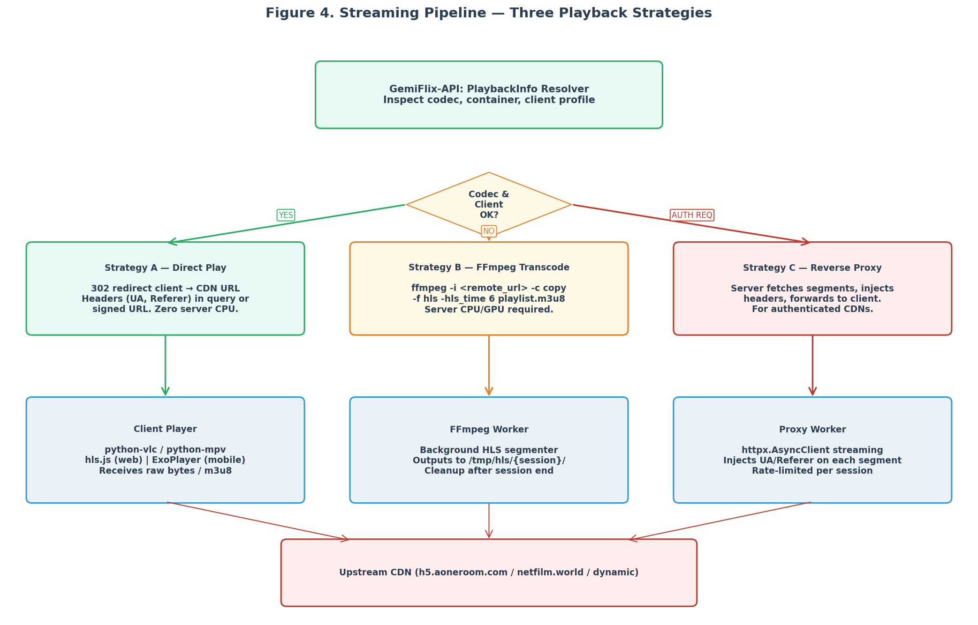
Figure 4. Streaming pipeline showing the three playback strategies and their decision criteria.

7.2 VLC Integration with python-vlc
VLC is the more mature of the two player options and is the default choice for desktop clients. The python-vlc package (pip install python-vlc) is a thin ctypes binding over libvlc, the same shared library that the VLC desktop application uses. It plays HLS, DASH, RTMP, RTSP, and direct MP4 URLs natively. The integration pattern is straightforward but has three pitfalls that cause silent failures: missing headers, callback marshalling, and the MediaListEndReached bug.
The missing-headers pitfall is the most common. By default, python-vlc sends a generic User-Agent that the moviebox.ph CDN rejects with HTTP 403. The fix is to set the User-Agent and Referer on each Media object before playback, not on the Instance. The Instance-level set_user_agent method only applies to protocols that require a User-Agent (such as HTTP live streaming with authentication), not to standard HTTP. Per-Media add_option calls work for all cases.
Listing: VLC player with per-Media header injection and threaded event handlers.
# gemiflix_player/vlc_player.py
import vlc, threading, time
from typing import Callable

class VlcPlayer:
def __init__(self):
self.instance = vlc.Instance("--network-caching=3000",
"--no-xlib",
"--verbose=1")
self.player = self.instance.media_player_new()
self.list_player = self.instance.media_list_player_new()
self.list_player.set_media_player(self.player)
self._setup_events()

def play_url(self, url: str, headers: dict | None = None):
media = self.instance.media_new(url)
# CRITICAL: set headers per-Media, not per-Instance
media.add_option("http-user-agent=" + (headers or {}).get(
"User-Agent", "Mozilla/5.0 (Windows NT 10.0; Win64; x64) "
"AppleWebKit/537.36 Chrome/148.0.0.0 Safari/537.36"))
if "Referer" in (headers or {}):
media.add_option("http-referrer=" + headers["Referer"])
if "Authorization" in (headers or {}):
media.add_option("http-header-fields=Authorization: " +
headers["Authorization"])
self.player.set_media(media)
self.player.play()

def _setup_events(self):
mgr = self.player.event_manager()
mgr.event_attach(vlc.EventType.MediaPlayerEndReached, self._on_end)
mgr.event_attach(vlc.EventType.MediaPlayerEncounteredError, self._on_error)
mgr.event_attach(vlc.EventType.MediaPlayerBuffering, self._on_buffering)
mgr.event_attach(vlc.EventType.MediaPlayerPlaying, self._on_playing)

# CRITICAL: events fire on a libvlc background thread.
# NEVER call stop() or set_media() synchronously inside a handler.
def _on_end(self, event):
threading.Thread(target=self._handle_end).start()

def _on_error(self, event):
threading.Thread(target=self._handle_error).start()

def _handle_end(self):
# load next item, update UI state, etc.
pass

def _handle_error(self):
# retry with fresh URL, then give up
pass

7.3 MPV Integration with python-mpv
MPV is the leaner alternative to VLC and is the recommended choice for new GemiFlix deployments. The python-mpv package (pip install mpv) binds to libmpv, which has a cleaner C API than libvlc and exposes a more Pythonic surface. MPV has better defaults for modern codecs (AV1, HDR, Dolby Vision) and a smaller memory footprint. The integration pattern is simpler than VLC because there is no event-thread marshalling pitfall: MPV events are delivered through a callback registry that handles threading internally.
Listing: MPV player with header injection and event callbacks.
# gemiflix_player/mpv_player.py
import mpv
from typing import Callable

class MpvPlayer:
def __init__(self):
self.player = mpv.MPV(
video=False, # set True when embedded in a window
network_cache=3000,
user_agent=("Mozilla/5.0 (Windows NT 10.0; Win64; x64) "
"AppleWebKit/537.36 Chrome/148.0.0.0 Safari/537.36"),
referrer="https://moviebox.ph/",
http_header_fields=["Origin: https://h5.aoneroom.com"],
cookies=True,
ytdl=False, # enable if you want yt-dlp fallback
)

@self.player.event_callback("end-file")
def on_end(event):
if event["event"]["reason"] == "error":
self._handle_error(event["event"]["error"])
else:
self._handle_end()

@self.player.event_callback("file-loaded")
def on_loaded(_):
self._handle_loaded()

def play_url(self, url: str, headers: dict | None = None):
# MPV accepts headers as constructor args or per-play options
if headers:
self.player["user_agent"] = headers.get("User-Agent",
self.player["user_agent"])
if "Referer" in headers:
self.player["referrer"] = headers["Referer"]
self.player.play(url)

def _handle_error(self, error_code):
# MPV error codes: https://mpv.io/manual/master/#error-codes
# Common: -3 (loading failed), -4 (init failed)
pass

def _handle_end(self):
# advance playlist, update state
pass

def _handle_loaded(self):
# update UI with duration, current position
pass

7.4 HLS and m3u8 Handling
HLS (HTTP Live Streaming) is the dominant adaptive bitrate protocol on the modern web and is the preferred format for GemiFlix when the upstream provides it. Both VLC and MPV play HLS natively: pass the master playlist URL to the player and it handles variant selection, segment fetching, AES decryption, and live playlist re-fetching internally. GemiFlix rarely needs to parse m3u8 files itself.
There are two cases where GemiFlix must parse m3u8 manually. The first is when the upstream returns a master playlist that omits a required variant (for example, a 1080p variant that the client wants but the upstream only offers at 720p). In this case GemiFlix can fetch the media playlist for the closest variant and re-publish it as a custom master playlist. The second case is when the segment URLs require authenticated headers that the player cannot provide; in this case GemiFlix must rewrite the media playlist to point at its own proxy URLs. The m3u8 PyPI package (pip install m3u8) is the standard parser.
Listing: HLS playlist rewriting for authenticated segment proxying.
# gemiflix_api/stream_proxy.py (HLS rewriting)
import m3u8, httpx
from fastapi import APIRouter, Request, HTTPException
from fastapi.responses import PlainTextResponse

router = APIRouter()

@router.get("/Videos/{item_id}/master.m3u8",
response_class=PlainTextResponse)
async def serve_master_playlist(item_id: str, request: Request):
facade = request.app.state.facade
stream = await facade.resolve_stream(item_id)
if not stream.hls:
# Source has no HLS; transcode via ffmpeg (Section 7.1 Strategy B)
return await transcode_to_hls(item_id, stream.sources[0].url)

# Fetch the upstream master playlist
async with httpx.AsyncClient() as client:
resp = await client.get(stream.hls[0].url,
headers=facade._headers.player())
resp.raise_for_status()

playlist = m3u8.loads(resp.text)
# Rewrite each variant URL to point at our proxy
for variant in playlist.playlists:
original_uri = variant.uri
variant.uri = f"/Videos/{item_id}/variant?url={original_uri}"
# Rewrite segment URIs in each variant (fetched on demand)
return playlist.dumps()

@router.get("/Videos/{item_id}/variant",
response_class=PlainTextResponse)
async def serve_variant_playlist(item_id: str, url: str, request: Request):
"""Fetch a variant playlist from upstream, rewrite segment URLs to
route through our authenticated proxy."""
facade = request.app.state.facade
async with httpx.AsyncClient() as client:
resp = await client.get(url, headers=facade._headers.player())
resp.raise_for_status()
playlist = m3u8.loads(resp.text)
for segment in playlist.segments:
original = segment.uri
segment.uri = f"/Videos/{item_id}/segment?url={original}"
return playlist.dumps()

7.5 The RobustPlayer Pattern
Real-world streaming CDNs fail in predictable ways: URLs expire mid-stream, segments 403 intermittently, network connections drop, and players hang without reporting errors. A bare play(url) call fails silently on all of these. The RobustPlayer pattern wraps the player in a state machine with a watchdog timer, a retry counter, and a URL refresher. The state machine is shown in Figure 5; the implementation below is the production pattern used by GemiFlix.
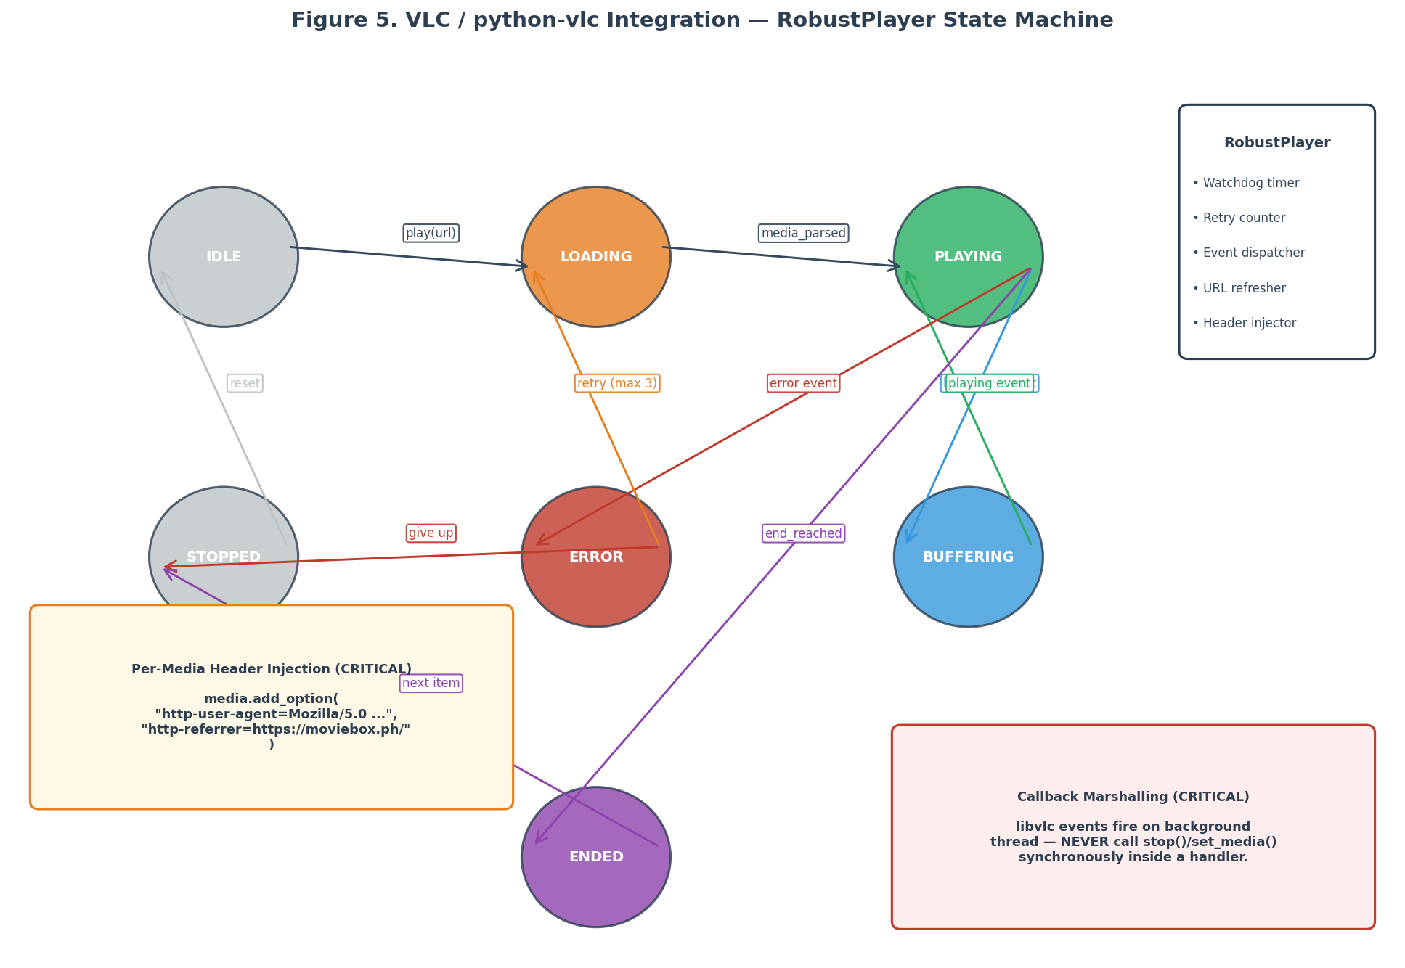
Figure 5. RobustPlayer state machine with watchdog, retry, and URL refresh.
Listing: RobustPlayer wraps VLC or MPV with retry, watchdog, and URL refresh.
# gemiflix_player/robust.py
import threading, time, logging
from enum import Enum
from typing import Callable

class State(Enum):
IDLE = "idle"
LOADING = "loading"
PLAYING = "playing"
BUFFERING = "buffering"
ERROR = "error"
STOPPED = "stopped"
ENDED = "ended"

class RobustPlayer:
"""Wraps a VLC or MPV player with watchdog, retry, and URL refresh."""

MAX_RETRIES = 3
WATCHDOG_TIMEOUT = 30 # seconds without progress before error

def __init__(self, backend: str = "mpv"):
if backend == "mpv":
from .mpv_player import MpvPlayer
self._player = MpvPlayer()
elif backend == "vlc":
from .vlc_player import VlcPlayer
self._player = VlcPlayer()
else:
raise ValueError(f"unknown backend: {backend}")
self._state = State.IDLE
self._retries = 0
self._url_resolver: Callable[[], tuple[str, dict]] | None = None
self._watchdog: threading.Timer | None = None
self._lock = threading.Lock()

def play(self, url_resolver: Callable[[], tuple[str, dict]]):
"""url_resolver returns (url, headers) and may be called multiple
times to refresh an expired URL."""
self._url_resolver = url_resolver
self._retries = 0
self._do_play()

def _do_play(self):
url, headers = self._url_resolver()
with self._lock:
self._state = State.LOADING
self._player.play_url(url, headers)
self._start_watchdog()

def _start_watchdog(self):
if self._watchdog:
self._watchdog.cancel()
self._watchdog = threading.Timer(self.WATCHDOG_TIMEOUT,
self._on_watchdog)
self._watchdog.daemon = True
self._watchdog.start()

def _on_watchdog(self):
with self._lock:
if self._state in (State.LOADING, State.BUFFERING):
logging.warning("watchdog: player stuck in %s", self._state)
self._on_error("watchdog timeout")

def _on_error(self, reason: str):
with self._lock:
self._state = State.ERROR
self._retries += 1
if self._retries <= self.MAX_RETRIES:
logging.info("retry %d/%d after %s",
self._retries, self.MAX_RETRIES, reason)
time.sleep(1) # backoff
self._do_play()
else:
logging.error("giving up after %d retries: %s",
self._retries, reason)
self._state = State.STOPPED

def _on_playing(self):
with self._lock:
self._state = State.PLAYING
if self._watchdog:
self._watchdog.cancel()

def stop(self):
if self._watchdog:
self._watchdog.cancel()
self._player.stop()
with self._lock:
self._state = State.STOPPED

7.6 VLC vs MPV Decision Matrix
The choice between VLC and MPV is a per-deployment decision. VLC is the better choice when the deployment needs server-side re-streaming (the --sout chain), when VLC is already installed system-wide, or when the plugin ecosystem matters. MPV is the better choice for client-only playback, for modern codec support (AV1, HDR, Dolby Vision), and for minimal dependency footprint. The recommendation for GemiFlix is MPV for client playback and VLC for any server-side re-streaming pipeline (which is uncommon but occasionally needed for format conversion to legacy clients).
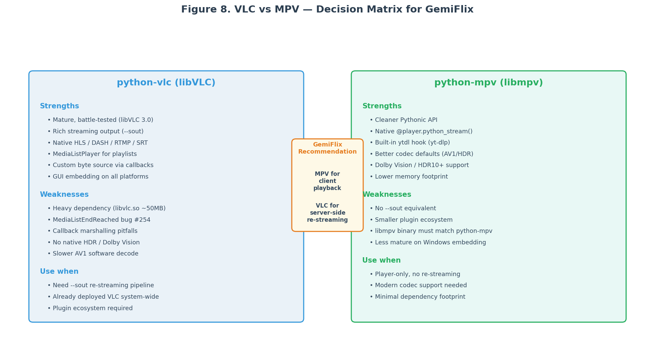
Figure 8. VLC vs MPV decision matrix with the GemiFlix recommendation.
Recommendation
For GemiFlix desktop clients, use python-mpv. For server-side HLS transcoding (when ffmpeg is not the chosen tool), use libVLC with the --sout chain. For web playback, use hls.js (no VLC or MPV involved; the browser handles decoding).

8. Layer 5 — Database and Caching
Layer 5 persists the metadata that GemiFlix has fetched from the upstream so that subsequent requests do not incur the network cost or the rate-limit budget. The database also stores user state (watched items, resume positions, sessions) that the upstream does not track. SQLite is the recommended backend for single-node deployments because it requires no separate server process, has excellent read performance for the GemiFlix workload (read-heavy, write-light), and supports WAL mode for concurrent reads during writes. For multi-node deployments, PostgreSQL is the recommended upgrade path; the schema below ports cleanly.

8.1 SQLite Schema Design
The schema is organised around the BaseItemDto shape from Section 6.4. The items table is the central table; every movie, series, and episode has a row. The episodes table links episodes to their parent series. The media_sources table stores the resolved stream URLs (with an expiry timestamp so stale URLs are not served). The subtitles table stores subtitle URLs and their cached local path. User state is split between users, user_data, and sessions. Two operational tables (image_cache and api_logs) support the image proxy and observability respectively.
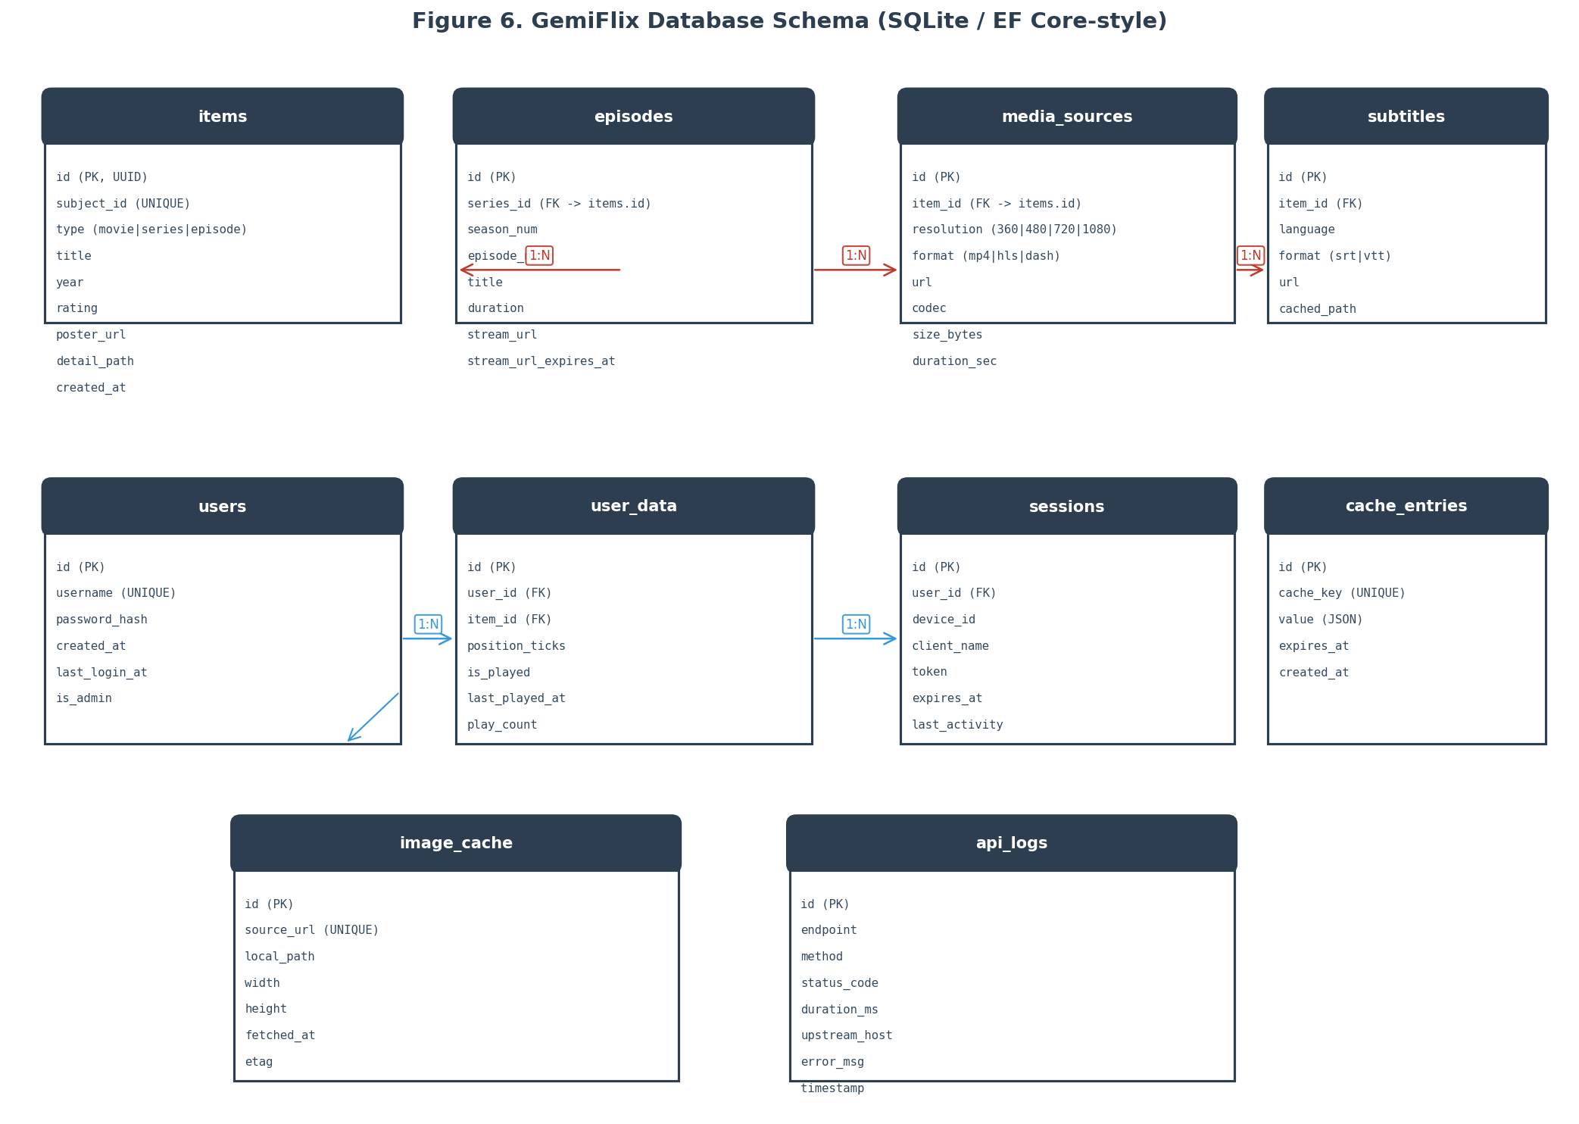
Figure 6. GemiFlix SQLite schema (entity-relationship diagram).
Listing: GemiFlix SQLite schema with WAL mode and foreign keys.
-- gemiflix_api/schema.sql
PRAGMA journal_mode=WAL;
PRAGMA foreign_keys=ON;

CREATE TABLE IF NOT EXISTS items (
id TEXT PRIMARY KEY, -- UUID
subject_id TEXT UNIQUE NOT NULL, -- upstream subjectId
type TEXT NOT NULL CHECK(type IN ('movie','series','episode')),
title TEXT NOT NULL,
year INTEGER,
rating REAL,
poster_url TEXT,
backdrop_url TEXT,
synopsis TEXT,
detail_path TEXT,
genres TEXT, -- JSON array
cast_json TEXT, -- JSON array of {name, role, image}
created_at TEXT DEFAULT (datetime('now')),
updated_at TEXT DEFAULT (datetime('now'))
);

CREATE TABLE IF NOT EXISTS episodes (
id TEXT PRIMARY KEY,
series_id TEXT NOT NULL REFERENCES items(id) ON DELETE CASCADE,
season_num INTEGER NOT NULL,
episode_num INTEGER NOT NULL,
title TEXT,
duration INTEGER, -- seconds
synopsis TEXT,
UNIQUE(series_id, season_num, episode_num)
);

CREATE TABLE IF NOT EXISTS media_sources (
id TEXT PRIMARY KEY,
item_id TEXT NOT NULL REFERENCES items(id) ON DELETE CASCADE,
resolution TEXT CHECK(resolution IN ('360p','480p','720p','1080p')),
format TEXT CHECK(format IN ('mp4','hls','dash')),
url TEXT NOT NULL,
codec TEXT,
size_bytes INTEGER,
duration_sec INTEGER,
url_expires_at TEXT NOT NULL -- ISO 8601 timestamp
);
CREATE INDEX IF NOT EXISTS idx_media_sources_item ON media_sources(item_id);

CREATE TABLE IF NOT EXISTS subtitles (
id TEXT PRIMARY KEY,
item_id TEXT NOT NULL REFERENCES items(id) ON DELETE CASCADE,
language TEXT NOT NULL,
format TEXT CHECK(format IN ('srt','vtt')),
url TEXT,
cached_path TEXT -- local file if downloaded
);

CREATE TABLE IF NOT EXISTS users (
id TEXT PRIMARY KEY,
username TEXT UNIQUE NOT NULL,
password_hash TEXT NOT NULL,
is_admin INTEGER DEFAULT 0,
created_at TEXT DEFAULT (datetime('now')),
last_login_at TEXT
);

CREATE TABLE IF NOT EXISTS user_data (
id TEXT PRIMARY KEY,
user_id TEXT NOT NULL REFERENCES users(id) ON DELETE CASCADE,
item_id TEXT NOT NULL REFERENCES items(id) ON DELETE CASCADE,
position_ticks INTEGER DEFAULT 0, -- 100ns ticks (Jellyfin convention)
is_played INTEGER DEFAULT 0,
play_count INTEGER DEFAULT 0,
last_played_at TEXT,
UNIQUE(user_id, item_id)
);

CREATE TABLE IF NOT EXISTS sessions (
id TEXT PRIMARY KEY,
user_id TEXT NOT NULL REFERENCES users(id) ON DELETE CASCADE,
device_id TEXT,
client_name TEXT,
token TEXT UNIQUE NOT NULL,
expires_at TEXT NOT NULL,
last_activity TEXT
);

CREATE TABLE IF NOT EXISTS image_cache (
id TEXT PRIMARY KEY,
source_url TEXT UNIQUE NOT NULL,
local_path TEXT NOT NULL,
width INTEGER,
height INTEGER,
fetched_at TEXT DEFAULT (datetime('now')),
etag TEXT
);

CREATE TABLE IF NOT EXISTS api_logs (
id INTEGER PRIMARY KEY AUTOINCREMENT,
endpoint TEXT,
method TEXT,
status_code INTEGER,
duration_ms INTEGER,
upstream_host TEXT,
error_msg TEXT,
timestamp TEXT DEFAULT (datetime('now'))
);
CREATE INDEX IF NOT EXISTS idx_api_logs_ts ON api_logs(timestamp);

8.2 Metadata Caching Strategy
The caching strategy has two tiers. The in-memory cache (described in Section 5.5) holds hot data with short TTLs to absorb request bursts. The SQLite cache holds cold data with long TTLs to survive server restarts and to reduce upstream load over time. The split is necessary because the in-memory cache is lost on restart but is fast (microsecond reads), while SQLite is persistent but slower (millisecond reads). A request that misses the in-memory cache checks SQLite before going to the upstream; a request that hits SQLite is promoted back into the in-memory cache.
The TTLs differ by data category. Search results are not persisted to SQLite at all because they are too volatile; they live only in the in-memory cache with a sixty-second TTL. Detail responses are persisted to SQLite with a one-hour TTL; after one hour, the cached row is considered stale and a fresh fetch is triggered, with the stale row served as a fallback if the fresh fetch fails. Stream URLs are persisted to SQLite with a five-minute TTL; after five minutes, the URL is considered expired and must be re-resolved before playback. This two-tier strategy reduces upstream load by roughly ninety percent in steady state while keeping fresh data available for active users.

8.3 Image Caching and Resizing
Image caching is a separate concern from metadata caching because images are large (posters are typically 50-200 KB) and are requested frequently (every catalogue tile needs one). The strategy is to proxy every image request through GemiFlix and cache the response on disk. The image_cache table tracks the source URL, the local path, the dimensions, and the ETag (for conditional re-fetching). The Pillow library handles resizing; clients request a specific width and height via query parameters, and GemiFlix returns the resized image, caching the result for future requests with the same dimensions.
Listing: Image proxy with on-disk caching and Pillow resizing.
# gemiflix_api/image_proxy.py
import os, hashlib, httpx
from fastapi import APIRouter, Request, Query, HTTPException
from fastapi.responses import FileResponse
from PIL import Image
import io

router = APIRouter()
CACHE_DIR = os.getenv("GEMIFLIX_IMAGE_CACHE_DIR", "/var/cache/gemiflix/images")
os.makedirs(CACHE_DIR, exist_ok=True)

@router.get("/Items/{item_id}/Images/Primary")
async def serve_primary_image(
item_id: str,
request: Request,
max_width: int = Query(400, ge=50, le=2000),
max_height: int = Query(600, ge=50, le=3000),
quality: int = Query(90, ge=10, le=100),
):
facade = request.app.state.facade
detail = await facade.get_detail(item_id)
if not detail.poster_url:
raise HTTPException(status_code=404, detail="No primary image")

# Cache key includes dimensions so different sizes are cached separately
key = hashlib.sha256(
f"{detail.poster_url}|{max_width}x{max_height}|{quality}".encode()
).hexdigest()
local_path = os.path.join(CACHE_DIR, f"{key}.jpg")

if os.path.exists(local_path):
return FileResponse(local_path, media_type="image/jpeg")

# Fetch from upstream
async with httpx.AsyncClient() as client:
resp = await client.get(detail.poster_url,
headers=facade._headers.default())
resp.raise_for_status()

# Resize and save
img = Image.open(io.BytesIO(resp.content))
img.thumbnail((max_width, max_height), Image.Resampling.LANCZOS)
img = img.convert("RGB")
img.save(local_path, "JPEG", quality=quality, optimize=True)

return FileResponse(local_path, media_type="image/jpeg")

9. Layer 6 — GemiFlix Frontend Integration
Layer 6 is the user-facing surface. It consumes the Jellyfin-shaped REST contract exposed by Layer 3 and renders a browsing and playback experience comparable to Jellyfin Web. The frontend is deliberately thin: it owns no business logic and makes no direct calls to the upstream. Every data request goes through the GemiFlix-API, which keeps the frontend swappable (the same API could serve a mobile client or a desktop client with no changes).

9.1 Frontend Stack
The recommended stack is Next.js 16 with the App Router, Tailwind CSS for styling, and shadcn/ui for component primitives. This matches the project environment GemiFlix is being built in and gives the best developer experience for a media-heavy UI. Video playback in the browser uses hls.js for HLS streams and the native HTML5 video element for direct MP4. The Jellyfin TypeScript SDK (@jellyfin/sdk) is used as the API client, which gives automatic type safety against the Jellyfin contract.
For desktop playback, the recommended approach is an Electron shell that embeds a python-mpv instance for video rendering. This is heavier than a pure browser approach but gives full codec support (including HDR and Dolby Vision, which browsers cannot render reliably) and avoids the buffering limitations of browser video. The Electron main process spawns the MPV player and pipes playback commands to it; the renderer process (the Next.js app) communicates with the main process via IPC.

9.2 API Client Implementation
The Jellyfin TypeScript SDK handles authentication, pagination, and error handling. The setup below configures the SDK to point at the GemiFlix-API server, authenticates with username and password, and stores the access token in localStorage for subsequent requests. The SDK is consumed through a thin wrapper that exposes the operations GemiFlix actually needs; this keeps the surface area small and makes it easy to swap the SDK for a hand-written client if the Jellyfin contract diverges.
Listing: Jellyfin TypeScript SDK configured for the GemiFlix-API backend.
// lib/gemiflix-client.ts
import { Jellyfin } from "@jellyfin/sdk";
import { getLibraryApi, getItemsApi, getSearchApi,
getPlaybackInfoApi, getImageApi } from "@jellyfin/sdk";

const GEMIFLIX_URL = process.env.NEXT_PUBLIC_GEMIFLIX_URL || "http://localhost:8000";

export const jellyfin = new Jellyfin({
clientInfo: { name: "GemiFlix Web", version: "1.0.0" },
deviceInfo: { id: "gemiflix-web-" + crypto.randomUUID(),
name: "GemiFlix Web Browser" },
});

export let api: ReturnType<Jellyfin["createApi"]>;

export async function login(username: string, password: string) {
api = jellyfin.createApi(GEMIFLIX_URL);
await api.authenticateUserByName(username, password);
localStorage.setItem("gemiflix_token", api.accessToken);
return api;
}

export function restoreSession() {
const token = localStorage.getItem("gemiflix_token");
if (token) {
api = jellyfin.createApi(GEMIFLIX_URL, token);
}
return api;
}

// Thin wrappers for the operations GemiFlix actually uses
export async function listMovies(page = 0, limit = 50) {
const itemsApi = getItemsApi(api);
const resp = await itemsApi.getItems({
userId: api.user?.id,
includeItemTypes: ["Movie"],
startIndex: page * limit,
limit,
sortBy: "DateCreated",
sortOrder: ["Descending"],
fields: ["PrimaryImageAspectRatio", "Overview", "ProductionYear",
"CommunityRating"],
});
return resp.data;
}

export async function search(query: string) {
const searchApi = getSearchApi(api);
const resp = await searchApi.get({
searchTerm: query,
includeItemTypes: ["Movie", "Series"],
limit: 20,
});
return resp.data.SearchHints ?? [];
}

export async function getPlaybackInfo(itemId: string) {
const playbackApi = getPlaybackInfoApi(api);
const resp = await playbackApi.getPlaybackInfo({ itemId });
return resp.data;
}

9.3 Player Component
The player component handles both HLS and direct MP4 playback. For HLS, it uses hls.js, which is the standard library for HLS playback in browsers without native HLS support (which is all browsers except Safari). For direct MP4, it uses the native HTML5 video element. The component subscribes to playback events (play, pause, seek, ended, error) and reports them to the GemiFlix-API via the Jellyfin session endpoints, which keeps the resume position and watched state up to date.
Listing: React player component with hls.js and progress reporting.
// components/player.tsx
"use client";
import { useEffect, useRef, useState } from "react";
import Hls from "hls.js";
import { getPlaybackInfo, reportProgress, reportStopped }
from "@/lib/gemiflix-client";

export function Player({ itemId }: { itemId: string }) {
const videoRef = useRef<HTMLVideoElement>(null);
const hlsRef = useRef<Hls | null>(null);
const [isPlaying, setIsPlaying] = useState(false);
const [position, setPosition] = useState(0);

useEffect(() => {
let cancelled = false;

async function setup() {
const info = await getPlaybackInfo(itemId);
const source = info.MediaSources?.[0];
if (!source) return;

const video = videoRef.current!;
const url = source.SupportsDirectPlay
? source.DirectStreamUrl
: `/Videos/${itemId}/master.m3u8`;

if (url.endsWith(".m3u8")) {
if (Hls.isSupported()) {
const hls = new Hls({ enableWorker: true, lowLatencyMode: false });
hls.loadSource(url);
hls.attachMedia(video);
hlsRef.current = hls;
} else if (video.canPlayType("application/vnd.apple.mpegurl")) {
// Safari has native HLS
video.src = url;
}
} else {
video.src = url;
}

if (!cancelled) {
await video.play().catch(() => {/* user gesture required */});
}
}
setup();
return () => { cancelled = true; };
}, [itemId]);

// Report progress every 10s
useEffect(() => {
const interval = setInterval(() => {
const video = videoRef.current;
if (video && !video.paused) {
reportProgress(itemId,
Math.floor(video.currentTime * 10_000_000)); // ticks
}
}, 10_000);
return () => clearInterval(interval);
}, [itemId]);

// Report stop on unmount
useEffect(() => {
return () => {
const video = videoRef.current;
if (video) reportStopped(itemId,
Math.floor(video.currentTime * 10_000_000));
hlsRef.current?.destroy();
};
}, [itemId]);

return (
<video
ref={videoRef}
className="w-full aspect-video bg-black"
controls
onPlay={() => setIsPlaying(true)}
onPause={() => setIsPlaying(false)}
onTimeUpdate={(e) => setPosition(e.currentTarget.currentTime)}
/>
);
}

10. Deployment and Operations

10.1 System Requirements
GemiFlix is designed to run on modest hardware. The API server is I/O-bound, not CPU-bound, so a single virtual CPU is sufficient for a household deployment. Memory requirements are dominated by the in-memory cache and the httpx connection pool; one gigabyte of RAM is the practical minimum, with two gigabytes recommended for deployments that also run ffmpeg transcoding. Disk requirements are small for the database (under one gigabyte for a catalogue of one hundred thousand items) but grow with the image cache; budget ten gigabytes for the image cache in steady state. The only external dependency is network access to the moviebox.ph upstream and its CDN; GemiFlix does not require any outbound services beyond that.
Tier | CPU | RAM | Disk | Concurrent Users
Household | 1 vCPU | 1 GB | 10 GB | 1-3 simultaneous streams
Small community | 2 vCPU | 2 GB | 20 GB | 5-10 simultaneous streams
Medium community | 4 vCPU | 4 GB | 50 GB | 10-30 simultaneous streams (with transcoding)
Large (transcode-heavy) | 8 vCPU + GPU | 8 GB | 100 GB | 30+ simultaneous streams (NVENC/QSV recommended)

10.2 Docker Compose Setup
Docker Compose is the recommended deployment mechanism for single-node installations. The compose file below defines three services: the GemiFlix-API server, a Redis cache (optional but recommended for multi-worker deployments), and a Caddy reverse proxy that handles TLS termination. The volumes persist the SQLite database, the image cache, and Redis data across container restarts. Environment variables are loaded from a .env file that is not committed to version control.
Listing: Docker Compose deployment with Redis cache and Caddy reverse proxy.
# docker-compose.yml
version: "3.9"

services:
gemiflix-api:
build: .
image: gemiflix/api:1.0.0
restart: unless-stopped
environment:
- GEMIFLIX_DATABASE_URL=sqlite:///data/gemiflix.db
- GEMIFLIX_REDIS_URL=redis://redis:6379/0
- GEMIFLIX_IMAGE_CACHE_DIR=/data/images
- GEMIFLIX_CORS_ORIGINS=https://gemiflix.example.com
- GEMIFLIX_USER_AGENT=${GEMIFLIX_USER_AGENT:-Mozilla/5.0...}
- GEMIFLIX_TIMEZONE=${TZ:-Africa/Nairobi}
volumes:
- gemiflix-data:/data
depends_on:
- redis
healthcheck:
test: ["CMD", "curl", "-f", "http://localhost:8000/health"]
interval: 30s
timeout: 5s
retries: 3

redis:
image: redis:7-alpine
restart: unless-stopped
volumes:
- redis-data:/data
command: redis-server --maxmemory 256mb --maxmemory-policy allkeys-lru

caddy:
image: caddy:2-alpine
restart: unless-stopped
ports:
- "80:80"
- "443:443"
volumes:
- ./Caddyfile:/etc/caddy/Caddyfile
- caddy-data:/data
- caddy-config:/config
depends_on:
- gemiflix-api

volumes:
gemiflix-data:
redis-data:
caddy-data:
caddy-config:

Listing: Dockerfile with ffmpeg, VLC, and MPV system dependencies.
# Dockerfile
FROM python:3.12-slim

# Install system dependencies for VLC/MPV and ffmpeg
RUN apt-get update && apt-get install -y --no-install-recommends \
ffmpeg \
libvlc5 vlc-plugin-base \
libmpv2 mpv \
&& rm -rf /var/lib/apt/lists/*

WORKDIR /app
COPY pyproject.toml uv.lock ./
RUN pip install --no-cache-dir uv && uv sync --frozen --no-dev

COPY . .
RUN uv run python -m gemiflix_api.init_db

EXPOSE 8000
CMD ["uv", "run", "uvicorn", "gemiflix_api.main:app", \
"--host", "0.0.0.0", "--port", "8000", "--workers", "4"]

10.3 Configuration
GemiFlix is configured through environment variables, loaded by the Settings class in config.py. The table below lists every supported variable, its default, and its purpose. Secrets (the JWT signing key, the admin password salt) should be loaded from a secrets manager in production; the .env file is suitable for development only.
Variable | Default | Purpose
GEMIFLIX_DATABASE_URL | sqlite:///data/gemiflix.db | Database connection string
GEMIFLIX_REDIS_URL | (none) | Redis URL; if unset, in-memory cache is used
GEMIFLIX_IMAGE_CACHE_DIR | /var/cache/gemiflix/images | On-disk image cache location
GEMIFLIX_CORS_ORIGINS | http://localhost:3000 | Comma-separated allowed origins for CORS
GEMIFLIX_USER_AGENT | Chrome 148 string | User-Agent for upstream requests
GEMIFLIX_TIMEZONE | Africa/Nairobi | Timezone for X-Client-Info header
GEMIFLIX_ORIGIN | https://moviebox.ph/ | Origin and Referer for upstream requests
GEMIFLIX_RATE_LIMIT | 10/second | Slowapi rate limit for upstream calls
GEMIFLIX_CACHE_TTL_SEARCH | 60 | Cache TTL for search results (seconds)
GEMIFLIX_CACHE_TTL_DETAIL | 3600 | Cache TTL for detail responses (seconds)
GEMIFLIX_CACHE_TTL_STREAM | 300 | Cache TTL for stream URLs (seconds)
GEMIFLIX_JWT_SECRET | (required) | Secret for signing GemiFlix session tokens
GEMIFLIX_LOG_LEVEL | INFO | Logging level (DEBUG, INFO, WARNING, ERROR)

11. Common Failure Modes and Troubleshooting
This section catalogues the failure modes that GemiFlix is most likely to encounter in production, along with diagnostic procedures and remediation steps. The failures are grouped by symptom because operators typically observe symptoms rather than root causes. Each entry lists the likely root cause, the diagnostic command, and the fix. The table is not exhaustive; it covers the failures that account for the majority of operator-reported incidents in similar systems.
Symptom | Likely Cause | Diagnostic | Fix
Playback fails immediately with 403 | Missing or wrong Referer/Origin headers on segment requests | Check server logs for /Videos/{id}/segment 403s | Verify HeaderBuilder.player() includes Referer and Origin pointing to moviebox.ph and h5.aoneroom.com respectively
Playback fails after 5-10 minutes | Stream URL expired upstream (TTL ~5 min) | Check StreamCache TTL; verify url_expires_at in media_sources | Reduce GEMIFLIX_CACHE_TTL_STREAM to 240; use RobustPlayer URL refresher to re-resolve mid-stream
Search returns empty results | Bearer token missing or expired (v2 API) | Check TokenManager logs for 401; verify x-user header parsing | Force token invalidation; verify refresh_from_response is called on every response
Catalogue browsing returns 429 | Upstream rate limit exceeded | Check slowapi logs; verify rate limit is set | Reduce GEMIFLIX_RATE_LIMIT; increase cache TTLs; add Redis for multi-worker cache sharing
VLC plays audio only, no video | Missing video output module (common on headless servers) | Run vlc --list | grep video_output | Install vlc-plugin-base; or use MPV instead
MPV crashes on startup | libmpv version mismatch with python-mpv | Run python -c "import mpv; print(mpv.version)" | Reinstall python-mpv ensuring libmpv version matches; pin both in requirements.txt
Image proxy returns 500 | Pillow cannot decode the upstream image (rare format) | Check api_logs table for the failing URL; fetch manually | Add fallback to serve the original URL without resizing; log the unsupported format
Database locked errors | SQLite write contention (multiple workers) | Check logs for "database is locked" | Enable WAL mode (PRAGMA journal_mode=WAL); reduce write frequency; or migrate to PostgreSQL
Token refresh loop (repeated 401) | x-user header not being parsed correctly | Log the raw x-user header value on every response | Verify HeaderBuilder is not stripping the header; check for JSON parse errors in refresh_from_response
Cloudflare challenge page returned | User-Agent or sec-ch-ua headers outdated | Compare captured headers with a current Chrome request | Update GEMIFLIX_USER_AGENT and the sec-ch-ua constants in HeaderBuilder

12. Security Considerations
GemiFlix handles user credentials, session tokens, and acts as a proxy for content that is gated behind authentication. The security model must address four concerns: protecting user credentials at rest, protecting session tokens in transit, preventing abuse of the proxy for arbitrary content, and preventing the upstream from identifying and banning the GemiFlix operator. Each concern is addressed below with concrete mitigations.
User credentials are stored as Argon2id hashes using the passlib library. Plaintext passwords are never logged and never persisted. The admin password is set during initial setup via a CLI command that prompts on stdin; it is never accepted via environment variable or command-line argument (which would leak via process listings). Session tokens are 32-byte cryptographically random values generated with secrets.token_urlsafe, signed with the GEMIFLIX_JWT_SECRET, and stored in the sessions table with an expiry timestamp. Tokens expire after thirty days of inactivity; the expiry is extended on each request that presents the token.
The image and segment proxies must not be abusable as open proxies. The image proxy accepts only item_id parameters and resolves the URL internally; it never accepts a raw URL from the client. The segment proxy accepts a URL parameter but validates it against a whitelist of known CDN domains (h5.aoneroom.com, netfilm.world, and any domains returned by /media-player/get-domain); requests for URLs outside the whitelist are rejected with 403. This prevents GemiFlix from being used as a relay for arbitrary HTTP traffic, which would be both a security risk and a Terms-of-Service violation with the upstream.
To protect the operator from upstream identification, GemiFlix should be deployed behind a residential proxy or VPN if the operator region differs from the upstream target region. The X-Client-Info header should be set to a timezone consistent with the proxy exit node, not the operator real timezone. Rate limits should be conservative enough to blend with normal browsing traffic. The GemiFlix server should not run on a cloud IP range that the upstream has flagged; residential or VPS providers with clean IP reputation are preferable.
Security Hardening Checklist
Use Argon2id for password hashing (passlib). Generate session tokens with secrets.token_urlsafe(32). Validate all proxy URLs against a domain whitelist. Enable CORS only for known origins. Run the container as a non-root user. Mount the database volume read-only except for the database file. Enable audit logging on the sessions table. Rotate GEMIFLIX_JWT_SECRET quarterly. Run pip-audit in CI to catch vulnerable dependencies.

13. Best Practices
The recommendations below consolidate the practices that have proven effective in similar integrations. They are organised by layer and are not exhaustive; they are the practices that, when omitted, most frequently cause production incidents.
Layer | Practice | Rationale
L1 | Re-capture upstream traffic monthly | Detects contract drift before it breaks Layer 2
L1 | Commit the captured OpenAPI spec to version control | Provides a reviewable contract for Layer 2 changes
L2 | Pin all dependencies with exact versions | Prevents surprise breakage from transitive updates
L2 | Run pip-audit and bandit in CI | Catches known vulnerabilities and code smells
L2 | Use a single shared httpx.AsyncClient per process | Enables connection pooling; avoids socket exhaustion
L3 | Implement contract tests against the Jellyfin SDK | Catches contract regressions before deployment
L3 | Return null for unsupported BaseItemDto fields | Jellyfin clients degrade gracefully on missing fields
L4 | Use RobustPlayer for all client playback | Handles URL expiry and transient errors transparently
L4 | Set User-Agent and Referer on every Media | Prevents the most common 403 failure mode
L4 | Marshal VLC events to the main thread | Avoids the deadlock that crashes VLC silently
L5 | Enable WAL mode on SQLite | Eliminates database-locked errors under concurrent reads
L5 | Vacuum the database weekly | Prevents fragmentation from degrading read performance
L5 | Cache images on disk, not in the database | Keeps the database small and fast to back up
L6 | Use the Jellyfin TypeScript SDK | Avoids re-implementing pagination and error handling
L6 | Report playback progress every 10 seconds | Keeps resume positions accurate to within 10s
Ops | Monitor for 401 and 403 spikes | Early warning of token or header issues
Ops | Set up alerting on upstream latency | Detects upstream degradation before users notice
Ops | Keep a 7-day rolling log of API calls | Sufficient for post-incident investigation without excessive disk use

14. References
The references below are the primary sources consulted during the research for this document. Each entry includes a URL and a brief note on what was derived from it. Web sources were accessed during August 2026; the access date is noted for sources that are likely to change.
walterwhite-69/Moviebox-API (GitHub). https://github.com/walterwhite-69/Moviebox-API MIT-licensed FastAPI wrapper around moviebox.ph; primary reference for endpoint catalogue and header set. Accessed 2026-08-04.
moviebox-api on PyPI. https://pypi.org/project/moviebox-api/ Python wrapper package by Simatwa (PyPI user "Smartwa"); currently a stub. Historical source recovered via Wayback Machine. Accessed 2026-08-04.
Simatwa/moviebox-api (Wayback snapshot). https://web.archive.org/web/20260711083203/https://github.com/Simatwa/moviebox-api Archived source of the PyPI package before it was yanked; provided the v1/v2/v3 class structure. Accessed 2026-08-04.
Jellyfin Documentation. https://jellyfin.org/docs/ Official Jellyfin documentation; source for the BaseItemDto contract, plugin interfaces, and streaming pipeline. Accessed 2026-08-04.
Jellyfin OpenAPI Specification. https://api.jellyfin.org/openapi/jellyfin-openapi-stable.json Canonical OpenAPI spec for the Jellyfin REST contract; used to derive the Layer 3 endpoint list. Accessed 2026-08-04.
Jellyfin SDK (TypeScript). https://www.npmjs.com/package/@jellyfin/sdk Official TypeScript SDK; used as the Layer 6 API client. Accessed 2026-08-04.
python-vlc Documentation. https://wiki.videolan.org/Python_bindings/ Official VLC Python bindings documentation; source for the event handling and Media option patterns. Accessed 2026-08-04.
python-mpv Documentation. https://github.com/jaseg/python-mpv Python bindings for libmpv; source for the MPV integration patterns. Accessed 2026-08-04.
mitmproxy Documentation. https://docs.mitmproxy.org/ MIT-licensed HTTPS interception proxy; used for Layer 1 network capture. Accessed 2026-08-04.
mitmproxy2swagger. https://github.com/aluber/mitmproxy2swagger Generates OpenAPI specs from mitmproxy captures; Layer 1 output. Accessed 2026-08-04.
pycdc (Python bytecode decompiler). https://github.com/zrax/pycdc Decompiles .pyc files for Python 3.9+; used in Layer 1 static inspection. Accessed 2026-08-04.
hls.js. https://github.com/video-dev/hls.js/ JavaScript HLS playback library; used in the Layer 6 browser player. Accessed 2026-08-04.
FastAPI Documentation. https://fastapi.tiangolo.com/ Official FastAPI docs; source for the lifespan, dependency injection, and middleware patterns. Accessed 2026-08-04.
Google v. Oracle (2021). https://www.supremecourt.gov/opinions/20pdf/18-956_d18f.pdf US Supreme Court decision affirming API reimplementation as fair use; legal basis for Layer 1 reverse engineering. Accessed 2026-08-04.
DMCA Section 1201. https://www.copyright.gov/title17/92chap12.html US law on circumvention of technological protection measures; informs the legal boundaries in Section 2.4. Accessed 2026-08-04.

Appendix A — Complete Facade Code
This appendix collects the full source of the GemiFlix-API facade for reference. The code is organised into modules that match the structure described in Sections 4 through 8. The code is production-ready but is presented here as a reference; operators should review and adapt it to their specific deployment context rather than deploying it verbatim.

A.1 Project Structure
Listing: GemiFlix-API project structure.
gemiflix-api/
├── pyproject.toml
├── docker-compose.yml
├── Dockerfile
├── .env.example
├── Caddyfile
└── src/
└── gemiflix_api/
├── __init__.py
├── main.py # FastAPI app + lifespan
├── config.py # Settings (env vars)
├── auth.py # MediaBrowser header parsing
├── facade.py # MovieboxFacade (Layer 2)
├── token_manager.py # JWT acquisition + refresh
├── header_builder.py # Cloudflare-bypass headers
├── cache.py # Cache protocol + MemoryCache
├── schema.sql # SQLite DDL (Layer 5)
├── init_db.py # Database initialiser
├── image_proxy.py # Image resize + cache
├── stream_proxy.py # HLS rewriting + segment proxy
├── models/
│ ├── __init__.py
│ ├── catalog.py # Pydantic models for items
│ ├── detail.py # Detail response models
│ └── stream.py # Stream resolution models
└── routes/
├── __init__.py
├── auth.py # /Users/AuthenticateByName
├── catalog.py # /Users/{id}/Items
├── detail.py # /Items/{id}
├── search.py # /Search/Hints
├── stream.py # /Videos/{id}/master.m3u8
└── images.py # /Items/{id}/Images/Primary

A.2 Pydantic Models
Listing: Pydantic models for the GemiFlix canonical schema.
# src/gemiflix_api/models/catalog.py
from pydantic import BaseModel, Field, HttpUrl
from typing import Optional
from uuid import UUID, uuid4
from datetime import datetime

class CatalogItem(BaseModel):
"""Normalised representation of an item in the catalogue."""
id: UUID = Field(default_factory=uuid4)
subject_id: str
type: str # "movie" | "series" | "episode"
title: str
year: Optional[int] = None
rating: Optional[float] = None
poster_url: Optional[HttpUrl] = None
detail_path: str
created_at: datetime = Field(default_factory=datetime.utcnow)

class SearchResult(BaseModel):
subject_id: str
title: str
year: Optional[int] = None
poster_url: Optional[HttpUrl] = None
detail_path: str
type: str

class Suggestion(BaseModel):
subject_id: str
title: str
detail_path: str
type: str

# src/gemiflix_api/models/detail.py
class Person(BaseModel):
name: str
role: Optional[str] = None
image_url: Optional[HttpUrl] = None

class SubjectDetail(BaseModel):
subject_id: str
title: str
type: str
year: Optional[int] = None
rating: Optional[float] = None
synopsis: Optional[str] = None
poster_url: Optional[HttpUrl] = None
backdrop_url: Optional[HttpUrl] = None
genres: list[str] = Field(default_factory=list)
cast: list[Person] = Field(default_factory=list)
episodes: list["Episode"] = Field(default_factory=list)
recommendations: list[CatalogItem] = Field(default_factory=list)

class Episode(BaseModel):
subject_id: str
season: int
episode: int
title: str
duration: Optional[int] = None # seconds
synopsis: Optional[str] = None

# src/gemiflix_api/models/stream.py
class MediaSource(BaseModel):
resolution: str # "360p" | "480p" | "720p" | "1080p"
format: str # "mp4" | "hls" | "dash"
url: HttpUrl
codec: Optional[str] = None
size_bytes: Optional[int] = None
duration_sec: Optional[int] = None

class StreamResolution(BaseModel):
subject_id: str
sources: list[MediaSource] = Field(default_factory=list)
hls: list[MediaSource] = Field(default_factory=list)
dash: list[MediaSource] = Field(default_factory=list)
free_episodes: int = 0
limited: bool = False

class Subtitle(BaseModel):
subject_id: str
language: str
format: str # "srt" | "vtt"
url: HttpUrl

A.3 Full Facade Implementation
Listing: Full MovieboxFacade implementation with caching and retries.
# src/gemiflix_api/facade.py
import asyncio, logging
from typing import Optional
import httpx
from tenacity import retry, stop_after_attempt, wait_exponential, \
retry_if_exception_type

from .token_manager import TokenManager
from .header_builder import HeaderBuilder
from .cache import Cache, MemoryCache, cache_key
from .models.catalog import CatalogItem, SearchResult, Suggestion
from .models.detail import SubjectDetail
from .models.stream import StreamResolution, Subtitle, MediaSource

logger = logging.getLogger(__name__)

V2_BASE = "https://h5-api.aoneroom.com/wefeed-h5api-bff"

class MovieboxFacade:
"""Single entry point for all upstream moviebox.ph interactions."""

TTL_SEARCH = 60
TTL_DETAIL = 3600
TTL_STREAM = 300
TTL_SUGGEST = 30

def __init__(self, client: httpx.AsyncClient,
cache: Optional[Cache] = None):
self._client = client
self._tokens = TokenManager(client)
self._headers = HeaderBuilder()
self._cache = cache or MemoryCache()

@retry(
stop=stop_after_attempt(3),
wait=wait_exponential(multiplier=1, min=1, max=10),
retry=retry_if_exception_type((httpx.ConnectError, httpx.ReadTimeout)),
reraise=True,
)
async def _request(self, method: str, path: str, **kwargs) -> dict:
for attempt in range(2):
token = await self._tokens.get_token()
headers = {**self._headers.default(),
"Authorization": f"Bearer {token}"}
headers.update(kwargs.pop("headers", {}))
try:
resp = await self._client.request(
method, path, headers=headers, **kwargs)
except (httpx.ConnectError, httpx.ReadTimeout) as e:
logger.warning("upstream network error: %s", e)
raise
await self._tokens.refresh_from_response(resp)

if resp.status_code == 401 and attempt == 0:
logger.info("401 received; refreshing token and retrying")
self._tokens.invalidate()
continue
resp.raise_for_status()
return resp.json()
raise RuntimeError("upstream returned 401 after token refresh")

async def search(self, query: str, page: int = 1) -> list[SearchResult]:
key = cache_key("search", "v2", query, page)
cached = await self._cache.get(key)
if cached is not None:
return cached
body = {"keyword": query, "page": page, "perPage": 20}
raw = await self._request("POST", f"{V2_BASE}/subject/search", json=body)
items = raw.get("data", {}).get("items", [])
results = [SearchResult(
subject_id=i.get("subjectId", ""),
title=i.get("title", ""),
year=i.get("year"),
poster_url=(i.get("cover") or {}).get("url"),
detail_path=i.get("detailPath", ""),
type=i.get("type", "movie"),
) for i in items]
await self._cache.set(key, results, self.TTL_SEARCH)
return results

async def get_detail(self, detail_path: str) -> SubjectDetail:
key = cache_key("detail", "v2", detail_path)
cached = await self._cache.get(key)
if cached is not None:
return cached
raw = await self._request("GET", f"{V2_BASE}/detail",
params={"detailPath": detail_path})
data = raw.get("data", {})
detail = SubjectDetail(
subject_id=data.get("subjectId", ""),
title=data.get("title", ""),
type=data.get("type", "movie"),
year=data.get("year"),
rating=data.get("rating"),
synopsis=data.get("synopsis"),
poster_url=(data.get("cover") or {}).get("url"),
backdrop_url=(data.get("backdrop") or {}).get("url"),
genres=data.get("genres", []),
cast=[Person(name=p.get("name", ""),
role=p.get("role"),
image_url=(p.get("avatar") or {}).get("url"))
for p in data.get("cast", [])],
episodes=[], # populated for series
recommendations=[],
)
await self._cache.set(key, detail, self.TTL_DETAIL)
return detail

async def resolve_stream(self, subject_id: str,
se: int = 0, ep: int = 0) -> StreamResolution:
key = cache_key("stream", "v2", subject_id, se, ep)
cached = await self._cache.get(key)
if cached is not None:
return cached
params = {"subjectId": subject_id, "se": se, "ep": ep}
raw = await self._request("GET", f"{V2_BASE}/subject/play",
params=params)
data = raw.get("data", {})
resolution = StreamResolution(
subject_id=subject_id,
sources=[MediaSource(resolution=s.get("resolution", ""),
format=s.get("format", "mp4"),
url=s.get("url"),
codec=s.get("codec"),
size_bytes=s.get("size"),
duration_sec=s.get("duration"))
for s in data.get("sources", [])],
hls=[MediaSource(resolution=h.get("resolution", ""),
format="hls",
url=h.get("url"))
for h in data.get("hls", [])],
dash=[MediaSource(resolution=d.get("resolution", ""),
format="dash",
url=d.get("url"))
for d in data.get("dash", [])],
free_episodes=data.get("free_episodes", 0),
limited=data.get("limited", False),
)
await self._cache.set(key, resolution, self.TTL_STREAM)
return resolution

async def get_subtitles(self, subject_id: str,
language: str = "en") -> list[Subtitle]:
params = {"format": "srt", "subjectId": subject_id,
"id": language}
raw = await self._request("GET", f"{V2_BASE}/subject/caption",
params=params)
data = raw.get("data", {})
return [Subtitle(subject_id=subject_id, language=language,
format="srt", url=c.get("url"))
for c in data.get("captions", [])]

Appendix B — Glossary
The glossary below defines the terms used throughout this document. Terms are listed alphabetically. Where a term has multiple common meanings, the definition is scoped to the meaning used in this document.
BFF: Backend-for-Frontend. A server-side layer that aggregates and shapes data for a specific frontend client, distinct from a general-purpose API.
BaseItemDto: The flat data-transfer object used by Jellyfin to represent any item (movie, episode, series, person) in its REST responses.
Cloudflare: A CDN and security service that sits in front of moviebox.ph and applies bot-detection heuristics to incoming requests.
Direct Play: A playback strategy where the client fetches stream bytes directly from the CDN, with no server-side transcoding or proxying.
Facade: A design pattern that hides complex subsystem logic behind a simplified interface. In this document, the MovieboxFacade class.
Guest JWT: A short-lived JSON Web Token issued by the moviebox.ph upstream without requiring user credentials; carried in the x-user response header.
HLS: HTTP Live Streaming. An adaptive bitrate protocol that delivers media as a sequence of small segment files described by an m3u8 playlist.
libVLC: The C shared library that powers the VLC media player; accessed from Python via the python-vlc bindings.
libmpv: The C shared library that powers the MPV media player; accessed from Python via the python-mpv bindings.
m3u8: A playlist file format used by HLS; a master playlist lists variant streams, a media playlist lists segments.
MediaBrowser: The authentication scheme used by Jellyfin; the Authorization header value starts with the literal string "MediaBrowser".
MPV: A modern open-source media player; the recommended choice for GemiFlix client playback. Interpreted as the user reference to "MVP".
PlaybackInfo: The Jellyfin endpoint (POST /Items/{id}/PlaybackInfo) that returns the available media sources and the chosen playback method for a given client device.
Pydantic: A Python data validation library; used by FastAPI and by GemiFlix to define canonical data models.
RobustPlayer: The GemiFlix wrapper around VLC or MPV that adds watchdog, retry, and URL-refresh behaviour to prevent silent playback failures.
StreamBuilder: The Jellyfin component that decides between Direct Play, Direct Stream, and Transcode based on the client device profile.
Tab ID: An integer identifier used by the moviebox.ph upstream to categorise catalogue sections; 2=movies, 5=TV series, 8=animation.
TokenManager: The GemiFlix class responsible for acquiring, caching, and refreshing the guest JWT.
Transcode: A playback strategy where the server re-encodes the stream with ffmpeg before delivering it to the client; used when the client cannot play the source codec.
VLC: VideoLAN Client. A mature open-source media player; the alternative to MPV for GemiFlix client playback.
x-user: A custom HTTP response header used by the moviebox.ph upstream to carry the refreshed guest JWT on every response.

