**Old Photographs: Abraham and Minna Bloch Family**

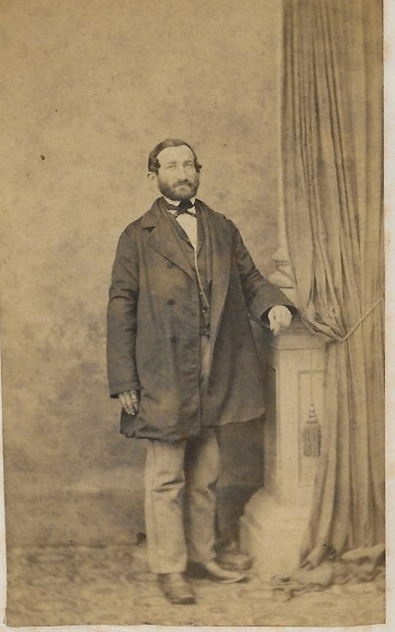 **Abraham Bloch**

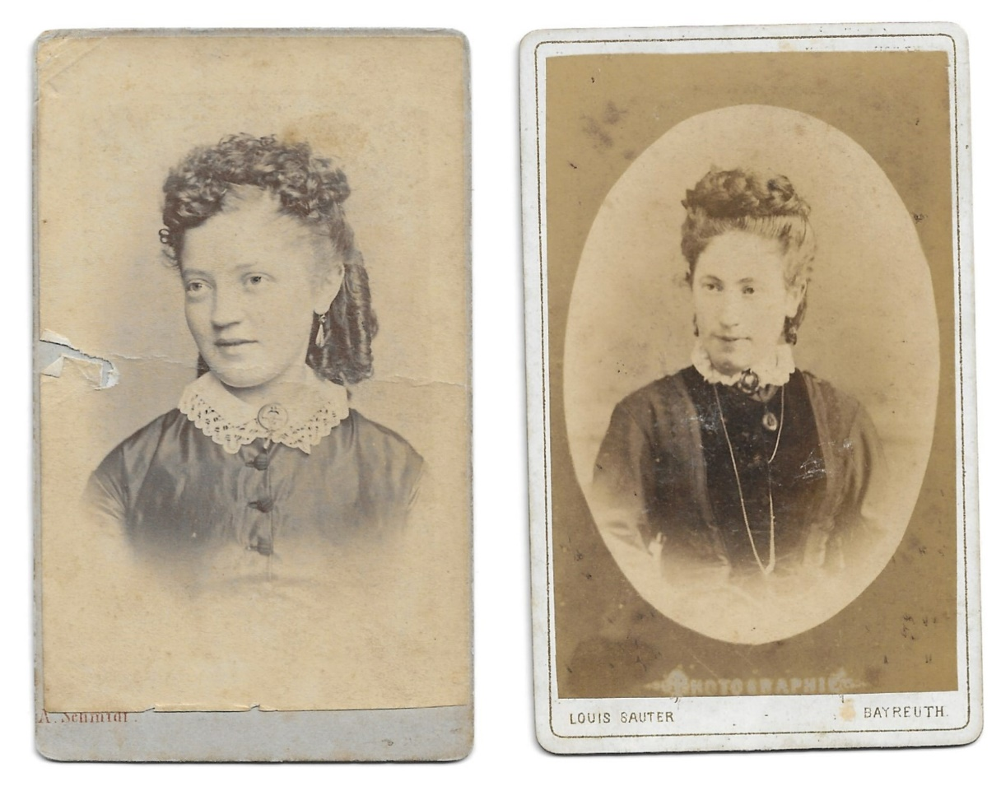

**Minna Boscowitz**, young woman; possibly photograph on right taken when married to Abraham Bloch as she looks older. She died after giving birth to seven children: Henrietta, Heinrich, Anton, Joseph, Arnold, Sophie, Julius.

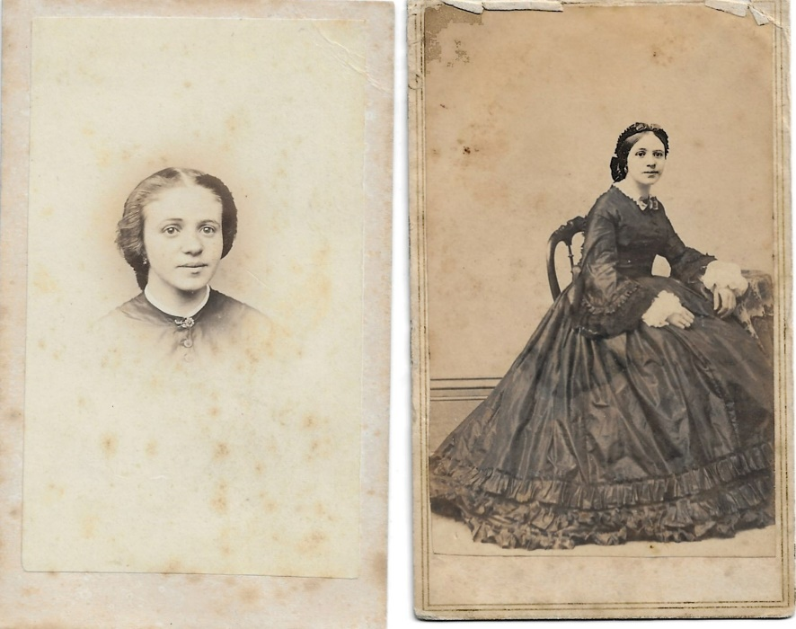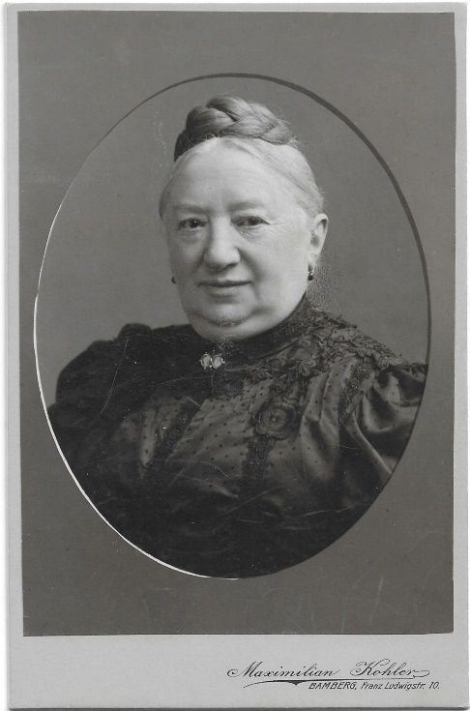

Caroline Weinshenk as young woman and right, in later years. **Second wife to Abraham Bloch**. As a young, unmarried woman she went to Georgia, USA, to keep house for her two brothers. When they married, she returned to Germany and married widower Abraham Bloch. Step grandmother to Minnie Jonas. Minnie told me she used to play American folk tunes on the piano. I am in possession of a wooden spoon that reportedly came from her time in the US. I was told her brothers ran a plantation. Not yet verified.

**Generation 5 Bloch Siblings for whom I have photos: Henrietta, Heinrich, Joseph, Anton and Sophie**

**Henrietta (Jetta) Bloch** married Solomon Lipp. They had three daughters: Mina who married Willi Engelbart (see letter from 1939); Tilda who married Friedel Schwager; Elsa who married E. Levy.

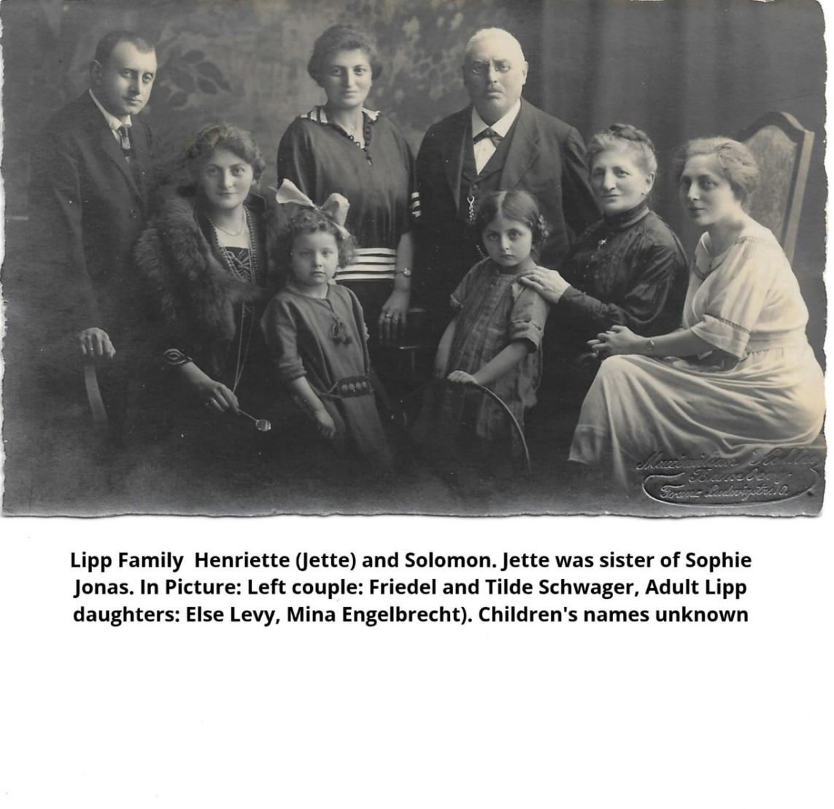

Lipp Family: Henriette (Jette) and Solomon. Left couple: Friedel and Tilde Schwager with daughter Thea. Two other women are Else and Mina, not sure which is which. The little girl in front of Jette could be one of Mina’s daughters: Elfriede or Edith, or Elsa’s daughter Hannah

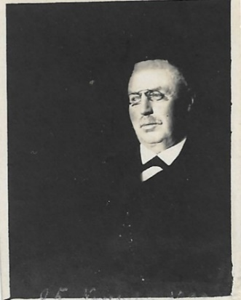 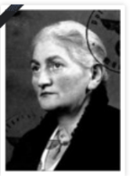 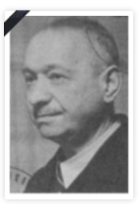 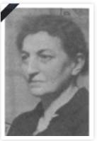

Solomon Lipp Tilde Schwager Willi Engelbert Mina Engelbert (photos’ source Geni)

From Edith Dorat (sister of Mina), 2005:

*Solomon Lipp died approximately 1924 in Bamberg. Jette Lipp moved in 1936 to Kassel with Nina and Willi Engelbert and died there. Tilde, Friedel and Thea Schwager perished in Theresienstadt. Else Levy divorced and perished with her son. Her daughter Hanni went to New York, married Erich Weiler and had two daughters, Marion and Carol. Willi Engelbert died in Kassel in 1942. His wife Mina was sent to Majdanek/Lubin concentration camp but never arrived there.*

**Heinrich Bloch** married Fanny Bruell, had one daughter: Martha.

*Fanny Bruell was daughter of Martin Bruell and his second wife Therese née Daniel. Fanny was the only child to survive after three sets of twins all died*.

*Therese, had three brothers and one sister, also called Fanny who also married a Bruell, perhaps a cousin. One brother went to South Africa, another to Switzerland, a third to America where he was killed by Indians around 1860*. **See Hauschild document for story of Martha and her family**

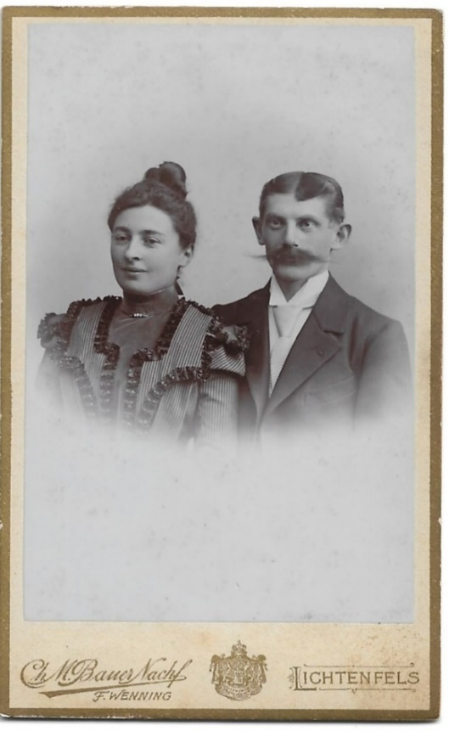 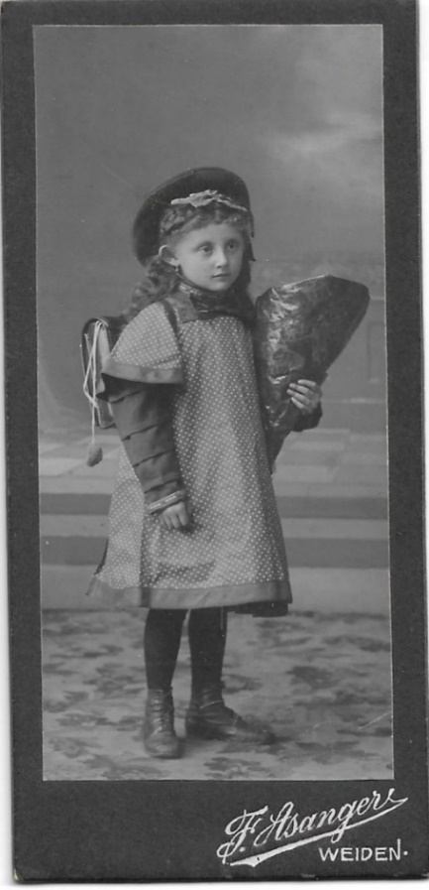

Fanny and Heinrich Martha

**Joseph Bloch**

Joseph married Louise Silberstein and had two children: Meta and Alfred.

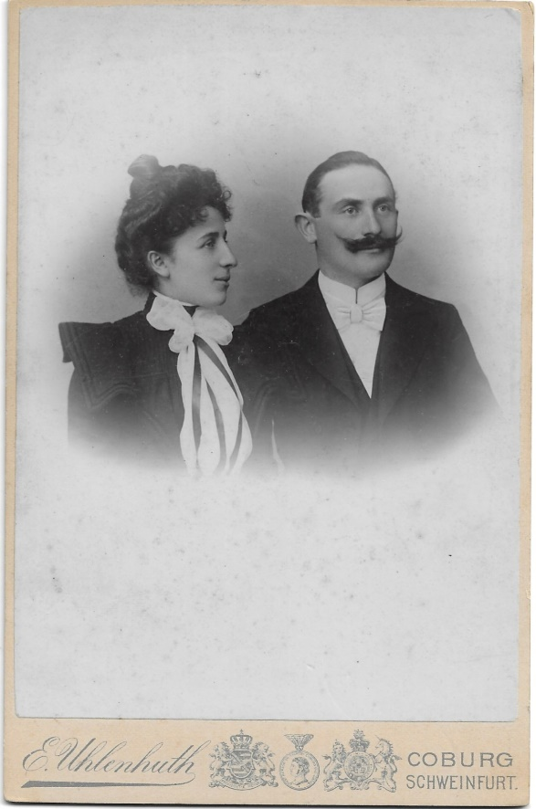 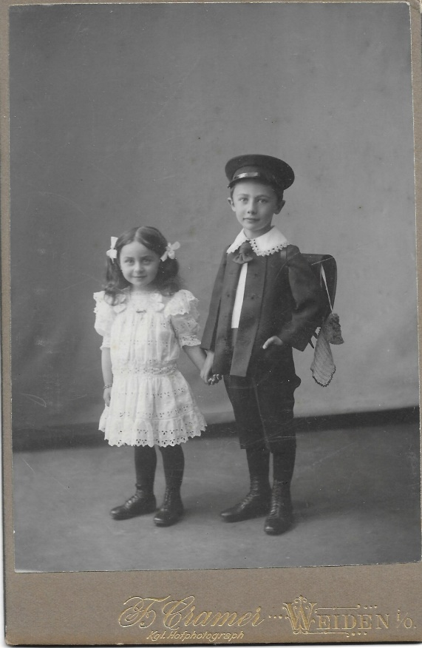

Louise and Joseph Meta and Alfred

Meta married Alfred Bayer and they had one daughter, Maryanne. At the time I met Meta, she was a widow living in Sydney, Australia, as were her daughter, son-in-law Jack Krygier and their daughters Ann and Rosemary.

Meta’s brother Alfred, a professor in mechanical engineering left Germany after persecution, moved to Dublin in 1934. He and his mother lived in England the rest of their lives. Alfred never married.

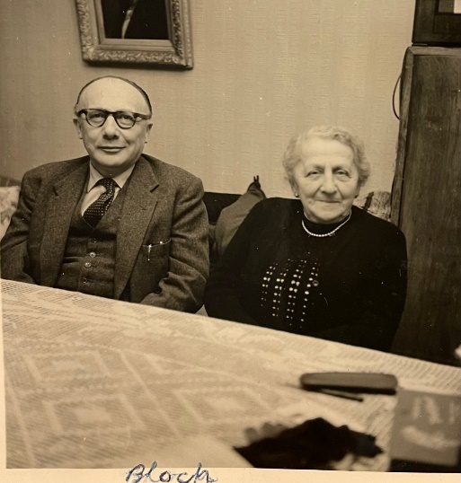Alfred and Louise, 1961 when my parents visited them

**Sophie Bloch**

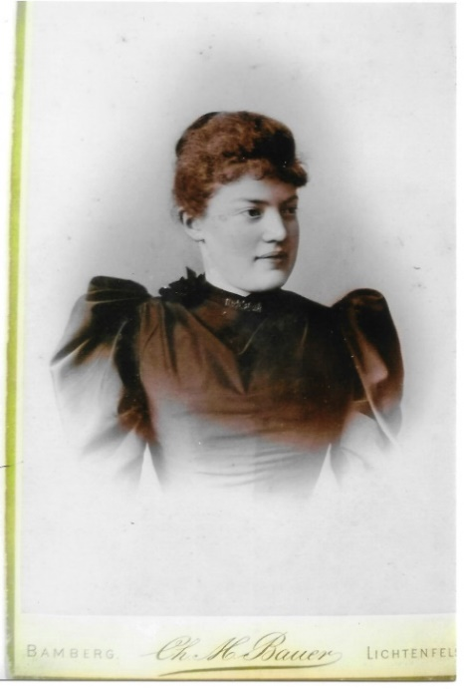 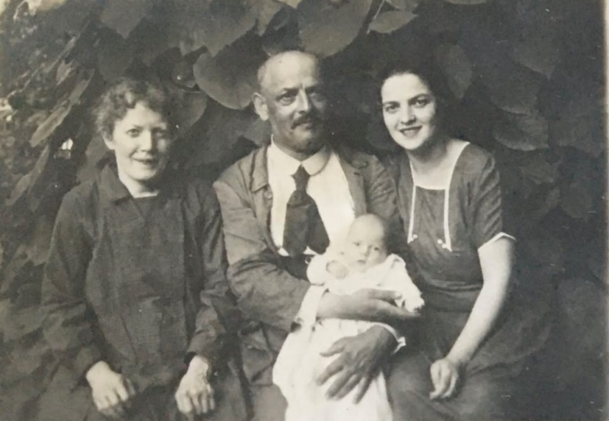

Sophie as young woman. Sophie Sophie, Julius, Minnie and baby Ursula in 1926

married Julius Jonas. They had two

daughters: My grandmother Minnie

and Paula who died after only three days.

**Anton Bloch**

I think the man standing on the right is Anton, with his sister Sophie and husband Julius Jonas.

Also in picture: my Uncle Udo, my mother Ursula and Minnie, circa 1930

