1. Number of episodes per rating

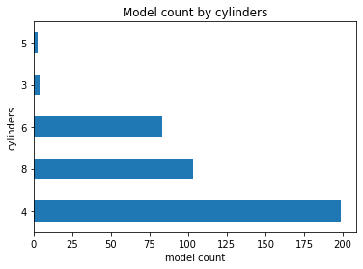

2. Top Cast/Director average rating

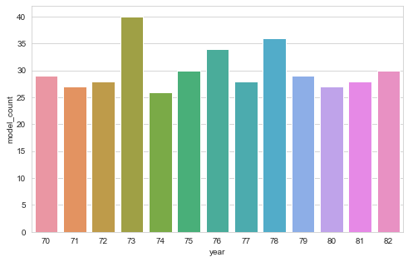

3. Rating Timeline

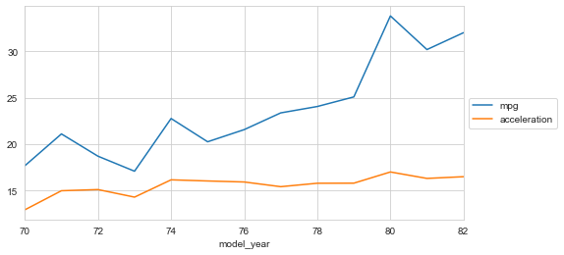

4. Scatter Plot

5. Pair Plot

6. Heatmaps