# **Scale and convert images using PIL**

**Download the file**

Your design contractor sent you the zipped file through his team drive. Download the file from the drive using the following CURL request:

curl -c ./cookie -s -L "https://drive.google.com/uc?export=download&id=$11hg55-dKdHN63yJP20dMLAgPJ5oiTOHF" > /dev/null | curl -Lb ./cookie "https://drive.google.com/uc?export=download&confirm=`awk '/download/ {print $NF}' ./cookie`&id=11hg55-dKdHN63yJP20dMLAgPJ5oiTOHF" -o images.zip && sudo rm -rf cookie

Output:

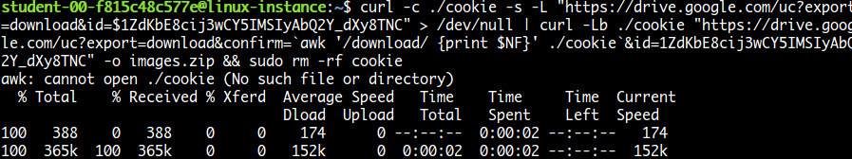

List files using the command:

ls

Output:



Unzip the file using the following command:

unzip images.zip

Navigate to the images folder using the following command:

cd images

To list images use the following command:

ls

The images received are in the wrong format:

* .tiff format
* Image resolution 192x192 pixel (too large)
* Rotated 90° anti-clockwise

The images required for the launch should be in this format:

* .jpeg format
* Image resolution 128x128 pixel
* Should be straight

**Install Pillow**

We should change the format and size of these pictures, and rotate them by 90° clockwise. To do this, we'll use Python Imaging Library (PIL). Install pillow library using the following command:

pip3 install pillow

Python Imaging Library (known as Pillow in newer versions) is a library in Python that adds support for opening, manipulating, and saving lots of different image file formats.

Pillow offers several standard procedures for image manipulation. These include:

* Per-pixel manipulations
* Masking and transparency handling
* Image filtering, such as blurring, contouring, smoothing, or edge finding
* Image enhancing, like sharpening and adjusting brightness, contrast or color
* Adding text to images (and much more!)

Click *Check my progress* to verify the objective.

Install Pillow

Check my progress

**Write a Python script**

This is the challenge section of the lab where you'll write a script that uses PIL to perform the following operations:

* Iterate through each file in the folder
* For each file:
  + Rotate the image 90° clockwise
  + Resize the image from 192x192 to 128x128
  + Save the image to a new folder in .jpeg format

Use a nano editor for this purpose. You can name the file however you'd like. And make sure to save the updated images in the folder: /opt/icons/

You'll use lots of methods from PIL to complete this exercise. You can refer to [Pillow](https://pillow.readthedocs.io/en/stable/reference/index.html) for detailed explanations and have a look at the [tutorials](https://pillow.readthedocs.io/en/stable/handbook/tutorial.html) to help you build the script and complete the task.

To save the file after editing, press Ctrl-O, Enter, and Ctrl-x.

Once your script is ready, grant executable permission to the script file.

chmod +x <script_name>.py

Replace <script_name> with the name of your script.

Now, run the file.

./<script_name>.py

Replace <script_name> with the name of your script.

On a successful run, this should produce images in the right format within the directory: /opt/icons/

To view the updated images use the following command:

ls /opt/icons

Output:

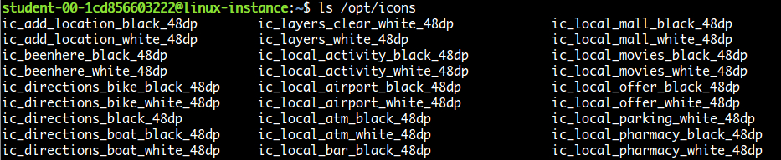

To check image properties, use the Python interpreter:

python3

Once the interactive shell opens, import the Image module from PIL:

from PIL import Image

Open any image from the folder, or you can use the following image:

img = Image.open("/opt/icons/ic_edit_location_black_48dp")

To view the format and size of the image:

img.format, img.size

Output:



Type exit() to exit from the Python interpreter.

Click *Check my progress* to verify the objective.

Python script

Check my progress

**Congratulations!**

Wow, nice work! You successfully wrote a Python script to manipulate and store a set of images.