# **Automatically Generate a PDF and send it by Email**

help

**Sample report**

In this section, you will be creating a PDF report named "**A Complete Inventory of My Fruit**". The script to generate this report and send it by email is already pre-done. You can have a look at the script in the scripts/ directory.

ls ~/scripts

Output:



In the scripts/ directory, you will find reports.py and emails.py files. These files are used to **generate PDF files** and **send emails** respectively.

Take a look at these files using cat command.

cat ~/scripts/reports.py

Output:

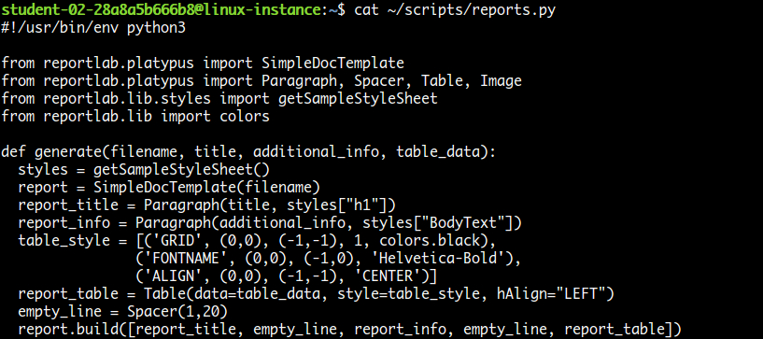

cat ~/scripts/emails.py

Output:

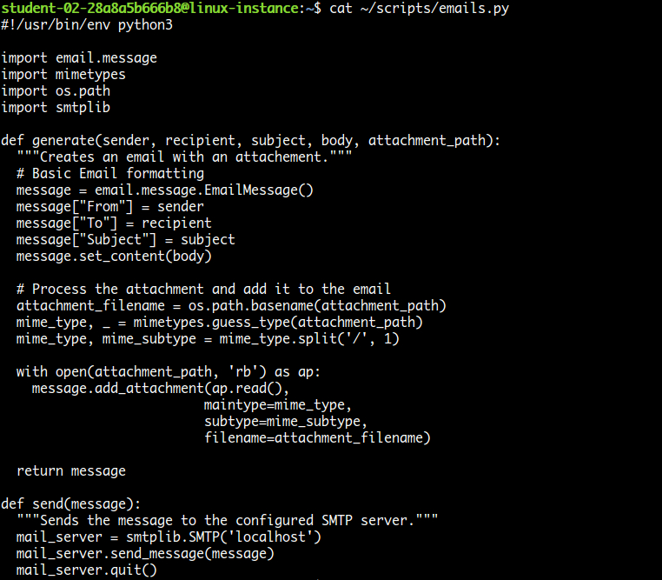

Now, take a look at example.py, which uses these two modules **reports** and **emails** to create a report and then send it by email.

cat ~/scripts/example.py

Grant executable permission to the example.py script.

sudo chmod o+wx ~/scripts/example.py

Run the example.py script, which will generate mail to you.

./scripts/example.py

A mail should now be successfully sent.

Copy the external IP address of your instance from the Connection Details Panel on the left side and open a new web browser tab and enter the IP address. The Roundcube Webmail login page appears.

Here, you'll need a login to **roundcube** using the username and password mentioned in the Connection Details Panel on the left hand side, followed by clicking **Login**.

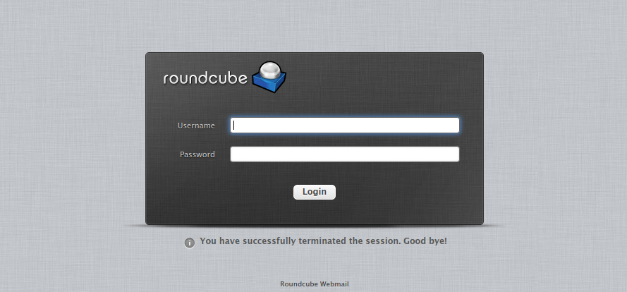

Now you should be able to see your inbox, with one unread email. Open the mail by double clicking on it. There should be a report in PDF format attached to the mail. View the report by opening it.

Output:

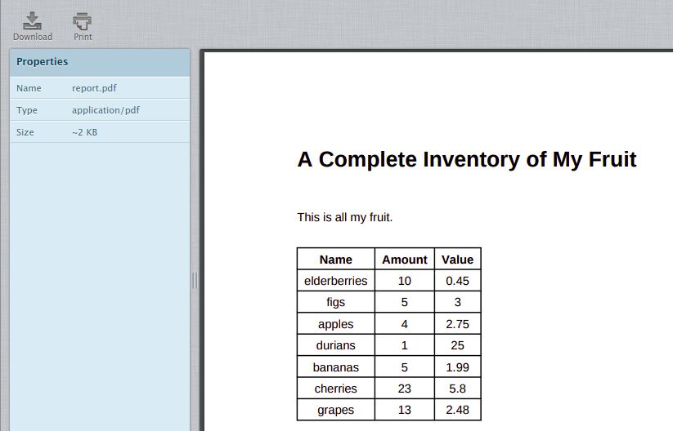

Generate report

Now, let's make a couple of changes in the example.py file to add a new fruit and change the sender followed by granting editor permission. Open example.py file using the following command:

nano ~/scripts/example.py

And update the following variables:

|  |  |
| --- | --- |
| **variable\_name** | **value** |
| sender | Replace **sender@example.com** with **automation@example.com** |
| table\_data | Add another entry into the list: ['kiwi', 4, 0.49] |

The file should now look similar to:

#!/usr/bin/env python3

import emails

import os

import reports

table\_data=[

['Name', 'Amount', 'Value'],

['elderberries', 10, 0.45],

['figs', 5, 3],

['apples', 4, 2.75],

['durians', 1, 25],

['bananas', 5, 1.99],

['cherries', 23, 5.80],

['grapes', 13, 2.48],

['kiwi', 4, 0.49]]

reports.generate("/tmp/report.pdf", "A Complete Inventory of My Fruit", "This is all my fruit.", table\_data)

sender = "automation@example.com"

receiver = "{}@example.com".format(os.environ.get('USER'))

subject = "List of Fruits"

body = "Hi\n\nI'm sending an attachment with all my fruit."

message = emails.generate(sender, receiver, subject, body, "/tmp/report.pdf")

emails.send(message)

Once you've made the changes in the example.py script, save the file by typing **Ctrl-o**, **Enter** key and **Ctrl-x**.

Now execute the example script again.

./scripts/example.py

Now, check the webmail for any new mail. You can click on the **Refresh** button to refresh your inbox.

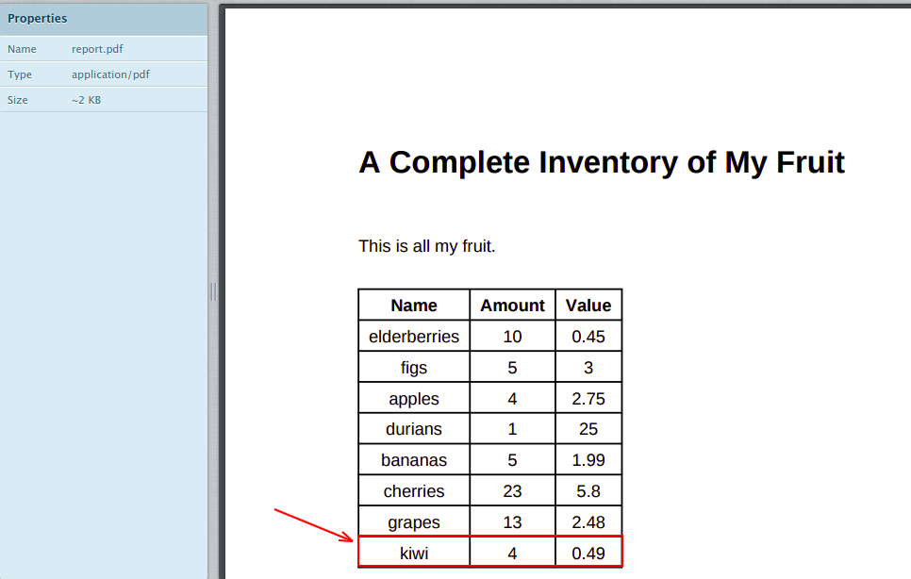

Click *Check my progress* to verify the objective.

Generate sample report

Check my progress

**Sales summary**

In this section, let's view the summary of last month's sales for all the models offered by the company. This data is in a JSON file named car\_sales.json. Let's have a look at it.

cat car\_sales.json

Output:

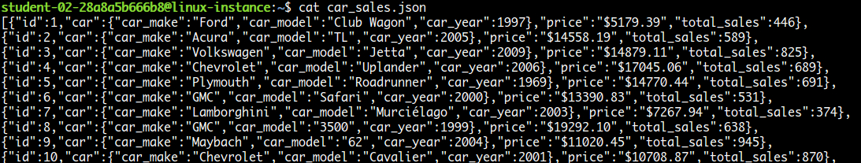

To simplify the JSON structure, here is an example of one of the JSON objects among the list.

{

"id": 47,

"car": {

"car\_make": "Lamborghini",

"car\_model": "Murciélago",

"car\_year": 2002

},

"price": "$13724.05",

"total\_sales": 149

}

Here id, car, price and total\_sales are the field names (key).

The script cars.py already contains part of the work, but learners need to complete the task by writing the remaining pieces. The script already calculates the car model with the most revenue (price \* total\_sales) in the process\_data method. Learners need to add the following:

1. Calculate the car model which had the most sales by completing the process\_data method, and then appending a formatted string to the summary list in the below format:

* "The {car model} had the most sales: {total sales}"

1. Calculate the most popular car\_year across all car make/models (in other words, find the total count of cars with the car\_year equal to 2005, equal to 2006, etc. and then figure out the most popular year) by completing the process\_data method, and append a formatted string to the summary list in the below format:

* "The most popular year was {year} with {total sales in that year} sales."

The challenge

Here, you are going to update the script cars.py. You will be using the above JSON data to process information. A part of the script is already done for you, where it calculates the car model with the most revenue (price \* total\_sales). You should now fulfil the following objectives with the script:

1. Calculate the car model which had the most sales.

a. Call format\_car method for the car model.

1. Calculate the most popular car\_year across all car make/models.

**Hint:** Find the total count of cars with the car\_year equal to 2005, equal to 2006, etc. and then figure out the most popular year.

Grant required permissions to the file cars.py and open it using nano editor.

sudo chmod o+wx ~/scripts/cars.py

nano ~/scripts/cars.py

The code is well commented including the TODO sections for you to understand and fulfill the objectives.

Generate PDF and send Email

Once the data is collected, you will also need to further update the script to generate a PDF report and automatically send it through email.

To generate a PDF:

* Use the reports.generate() function within the main function.
* The report should be named as **cars.pdf**, and placed in the folder **/tmp/**.
* The PDF should contain:
  1. A summary paragraph which contains the most sales/most revenue/most popular year values worked out in the previous step.

**Note:** To add line breaks in the PDF, use: <br/> between the lines.

* + A table which contains all the information parsed from the JSON file, organised by id\_number. The car details should be combined into one column in the form <car\_make> <car\_model> (<car\_year>).

**Note:** You can use the **cars\_dict\_to\_table** function for the above task.

Example:

|  |  |  |  |
| --- | --- | --- | --- |
| **ID** | **Car** | **Price** | **Total Sales** |
| 47 | Acura TL (2007) | €14459,15 | 1192 |
| 73 | Porsche 911 (2010) | €6057,74 | 882 |
| 85 | Mercury Sable (2005) | €45660,46 | 874 |

To send the PDF through email:

Once the PDF is generated, you need to send the email, using the emails.generate() and emails.send() methods.

Use the following details to pass the parameters to emails.generate():

* **From:** automation@example.com
* **To:** <user>@example.com
* **Subject line**: Sales summary for last month
* **E-mail Body:** The same summary from the PDF, but using \n between the lines
* **Attachment:** Attach the PDF path i.e. generated in the previous step

Once you have completed editing cars.py script, save the file by typing **Ctrl-o**, **Enter** key, and **Ctrl-x**.

Run the cars.py script, which will generate mail to their user.

./scripts/cars.py

Now, check the webmail for any new mail. You can click on the **Refresh** button to refresh your inbox.

Output:

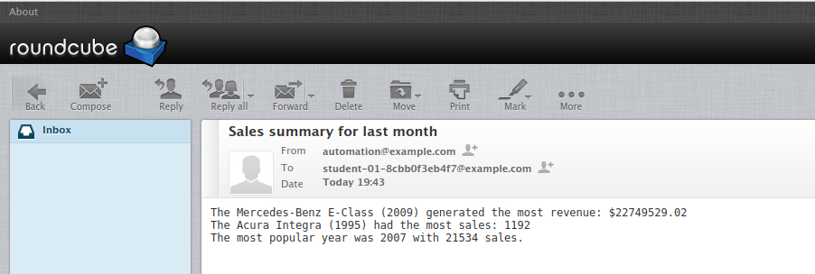

Open cars.pdf that's located on the right most side.

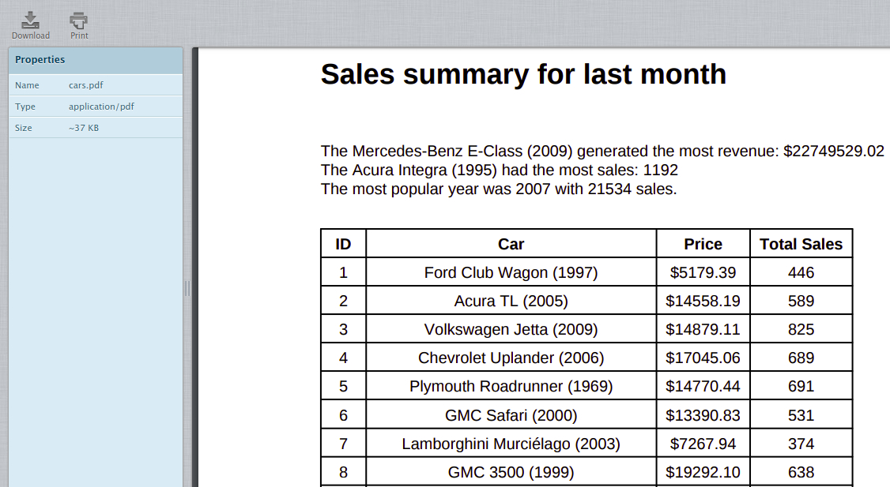

Click *Check my progress* to verify the objective.

Challenge: Sales summary

Check my progress

**Optional challenge**

As **optional** challenges, you could try some of the following functionalities:

1. Sort the list of cars in the PDF by total sales.
2. Create a pie chart for the total sales of each car made.
3. Create a bar chart showing total sales for the top 10 best selling vehicles using the [ReportLab Diagra library](https://www.reportlab.com/software/diagra/" \t "_blank). Put the vehicle name on the X-axis and **total revenue** (remember, price \* total sales!) along the Y-axis.

**Congratulations!**

Congrats! You've successfully written a Python script to automatically generate a PDF and send it through email.

s