
Kleim
UI/UX STYLE GUIDE
Interface Style Guide and Design System
Logo, tokens, components, screen patterns and copy rules for all four apps (blue and pink theme)
Field | Value
Product | Kleim — fashion delivery and discovery platform
Version | 1.0
Status | Draft for team review
Parent documents | SDD v1.1; Implementation Plan v1.0
Owner | [Team lead name]

1. Introduction
This guide makes Kleim’s customer app, seller app, rider PWA and admin console look and behave as one product. It turns the interactive prototype and the design canvas into rules the two frontend developers follow, and it implements SDD §20 (UI Design Requirements) and NFR-05 to NFR-07.
Design direction. Kleim should feel like a fashion boutique first and a delivery app second: generous space, strong product imagery, a clean cool-white ground, confident Kleim blue for actions and a small spark of Kleim pink for delight. Every colour comes from the logo. Delivery information is always visible but never louder than the clothes.
Principle | What it means in practice
Blue works, pink sparkles | Blue carries actions and navigation; pink is kept for hearts, badges, “your size” reasons and urgency, never large areas
Fashion first | Product imagery is the largest element on discovery screens; delivery details sit in badges and sub-lines
One clear action | Each screen has at most one filled Kleim blue button; other actions are outline or text buttons
Honest status | Status is shown in plain words with a colour tag and a time, never as a colour alone
Built for Kampala phones | Works on low-end Android over 3G; large touch targets; light pages; clear offline states
Same words everywhere | An action keeps its name through the flow: “Place order” creates an order; “Accept” produces “Accepted”

2. Logo and brand
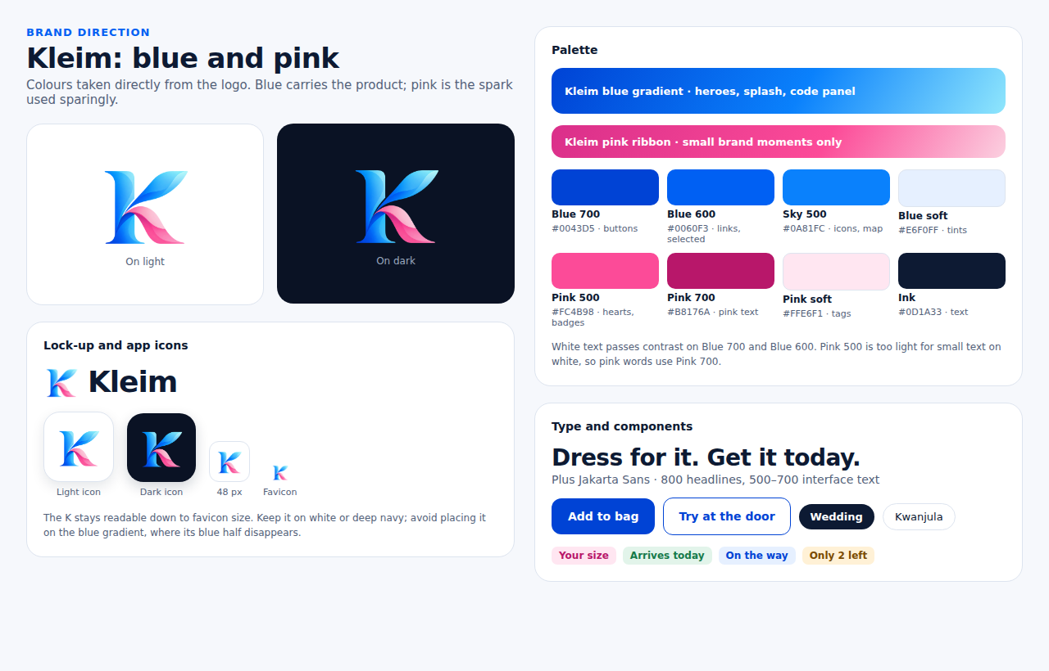
Figure 1. Kleim brand sheet: logo, app icons, palette and components

2.1 Logo files
File | Use | Repository location
kleim-logo.png (1215 × 1059, transparent) | Master artwork for documents and large placements | docs/design/brand/, frontend/packages/ui/src/assets/brand/
kleim-logo-512.png | In-app headers, splash screen | frontend/packages/ui/src/assets/brand/
icon-192.png, icon-512.png | PWA and Android launcher icons (white tile) | each app’s public/icons/
icon-maskable-192.png, icon-maskable-512.png | Android adaptive icons (extra safe-zone padding) | each app’s public/icons/
apple-touch-icon.png (180 px) | iOS home-screen icon | each app’s public/
favicon.ico, favicon-32.png | Browser tab | each app’s public/
icon-dark-512.png | Dark tile variant for stores and social profiles | docs/design/brand/

2.2 Logo rules
- Place the logo on white, the app screen colour or deep navy (#0A1224). Do not place it on the blue gradient or on photos: the blue half of the K disappears.
- Clear space around the logo equals at least a quarter of its width. Minimum size 24 px on screen.
- The lock-up is the K followed by the word Kleim in Plus Jakarta Sans ExtraBold (800), letter-spacing −3%, in Ink or white.
- Never recolour, stretch, rotate, add shadows or outline the logo.
- Print and single-colour use: the logo relies on soft gradients. Before printing on bags, stickers, stamps or receipts, commission a flat two-colour version (Blue 700 + Pink 500) and a one-colour version. Until then, do not print the gradient logo on low-quality materials.

3. Reference screens
These screens from the interactive prototype, in the Kleim theme, are the visual reference for M3–M8. The design canvas also has welcome, home, product, tracking and dark-mode screens. Where this guide and a screen disagree, this guide wins.
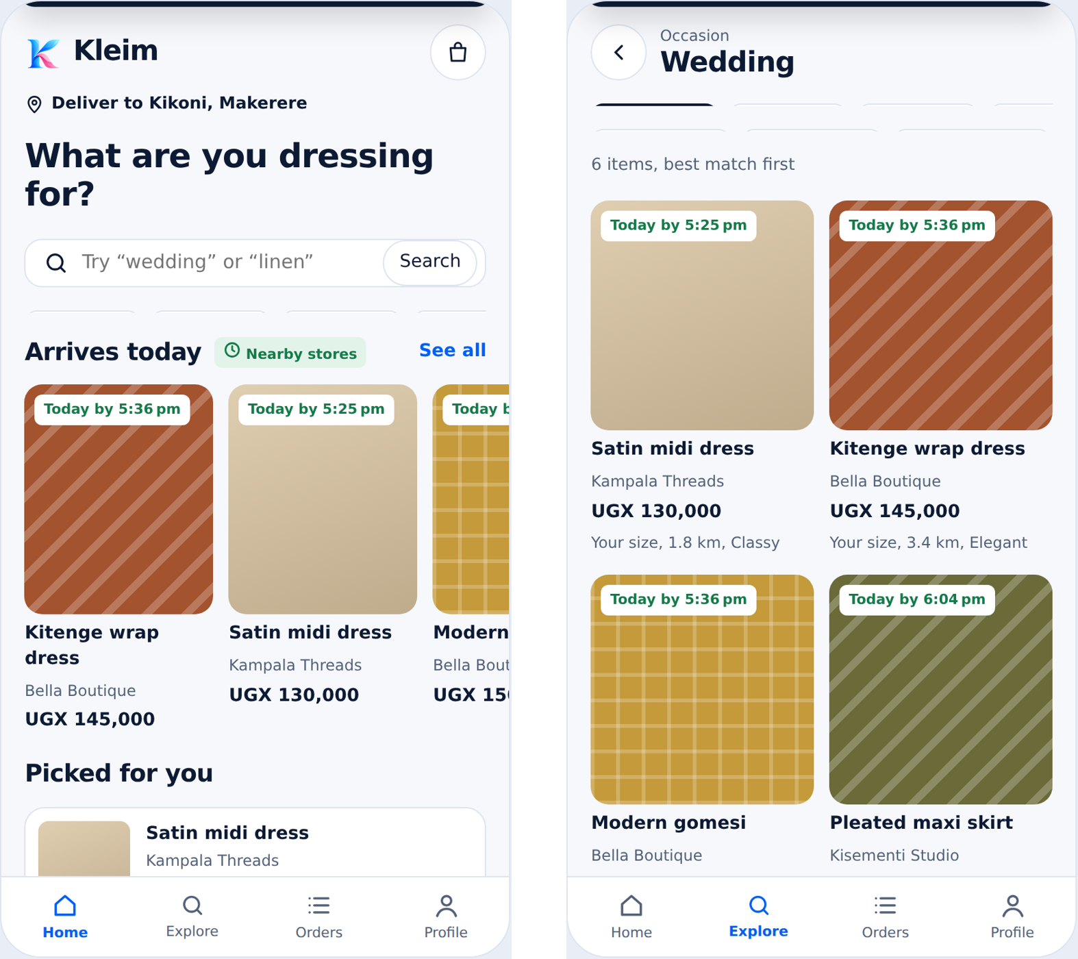
Figure 2. Customer home and occasion results
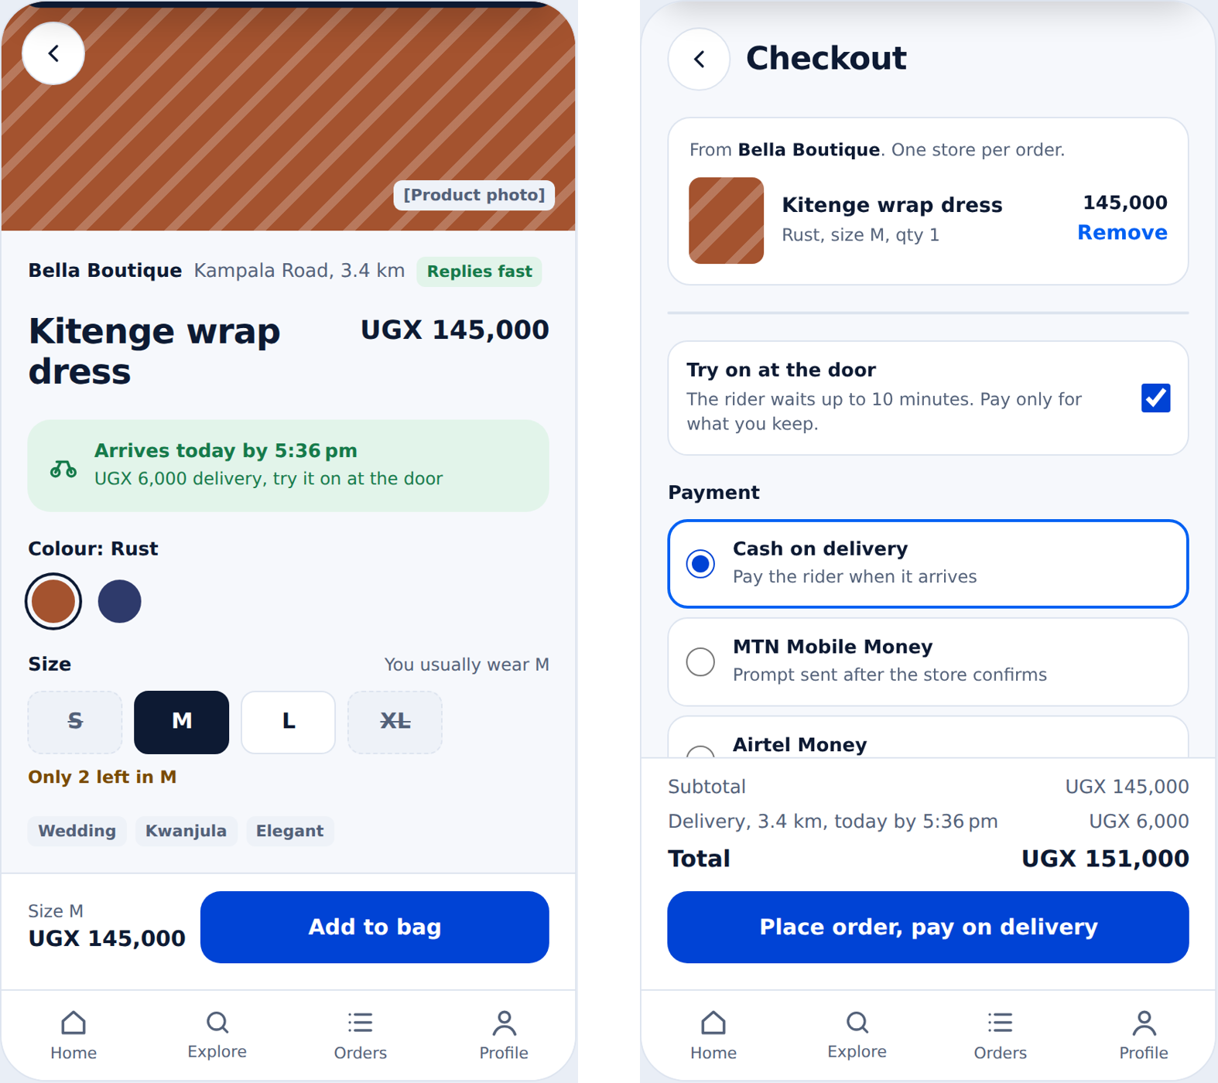
Figure 3. Product detail and checkout
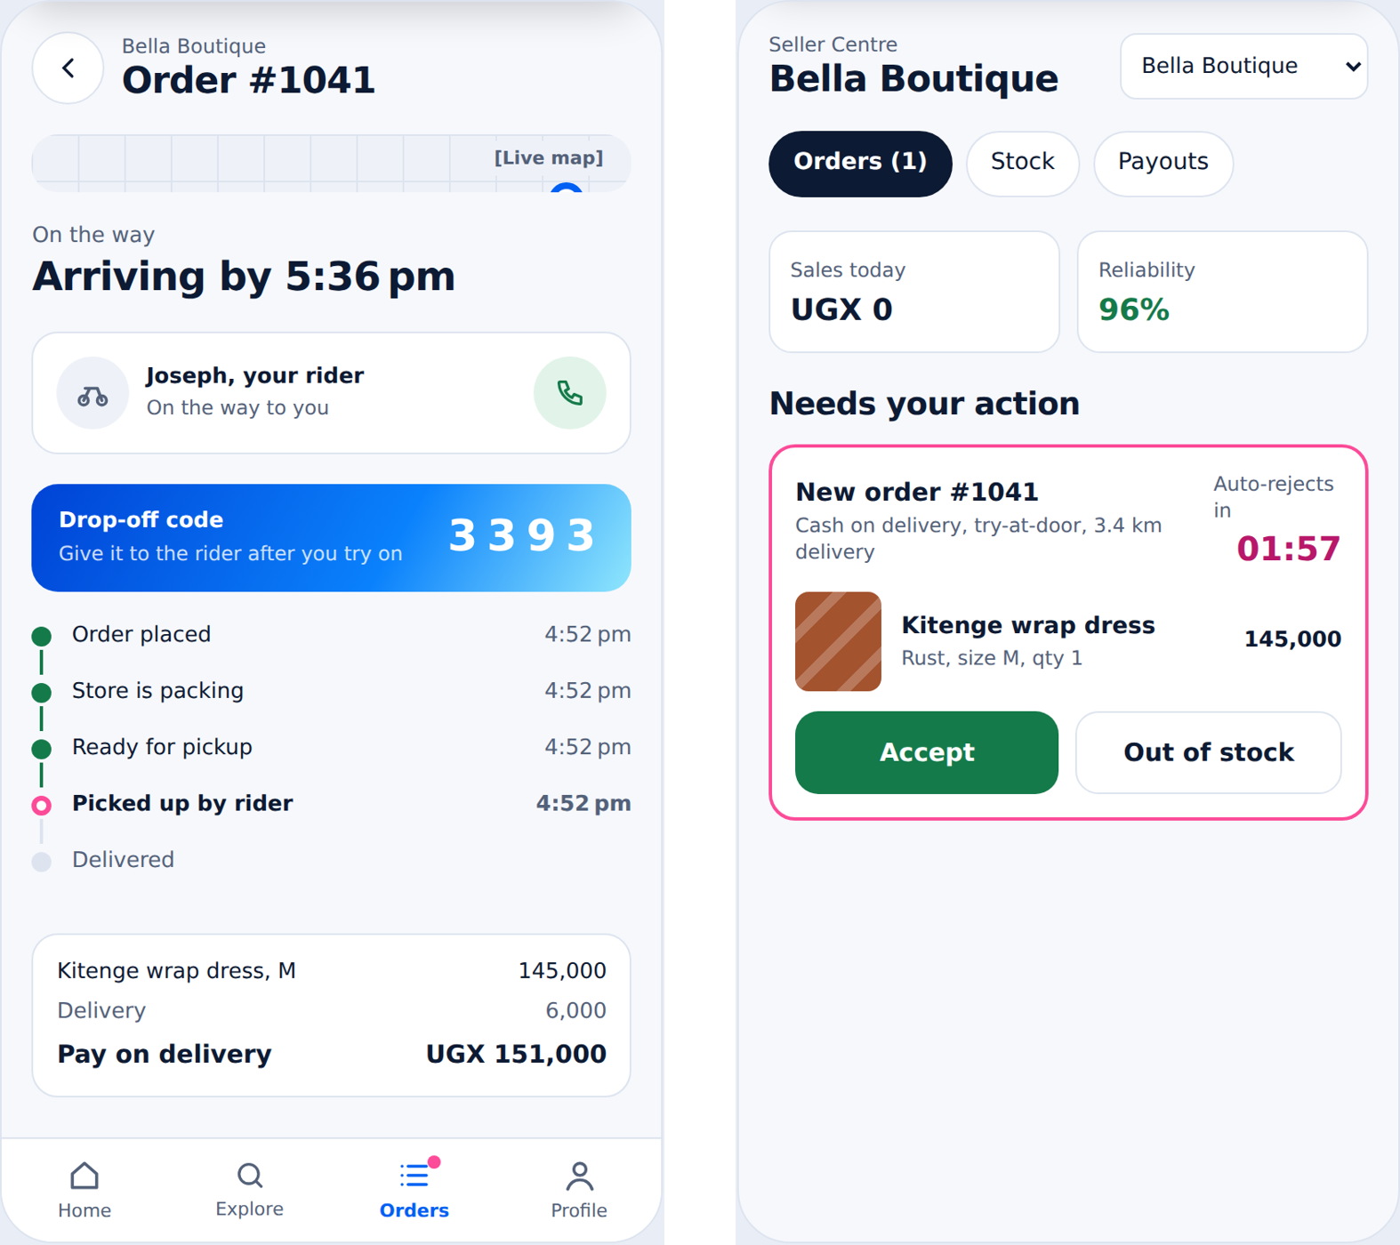
Figure 4. Live order tracking and seller order queue

4. Design tokens
Tokens live in frontend/packages/ui/tokens.css as CSS variables and are mirrored in the Tailwind config. Components use tokens only; raw hex values in component code fail review.

4.1 Colour
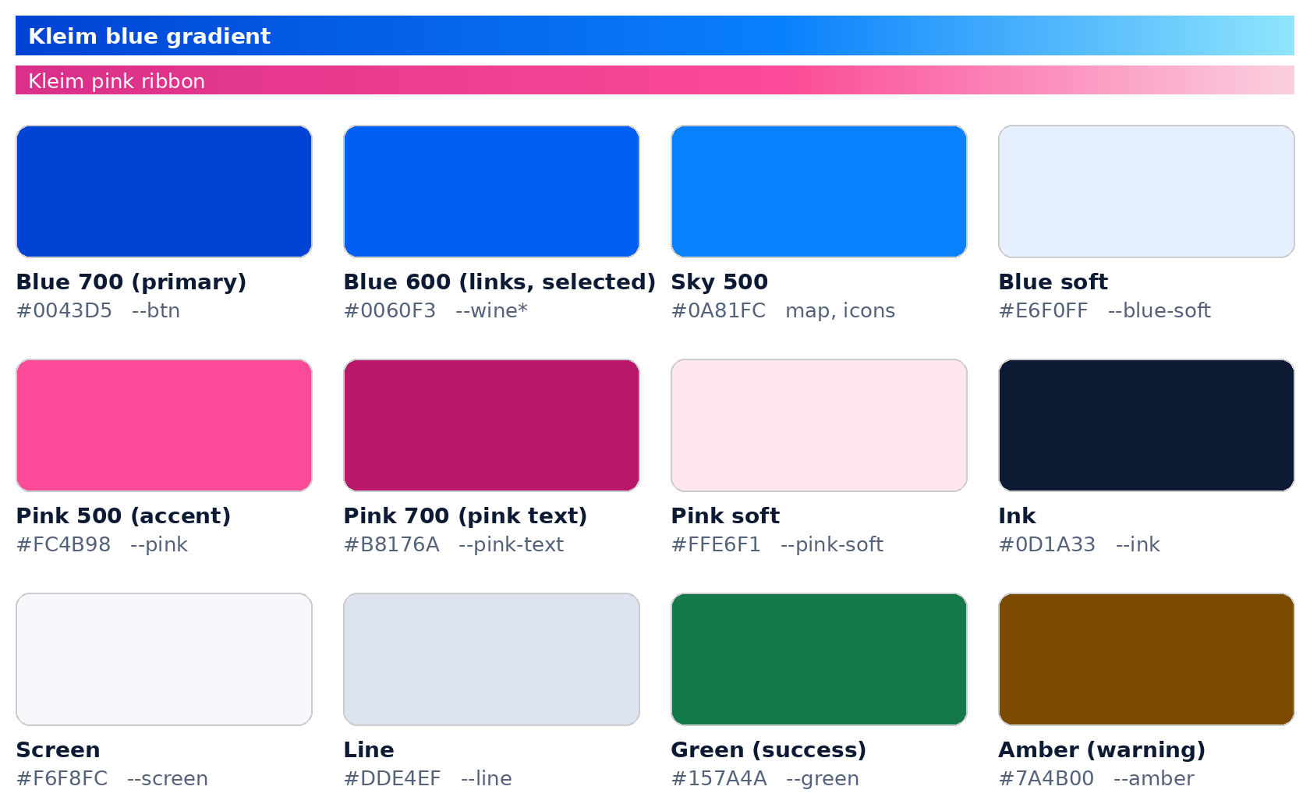
Figure 5. Core colour tokens (light theme)
Token | Light | Dark | Use
--page | #E9EEF6 | #070D1A | Area behind app frames (desktop)
--screen | #F6F8FC | #0A1224 | App background
--card | #FFFFFF | #121C33 | Cards, sheets, nav bar
--ink | #0D1A33 | #EEF3FB | Primary text, dark chips and buttons
--muted | #536179 | #9AA8BF | Secondary text (meets 4.5:1 on --screen)
--line | #DDE4EF | #22304D | Borders, dividers
--chip | #EEF2F8 | #1A2540 | Neutral tags, disabled fills
--btn (Blue 700) | #0043D5 | #1F5BEA | Primary button fill (white text)
--link (Blue 600) | #0060F3 | #6FA8FF | Links, selected borders, focus ring, current nav item
--blue-soft | #E6F0FF | #15264A | Selected chip background, info tags
--sky (Sky 500) | #0A81FC | #4FB3FF | Map route, icons
--pink (Pink 500) | #FC4B98 | #FF6AAB | Hearts, badge counters, timeline “now”, urgent borders (never text on white)
--pink-text (Pink 700) | #B8176A | #FF8CC0 | Pink words: reasons, countdowns, errors, failed states
--pink-soft | #FFE6F1 | #3D1430 | Reason and alert tag backgrounds
--green / --green-soft | #157A4A / #E2F4EA | #7FD8A6 / #133A28 | Success, delivered, arrives today
--amber / --amber-soft | #7A4B00 / #FFF1D6 | #EBC06A / #3A2E17 | Warnings, low stock, cash to collect
--grad | 120°: #0043D5 → #0A81FC → #8FE6FC | same | Hero banners, splash, drop-off code panel only

Rules:
- Kleim blue is for the single primary action, links and selection. The blue gradient appears at most once per screen.
- Pink is an accent: small shapes and short words only. Pink 500 fails contrast as text on white, so pink words always use Pink 700.
- Status colours always pair with a word (“Delivered”, “Only 2 left”), never colour alone.
- Dark theme follows the device setting; every screen is checked in both themes before a module exits.

4.2 Typography
Role | Font | Size / line height | Weight | Use
Display | Plus Jakarta Sans | 26 / 30, letter-spacing −2% | 800 | Screen titles (“Checkout”, “Arriving by 5:40 pm”)
Section | Plus Jakarta Sans | 19 / 24, letter-spacing −2% | 800 | Section headings (“Arrives today”)
Wordmark | Plus Jakarta Sans | 22–44, letter-spacing −3% | 800 | “Kleim” next to the logo
Body | Plus Jakarta Sans | 15 / 21 | 400–500 | Default text
Body strong | Plus Jakarta Sans | 15 / 21 | 700 | Names, prices, labels
Small | Plus Jakarta Sans | 13 / 18 | 400–600 | Sub-lines, meta text
Caption | Plus Jakarta Sans | 12 / 16 | 600–700 | Tags, badges
Code | Plus Jakarta Sans tabular numerals | 26–28 | 800, letter-spacing 0.2em | Handover codes, countdowns

Fallback stack: "Plus Jakarta Sans", system-ui, -apple-system, "Segoe UI", sans-serif. One family keeps pages light (NFR-07); load only weights 400, 500, 600, 700 and 800 with display=swap.
Money is always written UGX 145,000 (currency code, space, comma thousands, no decimals). Inside tables of amounts the UGX prefix may move to the column header.

4.3 Spacing, radius and elevation
Token | Value | Use
Space scale | 4, 6, 8, 10, 12, 14, 18, 24, 32 px | Gaps and padding; screens use 18 px side padding
--radius-sm | 8–10 px | Thumbnails, size buttons, steppers
--radius-md | 14–16 px | Cards, inputs, primary buttons
--radius-lg | 24 px | Bottom sheets, map card top edge
--radius-pill | 999 px | Chips, toggles
Phone frame (desktop preview) | 32 px | Prototype and demos only
Elevation | Borders first; shadow only on toast and bottom sheets | Keeps pages light and fast

4.4 Layout and breakpoints
Viewport | Layout
Under 520 px (phones) | Single column, full-bleed screens, fixed bottom navigation
520–1180 px (tablets, small laptops) | Centred column up to 400 px for customer and rider; seller and admin use two columns
Over 1180 px | Seller and admin: sidebar navigation plus content grid (see seller canvas screen)

Respect safe areas: viewport-fit=cover with env(safe-area-inset-*) padding on headers and bottom bars.

5. Components
Components live in frontend/packages/ui. Each has the states listed; a component is not done until every state is built and visible in the component preview page.
Component | Variants | States | Notes
Button | primary (Kleim blue), dark, success (green), outline, text | default, hover, focus, pressed, loading, disabled | Minimum height 50 px; full width on mobile; label says what happens (“Place order”)
Icon button | round 44 px | default, focus, with badge | Always has aria-label
Chip | filter, soft (selected tint), occasion | default, selected (aria-pressed) | Horizontal scroll rows; never wrap to more than one line
Tag / badge | neutral, pink, green, amber, blue | — | 11–12 px bold; used for status and reasons
Product card | rail (148 px), grid (half width), row | loading skeleton, sold out | Image, name, store, price, arrives badge, up to 3 reasons
Size selector | 5-column grid | selected, available, sold out (dashed, struck through, disabled) | Sold-out sizes stay visible
Colour swatch | 36 px circle | selected ring | aria-label with colour name
Input / search | text, search, code entry | default, focus, error, disabled | Error text below field in Pink 700, starts with what to do
Option row | radio, checkbox | selected (2 px Blue 600 border) | Payment methods, try-at-door
Stepper | − value + | min reached, max reached | Stock editing
Toggle switch | on/off | — | role="switch", used for rider online
Status timeline | vertical | done (green), now (pink ring), to do (grey), failed (Pink 700) | Each row shows time
Code box | Kleim gradient panel, white text | — | Handover codes; large tabular digits
Countdown | inline, ring | Pink 700 text; under 60 s bold | Seller deadline, rider offer, payment prompt
Bottom sheet | dialog | open, closing | Payment prompt, “start a new bag?”, confirmations
Toast | top of screen | — | role="status"; 4 s; one line; no action buttons
Empty state | centred | — | Heading, one sentence, one action
Bottom navigation | 4 items | current page (aria-current) | Customer: Home, Explore, Orders, Profile

6. Screen patterns

6.1 Customer app
Screen | Must contain (SDD §20) | Pattern
Home | Address selector, search, occasion chips, “Arrives today” rail, active order card, personalised list | Title asks “What are you dressing for?”; active order card appears above the fold when one exists
Results | Filter chips, count, sort, grid with arrives badges and reasons | Filters are chips, not a modal; empty state offers “Clear filters”
Product | Gallery, store and reliability badge, price, delivery panel, colour, size, stock message, tags, sticky add-to-bag | Pre-select the user’s usual size if in stock
Checkout | Single-store notice, items, address card with map pin, try-at-door, payment options, totals, primary action | Button text changes with payment method
Tracking | Map, status headline, rider card with call, drop-off code, timeline, order summary | Drop-off code only while in transit

6.2 Seller app
- Needs your action always sits at the top, with a pink border, the countdown in Pink 700 and two clear buttons: “Accept” (green) and “Out of stock” (outline).
- Orders are cards with a status tag; ready orders show the pickup code only when the rider has arrived.
- Stock screens use steppers and colour-coded counts: 0 in Pink 700, 1–2 in amber.

6.3 Rider PWA
- One job at a time. The screen title is the next physical action (“Head to the store”, “Collect the items”).
- Offer card: earnings in display type, countdown ring, pickup and drop-off rail, cash-to-collect panel in amber, Decline (outline) and Accept (Kleim blue).
- Code entry: one large numeric field, inputmode="numeric", error message states the fix.
- Buttons are at the bottom within thumb reach; minimum 54 px high.

6.4 Admin and operations console
- Desktop-first: sidebar navigation, tables with filters, and a detail drawer.
- The exceptions queue lists the oldest first, with the action button on each row.
- Destructive actions (suspend, cancel order, refund) require a reason and a confirmation dialog.

7. Content and copy

7.1 Voice
The product name is always written Kleim: capital K, never all capitals in running text, never translated. In SMS, start with “Kleim:” so recipients recognise the sender.
Plain, warm and specific. Sentence case everywhere. Active voice. No exclamation marks except in delivery success (“Delivered. Enjoy your outfit!”).

7.2 Status wording (customer-facing)
These strings map one-to-one to SDD §12.1 order states and are used in the timeline, order cards and notifications.
Status | Headline text | Timeline entry
PENDING_SELLER | Waiting for the store to confirm | Order placed
AWAITING_PAYMENT | Approve the payment prompt | Store confirmed, payment requested
PREPARING | Store is packing your order | Store is packing
READY_FOR_PICKUP | Ready, finding a rider | Ready for pickup
IN_TRANSIT | On the way | Picked up by rider
DELIVERED | Delivered | Delivered
PARTIALLY_DELIVERED | Delivered, some items returned | Delivered, some items returned
RETURNED | All items returned at the door | All items returned
REJECTED | Store couldn’t fulfil this order | Rejected by store
EXPIRED | Store didn’t respond in time | Expired: no response from store
PAYMENT_FAILED | Payment wasn’t completed | Payment not completed
DELIVERY_FAILED | Delivery failed | Delivery failed
CANCELLED_BY_CUSTOMER | Cancelled | Cancelled by you

7.3 Error and empty-state rules
- Say what happened and how to fix it: “That code doesn’t match. Ask the store to read it again.”
- Never blame the user or apologise vaguely. Never show raw error codes; show request_id only in “Contact support”.
- Empty screens invite action: “No orders yet. Orders you place show up here with live tracking.” plus one button.

7.4 Local terms
Use the words customers use: “boda” for motorcycle rider, “Kwanjula” for introduction ceremony, “MTN MoMo” and “Airtel Money”. Place names are written as locals write them (Kikoni, Wandegeya, Ntinda).

8. Accessibility
Requirement | Standard
Contrast | Text 4.5:1; large text and icons 3:1; checked in both themes
Touch targets | Minimum 44 × 44 px; rider actions 54 px high
Semantics | Real <button>, <a>, <input> with <label>; no clickable divs
Focus | Visible 3 px Blue 600 focus ring on every interactive element
Screen readers | aria-label on icon buttons; aria-live="polite" on toasts and countdowns; images have alt text (seller must add it)
Motion | Respect prefers-reduced-motion; only the toast slides
Text size | Layout holds at 200% zoom without horizontal scrolling

9. Performance and low-bandwidth rules
- First customer load under 1.5 MB (NFR-07); JavaScript under 250 KB gzipped per app.
- Images through Cloudinary with f_auto,q_auto and widths of 150, 300 and 600 px; lazy-load below the fold; always reserve space to avoid layout shift.
- Skeleton loaders for lists and cards; no full-screen spinners.
- Service worker caches the app shell, fonts and icons; offline state shows “You’re offline. We’ll update when you’re back.”
- Icons are inline SVG from one set (stroke 2 px, round caps). No emoji in the interface.

10. Implementation checklist per screen
- Uses only tokens and shared components.
- Loading, empty, error and offline states designed and built.
- Works at 360 px width and in dark theme.
- Keyboard and screen-reader pass (focus order, labels).
- Copy checked against §7, including status wording.
- Page weight measured on a throttled 3G profile.

