
Kleim
DATABASE DESIGN DOCUMENT
Database Design and Entity-Relationship Model
PostgreSQL 16 + PostGIS schema for all modules M0–M11
Field | Value
Product | Kleim — fashion delivery and discovery platform
Version | 1.0
Status | Draft for team review
Parent documents | SDD v1.1; Implementation Plan v1.0
Owner | [Team lead name]

1. Introduction
This document defines the complete database for Kleim: 36 tables in PostgreSQL 16 with PostGIS and pg_trgm, owned by modules M0–M10 of the Implementation Plan. It expands SDD §11 (Data Design) into column-level definitions, relationships, indexes, integrity rules and migration conventions.

1.1 Scope and precedence
- Covers every table in SDD §11, with the module that creates it (Implementation Plan, Appendix B).
- Where this document and the SDD disagree, the SDD wins; changes follow the SDD change-control process (Implementation Plan §7.3).
- Column names here are final and are used unchanged in SQLAlchemy models, Alembic migrations and API schemas.

1.2 Technology
Item | Choice | Reason
Engine | PostgreSQL 16 | Transactions for stock and money; mature tooling
Extensions | postgis, pg_trgm, pgcrypto | Geospatial queries, typo-tolerant search, gen_random_uuid()
ORM | SQLAlchemy 2 (typed models) | SDD §9
Migrations | Alembic, one migration per module task | Reviewable, reversible schema changes
Hosting | Managed PostgreSQL with daily backups | SDD §21 Backups

2. Design conventions

2.1 Naming
- Tables: plural snake_case (order_items). Columns: snake_case. Foreign keys: <entity>_id.
- Booleans read as statements (active, try_at_door, id_verified).
- Status columns are text with a CHECK constraint listing allowed values, not Postgres enums, so adding a state is a simple migration.
- Constraint names follow Alembic conventions: pk_<table>, fk_<table>_<column>_<ref>, uq_<table>_<column>, ck_<table>_<name>, ix_<table>_<column>.

2.2 Keys and identifiers
- Primary keys are uuid generated by gen_random_uuid(), except append-only high-volume logs (interaction_events, order_status_history, delivery_status_history, rider_locations, ledger_entries), which use bigserial.
- Orders also carry a 6-character public code (unambiguous characters only, no 0/O or 1/I) for customers, sellers and riders to quote.

2.3 Money
- All amounts are integer Uganda shillings (UGX). No float, numeric or decimals for money (ADR-002).
- CHECK (amount >= 0) on prices, fees and totals; ledger amounts are signed.

2.4 Time
- All timestamps are timestamptz stored in UTC. The API returns ISO 8601 with offset; apps display East Africa Time (UTC+3).
- Store opening hours are stored as local times in opening_hours JSON because they describe the shop’s wall clock.
opening_hours = {"mon": {"open": "09:00", "close": "20:00"}, ..., "sun": null}

2.5 Geography
- Points use geography(Point, 4326) (longitude, latitude, WGS84) so ST_Distance returns metres directly.
- Zones use geography(Polygon, 4326). All geography columns have a GIST index.

2.6 Soft deletion and history
- Users, stores and products are never physically deleted while orders reference them; they move to deleted, suspended or removed status (SDD §11.1).
- Orders and deliveries record every transition in history tables. audit_logs and ledger_entries are append-only: the application database role has no UPDATE or DELETE privilege on them.

3. Entity-relationship model
The model has six domains, colour-coded in the diagrams: identity (pink), catalogue (green), commerce (amber), delivery (blue), money (purple) and operations (grey). Crow’s feet mark the “many” side of each relationship.
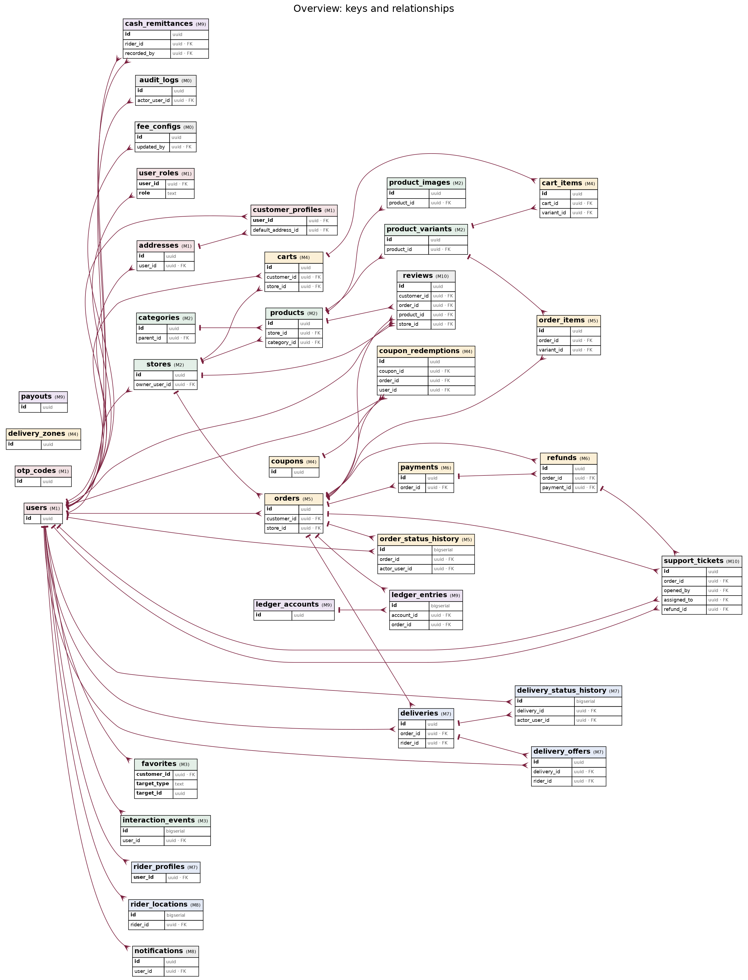
Figure 1. Overview of all tables, keys and relationships
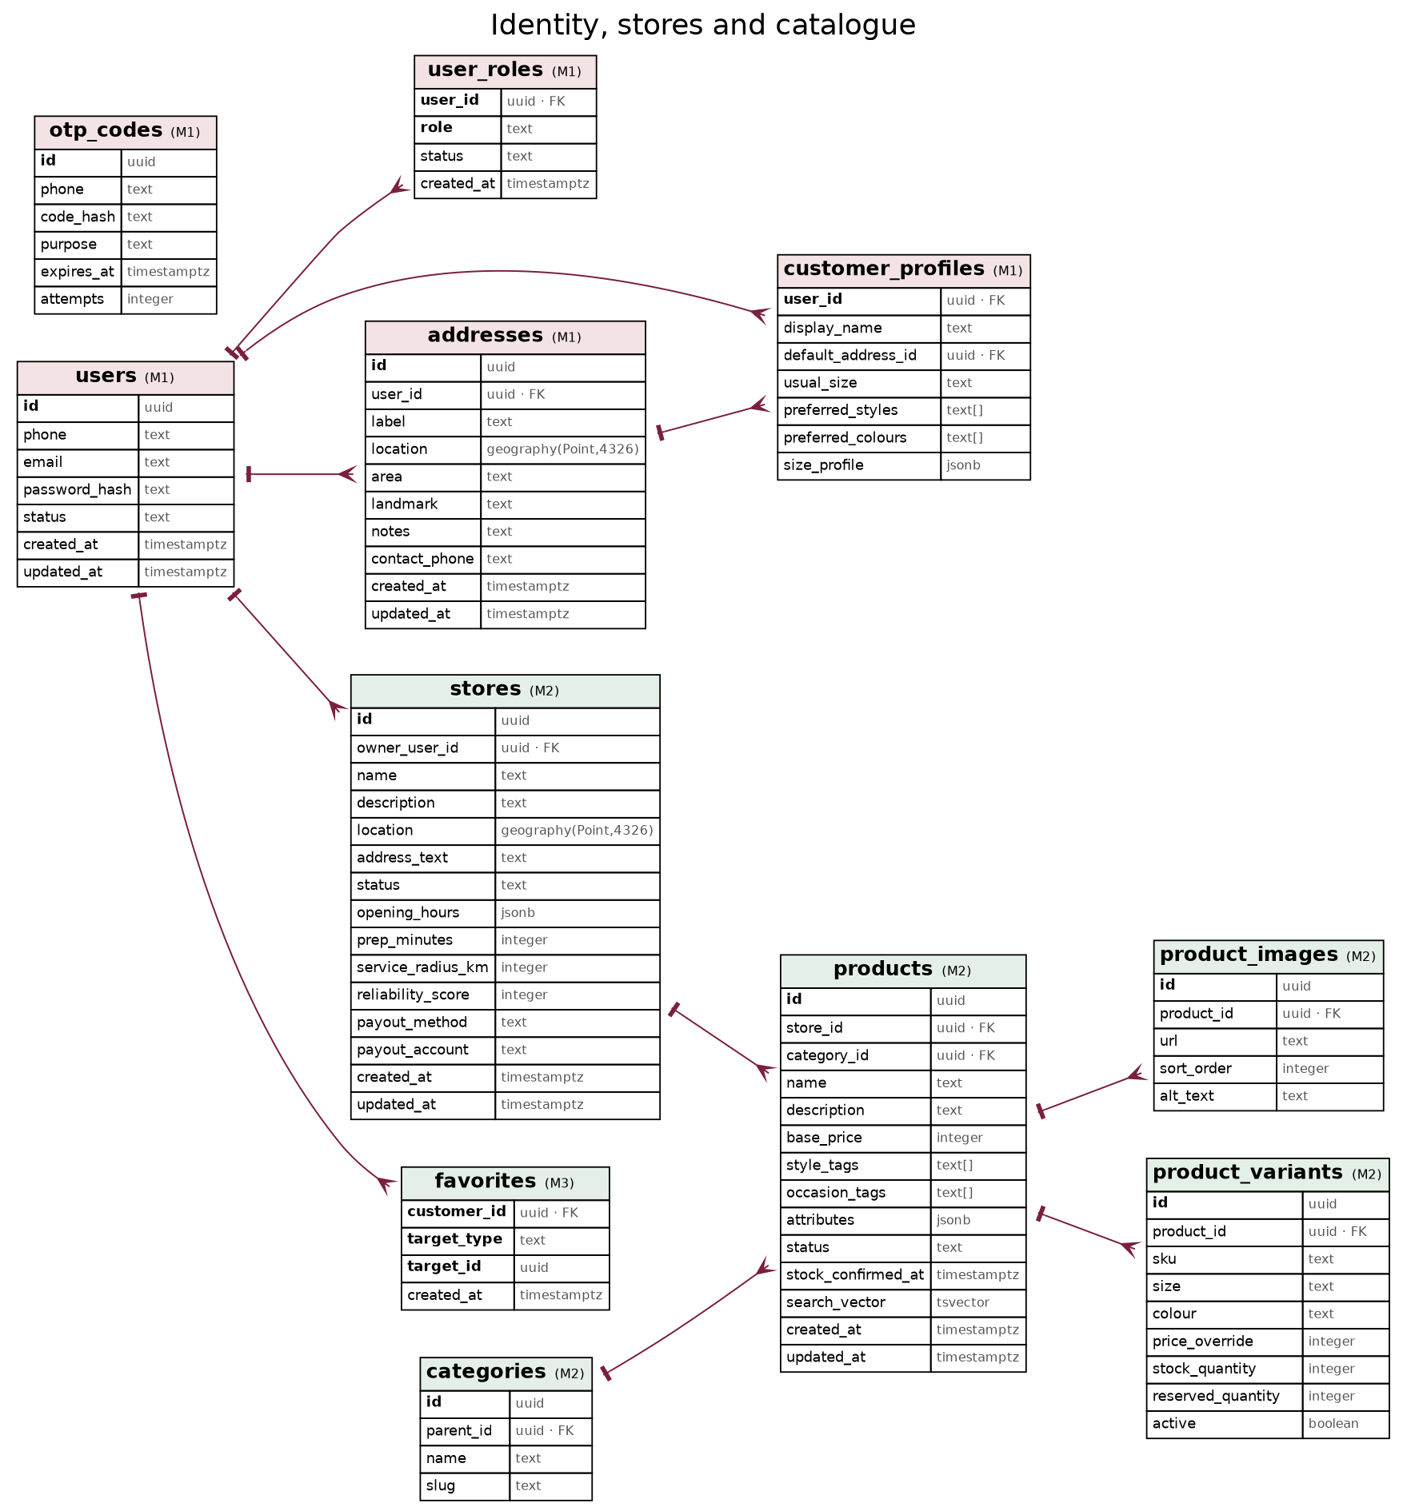
Figure 2. Identity, stores and catalogue
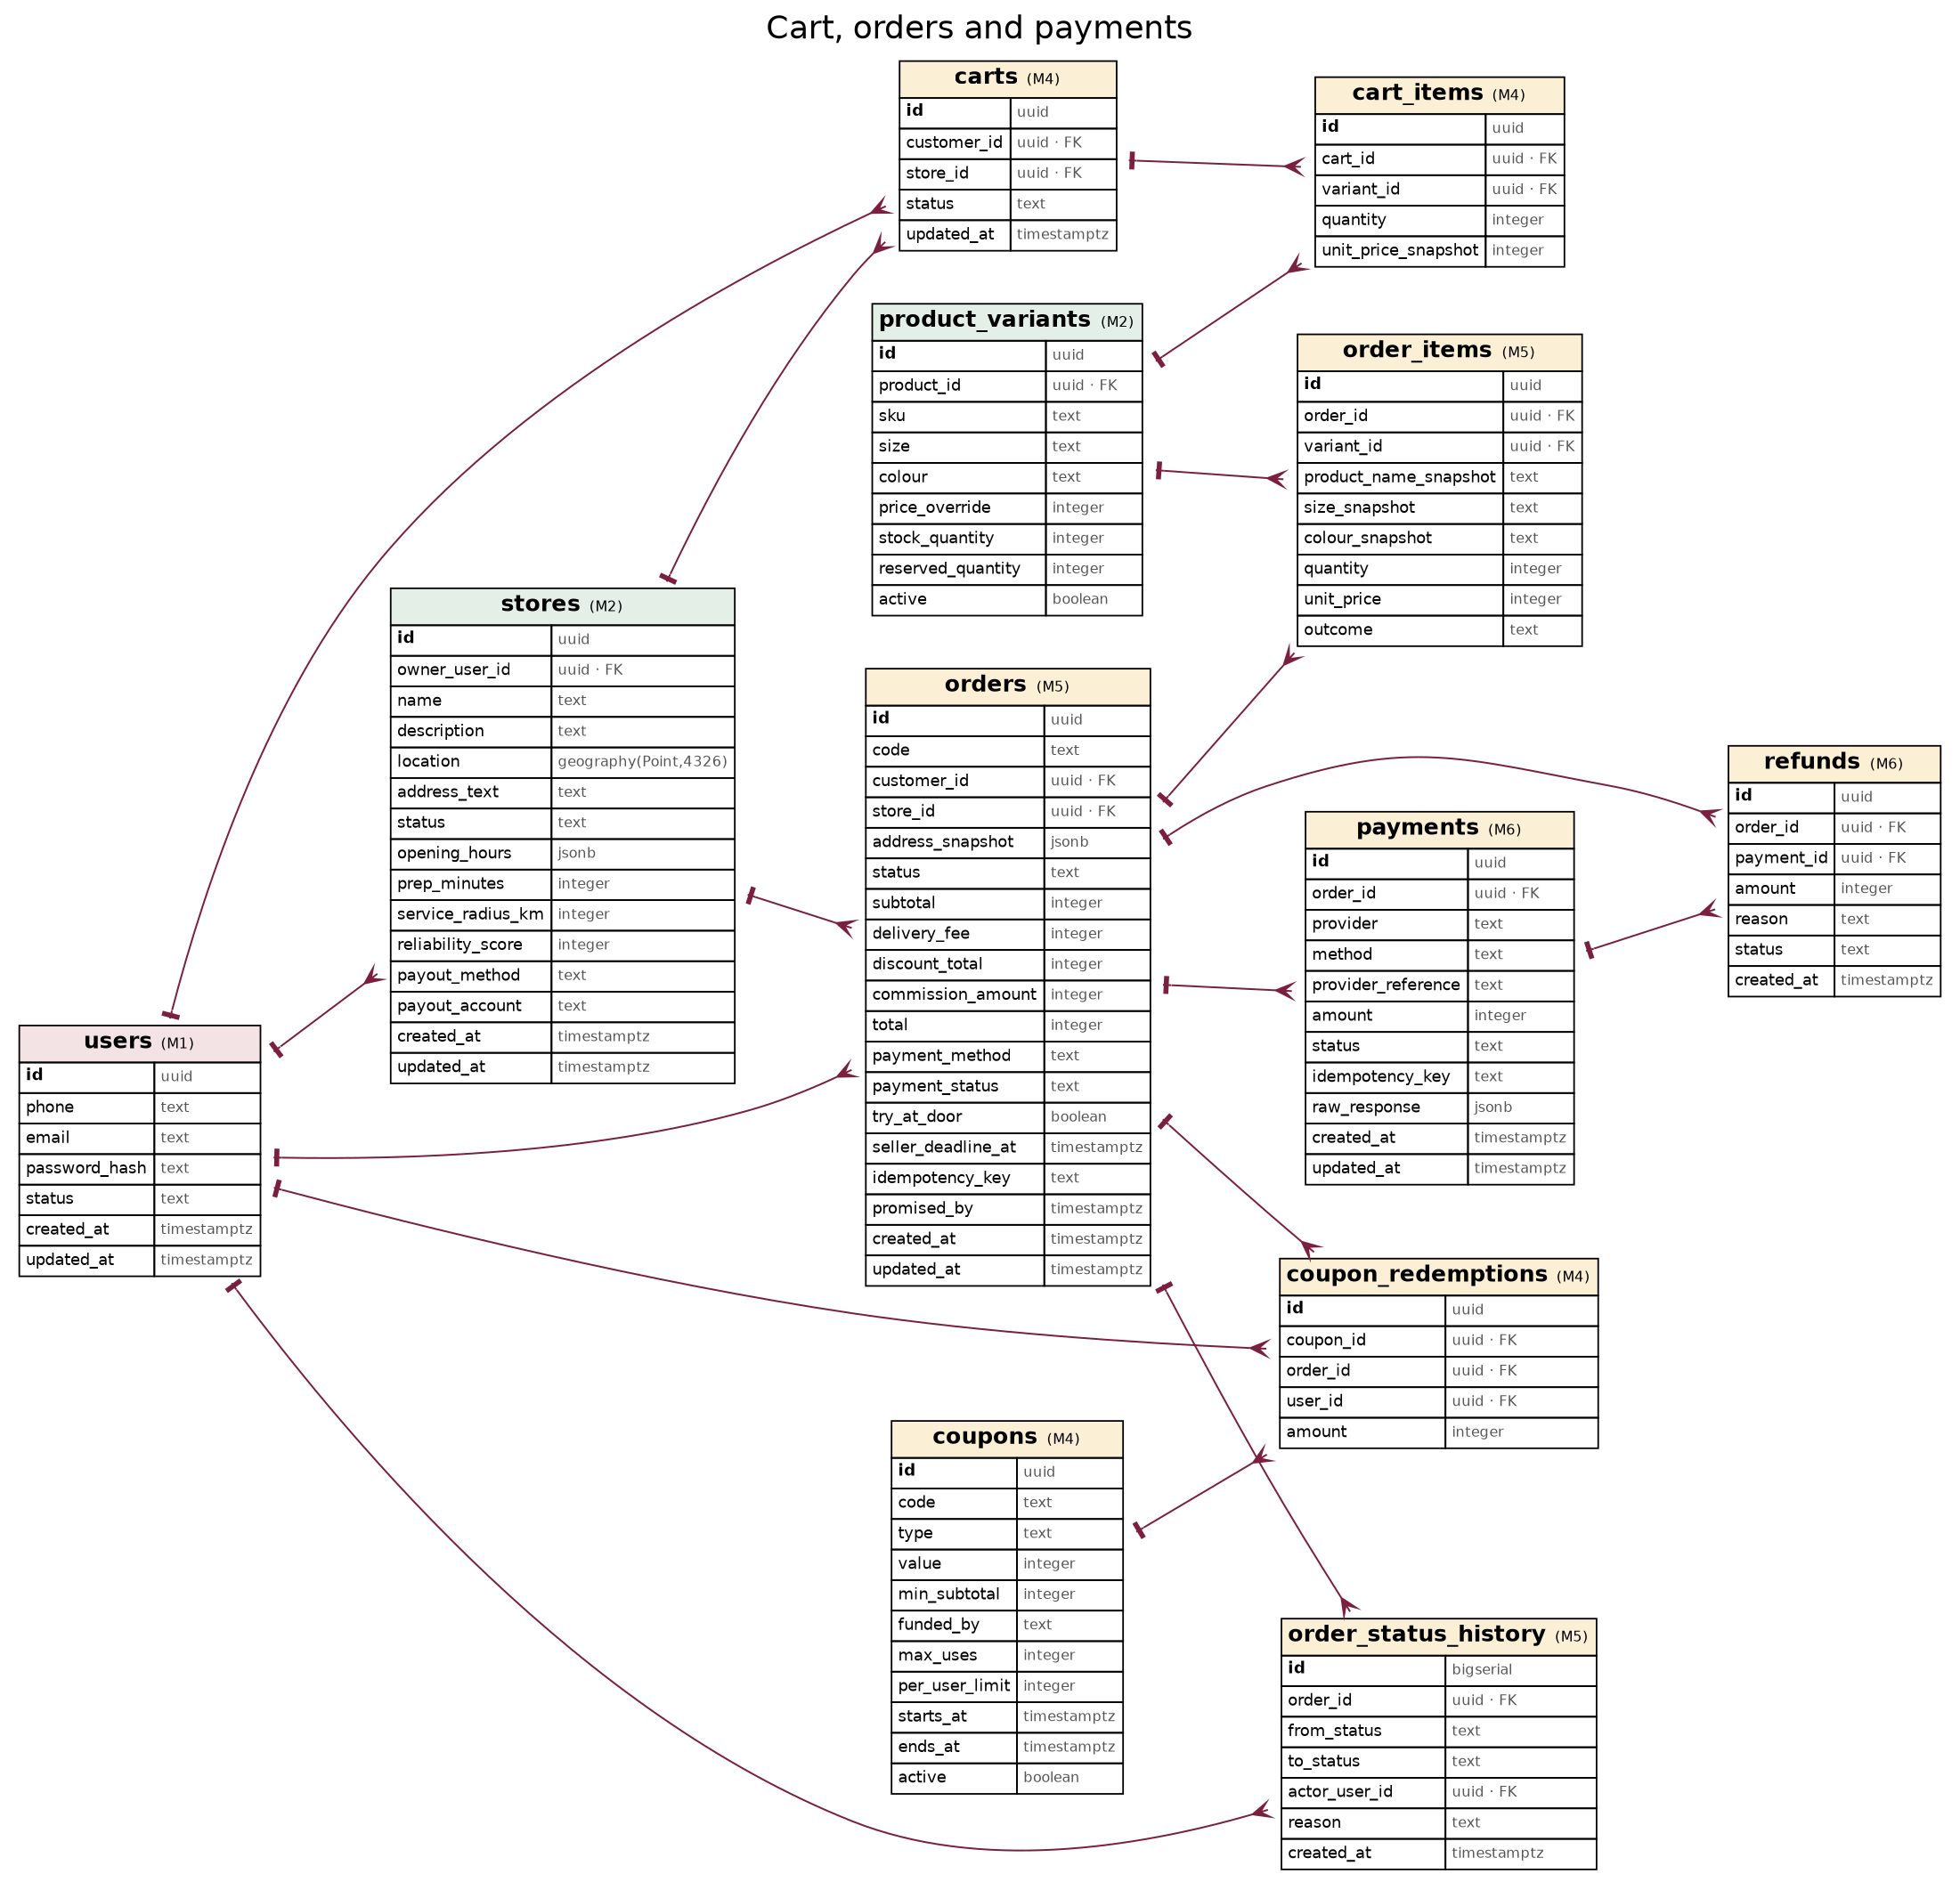
Figure 3. Cart, orders and payments
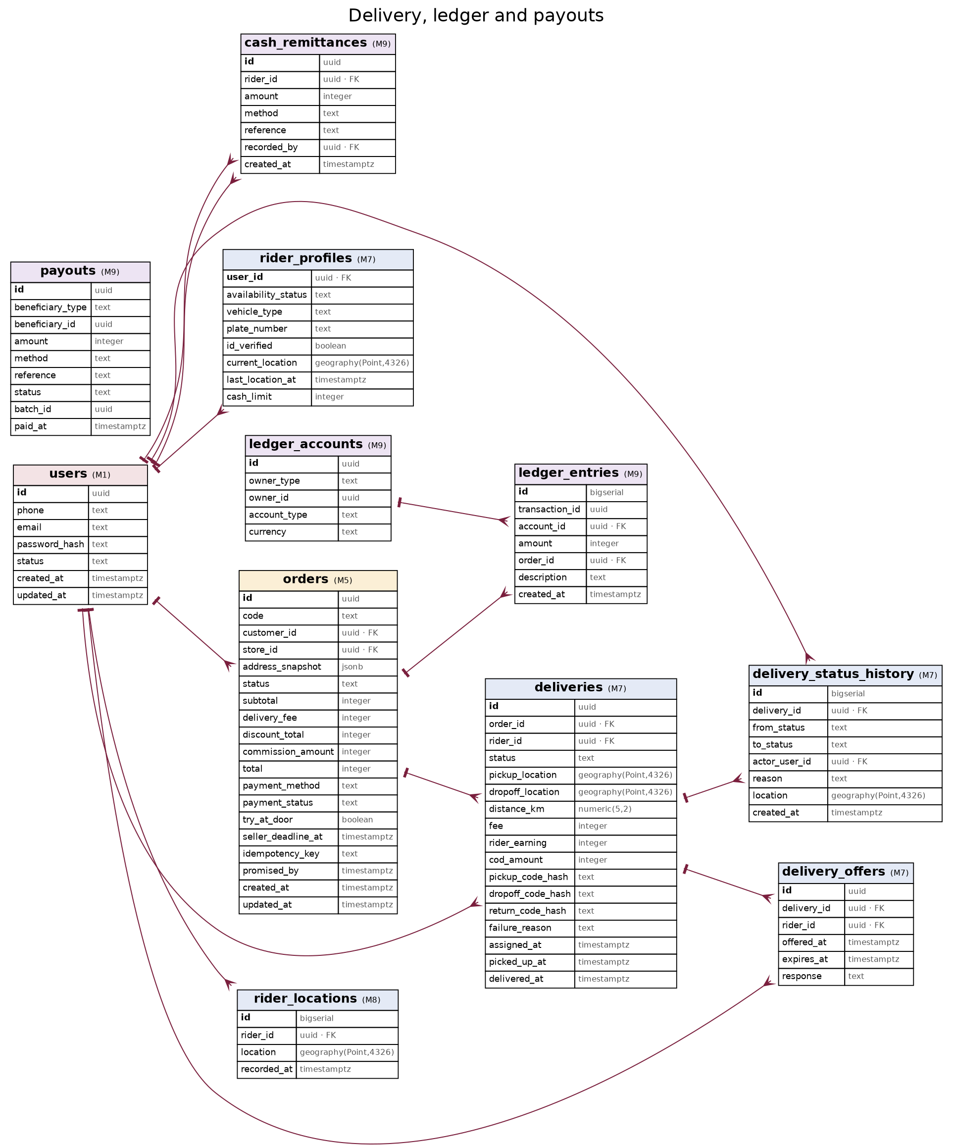
Figure 4. Delivery, ledger and payouts

3.1 Key relationships
Relationship | Cardinality | Rule
users → user_roles | 1 to many | One account, several roles (AUTH-03)
users → addresses | 1 to many | Customer address book (ADDR-02)
users → stores | 1 to many | A seller may own more than one store
stores → products → product_variants | 1 to many to many | Stock lives on variants only (SDD §11.1)
customers → carts | 1 to 1 active | One active cart per customer, bound to one store
orders → order_items | 1 to many | Items hold name, size, colour and price snapshots
orders → deliveries | 1 to 1 | One delivery per order in the MVP
orders → payments | 1 to many | Retries create new payment attempts
ledger_accounts → ledger_entries | 1 to many | Entries grouped by transaction_id sum to zero

4. Data dictionary
Tables are grouped by domain. The module in brackets creates the table (Implementation Plan Appendix B).

Identity and profiles

users (M1)
Column | Type | Constraints | Notes
id | uuid | PK | —
phone | text | UNIQUE NOT NULL | E.164, e.g. +2567…
email | text | UNIQUE NULL | —
password_hash | text | NULL | Argon2id, optional
status | text | NOT NULL | active
created_at | timestamptz | NOT NULL DEFAULT now() | Row creation time
updated_at | timestamptz | NOT NULL DEFAULT now() | Last update time

user_roles (M1)
Column | Type | Constraints | Notes
user_id | uuid | PK, FK users | —
role | text | PK | customer
status | text | NOT NULL | pending
created_at | timestamptz | NOT NULL | —

otp_codes (M1)
Column | Type | Constraints | Notes
id | uuid | PK | —
phone | text | NOT NULL, INDEX | —
code_hash | text | NOT NULL | —
purpose | text | NOT NULL | login
expires_at | timestamptz | NOT NULL | now + 5 min
attempts | integer | NOT NULL DEFAULT 0 | Max 5

customer_profiles (M1)
Column | Type | Constraints | Notes
user_id | uuid | PK, FK users | —
display_name | text | — | —
default_address_id | uuid | FK addresses NULL | —
usual_size | text | — | e.g. M
preferred_styles | text[] | — | —
preferred_colours | text[] | — | —
size_profile | jsonb | — | Optional measurements

addresses (M1)
Column | Type | Constraints | Notes
id | uuid | PK | —
user_id | uuid | FK users NOT NULL | —
label | text | NOT NULL | Home, Hostel, Work
location | geography(Point,4326) | NOT NULL, GIST | Map pin
area | text | NOT NULL | Neighbourhood
landmark | text | — | —
notes | text | — | —
contact_phone | text | NOT NULL | ADDR-01
created_at | timestamptz | NOT NULL DEFAULT now() | Row creation time
updated_at | timestamptz | NOT NULL DEFAULT now() | Last update time

Stores and catalogue

stores (M2)
Column | Type | Constraints | Notes
id | uuid | PK | —
owner_user_id | uuid | FK users NOT NULL | —
name | text | NOT NULL | —
description | text | — | —
location | geography(Point,4326) | NOT NULL, GIST | —
address_text | text | — | —
status | text | NOT NULL | pending
opening_hours | jsonb | NOT NULL | Per weekday open/close
prep_minutes | integer | NOT NULL DEFAULT 15 | —
service_radius_km | integer | NOT NULL | —
reliability_score | integer | DEFAULT 100 | 0–100, M11
payout_method | text | — | mtn
payout_account | text | — | Phone or account ref
created_at | timestamptz | NOT NULL DEFAULT now() | Row creation time
updated_at | timestamptz | NOT NULL DEFAULT now() | Last update time

categories (M2)
Column | Type | Constraints | Notes
id | uuid | PK | —
parent_id | uuid | FK categories NULL | —
name | text | NOT NULL | —
slug | text | UNIQUE NOT NULL | —

products (M2)
Column | Type | Constraints | Notes
id | uuid | PK | —
store_id | uuid | FK stores NOT NULL | —
category_id | uuid | FK categories | —
name | text | NOT NULL | —
description | text | — | —
base_price | integer | NOT NULL CHECK > 0 | UGX
style_tags | text[] | GIN | —
occasion_tags | text[] | GIN | —
attributes | jsonb | — | Fabric, fit…
status | text | NOT NULL | draft
stock_confirmed_at | timestamptz | — | M11 freshness
search_vector | tsvector | GIN | Generated
created_at | timestamptz | NOT NULL DEFAULT now() | Row creation time
updated_at | timestamptz | NOT NULL DEFAULT now() | Last update time

product_images (M2)
Column | Type | Constraints | Notes
id | uuid | PK | —
product_id | uuid | FK products NOT NULL | —
url | text | NOT NULL | Cloudinary
sort_order | integer | NOT NULL | —
alt_text | text | — | NFR-05

product_variants (M2)
Column | Type | Constraints | Notes
id | uuid | PK | —
product_id | uuid | FK products NOT NULL | —
sku | text | — | —
size | text | NOT NULL | —
colour | text | NOT NULL | —
price_override | integer | NULL | UGX
stock_quantity | integer | NOT NULL CHECK >= 0 | —
reserved_quantity | integer | NOT NULL DEFAULT 0 CHECK <= stock | —
active | boolean | NOT NULL DEFAULT true | —

favorites (M3)
Column | Type | Constraints | Notes
customer_id | uuid | PK, FK users | —
target_type | text | PK | product
target_id | uuid | PK | —
created_at | timestamptz | NOT NULL | —

interaction_events (M3)
Column | Type | Constraints | Notes
id | bigserial | PK | —
user_id | uuid | FK users NULL | —
session_id | text | — | —
event_type | text | NOT NULL | view
target_type | text | — | —
target_id | uuid | — | —
metadata | jsonb | — | Query, position…
created_at | timestamptz | NOT NULL, BRIN | —

Cart, orders and payments

carts (M4)
Column | Type | Constraints | Notes
id | uuid | PK | —
customer_id | uuid | FK users NOT NULL | —
store_id | uuid | FK stores NOT NULL | Single-store rule
status | text | NOT NULL | active
updated_at | timestamptz | NOT NULL | —

cart_items (M4)
Column | Type | Constraints | Notes
id | uuid | PK | —
cart_id | uuid | FK carts NOT NULL | —
variant_id | uuid | FK product_variants NOT NULL | —
quantity | integer | NOT NULL CHECK > 0 | —
unit_price_snapshot | integer | NOT NULL | UGX

delivery_zones (M4)
Column | Type | Constraints | Notes
id | uuid | PK | —
name | text | NOT NULL | —
area | geography(Polygon,4326) | NOT NULL, GIST | —
surcharge | integer | NOT NULL DEFAULT 0 | UGX
active | boolean | NOT NULL | —

coupons (M4)
Column | Type | Constraints | Notes
id | uuid | PK | —
code | text | UNIQUE NOT NULL | —
type | text | NOT NULL | percent
value | integer | NOT NULL | —
min_subtotal | integer | — | —
funded_by | text | NOT NULL | platform
max_uses | integer | — | —
per_user_limit | integer | — | —
starts_at | timestamptz | — | —
ends_at | timestamptz | — | —
active | boolean | NOT NULL | —

coupon_redemptions (M4)
Column | Type | Constraints | Notes
id | uuid | PK | —
coupon_id | uuid | FK coupons | —
order_id | uuid | FK orders | —
user_id | uuid | FK users | —
amount | integer | NOT NULL | UGX

orders (M5)
Column | Type | Constraints | Notes
id | uuid | PK | —
code | text | UNIQUE NOT NULL | 6-char public code
customer_id | uuid | FK users NOT NULL | —
store_id | uuid | FK stores NOT NULL | —
address_snapshot | jsonb | NOT NULL | Immutable
status | text | NOT NULL, INDEX | SDD §12.1
subtotal | integer | NOT NULL | —
delivery_fee | integer | NOT NULL | —
discount_total | integer | NOT NULL DEFAULT 0 | —
commission_amount | integer | — | Set on completion
total | integer | NOT NULL | —
payment_method | text | NOT NULL | cod
payment_status | text | NOT NULL | —
try_at_door | boolean | NOT NULL | —
seller_deadline_at | timestamptz | — | —
idempotency_key | text | UNIQUE | —
promised_by | timestamptz | — | Arrives-by
created_at | timestamptz | NOT NULL DEFAULT now() | Row creation time
updated_at | timestamptz | NOT NULL DEFAULT now() | Last update time

order_items (M5)
Column | Type | Constraints | Notes
id | uuid | PK | —
order_id | uuid | FK orders NOT NULL | —
variant_id | uuid | FK product_variants | —
product_name_snapshot | text | NOT NULL | —
size_snapshot | text | NOT NULL | —
colour_snapshot | text | NOT NULL | —
quantity | integer | NOT NULL | —
unit_price | integer | NOT NULL | UGX
outcome | text | NULL | kept

order_status_history (M5)
Column | Type | Constraints | Notes
id | bigserial | PK | —
order_id | uuid | FK orders, INDEX | —
from_status | text | — | —
to_status | text | NOT NULL | —
actor_user_id | uuid | FK users NULL | NULL = system
reason | text | — | —
created_at | timestamptz | NOT NULL | —

payments (M6)
Column | Type | Constraints | Notes
id | uuid | PK | —
order_id | uuid | FK orders NOT NULL | —
provider | text | NOT NULL | simulated
method | text | NOT NULL | —
provider_reference | text | UNIQUE | —
amount | integer | NOT NULL | —
status | text | NOT NULL | pending
idempotency_key | text | UNIQUE | —
raw_response | jsonb | — | —
created_at | timestamptz | NOT NULL DEFAULT now() | Row creation time
updated_at | timestamptz | NOT NULL DEFAULT now() | Last update time

refunds (M6)
Column | Type | Constraints | Notes
id | uuid | PK | —
order_id | uuid | FK orders | —
payment_id | uuid | FK payments NULL | —
amount | integer | NOT NULL | —
reason | text | NOT NULL | —
status | text | NOT NULL | pending
created_at | timestamptz | NOT NULL | —

Delivery and tracking

rider_profiles (M7)
Column | Type | Constraints | Notes
user_id | uuid | PK, FK users | —
availability_status | text | NOT NULL | offline
vehicle_type | text | — | boda
plate_number | text | — | —
id_verified | boolean | NOT NULL DEFAULT false | —
current_location | geography(Point,4326) | GIST | —
last_location_at | timestamptz | — | —
cash_limit | integer | NOT NULL | UGX

deliveries (M7)
Column | Type | Constraints | Notes
id | uuid | PK | —
order_id | uuid | FK orders UNIQUE | —
rider_id | uuid | FK users NULL | —
status | text | NOT NULL | SDD §12.2
pickup_location | geography(Point,4326) | NOT NULL | —
dropoff_location | geography(Point,4326) | NOT NULL | —
distance_km | numeric(5,2) | — | —
fee | integer | NOT NULL | —
rider_earning | integer | NOT NULL | —
cod_amount | integer | NOT NULL DEFAULT 0 | —
pickup_code_hash | text | — | —
dropoff_code_hash | text | — | —
return_code_hash | text | — | —
failure_reason | text | — | —
assigned_at | timestamptz | — | —
picked_up_at | timestamptz | — | —
delivered_at | timestamptz | — | —

delivery_status_history (M7)
Column | Type | Constraints | Notes
id | bigserial | PK | —
delivery_id | uuid | FK deliveries | —
from_status | text | — | —
to_status | text | NOT NULL | —
actor_user_id | uuid | FK users NULL | —
reason | text | — | —
location | geography(Point,4326) | — | —
created_at | timestamptz | NOT NULL | —

delivery_offers (M7)
Column | Type | Constraints | Notes
id | uuid | PK | —
delivery_id | uuid | FK deliveries | —
rider_id | uuid | FK users | —
offered_at | timestamptz | NOT NULL | —
expires_at | timestamptz | NOT NULL | +45 s
response | text | — | accepted

rider_locations (M8)
Column | Type | Constraints | Notes
id | bigserial | PK | —
rider_id | uuid | FK users | —
location | geography(Point,4326) | NOT NULL | —
recorded_at | timestamptz | NOT NULL, BRIN | Deleted after 30 days

Ledger and payouts

ledger_accounts (M9)
Column | Type | Constraints | Notes
id | uuid | PK | —
owner_type | text | NOT NULL | seller
owner_id | uuid | NULL | —
account_type | text | NOT NULL | receivable
currency | text | NOT NULL DEFAULT 'UGX' | —

ledger_entries (M9)
Column | Type | Constraints | Notes
id | bigserial | PK | —
transaction_id | uuid | NOT NULL, INDEX | Lines sum to 0
account_id | uuid | FK ledger_accounts | —
amount | integer | NOT NULL | Signed UGX
order_id | uuid | FK orders NULL | —
description | text | — | —
created_at | timestamptz | NOT NULL | Append-only

payouts (M9)
Column | Type | Constraints | Notes
id | uuid | PK | —
beneficiary_type | text | NOT NULL | seller
beneficiary_id | uuid | NOT NULL | —
amount | integer | NOT NULL | —
method | text | NOT NULL | —
reference | text | — | —
status | text | NOT NULL | pending
batch_id | uuid | — | —
paid_at | timestamptz | — | —

cash_remittances (M9)
Column | Type | Constraints | Notes
id | uuid | PK | —
rider_id | uuid | FK users | —
amount | integer | NOT NULL | —
method | text | NOT NULL | —
reference | text | — | —
recorded_by | uuid | FK users | —
created_at | timestamptz | NOT NULL | —

Operations, audit and configuration

audit_logs (M0)
Column | Type | Constraints | Notes
id | uuid | PK | —
actor_user_id | uuid | FK users, NULL for system | Who acted
action | text | NOT NULL | e.g. seller.approve
target_type | text | NOT NULL | Entity type
target_id | uuid | NOT NULL | Entity id
before | jsonb | — | State before
after | jsonb | — | State after
created_at | timestamptz | NOT NULL | Append-only

fee_configs (M0)
Column | Type | Constraints | Notes
id | uuid | PK | —
key | text | NOT NULL | e.g. delivery.base_fee
value | jsonb | NOT NULL | Typed value
effective_from | timestamptz | NOT NULL | Applies to orders after this
updated_by | uuid | FK users | —

notifications (M8)
Column | Type | Constraints | Notes
id | uuid | PK | —
user_id | uuid | FK users | —
channel | text | NOT NULL | in_app
type | text | NOT NULL | Event name
title | text | — | —
body | text | NOT NULL | —
status | text | NOT NULL | queued
read_at | timestamptz | — | —
created_at | timestamptz | NOT NULL | —

support_tickets (M10)
Column | Type | Constraints | Notes
id | uuid | PK | —
order_id | uuid | FK orders NULL | —
opened_by | uuid | FK users | —
type | text | NOT NULL | wrong_item
status | text | NOT NULL | open
assigned_to | uuid | FK users NULL | —
resolution | text | — | —
refund_id | uuid | FK refunds NULL | —
created_at | timestamptz | NOT NULL DEFAULT now() | Row creation time
updated_at | timestamptz | NOT NULL DEFAULT now() | Last update time

reviews (M10)
Column | Type | Constraints | Notes
id | uuid | PK | —
customer_id | uuid | FK users | —
order_id | uuid | FK orders | —
product_id | uuid | FK products NULL | —
store_id | uuid | FK stores | —
rating | integer | CHECK 1–5 | —
comment | text | — | —
status | text | NOT NULL | visible
created_at | timestamptz | NOT NULL | —

5. Integrity rules, indexes and queries

5.1 Critical integrity rules
Rule | Implementation
Stock never negative | CHECK (stock_quantity >= 0) and CHECK (reserved_quantity BETWEEN 0 AND stock_quantity) on product_variants
No overselling under concurrency | Reservation by conditional update inside the order transaction (below)
One active cart per customer | Partial unique index ON carts(customer_id) WHERE status = 'active'
Unique variant per product | UNIQUE (product_id, size, colour)
No duplicate orders on retry | UNIQUE (idempotency_key) on orders and payments
Balanced ledger | Service rejects a transaction whose lines do not sum to 0; nightly check query alerts on any imbalance
Valid statuses | CHECK (status IN (...)) on every status column, matching SDD §12
Append-only logs | Database role without UPDATE/DELETE on audit_logs, ledger_entries

5.2 Stock reservation pattern
-- inside the place_order transaction, once per cart line
UPDATE product_variants
SET reserved_quantity = reserved_quantity + :qty
WHERE id = :variant_id
AND active
AND stock_quantity - reserved_quantity >= :qty
RETURNING id;
-- zero rows returned => rollback and raise OUT_OF_STOCK

On pickup: stock_quantity -= qty, reserved_quantity -= qty. On rejection, expiry, cancellation or payment failure: reserved_quantity -= qty. On return-at-door after pickup: stock_quantity += qty.

5.3 Index plan
Table | Index | Serves
stores | GIST (location); btree (status) | Nearby stores, radius checks
products | GIN (search_vector); GIN trigram (name); GIN (occasion_tags); btree (store_id, status) | Search, occasion filter, seller listing
product_variants | btree (product_id); unique (product_id, size, colour) | Stock lookups
orders | btree (customer_id, created_at DESC); btree (store_id, status); partial btree (seller_deadline_at) WHERE status = 'PENDING_SELLER' | Order lists, seller queue, expiry job
deliveries | btree (rider_id, status); btree (status) | Rider jobs, dispatcher
rider_profiles | GIST (current_location) WHERE availability_status = 'online' | Nearest rider
ledger_entries | btree (account_id, created_at); btree (transaction_id); btree (order_id) | Balances, reconciliation
interaction_events, rider_locations | BRIN (created_at / recorded_at) | Cheap time-range scans on large tables
notifications | btree (user_id, created_at DESC) WHERE read_at IS NULL | Unread badge

5.4 Reference queries
Nearby active stores within their own service radius:
SELECT s.id, s.name, ST_Distance(s.location, :pin) / 1000 AS km
FROM stores s
WHERE s.status = 'active'
AND ST_DWithin(s.location, :pin, s.service_radius_km * 1000)
ORDER BY km;

Account balance (never stored, always derived):
SELECT COALESCE(SUM(amount), 0) FROM ledger_entries WHERE account_id = :account_id;

Nightly ledger check (must return no rows):
SELECT transaction_id FROM ledger_entries GROUP BY transaction_id HAVING SUM(amount) <> 0;

6. Migrations, seed data and environments

6.1 Migration rules
- One Alembic migration per pull request that changes the schema; autogenerate, then review by hand.
- Every migration has a working downgrade(); CI runs upgrade → downgrade → upgrade on an empty database (Implementation Plan gate G2).
- Destructive changes (dropping or renaming columns) happen in two releases: add new and backfill, then drop old.
- Large backfills run as worker jobs in batches, not inside the migration.

6.2 Migration order by module
Order | Module | Migration contents
1 | M0 | Extensions; audit_logs, fee_configs with seed values
2 | M1 | users, user_roles, otp_codes, customer_profiles, addresses
3 | M2 | stores, categories, products, product_images, product_variants
4 | M3 | favorites, interaction_events, search vector trigger and indexes
5 | M4 | carts, cart_items, delivery_zones, coupons, coupon_redemptions
6 | M5 | orders, order_items, order_status_history
7 | M6 | payments, refunds
8 | M7 | rider_profiles, deliveries, delivery_status_history, delivery_offers
9 | M8 | notifications, rider_locations
10 | M9 | ledger_accounts, ledger_entries, payouts, cash_remittances
11 | M10 | support_tickets, reviews; KYC columns on profiles
12 | M11 | reliability_score, stock_confirmed_at populated; ranking columns on events

6.3 Seed data
Environment | Seed
Development | 5 stores in Kampala CBD, Wandegeya, Nakasero, Kololo and Owino; 20 products with variants; 3 test customers; 2 riders; 1 admin; default fee configs; 2 delivery zones
Staging | Same as development plus 5,000 generated products for performance tests (M3)
Production | Categories, occasion and style vocabularies, fee configs, zones, admin account only

7. Security, privacy and retention
Data | Protection | Retention
OTP codes | Hashed; 5-minute expiry | Deleted after 24 hours
Handover codes | Hashed; single use | Kept with delivery for audit
Phone numbers, addresses | Access limited to owner and active delivery parties | While account active; anonymised 90 days after deletion request
Rider locations | Visible to customer only after pickup | Deleted after 30 days
Payment provider responses | No card data stored | 7 years with financial records
Audit logs, ledger | Append-only | 7 years
Interaction events | Pseudonymous session ids | 18 months, then aggregated

Backups run daily with 14-day retention; a restore to staging is tested monthly (SDD §21).

8. Open items
Item | Needed by | Default
Commission tiers stored per seller or per category | M9 | Per category in fee_configs
Retention periods confirmed against the Data Protection and Privacy Act 2019 | M12 | Values in §7, pending review
Partitioning rider_locations by day | M8 | Daily deletion job instead of partitions for the MVP

