AlluCloud

(version 20 May 2014)

Contents

Backlog for v2 2

Architecture 4

System Setup 5

Installation 5

Git Repo 5

Global Configuration File (alluCloud.conf) 5

Modules 6

DASHBOARD 7

BOOK 8

FILM 9

EVENT 10

WEB 11

BACKUP 12

NOTES 13

TOTALBACKUP 14

NEW START 2015 14

# 2105 Backlog for v2

(in priority order)

EPIC: Webserver is empty. Files taken from source and saved locally. then just uploaded en masse.

BOOK

Just about finished. I think index.html is working but advanced is overwriting it somehow.

Also get rid of config file stuff.

Instead of just uploading to web, save a copy to 'Ready To View'. This excersise it to take files only from 'source' and save only to 'Ready To View'. FTP upload is *one* final step.

EVENT

FILM

NOTES

WEB

DEPLOYMENT

alluCloud must be deployable easily to a new PC

Deployment script

Git checkout > run deployment script > populate local DB > run update script > upload dashboard to FTP.

1. Webserver/FTP is empty

2. Local DB is empty

TOTALBACKUP

Bullet proof backup of my system, Reporting, scheduling and alerting.

MODERN WEBUI

Looks good. Ability to add information via webui. Password protected.

VERSION CONTROL

Version control is done through GIT.

CONFIGURATION

*All* config is stored in DB

==============================================

TotalBackup: configure correct dirs for ""add: GUI command to "Delete all and copy to HDD now"

WebInterface>modify so that all NOTE scripts are together and WEBINTERFACE uses **alluCloudCommunicationNOTE.add_note_if_not_already_in_DB**

Get NewNotes to work with QNAP box on the web

Logging>Create “COMMON” dir for logs, backup, healthcheck

create a main alluCloud.log under root directory and somehow rotate it with ‘handler’

General> Make all modules read from DB configuration table!!

NOTE done alluCloud.conf >> DB

FILM done alluCloud.conf >> DB

WEB done alluCloud.conf >> DB

BOOKS done alluCloud.conf >> DB

EVENT

BACKUP

CONSOLE

DASHBOARD

WEBINTERFACE

COMMON

Notes> Add an ‘Archived’ column to hide notes but not delete them (that willl solve the weird

Thunderbird problem)

Backup>Make sure that everything is backed up (OFFSITE) properly at least monthly.

Includes: GIT, check that SQL files include everything, files from Elisa FTP, files from QNAP ftp

Latest timestamp could be in dashboard config table

Document backup process in doc.

Healthcheck>Add module to check EVERYTHING is ok regularly (ie backups, correct timestamps)

BOOKS> ToReadList is a txt file on the server. should be in DB

Doc> Update Architecture Picture

Update Notes Desc

Complete documentation about setting AlluCloud up from SCRATCH on new machine (tested)

Console> add a book and author

GENERAL IMPROVEMENTS:

separate common code into global functions

BOOKS:

V2. Add series

v2Add formats

v2Addcatagories

v2 Complete titles (series, formats, categories and all other fields)

WEB:

Group the results using the template so that it’s easier to scan

# Architecture

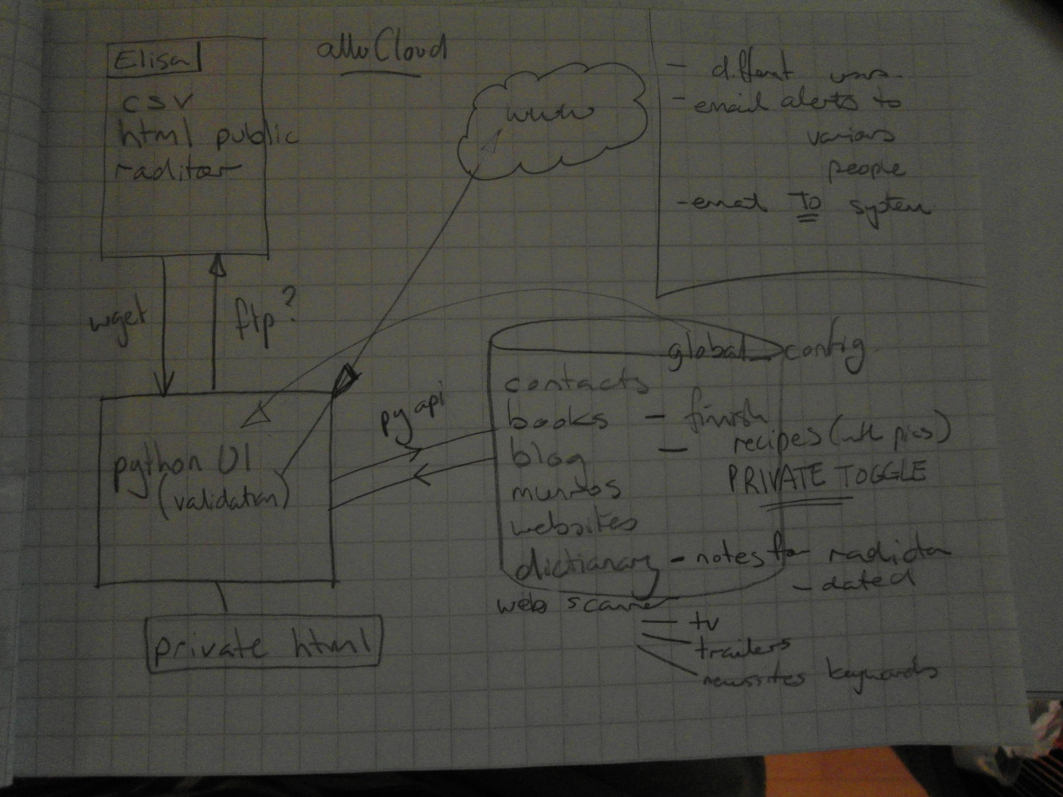

**Modules**:

DASHBOARD

* Update
* Backup

BOOKS

DIARY

* EventTracker
* Notes
* Contacts

WEB

* Scanner
* Sites

FINNISH

* Dictionary

MUNROS

BLOG

RECIPES

FILM

NOTES

TOTALBACKUP

System Setup

## Installation

1. Install MySQL 5.5
2. Install Python 2.6

Install MYSQLdb for python

NOTE: If Python2.7 is used then:

FTPLIB.py needs to be updated to this...

# The sizehint parameter passed to readline() calls

MAXLINE = 81920

1. Copy alluCloud directory to host
2. Create databases called: filmdb, booksdb, webdb,eventdb,dashdb,notedb
3. Populate these databases by running: “BACKUP\restore_scripts.bat”

## Git Repo

git@codebasehq.com:allucloud/allucloud/allucloudrepository.git

## Global Configuration File (alluCloud.conf)

Located in root of directory structure

# Modules

## DASHBOARD

Files:

<DASHBOARD>

* **alluCloudCommunicationDASHBOARD.py**

handles downloading and uploading for dashboard module

* **alluCloudUpdateALL_HTML.py**

gathers index files from all modules and puts them together into one dashboard HTML page, then uploads it to cloud

* **update_cloud.bat**

**(this is the file to add schedule to run on host startup)**

triggers all modules to update themselves, then triggers DASHBOARD update, then runs BACKUP of all databases.

## BOOK

Files:

<BOOKS>

**alluCloudUpdateBOOK.py**

* Updates HTML file on WWW server with current data from BOOKS module

**alluCloudCommunicationBOOK.py**

* Connections between cloud parts (FTP, MYSql, HTTP)

**alluCloudUpdateBOOKADVANCED.py**

* Updates the advanced HTML file on WWW server with current data from BOOKS module

## FILM

-functions in v1.0

* Basic to-watch list of films with comments. Turn on and off with ‘alreadySeen’ flag.

<FILM>

**alluCloudUpdateFILM.py**

* Updates HTML file on WWW server with current data from FILM module

**alluCloudCommunicationFILM.py**

* Connections between cloud parts (FTP, MYSql, HTTP)

## EVENT

-functions in v1.0

* Shows current update
* Roll over any past dates to next year if ‘recurring’ flag is set
* Sends summary email (on/off configurable)
* monthsToShow is configurable
* total number of events displayed

<EVENT>

**alluCloudUpdateEVENT.py**

* Updates HTML file on WWW server with current data from EVENT module

**alluCloudCommunicationEVENT.py**

* Connections between cloud parts (FTP, MYSql, HTTP)

## WEB

-functions in v1.0

* Very basic. Lots of URLs searched for various strings. No categories yet.
* Telkku website is checked for next 4 days TV listings

<WEB>

**alluCloudUpdateWEB.py**

* Updates HTML file on WWW server with current data from WEB module

**alluCloudCommunicationWEB.py**

* Connections between cloud parts (FTP, MYSql, HTTP)

## BACKUP

-functions in v1.0

* Every time cloud is updated all DBs get backed up just in case.

<BACKUP>

* **backup_scripts.bat**

usesmysqldump to backup whole database for each module

* **restore_scripts.bat**

usesmysqldump restore whole database for each module

<book>

* **booksback.sql**

<event>

* **eventback.sql**

<film>

* **filmback.sql**

<web>

* **webback.sql**

## NOTES

-functions in v1.0

* Very basic. Just reads notes.txt file from FTP server and displays the lines. No database stuff at all

<NOTES>

**alluCloudCommunicationNOTES.py**

* Updates HTML file on WWW server with current data from NOTES module

**alluCloudUpdateNOTES.py**

* Connections between cloud parts (FTP, HTTP)

## TOTALBACKUP

* Everything in ALLUSTORE\allanBackup is constantly zipped up and password protected in another directory ready for backing up to USB HDD

<TOTALBACKUP>

**totalbackup.py**

* maintains an updated directory of password protected zip files to be copied to an external USB HDD regularly