**AN ANDROID APP ON SMART NOTES**

**BY   
SUSHMITHA REDDY ALLA**

**W9546108**

**Module Leader: Julien Cordry**

**CONTENT**

Introduction And Target Users

Social, Legal And Ethical Issues

Professional Tools Used For Development

App Workflow

Agile project planning, management, and development

Prioritised feature list

Mobile App Screenshots

Self Reflection

**Introduction**

Simple notes is an application basically developed to ensure your mandatory data secure confidentially. This is an application where in you can save all your creative thoughts and ideas. Also, you can store any of your project details which are critical and you can access them at a fingertap. This Notes can be stored privately but cannot share with anyone. Any data which is provided in the Simple Notes application will be stored in firebase and cannot be viewed by anyone unless we provide user credentials. It is a very simple app but looks very clean. User can login to this application by providing login credentials.

**Social, Legal And Ethical Issues**

This App should adhere to all the rules that are required to guard user personal data. Any information provided here will not be shared to anyone and none of your personal data is collected from the user. Data which is collected from the user is very secure and stored privately in the firebase database. Any data like email address, passwords or mobile numbers are only recorded by the app and this info will not be shared.

**Professional Tools Used for Development**

**Android Studio:** Here is the tool where I have written all my source code files and saved. This tools build system helps you to modify build to generate multiple build variants for different devices from a single project.

**Firebase**:  Firebase is application development software based on google which provides tools for analytics tracking, fixing app crashes, marketing creating and product experiment, reporting.

**Mobile Phone**: It is used to test the end user application on physical device.

**App Work Flow:**

**Login Screen:**

User is asked to login with a valid name and password. Login Screen also has forgot password button and if you are new user signup to login in button.

**New User! Signup to Login:**

If the user is new to the application, Then it asks for signup and redirects to signup page.

**Forgot Password:**

If the user forgot the password, then user can reset password here.

**Main Activity:**

This Screen has list of notes that has been added, A search bar and Add button.

**Add Notes:**

Once the Add Button is clicked by the User the app redirects to the Add notes page where you can input your data.

**Edit/Delete:**

Once you have saved your note, you can delete and edit notes by just one click.

Logout:

User can easily logout by clicking on the more button provided on right hand corner.

**Agile project planning, management, and development:**

**Planning:**

Before developing any application, It is mandatory to understand end user expectations, having research over market, Setting goals for the app, create an app flowchart how to work and also to confirm feasibility on technical expectations.

**Management:**

After planning the project, I managed to complete the task by splitting into multiple parts so that the each task would be completed with more perfection. I have carried out my work in different Sprints in turn it helps us to get the better output. When we have to manage an application with multiple tasks, this is the best methodology to implement

**Development:**

In the development process, I have researched and Identified strategy options, resources that are most promising and deciding will be selected and allocated in order final output is achieved.

**Prioritised feature list**

App features have been segregated based on the activity that has to be formed. As I had limited time, it is really important to prioritise feature list. I have broken down my work into Sprints.

Sprint 1: In this stage, I have concentrated on UI design, I had a deisgn on pen and paper initially to get an idea on how my app should look. I have created a login activity, forgot password and sgnup page in this stage. This took me about 2 weeks to complete the activity by understanding all the code requirements.

Sprint 2: As I am done with creating the different screens, Now I have focused on validating data where in the I will ensure whether the entered input by the user has to be in the boundaries that is accepted by the application. Also I have connected the project with firebase. This process took me for almost 2 weeks.

Sprint 3: Once the firebase is connected with the project, I have created a new user on firebase with email Verification so that no unauthorised user cab be logged in. I have logged in to the app and created my first notes. After that I have created menu design using appropriate layout in order that proper user Interface Structure is defined.

Sprint 4: After creating menu design, then I have added Data on cloud firestore in app so that the structure of file to improve, Also will be more secure. Then I have retrieved data from cloud firestore in recycle view.

Sprint 5: After retrieving data then I have setup the app and checked for any bugs and tested the app in the final stage. Prepared Documentation, PPT and recordings demo videos which took about 2 weeks.

**Mobile App Screenshots**

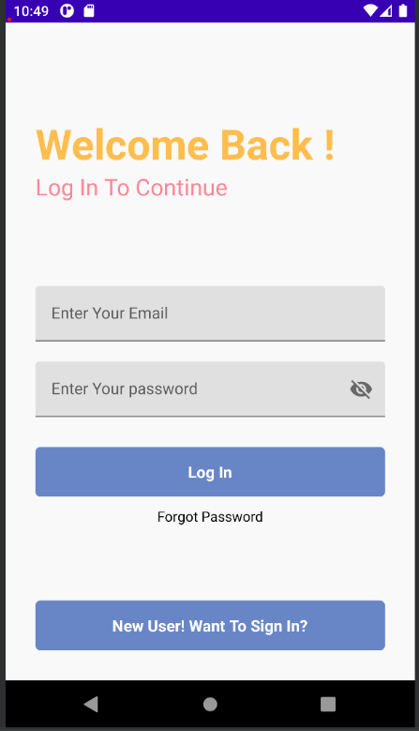

This is the main login page for App. Here we need to enter email address and password

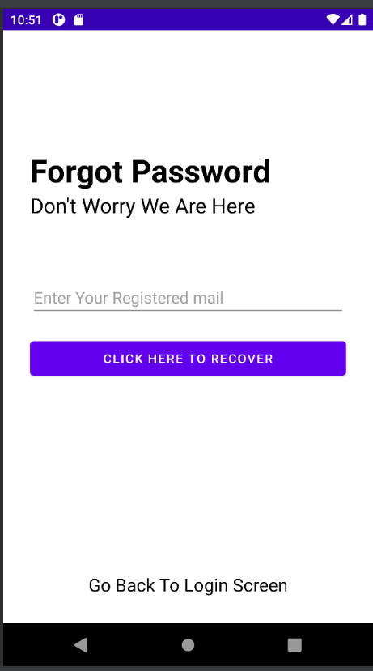

**In this screen we can recover our password**

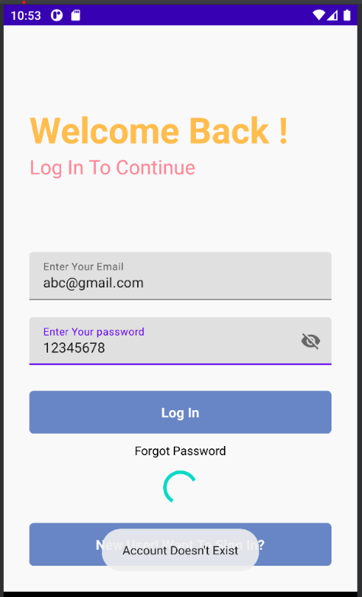

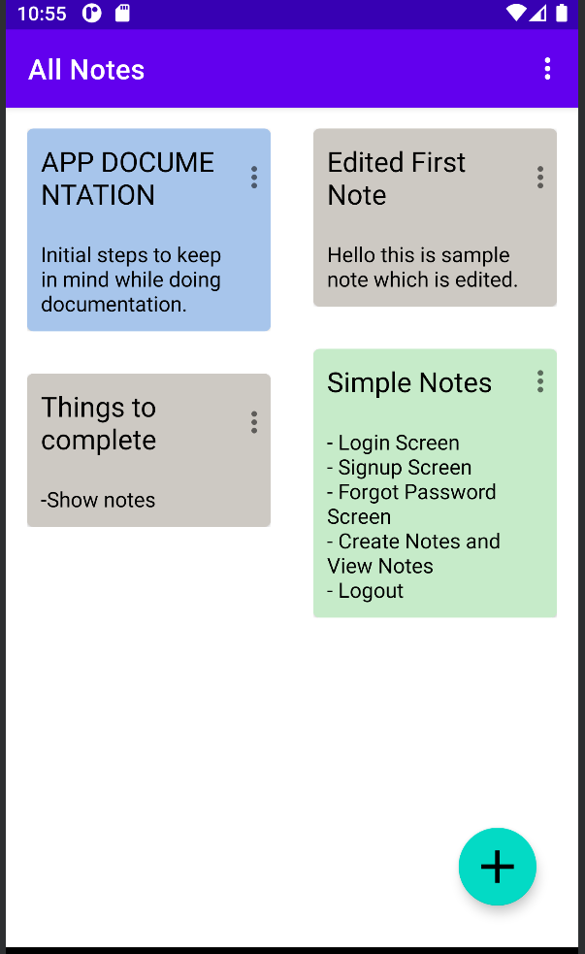

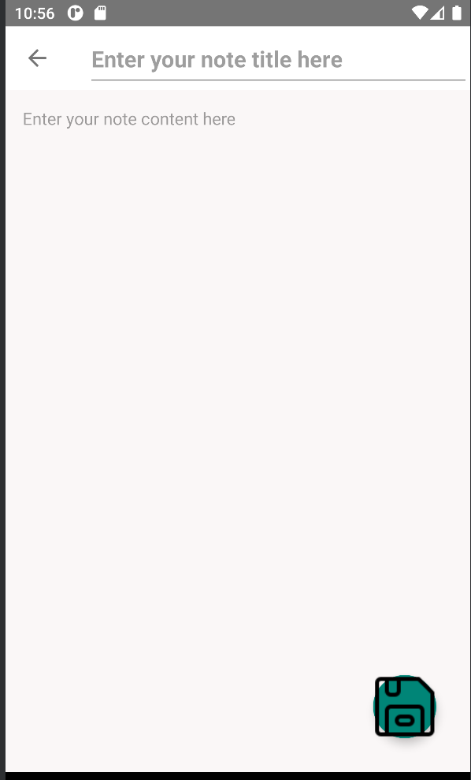

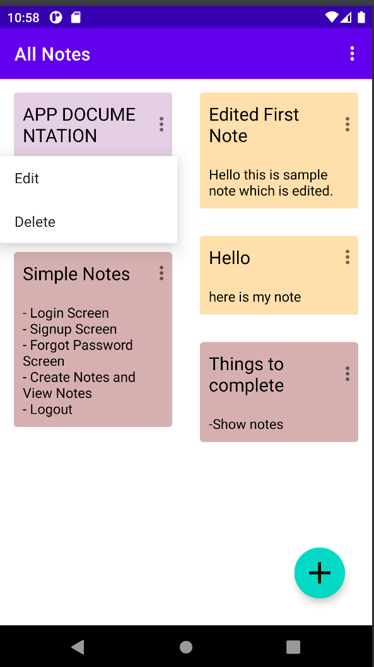

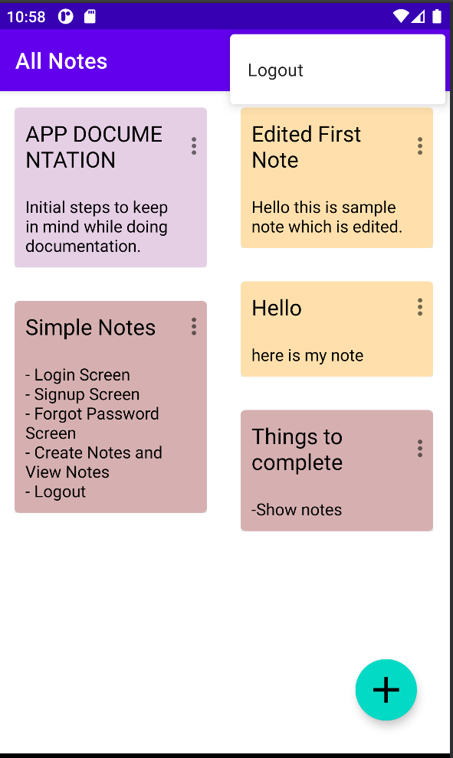

**Self Reflection**

Iam glad to work on tihis project which really helped me to develop my technical knowledge as Iam from a non technical background. While working on firebase I got to know how data storage works on firebase and implementing dependencies and import files. As Iam very passionate tp be a developer this module would is an added advantage to enhance my skills and be confident to go further for future projects. My Tutor cordry Julien was really helpful in each and every step of development of my app. My sincere thanks to my tutor.