Week-3
6.Aim: Program to Add a simple interactive form using JavaScript
Code:
<!DOCTYPE html>
<html>
<head>
<title>Interactive Form</title>
</head>
<body>

<h2>Simple Interactive Form</h2>

<form id="myForm">
<label for="name">Enter Your Name:</label>
<input type="text" id="name" placeholder="Your Name" required>
<br><br>
<button type="submit">Submit</button>
</form>

<h3 id="result"></h3>

<script>
// Get the form element
const form = document.getElementById("myForm");

// Add submit event listener
form.addEventListener("submit", function(event) {
event.preventDefault(); // Prevent page reload

// Get the input value
const name = document.getElementById("name").value;

// Display greeting
document.getElementById("result").textContent =
"Hello, " + name + "! Welcome!";
});
</script>

</body>
</html>
Output:
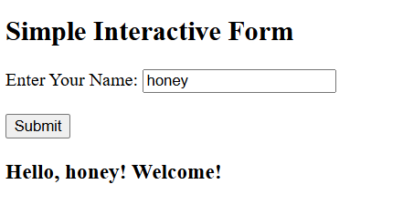

Week-4
7.Aim: Create a To-Do List app with JavaScript
Code:
<!DOCTYPE html>
<html>
<head>
<title>To-Do List</title>

<style>
body {
font-family: Arial;
text-align: center;
margin-top: 50px;
}

input {
padding: 10px;
width: 250px;
}

button {
padding: 10px;
margin-left: 5px;
cursor: pointer;
}

li {
list-style: none;
margin: 10px;
}

.completed {
text-decoration: line-through;
color: gray;
}

.delete {
background-color: red;
color: white;
border: none;
}
</style>
</head>

<body>

<h2>To-Do List</h2>

<input type="text" id="taskInput" placeholder="Enter a task">
<button onclick="addTask()">Add Task</button>

<ul id="taskList"></ul>

<script>
function addTask() {

let taskInput = document.getElementById("taskInput");
let task = taskInput.value;

if (task === "") {
alert("Please enter a task!");
return;
}

// Create list item
let li = document.createElement("li");

li.innerHTML = `
<span onclick="completeTask(this)">${task}</span>
<button class="delete" onclick="deleteTask(this)">Delete</button>
`;

document.getElementById("taskList").appendChild(li);

// Clear input
taskInput.value = "";
}

function completeTask(task) {
task.classList.toggle("completed");
}

function deleteTask(button) {
button.parentElement.remove();
}
</script>

</body>
</html>

Output:
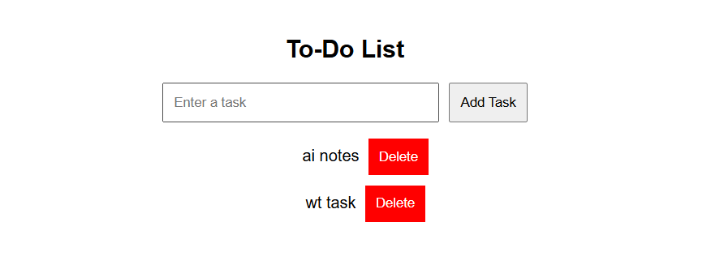

8.Aim: Fetch data from an API using Fetch/Axios.
Code:
<!DOCTYPE html>
<html>
<head>
<title>Fetch API Example</title>
</head>
<body>

<h2>Users List</h2>

<button onclick="fetchUsers()">Fetch Users</button>

<ul id="userList"></ul>

<script>
function fetchUsers() {

fetch("https://jsonplaceholder.typicode.com/users")
.then(response => response.json())
.then(data => {

let list = document.getElementById("userList");

data.forEach(user => {
let li = document.createElement("li");

li.textContent =
user.name + " - " + user.email;

list.appendChild(li);
});

})
.catch(error => {
console.log("Error:", error);
});
}
</script>

</body>
</html>
Output:
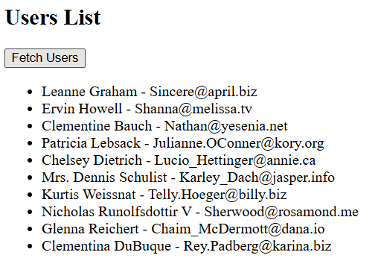

Week-5
9.Aim: Build a basic React app displaying a list of users from an API.
Code:
App.js:
import React, { useEffect, useState } from "react";

function App() {
const [users, setUsers] = useState([]);

useEffect(() => {
fetch("https://jsonplaceholder.typicode.com/users")
.then(response => response.json())
.then(data => setUsers(data))
.catch(error => console.log("Error:", error));
}, []);

return (
<div>
<h2>User List</h2>

<ul>
{users.map(user => (
<li key={user.id}>
<b>{user.name}</b> - {user.email}
</li>
))}
</ul>
</div>
);
}

export default App;
main.jsx:
import React from "react";
import ReactDOM from "react-dom/client";
import App from "./App";

ReactDOM.createRoot(document.getElementById("root")).render(
<React.StrictMode>
<App />
</React.StrictMode>
);
output:
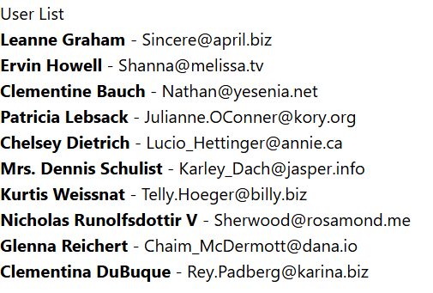

10.Aim: Implement state management for user interactions.
Code:
import React, { useState } from "react";

function App() {
// Create state variable
const [count, setCount] = useState(0);

return (
<div style={{ textAlign: "center", marginTop: "50px" }}>
<h2>Counter App</h2>

<h3>Count: {count}</h3>

<button onClick={() => setCount(count + 1)}>
Increase
</button>

<button onClick={() => setCount(count - 1)}>
Decrease
</button>

<button onClick={() => setCount(0)}>
Reset
</button>
</div>
);
}

export default App;
output:
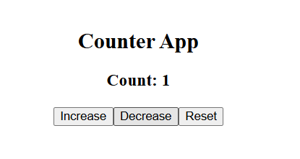
Week-6
11.Aim: Add dynamic routing to the React app.
Code:
import React from "react";
import { BrowserRouter, Routes, Route, Link, useParams } from "react-router-dom";

const users = [
{ id: 1, name: "John", email: "john@gmail.com" },
{ id: 2, name: "Alice", email: "alice@gmail.com" },
{ id: 3, name: "David", email: "david@gmail.com" }
];

// Home Page
function Home() {
return (
<div>
<h2>User List</h2>

{users.map(user => (
<div key={user.id}>
<Link to={`/user/${user.id}`}>
{user.name}
</Link>
</div>
))}
</div>
);
}

// User Details Page
function UserDetails() {
const { id } = useParams();

const user = users.find(user => user.id === Number(id));

return (
<div>
<h2>User Details</h2>

{user ? (
<>
<p><b>ID:</b> {user.id}</p>
<p><b>Name:</b> {user.name}</p>
<p><b>Email:</b> {user.email}</p>
</>
) : (
<p>User not found</p>
)}

<Link to="/">Back to Users</Link>
</div>
);
}

// Main App
function App() {
return (
<BrowserRouter>
<Routes>

<Route path="/" element={<Home />} />

<Route
path="/user/:id"
element={<UserDetails />}
/>

</Routes>
</BrowserRouter>
);
}

export default App;
12.Aim: Build a user registration form
Code:
import React, { useState } from "react";

function App() {
const [formData, setFormData] = useState({
name: "",
email: "",
password: "",
gender: ""
});

const [message, setMessage] = useState("");

// Handle input changes
const handleChange = (e) => {
setFormData({
...formData,
[e.target.name]: e.target.value
});
};

// Handle form submission
const handleSubmit = (e) => {
e.preventDefault();

setMessage("Registration Successful!");

console.log(formData);
};

return (
<div style={{ textAlign: "center", marginTop: "40px" }}>
<h2>User Registration Form</h2>

<form onSubmit={handleSubmit}>

<input
type="text"
name="name"
placeholder="Enter Name"
value={formData.name}
onChange={handleChange}
required
/>

<br /><br />

<input
type="email"
name="email"
placeholder="Enter Email"
value={formData.email}
onChange={handleChange}
required
/>

<br /><br />

<input
type="password"
name="password"
placeholder="Enter Password"
value={formData.password}
onChange={handleChange}
required
/>

<br /><br />

<select
name="gender"
value={formData.gender}
onChange={handleChange}
required
>
<option value="">Select Gender</option>
<option value="Male">Male</option>
<option value="Female">Female</option>
<option value="Other">Other</option>
</select>

<br /><br />

<button type="submit">
Register
</button>

</form>

<h3>{message}</h3>
</div>
);
}

export default App;

Output:
