**Project506**

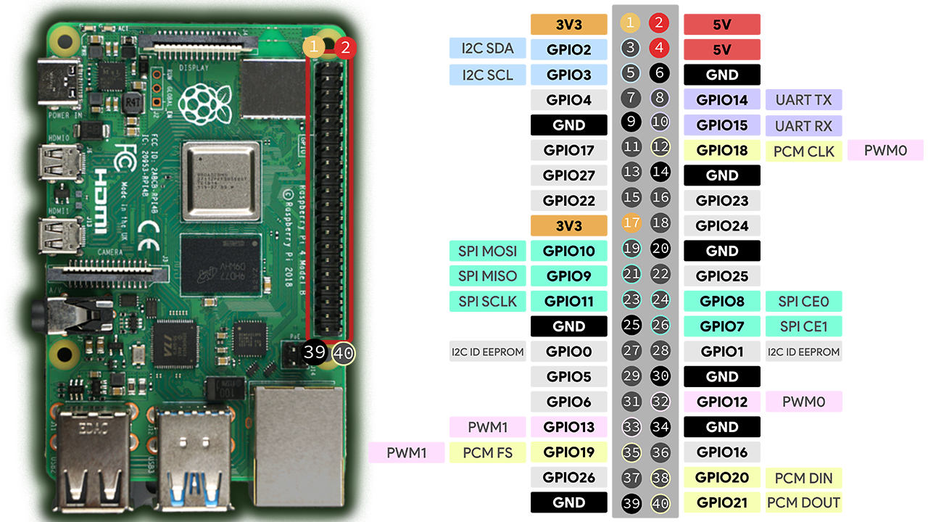

Water Pump:

**Components Required:**

1. **DC Motor**: The motor to control.
2. **Relay Module**
3. **External Power Supply**: To power the DC motor
4. **Flyback Diode**: Across the motor terminals to protect against voltage spikes.

**Relay Module Connections**:

* **VCC**: Connect to 5V of the Raspberry Pi.
* **GND**: Connect to the Raspberry Pi's GND.
* **IN**: Connect to a GPIO pin of the Raspberry Pi (GPIO17).

**Relay to Motor Connections**:

* **NO (Normally Open)**: Connect to one terminal of the motor.
* **COM (Common)**: Connect to the positive terminal of the power supply.
* Connect the negative terminal of the power supply to one terminal of the motor.

**Flyback Diode**:

* Connect across the motor terminals with the diode's cathode (the stripe) to the positive terminal.

Water levels:

**Components Required:**

* HC-SR04 Ultrasonic Sensor

**Wiring the HC-SR04 to the Raspberry Pi:**

1. **VCC** of the HC-SR04 to **5V** on the Raspberry Pi
2. **GND** of the HC-SR04 to **GND** on the Raspberry Pi
3. **Trigger (TRIG)** to a GPIO pin (GPIO22)
4. **Echo (ECHO)** to another GPIO pin (GPIO27)

Hydration valve:

**Components Required:**

1**.DC Motor**: The motor to control.

2**.Relay Module**

3**.External Power Supply**: To power the DC motor

4.**Flyback Diode**: Across the motor terminals to protect against voltage spikes.

**Relay Module Connections**:

* **VCC**: Connect to 5V of the Raspberry Pi.
* **GND**: Connect to the Raspberry Pi's GND.
* **IN**: Connect to a GPIO pin of the Raspberry Pi (GPIO16).

**Relay to Motor Connections**:

* **NO (Normally Open)**: Connect to one terminal of the motor.
* **COM (Common)**: Connect to the positive terminal of the power supply.
* Connect the negative terminal of the power supply to one terminal of the motor.

**Flyback Diode**:

* Connect across the motor terminals with the diode's cathode (the stripe) to the positive terminal.

Temperate and Humidity Sensors:

**Components Required:**

* DHT21/AM2301 temperature and humidity sensor
* 10kΩ resistor (for the pull-up resistor)

**1. Wiring the DHT21/AM2301 to Raspberry Pi:**

The DHT21 sensor has three pins:

* **VCC** connect to 3.3V
* **GND** (Ground, connect to GND on the Raspberry Pi)
* **DATA** (Data, connected to a GPIO pin) (GPIO05)

We ’ll also need a **pull-up resistor** (typically 10kΩ) between the **DATA** and **VCC** lines to ensure stable communication.

Day\Night Modes:

**1. Wiring the LDR sensor**

We’ll need to wire your LDR sensor to the Raspberry Pi using a **voltage divider** circuit. Connect:

* One end of the LDR to **3.3V**.
* The other end to **GPIO pin** (GPIO06) and also connect a **resistor** (10kΩ) to ground (GND).

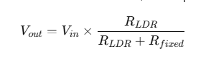

**Components;**

**Water Pump\** **Hydration valve:**

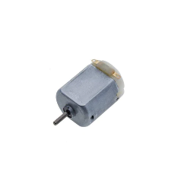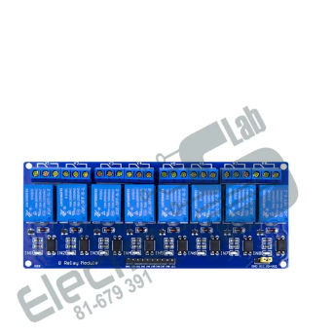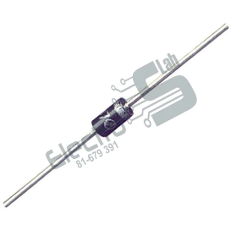

DC Motor Relay Diode

**Water levels:**

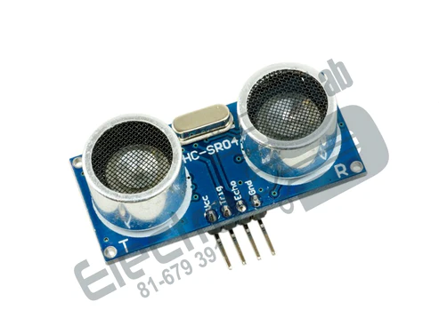

Ultrasonic Sensor

**Temperate and Humidity Sensors:**

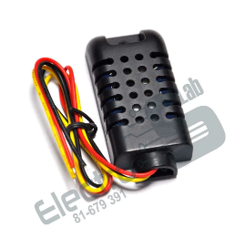 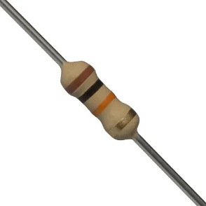

DHT21/AM2301 Resistor 10k

**Day\Night Modes:**

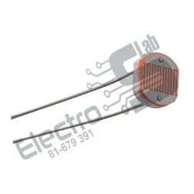 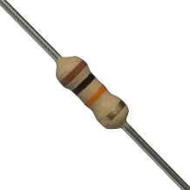

LDR Resistor 10k