**Lab 1 – I3350**

In this lab, we want to develop a simple application that allows you to copy the text written in an EditText into a TextView once the Copy button is selected (see the two figures below).

|  |  |
| --- | --- |
|  |  |

Fig 5

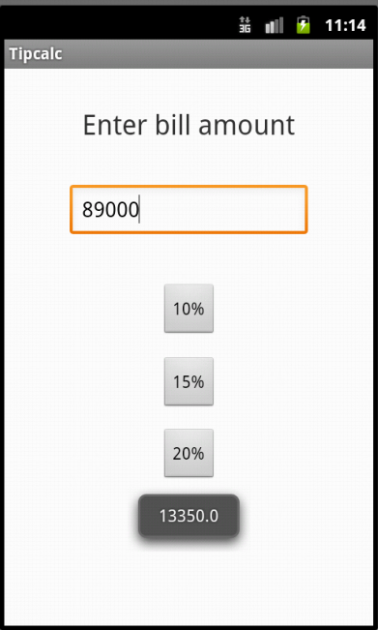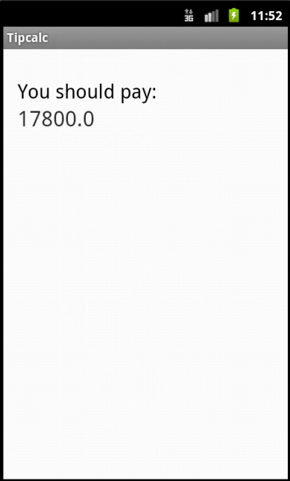

Fig 3

Fig 2

Fig 1

Fig 5

Fig 4

Fig 4