**TP 2_2 – I3305**

We want to develop a simple mobile application to calculate the BMI or the Body Mass Index (BMI) as shown in the figure. The BMI is calculated according to the following formula:

|  |  |  |  |
| --- | --- | --- | --- |
| BMI = | |  | | --- | | m | | h2 | |

Where m is the body weight in kg and h is the person's height in meters (*kg / m2*).

If the BMI value is less than 18.5, the person is considered thin, 18.5 to 25 as ideal weight, and greater than 25 as overweight.

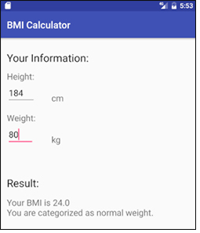

Fig 5

Fig 5

Fig 4

Fig 4

Note: In this lab, add also a button on the ui when clicked the calculation is done.