BookingAPP — Assignment #2
Allazhar — Navigation & Header Layout (Flexbox) + Deployment Lead
Dias — Card Layouts & Page Grid Structure (booking.html, hotel-detail.html)
Abylai — Image Gallery (Grid) & Report Lead
Live Website: https://aishhko.vercel.app/
Project Objective
Extend our Assignment 1 booking platform with modern CSS layout techniques — Flexbox and CSS Grid — to build a fully responsive, framework-free multi-page website.
Step-by-Step Description of Implementation
Step 1: Flexbox Navigation (Task 1)
- Turned #main-header into a flex container (display: flex; justify-content: space-between; align-items: center).
- Logo placed on the left, nav links on the right, vertically centered.
- .nav-menu ul set to display: flex; gap: 1.5rem for even spacing between links.
- Applied consistently across all six pages.
Step 2: Flexbox Cards (Task 2)
- Destination/hotel cards wrapped in a flex container (display: flex; gap: 1.5rem; flex-wrap: wrap).
- Each card uses flex: 1 for equal width/height.
- Added a hover effect (transform: translateY(-5px); box-shadow on hover) for lift feedback.
Step 3: CSS Grid Page Layout (Task 3)
- Main content areas restructured with display: grid and grid-template-areas defining header, sidebar, main content, and footer.
- Sidebar placed via grid-area: sidebar, main content via grid-area: main.
- Verified all sections render correctly in their assigned grid areas.
Step 4: Image Gallery (Task 4)
- Built a 9-image gallery using display: grid; grid-template-columns: repeat(3, 1fr); gap: 1rem.
- Added a hover caption overlay (opacity: 0 → 1 transition) showing image captions on hover.
Step 5: Testing & Deployment (Part 4)
- Verified layouts across breakpoints, confirmed no overlapping grid/flex elements.
- Committed and pushed all changes to the shared GitHub repository.
- Redeployed via GitHub Pages/Vercel; live URL verified working.
Page Screenshots & Feature Breakdown
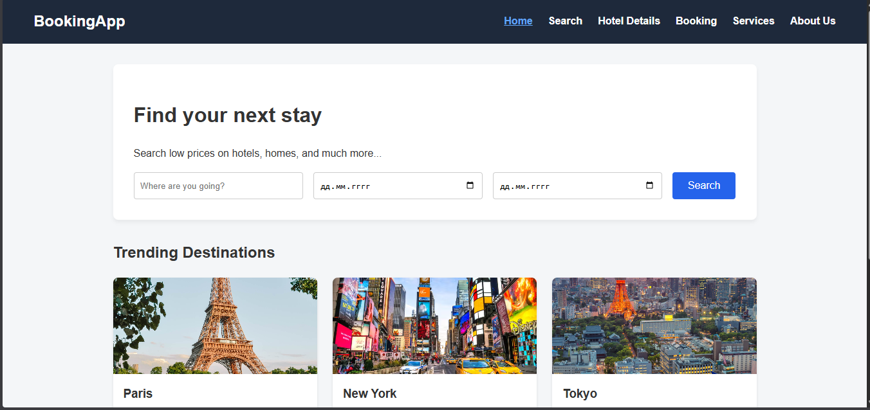 Flexbox navbar, flex destination cards.
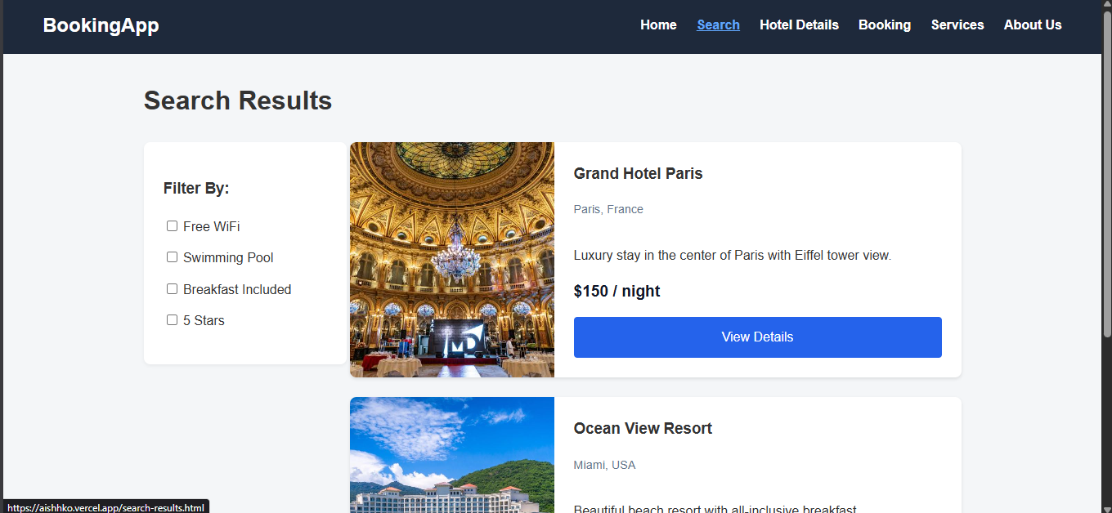Grid layout (sidebar + results).
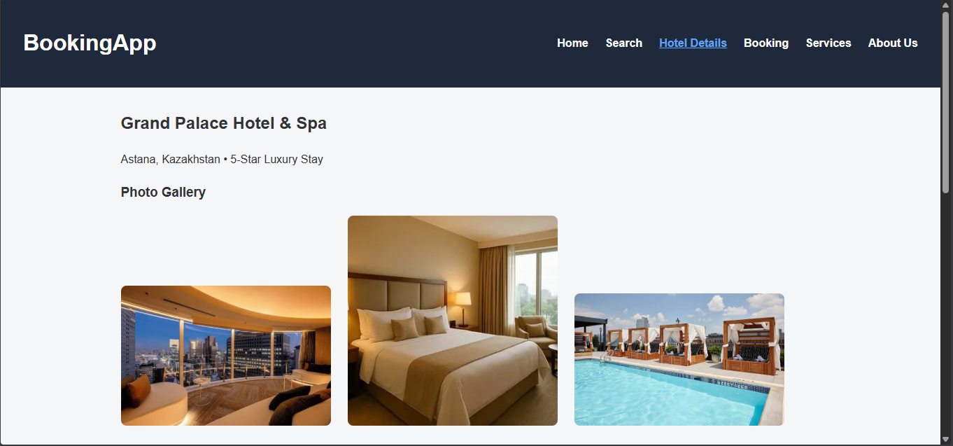Grid page structure, flex action box.
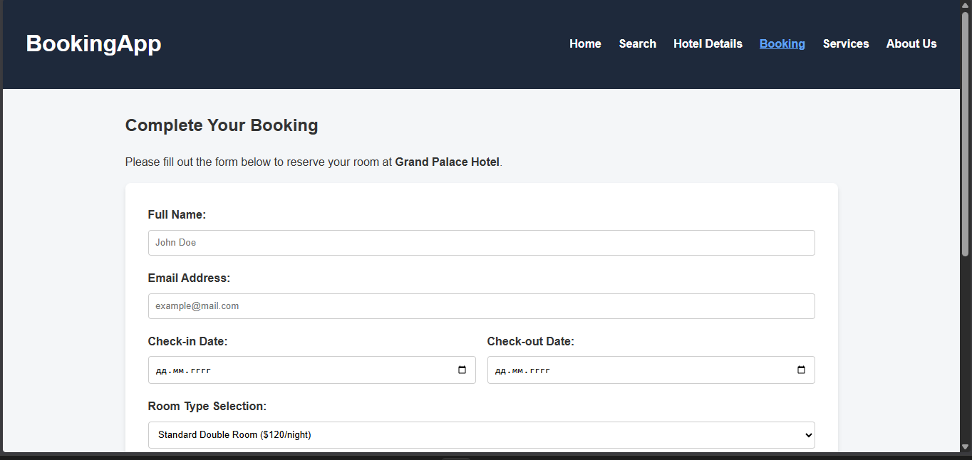Flexbox nav, flex form rows.
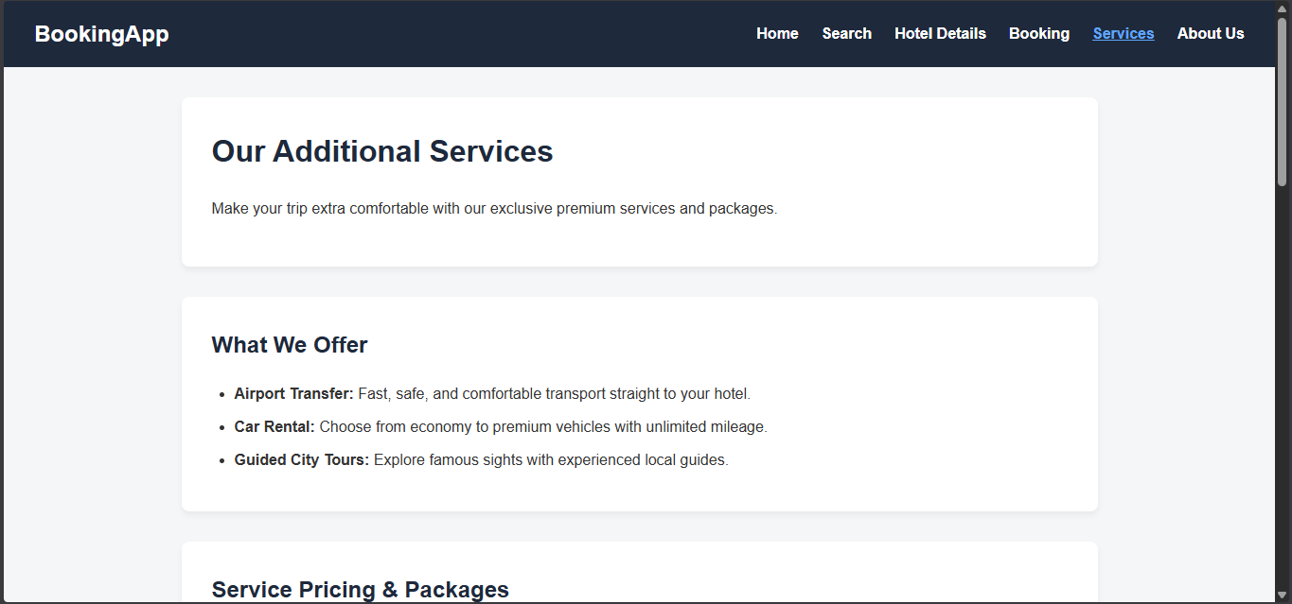Flexbox nav, grid content sections.
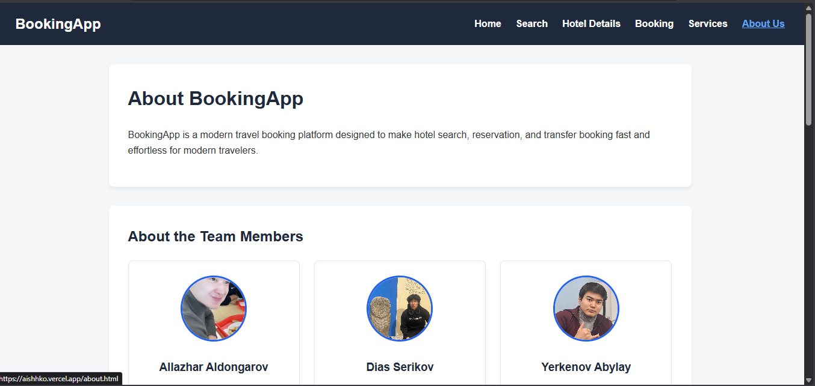 Grid image gallery with hover captions.
Demonstration of Flexbox & Grid Properties
css
#main-header {
display: flex;
justify-content: space-between;
align-items: center;
}
css
.card-row {
display: flex;
gap: 1.5rem;
}
css
.page-layout {
display: grid;
grid-template-areas:
"header header"
"sidebar main"
"footer footer";
}
css
.gallery-grid {
display: grid;
grid-template-columns: repeat(3, 1fr);
gap: 1rem;
}
Reflection
Through this assignment, our team gained practical experience applying Flexbox for component-level alignment and CSS Grid for full-page layout structure. We learned to combine both systems to build a fully responsive site without floats or frameworks, strengthening our understanding of modern layout workflows and reinforcing our Git/deployment practices.

