<https://www.mathworks.com/help/supportpkg/beagleboneio/ug/beaglebone-black-pin-map.htm>

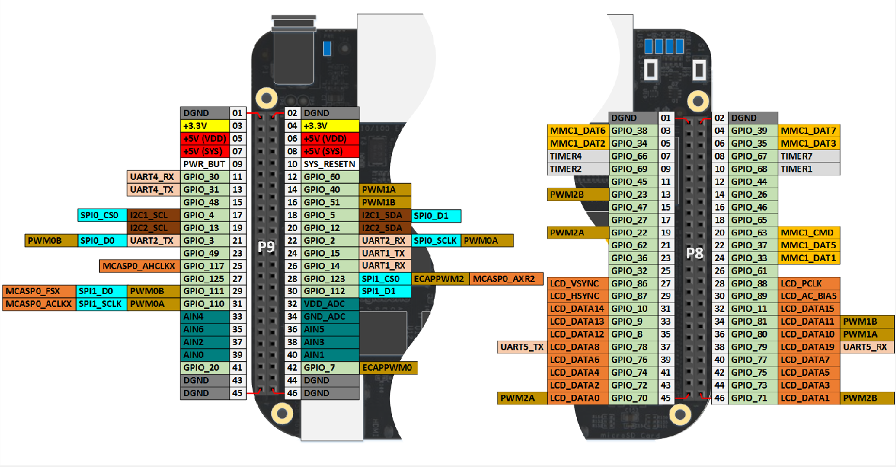

Pin Mapping Usage Types:

* GPIO : General Purpose Input Output
  + no pre-assigned role == can be customized to user purposes
  + binary IO, High at 3.3V, Low at 0V
* AIN : Analog INput
  + always enabled
  + Analog to Digital Conversion
  + input only
  + see manufacturer info for sampling rate and max discrete levels
* PWM : Pulse Width Modulation
  + output only
  + pseudo-analog output
* UART : Universal Asynchronus Receiver/Transmitter
  + IO
  + transmits serial data, one bit at a time i.e. 0→1→1→0, not 01→10
  + has dedicated circuitry
  + pins used in pairs, one transmits, one receives
  + transmits data in packets
  + asynchronus, UART hardware sends its own start-stop signals independent of clock
* SPI : Serial Peripheral Interface
  + synchronous
  + full duplex
  + master-slave based
    - device that generates the clock signal is master, other is slave
    - only one master, any number of slaves
  + master and slave can transmit at same time
  + 3-wire or 4-wire interface
    - 4-wire signals: clock, chip select, master-out slave-in, master-in slave-out
  + chip select
    - signal from master is used to select slave
    - normally active low signal, and pulled high to disconnect slave
* I2C : Inter-Integrated Circuit
  + uses 2 wires
  + any number of masters and slaves
    - masters can’t talk to each other, must take turns using bus lines

Pin IO Voltage and Current

* Max input: V = _ V, I = 8 mA
* Min input: V = _ V, I = _ mA
* Max output: V = 3.3 V, I = 4-6 mA
* Min output: V = _ V, I = _ mA
* Motor feedback:  
  Vout = 4.3-5V  
  Iout = 6 mA  
  Rneeded = 725-850 Ohm