# Declaration

This is to certify that the work being presented in the project entitled “ONLINE VOTING SYSTEM” submitted by undersigned student of Third Year B.SC in COMPUTER SCIENCE in partial fulfillment for award of degree of Bachelor of Science {Computer Science} is a record of my own work carried out by me under guidance and supervision of Prof. Pang’ of the Department of Computer Science and that this work has not submitted elsewhere for award of any other degree.

**Name of student: ____________________________________________**

**Registration Number: _____________________________________**

**Sign: __________________________________________**

# APPROVAL

This project was done and presented by me before the panel concerned on the 2nd May 2012 at Masinde Muliro University of Science and Technology with my approval and that of my supervisor Prof. Pang’

Name of Student: ______________________________________________

Registration Number: ____________________________________________

Signature: ______________________________________________________

Name Supervisor: **Professor Pang’**

Signature: ____________________

# DEDICATION

All the work done in coming up with this system is dedicated to my family for being with/part of me in the whole process especially my dear dad and mum who stood by me in all situations even at the times of financial need.

# ACKNOWLEDGEMENT

The satisfaction that accompanies that the successful completion of any task would be incomplete without the mention of people whose ceaseless cooperation made it possible, whose constant guidance and encouragement crown all efforts with success.

I am very grateful to my project supervisor Prof. Pang’ for the guidance, inspiration and constructive suggestions that helpful me in the preparation of this project. I won’t forget to also mention my course mates; Abed Sindani and Simon Muthusi for their wonderful and skillful guidance in assisting me with the necessary support to ensure that my project is a success. I also thank my parents and family at large for their moral and financial support in funding the project to ensure successful completion of the project.

Table of Contents

Declaration i

APPROVAL ii

DEDICATION iii

ACKNOWLEDGEMENT iv

ABSTRACT vii

DEFINITION OF TERMS viii

EXECUTIVE SUMMARY ix

1.0 CHAPTER ONE 1

1.1 INTRODUCTION 1

1.1.1 BACKGROUND OF STUDY 1

1.2 Problem definition 4

1.3 SIGNIFICANCE OF STUDY 4

1.4 Objectives of the project 5

1.5 Project justification 5

1.6 SCOPE OF STUDY 6

1.7 LIMITATION OF STUDY 6

2.0 CHAPTER TWO 7

2.1 Literature Review 7

2.1.1 THE SECURITY ISSUES OF ONLINE VOTING 9

3.0 CHAPTER THREE 11

3.1 RESEARCH METHODOLOGY 11

3.1.1 System Study 11

3.1.1.1 Description of the Existing Voter Registration System 11

3.1.1.2 Problems with the Existing Voter Registration System 12

3.1.2 System Implementation Technologies 13

3.1.2.1 SOFTWARE 13

3.1.2.2 HARDWARE 14

3.2 SYSTEM DESIGN 14

3.2.1 THE LOGIN FLOWCHART 14

3.2.2 DATABASE DESIGN 19

Table structure for table registrationdetails 19

Table structure for table vote 20

4.0 CHAPTER FOUR 21

4.1 SYSTEM SPECIFICATION AND DESIGN 21

4.1.1 Specifications 21

4.1.1.1 User Requirements for the Proposed System 21

4.1.2 REQUIREMENT SPECIFICATION 21

4.1.3 Functional Requirements 21

4.2 SYSTEM LOGIN 22

5.0 CHAPTER FIVE 23

5.1 IMPLEMENTATION OF THE SYSTEM 23

5.1.1 Form input and Reports Design 23

5.1.2 The login form 23

5.1.3 The voter registration form 24

5.2 System Modules and Components 25

5.2.1 Shortcomings with the System 25

5.3 Testing and validation 25

6.0 CHAPER SIX 26

6.1 CONCLUSION 26

6.2 RECOMMENDATIONS 26

APPENDIX 27

PROJECT SCHEDULE 27

PROJECT BUDGET 28

REFERENCES 29

# ABSTRACT

The word “vote” means to choose from a list, to elect or to determine. The main goal of voting (in a scenario involving the citizens of a given country) is to come up with leaders of the people’s choice.

Most countries, Kenya not an exception have problems when it comes to voting. Some of the problems involved include ridging votes during election, insecure or inaccessible polling stations, inadequate polling materials and also inexperienced personnel.

This online voting/polling system seeks to address the above issues. It should be noted that with this system in place, the users, citizens in this case shall be given ample time during the voting period. They shall also be trained on how to vote online before the election time.

# DEFINITION OF TERMS

IEBC - Independent Electoral and Boundaries Commission

OVS - Online Voting System

# EXECUTIVE SUMMARY

“ONLINE VOTING SYSTEM” is an online voting technique. In this system people who have citizenship of Kenya and whose age is above 18 years of age and any sex can give his\her vote online without going to any physical polling station. There is a database which is maintained by the Independent Electoral and Boundaries Commission of Kenya (IEBC) in which all the names of voters with complete information is stored.

In “ONLINE VOTING SYSTEM” a voter can use his\her voting right online without any difficulty. He\She has to be registered first for him/her to vote. Registration is mainly done by the system administrator for security reasons. The system Administrator registers the voters on a special site of the system visited by him only by simply filling a registration form to register voter. Citizens seeking registration are expected to contact the system administrator to submit their details. After the validity of them being citizens of Kenya has been confirmed by the system administrator by comparing their details submitted with those in existing databases such as those as the Registrar of Persons, the citizen is then registered by the IEBC as a voter.

After registration, the voter is assigned a secret Username and Password with which he/she can use to log into the system and enjoy services provided by the system such as voting, checking results among others. If invalid/wrong details are submitted, then the citizen is not registered to vote.

1.0 CHAPTER ONE

## 1.1 INTRODUCTION

## 1.1.1 BACKGROUND OF STUDY

The republic of Kenya comprises of eight (8) provinces now forty-seven counties. The country is located in East Africa and shares land borders with the Republics of Somalia in the East, Uganda in the West, Tanzania in the South and Ethiopia and Sudan (now South Sudan) in the North. The three largest and most influential ethnic groups in Kenya are the kikuyu, Luhya, and Kalenjins. In terms of religion Kenya is roughly split into 80% Christians while the rest are Muslims.

In Kenya, general elections are carried out every after five years where a head of state the President and The National Assembly representatives are elected. They are elected by the people. The national Assembly has about 220 members representing respective constituencies.

In the Local Governments they have the chairman and the Counselor. The counselors are all elected by the people of the state in the respective wards.

That is to say, in any given general elections, Kenyans vote for the president, the members of the National Assembly and the counselors.

Most African Electoral bodies IEBC not an exception right from their inception to date, even with latest advancements in technology, still use a primitive paper based methods during voting; this system is characterized by manual form filling to chose leaders and transfer of the information from manual data capture forms to computerized datasheets, this has led to an excessive number of mistakes making their way into the final vote counts hence leading to confusion at the time of announcing the results. The main advantage of paper-based systems is that ballot papers are easily human auditable. The disadvantages outweigh the advantages for instance the need to print ballot papers is a slow, expensive, inflexible, environmentally hostile process, visual impairments, or literacy limitations and also last minute changes to the voter register are difficult to accommodate among others.

Over the last few years, there have been a number of election observers who have suggested electoral organizations should introduce electronic voting at State and Local Government election processes. A general observation is that as more business is done using electronic mediums, it should not be difficult to carry out voting using electronic equipment rather than turning up at the polling place on voting day to use paper and pen. The Online Voting System (OVS) under implementation mainly addresses the voting phase. Electronic voting using the OVS should be cheaper than the present paper based arrangement of Kenyan Electoral Commission (IEBC). The phenomenal use of the Internet as a vehicle for improving communication, access to information and electronic commerce has led to the claim that the Internet could be used as either a replacement to attendance voting or as an additional voting option.

Throughout history, election fraud has occurred in many electoral processes from which experience shows that the manual voting process is a major source of such vices and violence in many democratic countries, a case in point is the Kenyan Electoral Commission (IEBC) that has on several occasions failed to update the Kenyan national voters’ register in time before the voting date. For instance, the register that was used for the Multi-Party elections in 1992 was used for the 1997 Presidential and Parliamentary elections, the 2002 National elections, 2005 referendum and 2007 Presidential Elections which led to disputation. This did not prevent unregistered voters from getting voters’ cards thus making rigging easier and undermining the credibility of elections. The mechanism leading to fraud is manifested in registration places by corrupt officials on local commissions who are in a position to issue voter registration data capture forms to illegitimate individuals, stuff ballot boxes, invalidate registration for opposition voters or even coerce voters. Domestic and international observers reported serious irregularities in the Kenyan elections in December 2007; they observed that across the country, election officers denied possibly hundreds or thousands of registered voters the right to vote because they were allegedly not on the Voters’ register. This is evidently a result of poor techniques applied in registration, updating and displaying of voters’ register by the IEBC and therefore there is need to further fine tune both the registering and voting process to minimize incidences of “missing names” on the registers and canvassing of votes during voting.

The Online voting system (OVS) also known as e-voting is a term encompassing several different types of voting embracing both electronic means of counting votes. Electronic voting technology can include punched cards, optical scan voting systems and specialized voting kiosks (including self contained direct-recording electronic voting systems or DRE). It can also involve transmission of ballots and votes via telephones, private computer networks, or the internet.

Online voting is an electronic way of choosing leaders via a web driven application. The advantage of online voting over the common “queue method” is that the voters have the choice of voting at their own free time and there is reduced congestion. It also minimizes on errors of vote counting. The individual votes are submitted in a database which can be queried to find out who of the aspirants for a given post has the highest number of votes.

This system is geared towards increasing the voting percentage in Kenya since it has been noted that with the old voting method {the Queue System}, the voter turnout has been a wanting case. With system in place also, if high security is applied, cases of false votes shall be reduced.

With the “ONLINE VOTING SYSTEM”, a voter can use his\her voting right online without any difficulty. He\She has to register as a voter first before being authorized to vote. The registration should be done prior to the voting date to enable data update in the database.

However, not just anybody can vote. For one to participate in the elections, he/she must have the requirements. For instance, he/she must be a registered citizen i.e. must be 18 and above years old. As already stated, the project ‘Online Voting' provides means for fast and convenient voting and access to this system is limited only to registered voters.

This project done by Mayinje Nandasaba Wilson, a student at Masinde Muliro University of Science and Technology is geared towards addressing problems encompassing manual voting systems that have been in place ever since independence.

Internet voting systems are appealing for several reasons which include; People are getting more used to work with computers to do all sorts of things, namely sensitive operations such as shopping and home banking and they allow people to vote far from where they usually live, helping to reduce absenteeism rate.

## 1.2 Problem definition

The voting/polling process by registered voters in Kenya is very cumbersome. So many cases of missing data in the voter registration files have been reported. There are also scenarios where unregistered voters flock in the polling centers as “Dead Voters” to participate in the voting process. Even after voting, malicious clerks and officers-in-charge of a polling station end up playing with the results figures. This results in the release of wrong results leading to cases of post election violence such as the one that happened in early 2008 in Kenya.

Such cases can be solved by insisting on voters exercising that task online using the OVS-KENYA. The voters can also vote from anywhere around the globe, they don’t need to travel back to Kenya during election time in case they are abroad.

## 1.3 SIGNIFICANCE OF STUDY

The main purposes of OVS include:

* Provision of improved voting services to the voters through fast, timely and convenient voting.
* Reduction of the costs incurred by the Kenyan Electoral Commission during voting time in paying the very many clerks employed for the sake of the success of the manual system.
* Check to ensure that the members who are registered are the only ones to vote. Cases of “Dead People” voting are also minimized.
* Online voting system (OVS) will require being very precise or cost cutting to produce an effective election management system.
* Therefore crucial points that this (OVS) emphasizes on are listed below.

1. Require less number of staff during the election.
2. This system is a lot easier to independently moderate the elections and subsequently reinforce its transparency and fairness.
3. Less capital, less effort, and less labor intensive, as the primary cost and effort will focus primarily on creating, managing, and running a secure online portal.
4. Increased number of voters as individual will find it easier and more convenient to vote, especially those abroad.

## 1.4 Objectives of the project

The specific objectives of the project include:

* Reviewing the existing/current voting process or approach in Kenya;
* Coming up with an automated voting system in Kenya;
* Implementing a an automated/online voting system;
* Validating the system to ensure that only legible voters are allowed to vote.

## 1.5 Project justification

The ONLINE VOTING SYSTEM-KENYA shall reduce the time spend making long queues at the polling stations during voting. It shall also enable the voters to vote from any part of the globe as explained since this is an online application available on the internet. Cases of vote miscounts shall also be solved since at the backend of this system resides a well developed database using MYSQL that can provide the correct data once it’s correctly queried. Since the voting process shall be open as early as possible, the voters shall have ample time to decide when and whom to vote for.

## 1.6 SCOPE OF STUDY

It is focused on studying the existing system of voting in Kenya and to make sure that the peoples vote is counts, for fairness in the elective positions. This is also will produce:

* Less effort and less labor intensive, as the primary cost and focus primary on creating, managing, and running a secure web voting portal.
* Increasing number of voters as individuals will find it easier and more convenient to vote, especially those abroad.

## 1.7 LIMITATION OF STUDY

Time factor was the greatest barrier to the successful completion of this exercise since it had to be done within the semester. I also had financial constraints since all the activities involved were self-sponsored.

# 2.0 CHAPTER TWO

## 2.1 Literature Review

All computer scientists who have done work in or are interested in electronic voting seem to agree that online voting does not meet the requirements for public elections and that the current widely-deployed voting systems need improvement.

Voting on the Internet has disadvantages based on the areas of secrecy and protection against coercion and/or vote selling. It's such a truly bad idea that there seems to be no credible academic effort to deploy it at all. The Kenyan General elections of 2007 brought national attention to problems with current methods of casting and counting votes in public elections. Most people believe that the current system should be changed; there is much disagreement on how such changes should be made.

Kenyans in the Diaspora have begun signing a petition in a fresh attempt to force the electoral body to allow them vote online in the next General Election. They advocate using the OVS since it reduces cases of uncounted, unmarked, and spoiled ballots and the cost of travelling to cited polling stations. They are opposed to the use of High Commissions and embassies as polling stations and embassy officials as returning officers. The IEBC has in the past recommended that Kenyans abroad vote at the embassies and consulates closest to them. In the US, for example, Kenyans are expected to vote in Los Angeles and New York. Their report even proposes a framework for a new voting system with a decentralized, modular design.

Other researchers have done work in electronic voting; while they may not explicitly mention voting from remote poll sites, their work is nonetheless relevant to any effort at designing or implementing a remote poll site voting system. Lorrie Cranor acknowledges the problems inherent in each kind of voting apparatus, but doesn't make an overt recommendation on her site for one technology over the rest. Some other academicians like Peter Neumann focus on the immensity of the problem one faces when trying to design and implement a truly secure voting system. They often remind us of Ken Thompson's Turing acceptance speech and the fact that we really can't trust any code which we did not create ourselves. Therefore, they tend to be extremely suspicious of proprietary voting machines and their makers who insist that we should “just trust [them].”

Neumann gives a list of suggestions for "generic voting criteria" which suggests that a voting system should be so hard to tamper with and so resistant to failure that no commercial system is likely to ever meet the requirements, and developing a suitable custom system would be extremely difficult and prohibitively expensive.

A voting machine must produce human-readable hardcopy paper results, which can be verified by the voter before the vote is cast, and manually recounted later if necessary.

David Chaum presents a very interesting scheme, whereby voters could get receipts for their votes. This receipt would allow them to know if their votes were included in the final tally or not, and to prove that they voted without revealing any information about how they voted. The security of this scheme depends on visual cryptography developed by Naor and Shamir, and on voters randomly choosing one of two pieces of paper. Mercuri and Neumann advocate the use of this technique in electronic voting systems.

In the recent years, voting equipments which were widely adopted in many countries may be divided into five types

1. **Paper-based voting**: The voter gets a blank ballot and use a pen or a marker to indicate he want to vote for which candidate. Hand-counted ballots is a time and labor consuming process, but it is easy to manufacture paper ballots and the ballots can be retained for verifying, this type is still the most common way to vote.
2. **Lever voting machine**: Lever machine is peculiar equipment, and each lever is assigned for a corresponding candidate. The voter pulls the lever to poll for his favorite candidate. This kind of voting machine can count up the ballots automatically. Because its interface is not user-friendly enough, giving some training to voters is necessary.
3. **Direct recording electronic voting machine**: This type, which is abbreviated to DRE, integrates with keyboard; touch screen, or buttons for the voter press to poll. Some of them lay in voting records and counting the votes is very quickly. But the other DRE without keep voting records are doubted about its accuracy.
4. **Punch card**: The voter uses metallic hole-punch to punch a hole on the blank ballot. It can count votes automatically, but if the voter’s perforation is incomplete, the result is probably determined wrongfully.
5. **Optical voting machine**: After each voter fills a circle correspond to their favorite candidate on the blank ballot, this machine selects the darkest mark on each ballot for the vote then computes the total result. This kind of machine counts up ballots rapidly. However, if the voter fills over the circle, it will lead to the error result of optical-scan.

Recent years, a considerable number of countries has adopted E-voting for their official elections. These countries include; America, Belgium, Japan and Brazil.

## 2.1.1 THE SECURITY ISSUES OF ONLINE VOTING

Foreign experience revealed that they are often confronted by security issues while the online voting system is running. The origin of the security issues was due to not only outsider (such as voters and attackers) but also insider (such as system developers and administrators), even just because the inheritance of some objects in the source code are unsuitable. These errors caused the voting system to crash.

The proposed solutions were correspondingly outlined to hold back these attacks. For example, to avoid hacker making incursion into the voting system via network, we can design our system to transmit data without network. Another example is to limit voter to input particular data, so that we can prevent the command injection from running

# 3.0 CHAPTER THREE

## 3.1 RESEARCH METHODOLOGY

In this chapter, the source of data methods of collection, the evaluation of the existing system and the organization structure of the system problem are presented. It includes specific methods which were used in order to achieve the objectives of the project, particular requirements for implementation of the project and a brief explanation of why such methods were used for implementing the proposed system, also included is a brief description of the current system of voting.

## 3.1.1 System Study

This section explores the current voting system and problems associated with it.

## 3.1.1.1 Description of the Existing Voter Registration System

The existing system of voting is highly manual; the IEBC has a laid out data capture form that is used to register residents in their areas. A Period for registration is set to start and end on a particular day, such a period is announced to the public using the various mass communication medium including newspapers and radio. During such a period potential voters are expected to report to these officers in order to be registered using paper and pen. Every potential voter fills out a form with details such as location, date of birth among others; such an individual must be verified to be residents of that particular area.

The IEBC officers collect filled in Data capture forms from officials at the end of the registration period to be taken to the central IEBC offices where data entry clerks are then employed to do entry into the central database from which a voter register is produced. At the end of this process, voters are registration cards are produced to be issued to voters.

## 3.1.1.2 Problems with the Existing Voter Registration System

The problems of the existing manual system of voting include among others the following:

1. Expensive and Time consuming: The process of collecting data and entering this data into the database takes too much time and is expensive to conduct, for example, time and money is spent in printing data capture forms, in preparing registration stations together with human resources, and there after advertising the days set for registration process including sensitizing voters on the need for registration, as well as time spent on entering this data to the database.
2. Too much paper work: The process involves too much paper work and paper storage which is difficult as papers become bulky with the population size.
3. Errors during data entry: Errors are part of all human beings; it is very unlikely for humans to be 100 percent efficient in data entry.
4. Loss of registration forms: Some times, registration forms get lost after being filled in with voters’ details, in most cases these are difficult to follow-up and therefore many remain unregistered even though they are voting age nationals and interested in exercising their right to vote.
5. Short time provided to view the voter register: This is a very big problem since not all people have free time during the given short period of time to check and update the voter register.
6. Above all, a number of voters end up being locked out from voting.

Hence there is great desire to reduce official procedure in the current voter registration process if the general electoral process is to improve.

## 3.1.2 System Implementation Technologies

The web-based OVR was developed as an online information system to offer users convenient access to the voter register. Several tools used during implementation include the following:

## 3.1.2.1 SOFTWARE

1. **MYSQL DBMS-**it allows combination, extraction, manipulation and organization of data in the voters’ database. It is platform independent and therefore can be implemented and used across several such as Windows, Linux server and is compatible with various hardware mainframes. It is fast in performance, stable and provides business value at a low cost.
2. **HTML -Hypertext Markup Language-**This is currently the core of the web world, it is a language used to makeup web page. It is the glue that holds everything together. Although HTLM was used for the implementation of the OVS, it is highly compatible with eXtensible HTML (XHTML) which is designed to be a replacement of HTML made to handle data and is also portable between different browsers and platforms with little or no alterations in code. Macromedia Dreamweaver is a prefer tool for designing HTML pages and that is the tool used in coming up with this OVS system.
3. **PHP coding-**This is for advanced user who find PHP codes easy to work with.
4. **Testing** is done via WAMPSERVER.
5. **Web browsers**: Mozilla Firefox, Google chrome, Opera and Internet Explorer
6. **Reporting Tool** i.e. through Data Report.

## 3.1.2.2 HARDWARE

Desktop or laptop with at least 2.0 GHz Processor speed, At least 40 GB Hard Disk Capacity and 512 RAM and Printer.

## 3.2 SYSTEM DESIGN

## 3.2.1 THE LOGIN FLOWCHART

LOGIN

HOME PAGE

ABOUT US

ONLINE SUPPORT

FAQS

CONTACT US

VOTE

RESULTS

REGISTER

DOWNLOADS

VIEW REGISTERED VOTERS

Note that for one to experience the system administrator’s privilege, he/she must login as the system admin with the admnin’s password and username which is kept secret/confidential at all costs

At the first visit of the OVS site, the user interacts with the system via the interface below.

1. **First page a user interacts with.**



He or she is required to be a registered user of the system possessing a valid username and password. These requirements enable him/her to log in and carry out tasks as per the privileges granted to him or her.

On logging into the system, the user is automatically taken to the home page shown below. At the home page, the user is able to briefly learn about the OVS.

1. **Home page**



Each user once logged in, it means you are a legitimate user of the system. You are therefore given the privilege to visit the voting page where you are introduced to the aspirants for a given post before casting your vote. Note that, if you have already voted you cannot vote again. The interface for the voting page is as shown below.

1. **Voting page**

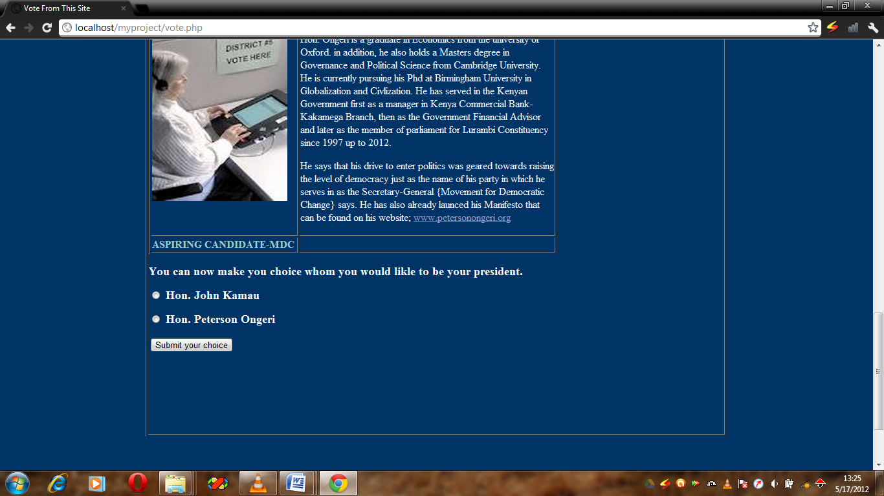

After voting, a voter is allowed to check the results by visiting the results page shown below.

1. **Results page**



The task of voter registration is strictly preserved for the system administrator. Therefore if you are logged in as a mere user/voter, you don’t have this privilege, therefore, the registration page link is disabled for you.

1. **Voter registration page**



The system administrator can view a list of registered voters by clicking on the **view registered voters** link.

1. **Registered voters.**

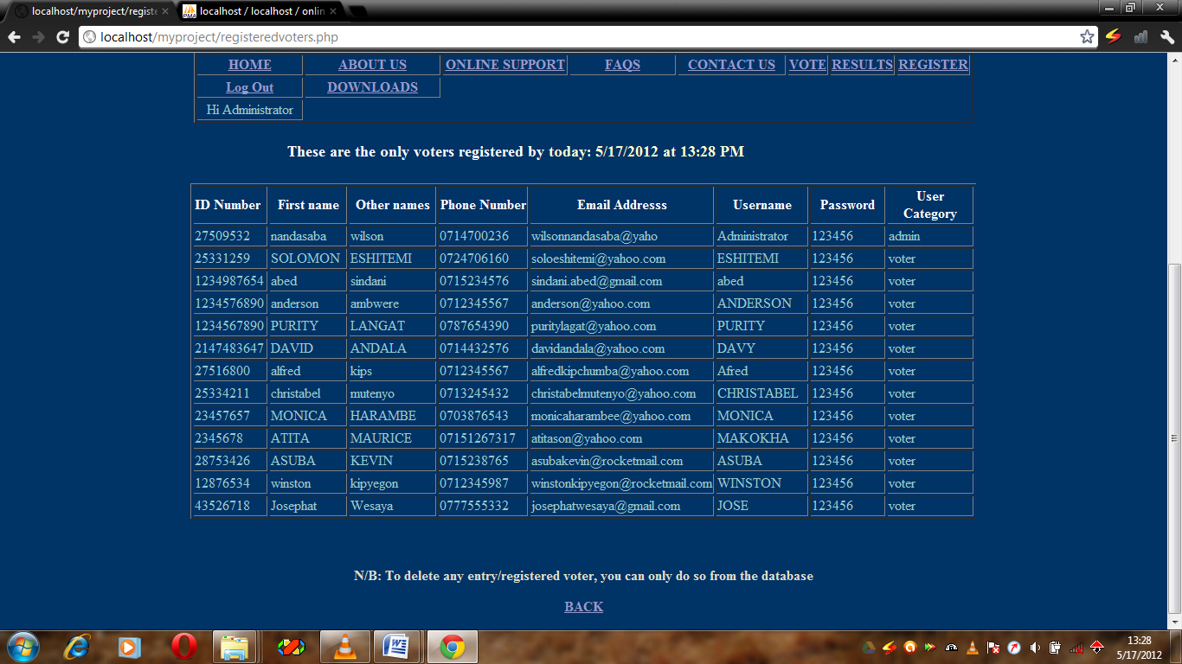

These are just but a few of the important sites of the OVS. Others include the **about us, contact us, online support system, downloads** e.t.c.

## 3.2.2 DATABASE DESIGN

The OVS uses a database called Online_Voting comprising of two tables as illustrated below;

**Database Online_Voting**

1. **Registrationdetails table-**the table holds records of registered users/voters with their respective preferred usernames and passwords. It also has the contacts {phone numbers, and email address} of voters/users.

## Table structure for table registrationdetails

|  |  |  |  |
| --- | --- | --- | --- |
| **Field** | **Type** | **Null** | **Default** |
| ***IdNo*** | int(10) | No |  |
| Fname | varchar(15) | No |  |
| Othername | varchar(15) | No |  |
| PhoneNo | varchar(15) | No |  |
| Email | varchar(50) | No |  |
| Username | varchar(15) | No |  |
| Password | varchar(20) | No |  |
| User | varchar(40) | No | Voter |

This same table is used by the user to get the username and password for logging in.

1. **Vote table-**That holds records of the candidate, and the voter who casts a vote in favor of the candidate. Its primary key is the *id* field which is also necessary during vote counting. The database is queried to find out how many voters casts their votes for a given contestant.

## Table structure for table vote

|  |  |  |  |
| --- | --- | --- | --- |
| **Field** | **Type** | **Null** | **Default** |
| candidate | varchar(25) | No |  |
| voter | varchar(15) | No |  |
| ***id*** | int(8) | No |  |
|  |  |  |  |

# 4.0 CHAPTER FOUR

## 4.1 SYSTEM SPECIFICATION AND DESIGN

# 4.1.1 Specifications

## 4.1.1.1 User Requirements for the Proposed System

The OVS should:

1. Be able to display all registered voters in the database to the SYSTEM ADMIN(s) as per their access rights and privileges.
2. Have a user-friendly interface and user guides understandable by people of average computer skills.
3. Be robust enough so that users do not corrupt it in the event of voting.
4. Be able to handle multiple users at the same time and with the same efficiency, this will cater for the large and ever growing population of voters.

## 4.1.2 REQUIREMENT SPECIFICATION

A system should meet the following requirements for it to run the OVS:

1. Web browsers: Mozilla Firefox, Google chrome, Opera and Internet Explorer, MYSQL DBMS, WampServer, Macromedia Dreamweaver 8, Programming language such as JAVA and XML
2. Windows OS Xp, Windows Vista or Windows 7. At least 2.0 GHz Processor speed, At least 40 GB Hard Disk Capacity and 512 RAM

## 4.1.3 Functional Requirements

1. Secure storage and retrieval of voters’ details from the database.
2. Enable secure login of voters, that is to say non- legitimate voters should never be allowed to login to the tool, these include the under aged and non nationals.
3. Maintaining and manipulating records in database through functions like edit, delete, and view.
4. Validate and verify input and output data.

## 4.2 SYSTEM LOGIN

As already stated, to login into the system, one has to have a valid username and password. It has also been noted that there are absolutely different privileges for the voter and the system administrator.

At the first visit of the system, the voter/admin interacts with the login page where he/she is required to provide a valid username and password in order to login. Once logged in, then the voter/user is allowed to perform activities such as voting, viewing results and voter registration as per the privileges.

# 5.0 CHAPTER FIVE

## 5.1 IMPLEMENTATION OF THE SYSTEM

This chapter gives an overview of the implementation and explains how users can navigate through the newly developed tool in order to use it easily.

## 5.1.1 Form input and Reports Design

The system was developed as an interactive mechanism between the user at the interface and the database using the web-browser. This tool enables a user through a web browser to interact with the MYSQL database to enter, edit, view and retrieve such data as per the privileges granted. These activities were achieved using Java servlets. HTML forms offer the best layout to enter data, change and view the database. These forms were also kept as short and simple as possible for easy public awareness on the use of the tool, some of the forms and report interfaces created include the following:

## 5.1.2 The login form

|  |  |  |  |  |  |  |
| --- | --- | --- | --- | --- | --- | --- |
| Top of Form  **PLEASE LOG IN HERE BY ENTERING YOUR USERNAME AND PASSWORD CORRECTLY:**   |  |  | | --- | --- | | **USERNAME:** | ***\**** | | **PASSWORD** | **\*** | |  |  |   Fields marked by * must be filled correctly.  Bottom of Form |

This is where a new user/voter starts; the individual is required to provide a username and password. When this is provided the system validates the user if the entered information tallies with what is in the database. He/she is then logged in otherwise the voter/user isn’t logged in.

## 5.1.3 The voter registration form

|  |  |  |  |  |  |  |  |  |  |  |  |  |  |  |  |  |  |  |
| --- | --- | --- | --- | --- | --- | --- | --- | --- | --- | --- | --- | --- | --- | --- | --- | --- | --- | --- |
| Top of Form  **Please note that for one to be able to use this online system in voting, you must be a registered voter. If he/she is not registered, please register him/her by filling in the form below:**   |  |  | | --- | --- | | First Name: | * | | Other Name: | * | | ID Number: | * | | Phone Number: | * | | Email Address: | * | | Username: | * | | Password: | * | | Confirm Password: | * | |  |  |   Bottom of Form |

This form is strictly preserved for the system administrator. He/she is the only one with the privileges to access and use this form. The link leading to this page is disabled for ordinary users.

## 5.2 System Modules and Components

The system was implemented as a web-based online voting and modification solution using MYSQL server, Java web server, Internet explorer as the main browser and accessible on the World Wide Web; other web browsers such as Mozilla Firefox, Opera and Google Chrome are also applicable. The implementation and deployment was made successfully using N-tier architecture. Web security and accessibility to the system is ensured

## 5.2.1 Shortcomings with the System

The System implemented is hindered by the following factors:

1. There are limited finance resources to fully implement the system.
2. There is resistance from; commissioners who believe their work will all be done by the tool, and voters who do not believe it is a secure way to go about with voting online.
3. Power supply to the various areas of the country is not reliable and therefore may deter voters from using the OVS to vote.
4. Just like any other computer based information system, garbage in is garbage out, that is if wrong information is entered to the OVS, so will be the output.
5. There is a significant loss of human touch in the voting process.

## 5.3 Testing and validation

Traditional software testing procedures were used for the web-based OVS where testing took place throughout the development process.

# 6.0 CHAPER SIX

## 6.1 CONCLUSION

The main aspect behind OVS is that it enabled us to bring out the new ideas that were sustained within us for many for many days. This project offers the voters to cast easily through internet. Vote counting is also made easy by the OVS since it’s just a matter of querying the database. OVS is used by a number of countries today. Developing a good system is critical to the success of the system to prevent system failures and to gain wide acceptance as the best method available. A good OVS system requires ten characteristics which this system already has. These are:

|  |  |  |
| --- | --- | --- |
| Accuracy | Convenience | Reliability |
| Verifiability | Flexibility | Consistency |
| Democracy | Mobility | Social Acceptance |
| Privacy |  |  |

In analyzing, designing, implementing, and maintaining standards, we considered these characteristics as the foundation. These standards were made national. OVS will be an inexpensive, and less time consuming method once a system exhibiting national standards and the above mentioned characteristics is implemented.

## 6.2 RECOMMENDATIONS

After my research and my finalization of this project, I highly recommend that the online voting system (OVS) serves to be the best to be put in use especially in the 21st century where human beings are embracing technology and where there is malicious struggle for power by leaders all over the world. This struggle for power has resulted in the use of all approaches by the leaders in power to remain in their positions at whatever costs even if it means applying vote rigging to win elections.

With this system in place, a number of such problems shall be forgotten. I therefore recommend that the IEBC should put the OVS technology at practice to phase out some of the problems they go through during manual voting.

# APPENDIX

## PROJECT SCHEDULE



## PROJECT BUDGET



## REFERENCES

Anderson C. (2006). How to Rig a Democracy: A Timeline of Electronic Voting in the United States. *The Independent.* Retrieved November 28, 2006 from: http://www.indypendent.org/?p=608

Bellis, M. (2007). The *History of Voting Machines.* Retrieved November 9, 2006 from: http://inventors.about.com/library/weekly/aa111300b.htm

Cranor, L.F., & Cytron, R.K. (1996). Design and Implementation of a Security-Conscious Electronic Polling System. *Washington University Computer Science Technical Report (WUCS)*. Retrieved October 9, 2006 from: http://www.acm.org/crossroads/ords2-4/voting.html

*Electronic Voting and Counting* – *Development of the System. (2005). Elections* ACT. Retrieved February 11, 2007 from: http://www.elections.act.gov.au/EVACS.html

http://www.iiec.or.ke/