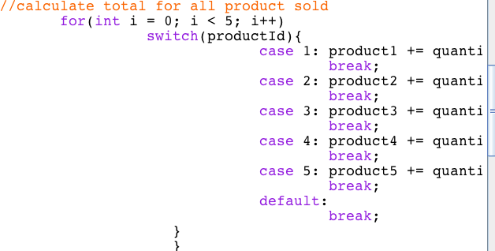

import javax.swing.*;  
import java.text.NumberFormat;  
import java.util.Locale;  
  
public class Products  
{   
public static void main (String args[])  
{  
//calculate product sold, quantity and overall sales  
float product1 = 0, product2 = 0, product3 = 0;  
float product4 = 0, product5 = 0;  
String inputString;  
int productId = 1;  
int totalCost = 0;  
//request input for product and quantity, until flag value is entered  
  
while (productId != -1) {  
 inputString = JOptionPane.showInputDialog  
 ("Enter product no.1-5 (-1 to Quit): ");  
 productId = Integer.parseInt( inputString );  
 if ( productId >= 1 && productId <= 5 ) {  
   
 inputString = JOptionPane.showInputDialog  
 ("Enter quantity (-1 to Quit: ");  
int quantity = Integer.parseInt( inputString );  
//calculate total for all product sold  
 for(int i = 0; i < 5; i++)  
 switch(productId){  
 case 1: product1 += quantity * 2.98;  
 break;  
 case 2: product2 += quantity * 4.50;  
 break;  
 case 3: product3 += quantity * 9.98;  
 break;   
 case 4: product4 += quantity * 4.49;  
 break;   
 case 5: product5 += quantity * 6.87;  
 break;   
 default:   
 break;  
 }  
 }  
else if ( productId != 0 ) {  
JOptionPane.showMessageDialog( null,  
"Product number must be between 1 and 5 or -1 to Quit",  
"Input Error", JOptionPane.INFORMATION_MESSAGE );  
}  
}  
  
// create decimal format to format floating point numbers  
// with two digits to the right of the decimal point  
NumberFormat moneyFormat =  
NumberFormat.getCurrencyInstance( Locale.US );  
// create a summary message  
String output = "Product 1: " + moneyFormat.format( product1 );  
output += "\nProduct 2: "+ moneyFormat.format( product2 );  
output += "\nProduct 3: " + moneyFormat.format( product3 );  
output += "\nProduct 4: " + moneyFormat.format( product4 );  
output += "\nProduct 5: " + moneyFormat.format( product5 ) + "\n";  
JTextArea outputArea = new JTextArea( 6, 20 );  
outputArea.setText( output );  
// show results  
JOptionPane.showMessageDialog( null, outputArea,  
"Totals", JOptionPane.INFORMATION_MESSAGE );  
System.exit( 0 );  
}  
